Initial TF Conductor Flexible Link Sample

Examination (deviations from design):

- Solder voids between laminations in terminal portion.
- Solder filling some gaps within flex portion.
- Laminations within flex portion in tight physical contact.
- Surface variations in terminal contact face of greater than 0.025”.
- Terminal portion thickness variation of 0.14”.

Contact Surface Test:

- Initial impression with ground surface steel plate at about 10 psi indicated contact over < 5% of the contact surface.
- Impression made using a ground surface steel plate with super-bolts at specified torque indicated contact over ~80% of the total contact surface.
- After setting for about 30 minutes, the super bolts were under noticeable less tension then when initially tightened.
- It appears that the compressed terminal copper and solder structure flowed some while under compression.

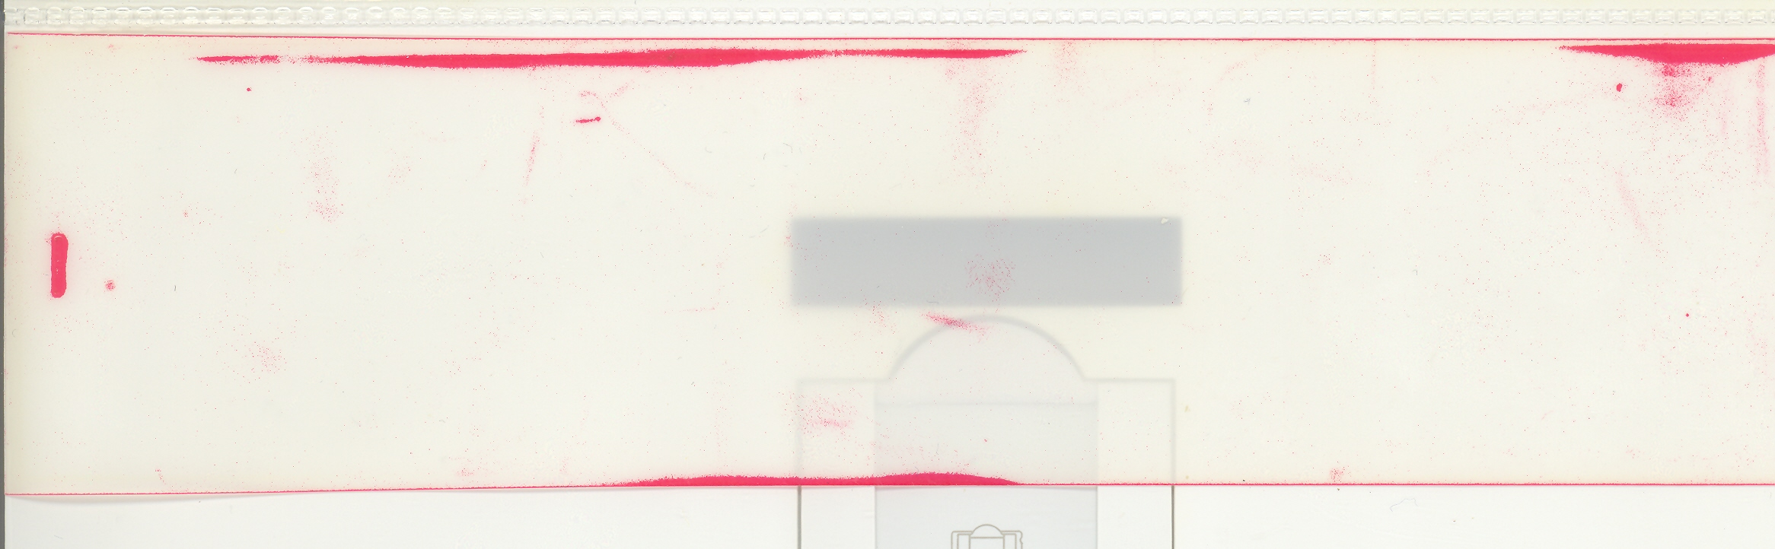

Initial contact surface impression

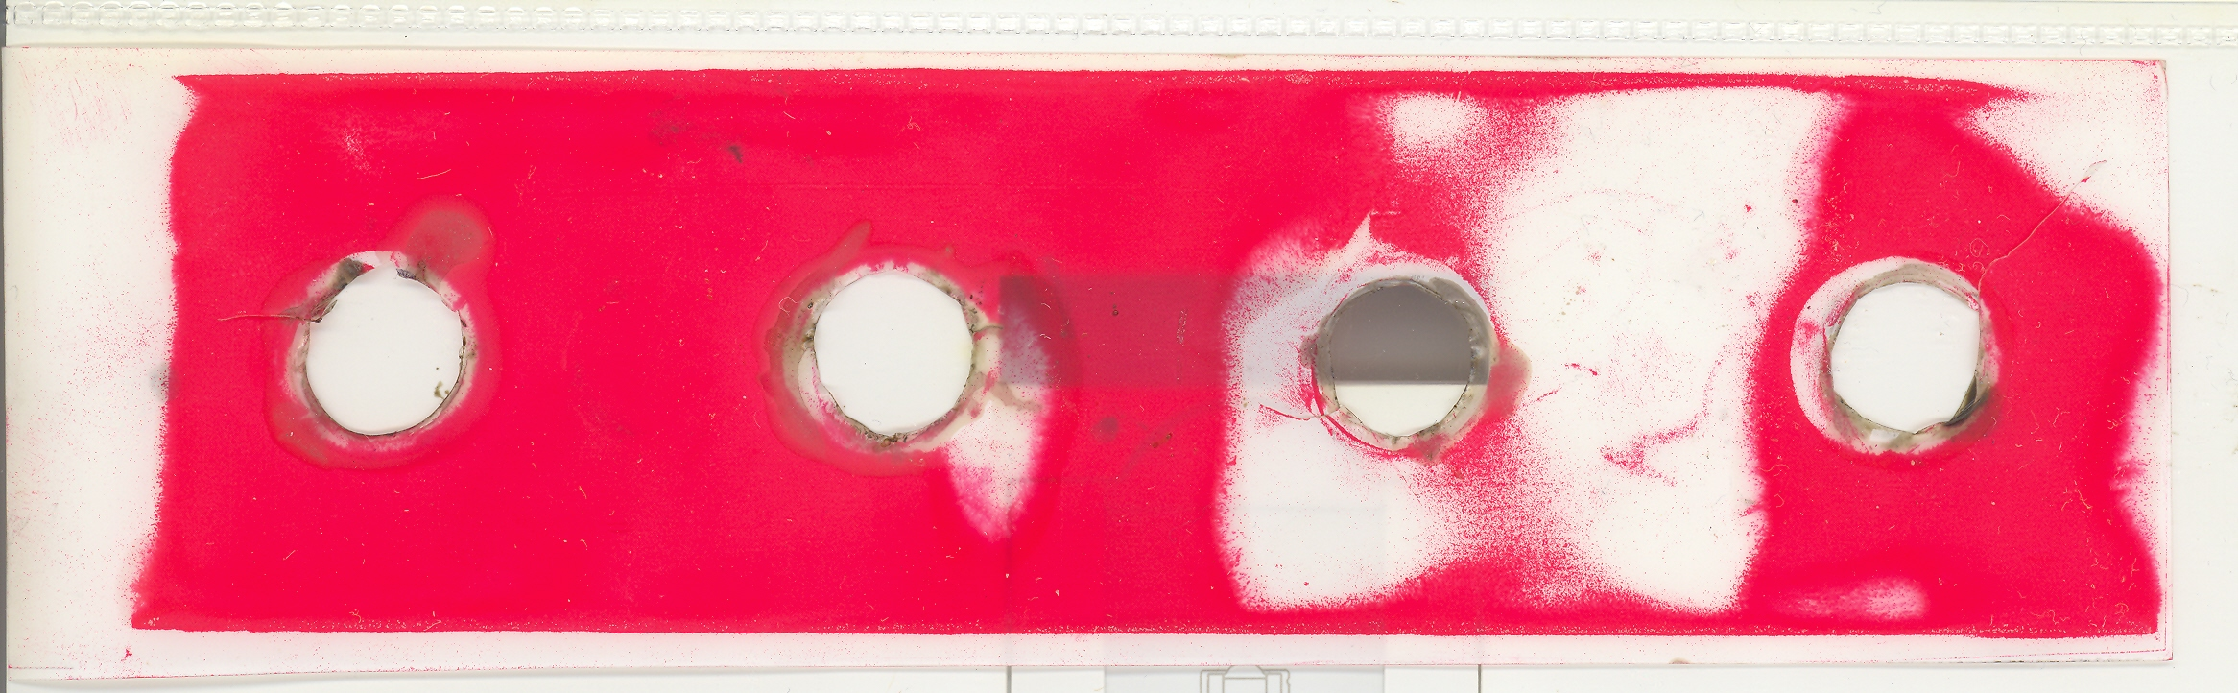

Contact surface impression with super-bolts

