August 5, 2009
P Titus Outer PF Support Analyses

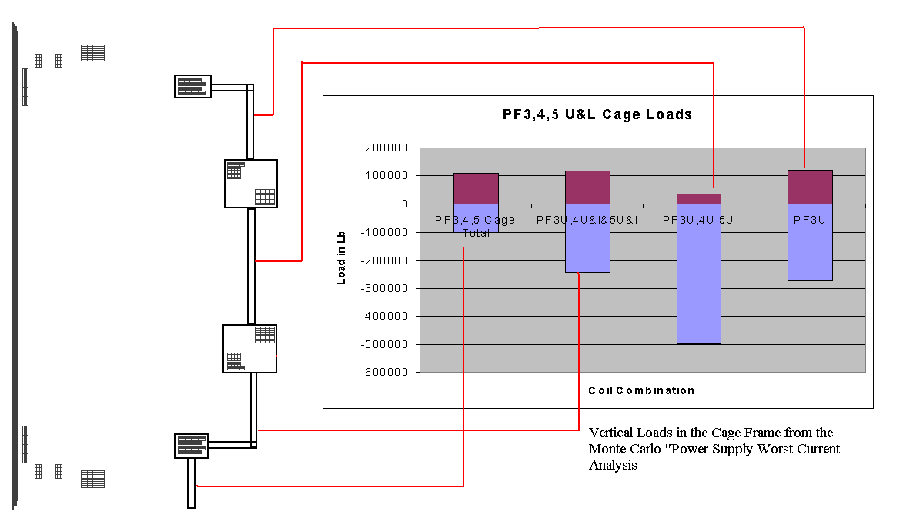
Outer PF 3,4,5 Cage Loads
let nam$(numpf+2)="PF3,4,5,Cage"
let vf(numpf+2)=vf(6)+vf(7)+vf(8)+vf(13)+vf(14)+vf(15) !PF34+5U&L
let nam$(numpf+3)="PF3U,4U&L,5U&L"
let vf(numpf+3)=vf(6)+vf(7)+vf(8)+vf(14)+vf(15) !PF4&5l+PF3,4+5U
let nam$(numpf+4)="PF3U,4U,5U"
let vf(numpf+4)=vf(6)+vf(7)+vf(8) !PF3,4+5U
let nam$(numpf+3)="PF3U,4U&L,5U&L"
let nam$(numpf+5)="PF3U"
let vf(numpf+5)=vf(6) !PF3U
Fz(lbf) | PF3U | PF4U | PF5U | PF5L | PF4L | PF3L
Min | -150417 | -216571 | -242555 | -62432 | -91785 | -35783
Worst Case Min | -314951 | -450863 | -541645 | -212419 | -161901 | -272627
Max | 103217 | 91746 | 62512 | 242490 | 198573 | 150425
Worst Case Max | 272631 | 161856 | 212552 | 541490 | 450422 | 314965

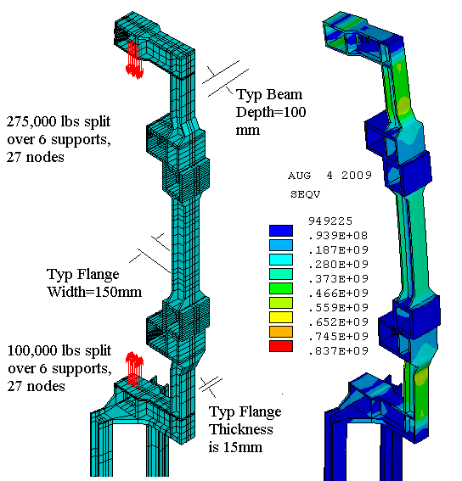
The Min value for PF3U is 140,000 Lbs from C. Neumeyer’s design point.
With only 6 supports, the support frame would be over-stressed – 12 may be needed
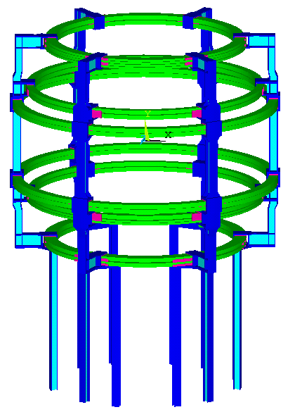
6 Supports and PF3,4,5U/L
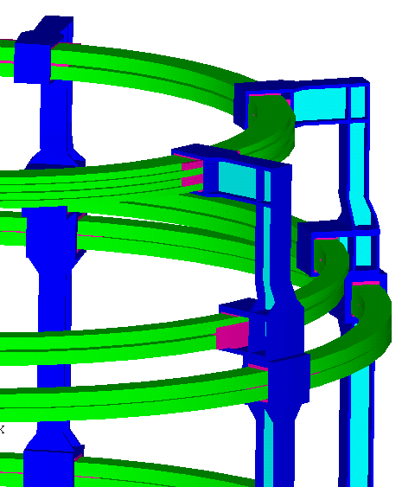
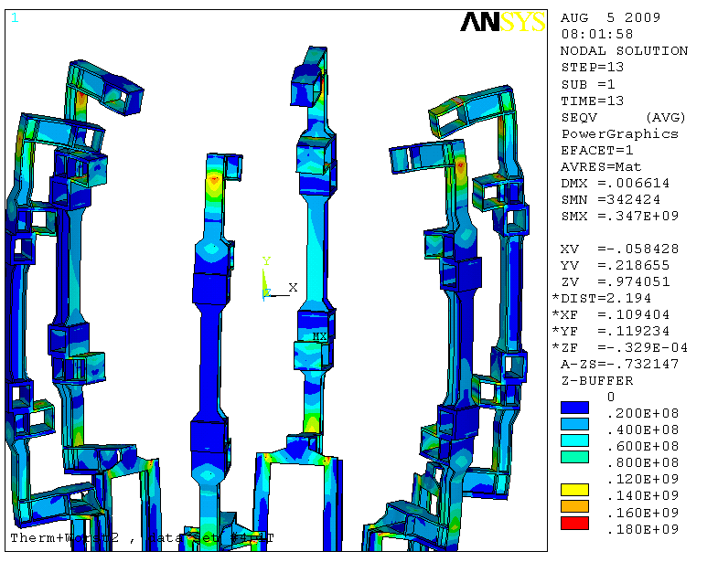
Global Model Results for a “Worst Case” PF Scenario
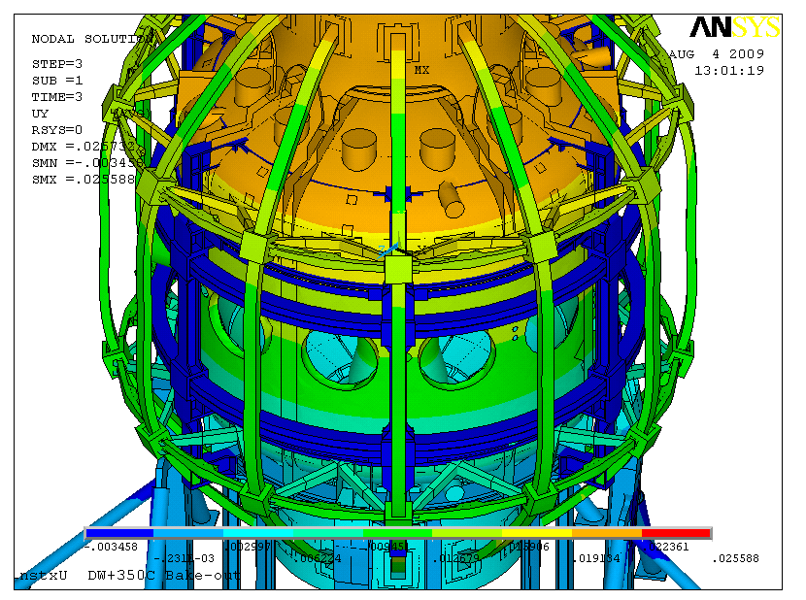
Outer PF Support “Cage” is Not Connected to the Vessel During Normal Operation or Bake-Out
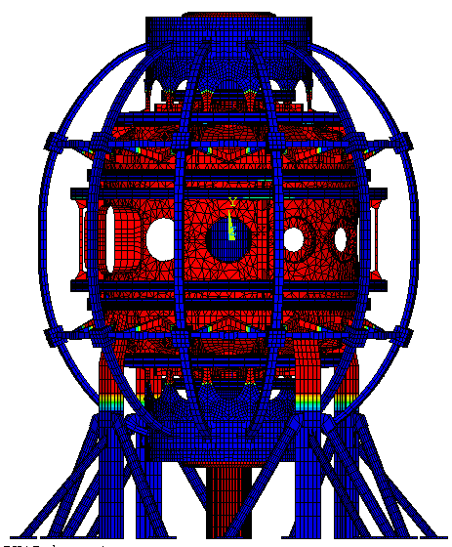
350C Bake-Out Temp

