Analysis Progress July 22 2009

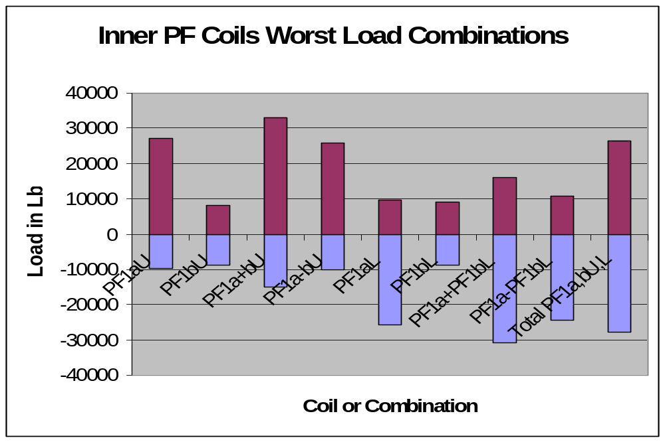

Outer PF Support Cage.

These loads were developed assuming support at the bottom with some sort of column or strut either to the ground or to the vessel support columns/legs.
let nam$(numpf+2)="PF3,4,5,Cage"
let vf(numpf+2)=vf(6)+vf(7)+vf(8)+vf(13)+vf(14)+vf(15) !PF34+5U&L
let nam$(numpf+3)="PF3U,4U&L,5U&L"
let vf(numpf+3)=vf(6)+vf(7)+vf(8)+vf(14)+vf(15) !PF4&5l+PF3,4+5U
let nam$(numpf+4)="PF3U,4U,5U"
let vf(numpf+4)=vf(6)+vf(7)+vf(8) !PF3,4+5U
let nam$(numpf+3)="PF3U,4U&L,5U&L"
let nam$(numpf+5)="PF3U"
let vf(numpf+5)=vf(6) !PF3U
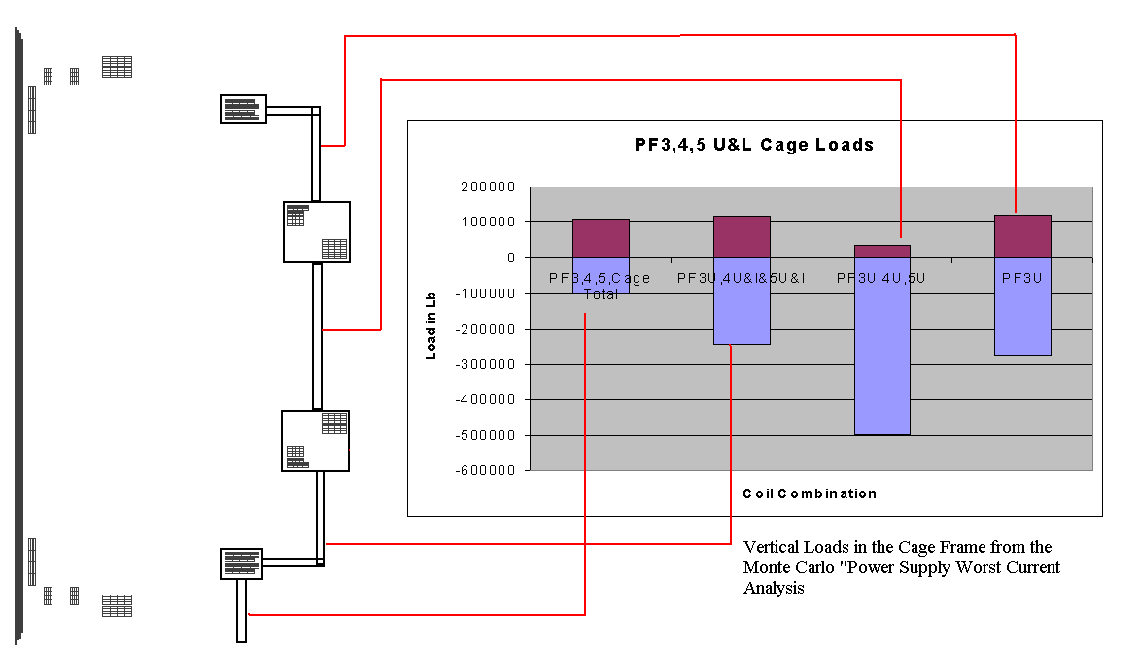
Cage Loads
Global Model Results
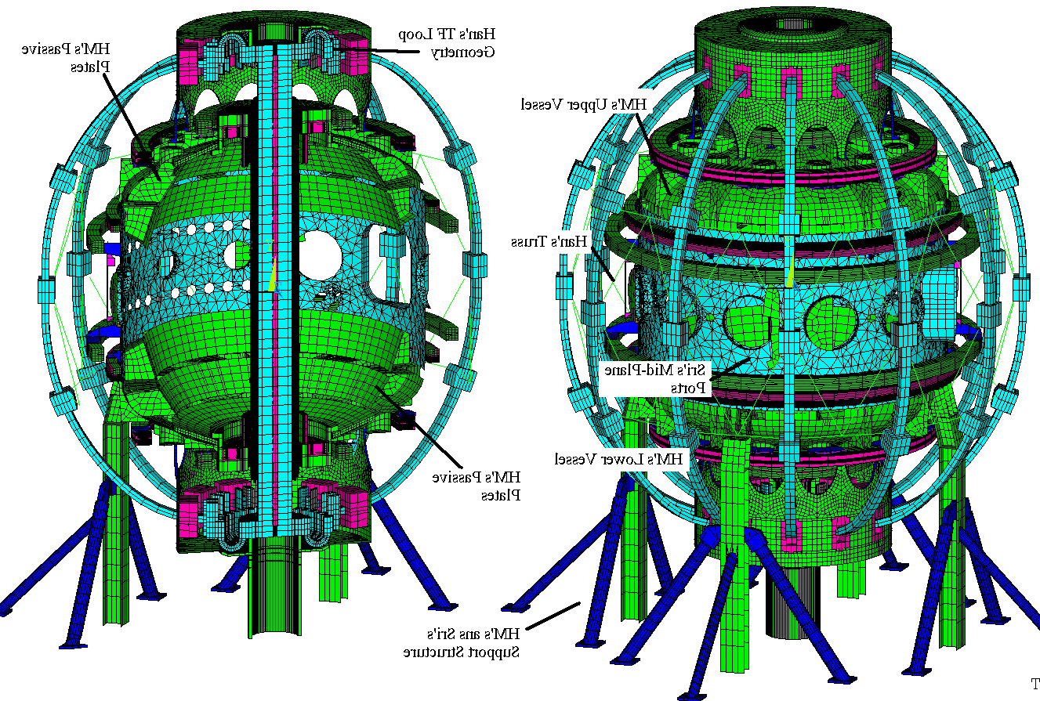
Global Model Status as of June 22 2009
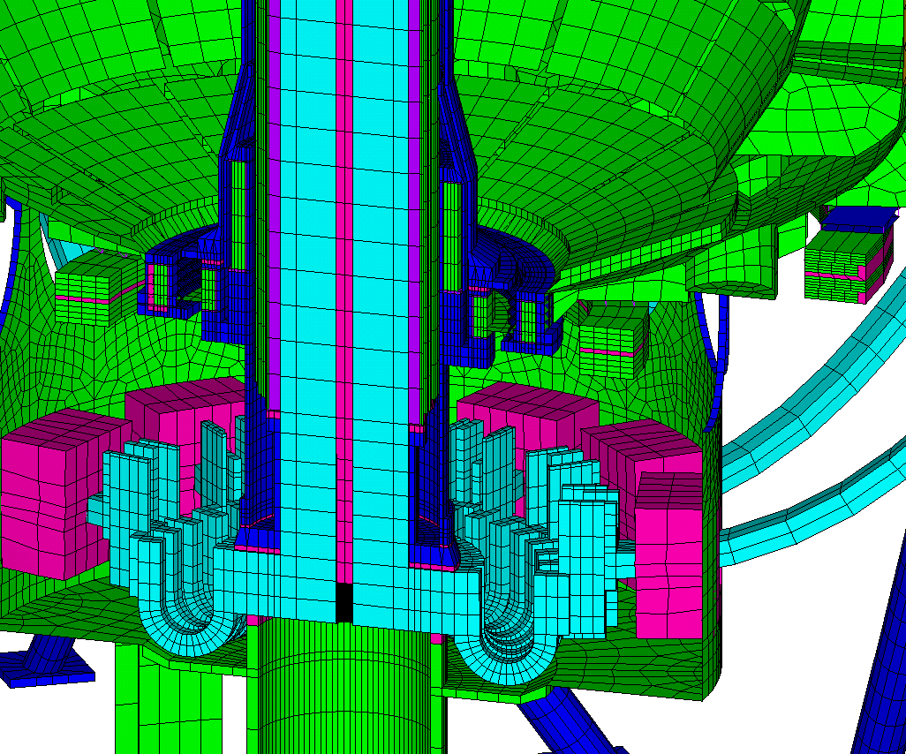
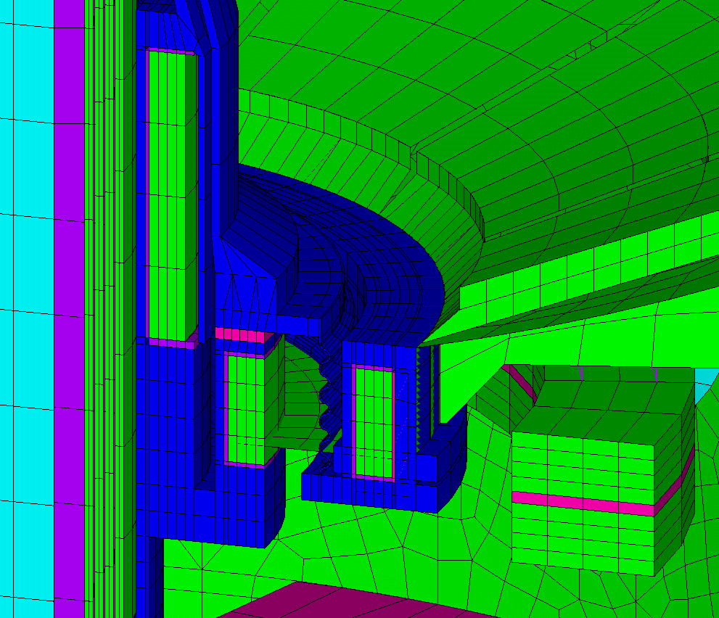
Center Stack – TF Inner Leg Torsional Shear, Global Model Results
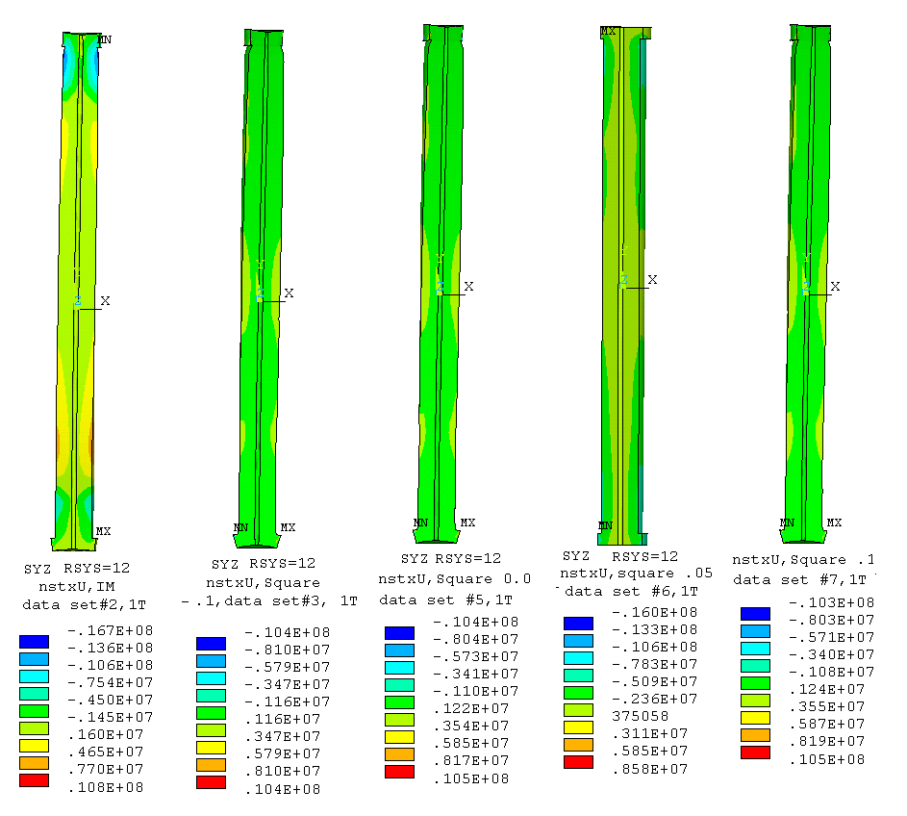

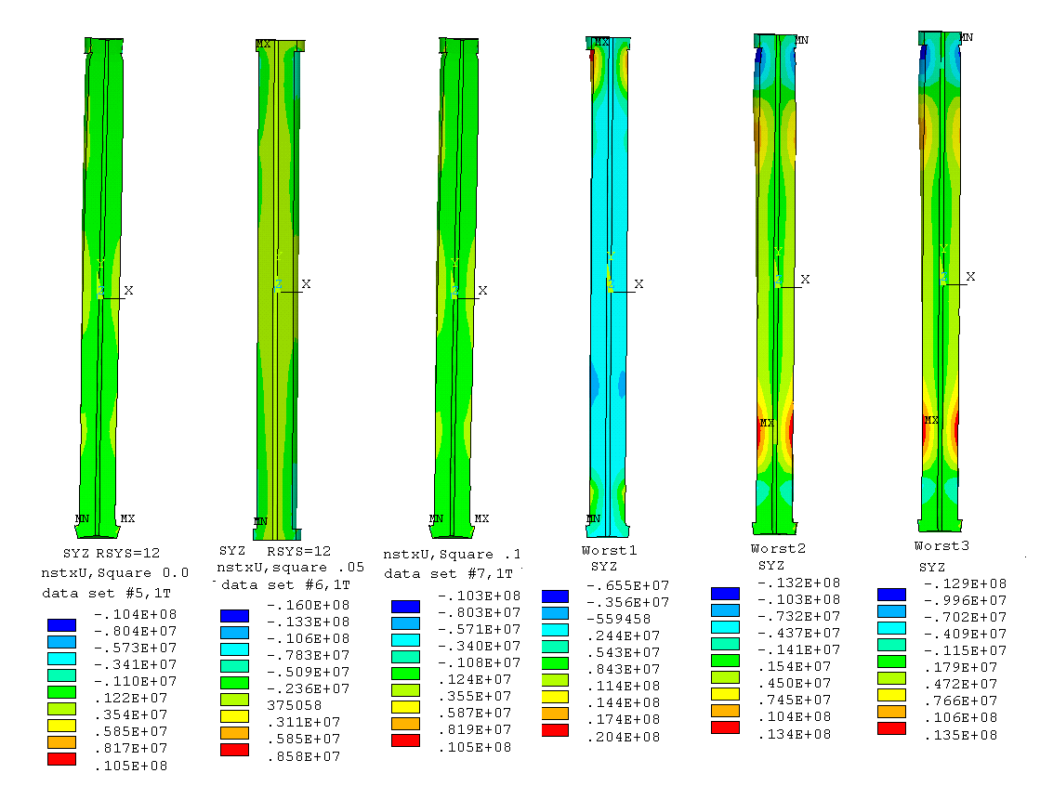
Shear strength, short-beam-shear, interlaminar, without Kapton 65 MPa
with Kapton 40 MPa

I-5.2.1.3 Shear Stress Allowable
The shear-stress allowable, Ss, for an insulating material is most strongly a function of the particular material and processing method chosen, the loading conditions, the temperature, and the radiation exposure level. The shear strength of insulating materials depends strongly on the applied compressive stress. Therefore, the following conditions must be met for either static or fatigue conditions:

Ss = [2/3 τo ]+ [c2 x Sc(n)]

2/3 of 40 MPa = 26.6 MPa
The worst torsional shear
So far is 20.4 MPa

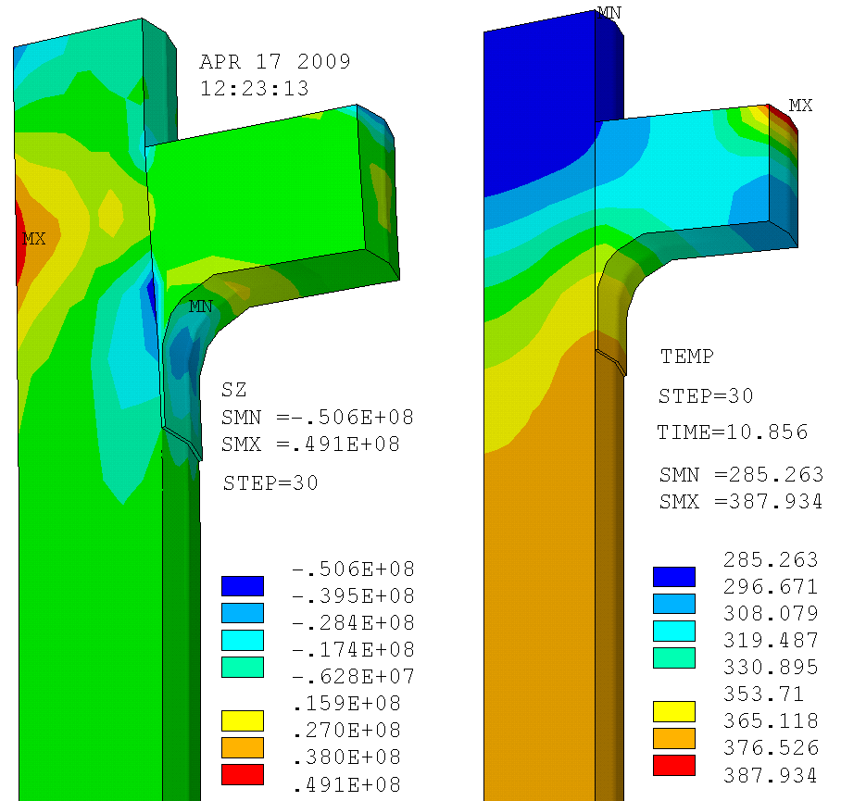

 | TF Stress (MPa) | Ring Stress (MPa) | Radius Rod Loads (kips)
Diamond Truss System | 500 | 500 | 30
12 Radius Rods | 220 | 216 | 35(sym) 43(asym)


