NSTX
NSTX Center Stack Upgrade
CoNCEPTUAL DESIGN REPORT
Structural analysis

November 20 2009

Prepared By:

P. Titus, H.Zhang, A. Zolfaghari, S.Avasarala, A. Brooks, R. Ellis,R.Woolley
PPPL Mechanical Engineering
L. Myatt,, Myatt Consulting

Reviewed By:

________________________________________
Peter Titus, Branch Head, Engineering Analysis Division
Reviewed By:

_______________________________________
Phil Heitzenroeder, Head, Mechanical Engineering
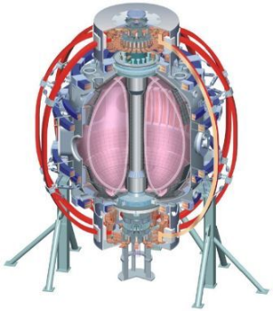

Table of Contents

1 Introduction, Summary, and Design Input 1
1.1 Introduction 1
1.2. Summary of the CDR Analysis Status 2
1.3. Design Point 3
1.4 Criteria 4
1.4.1 Monotonic Stress Criteria 5
1.4.1.1 Allowables for Coil Copper Stresses 5
1.4.2 Room Temperature Allowables for 316 and 304 SST 5
1.4.2.1 Mill Certifications for the 304 Vessel Show a 45 ksi Yield 6
1.4.2.2 Insulation Shear Stress Allowable 7
1.4.2.3 NSTX Fatigue Criteria Document Content 7
1.4.3 Design Loads 8
1.4.3.1 Lorentz Loads 8
1.4.3.2 Criteria Document Paragraph I-2.0 LOAD COMBINATIONS 10
1.4.3.3 Criteria Document Paragraph I-2.6 Damage Limits & Recovery From Events 11
1.4.3.4 Monte Carlo Analysis 12
1.5 List of References 13
2. Global Modeling 13
2.1. Status of the Global Model 13
3. Plasma Facing Components (WBS 1.1.1) 16
3.1. Heat Balance and Heat Loads on PFCs 16
3.2 Tile Stress Analysis 17
3.3. Disruption Analysis, Passive Plate Disruption Stress 19
3.4. Imposing the Background Fields 25
4. Vacuum Vessel & Support Structure (WBS 1.1.2) 26
4.1. Overview 26
4.2. Vessel Outer Leg Connection 27
4.3. Upper Diaphragm/Cover/Flex 28
4.4. Umbrella Structure 29
4.5. Center Stack Casing 32
4.5.1. Centerstack Casing Thermal Loads 32
4.5.2. Centerstack Casing Halo Loads 33
5. Magnet Systems (WBS 1.1.3) 37
5.1. Coil Builds 37
5.2. PF Currents 38
5.3. Lorentz Force Plots – TF and TF+OH 39
5.4 Toroidal Field Coils 43
5.4.1. Coupled Electromagnic-Thermal Analysis 43
5.4.2 Analysis Method 47
5.4.3. Extended Hub Structural Pass 48
5.4.4 Joint Option Studies 50
5.4.4.1 Concept Options 50
5.4.4.2 TF Joint Qualification and Model 51
5.4.4.2.1. TF Joint Qualification Boundary Conditions 51
5.4.4.2.2. TF Joint Local Model 54
5.4.4.2.3. Joint Mechanical Parameters Comparison 56
5.4.4.2.4. Joint Electrical/ Thermal Parameters Comparison 56
5.4.4.2.5. Static Bolt Strengths and Insert Pull-Out Loads Comparison 57
5.4.4.2.6. Comparison Summary 57
5.4.5. Global Torques 60
5.4.6. TF Inner Leg Torsional Shear 61
5.4.6.1. Global Model Results 61
5.4.6.2. Simplified Analysis 63
5.4.6.3. Effect of De-Wedged Area in the TF Corner 67
5.4.6.4. TF Outer Leg Reinforcement 68
5.4.6.5. TF Outer Leg Bond Shear 73
5.4.6.6. OH Analyses in the Centerstack Assembly 74
5.4.6.7 OH Conductor Fatigue Evaluation 79
5.4.6.8 OH Coolant Hole Optimization 83
5.4.6.8 Inner PF Support Design and Analysis 84
5.4.6.9 PF 2 Support Design and Analysis 87
5.4.6.10. PF Coil Hoop Stresses 87
5.4.6.11. Outer PF Supports Cage 89
6 Plasma Heating & Current Drive System (WBS 2) 91
6.1 High Harmonic Fast Wave (HHFW) – WBS 2.1 91
6.2 Electron Cyclotron Heating (ECH) – WBS 2.3 93
6.3 Neutral Beam Injection (NBI) – WBS 2.4 93

Index of Figures
Figure 1.1-1 Features of the NSTX Center Stack Upgrade 1
Figure 1.4-1 Material Certification for 304 Stainless Steel 6
Figure 1.4-2 Shear Compression Data 7
Figure 1.4-3 Analytic Sources of Lorentz Loading 8
Figure 1.4-4 Worst Case and Normal Operating Conditions 9
Figure 1.4-5 Monte Carlo Simulation Current Assignment Routine 12
Figure 1.4-6 Monte Carlo Graphical Representation 13
Figure 2.1-1 Global Model 14
Figure 2.1-2 Global Model Status as of June 22, 2009 14
Figure 2.1-3 Global Model at 350C Bake-Out Temperature Conditions 15
Figure 2.1-4 Bake-out Vertical Displacements 16
Figure 3.1-1 Heat Balance Summary Slide from the CDR 16
Figure 3.1-2 Heat Balance Summary Slide – Critical Areas Requiring Cooling 17
Figure 3.2-1 End of Pulse Temperature Distribution 18
Figure 3.2-2 Shows what??? 18
Figure 3.2-3 Stress Results Summary 19
Figure 3.3-1 Photograph of the NSTX Passive Plates (October 2009) 19
Figure 3.3-2 Passive Plate Disruption Analyses Process 20
Figure 3.3-3 Relation between Vector Potential (A) and Field (B) 21
Figure 3.3-4 Vessel Disruption Stresses 21
Figure 3.3-5 Passive Plate Disruption Eddy Currents and Stresses 22
Figure 3.3-6 Meshed Detailed Model 23
Figure 3.3-7 Photo of Passive Plate Attachment Details. 24
Figure 3.3-8 Constraint Equations that Stitch the Passive Plate Structure to the Vessel 24
Figure 3.3-9 shows what??? 25
Figure 3.4-1 Background Field Equations 25
Figure 4.1-1 Vessel Response to a Disruption 26
Figure 4.1-2 Global Model Results 27
Figure 4.2-1 Bay B C Gusset Plate 27
Figure 4.2-2 ANSYS Models of the Bay B C Gusset Plates 28
Figure 4.3-1 Upper Flex Plate Diaphragm 28
Figure 4.3-2 Another View of the Upper Flex Plate Diaphragm 29
Figure 4.4-1 Umbrella Structure Loading 30
Figure 4.4-2 Aluminum Block Analysis Results 30
Figure 4.4-3 View Inside Umbrella Structure 30
Figure 4.4-4 View from Outside the Umbrella Structure 31
Figure 4.4-5 FEA Model of the Umbrella Structure Showing Large Span Arch 31
Figure 4.4-6 Umbrella Structure Response to In-Plane Loads from the TF Outer Legs 31
Figure 4.5-1 Centerstack Casing and Upper Inner PF’s 32
Figure 4.5-2 Center Stack Casing Dimensions 33
Figure 4.5-3 Casing Stress Estimate 33
Figure 4.5-4 GRD Disruption Diagram 34
Figure 4.5-5 Center Stack Casing Disruption Results 35
Figure 4.5-6 Center Stack Disruption Analysis (Halo + Inductive) 36
Figure 5.1-1 Two Views of the PF Coil s 38
Figure 5.1-2 TF Coil Builds (Including Flag) 38
Figure 5.3-1 TFON 40
Figure 5.3-2 IM 41
Figure 5.3-3 Shows What??? 41
Figure 5.3-4 Shows What??? 42
Figure 5.3-5 Typical TF Out-of-Plane Loads 42
Figure 5.3-6 Typical TF Outer Leg Out-of-Plane 43
Figure 5.4-1 Results from the Electromagnetic-Thermal Model 44
Figure 5.4-2 Results from the Global Model 44
Figure 5.4-3 NSTX Normal Operation Waveform 45
Figure 5.4-4 Model of Arch 46
Figure 5.4-5 Displacements from the Electromagnetic Current Diffusion Model - Inner Leg Temperature, L/R Fault 47
Figure 5.4-6 Equatorial Plane Time History. End average temperature is 367.15, Ref [6],{7] 48
Figure 5.4-7 Structural Pass Forces, Constraints, and Temperatures 48
Figure 5.4-8 Inner Leg Stress Time History – No Thermal Stresses 49
Figure 5.4-9 Inner Leg Von Mises Stress Time History – With Thermal Stress 49
Figure 5.4-10 TF Center Stack Options 50
Figure 5.4-11 Concept 4 - Extended Hub Concept 51
Figure 5.4-12 TF Inner Joint Qualification 52
Figure 5.4-13 Details of the TF Inner Flex Joint 52
Figure 5.4-14 TF Inner Flex Joint Analyses 53
Figure 5.4-15 Maximum Vertical Field at the TF Straps 53
Figure 5.4-16 Toroidal Displacements at the Flex Joint 54
Figure 5.4-17 TF Joint Model 54
Figure 5.4-18 ANSYS Multiphysics Finite Element Analysis 55
Figure 5.4-19 Static Structural Analysis Results: von Mises Stress 58
Figure 5.4-20 Static Structural Analysis Results: TF Bundle Stub Bolted Joint 59
Figure 5.4-21 Inner-Most Lamination Model 59
Figure 5.4-22 Outer-Most LaminationModel 60
Figure 5.4-23 Net TF System Outer Leg Torque Equations 60
Figure 5.4-24 Net Upper Half TF System Torque Equations 61
Figure 5.4-25 Global Model Inner Leg Torsional Shear 61
Figure 5.4-26 Global Model Inner Leg Torsional Shear – Worst Case PF Loads 62
Figure 5.4-27 Another View of the Global Model Inner Leg Torsional Shear 62
Figure 5.4-28 Simple Toroidal Field Coil Shell Model 63
Figure 5.4-29 NSTX Shell Model 64
Figure 5.4-30 Comparison of Woolley, Global FEA and Simple Shell Analyses 64
Figure 5.4-31 Torsional Shear for IM and some Equilibria 65
Figure 5.4-32 OOP Force Density Along the TF CL Starting from the Outboard Equitorial Plane 65
Figure 5.4-33 OOP Torsional Shear Stress Along the TF CL Starting from the Outboard Equitorial Plane 66
Figure 5.4-34 shows WHAT??? 66
Figure 5.4-35 shows WHAT??? 66
Figure 5.4-36–Shows What??? 67
Figure 5.4-37 - shows What??? 67
Figure 5.4-38 Effect of De-Wedged Area in the TF Corner 68
Figure 5.4-39 NSTX Machine 69
Figure 5.4-40 shows what??? 69
Figure 5.4-41 Stresses Tangential (Radius) Rods 70
Figure 5.4-42 Design of Stainless Steel Case 71
Figure 5.4-43 NSTX Machine with Reinforcements 72
Figure 5.4-44 Vessel Stresses with Tangential Radius Rods 72
Figure 5.4-45 Outer Leg Stress with Tangential Radius Rods 73
Figure 5.4-46 Global Model Dimensional Error 74
Figure 5.4-47 Global Model Bending Related Shear 74
Figure 5.4-48 Influence of PF1A on the OH Coil 75
Figure 5.4-49 “Smeared” - Results with only the OH Current 75
Figure 5.4-50 Analysis of the OH Coil 76
Figure 5.4-51 CS Structure/Emag Modeling 77
Figure 5.4-52 – Net Load on CS 77
Figure 5.4-53 Shows What??? 78
Figure 5.4-54 Relative Torsional Displacements 78
Figure 5.4-55 – Estimate of Membrane Stress or Average Tresca Across the Radial Build 79
Figure 5.4-56 - Tresca Stress in the OH Conductor 80
Figure 5.4-57 - Typical SN data for Copper 80
Figure 5.4-58 – Fracture Mechanics Evaluation 81
Figure 5.4-59 - Fracture Mechanics Evaluation 82
Figure 5.4-60 - Nominal Conductor Max Principal Stress 83
Figure 5.4-61 Center Stack Coolant Hole Optimization Results Using CFX & FCOOL 84
Figure 5.4-62 Layout of Inner PF Coils 85
Figure 5.4-63 Inner PF Coils Worst Load Combinations 85
Figure 5.4-64 Inner PF Supports 86
Figure 5.4-65 Inner PF Analysis Results 86
Figure 5.4-66 PF2 Support Model 87
Figure 5.4-67 - OH “Smeared” Hoop Stress 88
Figure 5.4-68 Shows What??? 88
Figure 5.4-69 – Maximum and Minimum Hoop Stress 89
Figure 5.4-70 - Max And Min Vertical Loads in the Structural Elements of the Proposed Outer PF Support Cage 90
Figure 5.4-71 Monte Carlo Analysis Based on Worst Case PF Power Supply Capabilities 90
Figure 5.4-72 PF 4/5 Support Column Upgrade Mounted on the Vacuum Vessel 91
Figure 5.4-73 Vacuum Vessel Out-of-Roundness 91
Figure 6.1-1 – HHFW Disruption Analysis 92
Figure 6.2-1 – ECH Support Details 93
Figure 6.3-1 - The Model Without the Neutral Beam Port Covers is Shown. Blue and Purple Denote the Plate Element Faces 94
Figure 6.3-2 - Displacements With and Without Neutral Beam Port Covers 94
Figure 6.3-3 - Von Mises Stresses With and Without the Neutral Beam Port Covers 95
Figure 6.3-4 – Support Column Bending 95
Figure 6.3-5 - Displacements Without Braces, With and Without NB Port Covers 96
Figure 6.3-6 - Vessel Stresses Without Braces With and Without NB Port Covers 97

Listing of Tables

Table 1.3-1Summary of CSU Upgrade Design Point Data 3
Table 1.4-1 Room Temperature Allowables for 316 and 304 SST 5
Table 1.4-2 Damage Limits and Recovery from Events 11
Table 3.3-1 Passive Plate and Outboard Divertor Coordinates 22
Table 4.5-1 Disruption and Halo Current Analysis Procedure and Results 35
Table 4.5-2 Yield Data for Inconel 625 36
Table 5.1-1 PF Coil Builds 37
Table 5.2-1 PF Scenario Currents In Mat 39
Table 5.3-1 TF Current Spec ( L/R Decay) 40
Table 5.4-1 Design Operating Point Comparison 56
Table 5.4-2 Comparison of the Joint Mechanical Parameters 56
Table 5.4-3 Joint Electrical/Thermal Parameters Comparison 57
Table 5.4-4 Static Bolt Strength and Insert Pull-Out Comparison 57
Table 5.4-5 Stress Evaluation Based on the Criteria Document 70
Table 5.4-6 Fracture Crack Growth Life 82
Table 5.4-7 – Vertical Load Cases for the Outer PF Supports 90
Table 6.3-1 - Force Summations from the ANSYS Model and Load File 97
Table 6.3-2 – Loads on the Port Covers (Removed to Model the NB Bellows 98

Introduction, Summary, and Design Input

Introduction
The NSTX [1] is the world’s highest performance spherical torus (ST) research facility and is the centerpiece of the U.S. ST research program. Since starting operation in 1999, NSTX has established the attractiveness of the low-aspect-ratio tokamak ST concept characterized by strong intrinsic plasma shaping and enhanced stabilizing magnetic field line curvature. Error: Reference source not found shows the major features of the NSTX Center Stack Upgrade.
The purpose of the NSTX Center Stack Upgrade project is to expand the NSTX operational space and thereby the physics basis for next-step ST facilities. The plasma aspect ratio (ratio of major to minor radius) of the upgrade is increased to 1.5 from the original value of 1.26. The higher value of A matches the value found to be optimal in studies of future ST devices, and also increases the cross sectional area of the center stack by a factor of ~ 3 and makes possible higher levels of performance and pulse duration. The new center stack will provide a toroidal magnetic field at the major radius R₀ of 1 Tesla (T) compared to 0.55T in the existing NSTX device, and will enable operation at plasma current I_{p} up to 2 Mega-Amp (MA) compared to the 1MA rating of the existing. Plasma flat top duration is extended to 5.0 seconds from the present 0.5 second capability. This extension benefits substantially from another upgrade project which will add a second Neutral Beam Injection (NBI) line to NSTX such that flat-top current sustainment can be achieved non-inductively using NBI current drive.
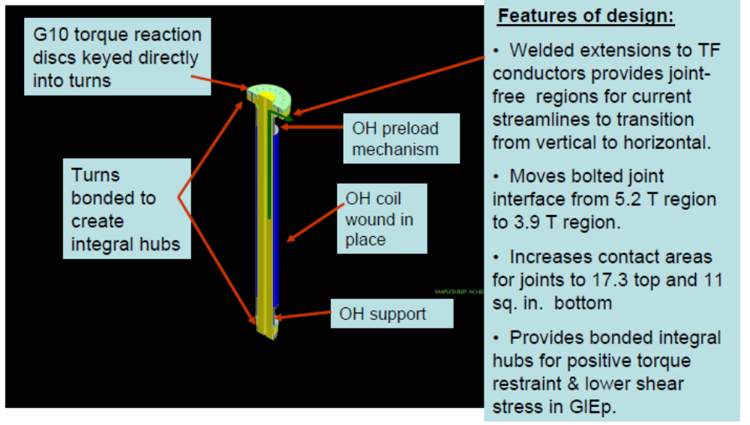
Figure 1.1-1 Features of the NSTX Center Stack Upgrade
The NSTX center stack (CS) consists of the inner legs of the toroidal field (TF) coil surrounded by an ohmic heating (OH) solenoid and a several poloidal field (PF) shaping coils, all encased in a vacuum-tight metallic center stack casing (CSC) covered by plasma facing tiles. Since the TF coils include a demountable joint between the inner and outer legs, and the CSC includes a bellows and vacuum seal connection to the outer vacuum vessel, the entire center stack assembly is removable as a modular unit. Thus the upgrade will be accomplished by replacing the existing CS with an entirely new assembly with new TF inner legs, OH and PF coils, CSC, and plasma facing tiles. The TF outer legs, originally designed with an upgrade in mind, are retained but with enhancements to their structural supports.
This document describes the analytic effort performed to support the conceptual design effort. Analyses build on a strong document package qualifying the original NSTX design. Operational history also contributed to understanding weaknesses in the design and afforded an opportunity to expand the engineering qualification more uniformly throughout the machine. Calculations which support thte original design may be found at:

http://nstx.pppl.gov/nstx/Engineering/NSTX_Eng_Site/Technical/General/Calculations/NSTX_Engr_Calcs.html

Calculations that support the conceptual design of the centerstack upgrade may be found at:

http://nstx-upgrade.pppl.gov/Engineering/WBS_Specific_Info/Design_Basis_Documentation/Calculations/index_Calcs.htm

Summary of the CDR Analysis Status
The design basis loading is evolving because of GRD guidance on Worst Case vs Normal +Machine Protection System. Cost savings are likely as we remove extreme load scenarios via inclusion in MPS.
TF Inner Joint Field and displacement boundary conditions have been passed to a detailed model of the joint (T. Willard’s Calculation [4])
TF reinforcements for in-plane and out-of plane loads have been designed to Worst Case loads and remain in the territory currently used by the present TF supports – Loosening or disassembly is not required for bake-out. Reinforcements of the umbrella structure are needed.
Centerstack TF and OH assembly meets normal operational loads, Belleville support system maintains OH coil contact at lower support to eliminate motion at leads and coolant connections.
As of the CDR no modifications of the vessel or passive plates are needed for disruption loads. More disruption cases are being run, and more detailed models of the passive plate support hardware are being modeled.
Active cooling being incorporated into the new center stack divertor areas has been sized. Tile surface temperatures for long pulse full power operation are high and require further evaluation.
Inner PF’s and structure are undergoing improvements as a part of the normal design process to meet Normal and Halo loads.
Analysis work continues to complete treatment of all details of the design and optimize and economize the design concepts.

Design Point

Some of the CSU Upgrade parameters are repeated here for convenience (Error: Reference source not found). An up-to-date complete listing of the these CSU Upgrade characteristics is provided in the design point spreadsheet available on the NSTX Upgrade engineering website at:

http://www.pppl.gov/~neumeyer/NSTX_CSU/Design_Point.html

Table 1.3-1Summary of CSU Upgrade Design Point Data

 |  | NSTX BASE | NSTX CSU
Ro | m | 0.854 | 0.934
Ip | MA | 1.0 | 2.0
Bt@Ro | T | 0.6 | 1.0
OH Flux Swing Total | Wb | 0.7 | 1.9
Initiation Vloop | V | 2.9 | 4.7
Ip Flat Top Time | s | 0.5 | 5.0
Ip Ramp Up Rate | MA/s | 5.0 | 2.0
Ip Ramp Down Rate | MA/s | 10.0 | 4.0
Ro+a | m | 1.477 | 1.504
A_95 |  | 1.4 | 1.6
a | m | 0.623 | 0.570
R0-a | m | 0.231 | 0.365
Zmax | m | 1.371 | 1.424
Rzmax | m | 0.480 | 0.593
Ip Duration | s | 0.8 | 6.5
OH Single Swing Flux | Wb | 0.4 | 1.4
OH Flux Initiation | Wb | 0.1 | 0.1
OH Flux Ramp | Wb | 0.5 | 1.3
OH Flux Flat Top | Wb | 0.1 | 0.5
TF Rcuinner | m | 0.0072 | 0.0260
TF Rcuouter | m | 0.0977 | 0.1941
TF �Zcu | m | 5.3300 | 5.3300
TF #turns | turns | 36 | 36
TF #layers | layers | 2 | 1
TF Ground insulation | m | 0.0014 | 0.0024
TF Turn insulation | m | 0.0008 | 0.0008
TF Cooling hole diameter | m | 0.0047 | 0.0047
TF Conductor corner radius | m | 0.0010 | 0.0010
TF Packing fraction |  | 0.8169 | 0.8900
TF Voltage | V | 1013 | 1013
TF Current | Amp | 71168 | 129778
TF Tesw (L/R Decay) | s | 1.38 | 7.57
TF Action (L/R Decay) | A^2-s | 7.01E+09 | 1.27E+11
TF Voltage stress max turn-turn | kv/mm | 0.6231 | 0.6231
TF Voltage stress max turn-ground | kv/mm | 0.4637 | 0.3190
TF Inlet Coolant Temp | C | 12 | 12
TF Inner leg maximum temp (L/R Decay) | C | 99 | 100
TF Outer leg maximum temp (L/R Decay) | C | 17 | 50
Total Copper Mass TF Inner Legs | Tonne | 1.2 | 0.0
Total Copper Mass TF Outer Legs | Tonne | 8.4 | 0.0
TF Rcuinner | in | 0.2819 | 1.0220
TF Rcuouter | in | 3.8469 | 7.6398
TF �Zcu | in | 209.8425 | 209.8425
TF #turns | turns | 36 | 36
TF #layers | layers | 2 | 1
TF Cooling hole diameter | in | 0.1860 | 0.1860
TF Conductor corner radius | in | 0.0390 | 0.0390
TF Packing fraction |  | 0.8169 | 0.8900
TF Current | Amp | 71168 | 129778
TF Tesw (L/R Decay) | s | 1.38 | 7.57
TF Action (L/R Decay) | A^2-s | 7.01E+09 | 1.27452E+11
TF Voltage stress max turn-turn | volt/mil | 16 | 16
TF Voltage stress max turn-ground | volt/mil | 12 | 8
TF Inlet Coolant Temp | C | 12 | 12
TF Inner leg maximum temp (L/R Decay) | C | 99 | 100
TF Outer leg maximum temp (L/R Decay) | C | 17 | 50
Total Copper Mass TF Inner Legs | lbs | 2560 | 0
Total Copper Mass TF Outer Legs | lbs | 18495 | 0

Criteria
For the conceptual design of NSTX Centerstack Upgrade, a structural criteria specific to the project, has been adopted. This and the General Requirements document provide the criteria for design of the upgrade. Both the GRD and the criteria document may be accessed through the NSTX Upgrade engineering web page. Summaries are included in the following sections.

Monotonic Stress Criteria

Allowables for Coil Copper Stresses
The TF copper ultimate is 39,000 psi or 270 MPa . The yield is 38ksi (262 MPa). Sm is 2/3 yield or 25.3ksi or 173 MPa – for adequate ductility, which is the case with this copper which has a minimum of 24% elongation. Note that the ½ ultimate is not invoked for the conductor (It is for other structural materials) . These stresses should be further reduced to consider the effects of operation at 100C. This effect is estimated to be 10% so the Sm value is 156 MPa. From NSTX Design Criteria Document [NSTX_DesCrit_IZ_080103], Sections I-4.1.1 and I-4.1.2:
- For conventional (i.e., non-superconducting) conductor materials, the design Tresca stress values (Sm) shall be 2/3 of the specified minimum yield strength at temperature, for materials where sufficient ductility is demonstrated (see Section I-4.1.2). *
- It is expected that the CS would be a similar hardness to the TF so that it could be wound readily. For the stress gradient in a solenoid, the bending allowable has been used for initial sizing. The bending allowable is 1.5*156 or 233MPa, Membrane or average tresca stress in the coil section should meet the membrane stress allowable.

Room Temperature Allowables for 316 and 304 SST
Error: Reference source not found below shows the room temperature allowables for 316 and 304 stainless steels.
Table 1.4-2 Room Temperature Allowables for 316 and 304 SST

Material | Sm | 1.5Sm
316 LN SST | 183Mpa (26.6 ksi) | 275Mpa (40ksi)
316 LN SST  weld | 160MPa(23.2ksi) | 241MPa(35ksi)

Mill Certifications for the 304 Vessel Show a 45 ksi Yield

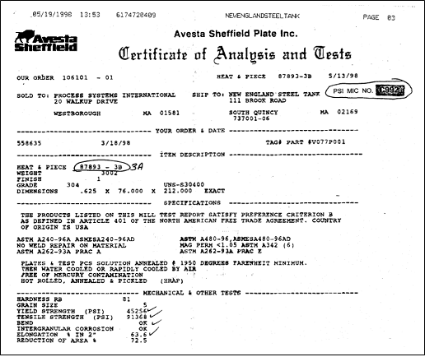

Figure 1.4-2 Material Certification for 304 Stainless Steel

Insulation Shear Stress Allowable
From Dick Reed (Cryogenic Materials, Inc.) reports and conversations concerning stress allowables at room temperature, shear strength, short-beam-shear, and interlaminar shear, the results are:
- Without Kapton: 65 Mpa (for TF, PF1 a,b,c)
- With Kapton: 40 MPa (CS)
- Estimated Strength at Copper Bond: 65 MPa/2 = 32.5 MPa (All Coils)
From the NSTX Criteria Document: SectionI-5.2.1.3 Shear Stress Allowable

The shear-stress allowable, Ss, for an insulating material is most strongly a function of the particular material and processing method chosen, the loading conditions, the temperature, and the radiation exposure level. The shear strength of insulating materials depends strongly on the applied compressive stress. Therefore, the following conditions must be met for either static or fatigue conditions:
Ss = [2/3 to ]+ [c2 x Sc(n)]
2/3 of 32.5 MPa = 21.7 MPa
5ksi=34 MPa
2/3 of this is 23 MPa
C2~=.1 (not .3)

Error: Reference source not found below shows the shear compression data from CTD for 101 K and BeCu.
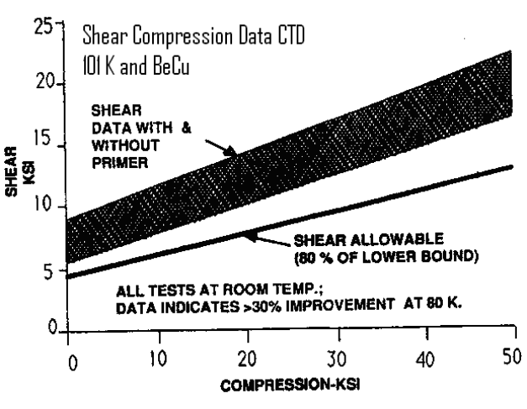
Figure 1.4-3 Shear Compression Data

NSTX Fatigue Criteria Document Content
- NSTX CSU is designed for approximately 3000 full power and 30,000 two-thirds power pulses.
- A fatigue strength evaluation is required for those NSTX CSU components with undetectable flaws that are either cycled over 10,000 times or are exposed to cyclic peak stresses exceeding yield stress.
- Any NSTX component without cyclic tensile loading and loaded only in compression shall not require a fatigue evaluation.
For engineering purposes, number of NSTX pulses, after implementing the Center Stack Upgrade, shall be assumed to consist of a total of ~ 60,000 pulses based on the GRD specified pulse spectrum.
Fatigue has not been considered extensively during the CDR, The Criteria and GRD need to be reconciled. A definition of the aged condition for “used” components needs to be developed. Because of the increase in loads, Minors Rule and Non-Linearity of Fatigue, previous stress cycles will add little in the cumulative damage evaluation.

Design Loads

Lorentz Loads
Lorentz Loads from coil currents are a major loading on NSTX. A range of identified operational current equilibria constitute the normal operating loads. These are included in the published design point, accessed through the NSTX Upgrade web page[1]. A plot of the currents is included in Error: Reference source not found and Error: Reference source not found.

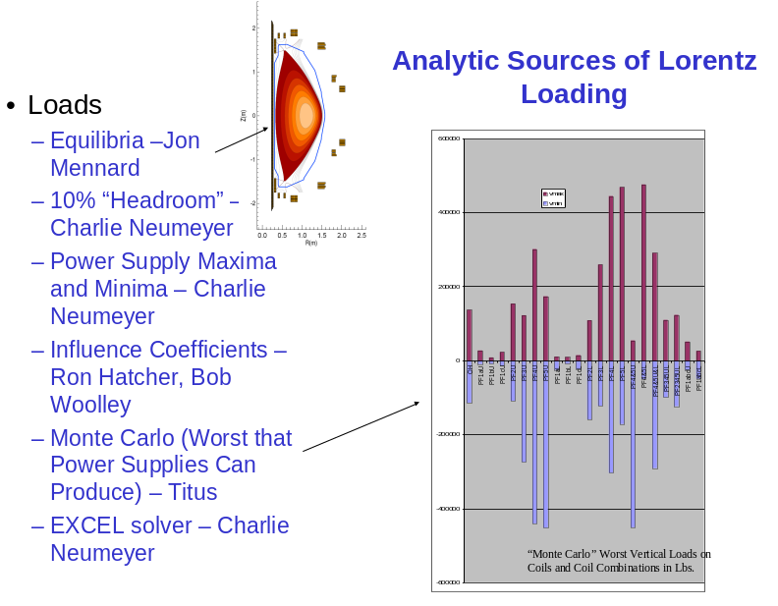

Figure 1.4-4 Analytic Sources of Lorentz Loading

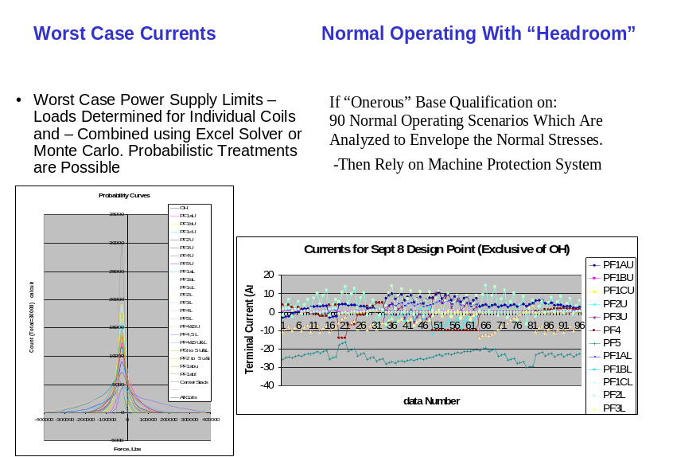
Figure 1.4-5 Worst Case and Normal Operating Conditions

A modest 10% “headroom is used in the current specs to provide for some scenario flexibility.
A challenging requirement in the GRD was to evaluate worst power supply loads and attempt to design to these. If the resulting designs are difficult or costly to implement, then the load combination that produces the “onerous” loading is to be addressed in the Machine Protection System (MPS). The magnitudes of the worst case combinations of loads have made it hard to design any of the structures to meet the worst case load criteria.
The TF self load effects i.e. the centering load in the centerstack and the tension loads in the outer legs have been designed with the maximum terminal current planned for the upgrade. It is the poloidal field coils that potentially combine in uncertain ways to produce large unanticipated loads. The outer leg reinforcements have been designed to the worst out-of-plane loads, and the hardware to react these loads does not appear excessive. On the other hand, support of the outer PF coils to resist the worst possible extremes in loading appears to be a costly and time consuming proposition. This area is one of the prime candidates for relaxing load requirements and obtaining some significant cost savings.
The specifics of the load spec for the poloidal field coils were still evolving at the time of the CDR. One approach is to rely exclusively on the machine protection system, and abandon designing to coil current overage, If this is chosen , the criteria, and the GRD need to be changed. One proposal is to add a probabalistic approach, this would remain within the GRD, and Criteria framework by describing what a reasonable level of over current loading should be. - essentially putting a spec on "onerous" During the CDR, J. Minerviini suggested a ITER like categorization of loads – MED is working to this on the ELM coils, port plugs etc. Excerpts from our NSTX criteria document were provided to the review committee. ITER uses a load spec that assigns "Anticipated" "Unlikely" etc. to loading - but no probabilities. The present NSTX Centerstack Upgrade criteria quotes probabilities. The NSTX CSU GRD and Criteria provides a better framework to categorize loads than ITER, but there is some consistency in approach and there would be an advantage in retaining a framework of load qualification used on other projects. The solution for these difficulties is to commit to building a robust Machine Protection System and shifting the worst case currents evaluation from an “Unlikely” category to an “Extremely Unlikely Category” In the structural design criteria, the load spec will be clarified. Load categorizations will be based on an update of the NSTX Failure Modes and Effects Analysis (FMEA) Numerical probabilities will not be assessed. A rigorous reliability analysis is not judged appropriate for the NSTX CSU experimental device.
A draft proposal (red text) follows in the following two sections.

Criteria Document Paragraph I-2.0 LOAD COMBINATIONS
The NSTX structural systems shall be designed for both normal operating conditions and off-normal events. These conditions are:
- Normal Events - Events that are planned to occur regularly in the course of facility operation. Normal EM loading shall consist of the 96 currently (Nov 2009) defined current scenarios, identified in the NSTX Upgrade Design Point, and other normal operating current scenarios identified as required for the NSTX Centerstack Upgrade mission, and included in the Design Point.
- Anticipated Events - Events of moderate frequency which may occur once or more in the lifetime of a facility. Anticipated EM loading shall consist of Normal loads plus disruptions judged to be common or anticipated.
- Unlikely Events - Events which are not anticipated but may occur during the lifetime of a facility.
EM Loading for Unlikely Events can result from:
- TBD – The Failure Modes and Effects Analysis (FMEA) will be re-evaluated by WAF cognizant Engineers for the Upgrade Design Point. A qualitative evaluation of the likelyhood of the failure and the severity of the consequences will be combined in a qualitative manner and be assigned to the list of “Unlikely” and “Extremely Unlikely” events
- Disruption Events that are judged to be unlikely
- Extremely Unlikely Events - Events which are not expected to occur during the lifetime of a facility but are postulated because of their safety consequences.
EM Loading for Extremely Unlikely Events can result from
- Machine Protection System( MPS) failure. Lower level power supply controls remaining intact, with random or pegged currents resulting, Consequences of current control failure shall be within the damage limits described in the table in section 1.2.6
- Other TBD events from the FMEA
- Catastrophic Disruption Events if identified for NSTX
- Incredible Events - Events of extremely low probability of occurrence or of non-mechanistic origin.

Criteria Document Paragraph I-2.6 Damage Limits & Recovery From Events
Table 1.4-3 Damage Limits and Recovery from Events

Condition | Functional and damage limit for the experimental facility | Damage limits to component or support | Recovery from damage
Normal | All the safety related structures, systems, and components are functional. | The component or support should maintain specified service function. | Within specified operational limit. Anticipated maintenance and minor adjustment.
Anticipated | All the safety related structures, systems, and components are functional. | The component or support must withstand this loading without significant damage requiring repair. | Within specified operational limit. Anticipated maintenance and minor adjustment
Unlikely | In addition to the challenged component, inspection may reveal localized large damage, which may call for repair of the affected components. | Material plasticity, local insulation failure or local melting which may necessitate the removal of the component from service for inspection or repair of damage to the component or support. | The facility may require major replacement of faulty component or repair work.
Extremely Unlikely | Gross damage to the affected system or component. Nevertheless the facility maintains the specified minimum safety function. | Gross general deformations, local melting and extensive insulation damage requiring repair, which may require removal of component from service. | Magnet system may be so damaged that repair is not considered economic.

Monte Carlo Analysis

This analysis and the procedures for quantifying worst case loads may still find some usefulness in identifying loads for the “Extremely Unlikely” Category.

Vertical and Radial force influence matrices were provided by Ron Hatcher(1). These were used in a Monte Carlo simulation which varied the coil current’s within their allowable ranges and computed forces on the individual coils. The maximums and minimums were determined for 10,000 sets of randomly selected coil currents. This yields the worst case loading the power supplies can produce, and ignores the likely loading during plasma shots. The resulting loads and hoop stresses are useful in providing an upper limit on the mechanical loads on the coils. Forces on coil groups, such as PF4 and 5 upper can be summed and maxima and minima determined to provide design loads for specific structural elements or regions.

The “random” results are similar to those obtained in the design point spreadsheet with EXCEL solver or Hatchers procedure to rack up max loads. Typically the Monte Carlo simulation with 10,000 simulations misses some of the peaks and captures more with a higher number of simulations. Modeling “pegged” currents extends the likelihood that the Monte Carlo simulation will capture the low probability max loads because currents are modeled as either at a max or a min, rather than simulations many intermediate currents. Error: Reference source not found shows a typical Monte Carlo current assignment routine. Error: Reference source not found shows a graphical representation of the Monte Carlo simulation run by Ron Hatcher.

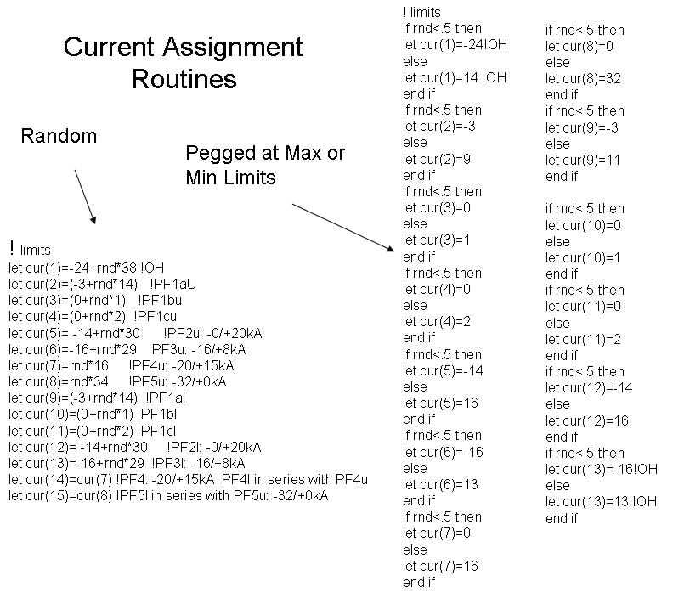

Figure 1.4-6 Monte Carlo Simulation Current Assignment Routine

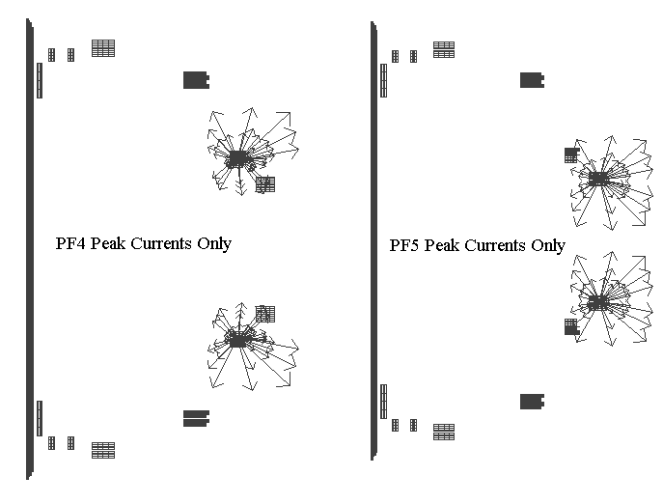
Figure 1.4-7 Monte Carlo Graphical Representation

List of References
[1] Charles L. Neumeyer, http://www.pppl.gov/~neumeyer/NSTX_CSU/Design_Point.html, dated 7-29-2009.
[2] NSTX-CALC-13-001-00, Global Model – Model Description, Mesh Generation, Results
[3] Disruption Analysis Of Vacuum Vessel and Passsive Plates NSTX-CALC-12-001-00, S. Avasarala
[4] Tom Willard, “TF Flex Joint and TF Bundle Stub”, NSTX-CALC-132-06-00, 2009.
[5] Robert D. Woolley, “TF Joint Pressure VS Temperature In NSTX CSU Upgrade”, CSU-CALC-132-090211-RDW-01, 2009.
[6] Peter Titus, “Coupled Electromagnetic-Thermal Analysis (04072009)”, NSTX-CALC-132-01-00, 2009.
[7] Peter Titus, “Coupled Electromagnetic-Thermal Analysis (04202009)”, NSTX-CALC-132-02-00, 2009.
[8] Robert D. Woolley, “TF Out-Of-Plane (OOP) PF/TF Torques on TF Conductors in NSTX CSU”, CSU-CALC-132-03-00, July 26 2009

[9] P. Titus, “Maximum TF Torsional Shear” CSU-CALC-132-07-00

- Global Modeling

Status of the Global Model
The Global model () of NSTX Center Stack Upgrade (NSTX-CSU) provides a simulation of the overall behavior of the machine. It provides boundary conditions for local models and sub Models , or allows inclusion of the detailed models of components in the global model. In many cases it has been built from from other available model segments – The upper and lower head sections of the vessel model come from H.M. Fan’s early vessel models. The cylindrical shell that contains the mid plane ports comes from a vessel model built by Srinivasa Avasarala from the Pro–E model of the vessel. In some instances parts of the global model were exported to be evaluateds in more detail. Multiple scenarios from the NSTX design point are run using the global model. The design points are publized on the web and are maintained by C. Neumeyer.
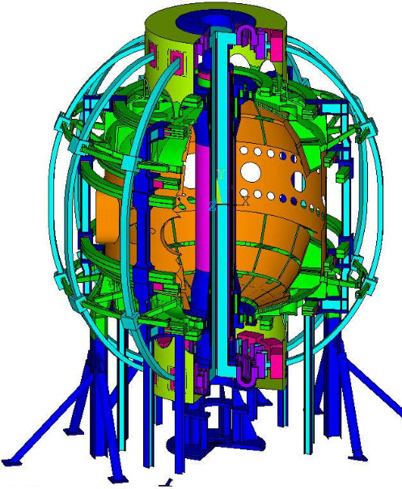

Figure 2.1-8 Global Model
As of this issue of the calculation, 70 of the 90 normal operating current sets published in the July 2009 design point have been run in the global model (Error: Reference source not found).
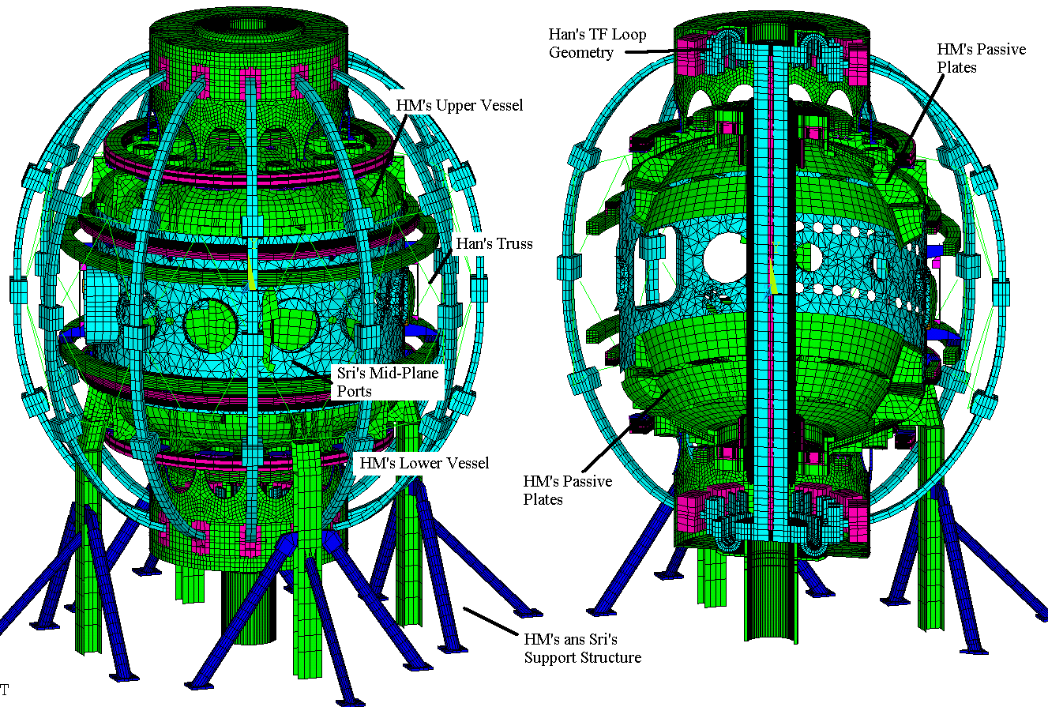
Figure 2.1-9 Global Model Status as of June 22, 2009

The September 8 design point has a revision to the OH current variations and these have not yet been run. Loads from normal operating current sets are in general much less severe than loads that are based on worst case power supply currents. In order to compare the global model results with some of the local models that have been run, some of the “worst case” currents have been run in the global model. The outer TF reinforcements are an example of this. Results reported in sub paragraphs of section 8 have been used to qualify components, check results and guide the need for further analyses. The outer TF leg reinforcements discussed in section 8.3 and in NSTX calculation number 132-04-00 are based on two pairs of current sets. These are intended to maximize the out-of-plane loading on the TF outer legs for an up-down symmetric loading and an up-down asymmetric loading that causes large net torques on the outer legs. These two current sets were included in the loading analyzed in the global model. Behavior of the two analyses is consistent. Section 8.3 of Ref [2] discusses these results and adds a qualifiucationn of the bending related bond shear in the TF outer leg. Section 8.1 documents the acceptable stresses in the diaphram plate that replaces the gear tooth torsional connection between the centerstack and the outer umbrella structure.Section 8.5 of Ref [2] provided global displacements to the detailed analysis of the flex joint [4] Section 1.3.2.3 or Secion 8.6 of Ref [2] is to date, the only treatment that shows acceptability of the torsional shear in the inner leg. Section ??? similarly profided guidance on global twist in the evaluation of the centerstack OH support details. Section 8.8 shows the stresses and loading around the I beam column attachmeents to the vessel and points to the need to evaluate the weld details of this connection.
Error: Reference source not foundshows the global model at 350 C bakeout conditions. Error: Reference source not found shows the bakeout vertical displacements. Note that the outer PF support “cage” is not connected to the vessel during normal operation or bake-out.

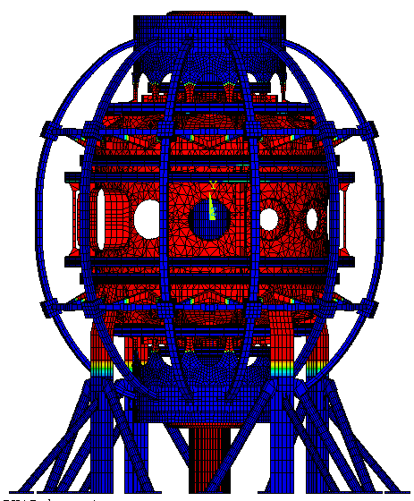

Figure 2.1-10 Global Model at 350C Bake-Out Temperature Conditions

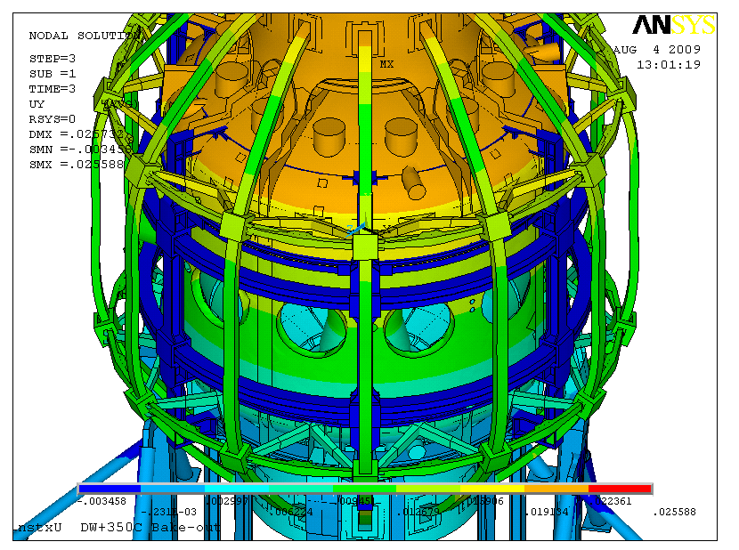
Figure 2.1-11 Bake-out Vertical Displacements
- Plasma Facing Components (WBS 1.1.1)

Heat Balance and Heat Loads on PFCs
A thermal analysis of the NSTX CSU was done to demonstrate that the adequacy of proposed active cooling of the CS, in conjunction with radiation cooling to outboard components, to limit the maximum temperatures and thermal gradients in the CS Casing to protect the CS coils and O-rings joints. Output of the thermal analysis (Error: Reference source not found) were used in a first cut thermal stress analysis of the graphite tiles. The impact of anticipated Lithium Coating on ratcheted temperatures was also investigated.
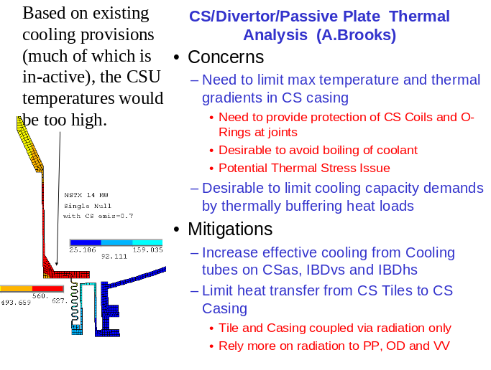

Figure 3.1-12 Heat Balance Summary Slide from the CDR

Results of the analysis were used to guide the design. In particular, it was found advantageous to thermally isolate as much as possible the CS tiles from the CS casing to limit the thermal ratcheting of the casing and thermal gradients with the actively cooled inboard divertor region. This does lead to higher temperatures in the graphite (in excess of 2000 C) which needs to be assessed by the project as to whether the increased carbon sublimation can be tolerated or if alternate materials (i.e. molybdenum) should be considered. Error: Reference source not found shows the heat balance summary and the critical areas requiring cooling. Error: Reference source not found shows the end of pulse temperature distribution.
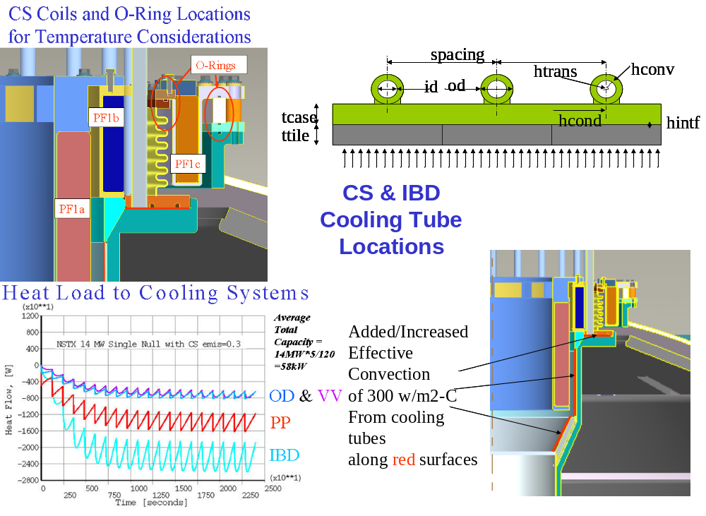
Figure 3.1-13 Heat Balance Summary Slide – Critical Areas Requiring Cooling

Tile Stress Analysis
The initial thermal stress analysis the inboard divertor tile assuming ATJ graphite at those temperatures appear marginally adequate. Efforts to increase margin by considering CFC's or by better characterizing the ATJ thermal-stress properties at temperature are needed. Error: Reference source not found shows the end of pulse temperature distribution. Error: Reference source not found shows what???. shows the test results summary.
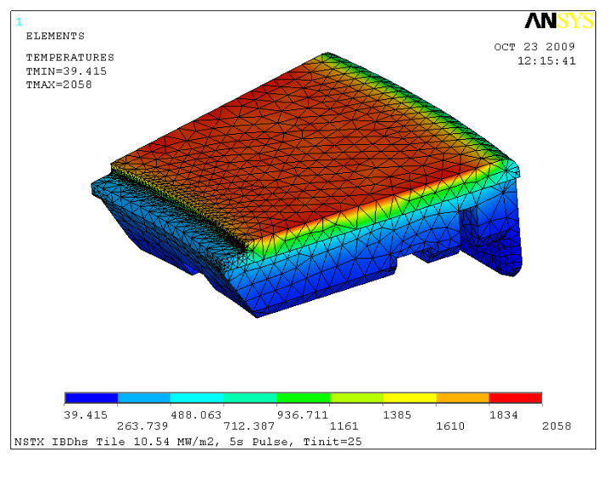
Figure 3.2-14 End of Pulse Temperature Distribution

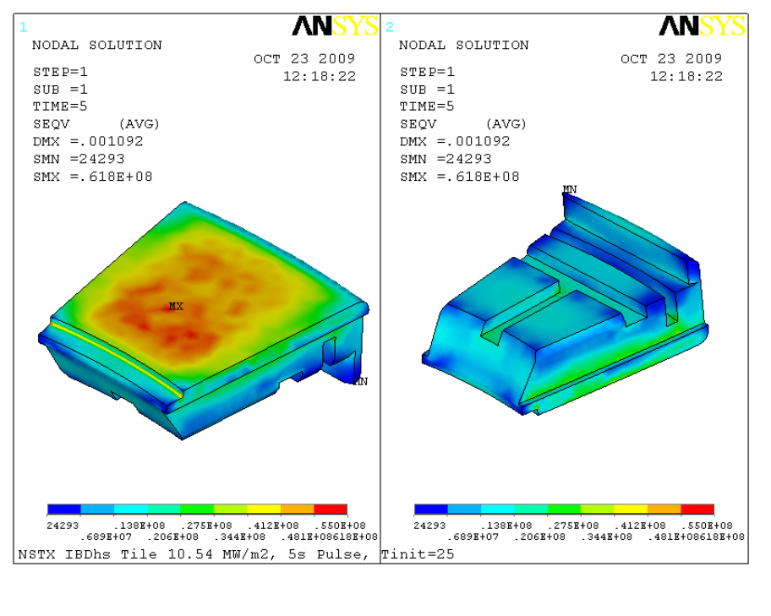
Figure 3.2-15 Shows what???
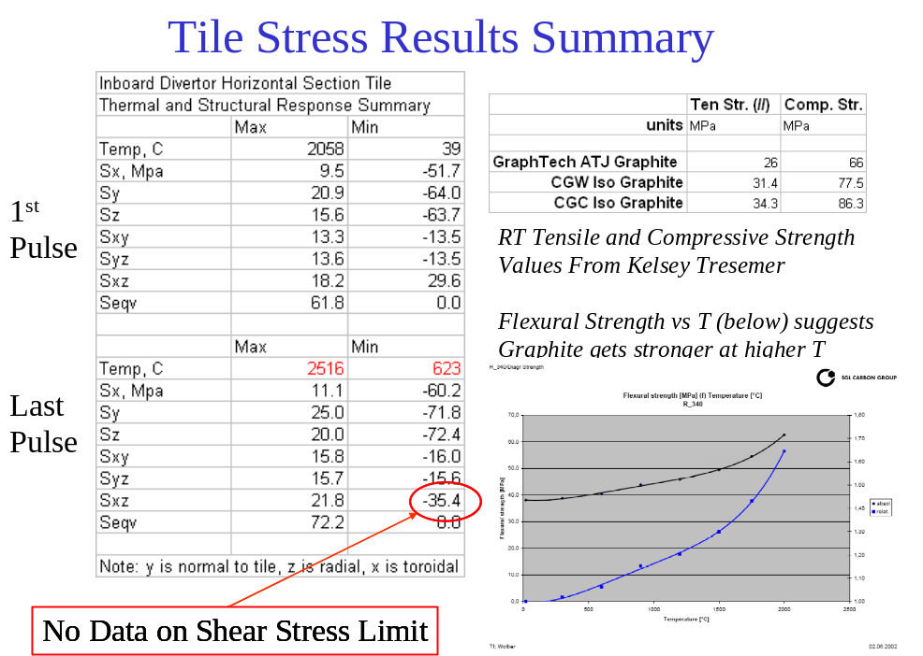

Figure 3.2-16 Stress Results Summary

Disruption Analysis, Passive Plate Disruption Stress
The objective of this analysis is to estimate the stresses in the vacuum vessel and passive plates () caused by the plasma disruption. The Vector Potential solution for a 2D axisymmetric simulation of disruption in OPERA is imposed on the 3-D model in ANSYS to obtain the eddy currents and Lorentz forces. A static and dynamic stress pass is then run and the stresses are computed. Only the outboard diverter disruption scenario is discussed in this report.
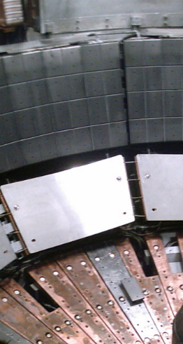

Figure 3.3-17 Photograph of the NSTX Passive Plates (October 2009)

The solid models of the vessel, umbrella structure, port extensions and support legs are imported from Pro-E. The model retains all the complex 3-D geometry but the port extensions, legs and the vessel are merged together to form one solid. The umbrella structure is a separate solid. This model is meshed with 8 node bricks in workbench and the mesh is carried into ANSYS classic. To get around the DOF compatibility issues, the mesh is rebuilt in ANSYS classic, retaining the number of nodes and elements and the connectivity. A vector potential gradient is then applied on this model to see if the model works. Eddy currents and Lorentz forces obtained agreed with intuition. An approximate model of the passive plates, in agreement with the 2-D model used in OPERA, is modeled in ANSYS. This is tied to the vessel using constraint equations. The degree of freedom coupled is Volt during the E-mag run and Displacement during the structural run. depicts the NSTX disruption analysis at the mid-plane for a 2 Ma Ip disruption.
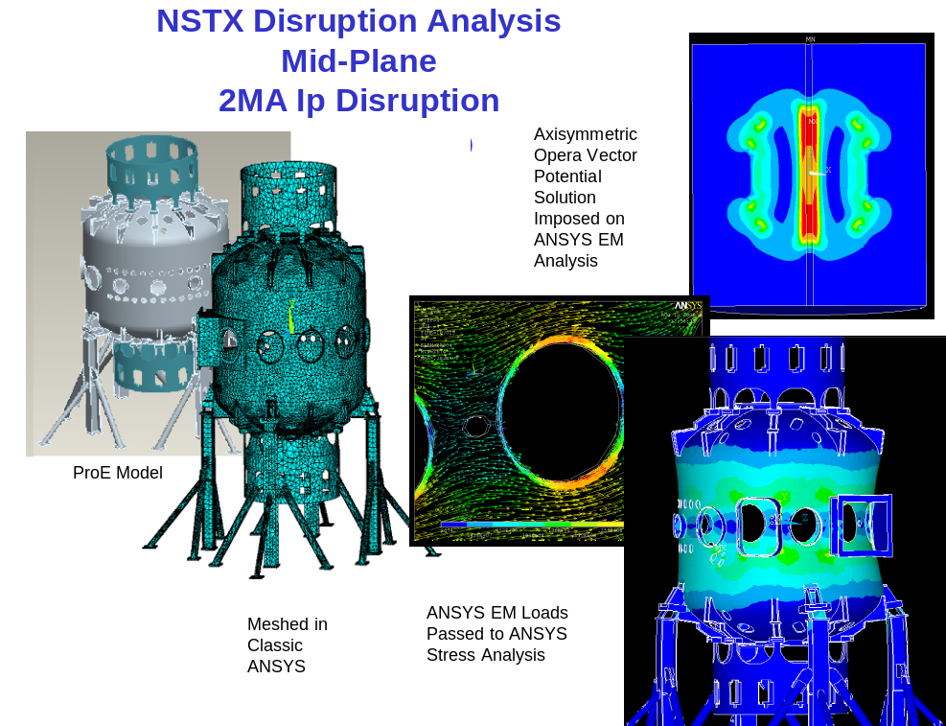

Figure 3.3-18 Passive Plate Disruption Analyses Process

The analysis uses a vector potential solution. Grad A is B:

Vector potentials obtained from OPERA are arranged in 80x80 tabular form so that they can be fed into ANSYS. The first 11 tables are considered for the study and these tables are spaced 0.5 ms apart. Macros are developed that read these values into ANSYS. The meshes in OPERA and ANSYS are dissimilar, but since ANSYS interpolates the tables between two adjacent indices, proper indexing of the coordinates yields a reasonable approximation of the Vector Potentials. The element type used was SOLID 97 and the material properties used are that of Stainless Steel except for the passive plates which are made up of Copper. This model is then solved for eddy currents and Lorentz forces. Error: Reference source not found shows the relationships between Vector Potential (A) and the Field (B).

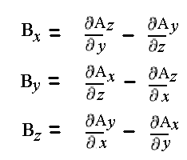

Figure 3.3-19 Relation between Vector Potential (A) and Field (B)

The model is then converted into a structural model by switching the SOLID 97s into SOLID 45s. 11 load steps, 5ms apart are written for the stress pass. Forces are read from the earlier E-mag results fie using LDREAD command and both the Static and Dynamic analyses are performed. A 0.5% damping factor is used in the dynamic run.

The maximum stress obtained during the static analysis (ignoring the sharp corners) is 1600 Mpa and that from the dynamic analysis is 290 Mpa. Four nodes are picked in the model to compute the DLFs and the stresses seem to have reduced by a factor of 0.18-0.23. Error: Reference source not found shows the vessel disruption stresses.

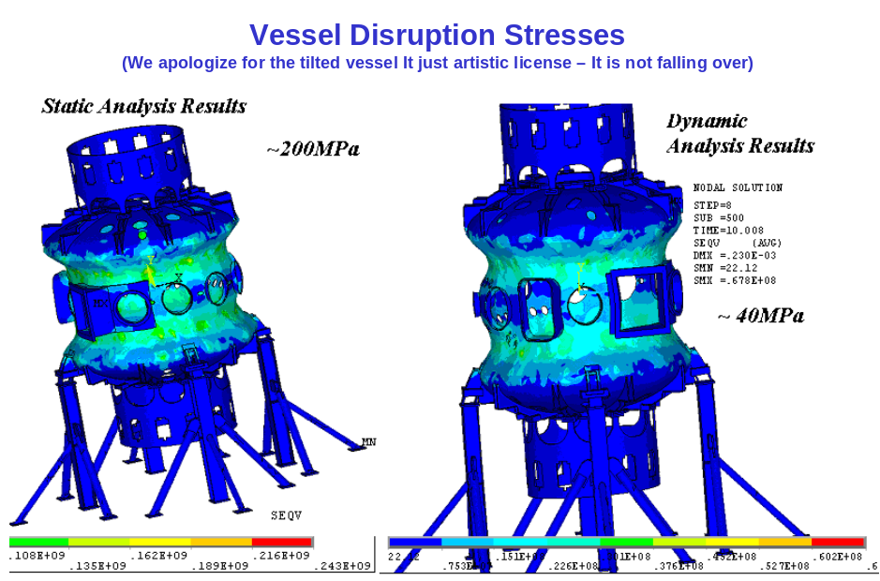

Figure 3.3-20 Vessel Disruption Stresses

The method employed uses the vector potential solution from an axisymmetric OPERA run and applies it to a mode complex model of the vessel and passive plates. In order to ensure the solution is in geometric registration with the passive plates, the coordinates that were used in the OPERA analysis were used to generate the passive plate mesh. Error: Reference source not found shows the passive plate disruption eddy currents and stresses. Error: Reference source not foundshows the passive plate and outboard divertor coordinates.

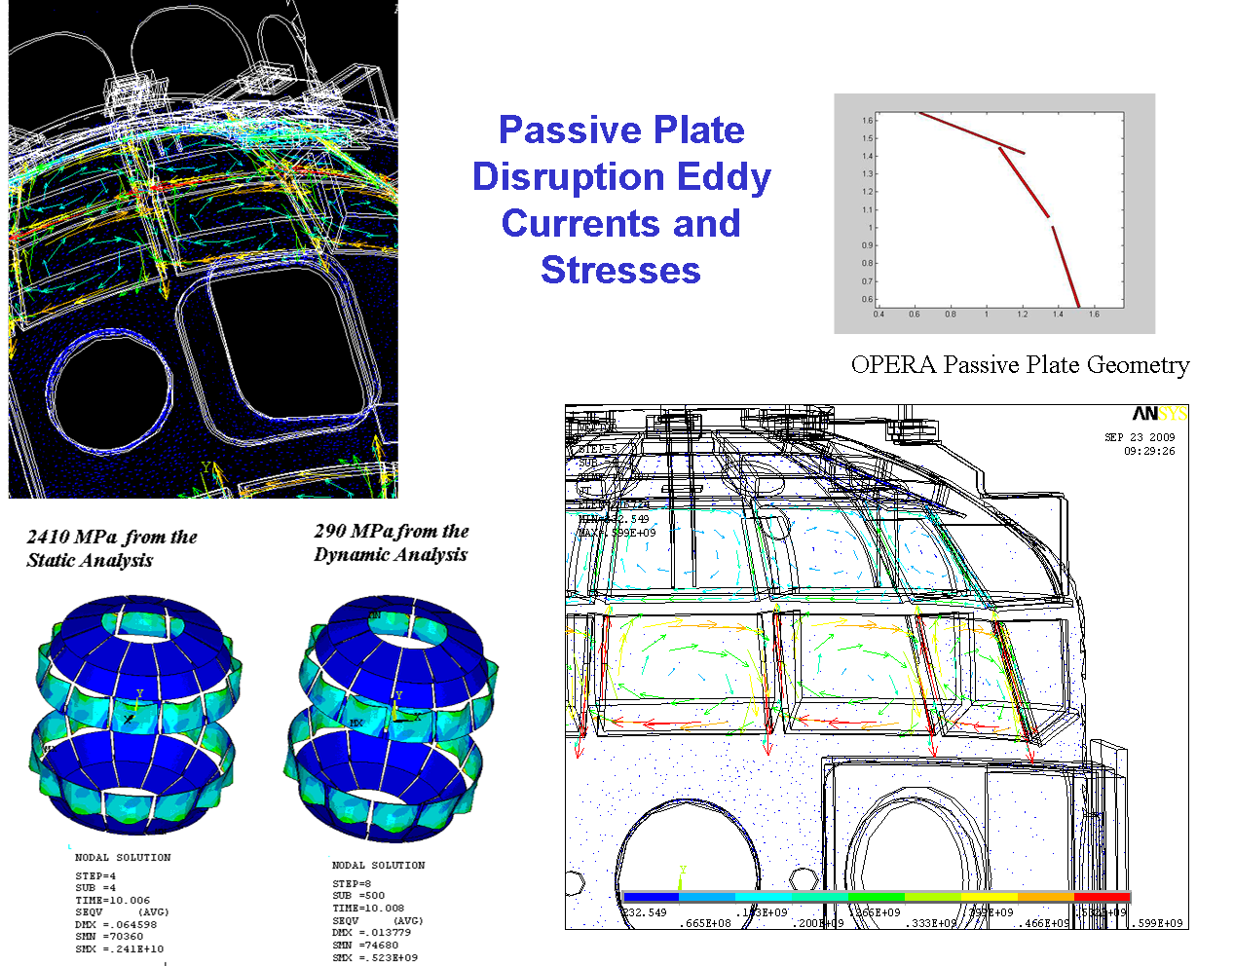

Figure 3.3-21 Passive Plate Disruption Eddy Currents and Stresses

Table 3.3-4 Passive Plate and Outboard Divertor Coordinates

Primary Passive Plate Coordinates | Secondary Passive Plate Coordinates | Outboard Divertor Coordinates
X=1.3600 Y=1.0056 | X=1.0640 Y=1.4447 | x=0.6208 y=1.6390
X=1.5092 Y=0.5530 | X=1.3399 Y=1.0543 | x=1.2056 y=1.4092
X=1.5213 Y=0.5569 | X=1.3503 Y=1.0617 | x=1.2149 y=1.4185
X=1.3720 Y=1.0095 | X=1.0744 Y=1.4520 | X=1.0744 Y=1.4520

Results from these analyses show that:
- The Dynamic Load Factors are found to less than 0.25
- The stresses are under acceptable limit.
- Macros developed here have been used for other models to simulate disruption stresses.
- This method (of imposing Vector Potentials) circumvents the modeling of air and other complexities involving complex 3-D geometry.
- The disruption scenario studied here is just the Outboard Diverter disruption. The other two scenarios : Primary Passive Plate and Secondary Passive Plate will be studied.
- All the high stress modes of vibration might not have been picked up by the dynamic analysis because of memory limitations of PC
- CAD model of the Passive Plates has been obtained, de-featured, meshed and is in the process of being analyzed
- All the high stress modes of vibration might not have been picked up by the dynamic analysis because of memory limitations of PC
- CAD model of the Passive Plates has been obtained, de-featured, meshed and is in the process of being analyzed
Error: Reference source not found shows the meshed detail model. As a cross check of the results, The vertical Bdot in the outer area of the vessel near the mid plane was compared with the results reported for the High Harmonic Fast Wave (HHFW) discussed in section 2.1. The passive plate analysis yielded a vertical field HHFW analyses yielded 280 Tesla/sec. Both were for 2 Mamp 1millisecond disruptions. The HHFW analysis was for a simple linear rampdown in plasma current. The passive plate analysis is for a more complex simulation of a the disruption at the divertor disruption. shows the passive plate attachment details - ss of November 9 the ProE model of the mounting hardware was available. Error: Reference source not found depicts the constraint equations that stitch the passive plate structure to the vessel.
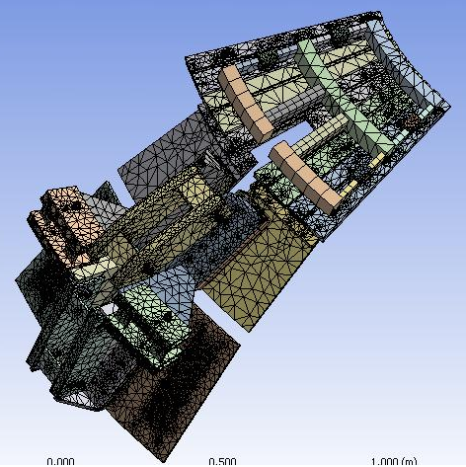

Figure 3.3-22 Meshed Detailed Model

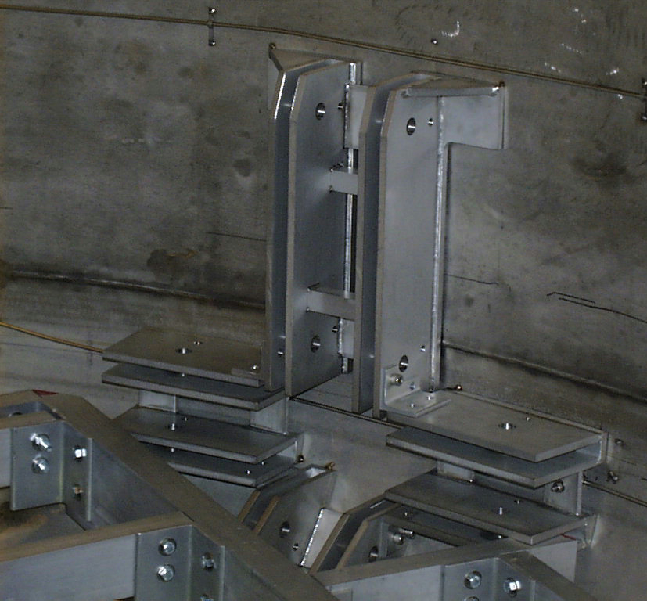

Figure 3.3-23 Photo of Passive Plate Attachment Details.

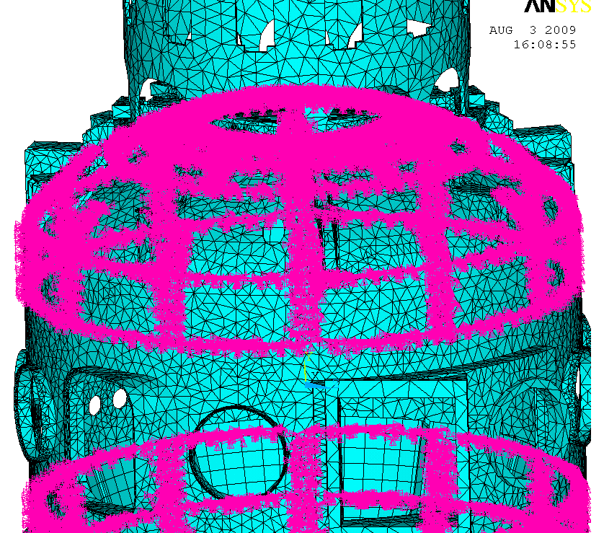

Figure 3.3-24 Constraint Equations that Stitch the Passive Plate Structure to the Vessel
Results of the passive plate analysis show no significant non-cyclic symmetry resulting from the distribution of differing ports at the equatorial plane. The current plan is to perform a detailed analysis of only a 60 degree sector of the vessel, divertor, and passive plates to allow an adequately detailed modeling of the actual mounting hardware. Error: Reference source not found shows what???
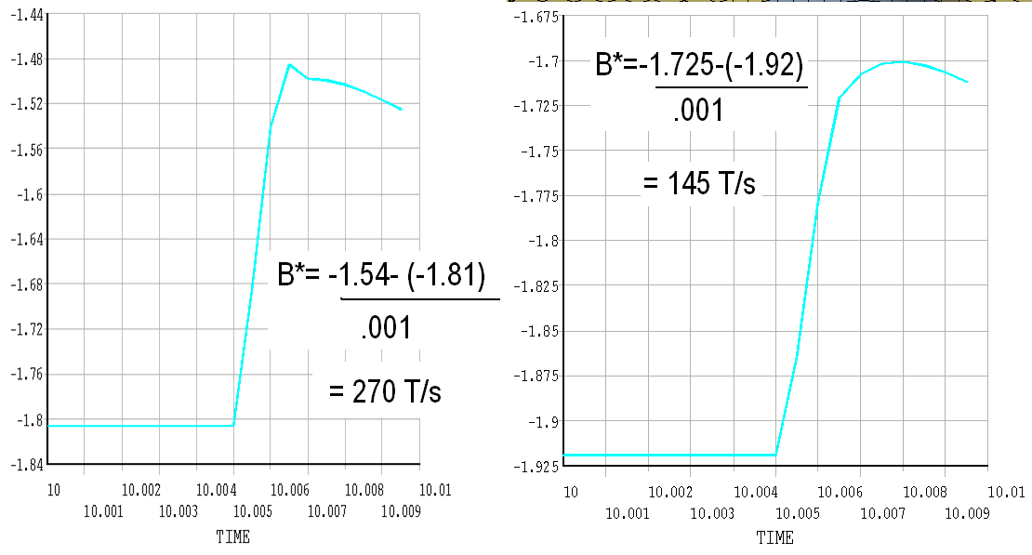
Figure 3.3-25 shows what???

Imposing the Background Fields
The following produce a 1/R field in a cylindrical volume:
It uses Az=-.5*BR*log(r^2). It's not necessary to nrotate the nodes into a cylindrical system if that conflict with other BC's.

Per Art Brooks, the following also works using: Az=-.5*BR*log(x^2+y^2). Error: Reference source not found shows the background field equations.

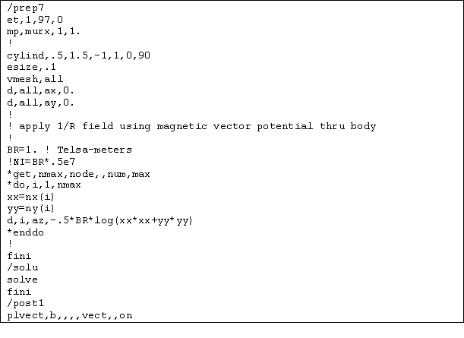
Figure 3.4-26 Background Field Equations

- Vacuum Vessel & Support Structure (WBS 1.1.2)

Overview
The vacuum vessel is a major component in many individual analyses because it is the major support structure for most of the outboard components of NSTX. The vessel supports the passive plates for which disruption loads are the major loading. The vessel participates in the electromagnetic response to the disruption, and is included in the disruption analysis discussed in section ___. The vessel provides in-plane support of the TF outer legs at the umbrella structure. The vessel also provides the support for OOP loads on the TF outer legs via connections through tangential radius rods just above the upper and below the lower head intersection with the cylindrical part of the shell. The vessel is included in the analysis of the TF outer legs. The global model includes a model of the vessel and attempts to bring all the loading together and addresses bake-out, operating temperatures and Lorentz Loads. As–builts are being gathered and evaluated.
The vessel is out of round by the followings:
- Most of the location, is is out round to within .13"
- Near ports, it is out of rough to about .75"
- The vessel is made of 2 arcs( ~179 deg each) and there are 2 flats , on the weld seems
Many of the as-built attachment details are being measured and detailed with the hope that many will not require upgrade.
Error: Reference source not found shows the vessel response to the disruption shown in Section 3.1. Error: Reference source not found shows the global model results.
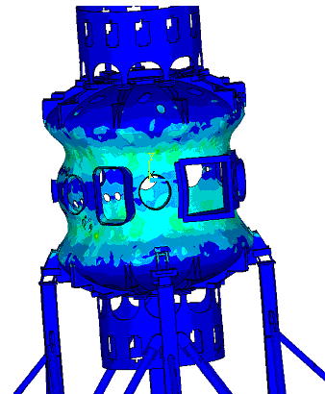

Figure 4.1-27 Vessel Response to a Disruption

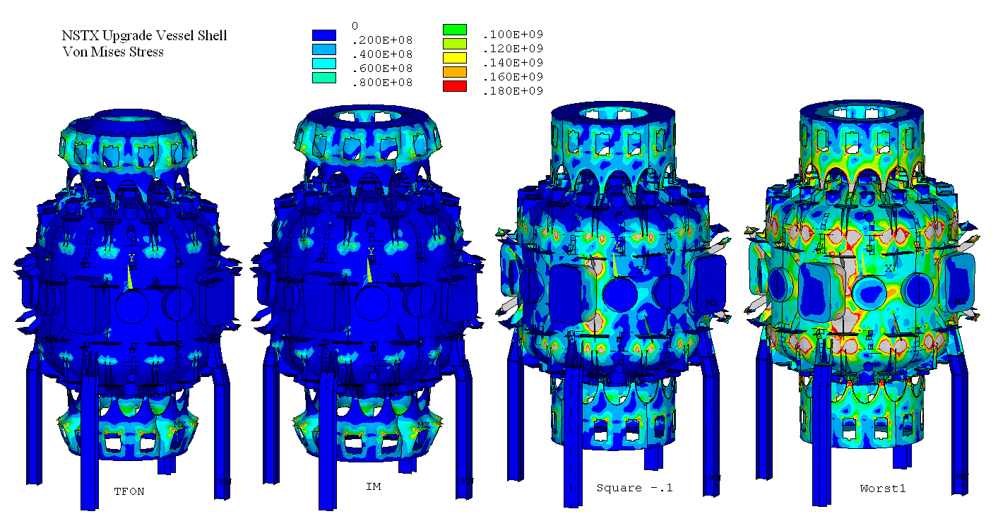

Figure 4.1-28 Global Model Results

Vessel Outer Leg Connection
The main beam gusset plates are 1.5 inches thick . Visually scaling the welds, they are about 2 inches long and maybe 3/8 fillets. Error: Reference source not found show pictures of the Bay B C gusset plates. Error: Reference source not found shows the ANSYS models of these gusset plates. There are 3 on each outside edge and 3 inside- maybe more on the underside.
Joe indicate that the weld seem to about 3/8”, definitely less than ½ “ and more than ¼ “. He will measure to confirm. I will ask Jim about the drawings instructions.
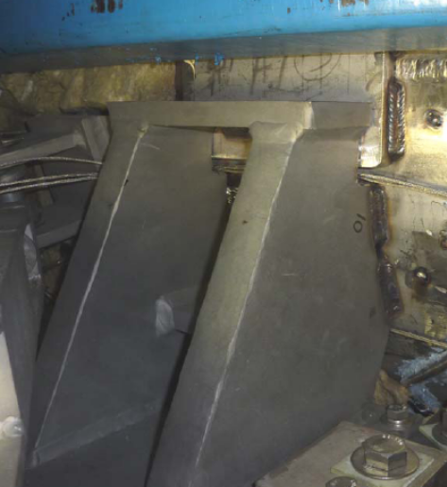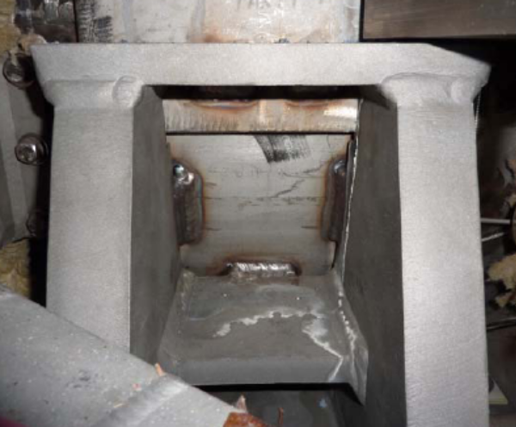
Figure 4.2-29 Bay B C Gusset Plate

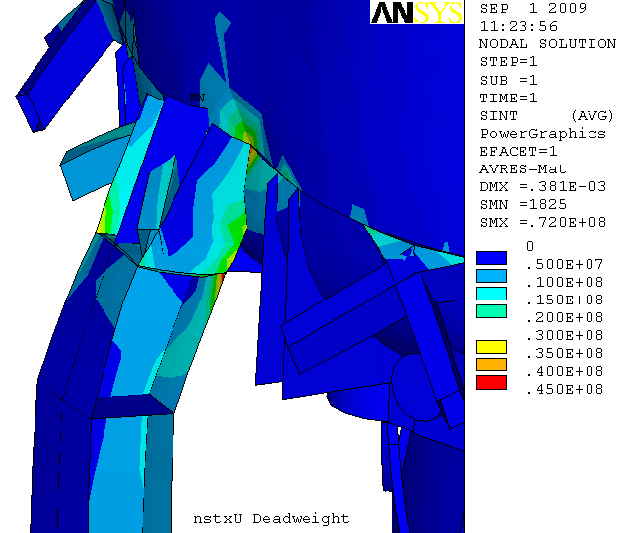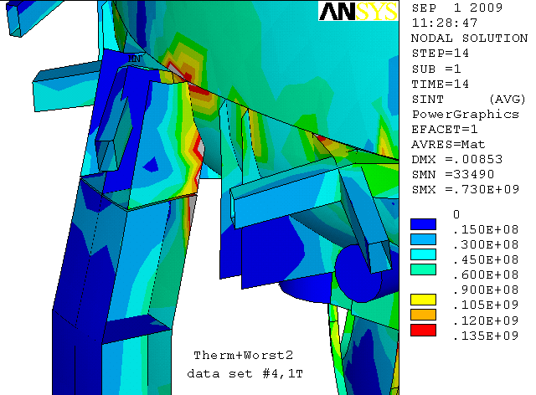

Figure 4.2-30 ANSYS Models of the Bay B C Gusset Plates

Upper Diaphragm/Cover/Flex
Error: Reference source not found and Error: Reference source not found show the several views of the Upper Flex Plate Diaphragm..
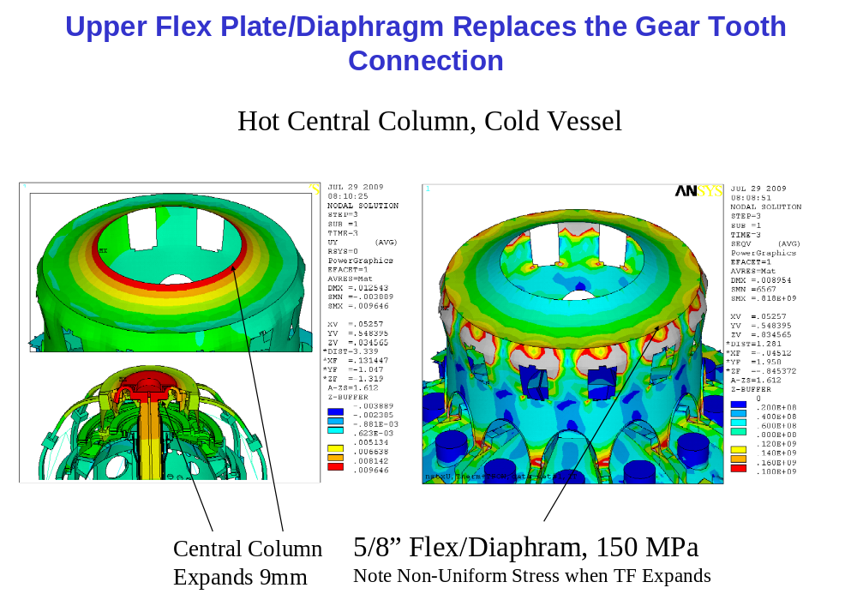

Figure 4.3-31 Upper Flex Plate Diaphragm

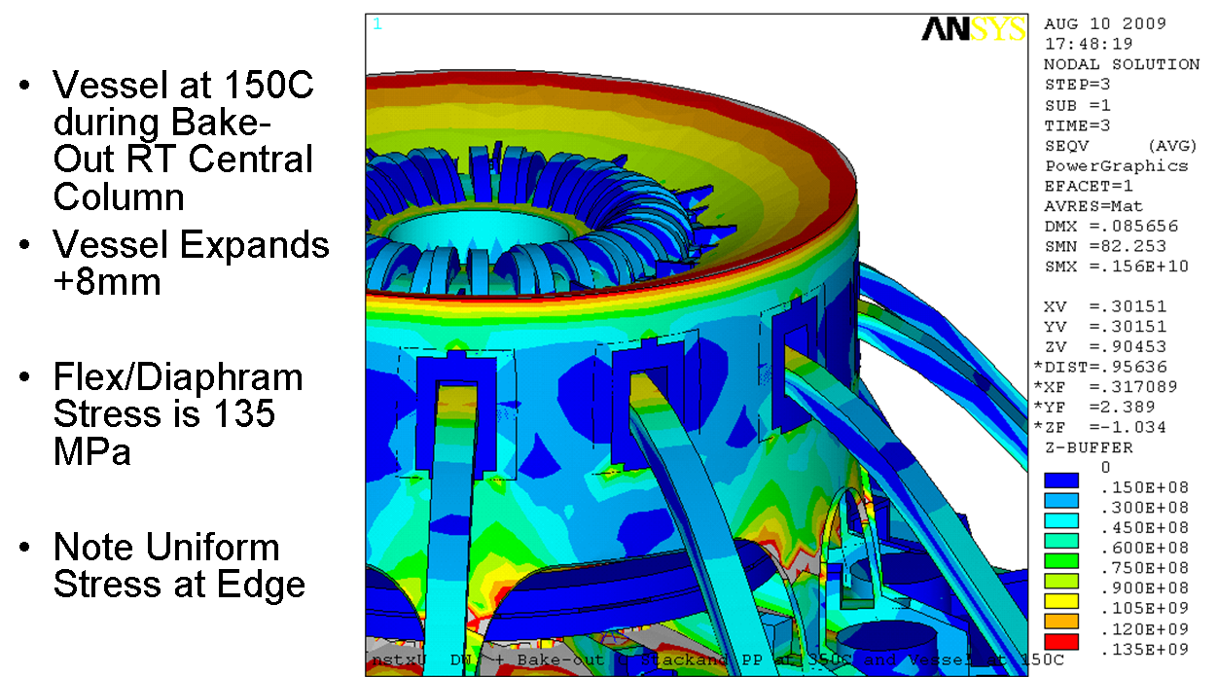

Figure 4.3-32 Another View of the Upper Flex Plate Diaphragm

Umbrella Structure
The Umbrella structure appears in a number of models. The figures shown here are from an early analysis of the TF outer leg loads on the aluminum block and bolting. The conclusion of this analysis is that there are some modest reinforcements needed to improve the capacity of the aluminum block bolting to take the TF tension. Loads were applied on the bolt hole locations in the umbrella structure. Out-of plane were applied as shear loads. Further analysis of the umbrella loads are presented in Section 5.4. Error: Reference source not found depicts the umbrella structure loading. Error: Reference source not found shows the results of the aluminum block analysis. Error: Reference source not found shows a view inside the umbrella structure. Plates will be added to distribute bolt loads into the shell more effectively. Error: Reference source not found shows a view outside the umbrella structure. Error: Reference source not found depicts a FEA model of the umbrella structure and shows a large span arch. Error: Reference source not found depicts the Umbrella Structure response to In-Plane Loads from the TF Outer Legs.

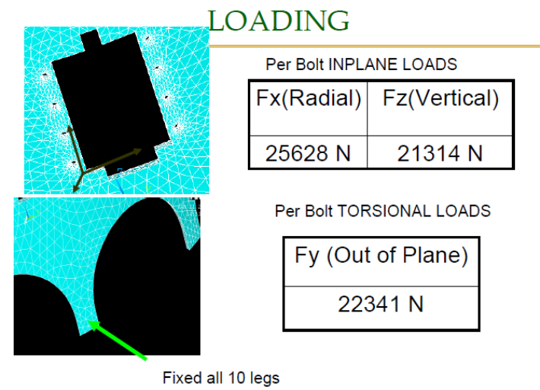
Figure 4.4-33 Umbrella Structure Loading

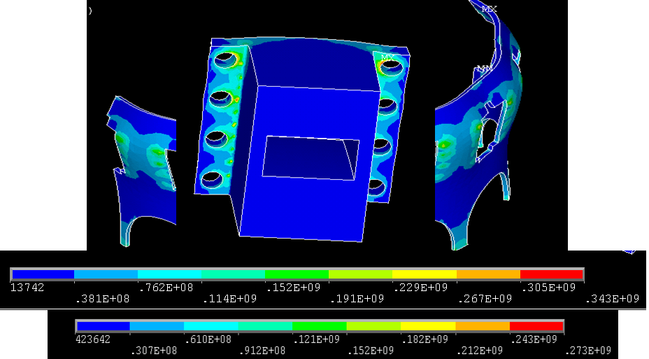

Figure 4.4-34 Aluminum Block Analysis Results

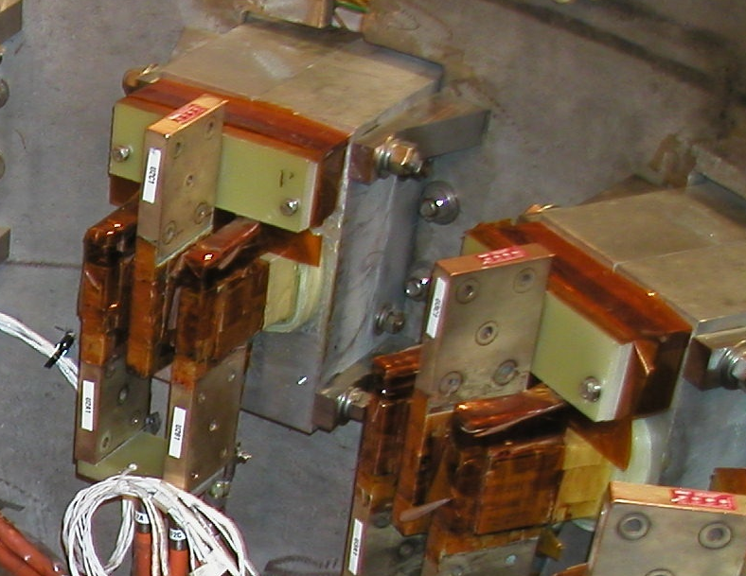

Figure 4.4-35 View Inside Umbrella Structure

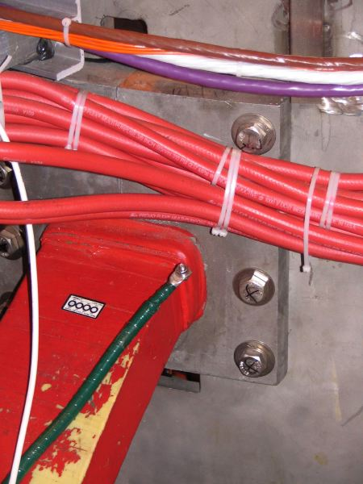

Figure 4.4-36 View from Outside the Umbrella Structure

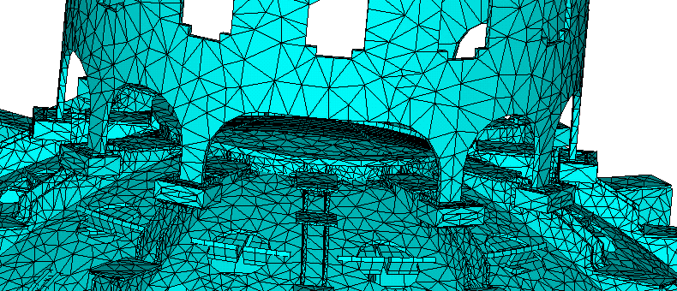

Figure 4.4-37 FEA Model of the Umbrella Structure Showing Large Span Arch
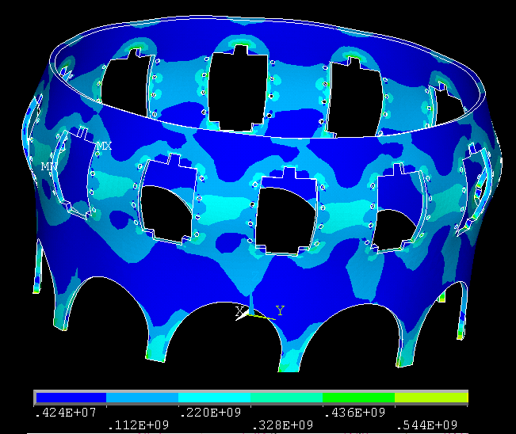
Figure 4.4-38 Umbrella Structure Response to In-Plane Loads from the TF Outer Legs

Center Stack Casing
There are a number of concerns to address in the design of the centerstack casing. It supports the inner PF’s – PF1a, and b. This is discussed in Section 1.3.3.3 . It supports the plasma facing components – tiles and backing plates for the central column and for the inner upper and lower divertor. Consequently it is exposed to the heat loads from these components. Current is run vertically through the casing to heat it during bake-out to 350 degrees C. Operationally, early estimates were that the casing could go to 500C or higher. This posed a problem for the support of the inner PF coils and local stresses in the and the halo current loads Figure 1.2.3.4.0-1 shows the upper end of the casing showing PF1a,and B, and PF1c which sit on the outboard side of the bellows and is supported by the vessel.

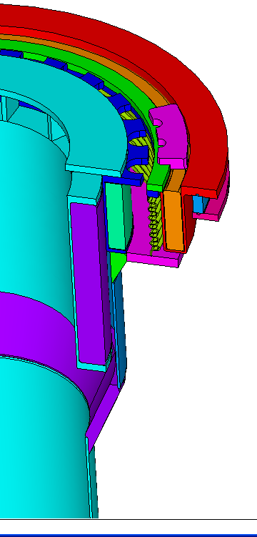

Figure 4.5-39 Centerstack Casing and Upper Inner PF’s

Centerstack Casing Thermal Loads
Heat balance calculations in Section 3.1 quantify the temperatures that result from plasma. Error: Reference source not found shows the center stack casing dimensions. Error: Reference source not found shows the casing stress estimate with the case at 500C peak operating temperature, and the PF support area maintained at 100C.
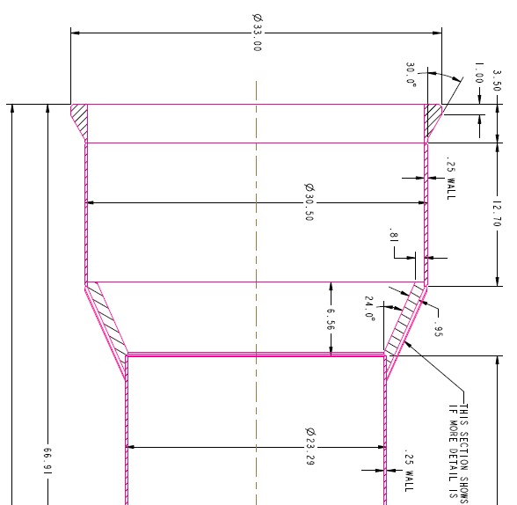
Figure 4.5-40 Center Stack Casing Dimensions

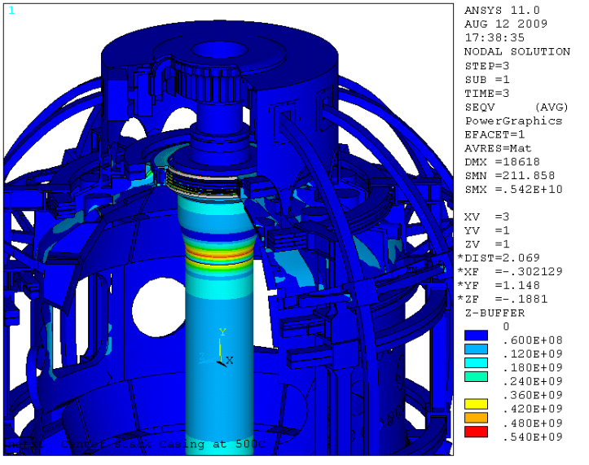
Figure 4.5-41 Casing Stress Estimate

Centerstack Casing Halo Loads
From the NSTX_CSU-RQMT-GRD rev. 0 10 March 30, 2009: “A peak poloidal halo current up to 10% of the maximum plasma current prior to the disruption, with a toroidal peaking factor of 2:1; that is, the toroidal dependence of the halo current is [1 + cos (φ - φ0)], for all toroidal phase angles φ0 from 0 to 2*π. Halo current entry/exit locations shall assume a separation of 1.0m with vertical displacement + or - 0.25m about the midplane Location of Disrupting Plasmas & Halo Current Entry/Exit Points. See Error: Reference source not found below.
.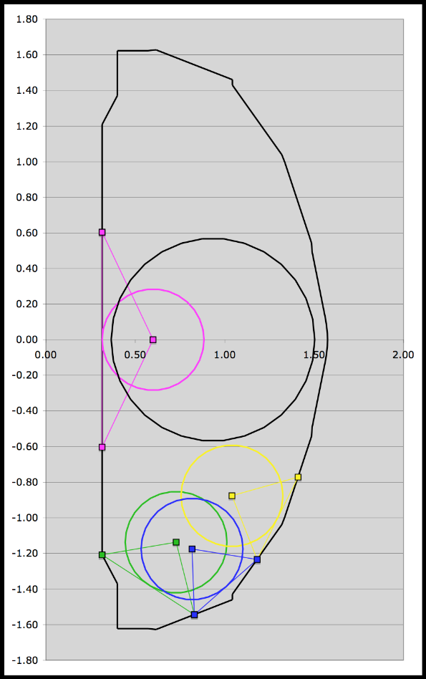
Figure 4.5-42 GRD Disruption Diagram

Current and field directions (referring to Figure 2.2-2) shall be as follows:
- Plasma current Ip into the page (counter-clockwise in the toroidal direction,viewed from above)
- Halo current exits plasma and enters the structure at the entry point, exits the structure and re-enters the plasma at the exit point (counter-clockwise poloidal current, in the view of the figure)
- Toroidal field into the page (clockwise in the toroidal direction, viewed from above)

Error: Reference source not found below shows the disruption and halo current analysis procedure and results.
Table 4.5-5 Disruption and Halo Current Analysis Procedure and Results
Halo Current | n.a. | 20%= | 35%= | 35%= | 35%=
Halo Current |  | 400kA | 700kA | 700kA | 700kA
Halo Current Entry point (r,z) | n.a. | 0.3148m | 0.3148m | 0.8302m | 1.1813m
Halo Current Entry point (r,z) |  | 0.6041m | -1.2081m | -1.5441m. | -1.2348m
Halo Current Exit point (r,z) | n.a. | 0.3148m | 0.8302m | 1.1813m | 1.4105m
Halo Current Exit point (r,z) |  | 0.6041m | -1.5441m | -1.2348m | -0.7713m

Sri Avasarala and Ron Hatcher’s disruption analyses were used to provide a vector potential “environment” for a model of the center stack casing. Sri has developed a procedure which starts with Ron Hatcher’s OPERA disruption simulation, and transfers the axisymmetric vector potential results into a 3 D model of the vessel and passive plates. With modest changes any of the internal components can be evaluated with this procedure. A model of the center stack casing was input to Sri’s electromagnetic analysis. The results are shown in Error: Reference source not found and Error: Reference source not found
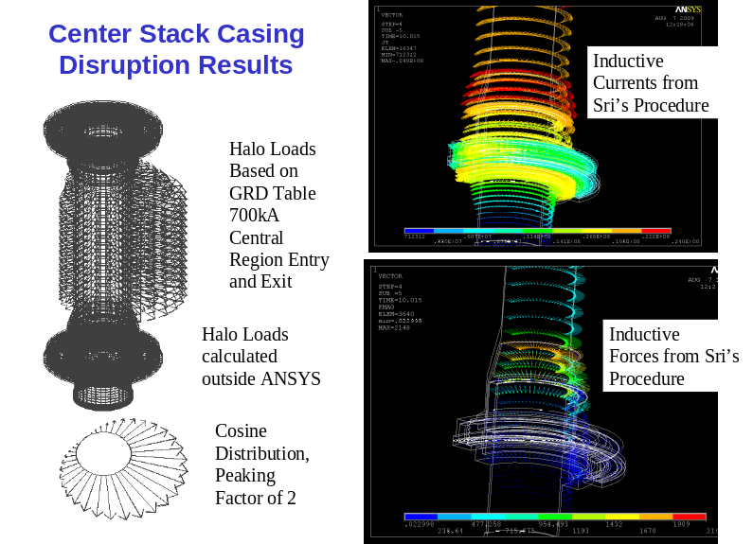
Figure 4.5-43 Center Stack Casing Disruption Results
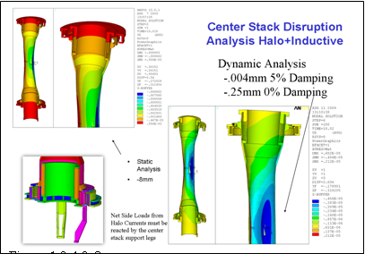
Figure 4.5-44 Center Stack Disruption Analysis (Halo + Inductive)
Lorentz loads from these current entry and exit points were calculated assuming a peaking factor of 2. At present, only the equatorial plane halo current distribution has been evaluated. The acceptability of the results depends on the Dynamic Load Factor. Static str4uctural analysis produces unacceptable results. Dynamic analysis produced manageable results, with further evaluation of the net loads action on the support legs and bellow, needing qualification. Error: Reference source not found provides yield data for Inconel 625.
Table 4.5-6 Yield Data for Inconel 625
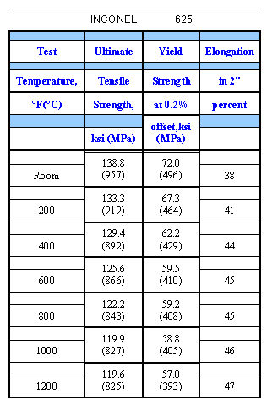

Magnet Systems (WBS 1.1.3)

Coil Builds

The latest coil builds are included inn the design point spreadsheet available on the NSTX engineering website. The builds tabulated here are from an early equilibrium flexibility based on “squareness” that was published by J. Menard. These builds were used in the global model described in Section 2. Table 5.1-7 shows the PF coil builds. Error: Reference source not found shows two views of the PF coils. Error: Reference source not found shows the coil builds for the TF Coils.
Table 5.1-7 PF Coil Builds
# |  |  | r | z | dr | dz | nx | nz
1 | CS |  | .2344 | .0021 | .01 | 4.3419 | 2 | 20
2 | CS |  | .2461 | .0067 | .01 | 4.2803 | 2 | 20
3 | CS |  | .2577 | .0022 | .01 | 4.2538 | 2 | 20
4 | CS |  | .2693 | -.0021 | .01 | 4.1745 | 2 | 20
5 | PF1aU | 28 | .3239 | 1.5906 | .0413 | .3265 | 4 | 4
6 | PF1bU | 10 | .4142 | 1.8252 | .042 | .1206 | 4 | 4
7 | PF1cU | 10 | .56 | 1.8252 | .042 | .1206 | 4 | 4
8 | PF2U | 14 | .7992 | 1.8526 | .1627 | .068 | 4 | 4
9 | PF2U | 14 | .7992 | 1.9335 | .1627 | .068 | 4 | 4
10 | PF3U | 7 | 1.4829 | 1.5696 | .1631 | .034 | 4 | 4
11 | PF3U | 8 | 1.4945 | 1.5356 | .1864 | .034 | 4 | 4
12 | PF3U | 7 | 1.4829 | 1.6505 | .1631 | .034 | 4 | 4
13 | PF3U | 8 | 1.4945 | 1.6165 | .1864 | .034 | 4 | 4
14 | PF4U |  | 1.795 | .8711 | .0922 | .034 | 4 | 4
15 | PF4U |  | 1.8065 | .9051 | .1153 | .034 | 4 | 4
16 | PF4U |  | 1.7946 | .8072 | .0915 | .068 | 4 | 4
17 | PF4L |  | 1.795 | -.8711 | .0922 | .034 | 4 | 4
18 | PF4L |  | 1.8065 | -.9051 | .1153 | .034 | 4 | 4
19 | Pf4L |  | 1.7946 | -.8072 | .0915 | .068 | 4 | 4
20 | PF5U | 12 | 2.0118 | .6489 | .1359 | .0685 | 4 | 4
21 | PF5U | 12 | 2.0118 | .5751 | .1359 | .0685 | 4 | 4
22 | PF5L | 12 | 2.0118 | -.6489 | .1359 | .0685 | 4 | 4
23 | PF5L | 12 | 2.0118 | -.5751 | .1359 | .0685 | 4 | 4
24 | PF3L | 7 | 1.4829 | -1.5696 | .1631 | .034 | 4 | 4
25 | PF3L | 8 | 1.4945 | -1.5356 | .1864 | .034 | 4 | 4
26 | PF3L | 7 | 1.4829 | -1.6505 | .1631 | .034 | 4 | 4
27 | PF3L | 8 | 1.4945 | -1.6165 | .1864 | .034 | 4 | 4
28 | PF2L | 14 | .7992 | -1.8526 | .1627 | .068 | 4 | 4
29 | PF2L | 14 | .7992 | -1.9335 | .1627 | .068 | 4 | 4
30 | PF1cL | 10 | .56 | -1.8252 | .042 | .1206 | 4 | 4
31 | PF1bL | 10 | .4142 | -1.8252 | .042 | .1206 | 4 | 4
32 | PF1aL | 28 | .3239 | -1.5906 | .0413 | .3265 | 4 | 4
33 | Ip |  | .9344 | 0 | .5696 | 1 | 6 | 8

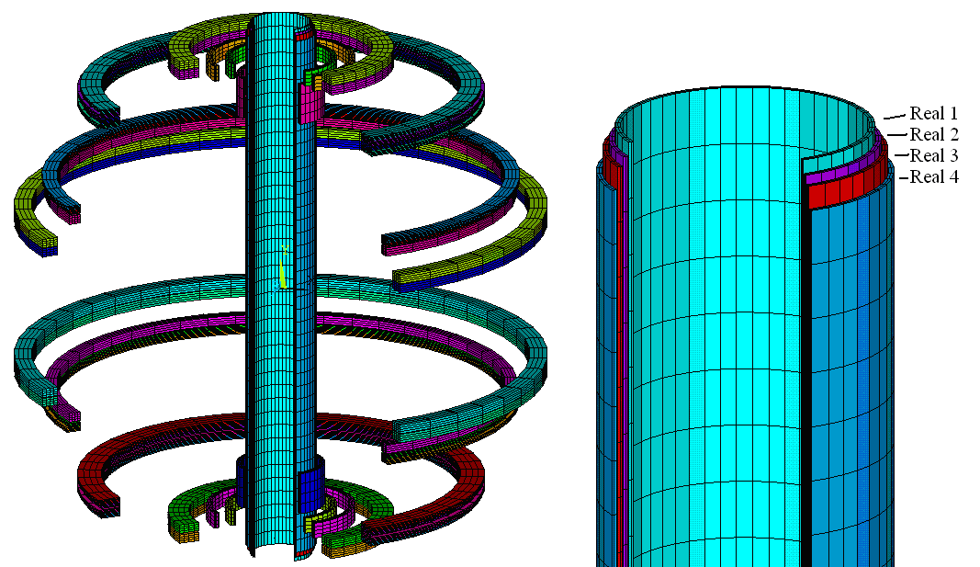
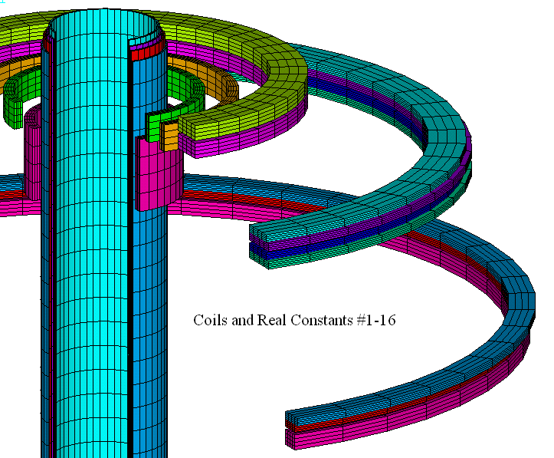

Figure 5.1-45 Two Views of the PF Coil s

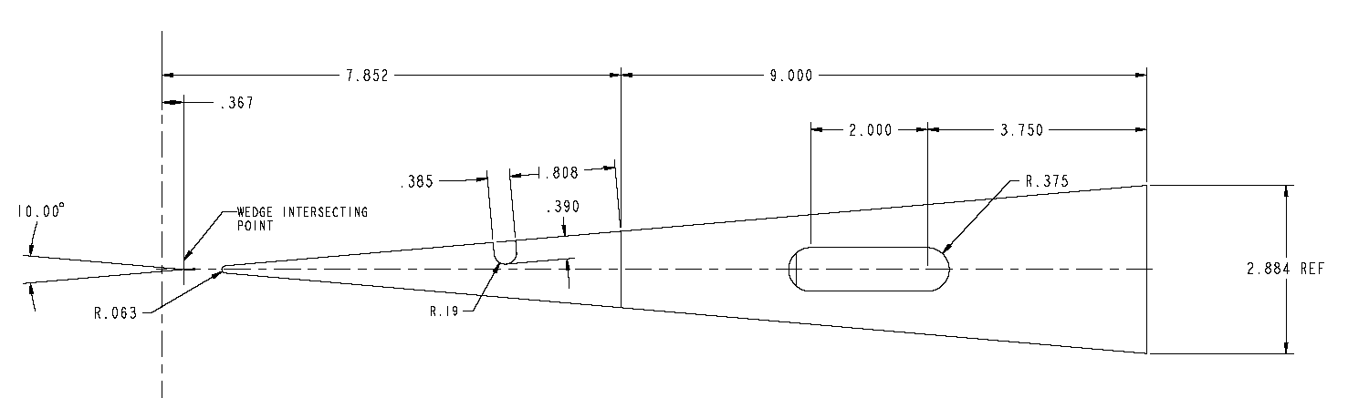
Figure 5.1-46 TF Coil Builds (Including Flag)

PF Currents
The latest design poiint on the NSTX engineering website includes 96 current scenarios. Table 5.2-8 is included because it is consistent with the coil build table above.
Table 5.2-8 PF Scenario Currents In Mat
Coil # | TFON | IM | -0.1 | -0.05 | 0 | 0.05 | 0.1 | Worst 1 | Worst 2 | Worst3 | Worst4 | Worst5
Step | 2 | 3 | 4 | 5 | 6 | 7 | 8 | 9 | 10 | 11 | 12 | 13
 | Nst1 | Nst2 | Nst3 | Nst4 | Nst5 | Nst6 | Nst7 | Nsw3 | Nsw4 | Nsw5 | Nsw6 | Nsw7
1 | 0 | 5.88 | .000 | .000 | .000 | .000 | .000 | -5.88 | 5.88 | 5.88 | -1.47 | -1.47
2 | 0 | 5.808 | .000 | .000 | .000 | .000 | .000 | -5.808 | 5.808 | 5.808 | -5.808 | -1.452
3 | 0 | 5.76 | .000 | .000 | .000 | .000 | .000 | -5.76 | 5.76 | 5.76 | -5.76 | -1.92
4 | 0 | 5.664 | .000 | .000 | .000 | .000 | .000 | -5.664 | 5.664 | 5.664 | -5.664 | -1.416
5 | 0 | 0 | 7.172 | 7.196 | 7.234 | 7.348 | 7.452 | 0.784 | 0.784 | 0.784 | 0.784 | 0.784
6 | 0 | 0 | -5.650 | -4.763 | -3.628 | -2.331 | -.946 | 0.12 | 0.12 | 0.12 | 0.12 | 0.12
7 | 0 | 0 | -4.922 | -4.014 | -2.936 | -1.755 | -.517 | 0.2 | 0.2 | 0.2 | 0.2 | 0.2
8 | 0 | 0 | 4.484 | 4.307 | 3.941 | 3.401 | 2.772 | 0.168 | 0.168 | 0.168 | 0.168 | 0.168
9 | 0 | 0 | 4.484 | 4.307 | 3.941 | 3.401 | 2.772 | 0.168 | 0.168 | 0.168 | 0.168 | 0.168
10 | 0 | 0 | -1.058 | -1.426 | -1.655 | -1.720 | -1.690 | -0.112 | -0.112 | -0.112 | -0.112 | -0.112
11 | 0 | 0 | -1.058 | -1.426 | -1.655 | -1.720 | -1.690 | -0.128 | -0.128 | -0.128 | -0.128 | -0.128
12 | 0 | 0 | -1.058 | -1.426 | -1.655 | -1.720 | -1.690 | -0.112 | -0.112 | -0.112 | -0.112 | -0.112
13 | 0 | 0 | -1.058 | -1.426 | -1.655 | -1.720 | -1.690 | -0.128 | -0.128 | -0.128 | -0.128 | -0.128
14 | 0 | 0 | -2.388 | -1.183 | -.206 | .488 | .923 | -0.08 | -0.08 | -0.08 | -0.08 | -0.08
15 | 0 | 0 | -2.388 | -1.183 | -.206 | .488 | .923 | -0.1 | -0.1 | -0.1 | -0.1 | -0.1
16 | 0 | 0 | -2.388 | -1.183 | -.206 | .488 | .923 | -0.16 | -0.16 | -0.16 | -0.16 | -0.16
17 | 0 | 0 | -2.388 | -1.183 | -.206 | .488 | .923 | -0.08 | -0.08 | -0.08 | -0.08 | -0.08
18 | 0 | 0 | -2.388 | -1.183 | -.206 | .488 | .923 | -0.1 | -0.1 | -0.1 | -0.1 | -0.1
19 | 0 | 0 | -2.388 | -1.183 | -.206 | .488 | .923 | -0.16 | -0.16 | -0.16 | -0.16 | -0.16
20 | 0 | 0 | -3.374 | -4.340 | -5.139 | -5.771 | -6.210 | -0.384 | -0.384 | -0.384 | -0.384 | -0.384
21 | 0 | 0 | -3.374 | -4.340 | -5.139 | -5.771 | -6.210 | -0.384 | -0.384 | -0.384 | -0.384 | -0.384
22 | 0 | 0 | -3.374 | -4.340 | -5.139 | -5.771 | -6.210 | -0.384 | -0.384 | -0.384 | -0.384 | -0.384
23 | 0 | 0 | -3.374 | -4.340 | -5.139 | -5.771 | -6.210 | -0.384 | -0.384 | -0.384 | -0.384 | -0.384
24 | 0 | 0 | -1.058 | -1.426 | -1.655 | -1.720 | -1.690 | -0.112 | -0.112 | -0.112 | -0.112 | -0.112
25 | 0 | 0 | -1.058 | -1.426 | -1.655 | -1.720 | -1.690 | -0.128 | -0.128 | -0.128 | -0.128 | -0.128
26 | 0 | 0 | -1.058 | -1.426 | -1.655 | -1.720 | -1.690 | -0.112 | -0.112 | -0.112 | -0.112 | -0.112
27 | 0 | 0 | -1.058 | -1.426 | -1.655 | -1.720 | -1.690 | -0.128 | -0.032 | -0.128 | -0.128 | -0.128
28 | 0 | 0 | 4.484 | 4.307 | 3.941 | 3.401 | 2.772 | 0.168 | 0.168 | 0.168 | 0.168 | 0.168
29 | 0 | 0 | 4.484 | 4.307 | 3.941 | 3.401 | 2.772 | 0.168 | 0.168 | 0.168 | 0.168 | 0.168
30 | 0 | 0 | -4.922 | -4.014 | -2.936 | -1.755 | -.517 | 0.2 | 0.2 | 0.2 | 0.2 | 0.2
31 | 0 | 0 | -5.650 | -4.763 | -3.628 | -2.331 | -.946 | 0.12 | 0.12 | 0.12 | 0.12 | 0.12
32 | 0 | 0 | 7.172 | 7.196 | 7.234 | 7.348 | 7.452 | 0.784 | 0.784 | 0.784 | 0.784 | 0.784
33 | 0 | 0 | 2.000 | 2.000 | 2.000 | 2.000 | 2.000 | 2 | 2 | 2 | 2 | 2

Lorentz Force Plots – TF and TF+OH
The peak toroidal field from the load files used in the global model is 4.9T. The peak field from the electromagnetic current diffusion model is 4.2T. They used different TF inner leg dimensions from different design point published throughout the CDR2009. Table 5.3-9 below provides the TF current specification L/R decay. Error: Reference source not found shows the currents when the TF coils are on. Error: Reference source not found shows what??? Error: Reference source not found shows what??? Error: Reference source not found shows what??? Error: Reference source not found shows typical TF Out-of-Plane loads (Note that the TF Inplane is Included at Left at a Different Scale). Error: Reference source not found shows another typical TF out-of-plane loads.
Table 5.3-9 TF Current Spec ( L/R Decay)

NumSteps | L/R Decay | NumSteps | L/R Decay | NumSteps | L/R Decay
*if b_0,eq,3, then !...NSTX Faulted Pulse (for 51 time steps)
t1=0.1 | $ i1 = 0 | t18=9.512 | $ i18 = 129778.84 | T35=11.576 | $ i35 = 12241.54
t2=0.2 | $ i2 =0 | t19=9.632 | $ i19 = 113132.22 | T36=11.696 | $ i36 = 10671.411
t3=1.952 | $ i3 = 15960.906 | t20=9.732 | $ i20 = 86621.613 | T37=11.816 | $ i37 = 9302.6701
t4=2.072 | $ i4 = 38658.746 | t21=9.872 | $ i21 = 85972.17 | T38=11.936 | $ i38 = 8109.4875
t5=2.192 | $ i5 = 58169.054 | t22=9.992 | $ i22 = 74945.174 | T39=12.056 | $ i39 = 7069.3453
t6=2.312 | $ i6 = 74742.32 | t23=10.136 | $ i23 =63563.326 | T40=12.176 | $ i40 =.6162.6142
t7=2.432 | $ i7 = 88820.681 | t24=10.256 | $ i24 = 55410.543 | T41=12.296 | $ i41 = 5372.1826
t8=2.552 | $ i8 = 100779.71 | t25=10.376 | $ i25 = 48303.454 | T42=12.416 | $ i42 = 4683.1337
t9=2.672 | $ i9 = 110938.46 | t26=10.496 | $ i26 = 42107.938 | T43=12.536 | $ i43 = 4082.4638
t10=2.792 | $ i10 = 119567.93 | t27=10.606 | $ i27 = 36707.073 | T44=12.656 | $ i44 = 3558.8372
t11=2.912 | $ i11 = 126898.33 | t28=10.736 | $ i28 = 31998.937 | T45=12.776 | $ i45 = 3102.3723
t12=3.032 | $ i12 = 129777.84 | t29=10.856 | $ i29 = 27894.677 | T46=12.896 | $ i46 = 2704.4546
t13=4.000 | $ i13 = 129777.84 | t30=10.976 | $ i30 = 24316.839 | T47=13.016 | $ i47 = 2357.5748
t14=5.000 | $ i14 = 129778.84 | t31=11.096 | $ i31 = 21197.903 | T48=15.000 | $ i48 = 1000.00
t15=6.000 | $ i15 = 129778.84 | t32=11.216 | $ i32 = 18479.01 | t49=20.000 | $ i49 = 100.00
t16=7.000 | $ i16 = 129778.84 | t33=11.336 | $ i33 = 16108.848 | T50=40.000 | $ i50 = 0.00
t17=8.000 | $ i17 = 129778.84 | t34=11.456 | $ i34 = 14042.689 | T51=1000.0 | $ i51 = 0.00
 |  |  |  |  | *endif

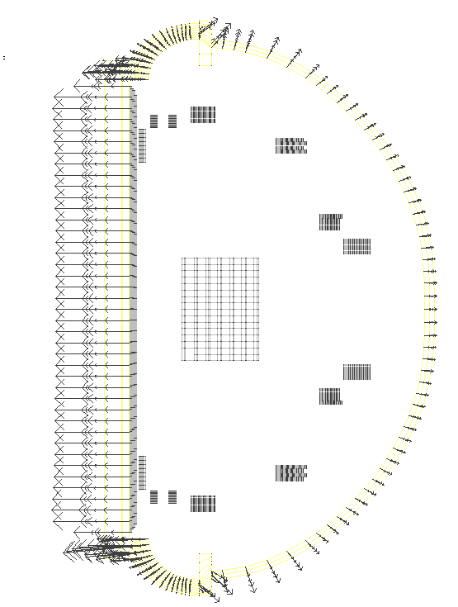

Figure 5.3-47 TFON
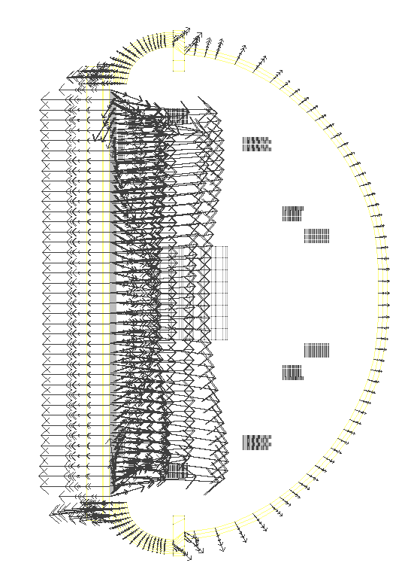
Figure 5.3-48 IM

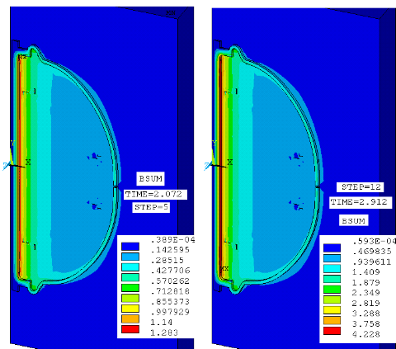

Figure 5.3-49 Shows What???

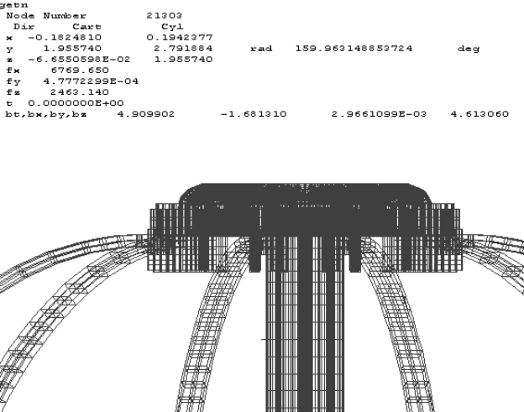

Figure 5.3-50 Shows What???

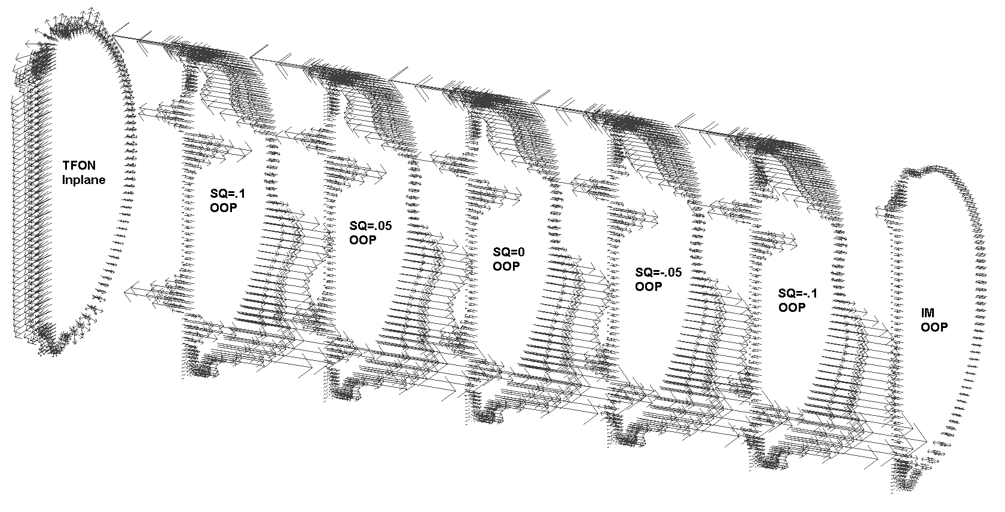
Figure 5.3-51 Typical TF Out-of-Plane Loads
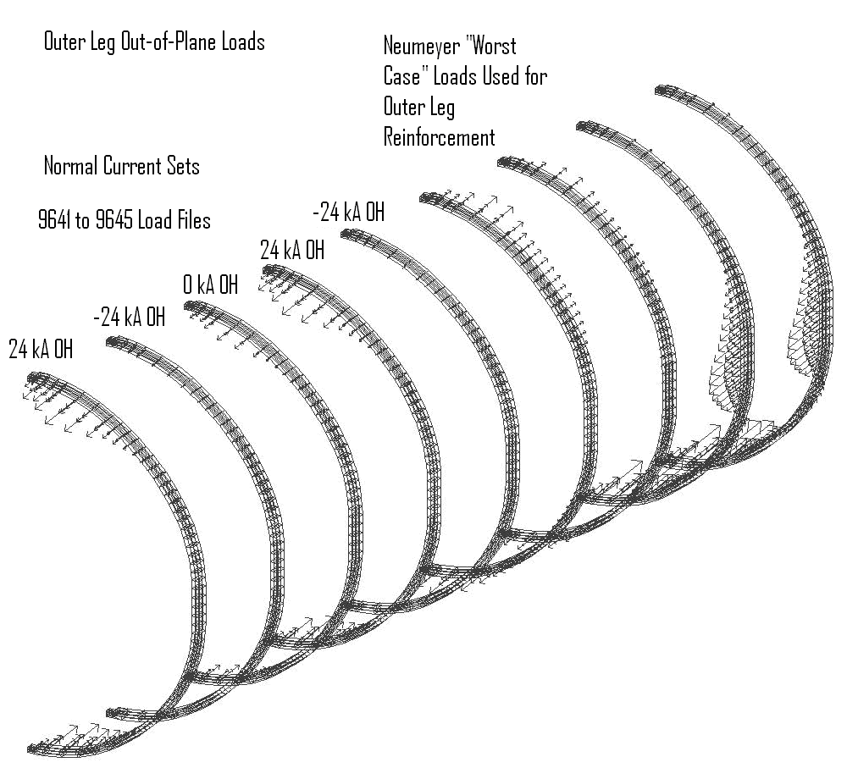
Figure 5.3-52 Typical TF Outer Leg Out-of-Plane

Toroidal Field Coils
The TF inner leg is sized mainly based on the inertial cooling requiremnents and not on stress limits. At the equatorial plane, the stress is modest – only 40 to 50 Mpa. This provides a conservative stress in the copper including ample allowance for the cooling holes, but minimal wedge pressure to augment the shear capacity.

Coupled Electromagnic-Thermal Analysis
The objective of this analysis is to calculate the temperature and stresses during TF coil ramp up, flat top and ramp down (Fig. 1). PF field is not considered. This analysis is based on the coupled field electromagnetic and thermal analysis for a simple model by P. Titus [1], [2].
Error: Reference source not found shows the results from the electomagnetic thermal model. Error: Reference source not found shows the results from the global model.

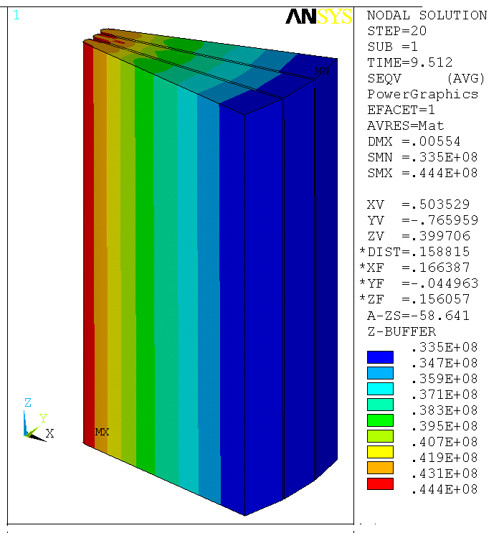

Figure 5.4-53 Results from the Electromagnetic-Thermal Model

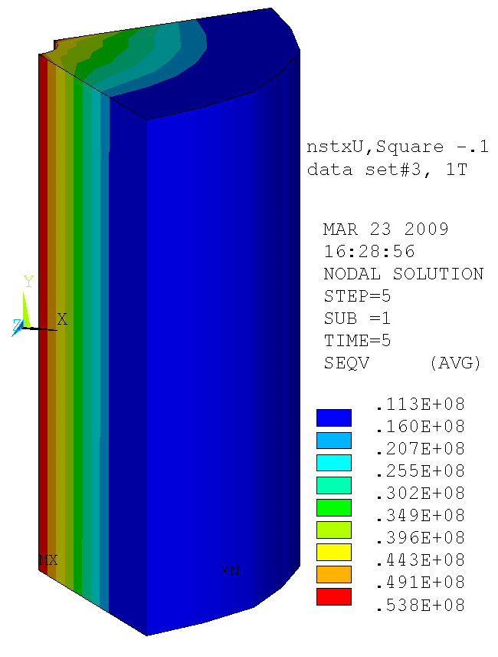
Figure 5.4-54 Results from the Global Model

The distribution of current in TF coil depends on the resistance, inductance and contact pressure in the contact area. Coil temperature reaches highest at the end of the pulse, i.e., 10.136s for normal operation (see Error: Reference source not found). Maximal temperature is 117ºC, at the inner side of arch and inner TF leg. Comparing with C. Neumeyer’s result (101 ºC temperature rise [3]), this analysis with current diffusion effect, results in a little higher temperature. But within this temperature range, active cooling is not necessary. Max coil temperature is 47 ºC at the end of pulse. But the temperature at the end of the coil can reach 65 ºC because it connects to the arch which has higher temperature.
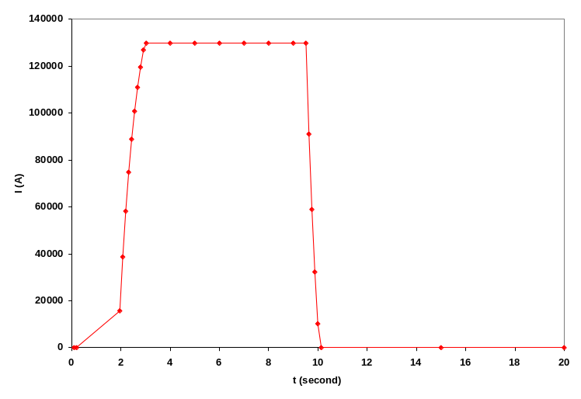
Figure 5.4-55 NSTX Normal Operation Waveform
In this model, the arch is modeled by two solid pieces. But in reality, they are made of many straps. So the arches in this model have anisotropic material properties (mechanical properties are based on the local structure model results of T. Willard [4]), Current density, magnetic flux density and temperature from this analysis have been provided to T. Willard for his detailed simulation of the joint (see Error: Reference source not found).
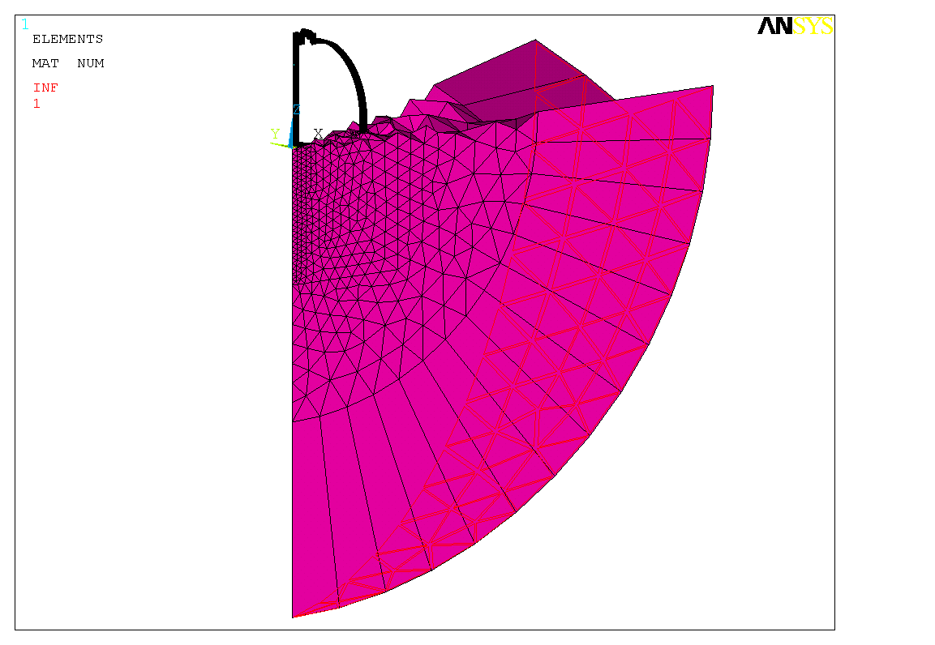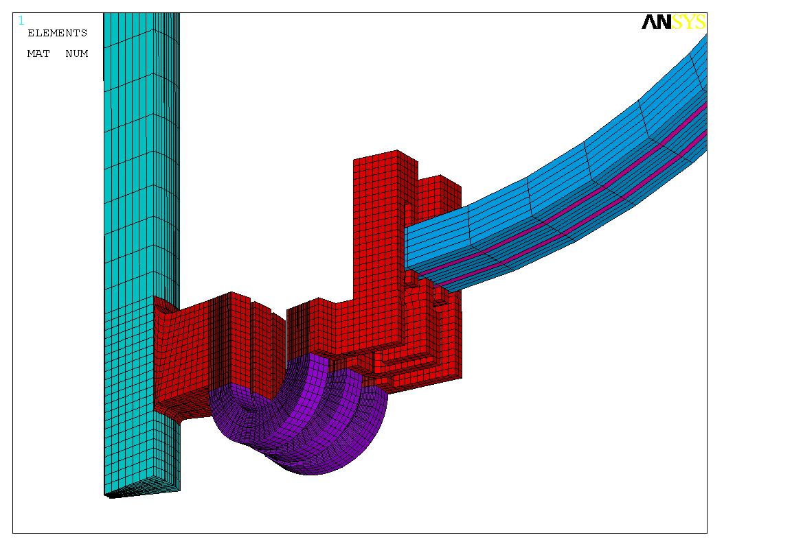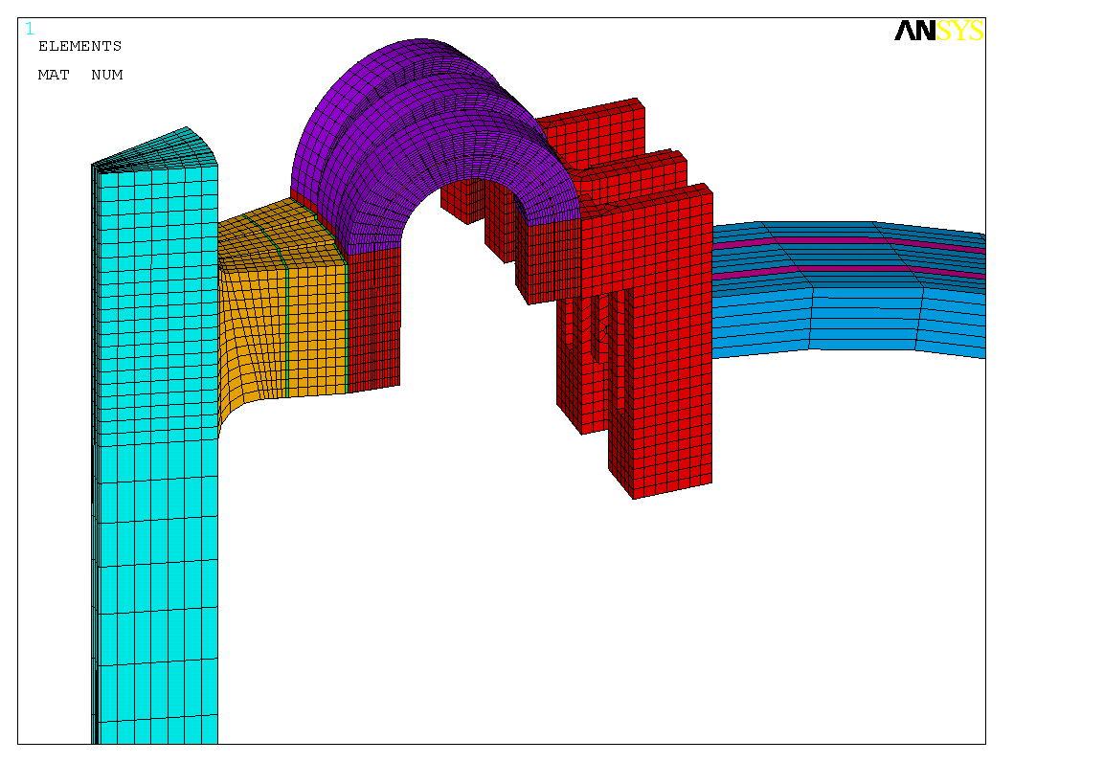
Arch: with anisotropic mat prop to simulate strips
Upper flag: high strength copper: with 1/0.8 resistivity and 80% thermal conductivity
Lower flag: pure copper
Contact area
Electrical insulation
TF coil
TF coil
air
Figure 5.4-56 Model of Arch
Using high strength copper (80% IACS) in the flag extension increases the temperature only by < 1ºC. Thus high strength copper can be used if required to increase the pressure of joint bolt insert over the capacity of pure copper.
The central beam has maximal hoop tension stress of 72.7MPa at 9.512s (i.e. the end of flat top) and 58.5MPa at 10.136s (i.e. the end of pulse), similar to Titus’s result [2]. But there is another even higher hoop stress point of 95.5MPa at 9.512s, at the connection between central beam and flag, which is due to the L-shape connection part between the arch and TF outer leg.
Toroidal field contours have been provided for use in other calculations—in particular the background field in the antenna calculation.
Structure response at the joint has been included for comparison with more detailed modeling of the joint [4].

Analysis Method
This is a transient and coupled field analysis. An electromagnetic model () is used to calculate current diffusion effect and transfer the generated heat and Lorenz force to thermal and structural model. The thermal and structural model calculates the temperature, displacement, thermal stress, contact pressure at contact areas, and then transfer these data back to electromagnetic model (Error: Reference source not found). The materials have temperature dependent material properties, including electrical resistivity, thermal conductivity, specific heat, coefficients of thermal expansion. The arches have anisotropic resistivity and thermal conductivity to simulate the straps. Because the arch is made of many straps and not a solid copper, it becomes much more compliant. The modulus of the arch is based on the results of T. Willard [4]. The upper flag uses high strength copper which has 1/0.8 resistivity and 80% thermal conductivity of pure copper. In next section, the results show that using high-strength copper or pure copper doesn’t have much difference. The lower flag uses pure copper. In the electromagnetic model, the contact regions have pressure dependent resistivity and the data are from Table 1 of R. Woolley [5].
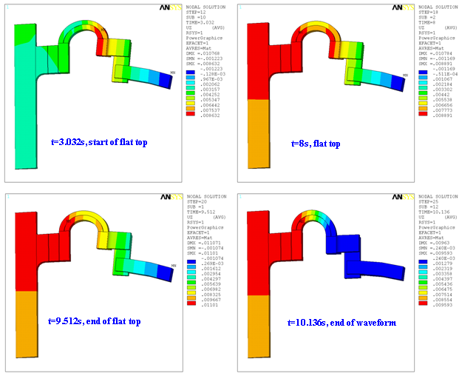

Figure 5.4-57 Displacements from the Electromagnetic Current Diffusion Model - Inner Leg Temperature, L/R Fault
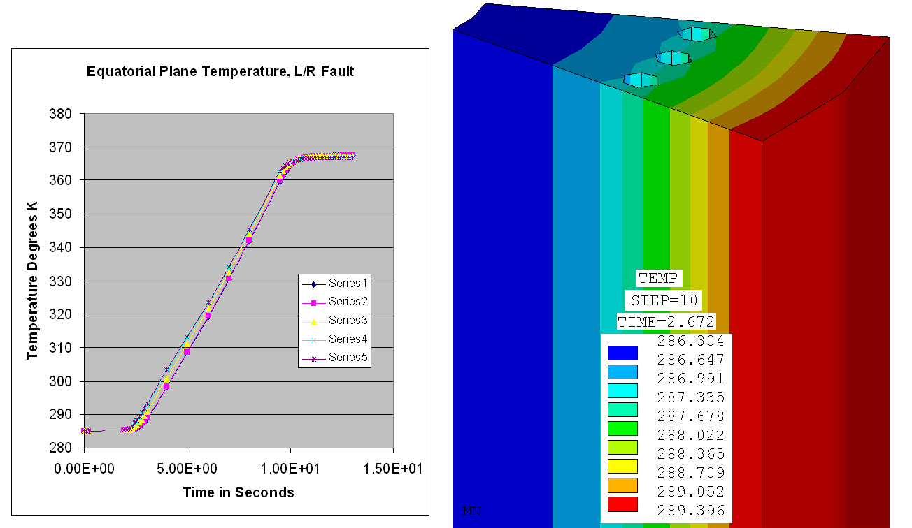

Figure 5.4-58 Equatorial Plane Time History. End average temperature is 367.15, Ref [6],{7]

Extended Hub Structural Pass
Error: Reference source not found shows the structural pass forces, constraints, and temperatures. Error: Reference source not found shows the inner TF leg stress time history with no thermal stress. Error: Reference source not found shows the inner leg Von Mises stress time history with thermal stresses - The higher stress at the end of the pulse results from the restraint of center stack thermal expansion by a stiff modeling of the joint loop. This for the Nominal TF Current Profile.
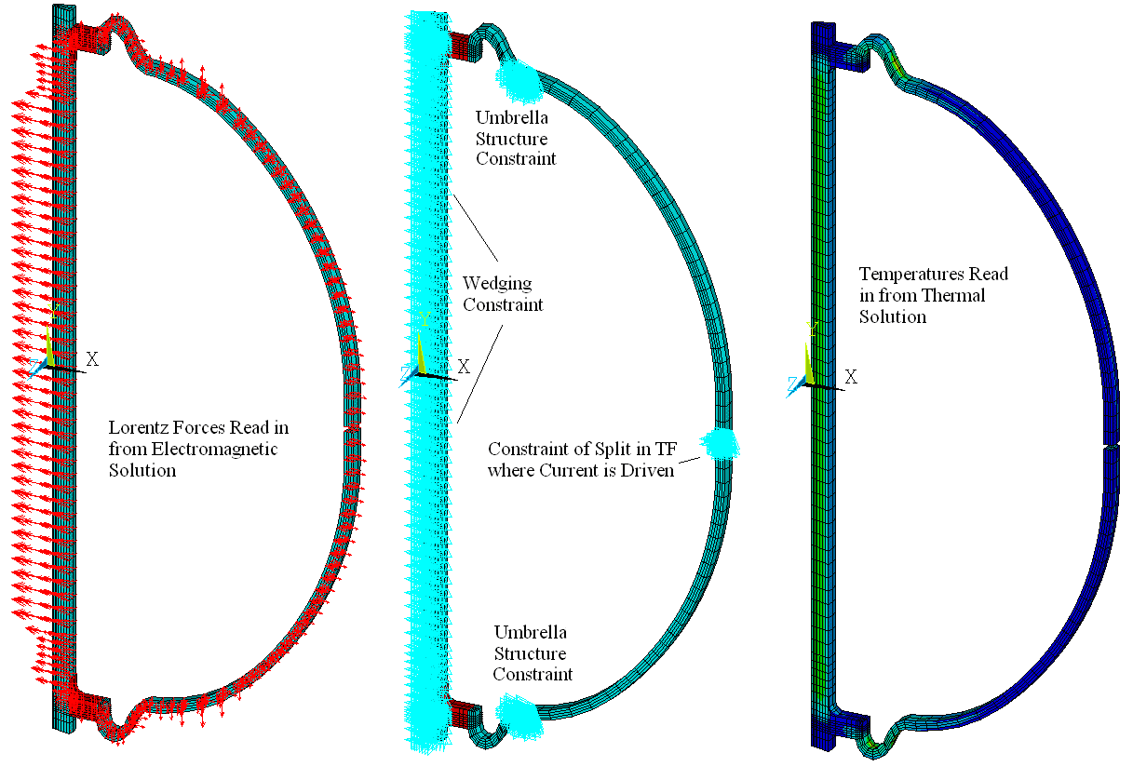
Figure 5.4-59 Structural Pass Forces, Constraints, and Temperatures
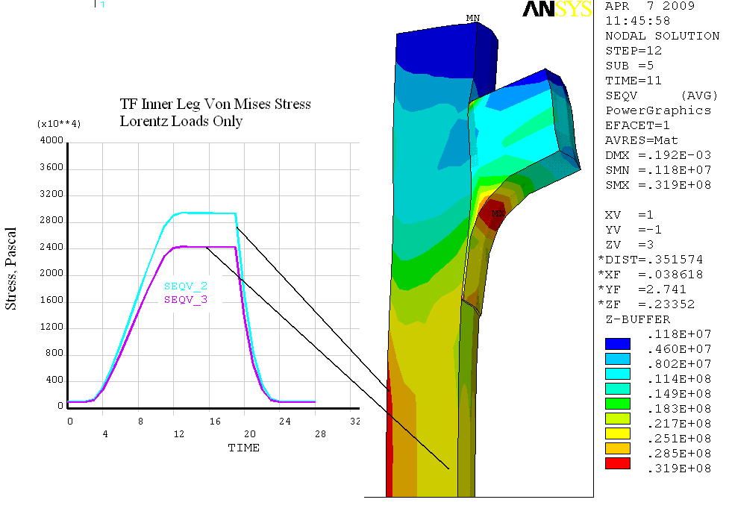
Figure 5.4-60 Inner Leg Stress Time History – No Thermal Stresses

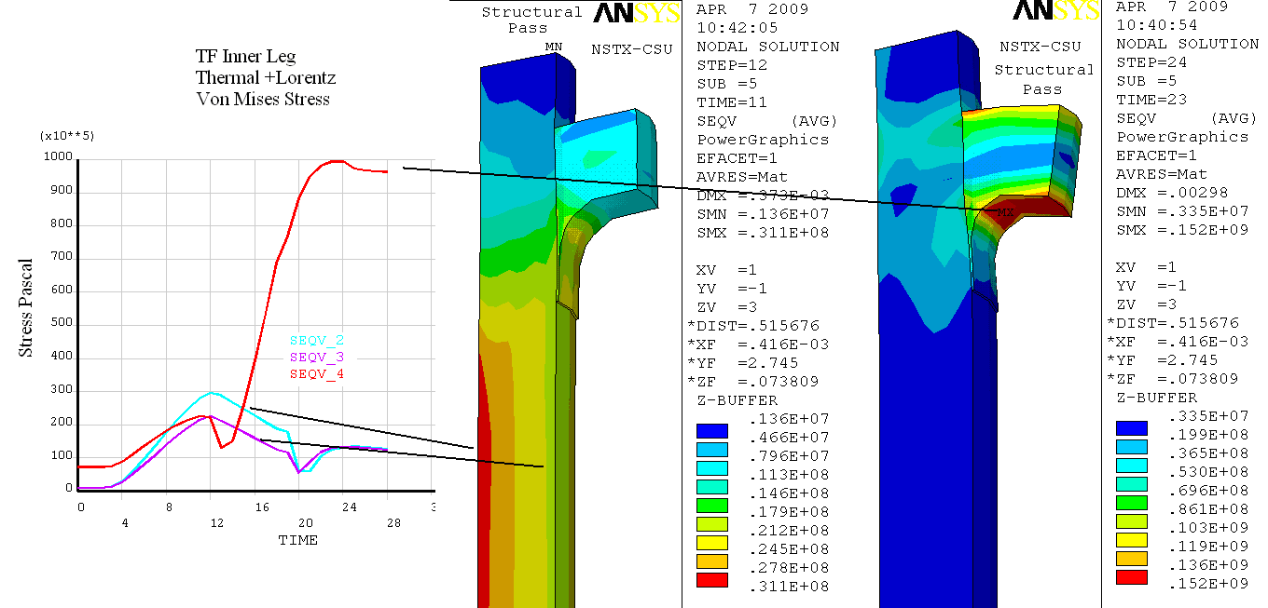

Figure 5.4-61 Inner Leg Von Mises Stress Time History – With Thermal Stress

Joint Option Studies

Concept Options
The demountable inner leg of the ST is a key feature which is also very challenging [2]. The current density is quite high and adequate contact pressure must be maintained at the joint under all conditions of electromagnetic loading. Currents, fields, and forces are quite high and in some cases bidirectional. The TF inner leg assembly experiences substantial axial thermal which has to be accommodated by the radial limbs without causing high stresses or moments which would spoil the contact pressure at the joint. The area is quite congested and access to fasteners is difficult. The radial limbs must make up for fabrication tolerances on the inner legs and assembly tolerances on the outer legs.
In order to develop a robust solution for the NSTX center stack upgrade four concepts have been independently developed and are now under assessment as shown in Error: Reference source not found.
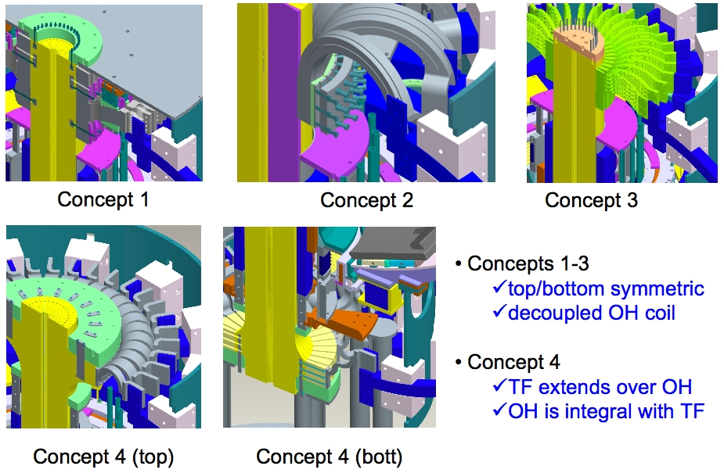
Figure 5.4-62 TF Center Stack Options
Concepts 1-3 are basically different than 4 since the TF inner legs do not include any extensions at the ends so that the OH coil can be separately manufactured and installed/removed repeatedly. In concept 4, radial extensions would be e-beam welded to the wedge shaped turns yielding the advantage of jointing at a greater radius (lower field, greater surface area) but the disadvantage of the fabrication of the TF and OH being linked, and the OH coil being trapped.
The essential features of the joint concepts are:
- Concept 1: Bolted joint with inserts, constant tension shaped radial, flexibility both in-plane & out-of-plane, torque transmitted to lid
- Concept 2: Jacking ring joint connection, flexibility in-plane, self-supported against torque
- Concept 3: Jacking ring joint connection, constant tension shaped radial, flexibility in-plane, self-supported against torque
- Concept 4: e-beam welded extensions, bolted joints with inserts, flexibility in-plane, torque transmitted to lid
Concept 4 was chosen for the conceptual design effort (See Error: Reference source not found).
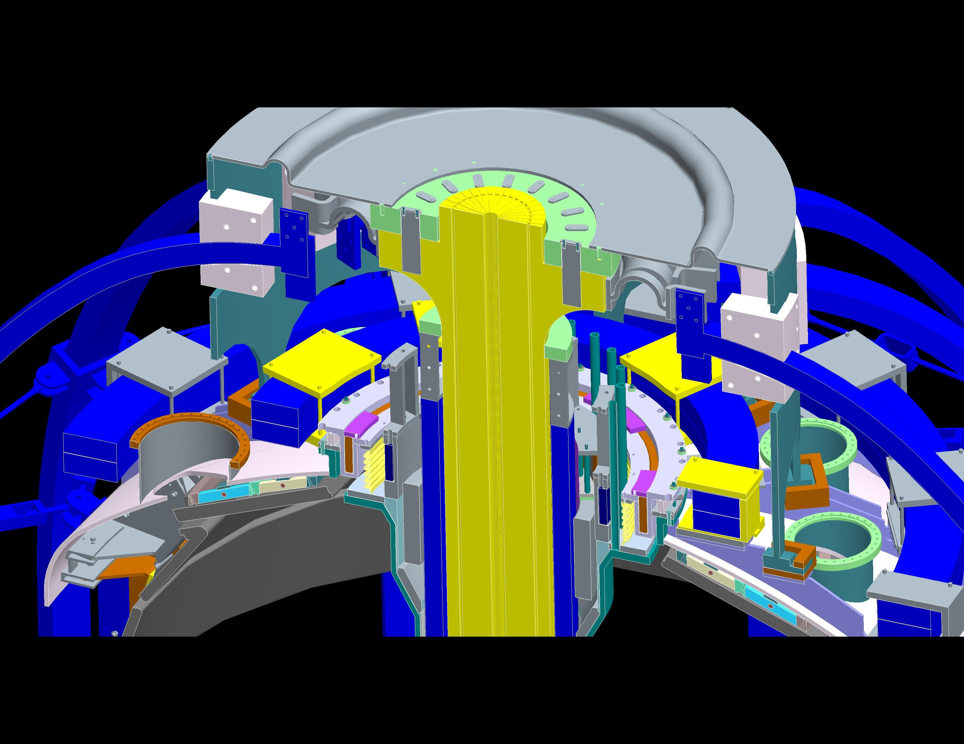
Figure 5.4-63 Concept 4 - Extended Hub Concept

TF Joint Qualification and Model
        - TF Joint Qualification Boundary Conditions
The TF joint is part of the larger NSTX structural system and has many interfaces. The outer flags are attched to the umbrella structure aluminum blocks which in turn are supported by the vessel umbrella structure and are loaded by the TF outer leg loads. The connection at the centerstack assembly sees the 8 mm vertical thermal growth of the joule heated TF inner leg. The inner and outer attachment points of the joint are held in toroidal registration by the upper and lower diaphragms described and analyzed in Section 4.3. Error: Reference source not found shows the TF Inner Flex Joint qualification. Error: Reference source not found shows the details of this joint. Error: Reference source not found shows the results of the analyses of the TF Inner Flex Joint. Error: Reference source not found shows the maximum vertical field at the TF straps. Error: Reference source not found shows the toroidal displacements at the Flex Joint

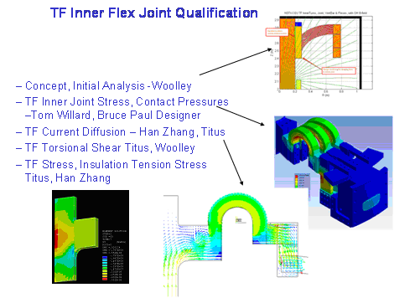
Figure 5.4-64 TF Inner Joint Qualification
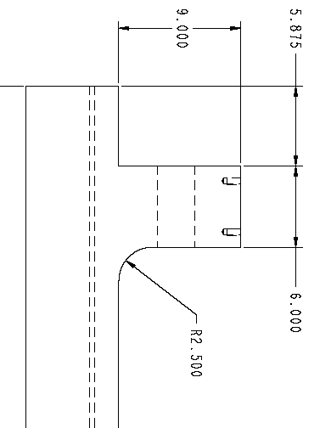
Figure 5.4-65 Details of the TF Inner Flex Joint
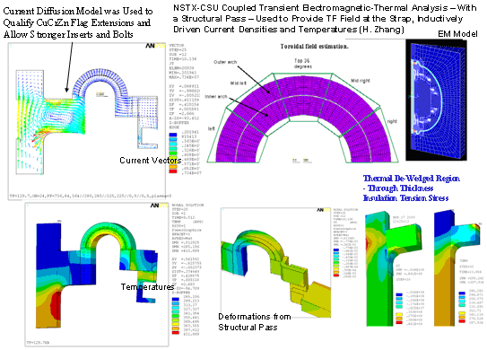
Figure 5.4-66 TF Inner Flex Joint Analyses
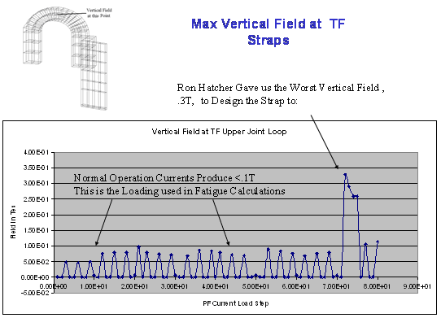
Figure 5.4-67 Maximum Vertical Field at the TF Straps

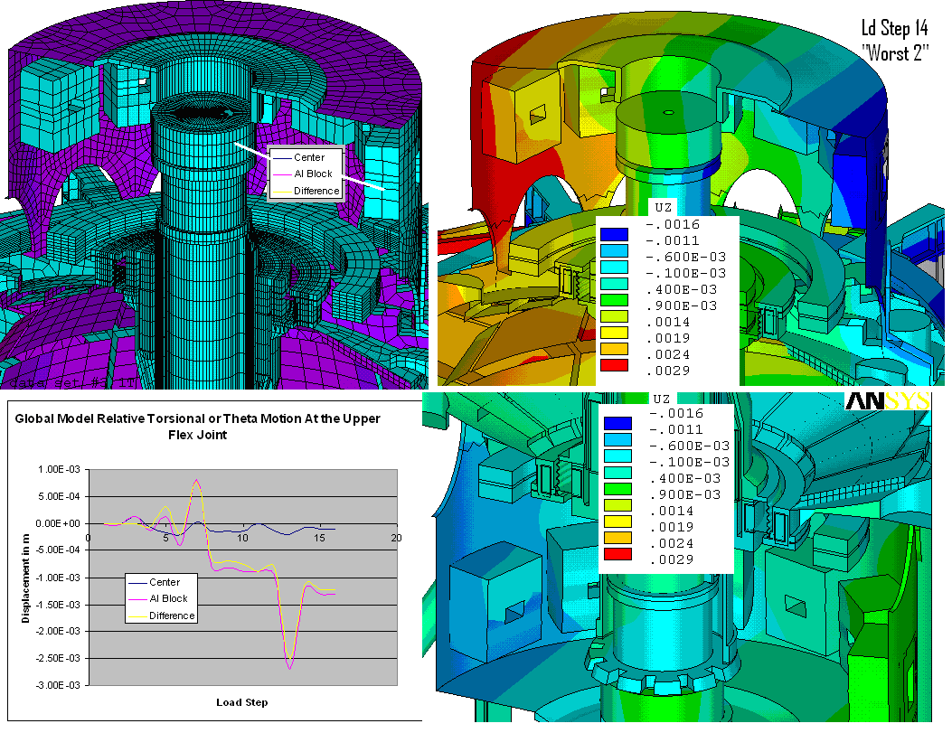
Figure 5.4-68 Toroidal Displacements at the Flex Joint

TF Joint Local Model
A complete treatment of this analysis may be found on the NSTX Centerstack Upgrade Engineering Web page and is documented in ref [4]. Error: Reference source not found is a model of the TF joint.
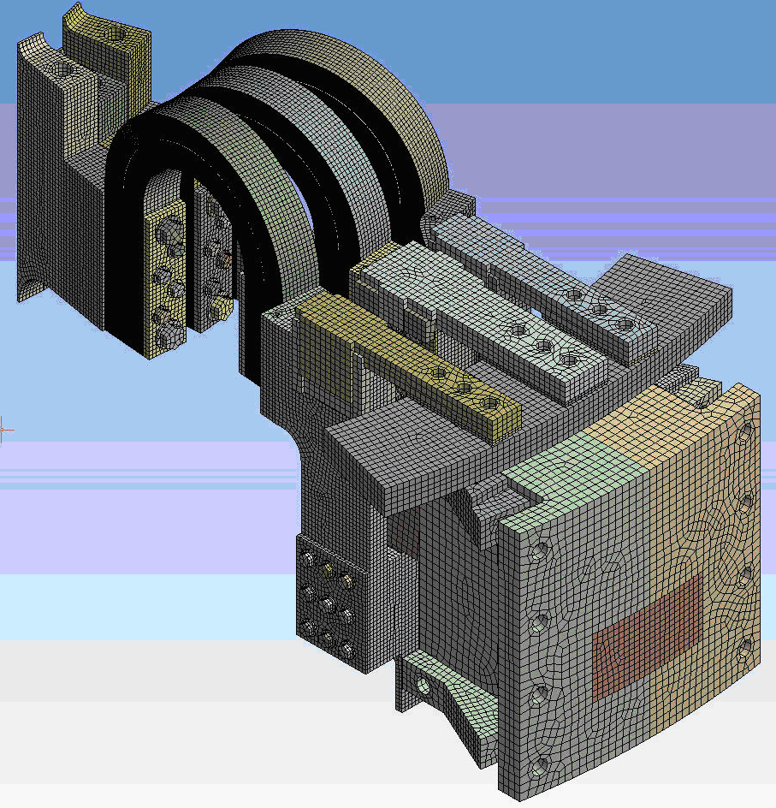
Figure 5.4-69 TF Joint Model
The objectives of this analysis of the NSTX Upgrade TF Flex Strap and TF Bundle Stub design were:
- To determine if the design is adequate to meet the requirements specified in the NSTX Structural Design Criteria, specifically, if the flex strap lamination stresses and the copper lead extension thread stresses meet the requirements for fatigue, yield, and buckling, under worst-case/ power supply-limit load conditions: 130,000 amps/ strap, 0.3 T poloidal field, and 1.0 T toroidal field; and
- To verify that the local contact pressure in the bolted electrical joints is a minimum of 1500 psi, sufficient to maintain the joint contact electrical conductance above the design goal, based on the current-design development tests, of 1.0E06 siemens/in².
The results of the ANSYS multiphysics finite element analysis - electric, transient thermal, magnetostatic, and static structural are shown in Error: Reference source not found. These results show that:
- The maximum equivalent stress in the laminations is 27.5 ksi, which is 25.5 ksi below the fatigue allowable for the full-hard C15100 copper-zirconium strip;
- The maximum equivalent stress in the copper threads is 29.1 ksi, which is 32.9 ksi below the fatigue allowable for the full-hard C18150 copper-chromium-zirconium plate;
- The minimum average contact pressure is >6500 psi, and the minimum local contact pressure is >2500 psi, which is 1000 psi above the design goal; and
- The lamination minimum linear buckling load multiplier factor (LMF) is > 58, which is approximately 10x the minimum allowable specified in the NSTX Design Criteria document.
Table 5.4-10 shows a design operating point comparison between the present and upgrade designs.
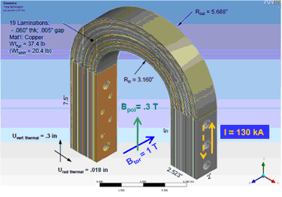
Figure 5.4-70 ANSYS Multiphysics Finite Element Analysis
Table 5.4-10 Design Operating Point Comparison
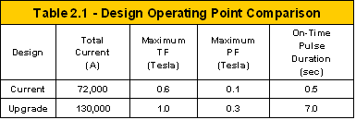

Joint Mechanical Parameters Comparison
A comparison of the mechanical parameters of the TF lead-extension bolted joint designs is shown in Table 5.4-11. From this table, it is clear that the upgrade design is much more robust.
Table 5.4-11 Comparison of the Joint Mechanical Parameters
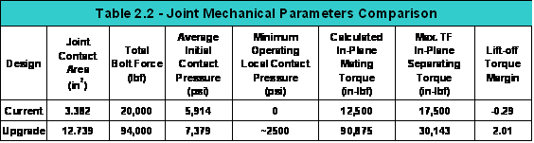
The joint is located further from the CS winding, so the joint contact area is much wider. It is also taller, so the contact area is approximately 4x larger. The number of bolts/ joint has increased, and there is a mix of 3/8 and 5/8 bolts, with the 5/8 bolts located furthest from the bolt centroid. The lead-extension material has been changed to a high strength copper alloy C18150 copper-chromium-zirconium, so that the bolt pretension is limited by the strength of the bolts and not the shear strength of the copper threads. All of this results in a nearly 5x increase in total bolt force, a 50% increase in initial contact pressure, and a large positive lift-off torque margin. Since there is no lift-off, the local contact pressure never falls below a minimum value, determined in the ANSYS analysis below to be > 2500 psi.

Joint Electrical/ Thermal Parameters Comparison
A comparison of the electrical and thermal parameters of the joints is shown in Table 2.3. Though the total current is higher in the upgrade design, the current density is only 1/2 the density in the current design. The initial (closed joint) electrical resistance and heat generated in both designs is small, as is the estimated temperature rise across the joints, assuming no thermal capacitance.
Table 5.4-12 Joint Electrical/Thermal Parameters Comparison
Design | Current Density  (A/in²) | Initial Electrical Resistance  (W) | Heat Generated I²R  (W) | Thermal Power Density  (W/in²) | Initial Thermal Resistance  (W/C) | Zero-Heat Capacity Temperature Rise  (C)
Current | 21,289 | 1.48E-07 | 7.66E+02 | 2.27E+02 | 1.18E-02 | 9.1
Upgrade | 10,205 | 3.93E-08 | 6.63E+02 | 5.21E+01 | 3.14E-03 | 2.1

Static Bolt Strengths and Insert Pull-Out Loads Comparison
A comparison of the static bolt strengths and insert pull-out loads of the two joint designs is shown in Table 5.4-13. From the table, it can be seen that the shear strength of the C10700 copper threads in the current design limits the 3/8 bolt pretension to below the maximum allowable bolt load. When the estimated 2000 lbf operational cyclic load is considered, the allowable bolt pretension is reduced to only 5000 lbf: a 2000 lbf reduction due to the cyclic load, and a 3000 lbf reduction due to the reduced shear strength of the copper for fatigue at 60,000 cycles.
Table 5.4-13 Static Bolt Strength and Insert Pull-Out Comparison
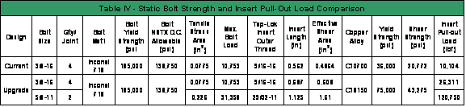
The upgrade design uses high strength C18150 copper-chromium-zirconium, with more than twice the shear strength of the C10700 copper, for the lead-extensions,. Also, because the extensions are longer, a longer 3/8 insert is used, with a larger shear area. This results in the copper thread strength being greater than the bolt tensile strength, so the maximum allowable bolt pretension is limited by the strength of the bolt. The bolt reactions from the ANSYS analysis below indicate that the cyclic load is small (10-15% of the bolt pretension), so can be reduced to nearly zero with the use of Belleville washers. To maximize the contact pressure and lift-off margin, without exceeding the maximum allowable bolt loads, the following bolt pretensions were chosen for the upgrade design: 10,000 lbf for the 3/8 bolts; and 27,000 lbf for the 5/8 bolts.

Comparison Summary
In summary, joint pitting damage in the current design occurs with TF fields > .45 T, in lift-off areas predicted by an ANSYS direct-coupled model and verified by in-situ measurements of joint resistivity. No pitting damage occurs in joints further from the plasma that do not lift-off. Bolt pretension, limited to 5000 lbf due to the low shear fatigue strength of the copper threads, is not sufficient to prevent lift-off, given the long lever arm of the TF Radial Flag.
The upgrade flex strap design reduces the lever arm length, minimizing the prying torque. The more robust design , with bolt pretensions limited by the strength of the bolts, also increases the mating torque, resulting in a large positive lift-off margin. A description of the ANSYS multiphysics analysis, used to determine the stresses in the laminations and the minimum local contact pressure in the joints, follows.

Figure 5.4-71 shows the static structural analyses results of the von Mises stress. Figure 5.4-72 shows the static structural analysis results of the TF Bundle Stub Bolted Joint. Figure 5.4-73 shows that the inner-most lamination stress increases only about 7% with the addition of the 2.5mm torsional displacement: 22899 psi vs 21445 psi. Figure 5.4-74 shows outer-most lamination model with the 2.5mm OOP displacement added to the Emag loads and thermal displacements, the stress increased by only 3% (21827 psi vs 21178 psi). This shouldn't be a problem if we use C15000 copper or better.
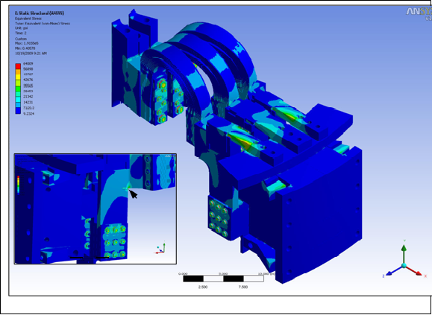
Figure 5.4-71 Static Structural Analysis Results: von Mises Stress

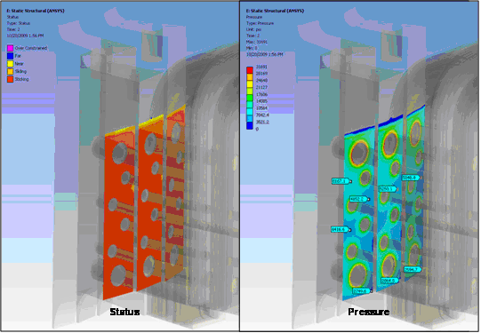
Figure 5.4-72 Static Structural Analysis Results: TF Bundle Stub Bolted Joint
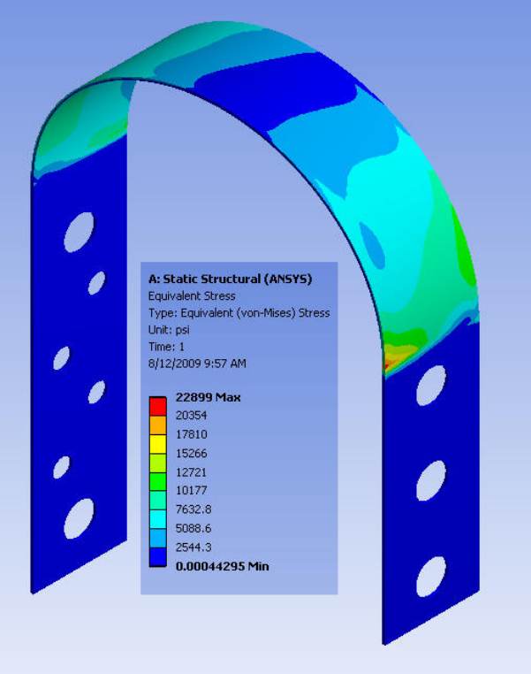
Figure 5.4-73 Inner-Most Lamination Model
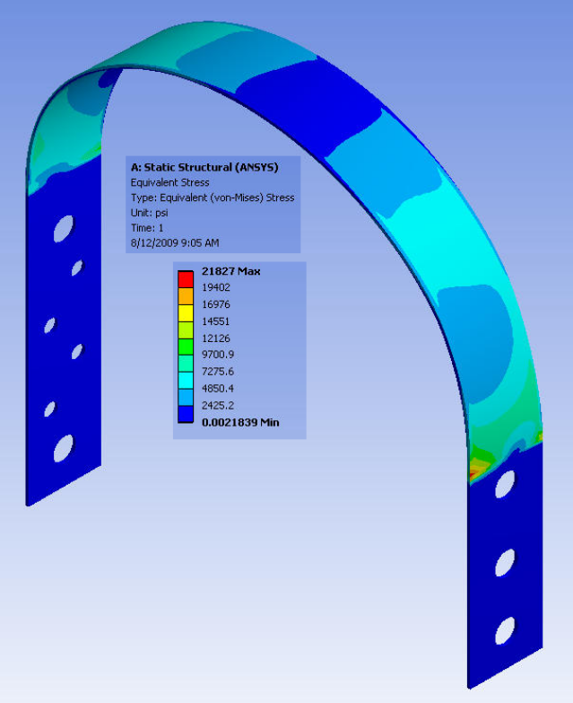
Figure 5.4-74 Outer-Most LaminationModel

Global Torques
Out-of-Plane loading can be calculated as a general function of the 13 independent PF currents and current streams in the TF coil geometry [8]. This allows certain out-of-plane torques to be included in the design point calculations. Figure 5.4-75shows the net TF system outer leg torque equations. Figure 5.4-76shows the net upper half TF system torque equations.
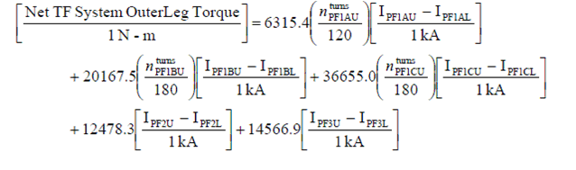
Figure 5.4-75 Net TF System Outer Leg Torque Equations

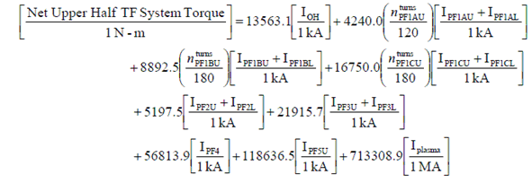
Figure 5.4-76 Net Upper Half TF System Torque Equations

TF Inner Leg Torsional Shear

Global Model Results
Out-of-Plane (OOP) loads on a toroidal field (TF) coil system result from the cross product of the poloidal field and toroidal field coil current. Support of OOP loads is statically in-determinant, requiring an understanding of the flexibility of the outboard structures and the inboard stiffness of the central column. For NSTX CSU, this is accomplished in the global model. For the worst PF loads considered in the global model, the peak torsional shear stress is 20 MPa – just below the allowable of 21.7 MPa. Figure 5.4-77 shows the global model inner leg torsional shear. Figure 5.4-78 also shows the global model inner leg torsional shear with the worst case PF Loads. Figure 5.4-79 shows a more detailed view of the global model inner leg torsional shear.
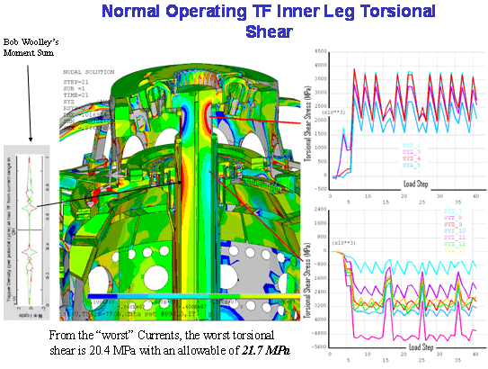
Figure 5.4-77 Global Model Inner Leg Torsional Shear

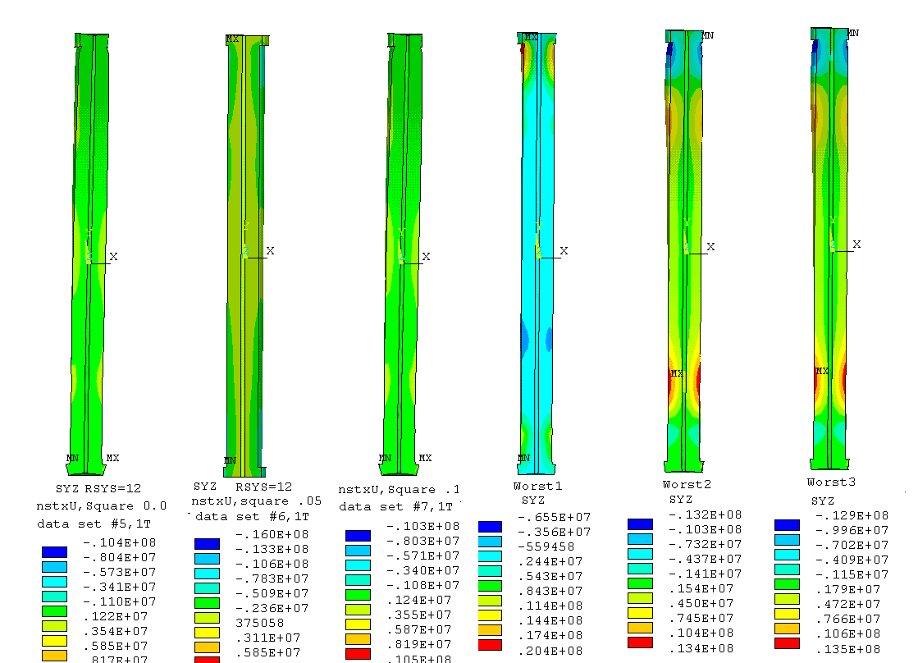
Figure 5.4-78 Global Model Inner Leg Torsional Shear – Worst Case PF Loads
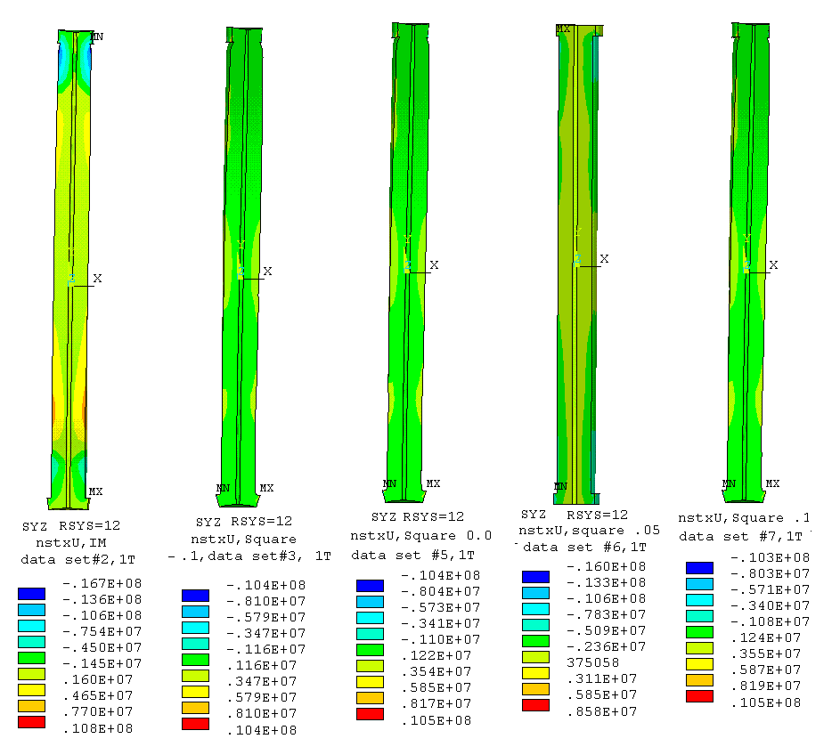
Figure 5.4-79 Another View of the Global Model Inner Leg Torsional Shear
Additional discussions of torsional shear may be found in Bob Woolley’s calculation NSTX-CALC-132-003-00 which provides moment calculations which are useful to find the maximums in thte NSTX Design Point spreadsheet. His summation of the outer leg moment is directly useful in evaluations of the up-down asymmetric case that Han Zhang is running in the diamond truss/tangential - radius rod calculations. (Section 5.4.4.2)

Simplified Analysis
A simplified method for calculating OOP shear stresses and their distributions, suitable for systems codes, is described here. The TF coil system and structure is modeled as a toroidal shell The poloidal field is calculated at the shell using axisymmetric current loops and an elliptic integral solution. OOP Lorentz forces are computed by crossing the TF current with the poloidal field. The torsional stiffness of segments of the TF shell is computed, adjusting shear modulus and thickness to simulate the stiffnesses of the tokamak. In practice the global finite element model is used as a guide in selecting the shell properties. This kind of approach can be implemented in the Design Point.
Figure 5.4-80 shows a simplified Toroidal Field Coil shell model. OOP loads are computed from the TF current and PF currents using an elliptical integral solution for the PF fields. TF OOP loads are assumed to be applied to a toroidal shell – with varying thickness to simulate more complex OOP structures. Shear deformations are accumulated to a split in the shell, then a moment is applied to align the split. Figure 5.4-81shows the NSTX TF shell model. Figure 5.4-82 shows a comparison of Woolley’s global FEA and a Simple Shell Analyses. Figure 5.4-83 shows torsional shear for IM and some equilibria. Figure 5.4-84 shows the out-of-plane force density along the TF center line starting with outboard equatorial plane. Figure 5.4-86, Figure 5.4-87, Figure 5.4-88, and Figure 5.4-89 show ???.
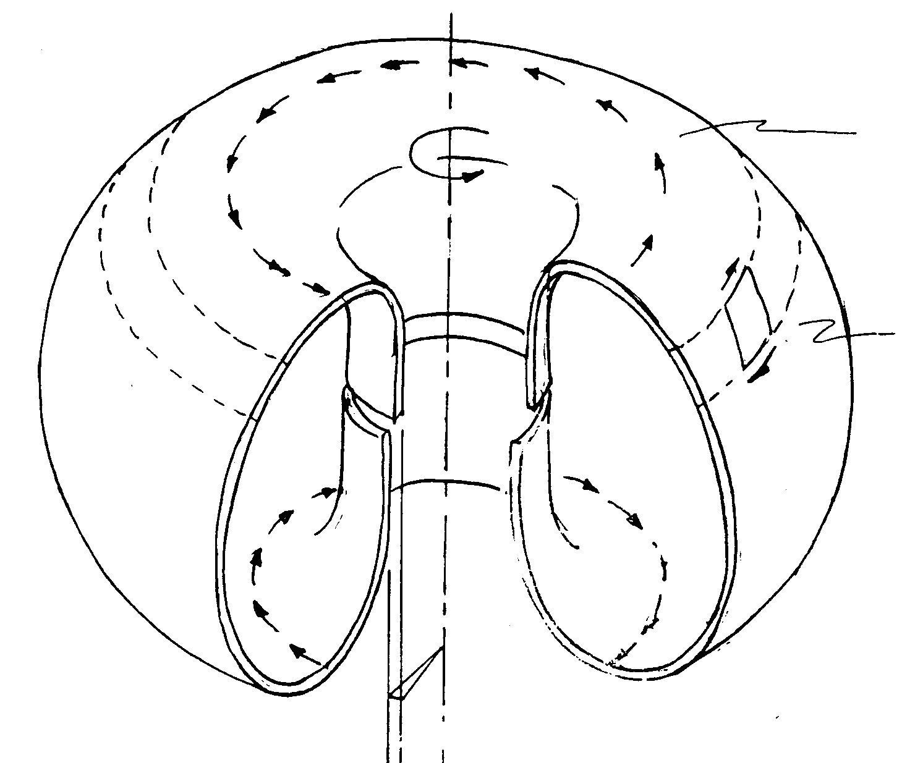
Figure 5.4-80 Simple Toroidal Field Coil Shell Model

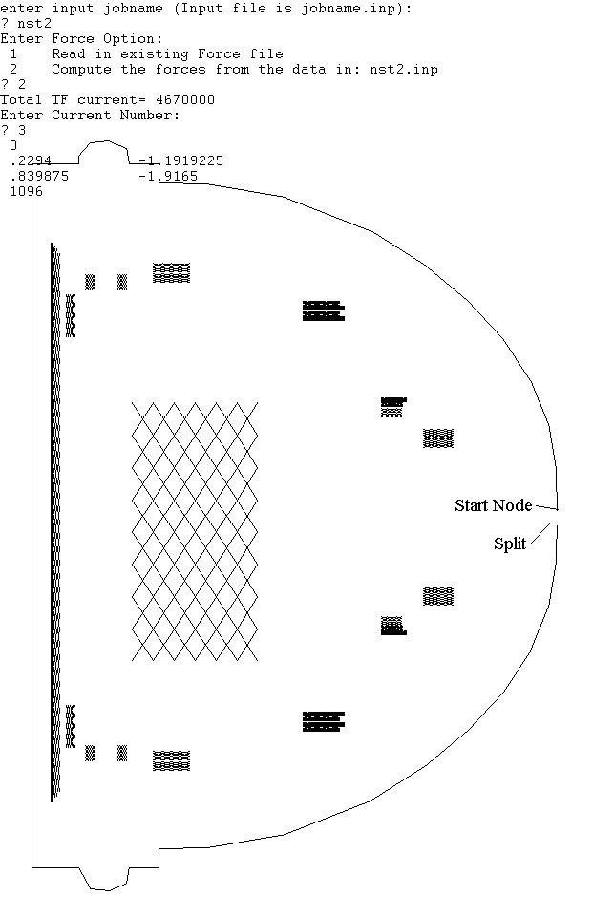
Figure 5.4-81 NSTX Shell Model
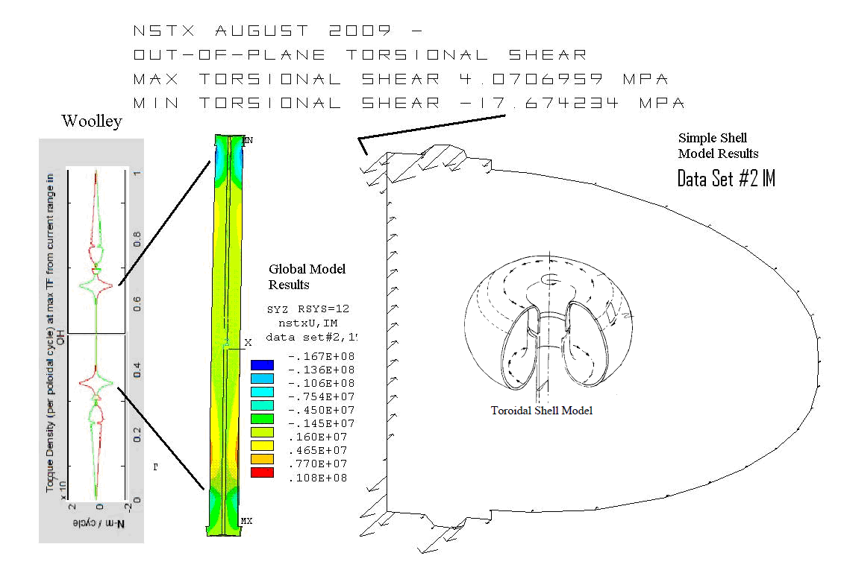
Figure 5.4-82 Comparison of Woolley, Global FEA and Simple Shell Analyses

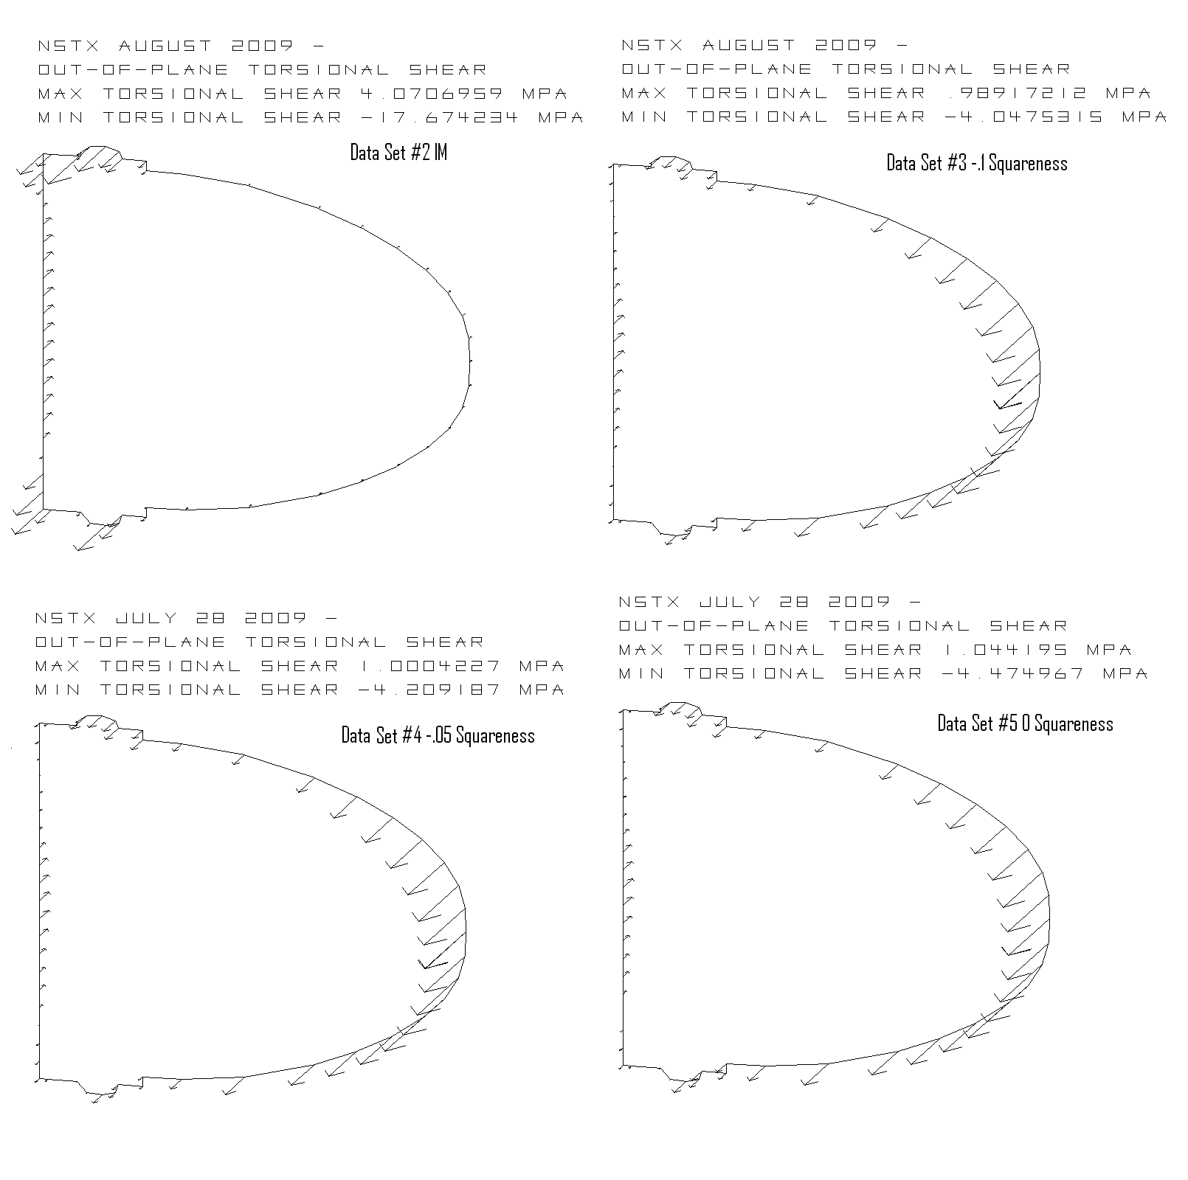
Figure 5.4-83 Torsional Shear for IM and some Equilibria
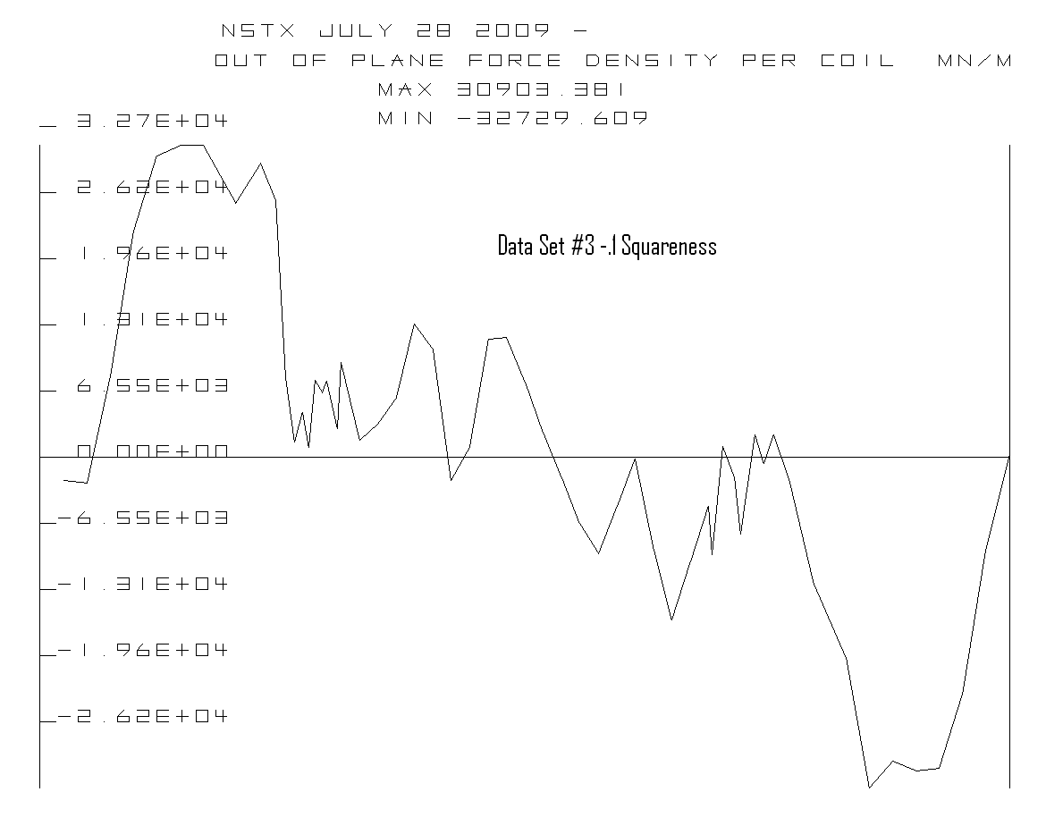
Figure 5.4-84 OOP Force Density Along the TF CL Starting from the Outboard Equitorial Plane
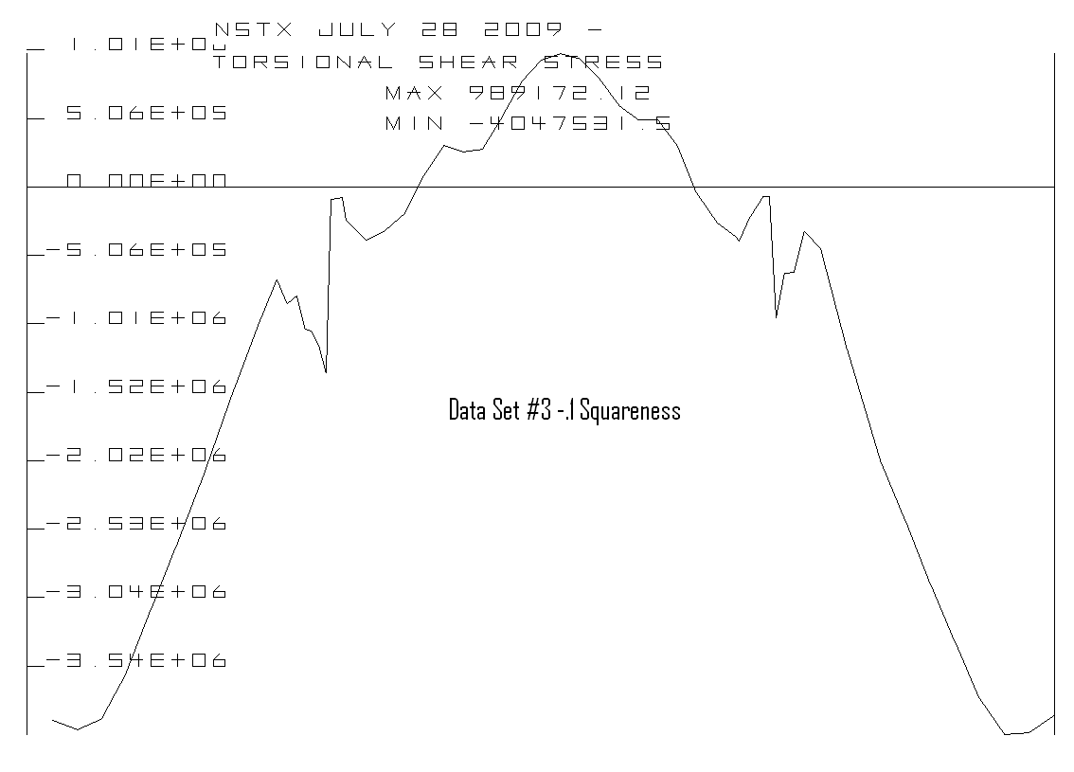

Figure 5.4-85 OOP Torsional Shear Stress Along the TF CL Starting from the Outboard Equitorial Plane
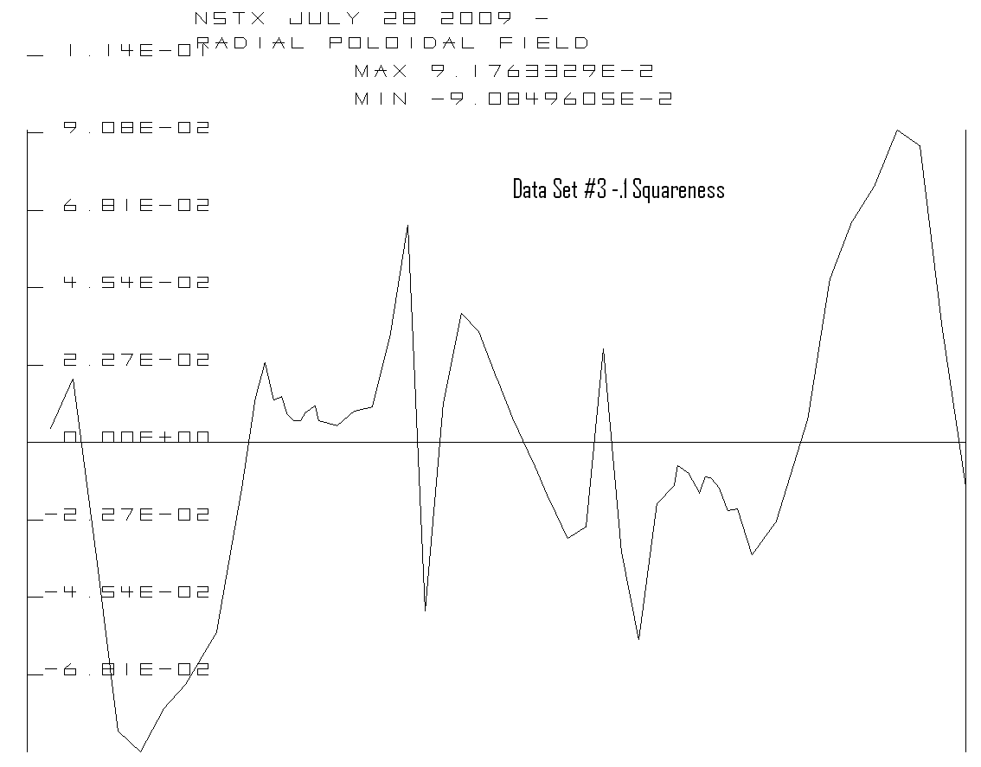
Figure 5.4-86 shows WHAT???
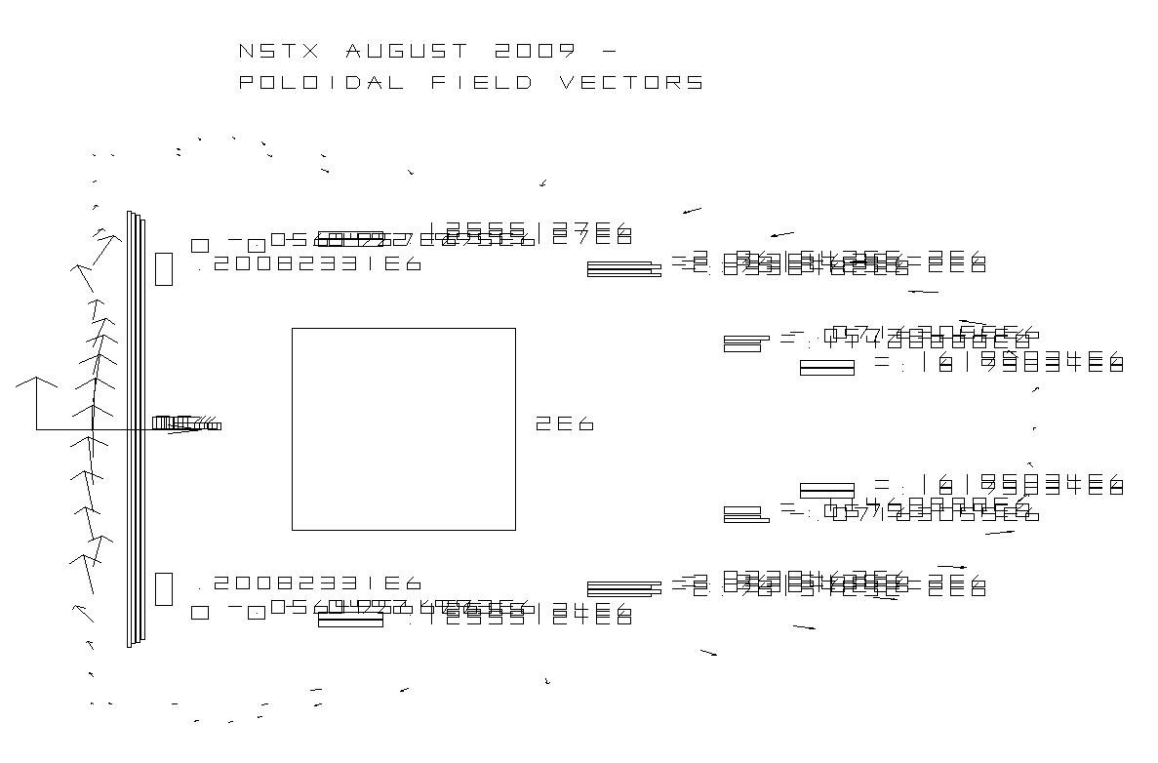
Figure 5.4-87 shows WHAT???
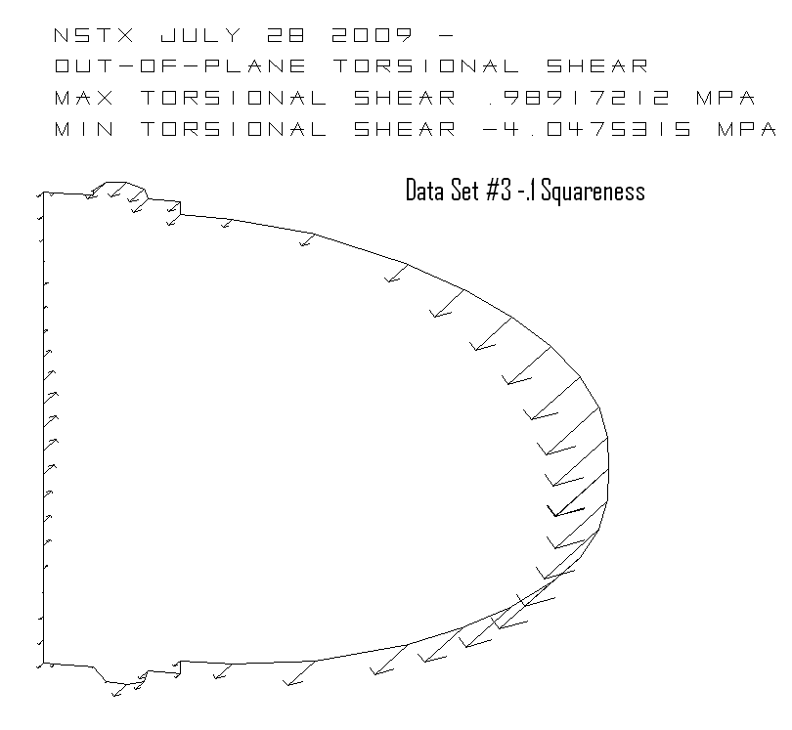
Figure 5.4-88–Shows What???

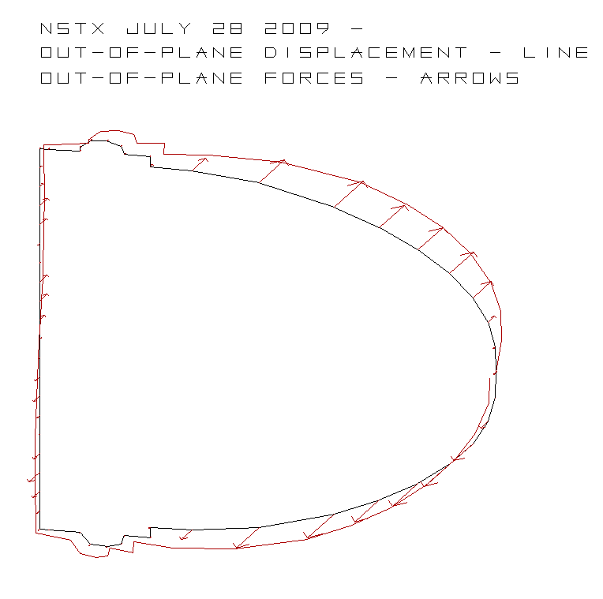
Figure 5.4-89 - shows What???

Effect of De-Wedged Area in the TF Corner
Electromagnetic current diffusion causes a concentration in current density in the corner of the TF. A thermal differential results that results in a tensile thermal stress (Figure 5.4-90). This occurs at the ID of the TF column, where the torsional shear is a minimum. In order to provide some additional assurance that de-lamination will not propagate into regions of the TF that must sustain shear, overwraps of tensioned glass tape are being considered.
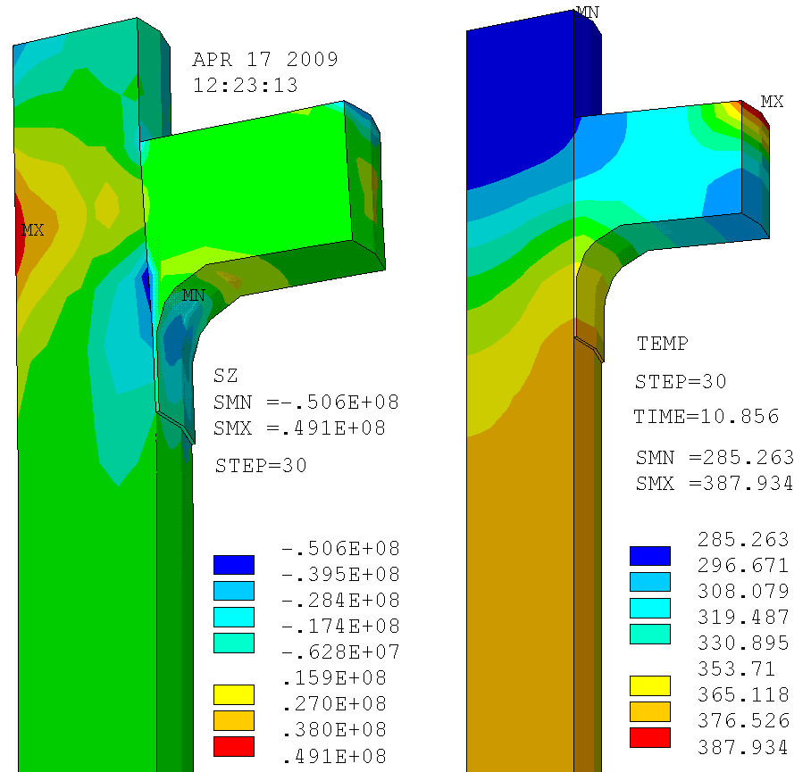
Figure 5.4-90 Effect of De-Wedged Area in the TF Corner

TF Outer Leg Reinforcement
NSTX-CALC-132-01 analyzed the TF outer leg reinforcement. The objective of this analysis was to study what kind of additional support structure can help take some of the in-plane and out-of-plane (OOP) force of TF outer leg.
The upgrade of NSTX CSU will increase the TF current to 130KA. Upon TF self field and poroidal field, TF outer leg will have in-plane (i.e. in the plane of TF outer leg) force and OOP (i.e. perpendicular to the plane of TF outer leg) force. The only support structure of TF outer leg is the umbrella structure. From previous analysis, with the worst case PF currents, the umbrella structure will have very high stress of >1GPa (145 ksi). The umbrella structure has a cylindrical shape and radial load should not be a problem. However, the blocks are bolted to the umbrella structure and must take the radial load. Vertical load will be transferred to vacuum vessel. OOP load will cause the rotation of umbrella structure and produce high stress on the arches. So it is necessary to add additional support structure to take some OOP load and so as to reduce the load to umbrella structure. Figure 5.4-91 shows the NSTX machine. Figure 5.4-92 shows what???

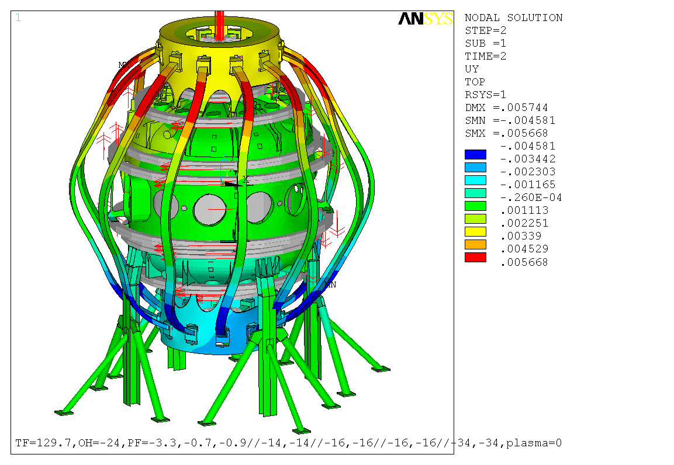
Umbrella structure
TF outer leg
Vacuum vessel
PF coils
Aluminum block
Out-of-plane (OOP) direction

Figure 5.4-91 NSTX Machine
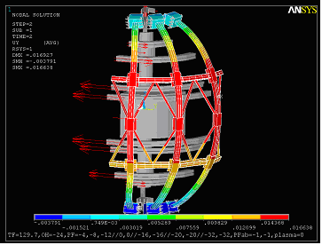

Figure 5.4-92 shows what???
The first idea is to add a stainless steel ring to take in-plane expansion and tie bar connected to vacuum vessel to transfer the load to vacuum vessel. But the tie bar will constrain the TF coil due to vacuum vessel bake out.

The second idea is to use stainless steel ring and diamond truss and there is no link to vacuum vessel. However, the space is quite limited and only a few of diamond truss can be added. The non-uniformly distributed diamond truss will cause the non-axisymmetric coil deformation and high stress points in the coil.
The third idea is to use ring and tangential (or radius) rods. They occupy the space of existing turn buckle and not affected by the vacuum vessel bake out. They can transfer the OOP load to vacuum vessel and effective on both symmetric and asymmetric PF currents. Table 5.4-14 shows the stress result based on criteria document. The stresses in TF outer legs are almost within allowable (See Figure 5.4-93). The highest stress is at the connection between TF coil and ring. Extending the case as shown in Figure 5.4-94 may help to reduce it, but this requires further analysis. The stress in the ring is a maximum of 30 ksi for symmetric and maximum of 32.5 ksi for asymmetric current. For symmetric current, max load in radius rod is 18.4 klbs and min load is 4.5 klbs. For asymmetric current, max load in radius rods is 20.3 klbs and min load is 4 klbs. Max load in the ring (in the middle of the ring where connects to radius rod): 86 KN or 19.3klbs for the asymmetric PF curr, and 80 KN or 18 klbs for the symmetric PF current.
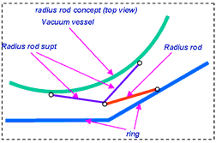
Figure 5.4-93 Stresses Tangential (Radius) Rods
Table 5.4-14 Stress Evaluation Based on the Criteria Document

 | Max Tresca (Mpa) [1] | Allowable (Mpa) [1] | Von Mises stress from analysis (Mpa)
TF outer leg at Al. block | 173 | 156 | 109 (symm) 107 (asym)
TF outer leg at ring | 173 | 156 | 147 (symm) 158 (asym)
vessel at Al. block | 183 | 183 | 313 (symm) 329 (asym)
vessel arch | 183 | 183 | 289 (symm) 273 (asym)
vessel at radius rod support structure | 160 | 160 | 139 (symm) 144 (asym)

Note: In this table, “symm” indicated the result is upon up-down symmetric PF currents and “asym” means up-down asymmetric PF currents.

A. current design. B. improved design.
ring
coil
ss case
ring
coil

Figure 5.4-94 Design of Stainless Steel Case
The vessel stress at the aluminum block is too high. It is mainly because the direct coupling of nodes of Al. block and umbrella structure so as to cause element discontinuity. This should be further analyzed by a detailed model. Stress in vessel arch area is too high and requires reinforcement in that area. Vessel stress at radius rod support area is within allowable.
In these analyses, rings were added to reduce the pull-out (in-plane) loads at the umbrella structure (Figure 5.4-95). Various trusses (including tie bars, diamond bracing, and tangential rods) were tried reduce out-of-plane loads from the outer TF legs. Since the machine is already crowded, interference was a severe problem limiting the addition of trusses. Although we don’t want to transfer more load to vacuum vessel, up-down asymmetric currents and resulting net twist required an attachment to the vessel. Tangential radius rods can take the net twist and also provided adequate OOP support for symmetric case. Tangential radius rods use the existing territory of turn buckle and there is enough room for them. Loads in the tangential radius rods allow attachment to the vessel with only modest modification and local stress of 20ksi. Vessel stresses in the umbrella structure and equatorial plane port region are acceptable or require only modest modification.
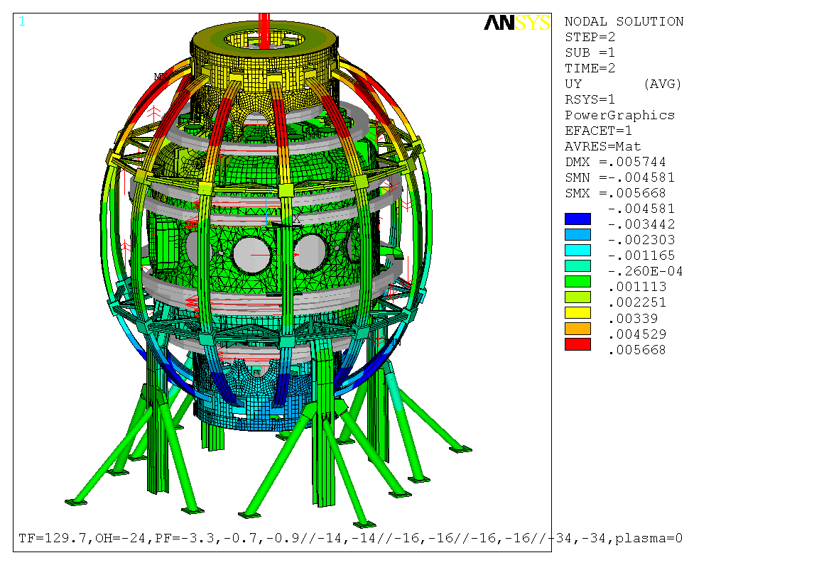
Radius rods and the support structures
NB port area reinforced
3” high ribs welded to reinforce double arch on upper and lower umbrella structures

Figure 5.4-95 NSTX Machine with Reinforcements
The vessel stress at the aluminum block is too high. It is mainly because the direct coupling of nodes of Al. block and umbrella structure so as to cause element discontinuity. This should be further analyzed by a detailed model. Stress in vessel arch area is too high and requires reinforcement in that area (Figure 5.4-96). Vessel stress at radius rod support area is within allowable (Figure 5.4-97). The Tangential Radius Rod concept supports OOP loads, uses territory that is already used by the TF Support Truss, and allows radial growth during bake-out.
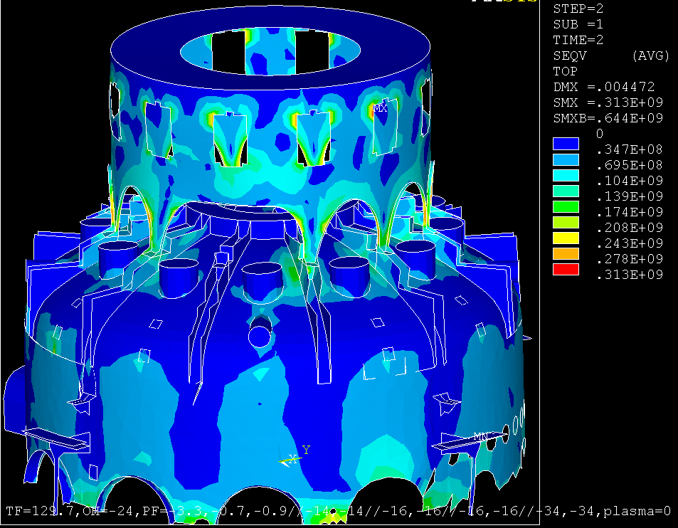
Arch Regions Needing Reinforcement
Positions of radius rod support (stress ~139MPa (20ksi)
Figure 5.4-96 Vessel Stresses with Tangential Radius Rods

Positions of radius rod support (stress ~139MPa (20ksi)
Arch Regions Needing Reinforcement
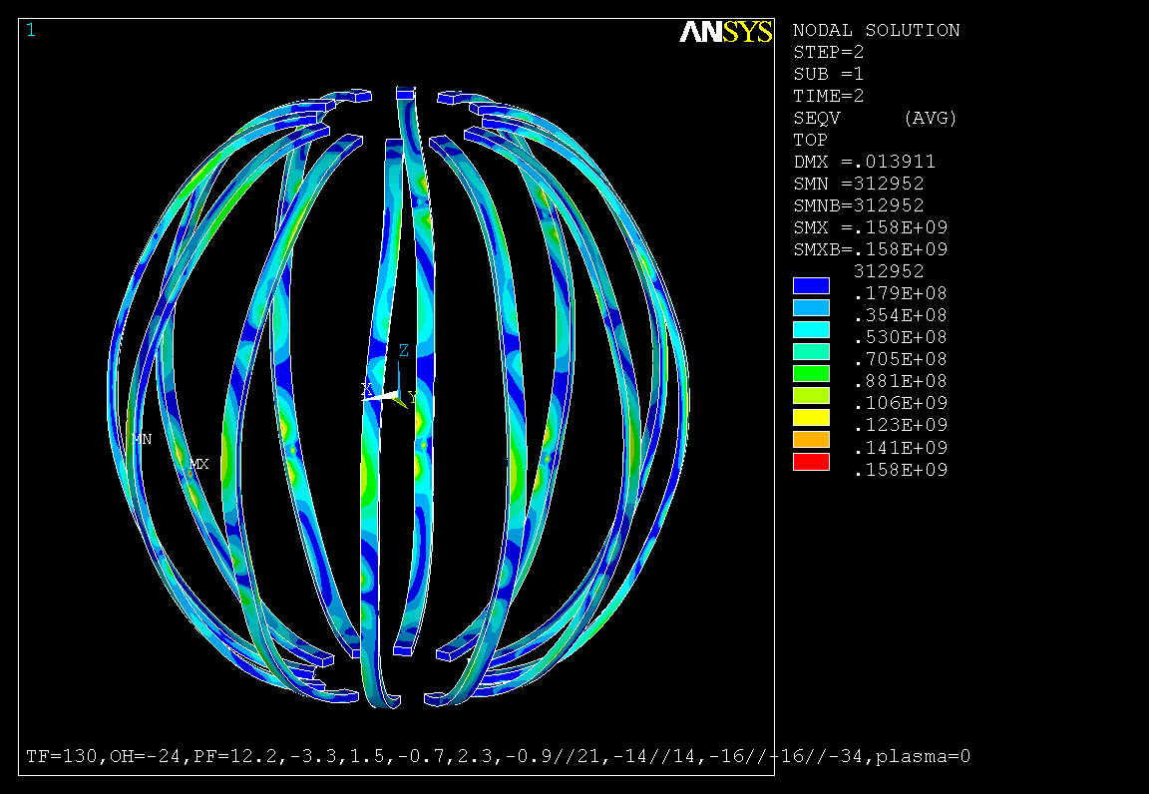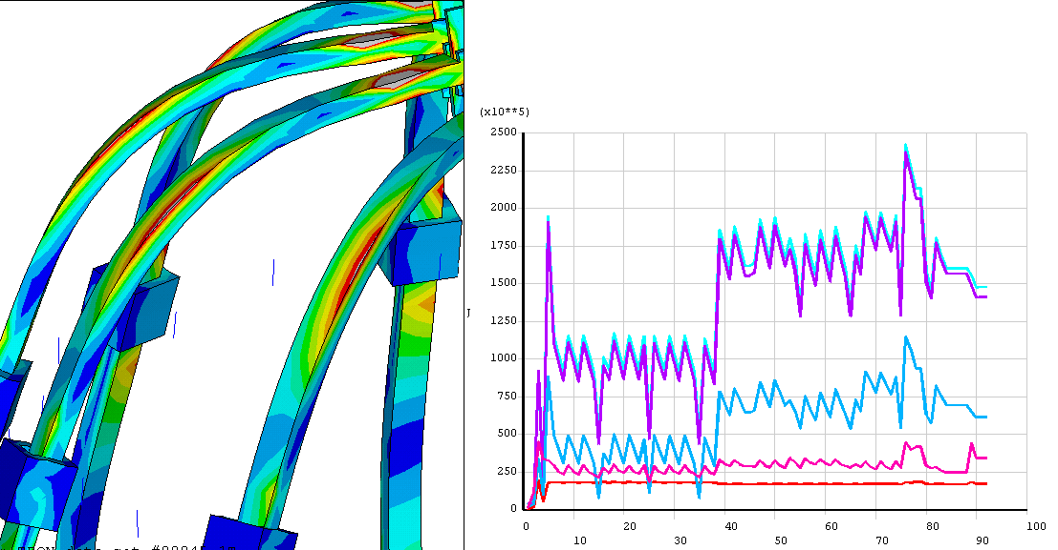
Coil Bending Stress Asymmetric PF currents, H.Zhang

Analysis of C. Neumeyer’s “Worst Asymmetric Currents”
TF Copper
1.5*Sm = 233MPa
Bending Stress =~ 100 MPa

Global Model Upper Outer TF Leg SI
The Global model contains an error that over-estimates the TF leg bending stress by the ratio of section modulus or 237 MPa*(4.5/6)^3 = 100 MPa which is closer to the stress reported by Han
140 MPa
Charlies “Worst”

Figure 5.4-97 Outer Leg Stress with Tangential Radius Rods

TF Outer Leg Bond Shear
The existing outer legs will be qualified for the higher loads – as mitigated with the addition of the support rings and tangential radius rods. Bending stresses have been qualified in section 5.4.6.4. Bending related shear stresses must be sustained with a turn to turn bond in the existing coils. The outer leg is made up from 3 turns of copper, each of which is 2 inches thick. The global model TF outer leg contains a dimensional error (See Figure 5.4-98) that over estimates the bending stress and the shear stress - the Toroidal Width of the TF Outer Leg Should Be 6 inches. Stresses would scale as the section modulus or by d^3. The mid-plane shear was plotted in the figure, and this actually is in the middle of one of the 3 conductors so the global model overestimates the shear in a couple of ways. However even with these errors, the shear stress for a range of normal scenarios is 6.25 MPa with a shear alowable that may be as high as 21.7 MPa (See Figure 5.4-99). Further evaluation will be required to address the worst case loads that have been used to qualify the bending stress.
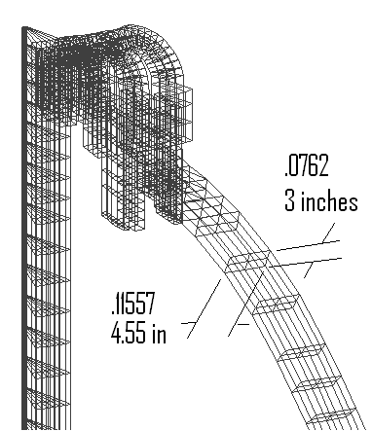
Figure 5.4-98 Global Model Dimensional Error
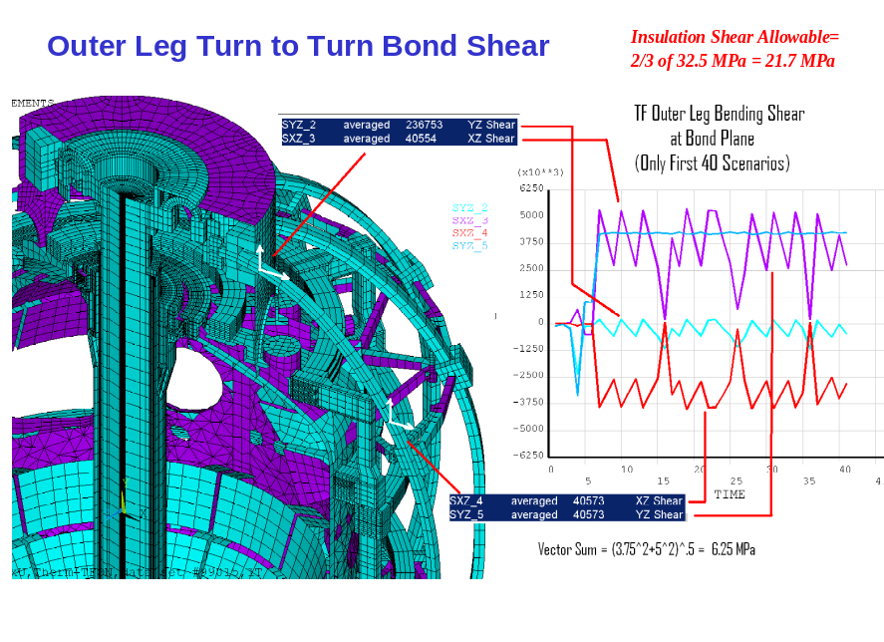
Figure 5.4-99 Global Model Bending Related Shear

OH Analyses in the Centerstack Assembly
The objective of this analysis was to estimate the anticipated stresses in the upgraded NSTX OH coil in various discharge scenarios. Axisymmetric coupled structural /Emag modeling of the OH coil and interaction with PF coils were performed using ANSYS. The OH coil was modeled both as a volume with smeared property and as discrete conductors and insulation volumes. Additionally the maximum stress in the OH coil due to thermal expansion in the TF coils was calculated. This stress results from the fault scenario where the OH coil, which is wound on the TF bundle, fails to energize while TF bundle is energized and expands out thermally. Figure 5.4-100 shows the influence of PF1A on the OH coil. Figure 5.4-101 shows the “smeared” results with only the OH current.
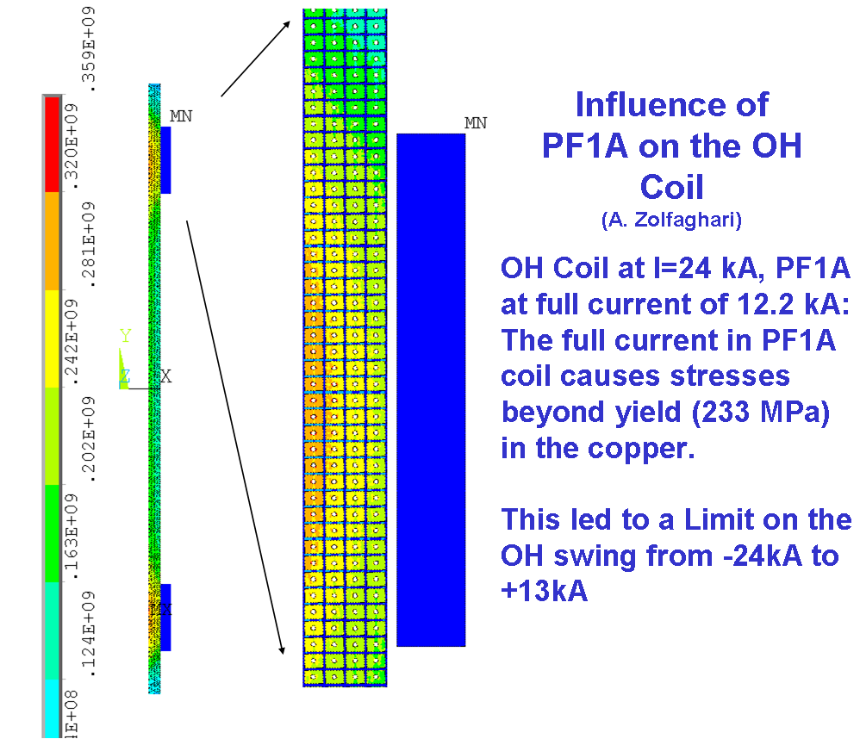
Figure 5.4-100 Influence of PF1A on the OH Coil
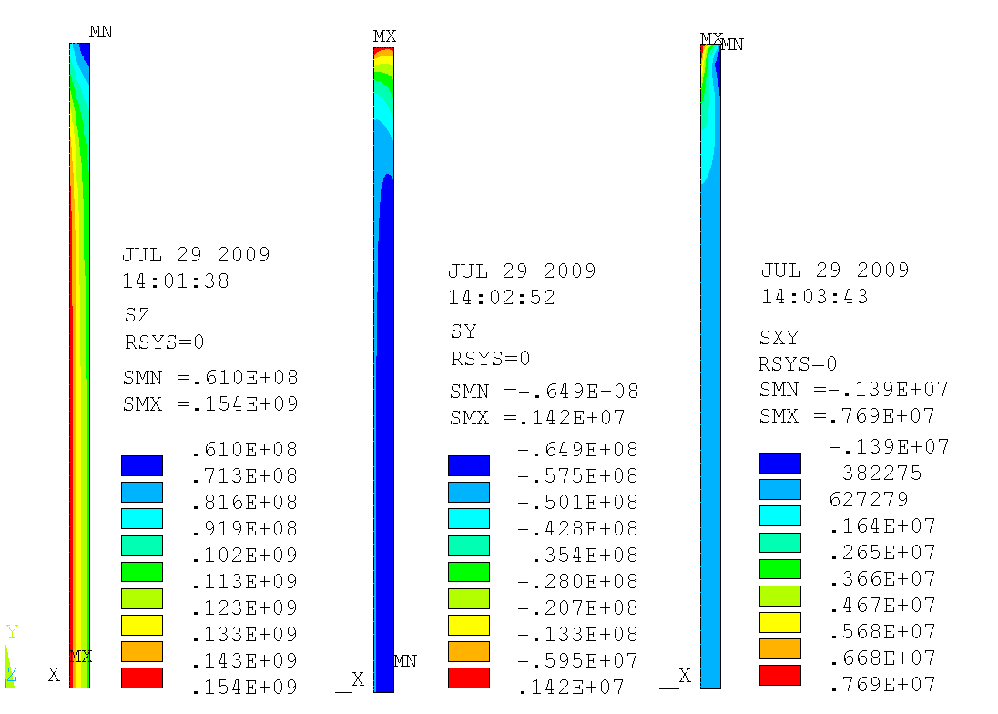
CS Hoop Stress CS Axial Stress CS Shear Stress
Figure 5.4-101 “Smeared” - Results with only the OH Current
Results of analysis (Figure 5.4-102) shows that the OH coil can withstand its self hoop stress, shear stress and normal to plane stresses at I=24kA. The analysis also revealed that running the PF1A coil at full 12.2 kA concurrently with the OH coil will cause stresses in the OH conductors beyond yield (233 MPA) in a large fraction of the OH coil cross section inside of PF1A coil. Limiting the OH current swing from +24kA to -13kA will keep this stress below yield. The stress in the OH coil due to hot-OH cold-TF scenario was found to be acceptable but the frictional shear along the length of the TF-OH interface produces unacceptable vertical tension in the OH coil. Mechanical solutions such as low friction interface and removable interface layer as well as electrical solutions in the coil current control system are being considered for this problem. Figure 5.4-103 represents the CS structure Emag modeling. Figure 5.4-104 shows the net load on the CS,
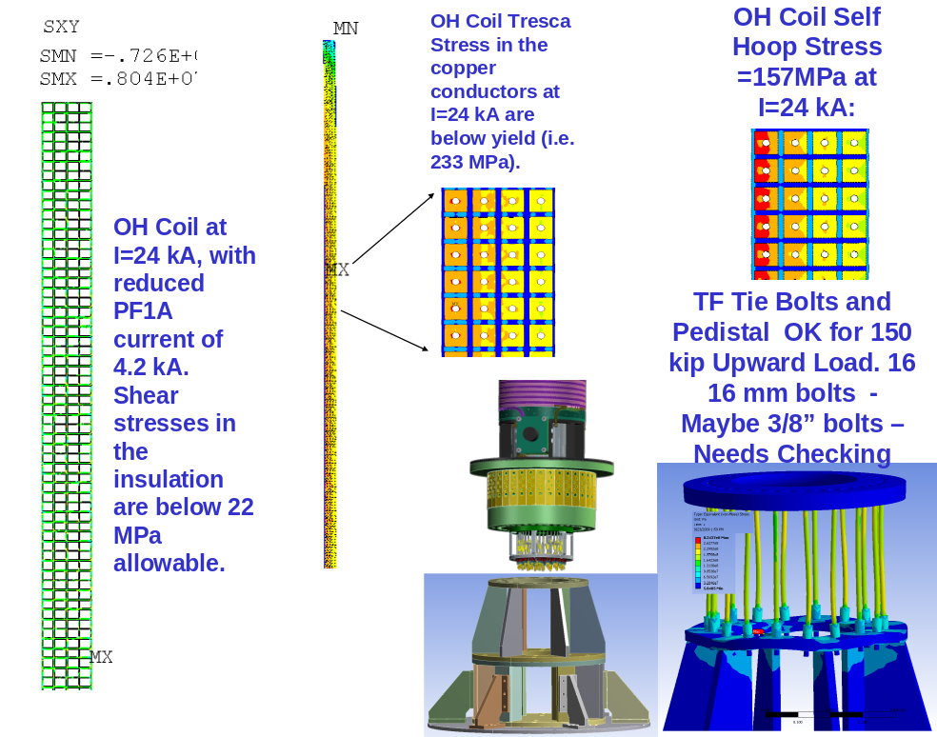
Figure 5.4-102 Analysis of the OH Coil

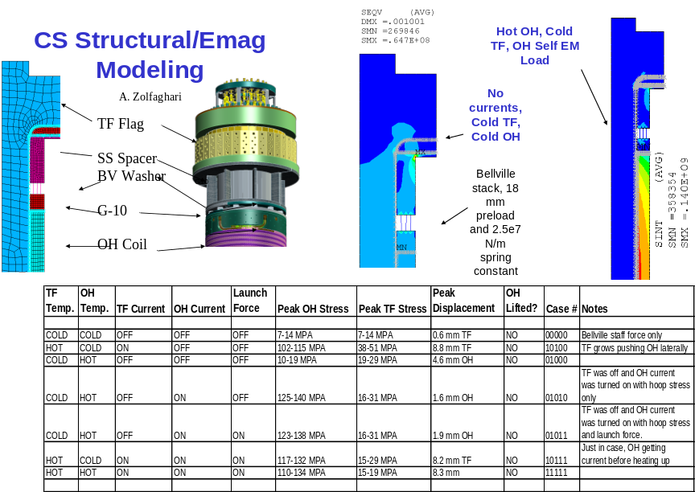

Figure 5.4-103 CS Structure/Emag Modeling

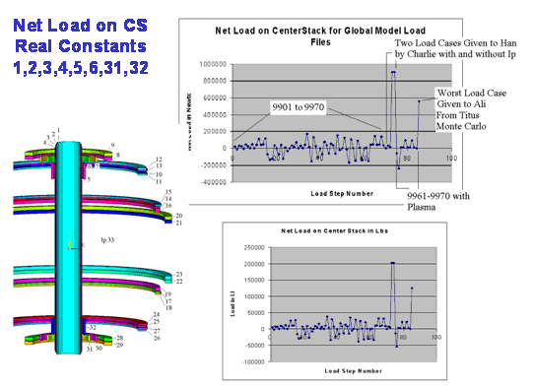

Figure 5.4-104 – Net Load on CS

Initial sizing was based on the peak Tresca in the conductor. This is interpreted as having a bending stress like distribution with a nearly linear variation across the build of the coil. Figure 5.4-105 shows what??? Figure 5.4-106 shows the relative torsional displacements that must be allowed by the OH Belleville precompression devices. The peak Tresca bus pass the bending stress allowable. The average Tresca must also pass the membrane allowable. In Figure 5.4-107, the Tresca stress across the build of the OH coil is plotted and the average of 168 MPa is above the membrane allowable of 155 MPa. (discussed in section 1.4) During preliminary design a bit more capacity will be found – either with an adjustment in build, or copper hardness.

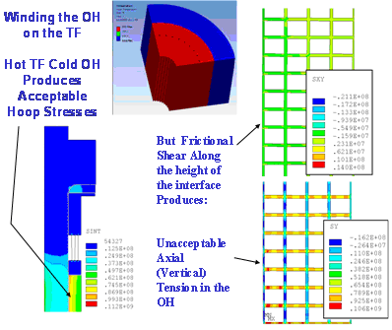

Figure 5.4-105 Shows What???

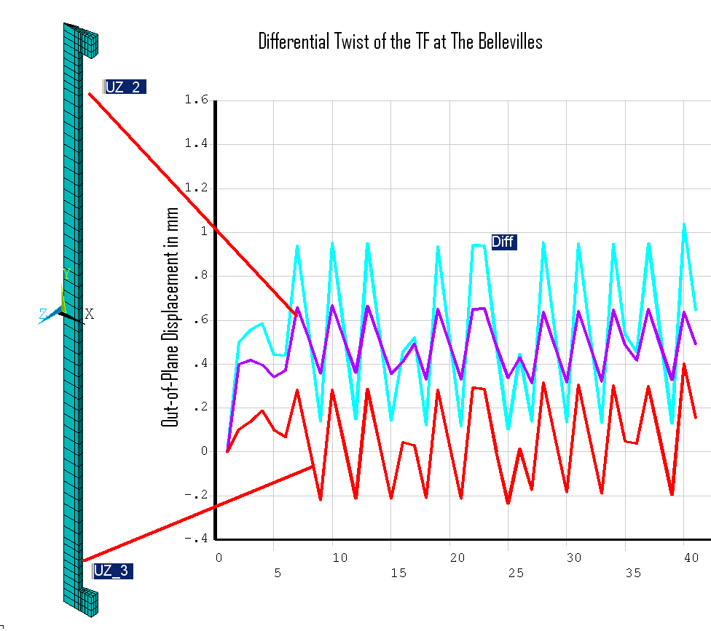
Figure 5.4-106 Relative Torsional Displacements

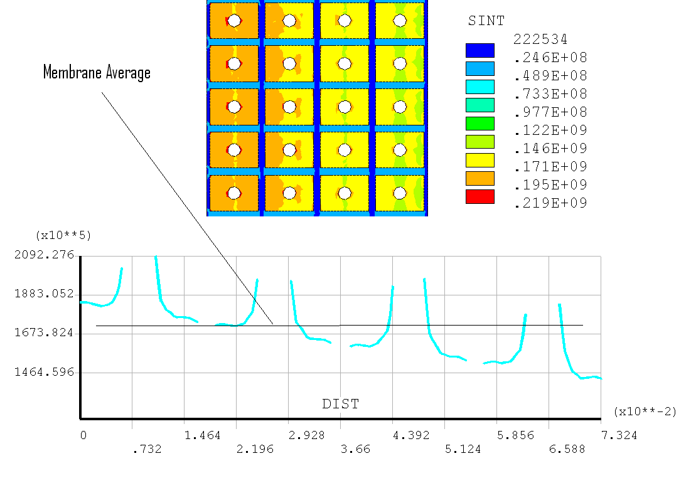
Figure 5.4-107 – Estimate of Membrane Stress or Average Tresca Across the Radial Build

OH Conductor Fatigue Evaluation
The OH coil has been sized based on static allowables. Two areas are checked, The peak ID Tresca stress, which must be below 1.5*Sm, and the average stress in the cross section which must be below Sm. NSTX structural criteria, and the GRD require fatigue to be addressed. A couple of possible conductor cross sections are evaluated. Currently the design point is based on a 24 kA conductor with a .175 inch hole. The conductors as currently designed fail the SN based fatigue qualification, but pass a fracture mechanics qualification based on a flaw size less than .5mm^2.

The NSTX criteria document requires either a SN fatigue qualification or a fracture mechanics qualification. The SN qualification requires use of the Tresca to enter the SN curve with factors of safety based on the worst of 2 x Stress or 20 on Life. The Tresca stress for the nominal conductor is shown in figure 1. The peak is 209 MPa. Doubling this to enter the SN curve would indicate no life (Figure 2). The design stress in the OH is well beyond what can be qualified. The alternative is to use fracture mechanics and to implement appropriate NDE on the conductor manufacture to ensure flaw sizes are acceptable for the required life. Figure 5.4-108 show the Tresca stresses in the OH conductor. Figure 5.4-109 shows the typical SN data for Copper.

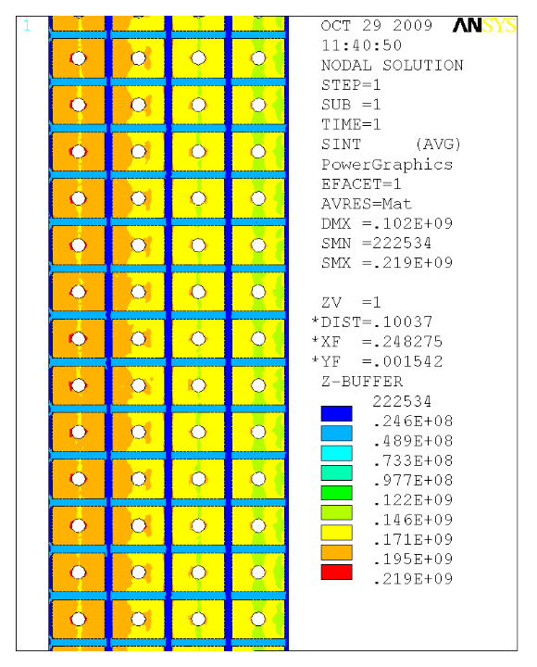

Figure 5.4-108 - Tresca Stress in the OH Conductor
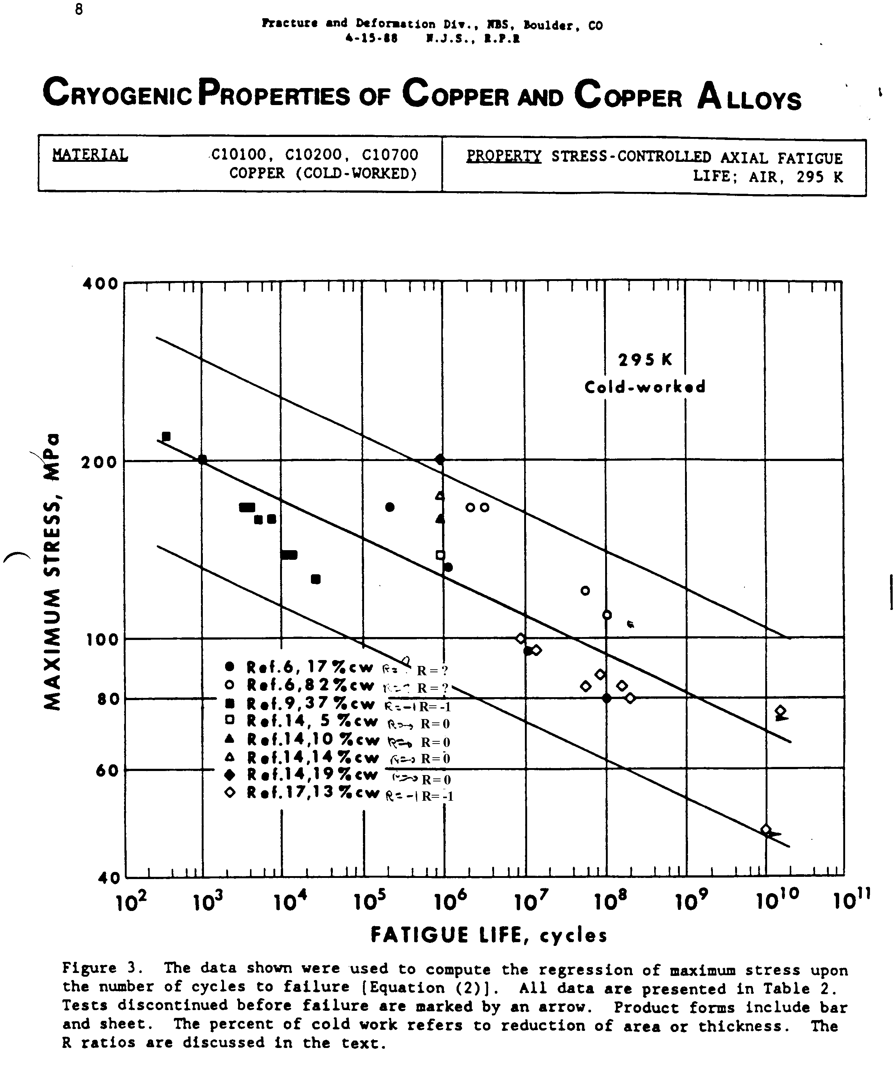
Figure 5.4-109 - Typical SN data for Copper
The basis for the fracture mechanics analysis is summarized in Error: Reference source not found. This procedure was implemented by Jun Feng to analyze a alternate candidate conductor and the procedure was also used to address the nominal conductor cross section. The following parameters reflect the fracture mechanics information:
- Material
Hardened copper;
Paris parameter: C=1.52e-12 m/cycles, m=4.347 ;
Fracture toughness : 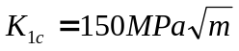;
Walker’s coef: 0.8.

- Sample geometry
Width: 30mm (assumed)
Thickness: 7.7mm

- Load history
0 to 149 MPa along axial direction. (Error: Reference source not found)
Stress gradient at the hole edge is neglected.

- Crack configuration
Surface crack at the edge of the hole;
Initial crack dimension: 0.25mm², 0.5mm²;
Initial aspect ratio: 1.

- Safety factor
Crack size: 2;
Fracture toughness: 1.5.
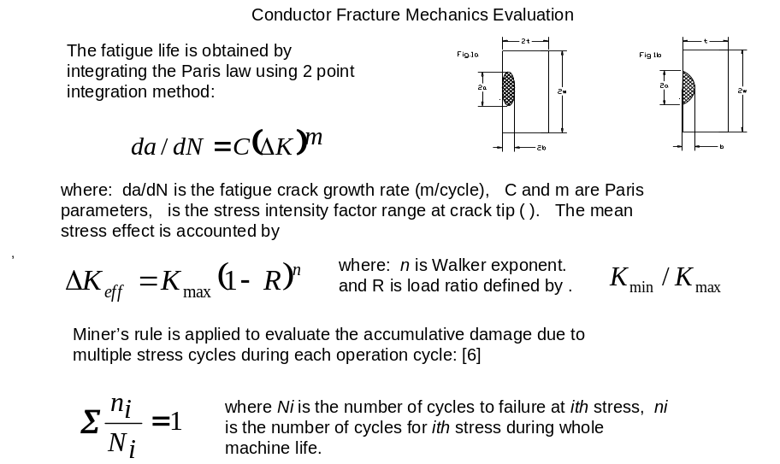
Figure 5.4-110 – Fracture Mechanics Evaluation

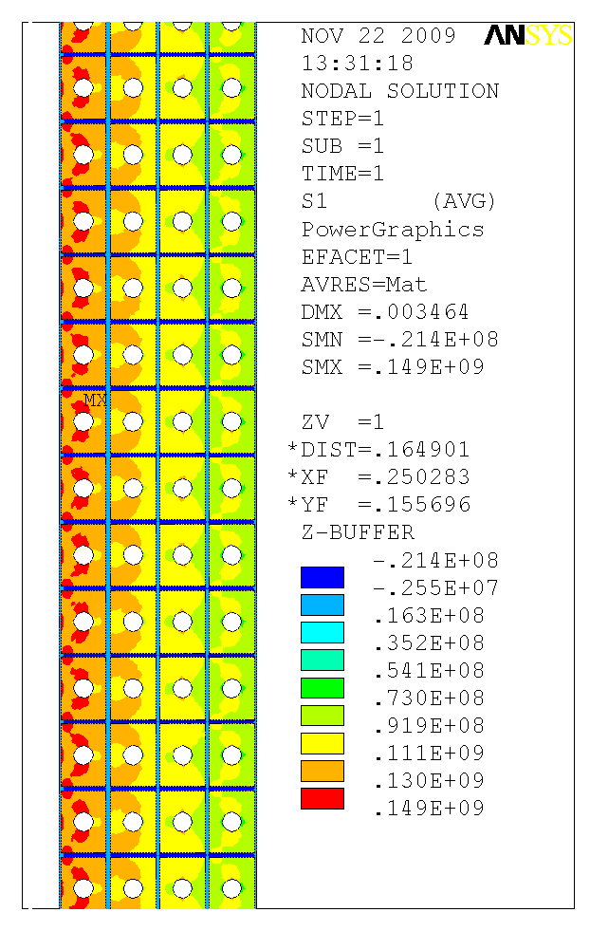
Figure 5.4-111 - Fracture Mechanics Evaluation
The results of the fracture crack growth life are shown in Table 5.4-15.
Table 5.4-15 Fracture Crack Growth Life
Safety factor | Initial crack size (mm²)
Safety factor | 0.25 | 0.5
Safety Fact Not Applied | 701,000 | 446,000
Safety Factor Applied | 446,000 | 277,000

Titus Calcs (Jun’s Program) show:
- 0.5mm^2 crack area;
- 0.707mm crack x 2= .00144 m crack with Safety Factor;
- 145 MPa (Figure 5.4-111) 201244 cycles
- 175 MPa (Figure 5.4-112) 103416 cycles

This Passes 30,000 cycle (Criteria Doc) Or 60,000 cycles GRD requirement but NDE of conductor will be needed.

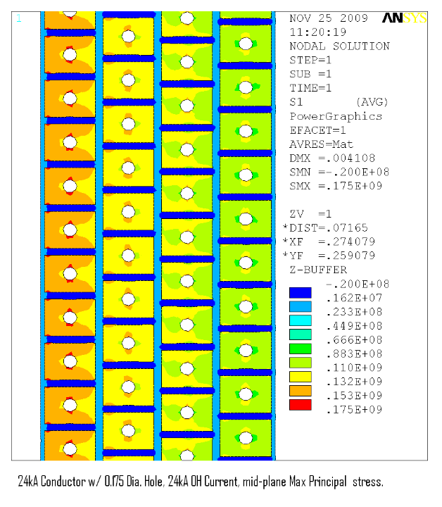
Figure 5.4-112 - Nominal Conductor Max Principal Stress

OH Coolant Hole Optimization
The objective of this analysis was to estimate the anticipated temperature rise in the OH coil in the upgraded NSTX OH coil during a discharge with 24 kA current and a Tesw of 0.85 seconds. The objective also included estimating the cooling time between OH discharges as a function of pressure drop in the cooling pump. Based on these analyses the coolant channel size was to be optimized in order to keep the maximum temperature of the coil to 100° C. The pump pressure required to keep the cooling time less than 20 minutes were to be estimated.
The in-house Fcool code and the Ansys-CFX CFD code were employed to perform the analyses. The results of the analyses showed that a coolant channel diameter of 0.175 in. is optimum in achieving the required Tesw in the coil without exceeding 100° C. The results also show that a 600 PSI pump pressure can provide cooling times less than the 20 minutes required. .
Coolant flow through the OH progresses in a wave that imposes a relatively sharp gradient in temperatures axially along the OH. The thermal differentials may introduce unacceptable stresses in the coil. These will be evaluated during preliminary design. Figure 5.4-113 shows the results from the CS coolant hole optimization using CFX and FCOOL
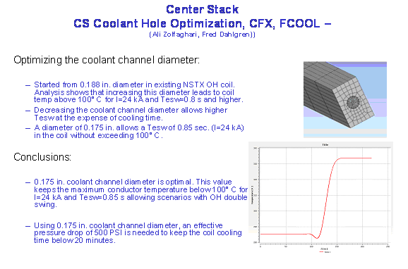
Figure 5.4-113 Center Stack Coolant Hole Optimization Results Using CFX & FCOOL

Inner PF Support Design and Analysis
A structural assessment of the NSTX CSU Inner PF coils (PF1a/1b/1c - Figure 5.4-114 has been performed based on finite element simulations of the coils and their support structure. A parametric 2D ANSYS EM field model is developed and used to calculate Lorentz forces for each of the 96 equilibria (Menard version F). This also serves as a benchmark for the PPPL force calculation. Nine of these 96 cases produce the largest loads on the subject PF1 coils; faulted conditions are not addressed. The “Worst Case” loads in the design point and in the Monte Carlo Simulation are much larger than is deemed feasible to support with the spaces allotted to the inner PF supports and coolant hardware (Figure 5.4-115).
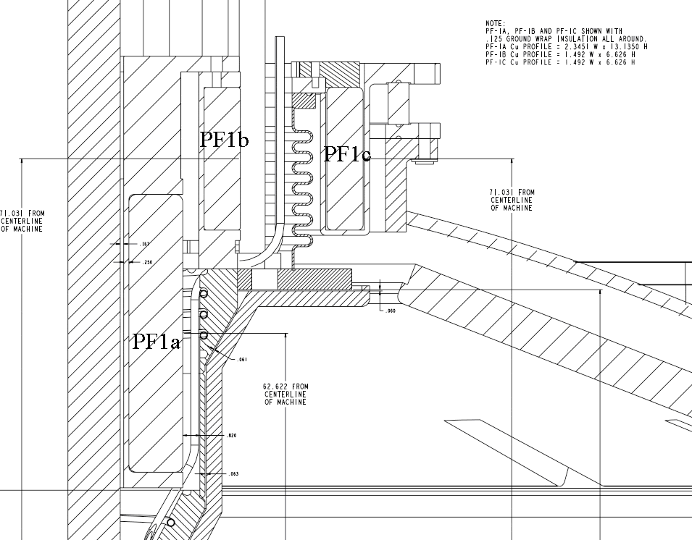
Figure 5.4-114 Layout of Inner PF Coils
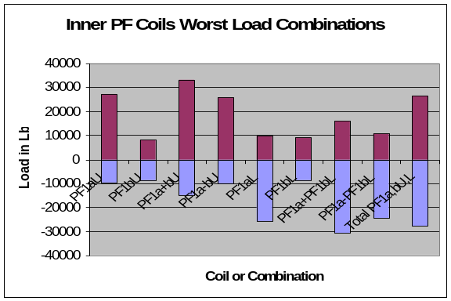
Figure 5.4-115 Inner PF Coils Worst Load Combinations
The 2D stress analyses indicates that an 80 kip launching force on PF1c requires a more robust hold-down design to stiffen the open coil case. A full cover is recommended over the four hold-down clips design. The 100 kip centering force on PF1a produces some bobbin flange deformations which would benefit from a slight increase in their thickness and/or stiffening gussets. Cu and insulation stresses are generally OK, but would gain some margin with any increases to the structure discussed above.

A 3D stress analysis is used to evaluate the non-axisymmetric structural elements of the support design. The model shows that the PF1a gussets which link the coil bobbin to the PF1b bobbin flange should be thickened and radiused. The net vertical loads which pass down through the three legs to ground produces some large bending stresses which must be addressed with a design/analysis cycle. The PF1c case needs a full cover with ID & OD bolt circles. Figure 5.4-116 displays the inner PF supports. Figure 5.4-117 shows the inner PF analysis results.

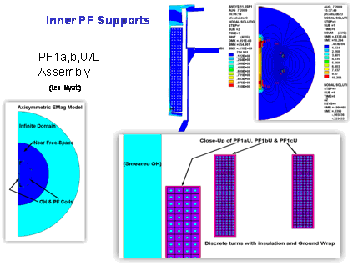
Figure 5.4-116 Inner PF Supports
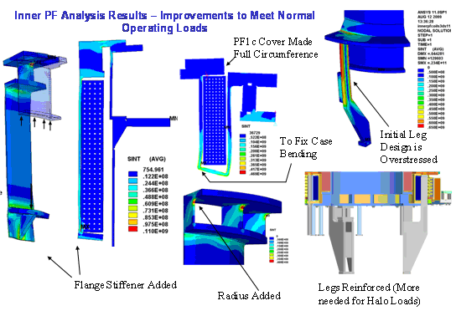
Figure 5.4-117 Inner PF Analysis Results

Differential thermal strains can lead to high bending stresses in the shell structure. However, a more detailed and consistent thermal-stress analysis is required.

PF 2 Support Design and Analysis
As of the CDR, support of PF2 has not been performed in detail The vessel dome has been analyzed with the maximum PF1c and PF2. The stresses are acceptable for these loads but this analysis does not include the full complement of loading. The global model will be used to assess these (Figure 5.4-118).
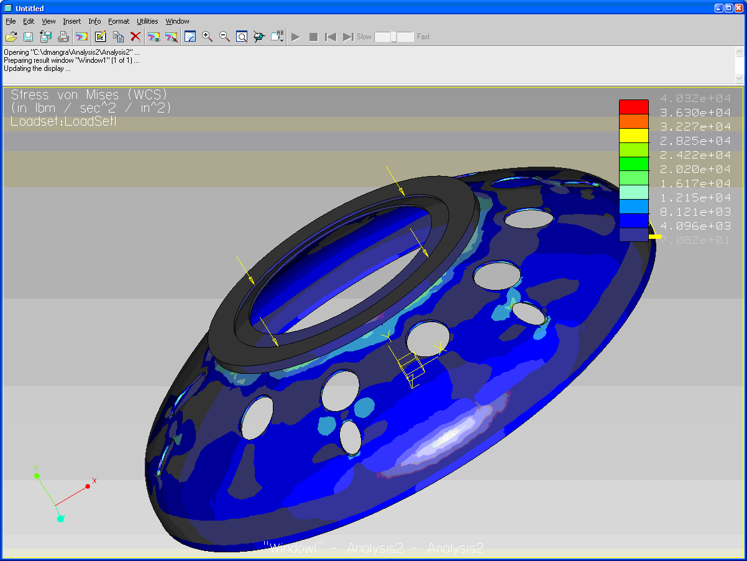
Figure 5.4-118 PF2 Support Model

PF Coil Hoop Stresses
PF coil hoop stresses(exclusive of the OH coil) are small for all the postulated coil currents, including the worst case power supply currents. The OH coil is the most severely loaded and continues to push the allowable stress. The OH coil is ????
Figure 5.4-119 shows the “smeared” hoop stresses. Figure 5.4-120 shows what????. Figure 5.4-121 shows the maximum and minimum hoop stresses based on Ron Hatcher’s influence coefficients..
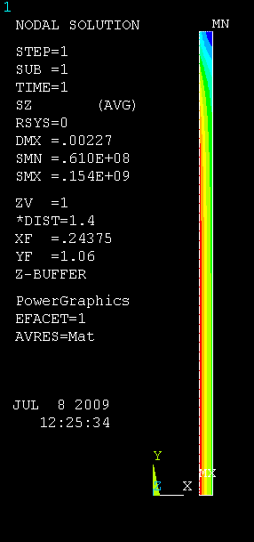
Figure 5.4-119 - OH “Smeared” Hoop Stress
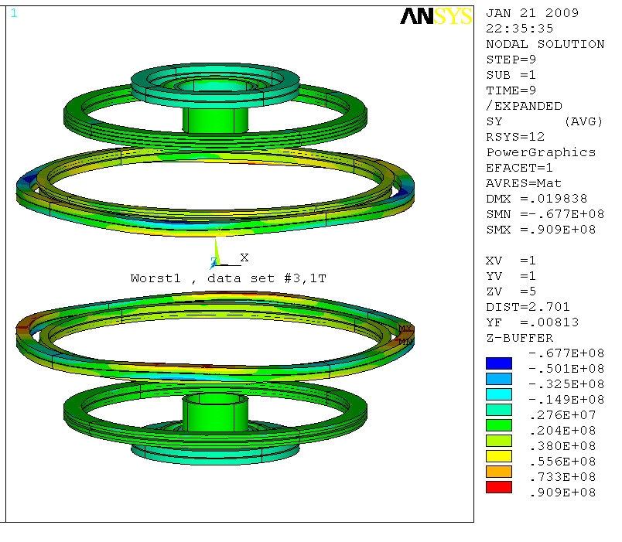
Figure 5.4-120 Shows What???
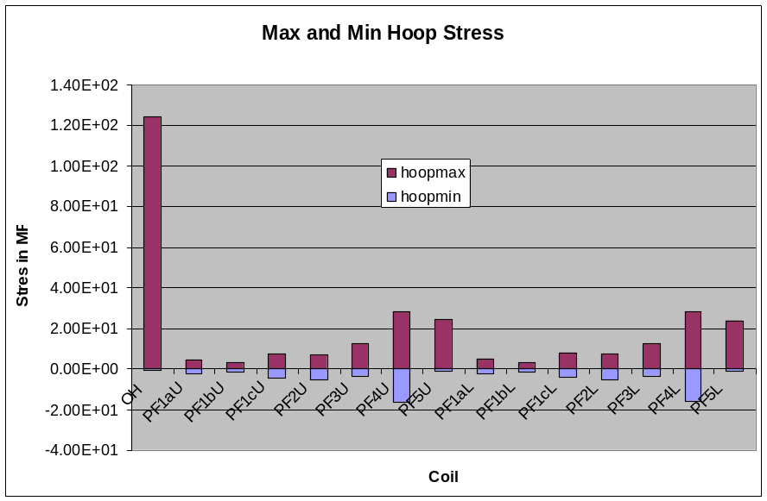
Figure 5.4-121 – Maximum and Minimum Hoop Stress

Outer PF Supports Cage
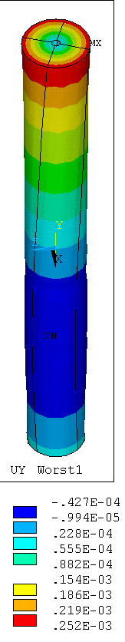

An attempt to design the outer PF supports to the extremes of maximum rack-ups of loads resulting from the power supply limits. The max and min vertical loads in the structural elements of the proposed outer PF support cage are presented in Figure 5.4-122. These loads were developed assuming support at the bottom with some sort of column or strut either to the ground or to the vessel support columns/legs. These loads are from the Monte Carlo analysis (Figure 5.4-123) based on worst case PF power supply capabilities. If this concept is not too excessive it would be worth considering as it de-couples the PF supports from the thermal and mechanical displacements of the vessel. Table 5.4-16 shows the vertical load cases for the outer PF supports.

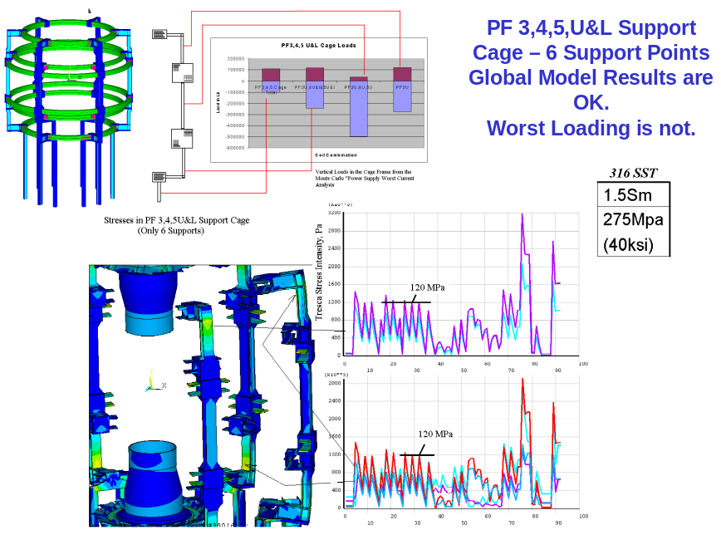

Figure 5.4-122 - Max And Min Vertical Loads in the Structural Elements of the Proposed Outer PF Support Cage

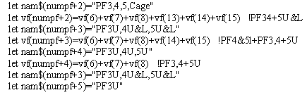

Figure 5.4-123 Monte Carlo Analysis Based on Worst Case PF Power Supply Capabilities

Table 5.4-16 – Vertical Load Cases for the Outer PF Supports

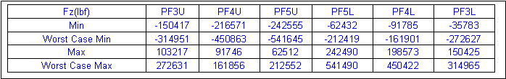

The expense of the outer PF frame – particularly the effort associated with removing material to install the cage structure has led to the investigation of returning to support off the vsssel. The re-categorization of the worst case current loads as “Extremely Unlikely” as described in the structural criteria document, has allowed consideration of less extensive modifications to the outer PF supports. In the next concept, stronger columns are being added to connect the upper PF4/5 grouping and PF4/5 lower groupings. The location for these six columns is chosen to be between the existing (small/weak) columns. These locations are judged less congested than the existing attachment points. Figure 5.4-124 shows the PF 4/5 support column upgrade mounted on the vacuum vessel. Figure 5.4-125 reflects documentation of the vacuum vessel out-of-roundness that needs to be taken into account for the outer PF supports.

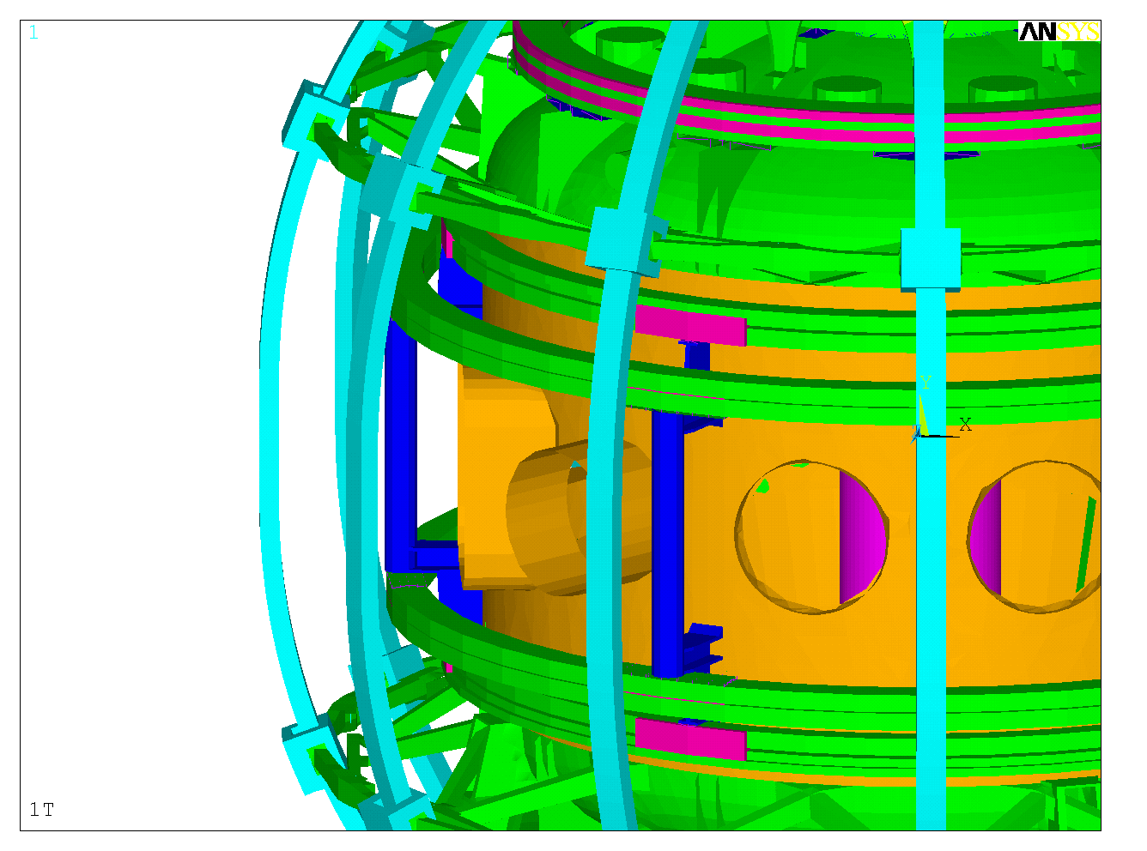

Figure 5.4-124 PF 4/5 Support Column Upgrade Mounted on the Vacuum Vessel

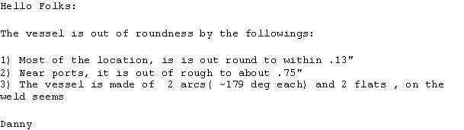

Figure 5.4-125 Vacuum Vessel Out-of-Roundness
- Plasma Heating & Current Drive System (WBS 2)

High Harmonic Fast Wave (HHFW) – WBS 2.1
The NSTX HHFW Antenna has been operating since 1999. For the 2009 run, it was upgraded from a single feed, bottom grounded strap configuration to a double feed, center grounded current strap.
A finite element electromagnetic model of the antenna was generated using the ANSYS code. The model included four of the 12 antennas, and fully represented the important in-vessel components including the straps, backplates, current straps, and Faraday shields. This analysis, performed to satisfy a CHIT from the final design review, indicated that the stresses in the critical areas near the center post of the strap, and the connection of the strap ends to the feedthroughs , were acceptable. Figure 6.1-126 summarizes the disruption analysis of the HHFW antenna.
As part of the NSTX upgrade design, the model was run with ambient fields and plasma current representative of the upgraded NSTX. Critical Hardware details are being evaluated for the higher loads.
Reference Drawings are:
- E-8C3B01, Rev. 2, RF Antenna General Arrangement 12 Antenna Array
- E-8C3B02, Rev. 2, RF Antenna 1 through 12 Assembly
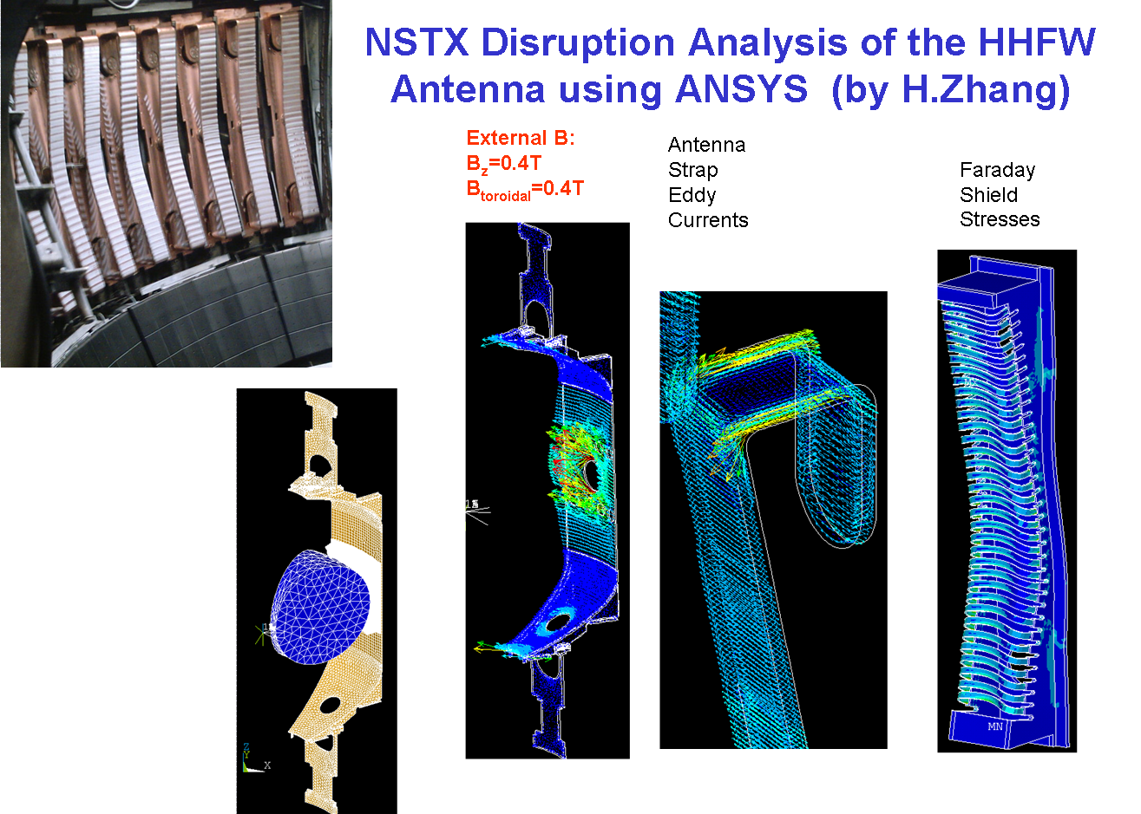
Figure 6.1-126 – HHFW Disruption Analysis

Electron Cyclotron Heating (ECH) – WBS 2.3
To date, no structural analysis has been performed on the ECH waveguide. This has been carried as a task to recognize that there are many areas in NSTX that may require upgrade to survive the higher background fields.
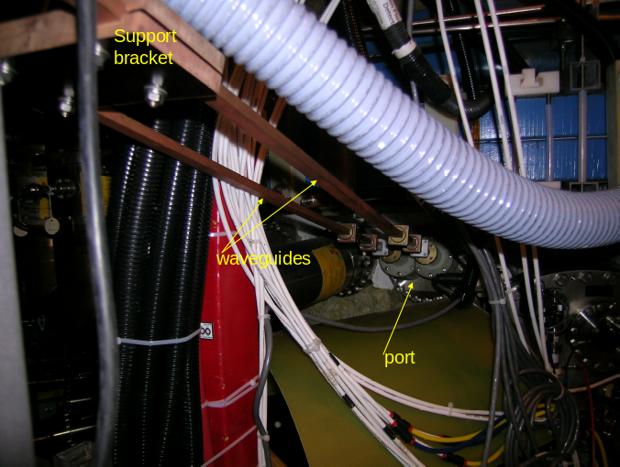
Figure 6.2-127 – ECH Support Details

Neutral Beam Injection (NBI) – WBS 2.4

Based on an e-mail from Danny Mangra, dated November 24, 2009, the following information is available on the effect of the vacuum load on the Neutral Beam Port Bellows.

With the addition of the second neutral beam, the net load due to the uncompensated pressure from the neutral beam bellows might produce enough of a net side load to stress the support columns and braces, or produce unacceptable displacements (Figure 6.3-128) These have been analyzed in a model of the vessel and legs. The Pressure load from two (one existing and one new addition) NB port bellows produces a net load of about 25000 lbs laterally on the tokamak vessel (see table 1). The diagonal braces on the I beam columns help keep the displacements below 2 mm and the column stress is less that 100 MPa. Figure 6.3-129 shows the displacements with and without the neutral beam port covers.

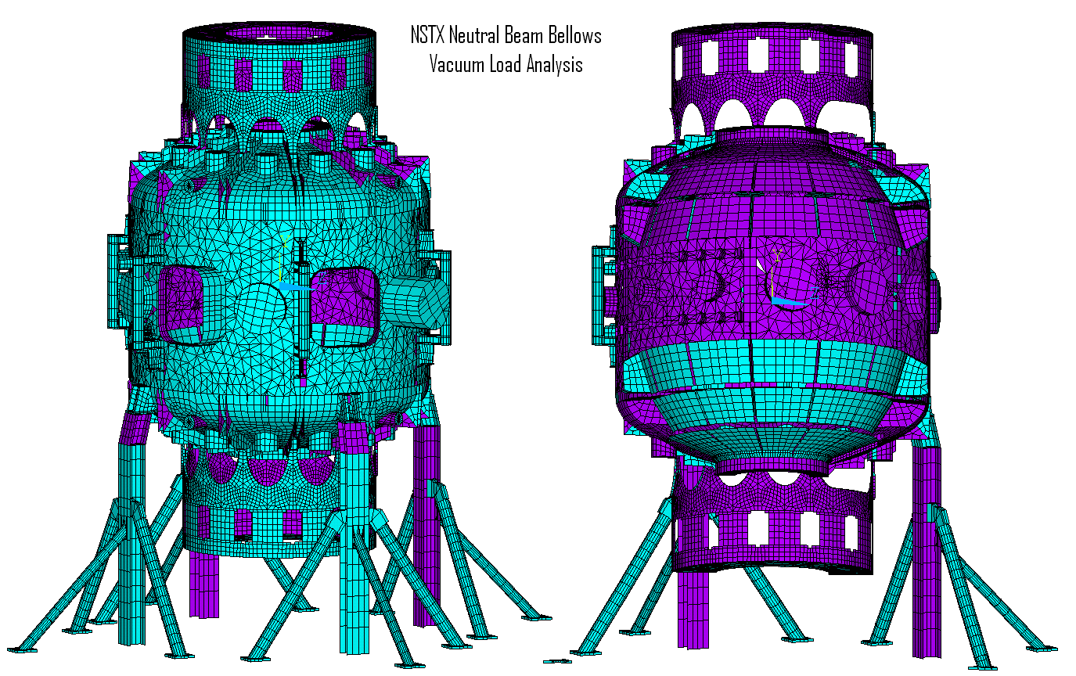
Figure 6.3-128 - The Model Without the Neutral Beam Port Covers is Shown. Blue and Purple Denote the Plate Element Faces

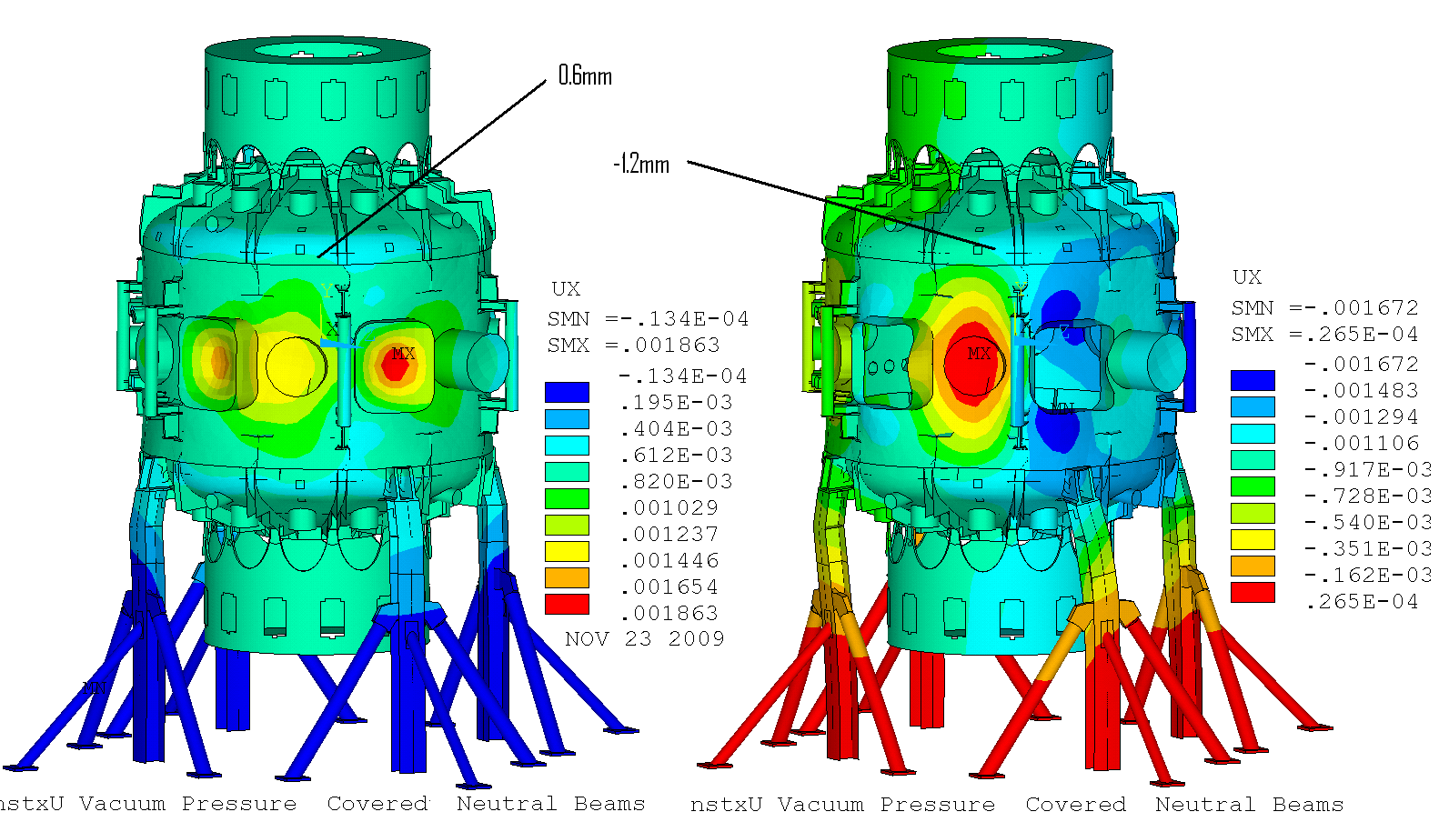

Figure 6.3-129 - Displacements With and Without Neutral Beam Port Covers

Vacuum loads produce small stresses in the vessel shell. The major radius of the vessel is 1.71m and the thickness is 5/8 inch. For 1 atm or 0.1MPa, the shell stress is .1*1.71/(5/8/39.37) = 10.8 MPa. – a very small contributor to the global stress. The larger components are those that the vessel must support resulting from Lorentz loads.. The vacuum vessel model portion of the global model was “cleaned-up” with almost all surface normals properly aligned. .All of the big ports and most of the small ports were covered to achieve pressure balance on the model. There are still some residual load imbalances and consequently the model was run with and without the NB ports covered to see the difference in behavior. The displacement range was about 2mm with and without the neutral beam port covers. Figure 1 show the model. The umbrella structure and passive plates were included, but they had no pressure loading. Figure 3 shows the stresses in the vessel and supports, only due to vacuum loads. Note there is a bit mor bending stress in the support column (Figure 6.3-130 and Figure 6.3-131)

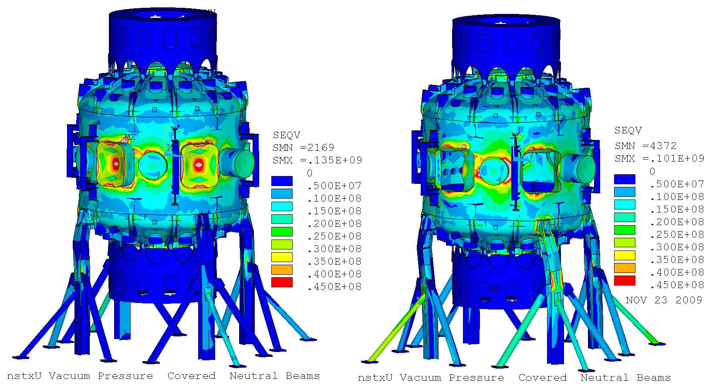

Figure 6.3-130 - Von Mises Stresses With and Without the Neutral Beam Port Covers

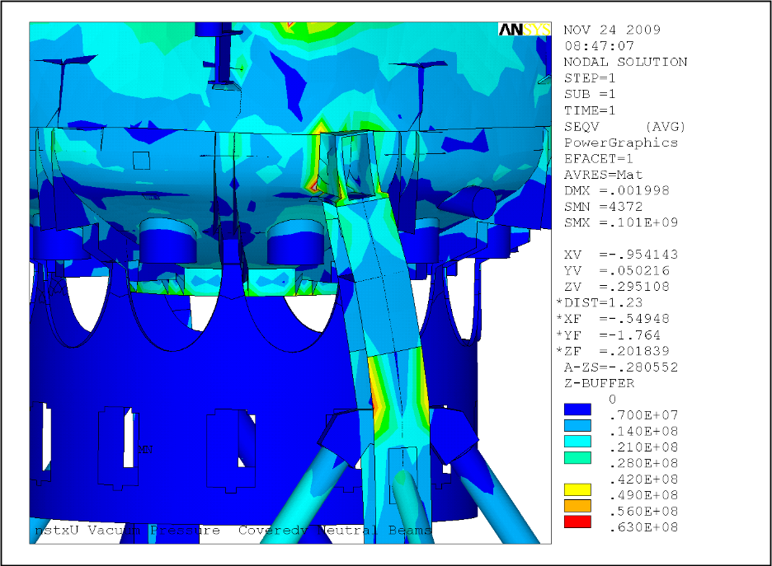

Figure 6.3-131 – Support Column Bending

The model was run without the bracing for comparison and the displacements were larger, about 4mm vs the 2mm with the braces. Figure 6.3-132 shows the displacements with and without the NB port covers. Figure 6.3-133 shows the vessel stresses with and without the NB port covers. Table 6.3-17 shows the details of the force summations from the ANSYS model and load model.
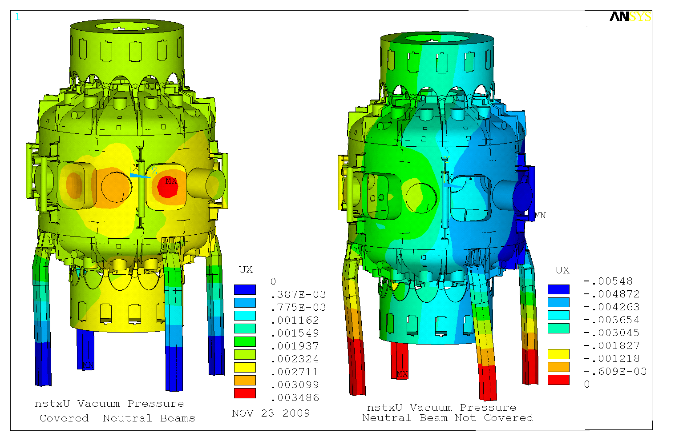
Figure 6.3-132 - Displacements Without Braces, With and Without NB Port Covers
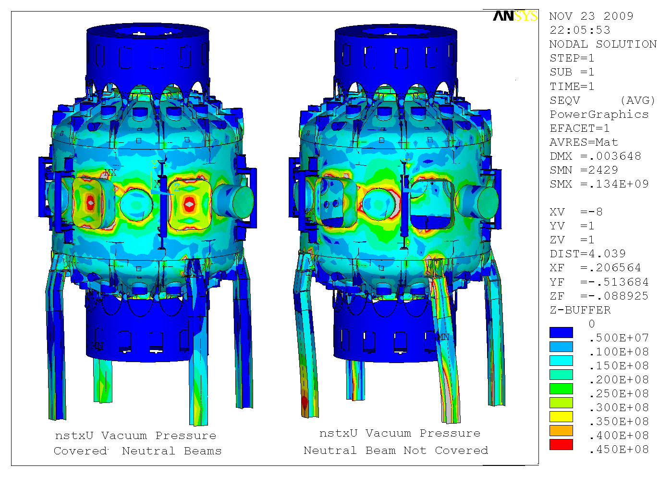
Figure 6.3-133 - Vessel Stresses Without Braces With and Without NB Port Covers
Table 6.3-17 - Force Summations from the ANSYS Model and Load File
 | FX | FY(vert) | FZ |  | SRSS
No Neutral Beam Port Covers | 68786 | 17011 | 44665 |  | 82015.1 | N
With Neutral Beam Covers | -43836 | 17011 | 17624 |  | 47246.17 | N
 | 112622 |  | -62289 |  | 128699.8 | N
Net Load from NB Press Load in FEA Model(2 ports) |  |  |  | Press Load (Lbs)(2 ports) | 28931.71
NB1 Port Area | 0.6653 | m^2 |  | Press Load (Lbs) | 15158.83 | lb
 | 0.6653 | m^2 |  | Press Load (Lbs) | 15158.83 | lb
 |  |  |  | Press Load (Lbs)(2 ports) | 30317.66 | lb
Vector Sum NB Press Loads from Model | 112622 | 0 | 0 |  | 112622 | N
 |  |  |  |  | 25317.43 | LB

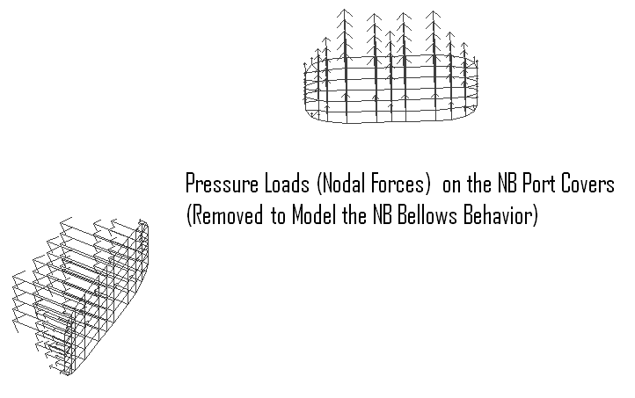
Table 6.3-18 – Loads on the Port Covers (Removed to Model the NB Bellows

