NSTX

TF Flex Joint and TF Bundle Stub

NSTX-xxxx-xx-xxx-xx

September 04, 2009

Prepared By:

___________________________________
Thomas Willard, PPPL Mechanical Engineering
Reviewed By:
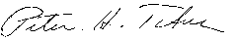
________________________________________
Peter Titus, Branch Head, Engineering Analysis Division
Reviewed By:

_______________________________________
Phil Heitzenroeder, Head, Mechanical Engineering

Executive Summary

The objectives of this analysis were: 1.) to verify that the local contact pressure at the TF Flex Joint and TF Bundle Stub bolted electrical joints is a minimum of 1500 psi, sufficient to maintain the contact conductance above the design goal, based on the previous-design development tests, of 1.0E06 siemens/in²; and 2.) to determine if the design is adequate to meet the criteria specified in the NSTX Structural Design Criteria, specifically, if the stresses in the strap laminations and the threaded joints meet the requirements for fatigue, yield, and buckling, under worst-case/ power supply-limit load conditions: 130,000 amps/ strap; .3 T poloidal field; and 1 T toroidal field.

The results of the ANSYS multiphysics finite element analysis - electric, transient thermal, electromagnetic, and static structural - show that: 1.) the minimum average contact pressure is >5500 psi, and the minimum local contact pressure is >2000 psi, 500 psi above the design goal; 2.) the maximum stress in the laminations is 22.9 ksi, 25.1 ksi below the fatigue allowable for the full-hard C15100 copper-zirconium strip; 3.) the maximum stress in the threads is 22.5 ksi, 29.5 ksi below the fatigue allowable for the full-hard C15000 copper-zirconium plate; and 4.) the linear buckling load multiplier factor LMF is > 58, approximately 10x the minimum allowable specified in the NSTX Design Criteria document.

Table of Contents

List of Figures
1.0 NSTX Upper Umbrella Assembly Upgrade Design Solid Model
1.1 Single Strap Assembly Solid Model and Boundary Conditions
2.0 ANSYS Multiphysics Analysis: Description and Results
3.0 Conclusions

List of Figures

Figure 1 - NSTX Upper Umbrella Assembly Upgrade Design
Figure 2 - Single Segment 3-Strap Assembly
Figure 3 - Single Strap Assembly Solid Model and Boundary Conditions
Figure 4 - ANSYS Multiphysics Analysis Block Diagram
Figure 5 - Finite Element Mesh
Figure 6 – Electric Analysis Results: Current Density
Figure 7 – Electric Analysis Results: Joule Heating
Figure 8 – Magnetostatic Analysis Results: Lorentz Forces
Figure 9 – Transient Thermal Analysis Results: Temperature
Figure 10 – Static Structural Analysis Results: von Mises Stress: Overall
Figure 11 – Static Structural Analysis Results: von Mises Stress: Laminations
Figure 12 – Static Structural Analysis Results: von Mises Stress: Threads
Figure 13– Static Structural Analysis Results: TF Bundle Stub Bolted Joint
Contact Pressure
Figure 14 – Linear Buckling Analysis Results: Load Multiplication Factor (LMF)
Figure 15 – Flex Strap Lamination Fatigue Life
Figure 16 – Bolted Joint Copper Thread Fatigue Life

1.0 NSTX Upper Umbrella Assembly Upgrade Design Solid Model

The solid model of the Upper Umbrella Assembly Upgrade Design is shown in Figure 1. The design is cyclic symmetric, with twelve 3-strap segments evenly spaced around the circumference. The solid model for a Single Segment 3-Strap Assembly is shown in Figure 2.

Figure 1 - NSTX Upper Umbrella Assembly Upgrade Design
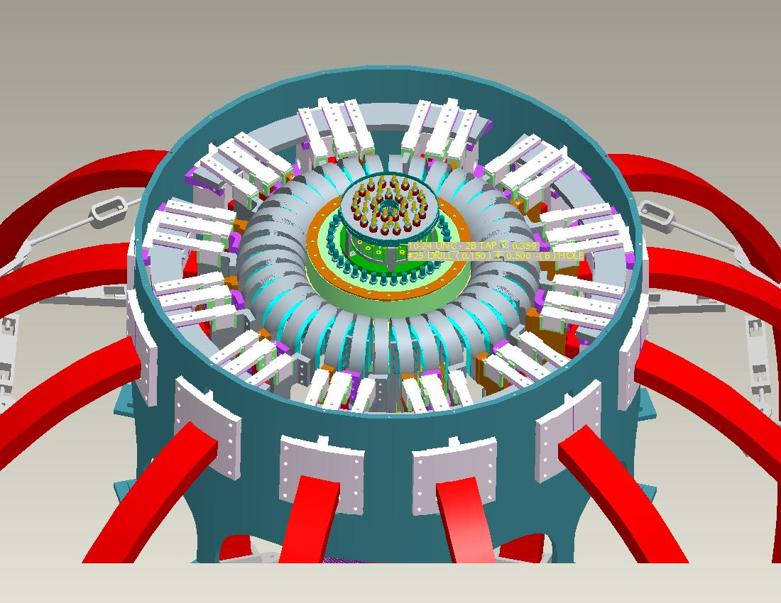

Figure 2 - Single Segment 3-Strap Assembly
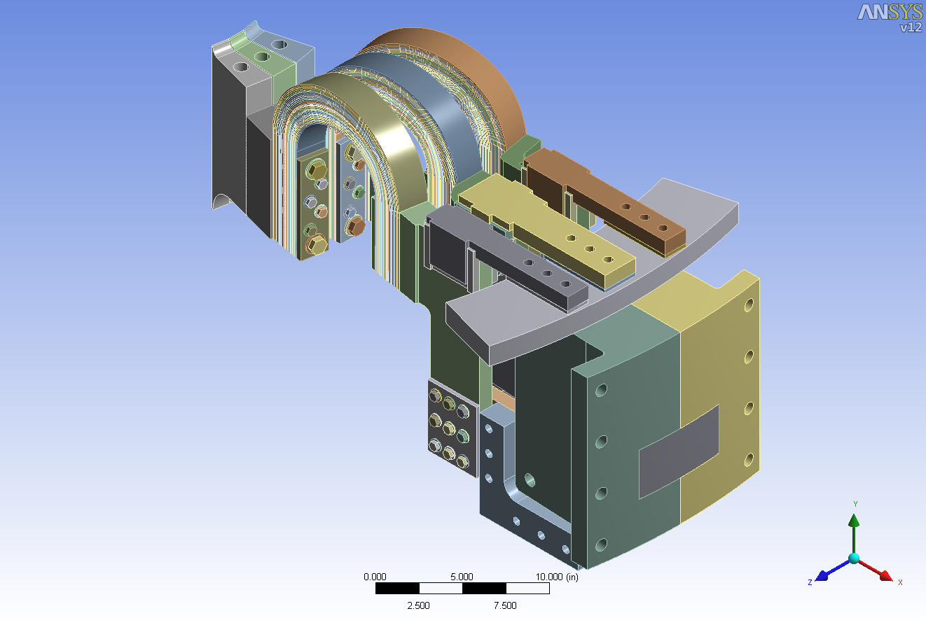

1.1 Single Strap Assembly Solid Model and Boundary Conditions

The solid model of a Single Strap Assembly is shown in Figure 3. The strap assembly consists of an inner assembly of 19X .060” thick laminations, and an outer assembly of 12X .090” thick laminations; the gap between each lamination is .005”. The material is fully-hardened C15100 H04 copper zirconium alloy, chosen for its high-temperature (>450 C) resistance to softening, and for its high-temperature fatigue strength (241 MPa for 300 E06 cycles).

The boundary conditions applied to each strap assembly, for the worst-case, power supply-limit conditions, are also shown in Figure 3. Electromagnetic forces result when the total current of 130,000 kA crosses with the poloidal field of .3 T and the toroidal field of 1 T. In addition to the electromagnetic forces, thermal expansion of the Center Stack produces a .3” vertical and a .018” radial displacement of the TF Bundle Stub-end of the strap assembly.
Figure 3 - Single Strap Assembly Solid Model and Boundary Conditions

2.0 ANSYS Multiphysics Analysis: Description and Results

The block diagram of the ANSYS multiphysics analysis used to evaluate the design is shown in Figure 4. The finite element mesh of the model is shown in Figure 5.

First, the current (I) of 130 kA/strap assembly was used in an Electric analysis to determine the current density (JS) and the Joule heating (Heat Gen) throughout the model (Figures 6 and 7). Next, the current density results were used in a Magnetostatic analysis, along with the toroidal field (Bz) and the poloidal field (By) strengths, to determine the nodal Lorentz forces (Figure 8). In parallel, the Joule heat results were used in a Transient Thermal analysis (initial temperature Tint = 25 C, time duration t = 7 seconds), to determine the nodal temperatures (Figure 9). Finally, the nodal Lorentz forces and temperatures were used in a nonlinear Static Structural analysis, along with the displacements from the Center Stack thermal expansion, to determine the lamination and thread stresses (Figures 10 thru 12), and the contact pressures at the bolted joints (Figure 13). A separate linear static and buckling analysis was also performed to determine the buckling load multiplier factor (LMF) of the laminations (Figure 14).

Figure 4 - ANSYS Multiphysics Analysis Block Diagram

Figure 5 - Finite Element Mesh
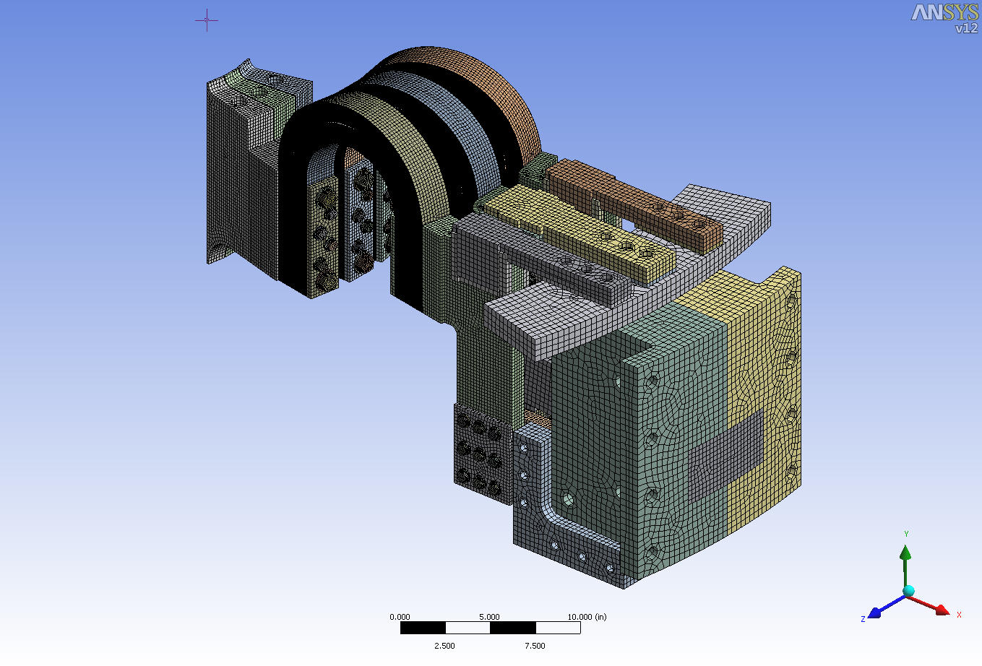

Figure 6 – Electric Analysis Results: Current Density
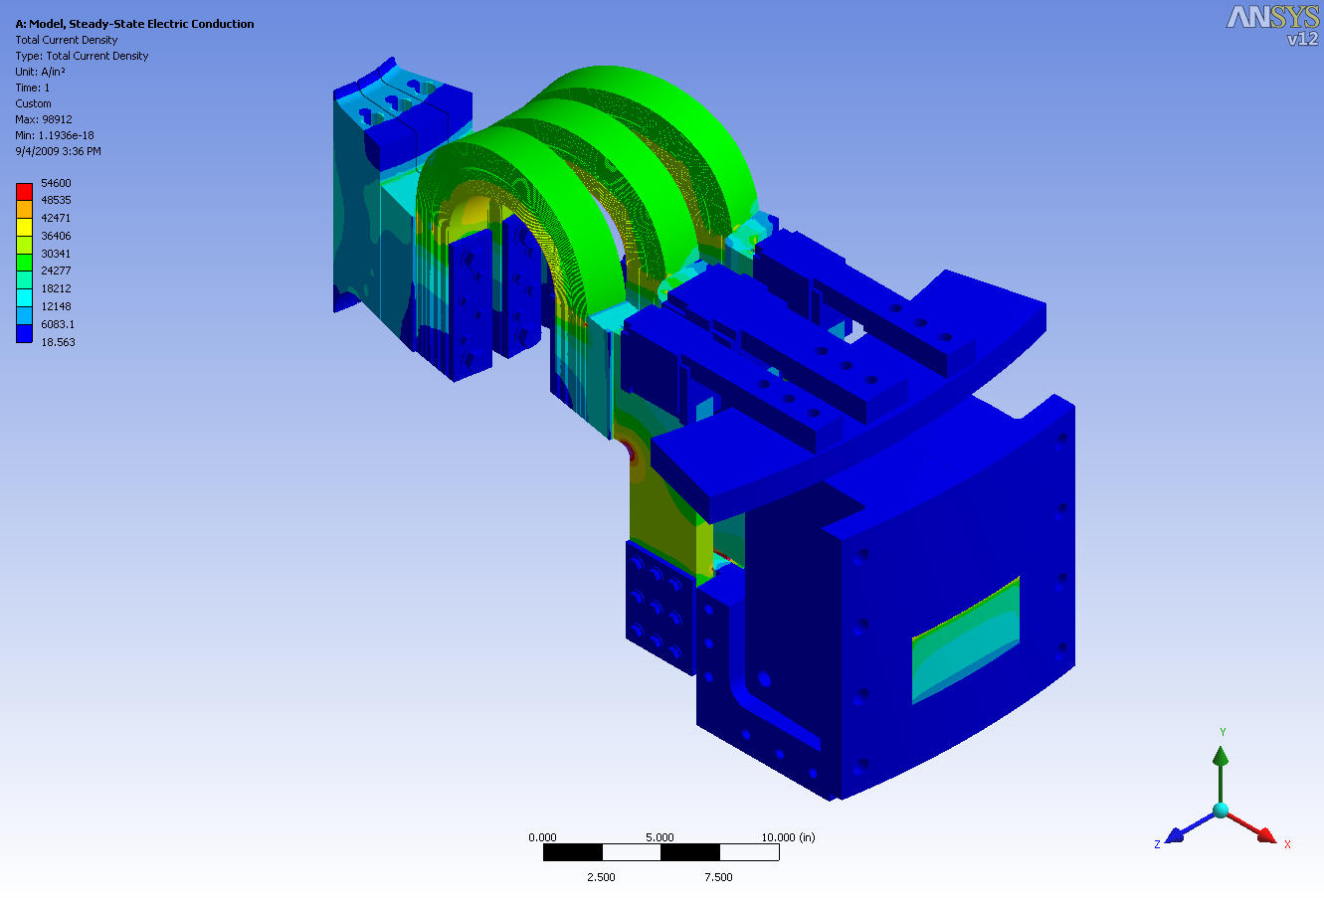

Figure 7 – Electric Analysis Results: Joule Heating
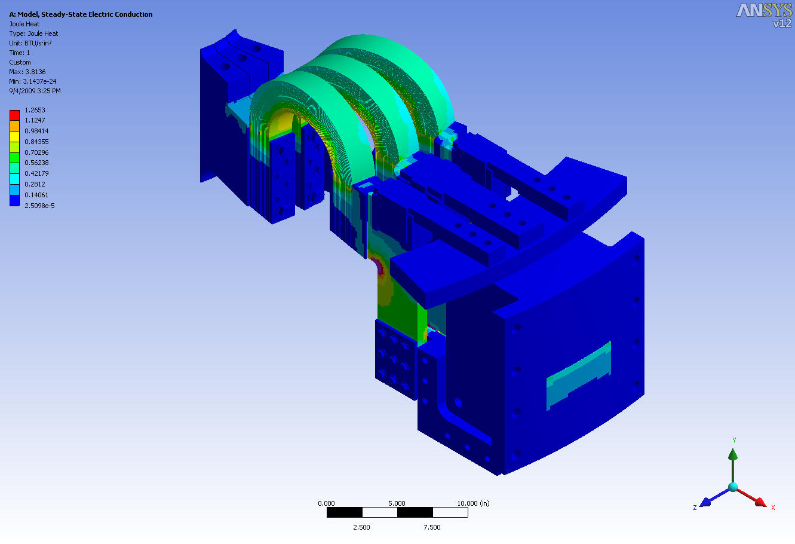

Figure 8 – Magnetostatic Analysis Results: Lorentz Forces
Figure 9 – Transient Thermal Analysis Results: Temperature
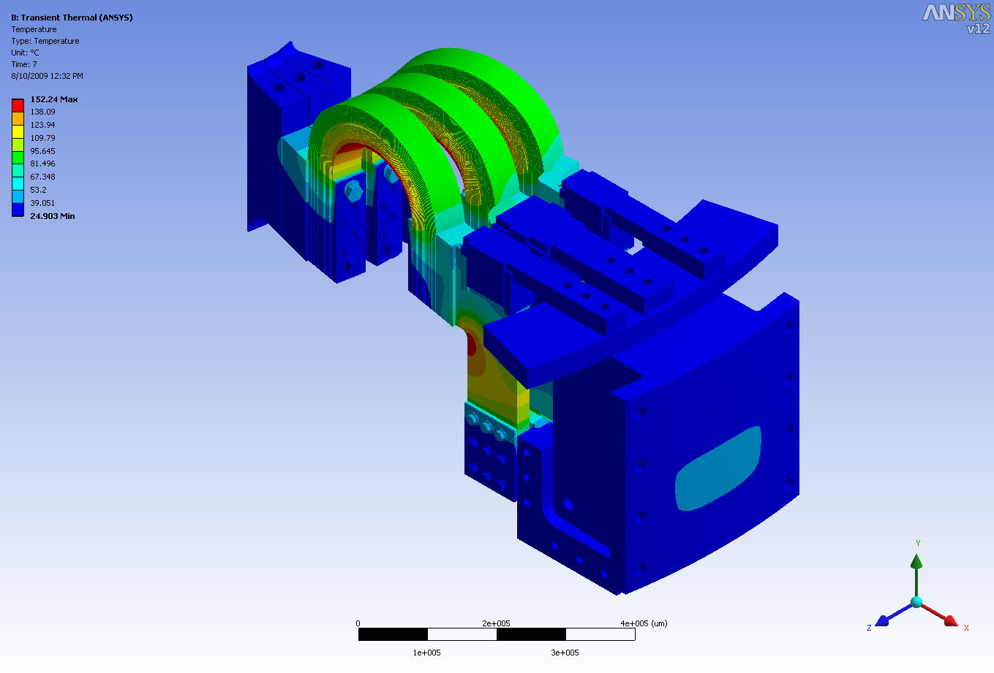

Figure 10 – Static Structural Analysis Results: von Mises Stress: Overall
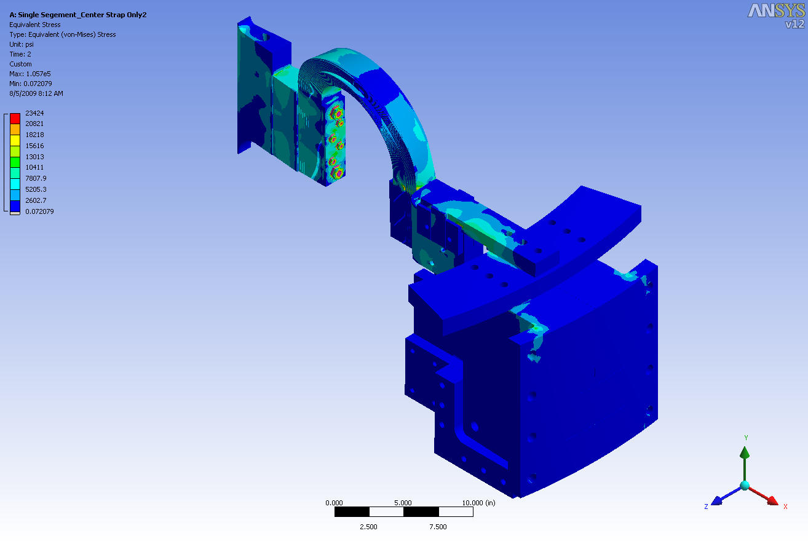

Figure 11 – Static Structural Analysis Results: von Mises Stress: Laminations

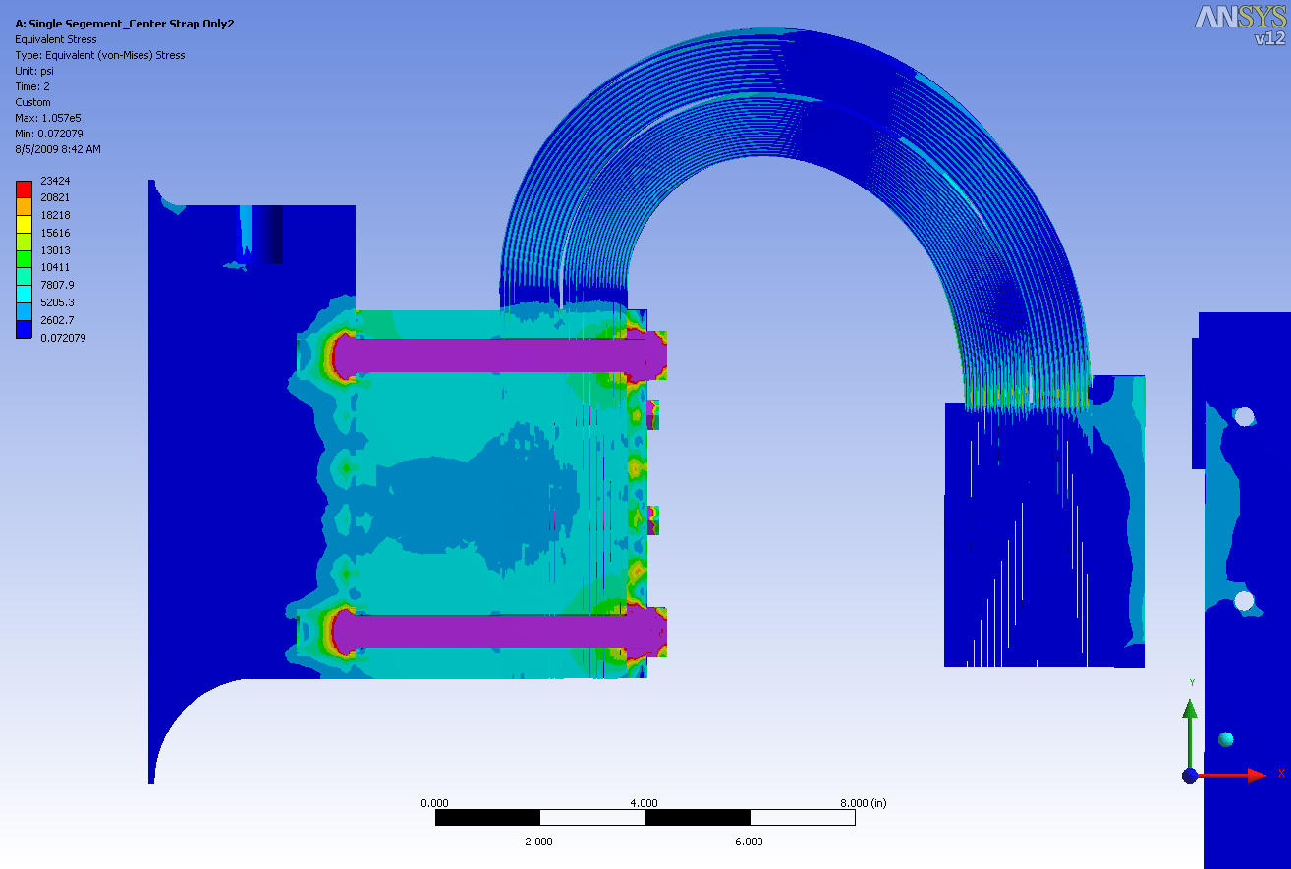
Figure 12 – Static Structural Analysis Results: von Mises Stress: Threads
Figure 13– Static Structural Analysis Results: TF Bundle Stub Bolted Joint
Contact Pressure
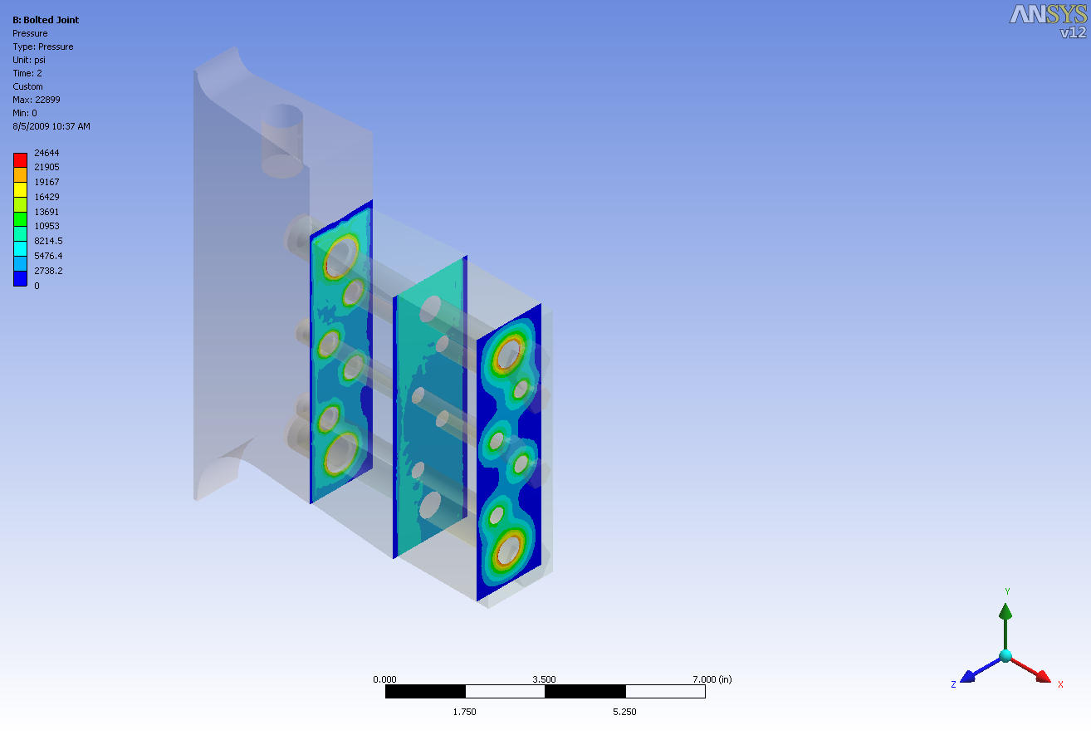

Figure 14 – Linear Buckling Analysis Results: Load Multiplication Factor (LMF)
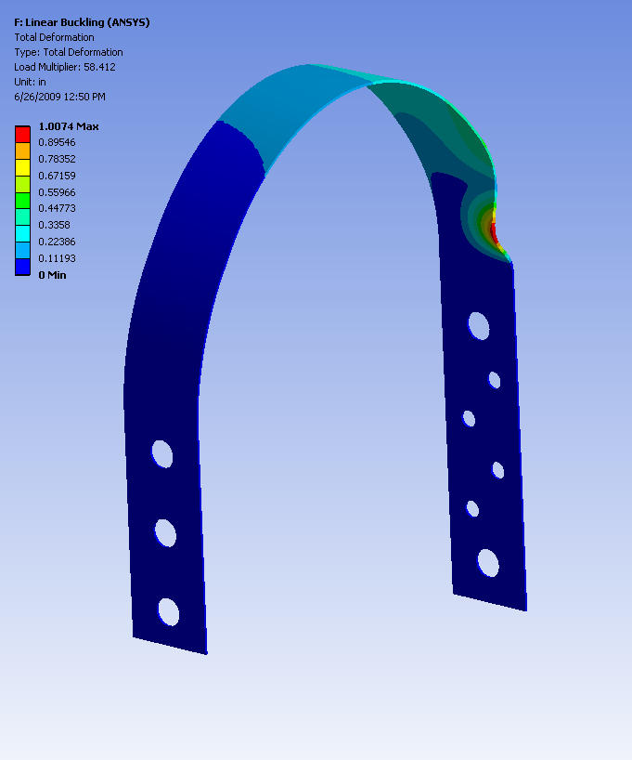

1st Mode
Load Multiplier = 58.4
3.0 Conclusions

From Figure 11, the maximum combined stress in the laminations is 22.9 ksi. To satisfy the requires of the NSTX Structural Design Criteria, the fatigue strength at 3000 cycles must be greater than twice this stress, or the fatigue strength at 60000 cycles (20x N) must be equal to or greater than this stress, whichever is the lesser of the two fatigue strengths. Figure 15 shows the fatigue S-N curve for C15100 copper-zirconium, including plots of full power and 2/3 full power stresses at N = 3000 cycles, and N = 60000 cycles. The design stresses are shown to meet the requirements of the Design Criteria.

From Figure 12, the maximum equivalent stress in the copper threads is 22. ksi. Figure 16 shows the fatigue S-N curve for C15000 copper-zirconium including plots of full power and 2/3 full power stresses at N = 3000 cycles, and N = 60000 cycles. The design stresses are shown to meet the requirements of the Design Criteria.

Figure 15 – Flex Strap Lamination Fatigue Life

Figure 16 – Bolted Joint Copper Thread Fatigue Life

