NSTX Upgrade

Moment Influence Coefficients

NSTXU-CALC-13-05-00
Rev 0
January 18 2011

Prepared By:

___________________________________
Peter Titus, PPPL Mechanical Engineering
Reviewed By:

________________________________________
R. Woolley

________________________________________
Ron Hatcher, NSTX Cognizant Engineer

Reviewed By:

_______________________________________
Phil Heitzenroeder, Head, Mechanical Engineering

PPPL Calculation Form

Calculation # NSTXU-CALC-13-05-00 Revision # 00 WP #, 5200
(ENG-032)

Purpose of Calculation: (Define why the calculation is being performed.)

Force coefficients are an input to the digital coil protection system (DCPS)[7]. This document is a calculation of the moment influence coefficients to be applied to the PF currents. Previously, influence coefficients were computed for only radial and axial loads on the coils. There was no adjustment for the force centroid, which could be substantially displaced from the geometric centroid. Where force centers differ from the coil geometric centers, reaction forces at supports may differ significantly from loads computed with the assumption that the forces are at the coil centroid. Moment coefficients are also being computed by R. Wooley and this calculation may serve as a check for his results, or this calculation may produce coefficients for the DCPS

References (List any source of design information including computer program titles and revision levels.)

Included in the body of the calculations

Assumptions (Identify all assumptions made as part of this calculation.)

Axisymmetry of the coils

Calculation (Calculation is either documented here or attached)

Included in the body of the calculations

Conclusion (Specify whether or not the purpose of the calculation was accomplished.)

Moment influence coefficients have been calculated and tabulated for
checking other's work or inclusion in the DCPS

Cognizant Engineer’s printed name, signature, and date

Ronald Hatcher

I have reviewed this calculation and, to my professional satisfaction, it is properly performed and correct.

Checker’s printed name, signature, and date

Robert Woolley

Table of Contents
Table of Contents 3
Executive Summary 3
Input to the Digital Coil Protection System (DCPS 3
References.................... 4
Analysis Code 4
Axisymmetric Analysis Finite Element Model…… 4
Results 6
Comparison with Bob Woolley's Moment Coefficients
Comparison with Ron Hatcher's Results 7
Shaped Plasma Results
Test Cases

Attachment A Influence Coefficient Subroutine in NTFTM 9

Executive Summary:

It is usual practice to utilize influence coefficient calculations to determine hoop and axial (vertical for tokamak's) loads from coil currents. However the centroid of the Lorentz loads may not be at the geometric center of the coils. Where there is significant offset between the Lorentz centroid and the geometric center, there will be a moment about the coil geometric center in addition to the net loads. This may be a significant contributor to the support reaction loads and to the stresses in the coils themselves. In design and analysis of coil systems, distributions of fields and forces are typically calculated for a useful structural/magnetic mesh which is typically fine enough to properly distribute the Lorentz forces and resolve any moments about the coil current centers. When influence coefficients are used in operating tokamaks to check coil stresses and support loading the effect of moments has been omitted. To the author's knowledge, this is true of Alcator C-Mod, TFTR and NSTX . Addition of the moment coefficients completes the three degrees of freedom available from the axisymmetric analysis of ring coils. For NSTX the effect of the moment coefficients is small for the compact ring coils but is interesting for the thin solenoids - the OH and PF1a,b,and c. Two plasma shapes have been investigated a rectangular cross section and a shaped plasma.
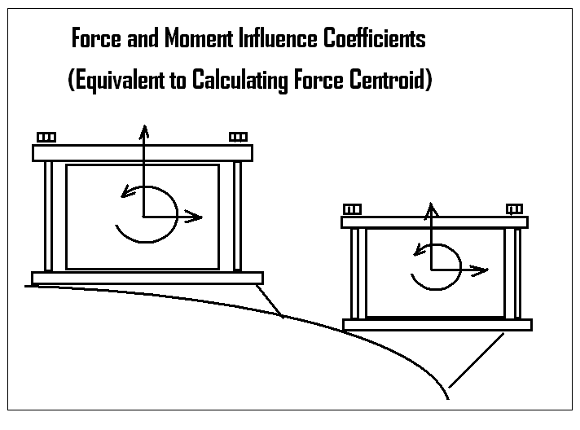
Figure 1 Moments at Current Centers.

Excerpt from the Shaped Plasma Moment Influence Coecfficients

The largest moment influence factors are for moments on the OH from PF1aU and L currents as might be expected from the coil geometries. The effect on the outer ring coils is minimal. The results of this calculation were compared with R. Hatchers results for the 2009 coil builds and with R. Woolley's calculations for the 2011 coil builds. The comparison with Wooley's moment coefficients show results typically within 2 to 5 % with two outliers at 8% and large difference ratios when the two analyses are both calculating essentially zero factors.

Digital Coil Protection System (DCPS) Input

The proposed DCPS is described in detail in a draft requirements document by Robert Woolley ref [7]. Force influence coefficients are already included in plans for the DCPS. Inclusion of these moment coefficients is proposed, depending on their usefulness in quantifying stresses for specific components. In the description of the DCPS, the “systems code” will actually be the analyses described in the filed structural calculations. There is a global model which is the closest thing we have to a single systems code, but this is augmented in many ways by separate calculations to address specific stress locations and components and support hardware. During the final design activity, Each preparer of a calculation will be assigned the development of “mini algorithms” These may make use of moment influence coefficients. One examples is:
.
PF 2,3 supports, welds bolts – At this stage, these are just calculated from influence coefficient matrix loads divided by weld or bolt area. Addition of moment influence coefficients adds overturning moments to the calculation of the bolt loads .

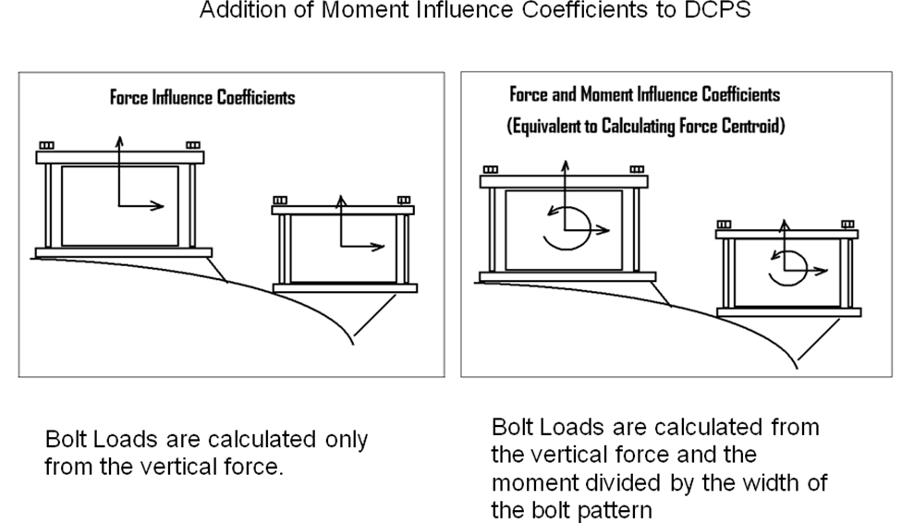
References

[1] NSTX Influence Coefficients, calculation # NSTXU 13 03-00, Ron Hatcher DATE: July 9 2009
[2] NSTX-CALC-13-001-00 Rev 1 Global Model – Model Description, Mesh Generation, Results, Peter H. Titus December 2010
[3] NSTX Structural Design Criteria Document, NSTX_DesCrit_IZ_080103.doc I. Zatz
[4] NSTX Design Point Sep 8 2009 http://www.pppl.gov/~neumeyer/NSTX_CSU/Design_Point.html
[5] OOP PF/TF Torques on TF , R. Woolley, NSTXU CALC 132-03-00
[6] "MHD and Fusion Magnets, Field and Force Design Concepts", R.J.Thome, John Tarrh, Wiley Interscience, 1982
[7] DIGITAL COIL PROTECTION SYSTEM (DCPS) REQUIREMENTS DOCUMENT (DRAFT), NSTX-CSU-RD-DCPS for the National Spherical Torus Experiment Center Stack Upgrade, February 5, 2010 R. Woolley
[8] NSTXU-CALC-132-04-00 ANALYSIS OF TF OUTER LEG, Han Zhang, August 31, 2009

Analysis Code, NTFTM

Mesh generation , calculation of the Lorentz forces, and generation of the influence coefficients is done using a code written by the author of this report. The influence coefficient subroutine is included as appendix A The mesh generation feature of the code is checked visually and within ANSYS during the PREP7 geometry check. . The authors code uses elliptic integrals for 2D field calculations, and Biot Savart solution for 3D field calculations. These are based 2D formulations, and single stick field calculations from Dick Thomes book [8] with some help from Pillsbury’s FIELD3D code to catch all the coincident current vectors, and other singularities.
The code in various forms has been used for 20 years and is suitable for structural calculations. It is also being used for calculation of load files in an NSTX global model[8]. Recent checks include NSTX out-of-plane load comparisons with ANSYS [9] and MAXWELL and calculations of trim coil fields for W7X compared with Neil Pomphrey's calculations. The analysts in the first ITER EDA went through an exercise to compare loads calculated by the US (using this code), RF and by Cees Jong in ANSYS, and agreements were good. Some information on the code, named FTM (Win98) and NTFTM2 (NT,XP), is available at: http://198.125.178.188/ftm/manual.pdf ). or, within PPPL: at P:\public\Snap-srv\Titus\NTFTM

Axisymmetric Analysis Model

Computation of influence coefficients is done by computing contributions of fields and forces in one element group with respect to other element groups. The element groups are identified by real constant numbers for the elements in the group. This allows coils or sections of coils to be considered in the matrix calculation. For this calculation, the element designations used by Ron Hatcher's calculation [1] have been used to allow a comparison with the force influence coefficients. Moment coefficients require the computation of the force contributions with a running summation of forces multiplied by the element force times the appropriate radial or axial lever arm with respect to the element group centroid. So computation of the moment influence coefficients also produces the force influence coefficients.
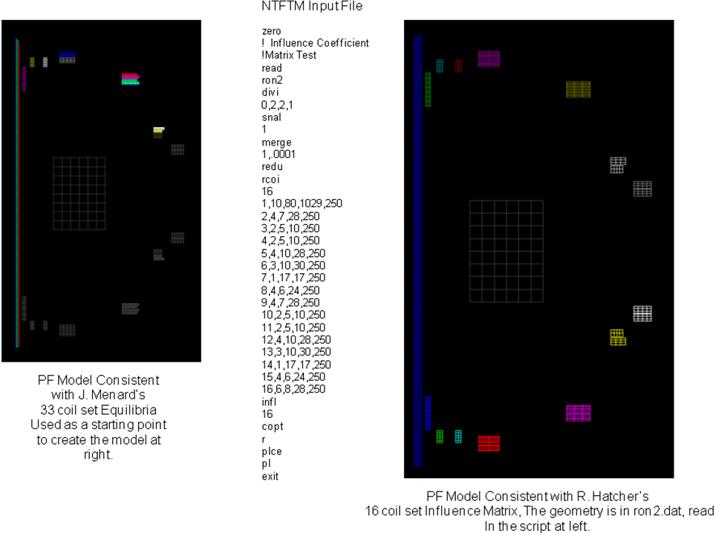
Figure 2 Axisymmetric Models

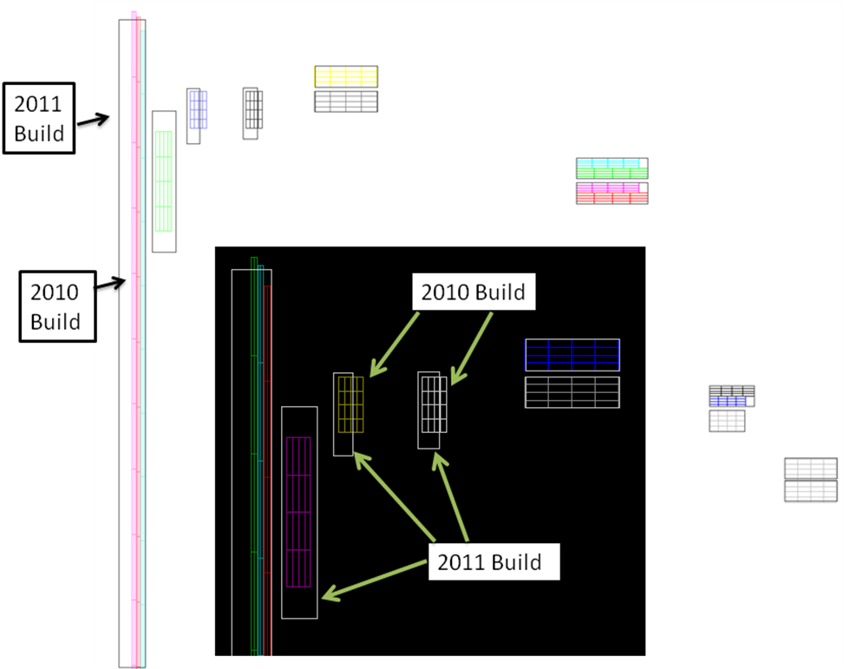
Input Geometries

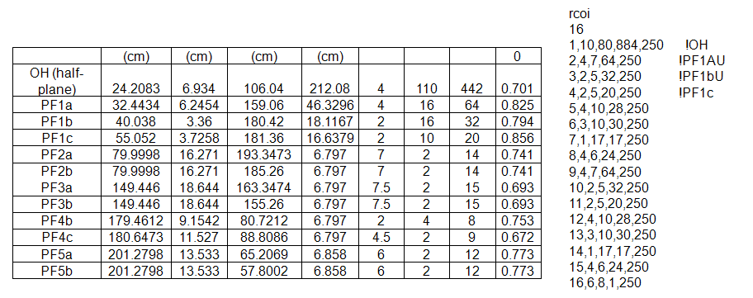
PF Builds and Number of Turns from the Design Point Spreadsheet [4]
Results

Moment Influence Coefficients

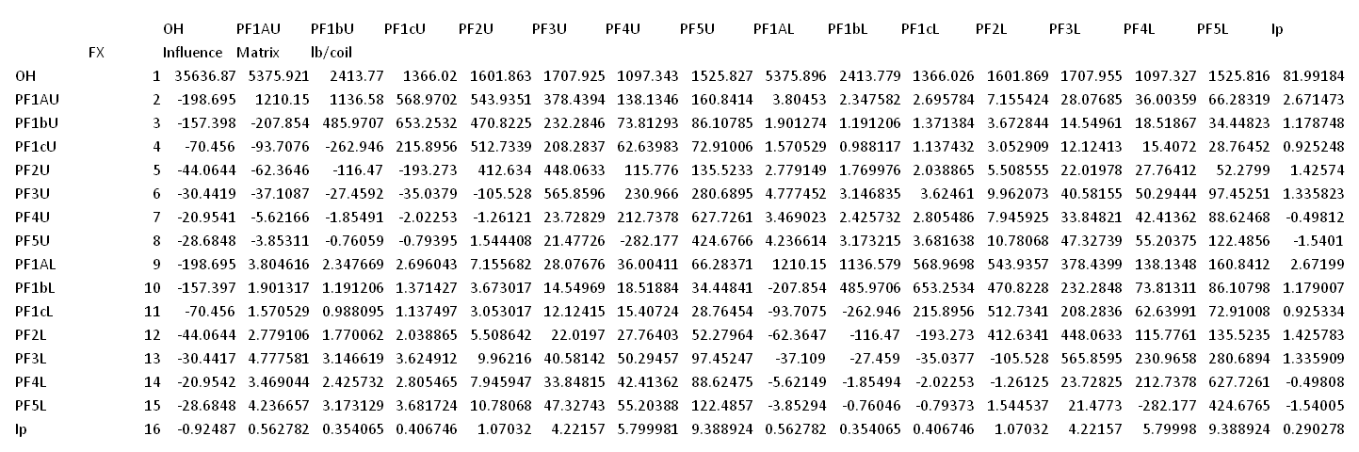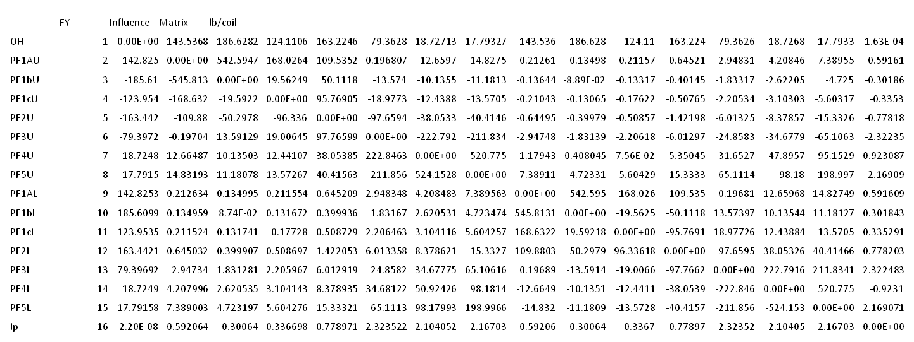

Moment Influence Coefficients
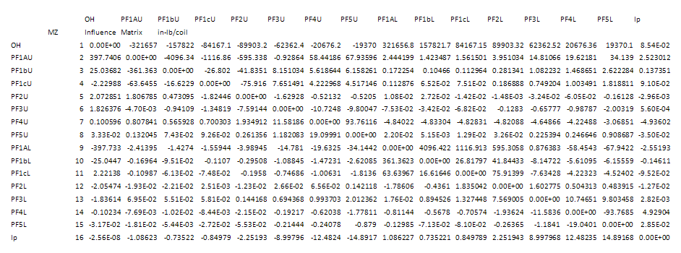
Comparison with Bob Woolley's Moment Influence Coefficients (2011 Coil Build)

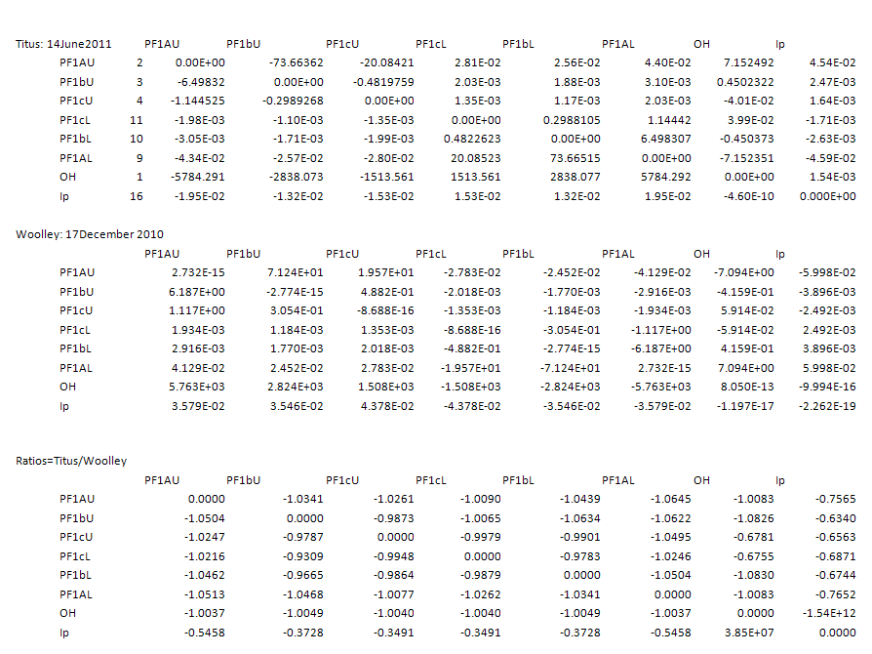

Comparison with Ron Hatcher's Radial Influence Coefficients (2010 Coil Build)

(Titus)

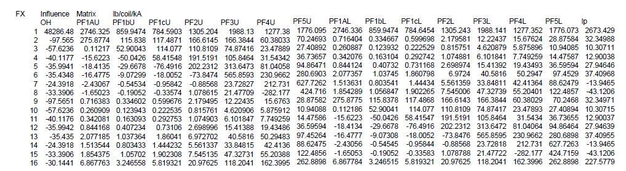

(Hatcher ref [1] )

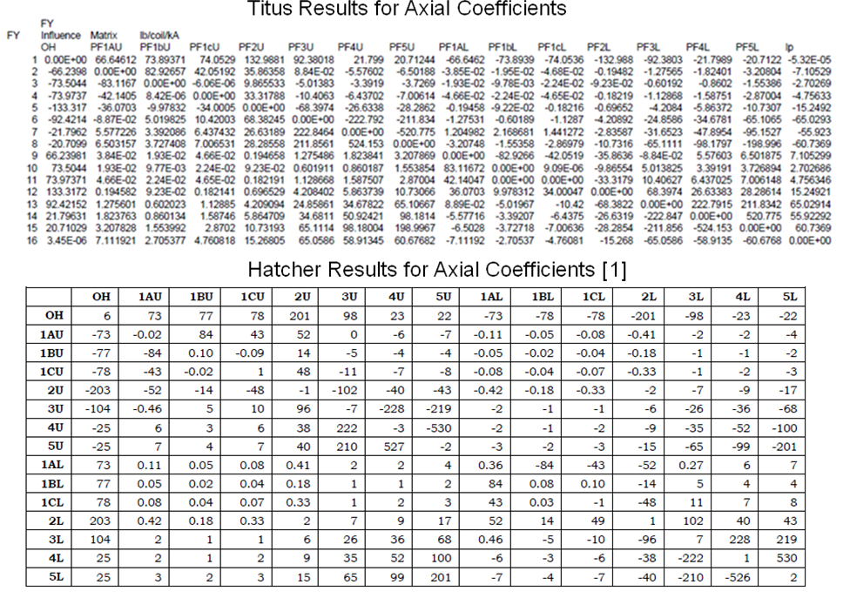

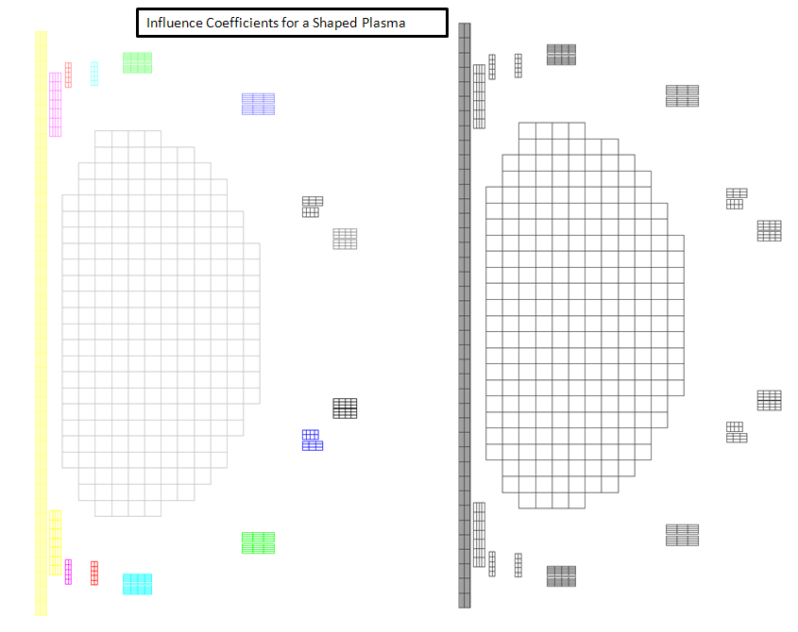

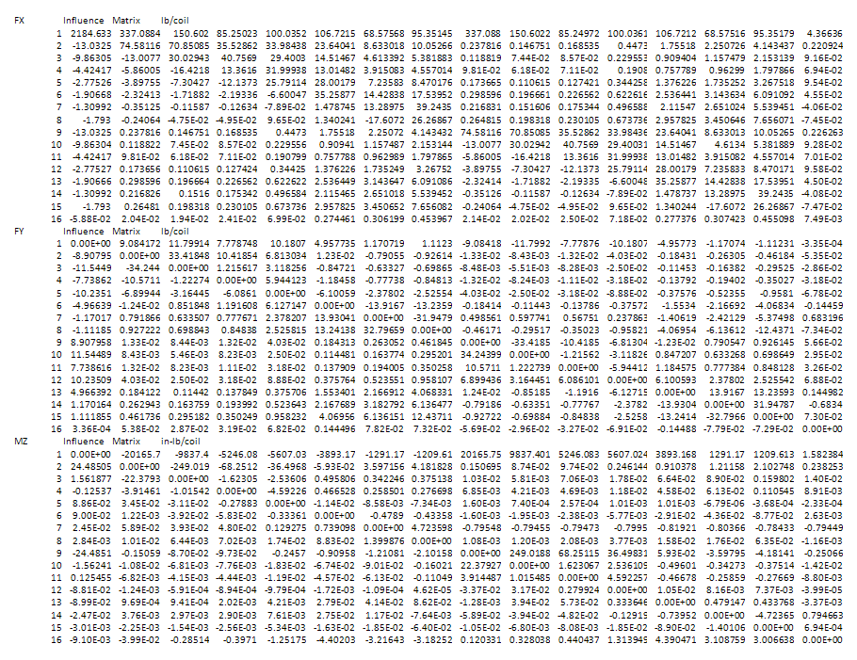

Test Cases

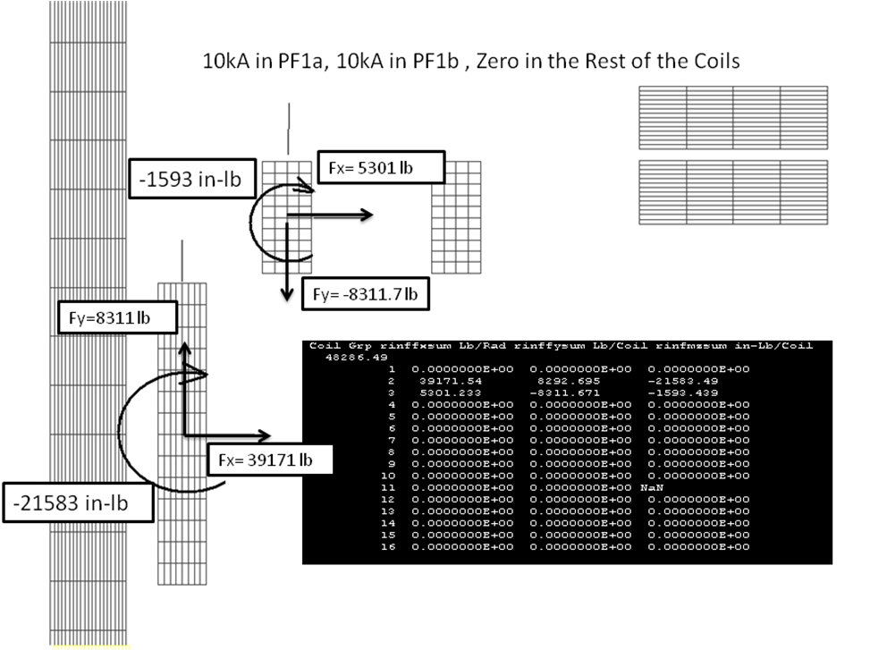

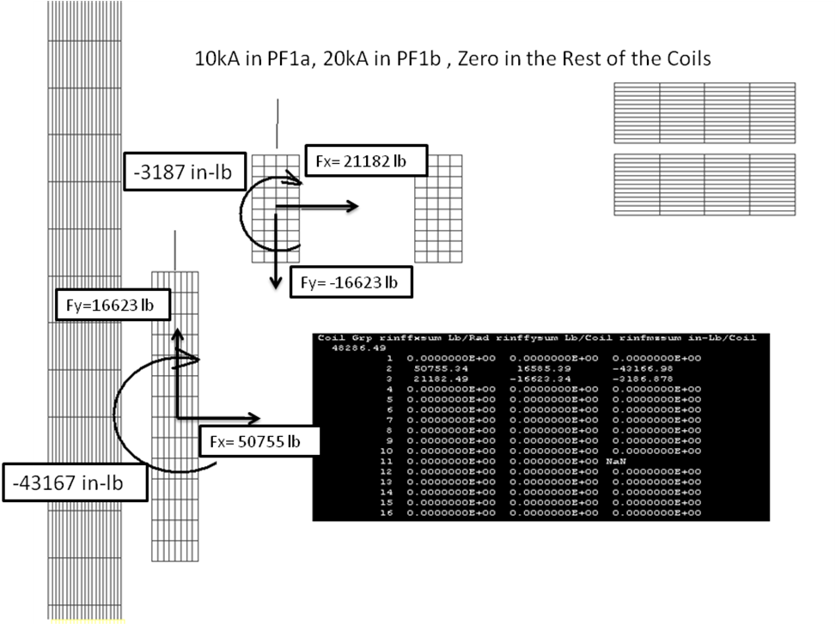

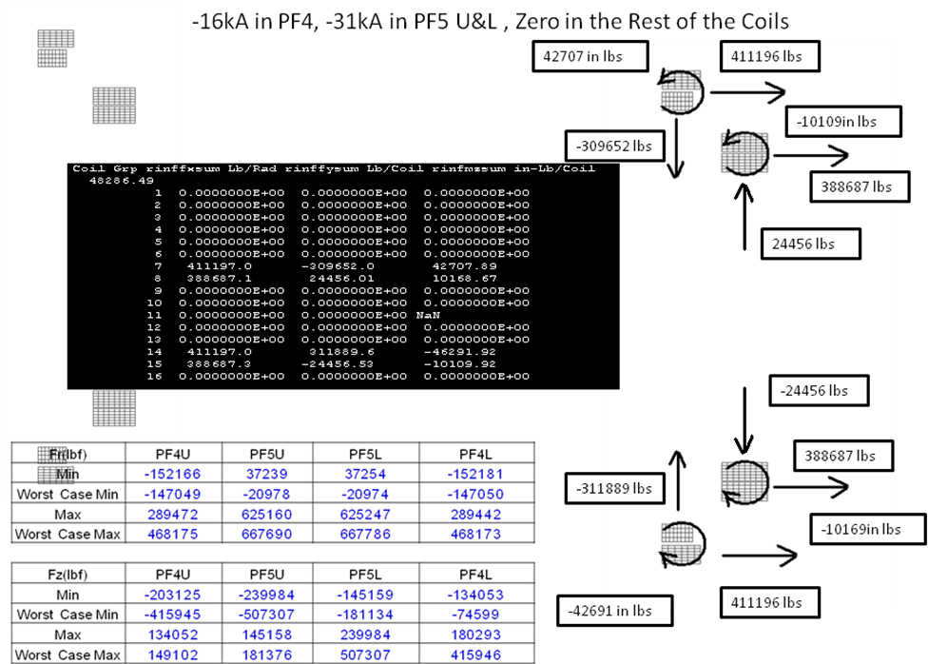
PF 4 and 5 Moment Study
Attachment A Influence Coefficient Subroutine

Subroutine Influence(numcoils)
include 'scommon.blk'
DIMENSION rinffx(50,50)
DIMENSION rinffy(50,50)
DIMENSION rinfmz(50,50)
do 9 i=1,50
do 9 j=1,50
rinffx(i,j)=0
rinffy(i,j)=0
rinfmz(i,j)=0
9 Continue
do 10 i=1,numcoils
do 10 j=1,numcoils
call snal(0)
call seal(0)
ia1=1
ia2=2
ia3=3
ia4=4
ib1=0
ib2=0
ib3=0
ib4=0
CALL Sreal(i,i)
CALL Sreal(j,i)
call SNELEM(i,i)
typekeydum=typekey
typekey=7
egrpkeydum=egrpkey
egrpkey=7
r=0.0
c Creating Current Elements from Quad Elements
call CCUR(R,i,ia1,ia2,ia3,ia4,ib1,ib2,ib3,ib4)
call stype(7,70)
call snelem(70,70)
call sfield(i)
call snal(0)
call seal(0)
call stype(7,70)
call gerase(70)
call reduce
CALL Sreal(i,i)
call SNELEM(i,i)
CALL Sreal(j,j)
call SNELEM(j,j)
call mfor(i,ia1,ia2,ia3,ia4,ib1,ib2,ib3,ib4)
call mfsum(i,i,fxsum,fysum,xmzsum)
rinffx(i,j)=fxsum
rinffy(i,j)=fysum
rinfmz(i,j)=xmzsum
bxs=0.0
bys=0.0
byz=0.0
call bscale(i,bxs,bys,bzs)
call fscale(i,bxs,bys,bzs)
call bscale(j,bxs,bys,bzs)
call fscale(j,bxs,bys,bzs)

10 CONTINUE
54 CONTINUE
do 15 i=1,numcoils
do 15 j=1,numcoils
if (i.ne.j) rinffx(i,j)=rinffx(i,j)-rinffx(i,i)
rinffy(i,j)=rinffy(i,j)-rinffy(i,i)
rinfmz(i,j)=rinfmz(i,j)-rinfmz(i,i)
15 Continue

write(7,*) 'FX Influence Matrix N/rad'
do 11 i=1,numcoils
write(7,*) i,rinffx(i,1),rinffx(i,2),rinffx(i,3),rinffx(i,4),
c rinffx(i,5),rinffx(i,6),rinffx(i,7),rinffx(i,8),rinffx(i,9),
c rinffx(i,10),rinffx(i,11),rinffx(i,12),rinffx(i,13),rinffx(i,14),
c rinffx(i,15),rinffx(i,16),rinffx(i,17),rinffx(i,18),rinffx(i,19)
11 continue
write(7,*) 'FY Influence Matrix N/rad'
do 12 i=1,numcoils
write(7,*) i,rinffy(i,1),rinffy(i,2),rinffy(i,3),rinffy(i,4),
c rinffy(i,5),rinffy(i,6),rinffy(i,7),rinffy(i,8),rinffy(i,9),
c rinffy(i,10),rinffy(i,11),rinffy(i,12),rinffy(i,13),rinffy(i,14),
c rinffy(i,15),rinffy(i,16),rinffy(i,17),rinffy(i,18),rinffy(i,19)
12 continue
write(7,*) 'MZ Influence Matrix N-m/rad'
do 13 i=1,numcoils
write(7,*) i,rinfmz(i,1),rinfmz(i,2),rinfmz(i,3),rinfmz(i,4),
c rinfmz(i,5),rinfmz(i,6),rinfmz(i,7),rinfmz(i,8),rinfmz(i,9),
c rinfmz(i,10),rinfmz(i,11),rinfmz(i,12),rinfmz(i,13),rinfmz(i,14),
c rinfmz(i,15),rinfmz(i,16),rinfmz(i,17),rinfmz(i,18),rinfmz(i,19)
13 continue

do 16 i=1,numcoils
do 16 j=1,numcoils
rinffx(i,j)=rinffx(i,j)*.2248*2*3.1416
rinffy(i,j)=rinffy(i,j)*.2248*2*3.1416
rinfmz(i,j)=rinfmz(i,j)*.2248*2*3.1416*39.37
16 Continue
write(7,*) 'FX Influence Matrix lb/coil'
do 17 i=1,numcoils
write(7,*) i,rinffx(i,1),rinffx(i,2),rinffx(i,3),rinffx(i,4),
c rinffx(i,5),rinffx(i,6),rinffx(i,7),rinffx(i,8),rinffx(i,9),
c rinffx(i,10),rinffx(i,11),rinffx(i,12),rinffx(i,13),rinffx(i,14),
c rinffx(i,15),rinffx(i,16),rinffx(i,17),rinffx(i,18),rinffx(i,19)
17 continue
write(7,*) 'FY Influence Matrix lb/coil'
do 18 i=1,numcoils
write(7,*) i,rinffy(i,1),rinffy(i,2),rinffy(i,3),rinffy(i,4),
c rinffy(i,5),rinffy(i,6),rinffy(i,7),rinffy(i,8),rinffy(i,9),
c rinffy(i,10),rinffy(i,11),rinffy(i,12),rinffy(i,13),rinffy(i,14),
c rinffy(i,15),rinffy(i,16),rinffy(i,17),rinffy(i,18),rinffy(i,19)
18 continue
write(7,*) 'MZ Influence Matrix in-lb/coil'
do 19 i=1,numcoils
write(7,*) i,rinfmz(i,1),rinfmz(i,2),rinfmz(i,3),rinfmz(i,4),
c rinfmz(i,5),rinfmz(i,6),rinfmz(i,7),rinfmz(i,8),rinfmz(i,9),
c rinfmz(i,10),rinfmz(i,11),rinfmz(i,12),rinfmz(i,13),rinfmz(i,14),
c rinfmz(i,15),rinfmz(i,16),rinfmz(i,17),rinfmz(i,18),rinfmz(i,19)
19 continue

typekey=typekeydum
egrpkey=egrpkeydum
return
end

SUBROUTINE mFSUM(IGRPs,igrpe,fxsum,fysum,xmzsum)
include 'scommon.blk'
do 13 igrp=igrps,igrpe
numn=0
centx=0
centy=0
FxSUM=0.
FYSUM=0.
xmzsum=0
ymzsum=0
! FZSUM=0.
DO 12 I=1 , N
IF(NGROUP(I).EQ.IGRP) THEN
numn=numn+1
centx=centx+x(i)
centy=centy+y(i)
FXSUM=FXSUM+FX(I)
FYSUM=FYSUM+FY(I)
! FZSUM=FZSUM+FZ(I)
xMZSUM=xMZSUM-FX(I)*Y(I)
yMZSUM=yMZSUM+FY(I)*X(I)
end if
12 CONTINUE
centx=centx/numn
centy=centy/numn
ymom= -xmzsum/fxsum
xmom=ymzsum/fysum
xMZSUM=-fxsum*(ymom-centy)+fysum*(xmom-centx)
print*,igrp,fxsum,fysum,xmzsum
write(7,*) igrp,',',fxsum,',',fysum,',',fzsum,',',
cxmxsum,',',xmysum,',',xmzsum
13 CONTINUE
RETURN
END

Some of the subroutines in this subroutine may be called in scripts, the script commands are described below:

mfsu Prompts for the start and end node group
Calculates the x force sum, y force sum and moment sum about the
centroid of nodes defined by node groups starting at igrps and
ending at ,igrpe

mfor Calculates Lorentz forces on a brick or quad element from fields
corner nodes, currents specified as real constants, and current
directions specified by inputting an element nodal sequence that
defines the brick element start and end face. For an axisymmetric
analysis using, the connectivity specification is 1,2,3,4,0,0,0,0.
Forces computed for an axisymmetric analysis are per radian. For
ANSYS analyses these loads need to be multiplied by 2*pi.

sfie Computes 2D fields using Elliptic Integrals from loops defined by
type 7 elements.

Attachment B
Influence Coefficient Matrix Script

zero
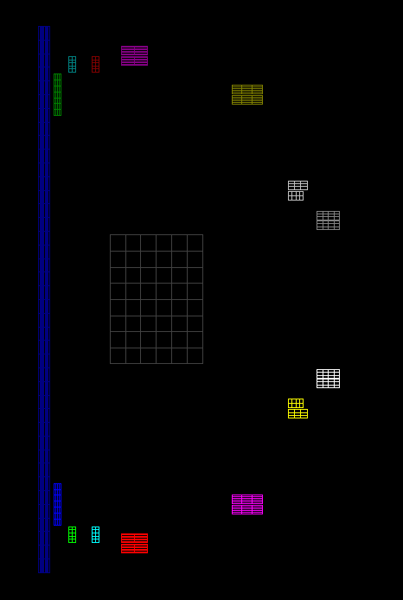
Node and Element File ron2.dat
plotted with copt,r
! Influence Coefficient Matrix Test
read
ron2
divi
0,2,2,1
snal
1
merge
1,.0001
redu

rcoi
16
1,10,80,1029,250
2,4,7,28,250
3,2,5,10,250
4,2,5,10,250
5,4,10,28,250
6,3,10,30,250
7,1,17,17,250
8,4,6,24,250
9,4,7,28,250
10,2,5,10,250
11,2,5,10,250
12,4,10,28,250
13,3,10,30,250
14,1,17,17,250
15,4,6,24,250
16,6,8,28,250

infl
16

copt
r
plce
pl

exit

