NSTX

DCPS Force Influence Coifficients

NSTXU-CALC-13-03-01

May 13,, 2011

Prepared By:

________________________________________
Ronald Hatcher, Electrical Design

Reviewed By:

________________________________________
Peter Titus, Engineering Analysis Branch Head

Approved By:

_______________________________________
Phil Heitzenroeder, Head, Mechanical Engineering
PPPL Calculation Form

Calculation # NSTXU-CALC-13-03-01 Revision # 01 WP: #1511
(ENG-032)

Purpose of Calculation: (Define why the calculation is being performed.)

Force influence coefficients are used to allow for simplified coil-to-coil force calculations. In this instance an element for the plasma current was added to coil elements to allow the effect of the plasma current on coil forces to be assessed. Two memorandum were issued:
- NSTXU Memo: 13-11232010-REH-01 and
- NSTXU Memo: 13-05062011-REH-01

References (List any source of design information including computer program titles and revision levels.)

Design point spreadsheet -
Opera v13
Matlab v2010a

Assumptions (Identify all assumptions made as part of this calculation.)

Linearity of materials.
Coils as rigid bodies.
Zero net vertical force on individual coils.

Calculation (Calculation is either documented here or attached)

Attached.

Conclusion (Specify whether or not the purpose of the calculation was accomplished.)

Force influence matrices including the effect of a plasma element were successfully produced.

Cognizant Engineer’s printed name, signature, and date

I have reviewed this calculation and, to my professional satisfaction, it is properly performed and correct.

Checker’s printed name, signature, and date:

PRINCETON UNIVERSITY: PLASMA PHYSICS LABORATORY
Electrical Design Branch

TO: Distribution DATE: 11/23/2010

FROM: R.E. Hatcher SUBJECT: NSTX-CSU Force Influence Matrix
NSTX Memo: 13-11232010-REH-01
NSTXU-CALC-13-003-01

INTEROFFICE MEMORANDUM

This memo documents the calculation of force influence matrices for the NSTX Center Stack Upgrade (NSTX-CSU) configuration of May 4, 2010 (NSTX_CSU_100504). These influence matrices can be used to quickly calculate in-plane (F_{r}, and F_{z}) loads on the NSTX CSU poloidal field coil system (including the OH coil). One difference between this memo and those on previous configurations is the inclusion of a plasma element. This allows one to assess the effect of plasma current on the coil forces.

The Opera program written for this analysis loops over all possible pairs of conducting elements and computes the static magnetic field for the case where each of the elements has a current density equivalent to 1 kA of current flowing through it. A Matlab™ routine was written to read the Opera output and produce contracted F_{R} and F_{Z} influence matrices that also include the effect of coil turns (contraction reduces the matrix order by combining elements into coil systems).

The following table and figure details the coil configuration used in this analysis. Note that all of the coils, with the exception of the OH coil, have a mirrored coil in the lower z half- plane. The OH coil is modeled as a single entity to simplify some of the bookkeeping required. The plasma is modeled with a circular cross section and constant current density.

Elem | Elem | Group | System | Rc | dR | Zc | dZ | nr | nz
No. | Name | No. | Name | [m] | [m] | [m] | [m]
1 | OH | 15 | OH | 0.2421 | 0.0693 | 0.0000 | 4.2416 | 4 | 221
2 | PF1aU | 1 | PF1aU | 0.3193 | 0.0593 | 1.5906 | 0.4635 | 4 | 16
3 | PF1bU | 2 | PF1bU | 0.4004 | 0.0336 | 1.8042 | 0.1812 | 2 | 16
4 | PF1cU | 3 | PF1cU | 0.5505 | 0.0373 | 1.8136 | 0.1664 | 2 | 10
5 | PF2aU | 4 | PF2U | 0.8000 | 0.1627 | 1.9335 | 0.0680 | 7 | 2
6 | PF2bU | 4 | PF2U | 0.8000 | 0.1627 | 1.8526 | 0.0680 | 7 | 2
7 | PF3aU | 5 | PF3U | 1.4945 | 0.1864 | 1.6335 | 0.0680 | 7.5 | 2
8 | PF3bU | 5 | PF3U | 1.4945 | 0.1864 | 1.5526 | 0.0680 | 7.5 | 2
9 | PF4bU | 6 | PF4U | 1.7946 | 0.0915 | 0.8072 | 0.0680 | 2 | 4
10 | PF4cU | 6 | PF4U | 1.8065 | 0.1153 | 0.8881 | 0.0680 | 4.5 | 2
11 | PF5aU | 7 | PF5U | 2.0128 | 0.1353 | 0.6521 | 0.0686 | 6 | 2
12 | PF5bU | 7 | PF5U | 2.0128 | 0.1353 | 0.5780 | 0.0686 | 6 | 2
13 | PF1aL | 14 | PF1aL | 0.3193 | 0.0593 | -1.5906 | 0.4635 | 4 | 16
14 | PF1bL | 13 | PF1bL | 0.4004 | 0.0336 | -1.8042 | 0.1812 | 2 | 16
15 | PF1cL | 12 | PF1cL | 0.5505 | 0.0373 | -1.8136 | 0.1664 | 2 | 10
16 | PF2aL | 11 | PF2L | 0.8000 | 0.1627 | -1.9335 | 0.0680 | 7 | 2
17 | PF2bL | 11 | PF2L | 0.8000 | 0.1627 | -1.8526 | 0.0680 | 7 | 2
18 | PF3aL | 10 | PF3L | 1.4945 | 0.1864 | -1.6335 | 0.0680 | 7.5 | 2
19 | PF3bL | 10 | PF3L | 1.4945 | 0.1864 | -1.5526 | 0.0680 | 7.5 | 2
20 | PF4bL | 9 | PF4L | 1.7946 | 0.0915 | -0.8072 | 0.0680 | 2 | 4
21 | PF4cL | 9 | PF4L | 1.8065 | 0.1153 | -0.8881 | 0.0680 | 4.5 | 2
22 | PF5aL | 8 | PF5L | 2.0128 | 0.1353 | -0.6521 | 0.0686 | 6 | 2
23 | PF5bL | 8 | PF5L | 2.0128 | 0.1353 | -0.5780 | 0.0686 | 6 | 2
24 | Plasma | 16 | Pl | 0.9344 | 0.5696 | 0.0000 | 0.5696 | 1 | 1

Table 1 - Coil configuration parameters used for NSTX CSU influence matrix coefficient calculation

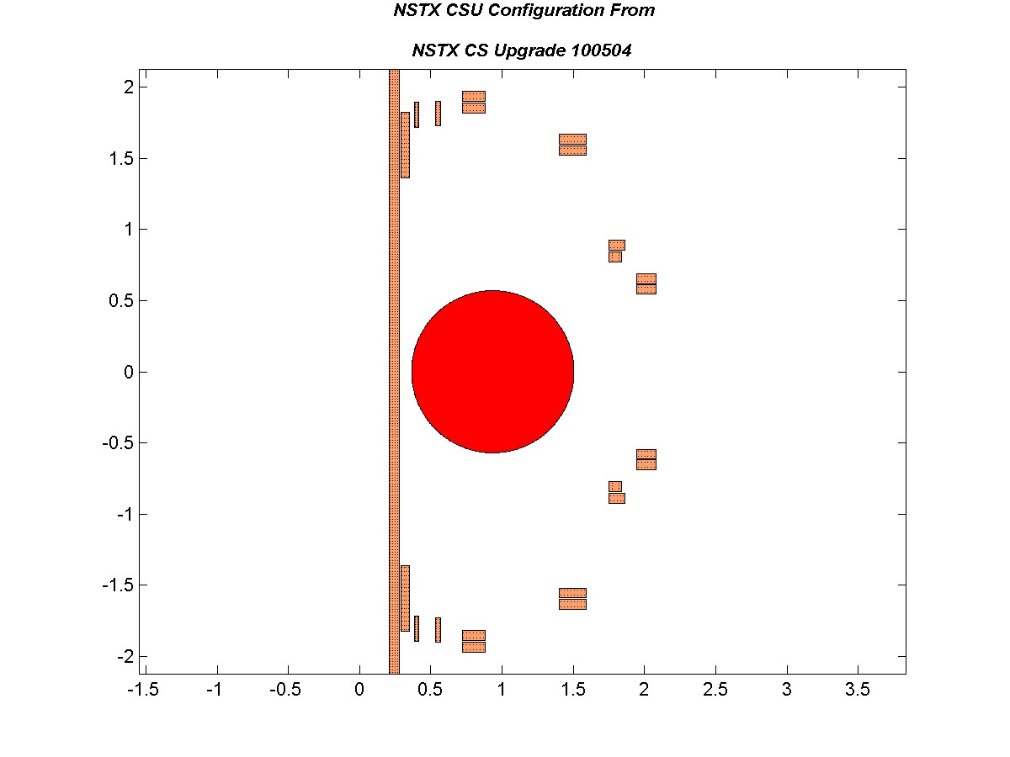
Figure 1 – Coil Configuration for NSTX CSU Influence Matrix Calculation (individual turns represented by “.”)

 | PF1aU | PF1bU | PF1cU | PF2U | PF3U | PF4U | PF5U | PF5L | PF4L | PF3L | PF2L | PF1cL | PF1bL | PF1aL | OH | Pl
PF1aU | 1172.7 | 1109.9 | 556.7 | 530.6 | 362.0 | 130.2 | 148.7 | 59.2 | 31.8 | 23.5 | 5.9 | 2.3 | 2.0 | 3.2 | -265.6 | 2.5
PF1bU | -214.8 | 460.7 | 652.6 | 467.8 | 225.3 | 69.9 | 79.9 | 30.5 | 16.2 | 12.0 | 3.0 | 1.1 | 1.0 | 1.6 | -186.3 | 1.1
PF1cU | -97.3 | -271.4 | 200.8 | 509.8 | 202.4 | 59.3 | 67.7 | 25.4 | 13.4 | 9.9 | 2.4 | 0.9 | 0.8 | 1.3 | -87.2 | 0.9
PF2U | -67.2 | -122.3 | -199.8 | 383.0 | 436.4 | 109.0 | 125.2 | 45.5 | 23.7 | 17.5 | 4.3 | 1.6 | 1.4 | 2.2 | -66.1 | 1.3
PF3U | -41.5 | -31.4 | -39.1 | -116.5 | 497.3 | 218.9 | 265.3 | 85.2 | 42.7 | 31.9 | 7.5 | 2.7 | 2.3 | 3.5 | -57.2 | 1.3
PF4U | -7.7 | -3.3 | -3.5 | -5.1 | 12.1 | 178.8 | 620.1 | 81.4 | 37.2 | 27.5 | 6.0 | 2.1 | 1.8 | 2.4 | -37.2 | -0.5
PF5U | -6.6 | -2.7 | -2.8 | -3.9 | 2.6 | -307.7 | 356.4 | 108.9 | 45.5 | 36.4 | 7.5 | 2.5 | 2.0 | 2.4 | -51.6 | -1.8
PF5L | 2.4 | 2.0 | 2.5 | 7.5 | 36.4 | 45.5 | 108.9 | 356.4 | -307.8 | 2.6 | -3.9 | -2.8 | -2.7 | -6.6 | -51.6 | -1.8
PF4L | 2.4 | 1.8 | 2.1 | 6.0 | 27.5 | 37.2 | 81.4 | 620.1 | 178.7 | 12.1 | -5.1 | -3.5 | -3.3 | -7.7 | -37.2 | -0.5
PF3L | 3.5 | 2.3 | 2.7 | 7.5 | 31.9 | 42.7 | 85.2 | 265.3 | 218.9 | 497.4 | -116.5 | -39.1 | -31.4 | -41.5 | -57.2 | 1.3
PF2L | 2.2 | 1.4 | 1.6 | 4.3 | 17.5 | 23.7 | 45.5 | 125.2 | 109.0 | 436.4 | 383.1 | -199.8 | -122.3 | -67.2 | -66.1 | 1.3
PF1cL | 1.3 | 0.8 | 0.9 | 2.4 | 9.9 | 13.4 | 25.4 | 67.7 | 59.3 | 202.4 | 509.8 | 200.7 | -271.4 | -97.3 | -87.2 | 0.9
PF1bL | 1.6 | 1.0 | 1.1 | 3.0 | 12.0 | 16.2 | 30.5 | 79.9 | 69.9 | 225.3 | 467.8 | 652.6 | 460.6 | -214.7 | -186.3 | 1.1
PF1aL | 3.2 | 2.0 | 2.3 | 5.9 | 23.5 | 31.8 | 59.2 | 148.7 | 130.2 | 362.0 | 530.6 | 556.7 | 1109.8 | 1172.7 | -265.6 | 2.5
OH | 5339.5 | 2394.2 | 1352.3 | 1572.7 | 1633.5 | 1048.0 | 1438.1 | 1438.1 | 1048.0 | 1633.5 | 1572.7 | 1352.3 | 2394.2 | 5339.5 | 34893.7 | 80.7
Pl | 0.5 | 0.3 | 0.3 | 0.9 | 3.7 | 5.5 | 9.1 | 9.1 | 5.5 | 3.7 | 0.9 | 0.3 | 0.3 | 0.5 | -1.9 | 0.2

Table 2 - NSTX CSU Radial Force Influence Matrix (forces in lbf / ka^2)

 | PF1aU | PF1bU | PF1cU | PF2U | PF3U | PF4U | PF5U | PF5L | PF4L | PF3L | PF2L | PF1cL | PF1bL | PF1aL | OH | Pl
PF1aU | 0.0 | 524.9 | 163.8 | 107.5 | -0.2 | -12.8 | -14.8 | -7.8 | -4.5 | -3.4 | -0.9 | -0.4 | -0.3 | -0.5 | -151.2 | -0.6
PF1bU | -524.9 | 0.0 | 19.8 | 50.7 | -13.9 | -10.5 | -11.5 | -5.1 | -2.9 | -2.1 | -0.6 | -0.2 | -0.2 | -0.3 | -194.2 | -0.3
PF1cU | -163.8 | -19.8 | 0.0 | 96.5 | -19.4 | -12.8 | -13.8 | -5.9 | -3.3 | -2.5 | -0.6 | -0.3 | -0.2 | -0.4 | -129.7 | -0.3
PF2U | -107.5 | -50.7 | -96.5 | 0.0 | -99.3 | -38.9 | -40.9 | -16.0 | -8.8 | -6.5 | -1.7 | -0.6 | -0.6 | -0.9 | -171.7 | -0.8
PF3U | -0.2 | 13.9 | 19.4 | 99.3 | 0.0 | -225.4 | -211.9 | -66.6 | -35.5 | -25.7 | -6.5 | -2.5 | -2.1 | -3.4 | -86.4 | -2.4
PF4U | 12.8 | 10.5 | 12.8 | 38.9 | 225.4 | 0.0 | -490.4 | -99.8 | -51.7 | -35.5 | -8.8 | -3.3 | -2.9 | -4.5 | -20.8 | -2.4
PF5U | 14.8 | 11.5 | 13.8 | 40.9 | 211.9 | 490.4 | 0.0 | -203.9 | -99.8 | -66.6 | -16.0 | -5.9 | -5.1 | -7.8 | -19.8 | -2.6
PF5L | 7.8 | 5.1 | 5.9 | 16.0 | 66.6 | 99.8 | 203.9 | 0.0 | -490.4 | -211.9 | -40.9 | -13.8 | -11.5 | -14.8 | 19.8 | 2.6
PF4L | 4.5 | 2.9 | 3.3 | 8.8 | 35.5 | 51.7 | 99.8 | 490.4 | 0.0 | -225.4 | -38.9 | -12.8 | -10.5 | -12.8 | 20.8 | 2.4
PF3L | 3.4 | 2.1 | 2.5 | 6.5 | 25.7 | 35.5 | 66.6 | 211.9 | 225.4 | 0.0 | -99.3 | -19.4 | -13.9 | 0.2 | 86.4 | 2.4
PF2L | 0.9 | 0.6 | 0.6 | 1.7 | 6.5 | 8.8 | 16.0 | 40.9 | 38.9 | 99.3 | 0.0 | 96.5 | 50.7 | 107.5 | 171.7 | 0.8
PF1cL | 0.4 | 0.2 | 0.3 | 0.6 | 2.5 | 3.3 | 5.9 | 13.8 | 12.8 | 19.4 | -96.5 | 0.0 | 19.8 | 163.8 | 129.7 | 0.3
PF1bL | 0.3 | 0.2 | 0.2 | 0.6 | 2.1 | 2.9 | 5.1 | 11.5 | 10.5 | 13.9 | -50.7 | -19.8 | 0.0 | 524.9 | 194.2 | 0.3
PF1aL | 0.5 | 0.3 | 0.4 | 0.9 | 3.4 | 4.5 | 7.8 | 14.8 | 12.8 | 0.2 | -107.5 | -163.8 | -524.9 | 0.0 | 151.2 | 0.6
OH | 151.2 | 194.2 | 129.7 | 171.7 | 86.4 | 20.8 | 19.8 | -19.8 | -20.8 | -86.4 | -171.7 | -129.7 | -194.2 | -151.2 | 0.0 | 0.0
Pl | 0.6 | 0.3 | 0.3 | 0.8 | 2.4 | 2.4 | 2.6 | -2.6 | -2.4 | -2.4 | -0.8 | -0.3 | -0.3 | -0.6 | 0.0 | 0.0

Table 3 - NSTX CSU Vertical Force Influence Matrix (forces in lbf / ka^2)

Distribution: C. Neumeyer, P. Titus, J. Menard, R. Woolley, P. Heitzenroeder, L. Dudek, R. Simmons
PRINCETON UNIVERSITY: PLASMA PHYSICS LABORATORY
Electrical Design Branch

TO: Distribution DATE: May 6, 2011

FROM: R.E. Hatcher SUBJECT: NSTX-CSU Force Influence Matrix (Update)
NSTX Memo: 13-05062011-REH-01

INTEROFFICE MEMORANDUM

This memo documents the results of further analyses to generate force influence matrices for the calculation of in-plane (F_{r}, and F_{z}) loads on the NSTX CSU poloidal field coil system (including the OH coil). This memo computes an updated set of influence matrix coefficients for the configuration dated March 8, 2011 (030811).

Details of the method of calculation are described in a prior memo (NSTX-CALC-13-03-00) and will not be repeated here. We enumerate any changes from the methods defined therein here.

- To standardize, amongst ourselves and with other machine designs, we have changed the ordering of coil systems with respect to the previous work. The new ordering progresses clockwise in the poloidal direction with the OH coil coming last,
- The original version of the F_{z} influence matrix had non-zero diagonal entries and was not symmetric as it must be (this is due to small asymmetries in the mesh). In subsequent versions the diagonal entries of the F_{z} matrix have been zeroed (there can be no self vertical force on the coil) and we have forced symmetry by averaging the magnitudes of the entries above and below the main diagonal.
- A conducting element representing the plasma has been added to the analysis to determine the effect of the plasma on the coil forces. Both circular and shaped plasma models are used in an attempt to cover a range of plasma shapes and current densities.
The following table and figure shows details of the coil configuration used in this analysis. Note that all of the coils, with the exception of the OH coil, have a mirrored coil in the lower z half- plane. The OH coil was modeled as a single entity to simplify some of the bookkeeping required.

Elem | Elem | Group | System | Rc | dR | Zc | dZ | nr | nz
No. | Name | No. | Name | [m] | [m] | [m] | [m]
1 | OH | 15 | OH | 0.2421 | 0.0693 | 0.0000 | 4.2416 | 4 | 221
2 | PF1aU | 1 | PF1aU | 0.3244 | 0.0625 | 1.5906 | 0.4633 | 4 | 16
3 | PF1bU | 2 | PF1bU | 0.4004 | 0.0336 | 1.8042 | 0.1812 | 2 | 16
4 | PF1cU | 3 | PF1cU | 0.5505 | 0.0373 | 1.8136 | 0.1664 | 2 | 10
5 | PF2aU | 4 | PF2U | 0.8000 | 0.1627 | 1.9335 | 0.0680 | 7 | 2
6 | PF2bU | 4 | PF2U | 0.8000 | 0.1627 | 1.8526 | 0.0680 | 7 | 2
7 | PF3aU | 5 | PF3U | 1.4945 | 0.1864 | 1.6335 | 0.0680 | 7.5 | 2
8 | PF3bU | 5 | PF3U | 1.4945 | 0.1864 | 1.5526 | 0.0680 | 7.5 | 2
9 | PF4bU | 6 | PF4U | 1.7946 | 0.0915 | 0.8072 | 0.0680 | 2 | 4
10 | PF4cU | 6 | PF4U | 1.8065 | 0.1153 | 0.8881 | 0.0680 | 4.5 | 2
11 | PF5aU | 7 | PF5U | 2.0128 | 0.1353 | 0.6521 | 0.0686 | 6 | 2
12 | PF5bU | 7 | PF5U | 2.0128 | 0.1353 | 0.5780 | 0.0686 | 6 | 2
13 | PF1aL | 14 | PF1aL | 0.3244 | 0.0625 | -1.5906 | 0.4633 | 4 | 16
14 | PF1bL | 13 | PF1bL | 0.4004 | 0.0336 | -1.8042 | 0.1812 | 2 | 16
15 | PF1cL | 12 | PF1cL | 0.5505 | 0.0373 | -1.8136 | 0.1664 | 2 | 10
16 | PF2aL | 11 | PF2L | 0.8000 | 0.1627 | -1.9335 | 0.0680 | 7 | 2
17 | PF2bL | 11 | PF2L | 0.8000 | 0.1627 | -1.8526 | 0.0680 | 7 | 2
18 | PF3aL | 10 | PF3L | 1.4945 | 0.1864 | -1.6335 | 0.0680 | 7.5 | 2
19 | PF3bL | 10 | PF3L | 1.4945 | 0.1864 | -1.5526 | 0.0680 | 7.5 | 2
20 | PF4bL | 9 | PF4L | 1.7946 | 0.0915 | -0.8072 | 0.0680 | 2 | 4
21 | PF4cL | 9 | PF4L | 1.8065 | 0.1153 | -0.8881 | 0.0680 | 4.5 | 2
22 | PF5aL | 8 | PF5L | 2.0128 | 0.1353 | -0.6521 | 0.0686 | 6 | 2
23 | PF5bL | 8 | PF5L | 2.0128 | 0.1353 | -0.5780 | 0.0686 | 6 | 2
24 | Plas | 16 | Pl | 0.9344 | 0.5696 | 0.0000 | 0.5696 | 1 | 1

Table 4 - Coil configuration parameters used for NSTX CSU influence matrix coefficient calculation

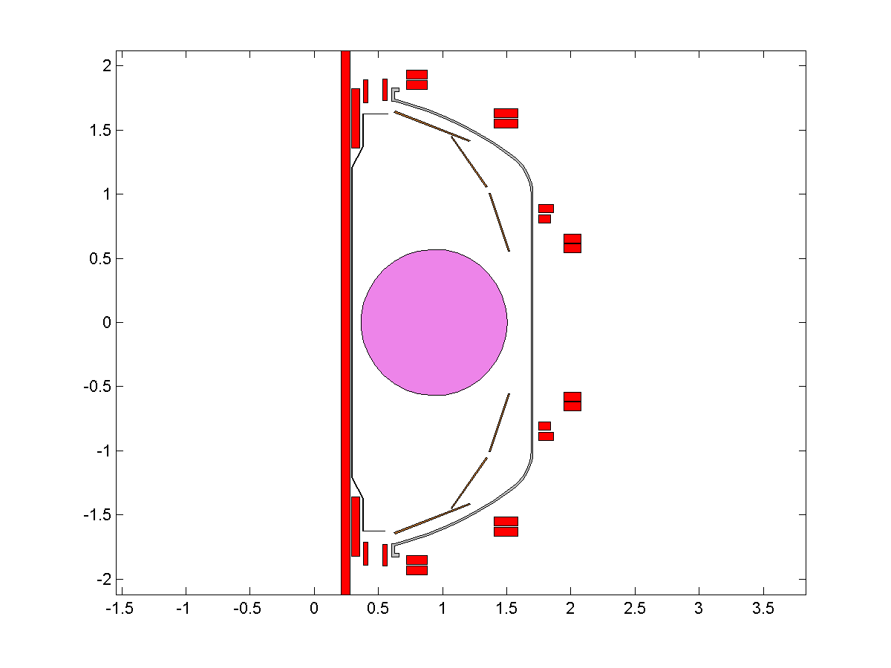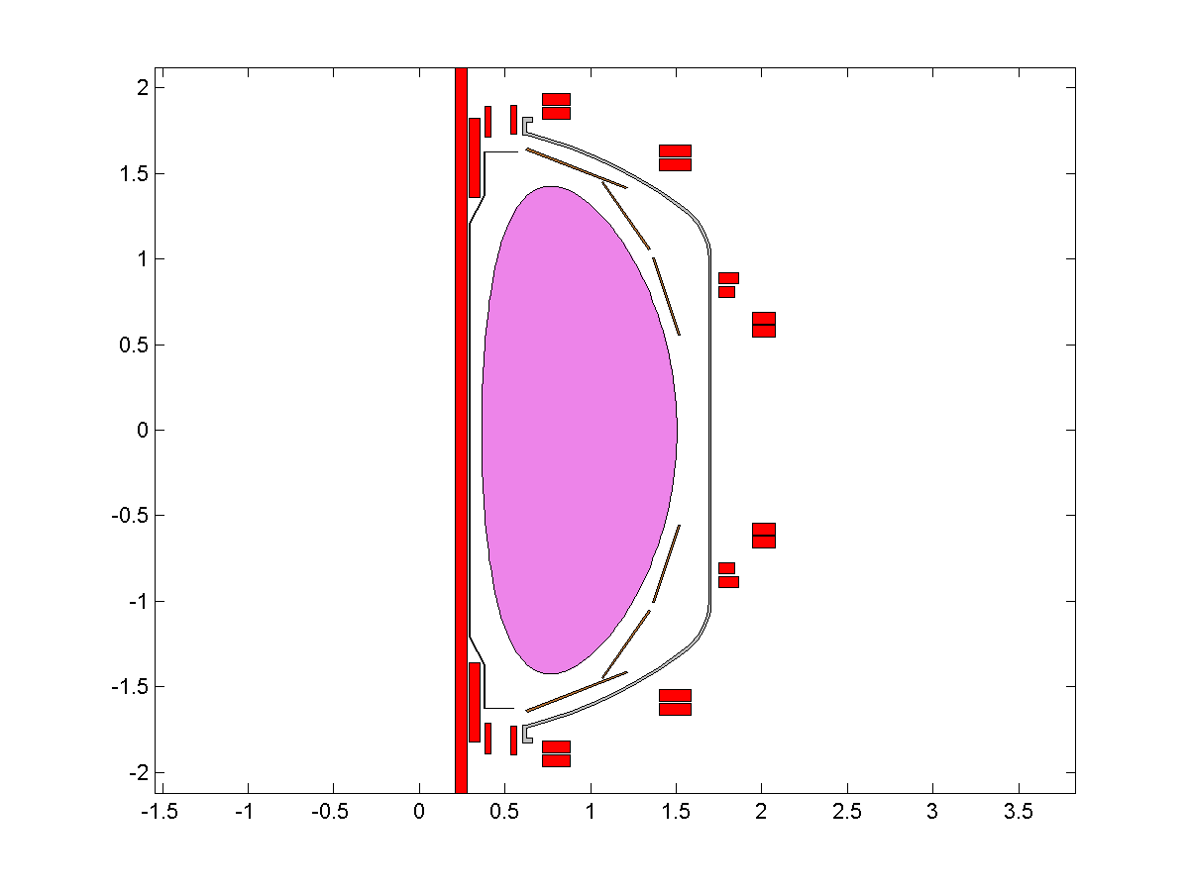
Figure 2 – Coil Configuration with plasmas for NSTX CSU Influence Matrix Calculation

The Opera program written for this analysis loops over all possible pairs of conducting elements and computes the static field for the case where each of the elements has a current density equivalent to 1 kA of current flowing through it. A Matlab™ routine was written to read the Opera output and produce contracted F_{R} and F_{Z} influence matrices. Contraction and application of turns are necessary at this point is necessary as most of the coils are made from multiple multi-turn elements in the model. Contracted vertical and radial force influence matrices are included in the following tables.

 | PF1aU | PF1bU | PF1cU | PF2U | PF3U | PF4U | PF5U | PF5L | PF4L | PF3L | PF2L | PF1cL | PF1bL | PF1aL | OH | Pl
PF1aU | 1179.0 | 1132.8 | 567.3 | 539.8 | 368.3 | 132.3 | 151.1 | 60.1 | 32.3 | 23.8 | 6.0 | 2.3 | 2.0 | 3.3 | -266.5 | 2.5
PF1bU | -223.0 | 460.1 | 652.6 | 467.8 | 225.3 | 69.9 | 79.9 | 30.5 | 16.2 | 12.0 | 3.0 | 1.1 | 1.0 | 1.6 | -186.3 | 1.1
PF1cU | -100.7 | -271.3 | 200.7 | 509.8 | 202.4 | 59.3 | 67.7 | 25.4 | 13.4 | 9.9 | 2.4 | 0.9 | 0.8 | 1.3 | -87.2 | 0.9
PF2U | -69.4 | -122.3 | -199.8 | 382.9 | 436.4 | 109.0 | 125.2 | 45.5 | 23.7 | 17.5 | 4.3 | 1.6 | 1.4 | 2.2 | -66.1 | 1.3
PF3U | -42.9 | -31.4 | -39.1 | -116.5 | 497.4 | 218.9 | 265.3 | 85.2 | 42.7 | 31.9 | 7.5 | 2.7 | 2.3 | 3.6 | -57.2 | 1.3
PF4U | -7.9 | -3.3 | -3.5 | -5.1 | 12.1 | 178.8 | 620.1 | 81.4 | 37.2 | 27.5 | 6.0 | 2.1 | 1.8 | 2.5 | -37.2 | -0.5
PF5U | -6.8 | -2.7 | -2.8 | -3.9 | 2.6 | -307.7 | 356.3 | 108.9 | 45.5 | 36.4 | 7.5 | 2.5 | 2.0 | 2.5 | -51.6 | -1.8
PF5L | 2.5 | 2.0 | 2.5 | 7.5 | 36.4 | 45.5 | 108.9 | 356.3 | -307.7 | 2.6 | -3.9 | -2.8 | -2.7 | -6.8 | -51.6 | -1.8
PF4L | 2.5 | 1.8 | 2.1 | 6.0 | 27.5 | 37.2 | 81.4 | 620.1 | 178.8 | 12.1 | -5.1 | -3.5 | -3.3 | -7.9 | -37.2 | -0.5
PF3L | 3.6 | 2.3 | 2.7 | 7.5 | 31.9 | 42.7 | 85.2 | 265.3 | 218.9 | 497.4 | -116.5 | -39.1 | -31.4 | -42.9 | -57.2 | 1.3
PF2L | 2.2 | 1.4 | 1.6 | 4.3 | 17.5 | 23.7 | 45.5 | 125.2 | 109.0 | 436.4 | 382.9 | -199.8 | -122.3 | -69.4 | -66.1 | 1.3
PF1cL | 1.3 | 0.8 | 0.9 | 2.4 | 9.9 | 13.4 | 25.4 | 67.7 | 59.3 | 202.4 | 509.8 | 200.9 | -271.3 | -100.7 | -87.2 | 0.9
PF1bL | 1.6 | 1.0 | 1.1 | 3.0 | 12.0 | 16.2 | 30.5 | 79.9 | 69.9 | 225.3 | 467.8 | 652.6 | 460.3 | -223.0 | -186.3 | 1.1
PF1aL | 3.3 | 2.0 | 2.3 | 6.0 | 23.8 | 32.3 | 60.1 | 151.1 | 132.3 | 368.3 | 539.8 | 567.3 | 1132.8 | 1178.9 | -266.5 | 2.5
OH | 5328.7 | 2394.2 | 1352.3 | 1572.7 | 1633.5 | 1048.0 | 1438.1 | 1438.1 | 1048.0 | 1633.5 | 1572.7 | 1352.3 | 2394.2 | 5328.6 | 34893.9 | 80.7
Pl | 0.5 | 0.3 | 0.3 | 0.9 | 3.7 | 5.5 | 9.1 | 9.1 | 5.5 | 3.7 | 0.9 | 0.3 | 0.3 | 0.5 | -1.9 | 0.2

Table 5 – Radial force influence matrix [lbf/kA²] for the circular plasma model.

 | PF1aU | PF1bU | PF1cU | PF2U | PF3U | PF4U | PF5U | PF5L | PF4L | PF3L | PF2L | PF1cL | PF1bL | PF1aL | OH | Pl
PF1aU | 0.0 | 552.0 | 171.1 | 111.7 | -0.2 | -13.2 | -15.3 | -8.1 | -4.7 | -3.5 | -1.0 | -0.4 | -0.3 | -0.6 | -154.1 | -0.6
PF1bU | -552.0 | 0.0 | 19.8 | 50.7 | -13.9 | -10.5 | -11.5 | -5.1 | -2.9 | -2.1 | -0.6 | -0.2 | -0.2 | -0.3 | -194.2 | -0.3
PF1cU | -171.1 | -19.8 | 0.0 | 96.5 | -19.4 | -12.8 | -13.8 | -5.9 | -3.3 | -2.5 | -0.6 | -0.3 | -0.2 | -0.4 | -129.7 | -0.3
PF2U | -111.7 | -50.7 | -96.5 | 0.0 | -99.3 | -38.9 | -40.9 | -16.0 | -8.8 | -6.5 | -1.7 | -0.6 | -0.6 | -1.0 | -171.7 | -0.8
PF3U | -0.2 | 13.9 | 19.4 | 99.3 | 0.0 | -225.4 | -211.9 | -66.6 | -35.5 | -25.7 | -6.5 | -2.5 | -2.1 | -3.5 | -86.4 | -2.4
PF4U | 13.2 | 10.5 | 12.8 | 38.9 | 225.4 | 0.0 | -490.4 | -99.8 | -51.7 | -35.5 | -8.8 | -3.3 | -2.9 | -4.7 | -20.8 | -2.4
PF5U | 15.3 | 11.5 | 13.8 | 40.9 | 211.9 | 490.4 | 0.0 | -203.9 | -99.8 | -66.6 | -16.0 | -5.9 | -5.1 | -8.1 | -19.8 | -2.6
PF5L | 8.1 | 5.1 | 5.9 | 16.0 | 66.6 | 99.8 | 203.9 | 0.0 | -490.4 | -211.9 | -40.9 | -13.8 | -11.5 | -15.3 | 19.8 | 2.6
PF4L | 4.7 | 2.9 | 3.3 | 8.8 | 35.5 | 51.7 | 99.8 | 490.4 | 0.0 | -225.4 | -38.9 | -12.8 | -10.5 | -13.2 | 20.8 | 2.4
PF3L | 3.5 | 2.1 | 2.5 | 6.5 | 25.7 | 35.5 | 66.6 | 211.9 | 225.4 | 0.0 | -99.3 | -19.4 | -13.9 | 0.2 | 86.4 | 2.4
PF2L | 1.0 | 0.6 | 0.6 | 1.7 | 6.5 | 8.8 | 16.0 | 40.9 | 38.9 | 99.3 | 0.0 | 96.5 | 50.7 | 111.7 | 171.7 | 0.8
PF1cL | 0.4 | 0.2 | 0.3 | 0.6 | 2.5 | 3.3 | 5.9 | 13.8 | 12.8 | 19.4 | -96.5 | 0.0 | 19.8 | 171.1 | 129.7 | 0.3
PF1bL | 0.3 | 0.2 | 0.2 | 0.6 | 2.1 | 2.9 | 5.1 | 11.5 | 10.5 | 13.9 | -50.7 | -19.8 | 0.0 | 552.0 | 194.2 | 0.3
PF1aL | 0.6 | 0.3 | 0.4 | 1.0 | 3.5 | 4.7 | 8.1 | 15.3 | 13.2 | 0.2 | -111.7 | -171.1 | -552.0 | 0.0 | 154.1 | 0.6
OH | 154.1 | 194.2 | 129.7 | 171.7 | 86.4 | 20.8 | 19.8 | -19.8 | -20.8 | -86.4 | -171.7 | -129.7 | -194.2 | -154.1 | 0.0 | 0.0
Pl | 0.6 | 0.3 | 0.3 | 0.8 | 2.4 | 2.4 | 2.6 | -2.6 | -2.4 | -2.4 | -0.8 | -0.3 | -0.3 | -0.6 | 0.0 | 0.0

Table 6 - Vertical force influence matrix [lbf/kA²] for the circular plasma model.

 | PF1aU | PF1bU | PF1cU | PF2U | PF3U | PF4U | PF5U | PF5L | PF4L | PF3L | PF2L | PF1cL | PF1bL | PF1aL | OH | Pl
PF1aU | 1180.0 | 1133.7 | 568.4 | 543.0 | 377.2 | 137.1 | 158.4 | 64.9 | 35.0 | 26.9 | 6.8 | 2.6 | 2.2 | 3.7 | -261.9 | 4.1
PF1bU | -222.3 | 461.0 | 653.3 | 470.1 | 231.5 | 73.1 | 84.8 | 33.6 | 17.9 | 13.8 | 3.5 | 1.3 | 1.1 | 1.8 | -183.2 | 1.7
PF1cU | -100.1 | -270.8 | 201.4 | 511.7 | 207.6 | 62.0 | 71.8 | 28.0 | 14.9 | 11.5 | 2.9 | 1.1 | 0.9 | 1.5 | -84.6 | 1.3
PF2U | -68.2 | -121.2 | -198.5 | 386.8 | 447.1 | 114.6 | 133.6 | 50.8 | 26.6 | 20.7 | 5.1 | 1.9 | 1.6 | 2.6 | -60.8 | 1.7
PF3U | -41.2 | -30.0 | -37.4 | -111.4 | 512.4 | 227.4 | 278.5 | 94.4 | 47.8 | 37.7 | 9.1 | 3.3 | 2.8 | 4.2 | -49.3 | 0.7
PF4U | -7.2 | -2.7 | -2.8 | -3.0 | 18.8 | 183.1 | 626.8 | 87.0 | 40.4 | 31.5 | 7.2 | 2.5 | 2.1 | 2.9 | -33.2 | -0.8
PF5U | -5.8 | -1.9 | -1.9 | -1.1 | 11.6 | -301.9 | 366.0 | 117.3 | 50.3 | 42.8 | 9.4 | 3.1 | 2.6 | 3.2 | -45.7 | -1.5
PF5L | 3.2 | 2.6 | 3.1 | 9.4 | 42.8 | 50.3 | 117.3 | 366.1 | -301.9 | 11.6 | -1.1 | -1.9 | -1.9 | -5.8 | -45.7 | -1.5
PF4L | 2.9 | 2.1 | 2.5 | 7.2 | 31.5 | 40.4 | 87.0 | 626.8 | 182.9 | 18.8 | -3.0 | -2.8 | -2.7 | -7.2 | -33.2 | -0.8
PF3L | 4.2 | 2.8 | 3.3 | 9.1 | 37.7 | 47.8 | 94.4 | 278.5 | 227.4 | 512.4 | -111.4 | -37.4 | -30.0 | -41.2 | -49.3 | 0.7
PF2L | 2.6 | 1.6 | 1.9 | 5.1 | 20.7 | 26.6 | 50.8 | 133.6 | 114.6 | 447.1 | 386.8 | -198.5 | -121.2 | -68.2 | -60.8 | 1.7
PF1cL | 1.5 | 0.9 | 1.1 | 2.9 | 11.5 | 14.9 | 28.0 | 71.8 | 62.0 | 207.6 | 511.7 | 201.4 | -270.8 | -100.1 | -84.6 | 1.3
PF1bL | 1.8 | 1.1 | 1.3 | 3.5 | 13.8 | 17.9 | 33.6 | 84.8 | 73.1 | 231.5 | 470.1 | 653.3 | 460.9 | -222.3 | -183.2 | 1.7
PF1aL | 3.7 | 2.2 | 2.6 | 6.8 | 26.9 | 35.0 | 64.9 | 158.4 | 137.1 | 377.2 | 543.0 | 568.4 | 1133.6 | 1179.9 | -261.9 | 4.1
OH | 5334.8 | 2399.3 | 1358.3 | 1590.8 | 1688.0 | 1082.3 | 1494.5 | 1494.5 | 1082.3 | 1688.0 | 1590.8 | 1358.4 | 2399.3 | 5334.8 | 34935.7 | 80.1
Pl | 0.3 | 0.3 | 0.4 | 1.3 | 5.0 | 5.6 | 8.2 | 8.2 | 5.6 | 5.0 | 1.3 | 0.4 | 0.3 | 0.3 | -1.9 | 0.2

Table 7 - Radial force influence matrix [lbf/kA²] for the shaped plasma model.

 | PF1aU | PF1bU | PF1cU | PF2U | PF3U | PF4U | PF5U | PF5L | PF4L | PF3L | PF2L | PF1cL | PF1bL | PF1aL | OH | Pl
PF1aU | 0.0 | 552.0 | 171.1 | 111.7 | 0.2 | -13.2 | -15.3 | -8.1 | -4.7 | -3.5 | -1.0 | -0.4 | -0.3 | -0.6 | -154.1 | -1.0
PF1bU | -552.0 | 0.0 | 19.8 | 50.7 | -13.9 | -10.5 | -11.5 | -5.1 | -2.9 | -2.2 | -0.6 | -0.2 | -0.2 | -0.3 | -194.2 | -0.6
PF1cU | -171.1 | -19.8 | 0.0 | 96.5 | -19.4 | -12.8 | -13.8 | -6.0 | -3.3 | -2.5 | -0.7 | -0.3 | -0.2 | -0.4 | -129.7 | -0.6
PF2U | -111.7 | -50.7 | -96.5 | 0.0 | -99.3 | -39.0 | -41.0 | -16.1 | -8.8 | -6.5 | -1.7 | -0.7 | -0.6 | -1.0 | -171.8 | -1.3
PF3U | -0.2 | 13.9 | 19.4 | 99.3 | 0.0 | -225.4 | -212.0 | -66.8 | -35.6 | -25.9 | -6.5 | -2.5 | -2.2 | -3.5 | -86.5 | -2.7
PF4U | 13.2 | 10.5 | 12.8 | 39.0 | 225.4 | 0.0 | -490.5 | -99.9 | -51.8 | -35.6 | -8.8 | -3.3 | -2.9 | -4.7 | -20.8 | -1.5
PF5U | 15.3 | 11.5 | 13.8 | 41.0 | 212.0 | 490.5 | 0.0 | -204.1 | -99.9 | -66.8 | -16.1 | -6.0 | -5.1 | -8.1 | -19.8 | -1.4
PF5L | 8.1 | 5.1 | 6.0 | 16.1 | 66.8 | 99.9 | 204.1 | 0.0 | -490.5 | -212.0 | -41.0 | -13.8 | -11.5 | -15.3 | 19.8 | 1.4
PF4L | 4.7 | 2.9 | 3.3 | 8.8 | 35.6 | 51.8 | 99.9 | 490.5 | 0.0 | -225.4 | -39.0 | -12.8 | -10.5 | -13.2 | 20.8 | 1.5
PF3L | 3.5 | 2.2 | 2.5 | 6.5 | 25.9 | 35.6 | 66.8 | 212.0 | 225.4 | 0.0 | -99.3 | -19.4 | -13.9 | 0.2 | 86.5 | 2.7
PF2L | 1.0 | 0.6 | 0.7 | 1.7 | 6.5 | 8.8 | 16.1 | 41.0 | 39.0 | 99.3 | 0.0 | 96.5 | 50.7 | 111.7 | 171.8 | 1.3
PF1cL | 0.4 | 0.2 | 0.3 | 0.7 | 2.5 | 3.3 | 6.0 | 13.8 | 12.8 | 19.4 | -96.5 | 0.0 | 19.8 | 171.1 | 129.7 | 0.6
PF1bL | 0.3 | 0.2 | 0.2 | 0.6 | 2.2 | 2.9 | 5.1 | 11.5 | 10.5 | 13.9 | -50.7 | -19.8 | 0.0 | 552.0 | 194.2 | 0.6
PF1aL | 0.6 | 0.3 | 0.4 | 1.0 | 3.5 | 4.7 | 8.1 | 15.3 | 13.2 | -0.2 | -111.7 | -171.1 | -552.0 | 0.0 | 154.1 | 1.0
OH | 154.1 | 194.2 | 129.7 | 171.8 | 86.5 | 20.8 | 19.8 | -19.8 | -20.8 | -86.5 | -171.8 | -129.7 | -194.2 | -154.1 | 0.0 | 0.0
Pl | 1.0 | 0.6 | 0.6 | 1.3 | 2.7 | 1.5 | 1.4 | -1.4 | -1.5 | -2.7 | -1.3 | -0.6 | -0.6 | -1.0 | 0.0 | 0.0

Table 8 – Vertical force influence matrix [lbf/kA²] for the shaped plasma model.

Distribution: C. Neumeyer, P. Titus, J. Menard, R. Woolley, L. Dudek, R. Simmons

