NSTX Upgrade

OH-PF1a/b Magnetic Stability

NSTXU-CALC-133-11-00
Rev 0
March 2 2010

Prepared By:

___________________________________
Peter Titus, , PPPL Mechanical Engineering

Reviewed By:

________________________________________
Ali Zolfaghari

Approved By:

________________________________________
Jim Chrzanowski, NSTX Cognizant Engineer

PPPL Calculation Form

Calculation # NSTXU-CALC-133-11-00 Revision # 00 WP #: 1672
(ENG-032)
Purpose of Calculation: (Define why the calculation is being performed.)

To demonstrate that the structural elements that center the centerstack are stiff enough to overcome magnetic instabilites between the OH and PF1a, and b which are mounted on the centerstack casing. This calculation has been prepared in response to a PDR CHIT.

References (List any source of design information including computer program titles and revision levels.)

[1] NSTX-CALC-13-001-00 Rev 1 Global Model – Model Description, Mesh Generation, Results, Peter H. Titus February 2011
[2] NSTX Structural Design Criteria Document, NSTX_DesCrit_IZ_080103.doc I. Zatz
[3] NSTX Design Point June 3 2010 http://www.pppl.gov/~neumeyer/NSTX_CSU/Design_Point.html
[4] Centerstack Casing Bellows, Peter Rogoff, NSTXU-CALC-133-10-00
[5] OH Preload System and Belleville Spring Stack Design, Peter Rogoff, NSTXU-CALC-133-04-00
[6] Email from Jim Chrzanowski Sent: Wed 3/9/2011 9:09 AM
Pete
We can probably hold the current centers +/- 0.060 inch or better
Jim
[7] NSTX Upgrade Centerstack Casing and Lower Skirt Stress Summary NSTXU-CALC-133-03-00
Rev 0 August 2011 Prepared by P.Titus

Assumptions (Identify all assumptions made as part of this calculation.)

The only PF interaction that was investigated was the PF1a/b -OH pairing. This is judged to be the most flexible structural interaction in the PF system because at the upper end of the casing and OH, the PF1a,and b are only stabilized by the stiffness of the bellows, and OH preload mechanism.

Calculation (Calculation is either documented here or attached)

Attached in the body of the calculation

Conclusion (Specify whether or not the purpose of the calculation was accomplished.)

The magnetic stiffness was calculated to be .637 MN/m and the structural stiffness was calculated to be 100 MN/m (Combined bellows and Belleville Spring Post Stiffness) . The structural stiffness was found to be well in excess of the magnetic stiffness, indicating stability against field errors and manufacturing tolerances. The stress due to the manufacturing tolerance would be a maximum of .43 MPa and the bellows stress would be 9.77 MPa. An assessment of the bellows stress based on ref [4] is included in Appendix A. Bellows stresses are acceptable.

Cognizant Engineer’s printed name, signature, and date

Jim Chrzanowski

I have reviewed this calculation and, to my professional satisfaction, it is properly performed and correct.

Checker’s printed name, signature, and date

A Zolfaghari
Table of Contents
Page
Executive Summary 3
DCPS Input
Interaction Forces Due to Concentric Misalignment of Inner PF Coils with
Respect to the OH Coil Using MAXWELL
OH/PF1a Interaction 4
OH/PF1a,b Interaction
Interaction Forces Due to Concentric Misalignment of Inner PF Coils with
Respect to the OH Coil Using NTFTM 7
Lateral Structural Stiffness - Bellows and Cantelevered Centerstack Casing 8
Centerstack Casing Stress due to Lateral Offset 10
Compliance of the Belleville Spring Preload System. 11
Appendix A Bellows Stress Check 12
Executive Summary:

The possibility of magnetic instabilities of the various poloidal coils was raised at the CDR and PDR. All the coils are well supported off the vacuum vessel or centerstack casing. There are no coils supported by light, flexible supports. PF 1a and 1b upper and lower are mounted on the centerstack casing. The radial connection between the centerstack casing and the rest of the NSTX structure is rigid and strong at the lower casing connections. A "skirt" connects the lower casing flange to the lower TF flag structures. PF1 a and b lower are aligned stiffly with respect to the OH. At the upper end there is no connection between the centerstack and the TF or the OH. Alignment is maintained by the upper bellows. The OH is also well positioned with respect to the TF at the lower end through the "skirt", but at the upper end, alignment is maintained by the lateral stiffnesses of the belleville preload mechanism. The centerstack TF components are well centered by the spoked lid and collar. This calculation addresses the magnetic stability of the centerstack assembly with respect to the OH coil, Magnetic loads that result from a unit offset of the centers of the coils are computed using a Biot Savart program written by the author of the report and in MAXWELL, by the checker of this report.

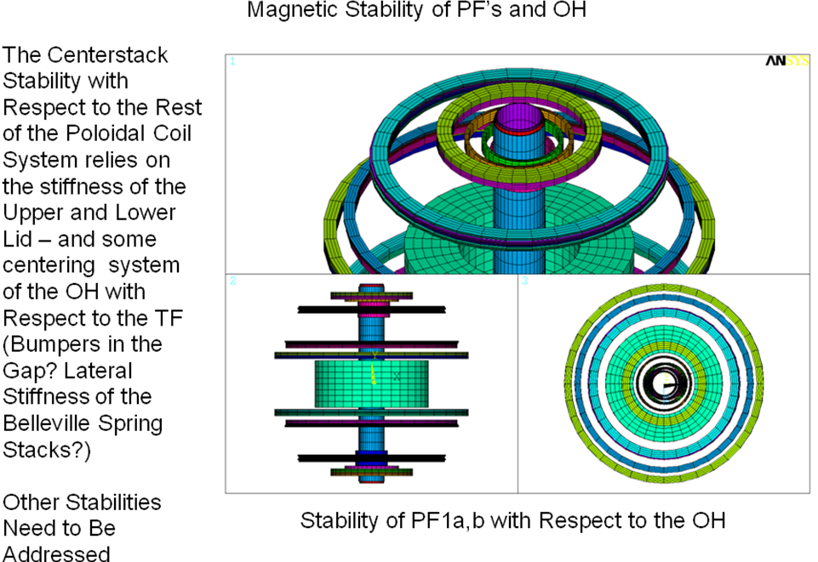
The structural stiffness was found to be well in excess of the magnetic stiffness, indicating stability against field errors and manufacturing tolerances. The stress due to the manufacturing tolerance would be a maximum of.43 MPa and the bellows stress would be 9.77 MPa An assessment of the bellows stress based on ref [4] is included in Appendix A. Bellows stresses are acceptable.
DCPS Input
This establishes an Magnetic "stiffness". This is then compared with a structural stiffness. The structural stiffness must exceed the magnetic stiffness for the coils to be stable. The magnetic stiffness was calculated to be .637 MN/m and the structural stiffness was calculated to be 425 MN/m This calculation demonstrates a large stability margin between the inner PF coils and the OH coil, with peak coil currents applied. No interface with the DCPS is required. Stress evaluations of the more significant loads on the centerstack casing are included in ref [7]

Interaction Forces Due to Concentric Misalignment of Inner PF Coils with Respect to the OH Coil Using MAXWELL

Interactions between the inner PF coils and the OH due to deviations in concentricity have been evaluated using the MAXWELL code. MAXWELL is a finite element electromagnetic code used to solve electromagnetic field equations in 2d and 3D. In this analysis we have used MAXWELL 3D to obtain forces on solenoids that represent the OH, PF1a and PF1b coils in NSTX upgrade.

Interaction Forces Due to Concentric Misalignment of PF1a Coil with Respect to the OH Coil

Coil Current (kA) Turns
OH 24 884 reference [3]
PF1a 18.3 64 reference [3]

PF1a and is moved from its concentric position with respect to the OH coil by two different distances of 2mm and 5 mm.
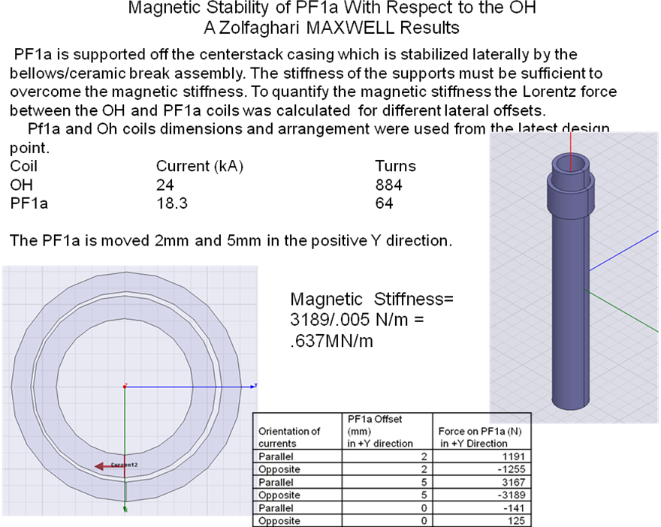

Interaction Forces Due to Concentric Misalignment of PF1a and PF1b Coils with Respect to the OH Coil

PF1a and PF1b are moved from their concentric position with respect to the OH coil by two different distances of 2mm and 5 mm. As expected, if the currents in PF1a and PF1b are in parallel to the current in OH, once the Pf1a and PF1b are moved from their concentric orientation with respect to the OH, a force appears which is increased with the distance and tries to further the distance. This can be interpreted as resulting in a magnetic stiffness equivalent to the magnetic force divided by the distance. The table below list the computed forces vs. distance.

Setup:

Coil Current (kA) Turns
OH 24 884 Reference [3]
PF1a 18.3 64 Reference [3]
PF1b 13 32 Reference [3]

The PF1a and PF1b are moved together 2mm and 5mm in the positive Y direction.

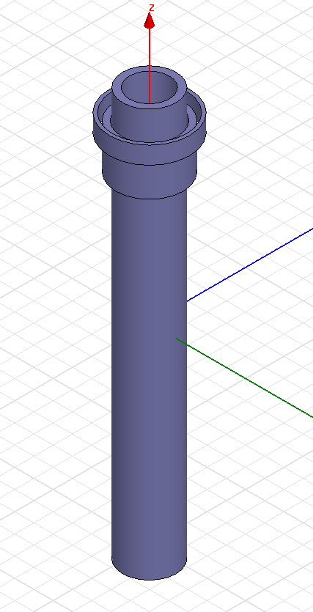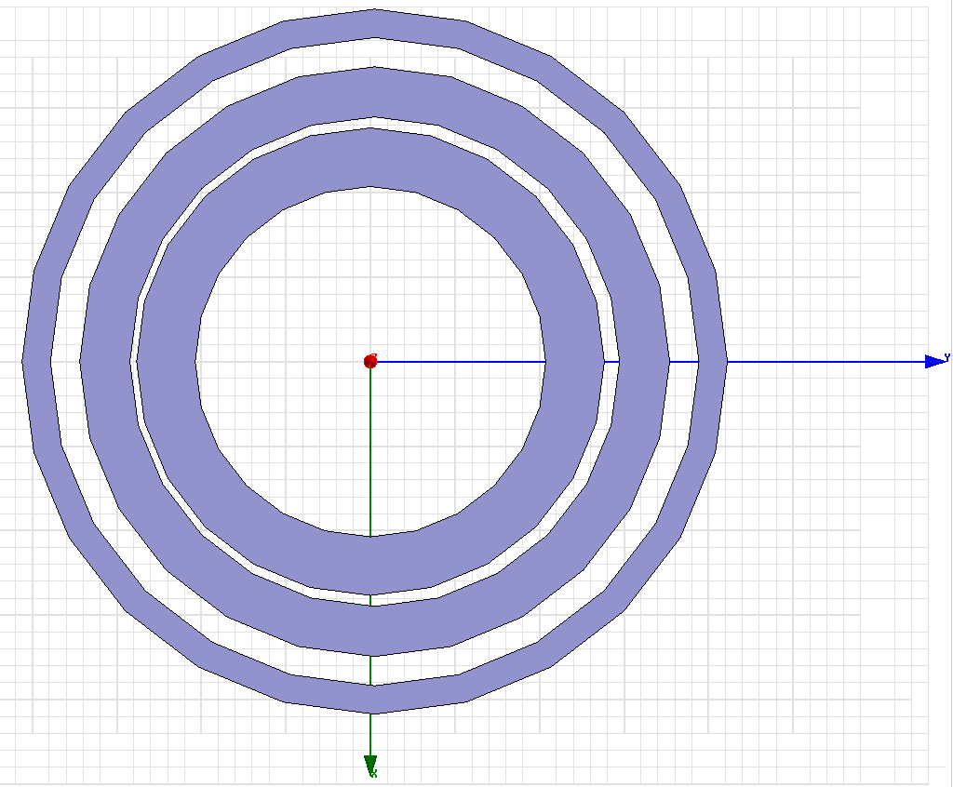

Orientation of  PF1a and PF1b currents with OH current | PF1a and PF1b Offset (mm) with respect to OH  in +Y direction | Total Force (N) on PF1a & PF1b in +Y Direction
Parallel | 2 | 2124
Opposite | 2 | -2140
Parallel | 5 | 6099
Opposite | 5 | -5579
Parallel | 0 | -311
Opposite | 0 | 576

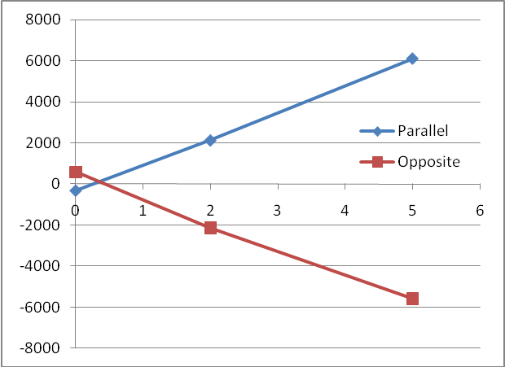
Magnetic Stiffness= 6000/.005 N/m = 1.274MN/m For the combined effects of PF1a,b and the OH

Interaction Forces Due to Concentric Misalignment of Inner PF Coils with Respect to the OH Coil using the NTFTM Code
NTFTM2 is a mesh generation code with some capabilities to calculate magnetic fields and forces. It is used here partly to calculate the lateral forces as a function of lateral offset. It also provides a check of the MAXWELL modeling and the comparison with Maxwell supports the qualification of the NTFTM code as used in ref [1] and elsewhere. The MAXWELL OH PF1a,b force calculations are are the same as those calculated by NTFTM2.

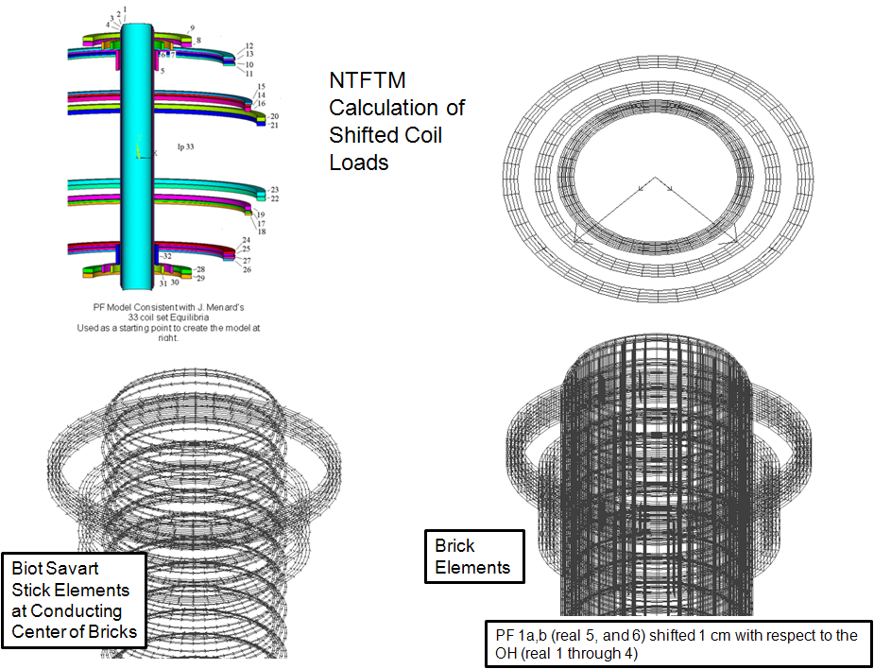

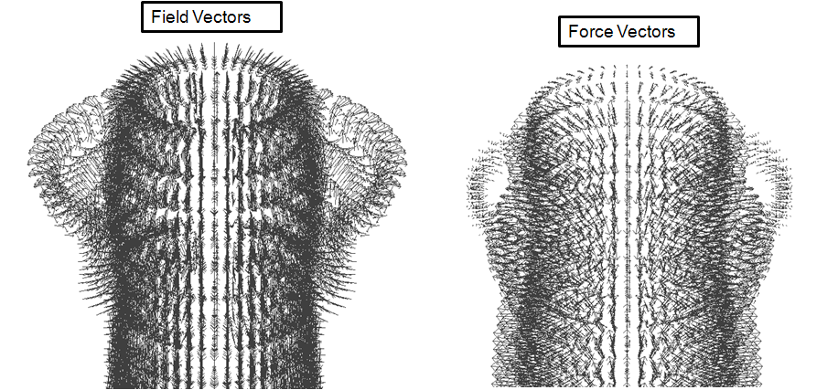

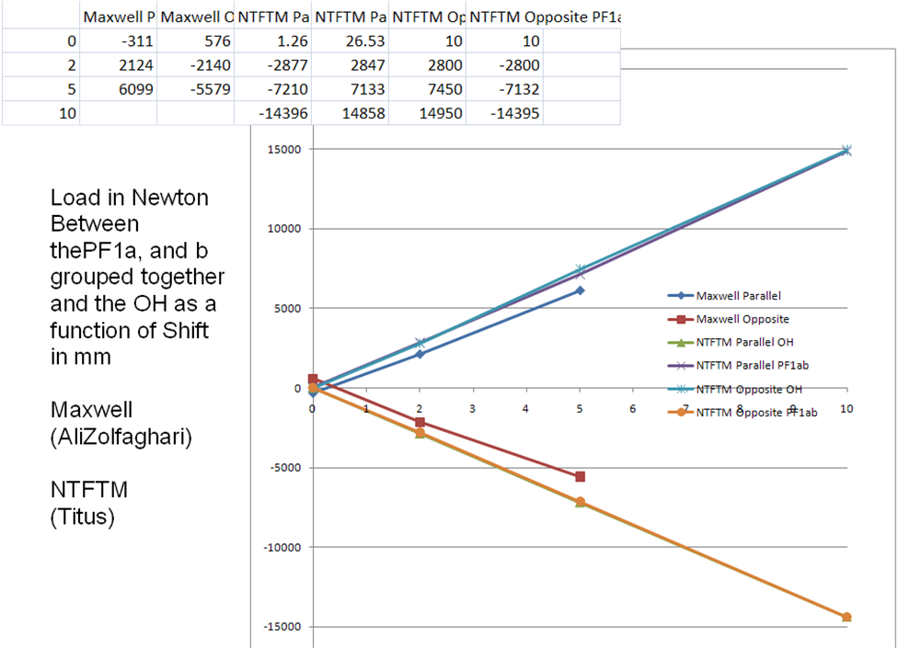
Load in Newton, Between thePF1a, and b grouped together and the OH as a function of Shift in mm - MAXWELL (Ali Zolfaghari) - NTFTM (Titus)

Lateral Structural Stiffness - Bellows and Cantilevered Centerstack Casing

A portion of the global model [1] was extracted to obtain an estimate of the structural lateral stiffness. The model is shown below, and the results of the analysis are shown in the following Figure:
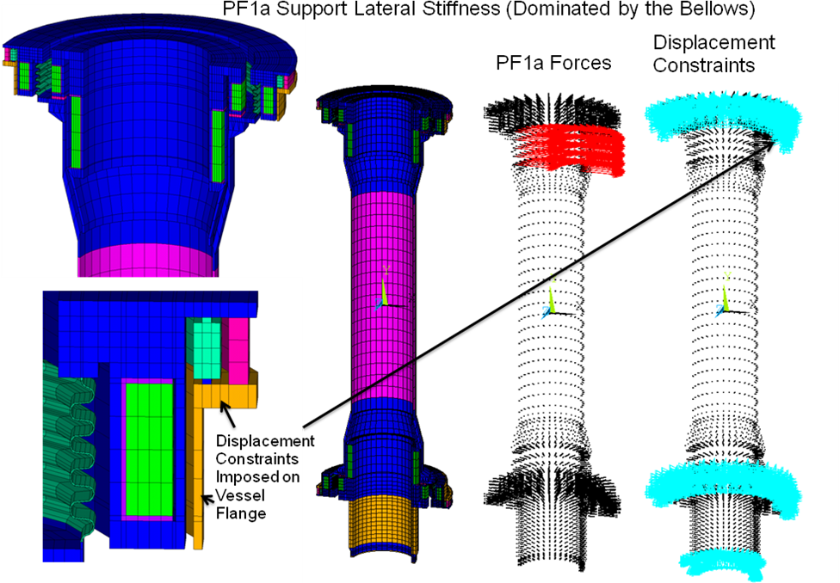

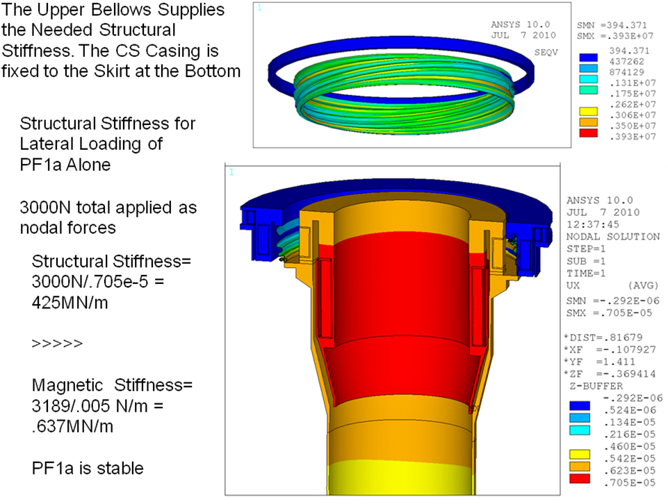
The bellows detail in this analysis is old and could be updated to be consistent with ref [4], but the margins are large and the small change in bellows stiffness will not alter the conclusions of this calculation.
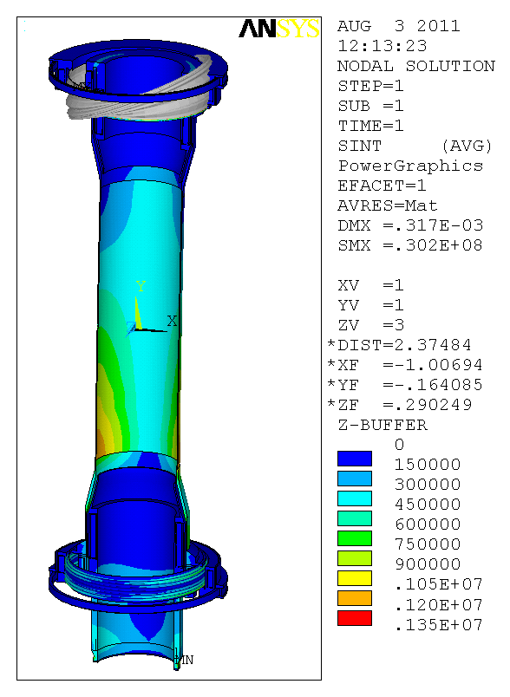
Stress Due to 3000N Load
Jim Chrzanowski estimated the tolerance in the manufacture of the coils as .060 inches on the alignment of the magnetic centers with respect to the geometric centers of the coils [6]. This is 1.524mm. The magnetic load would be .627e6*.001524 = 971 N or 218 lbs. This would produce an additional offset of 971/425e6 = 2.28e-6 m.
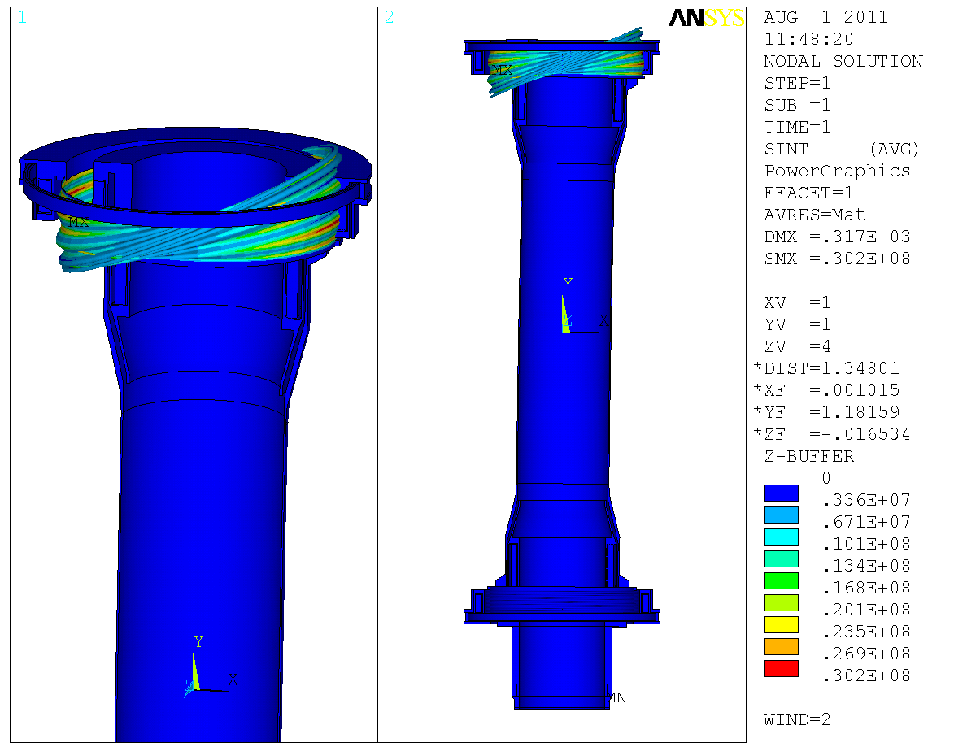
Bellows Stress Due to 3000N Load

Scaling the centerstack casing stress from the 3000 N stiffness calculation, The stress due to the manufacturing tolerance would be 971/3000*1.35MPa = .43 MPa and the bellows stress would be 30.2 MPa*971/3000 = 9.77 MPa
Compliance of the Belleville Spring Preload System.

The lateral stiffness of this assembly is complex, but a major contributor is the cantilevered posts that center the Bellevilles. These are simply represented by 14 cantilevered beams.
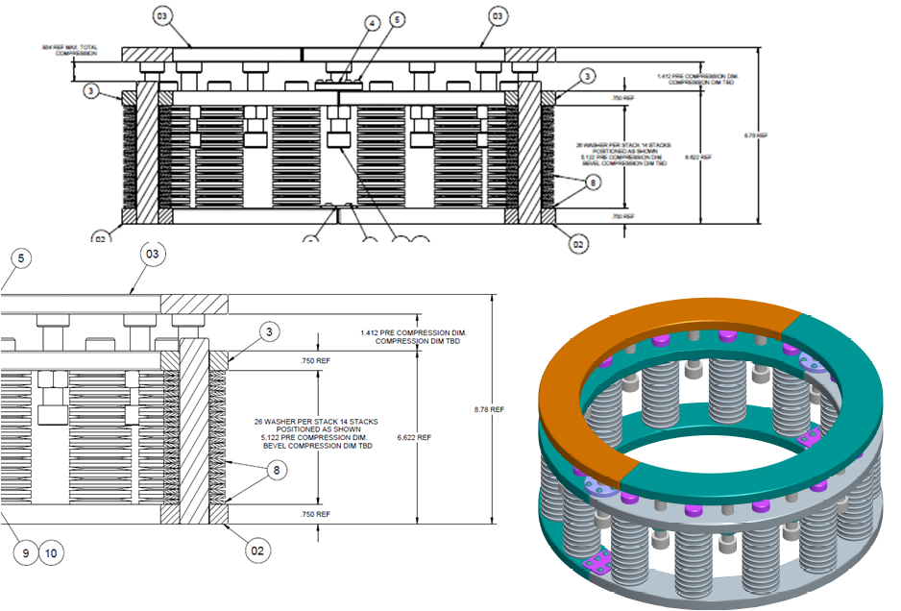

The lateral stiffness of the posts is 131 MN/m (see below) The combined bellows and post stiffness is (1/K bellows + 1/K Belleville posts)^-1 or (1/131+1/425)^-1= 100 MN/m

The bending stiffness per post is 3*E*I/L^3
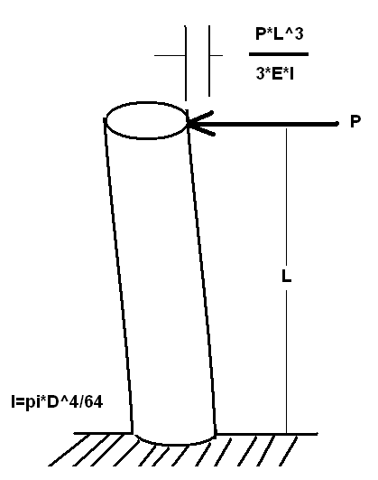

Num of Spring Stacks |  | 14
Post Diameter |  | 1.2 |  | inches
Post Mom of Inertia= |  | -0.08482 |  | inches^3
Post Height, L= |  | 5.2 |  | Inches
Modulus |  |  | 2.95E+07
Bend Stiff per Post |  | -5.34E+04
Bend Stiff all Posts |  | -7.47E+05 |  | lbs/in
Bend Stiff All Posts |  | -1.31E+02 |  | MN/m

Appendix A
Bellows Extra 9 MPa Check

