CALCULATION OF OH COIL STRESSES IN THE NSTX CSU

NSTXU-CALC-133-08-00

April 28, 2011

Prepared By:

___________________________________
Ali Zolfaghari, PPPL Mechanical Engineering
Reviewed By:

________________________________________
Peter Titus, Branch Head, Engineering Analysis Division
Reviewed By:

_______________________________________
Phil Heitzenroeder, Head, Mechanical Engineering

PPPL Calculation Form

Calculation # NSTXU-CALC-133-08 Revision # WP #, if any 1672
(ENG-032)

Purpose of Calculation: (Define why the calculation is being performed.)

To estimate the anticipated stresses in the upgraded NSTX OH coil in various discharge scenarios and to qualify OH design to withstand the forces.

References (List any source of design information including computer program titles and revision levels.)

[1] NSTX Structural Design Criteria Document, I. Zatz
[2] NSTX Design Point March 2011
http://www.pppl.gov/~neumeyer/NSTX_CSU/Design_Point.html
[3] NSTX Upgrade OH Conductor Fatigue Analysis, P. Titus, Calc #NSTXU-Calc-133-09

Assumptions (Identify all assumptions made as part of this calculation.)

For the TF/OH interaction analysis, the friction ratio between the TF and OH at the interface was assumed to be 0.15.

Calculation (Calculation is either documented here or attached)

Attached.

Conclusion (Specify whether or not the purpose of the calculation was accomplished.)

Please see executive summary in the attached report.

Cognizant Engineer’s printed name, signature, and date

I have reviewed this calculation and, to my professional satisfaction, it is properly performed and correct.

Checker’s printed name, signature, and date

Executive Summary

The objective of this analysis was to estimate the anticipated stresses in the upgraded NSTX OH coil in various scenarios. Axisymmetric coupled structural /Emag modeling of the OH coil and interaction with PF coils were performed using ANSYS. The OH coil was modeled both as a volume with smeared property and as discrete conductors and insulation volumes. Additionally the maximum stress in the OH coil due to thermal expansion in the TF coils was calculated. This stress results from the fault scenario were the OH coil which is wound on the TF bundle fails to energize while TF bundle is energized and expands out thermally.

Analysis shows that the OH coil can withstand hoop stress and shear stress at I=24kA. The analysis also revealed that in order to run the PF1A coil at 16.6 kA concurrently with the OH coil, the current in the OH will need to be limited to 13kA. The stress in the OH coil due to hot-OH cold-TF scenario was found to be acceptable but the frictional shear along the length of the TF-OH interface produces unacceptable vertical tension in the OH coil. Mechanical solutions such as low friction interface and removable interface layer as well as electrical solutions in the coil protection system need to be considered for this problem.

In analyzing the cooling stresses, we also pointed out the need to equalize flow velocity in the inside and outside OH turns in order to avoid large thermal stresses in the OH coil winding. In the bottom of the coil where cold water enters the coil that has been heated to near 100 Deg C due to the current and where the coil is attached to a cold G-10 base, stress in small localized regions in the insulation exceeds the limit. It is recommended to put a slip plane at the interface of the base and the outside layer of the coil.

Introduction

The main structural loads on the OH coil and the center stack components are the results of electromagnetic (EM) forces and differential thermal expansion. The EM forces in the OH coil result from the hoop forces and the axial compression in the coil. In addition, the field from nearby coils especially the PF coils exerts force on the OH coil windings.
Since the OH in NSTX upgrade is directly wound on the TF inner leg bundle, the thermal expansion in the TF in fault cases where the OH is not energized (and remains cold) causes stress in the OH. In the calculations reported here, the OH design analyzed is the latest and final design of the OH reported in http://www.pppl.gov/~neumeyer/NSTX_CSU/Design_Point.html and whose detail are in the Design Point Spreadsheet:

http://www.pppl.gov/~neumeyer/NSTX_CSU/Design_Point_Spreadsheets/NSTX_CS_Upgrade_100504.xls

Calculation

OH Stress Analysis

To study EM and thermal expansion loads on the OH coil, an axisymmetric discrete-conductor finite element model of the entire OH coil was developed. Figure 1 is a section of this model showing the finite element mesh of the copper (dark blue), epoxy insulation (light blue), and air (green). Air was meshed for electromagnetic simulation. Ansys Multiphysics FEA code was used to study the coupled EM, structural and thermal effects.

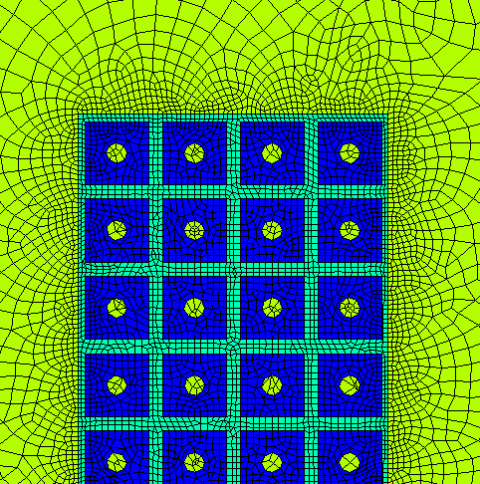
Figure 1: Finite Element Mesh Used in Axisymmetric Structural Analysis of the OH coil

Figure 2 is a plot of hoop stress in the coil at 24kA. The stress is below 156 MPa limit for copper. Figure 3 is a plot of the mid-plane (Tresca) stress intensity resulting from the combination of hoop and axial stresses. The stress is below the 156 MPa limit in the copper and therefore acceptable. A discussion of the fatigue analysis will follow. Figure 4 is a contour plot of shear stress in the coil epoxy insulation which is shown to be below the 22 MPa limit.

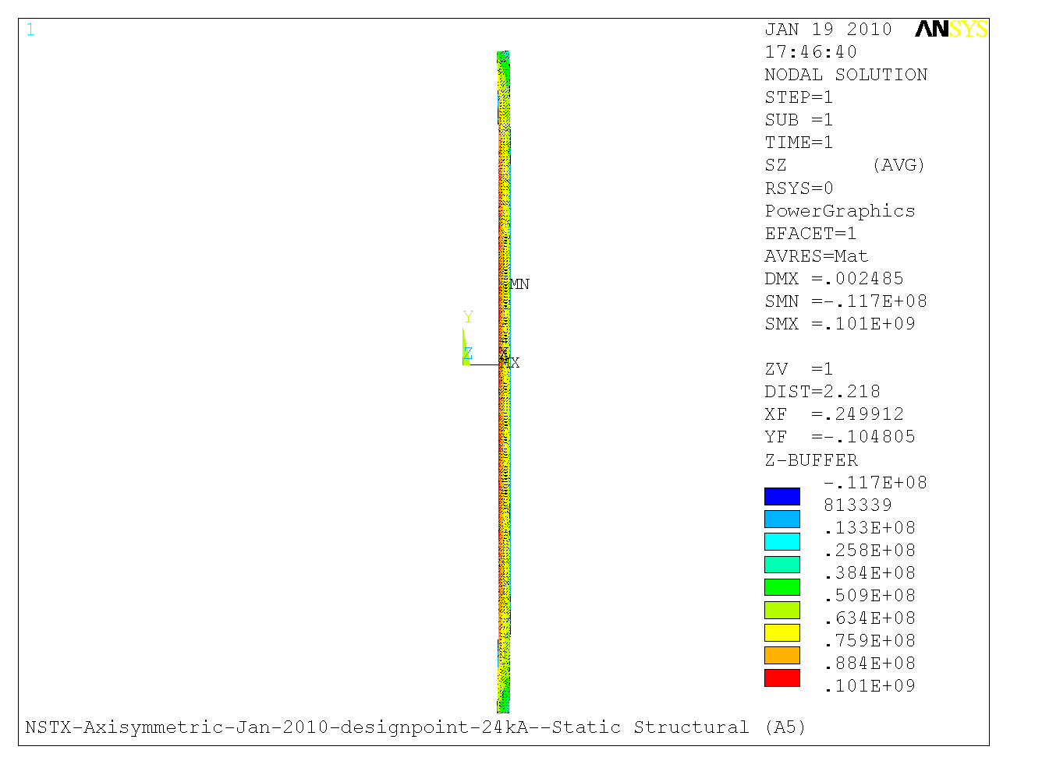
Figure 2

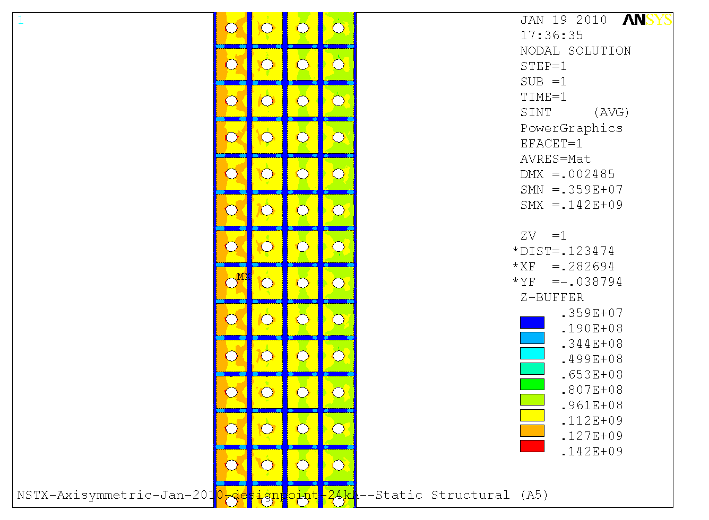
Figure 3

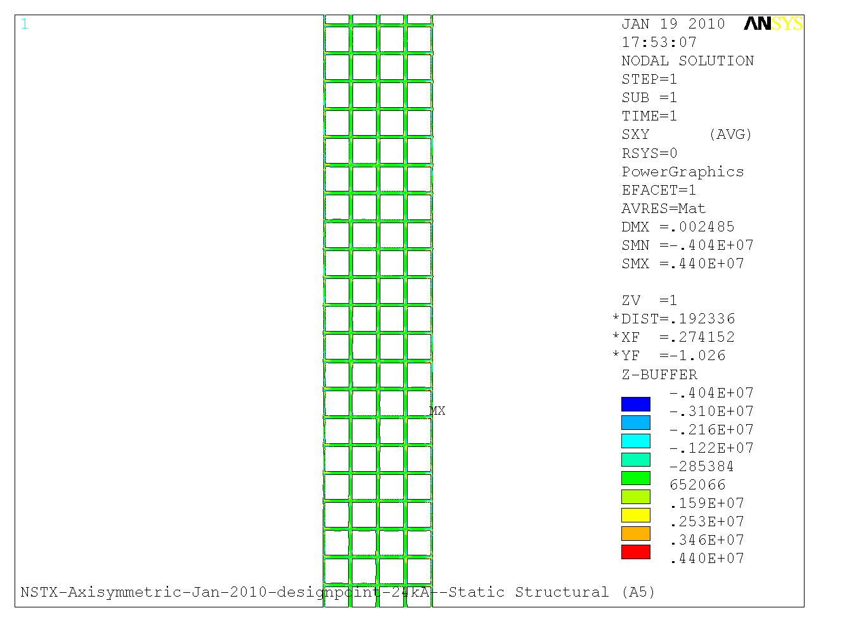
Figure 4

Conductor Fatigue Analysis

Ref[3] includes a detailed analysis of the fatigue in the OH conductor. NSTX structural criteria, and the GRD require fatigue to be addressed. The criteria allows either SN or fracture mechanics evaluations of fatigue. For SN evaluations, the more restrictive of 2 on stress and 20 on life must be met. For the Fracture mechanics evaluation a factor of 2 on flaw size, 1.5 on fracture toughness, and 2 on life must be met. The stress levels in the NSTX-U OH coil satisfy the fracture mechanics criteria, and therefore satisfy the NSTX structural requirements. Table below from Ref[3] summarizes this information.
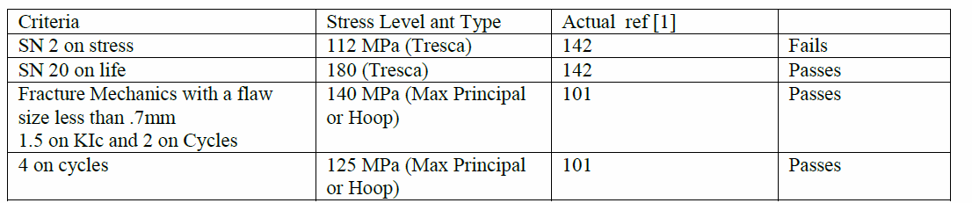

Effect of PF1A

Figure 5 shows the stress intensity in the OH winding resulting from interaction with the poloidal field coils PF1A (Upper and Lower) which is housed close to the OH coil inside the center stack housing. The plot is for a case where the OH coil current is 13 kA and PF1A coils carry 16.6 kA current. The plot shows the stress in the copper is below the stress limit. From the results of analyses with this model we derived criteria limiting the currents that can flow in the OH and PF1A coils at any one time during the discharge in order to avoid damaging the OH coil.

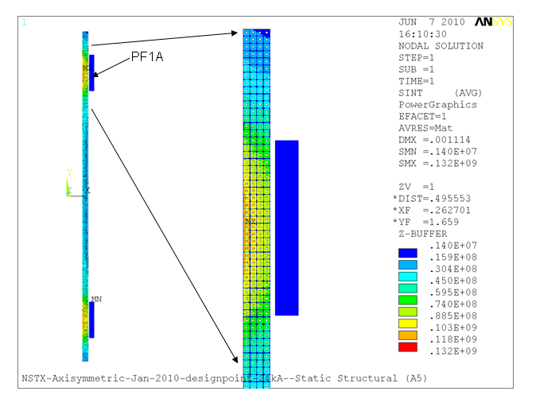
Figure 5: Stress Intensity in the OH Coil Due to Self Currents and Interaction with Current in Adjacent PF1A Poloidal Field Coil

Analysis of TF/OH Interaction

The OH coil in NSTX upgrade is directly wound on the TF inner legs bundle and preloaded against the TF flag extensions using Bellville spring washers.
The spring washer stacks need to be designed such as to keep the OH coil from lifting (and breaking the leads in the bottom) under all possible machine operation scenarios. Calculation number NSTX-CALC-133-04-00 by Peter Rogoff covers the design of the spring washer stacks.

In fault cases where the OH is not energized and the TF is energized (hot) the thermal expansion in the TF causes stress in the OH which is wound directly on the TF inner legs. To study this we developed two models. First model was an axisymmetric model of the center stack components in which OH was modeled as smeared property cylinder (rectangle in axisymmetry). The Bellville washer stacks were modeled as axisymmetric spring elements in the FEA model. Figure 6 shows the center stack components and this axisymmetric FEA model.

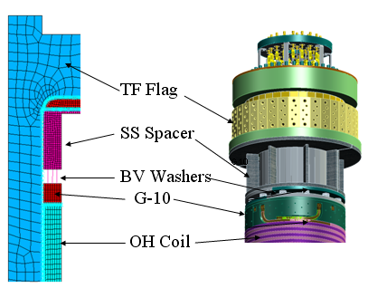

Figure 6

The second model developed was an axisymmetric coupled EM-structural Ansys FEA model in which the OH was modeled as discrete copper and insulation elements. (figure 7).

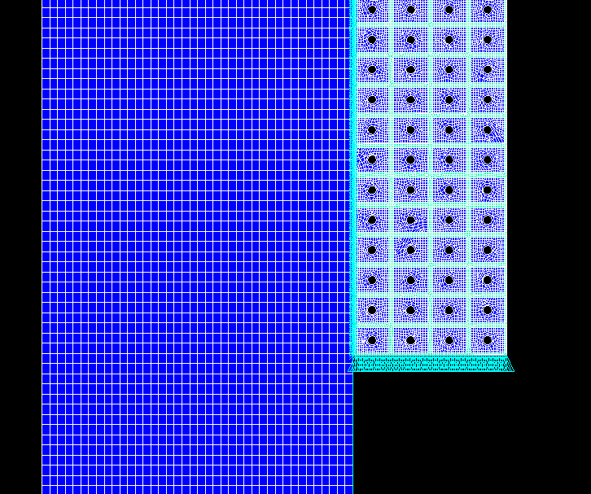
Figure 7

The TF inner leg bundle was modeled as a thick copper tube with contact elements between the TF and OH mesh with a friction ratio of 0.15. OH was held fixed in the bottom and preloaded on the top with 100,000 lbs. The model was simulated with cold OH and TF temperature allowed to rise from 12 to 100 deg. C. Figure 8 shows the resulting stress in the coil and the shear stress in the insulation on top portion of the coil. These stress values are acceptable.

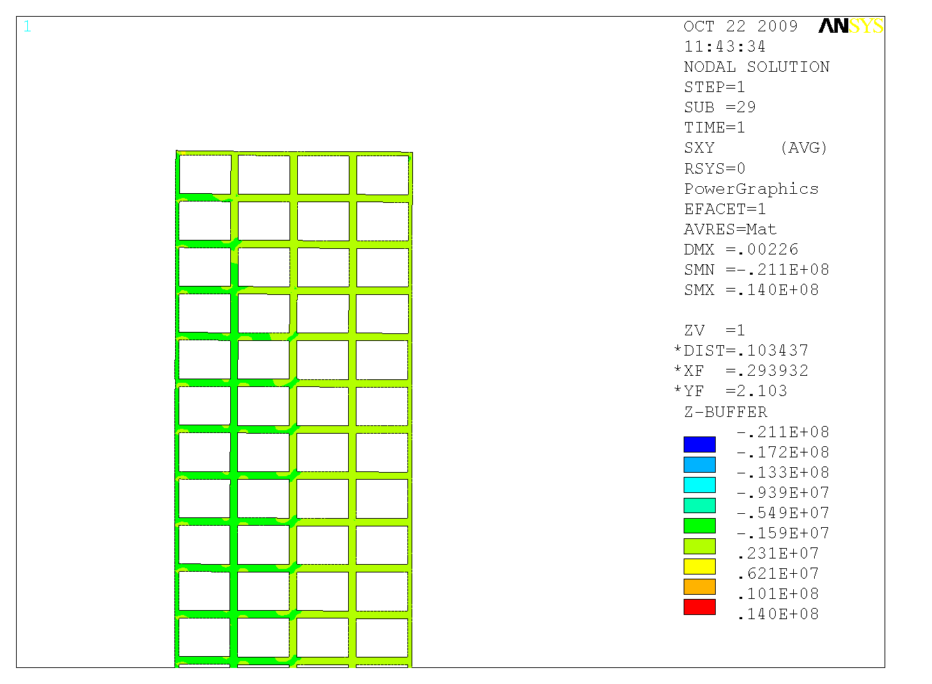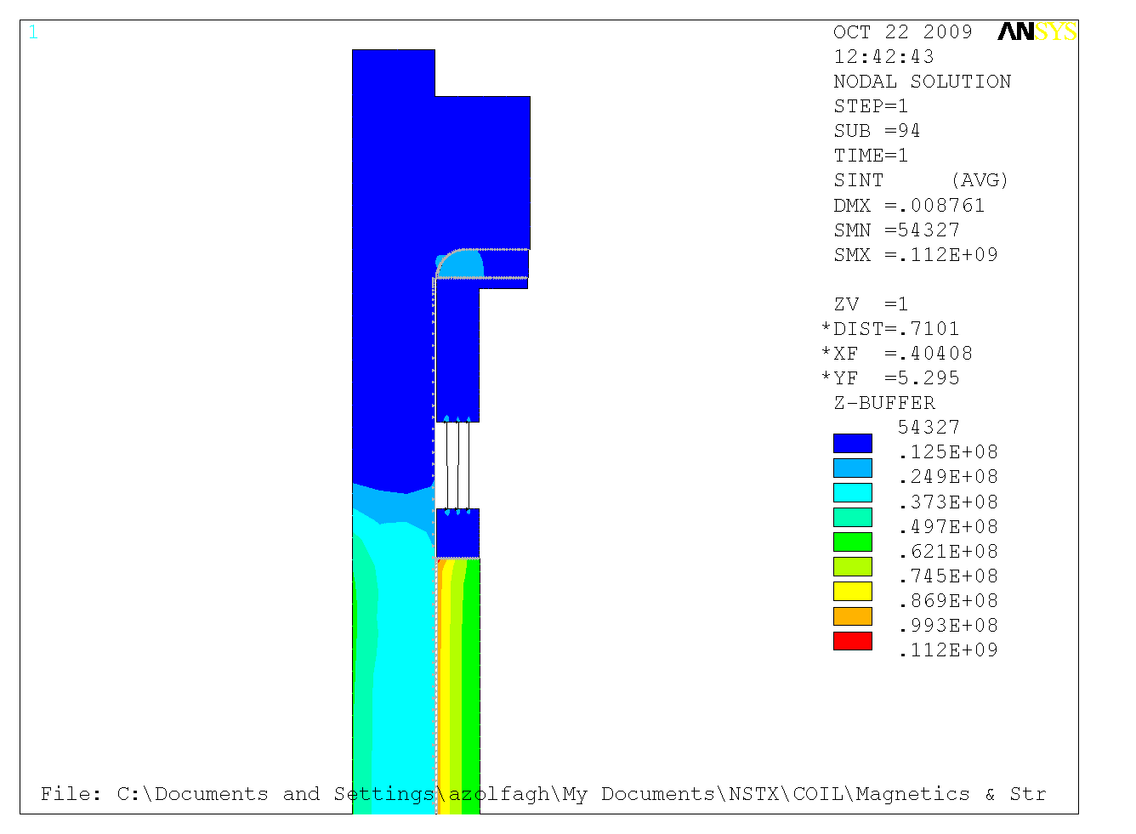
Figure 8

However, as Figure 9 shows the frictional shear of the expanding TF coil causes large unacceptable vertical tension stress in the OH. Mechanical solutions such as low friction interface and removable interface layer as well as solutions in the coil protection system need to be considered to avoid this problem.

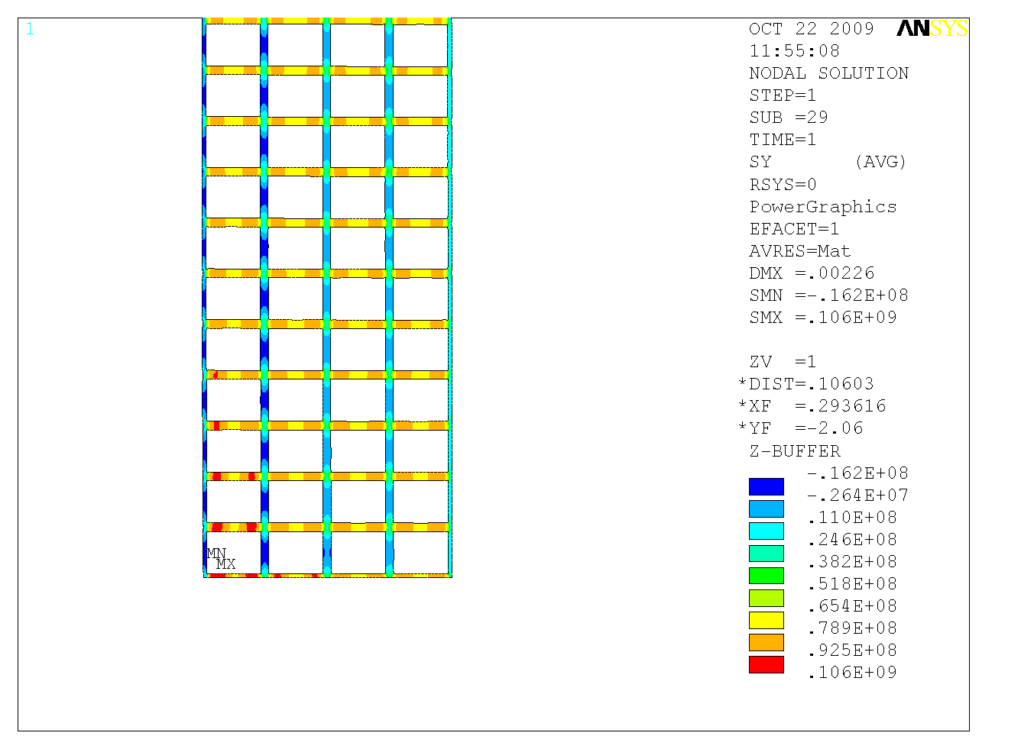
Figure 9

Stresses Induced by Differential Cooling between Inner and Outer turns:

Another phenomena which exerts stresses in the OH coil is the differential cooling stresses also discussed in NSTXU-CALC-133-06-00 which are caused by the inner turns of the coil which have shorter lengths cooling down faster than the outer turns that are longer.

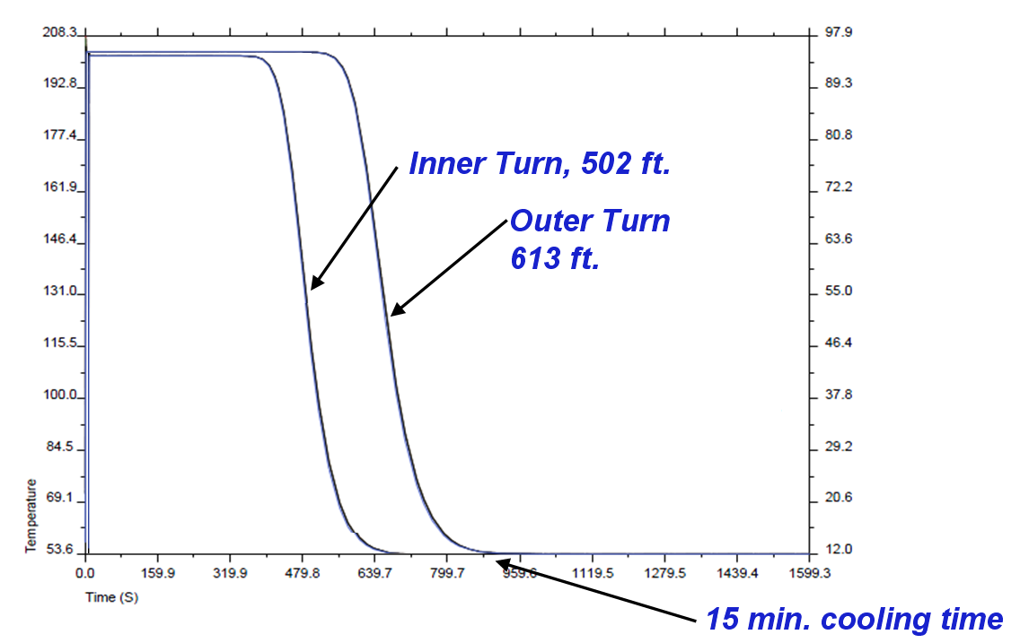

Fig. 10: Superposition of cooling plot for the shortest and longest cooling paths.

Fig. 10 is a superposition of the cooling curves for the longest path (outside layer) and the shortest cooling path (inside layer) for 430 psi pump pressure. The figure shows that at 700 seconds into the cooling, at the end of the coil the inner layer has cooled down completely while the outer layer is still at the peak temperature. This was identified as a possible source of thermal stress on the coil structure. To study this effect we used an Ansys axisymmetric FEA model of the end of the coil with imposed temperatures of 12, 40, 70, and 100 deg. C on the layers. Figure 11 shows the model and the corresponding mesh.

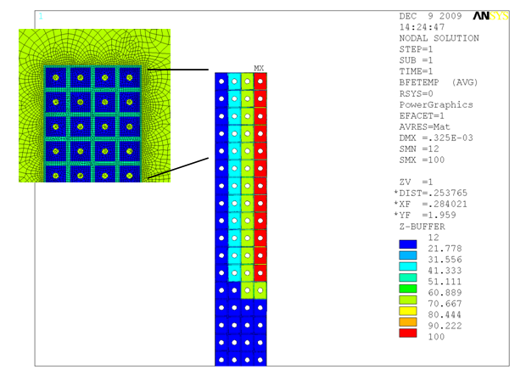
Fig. 11: Ansys FEA axisymmetric model of the end of the OH coil

Figure 12 shows the resulting stresses in OH copper conductors. The stresses are high but below the 233 MPa limit for copper. However fatigue becomes an issue with this stress. Figure 10 shows the resulting stress in the epoxy insulation between the conductors. The figure shows areas on the inside of the OH coil where the tension stresses are beyond the limits for epoxy. For these reasons we must try to avoid this situation altogether by throttling the flow speed in the short inside layers (e.g. by using pressure reduction valves) to equalize the flow velocity and thereby cooling wave velocity in the layers.

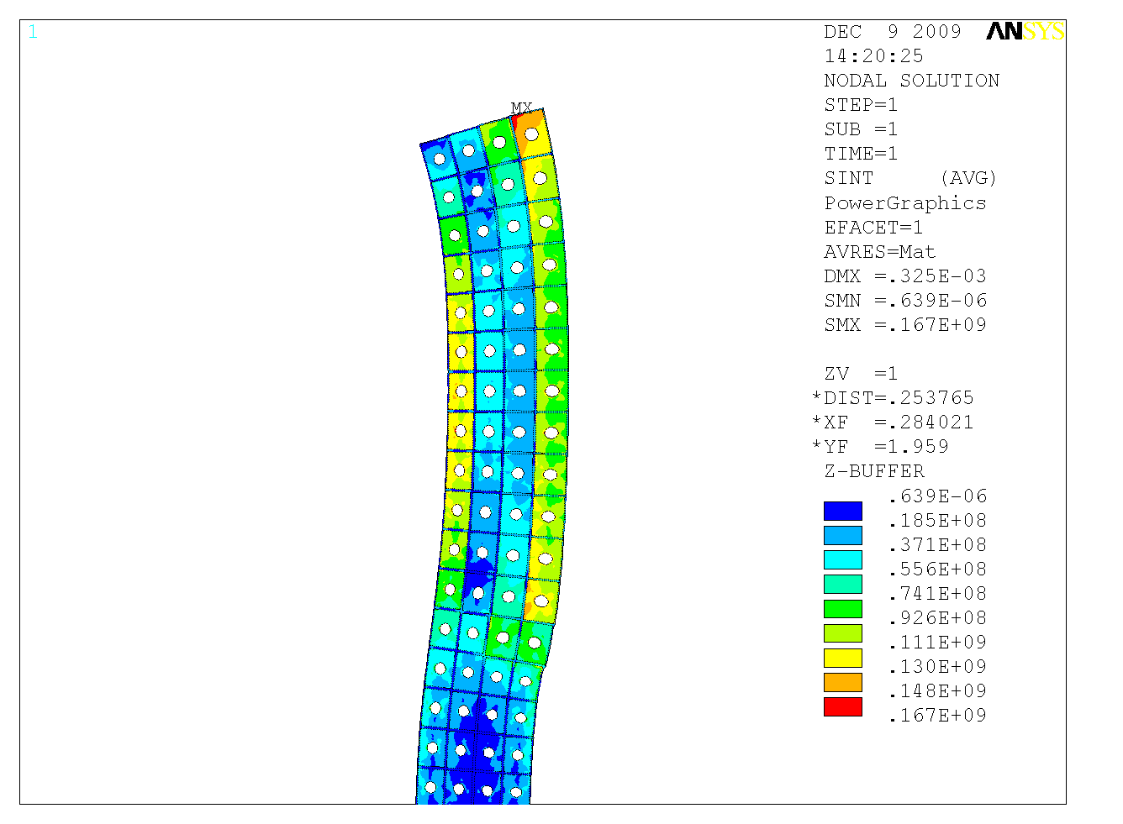
Fig. 12: Thermal stress in the OH coil

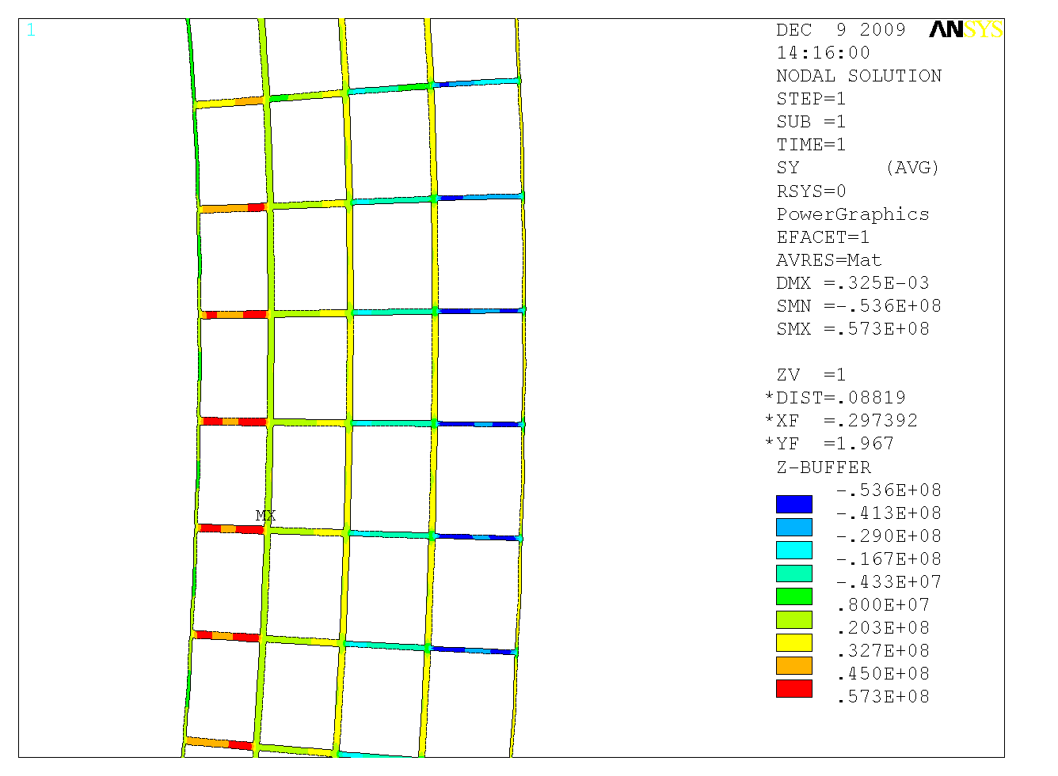
Fig. 13: Thermal stress in the OH coil insulation

Digital Coil Protection System (DCPS) Input

Input to the DCPS will be developed based on the OH stress calculations as done in the NSTX Upgrade design point spreadsheet (worksheet “Base”) [2]. The advantage of this method is that OH stresses can be calculated algebraically based on current, coil dimensions. The max principal stress in the conductor must be kept below 125 MPa.

Stresses Induced by Cold Water Entering the Hot Coil after the Shot

The temperature of the coil reaches close to 100 C in a few seconds but the water entering the coil (from the bottom of the coil) is at 12 degrees C. As the colder water moves through the coil, it creates a temperature gradient in the coil that causes stress in the coil. To study this effect we analyzed the results of cooling in the inner most layer of the OH coil. The highest temperature gradient over the first 4 turn (each turn is 1.378 m) of the coil happens at t=5.96 seconds after the start of the shot and is shown in Figure 14.

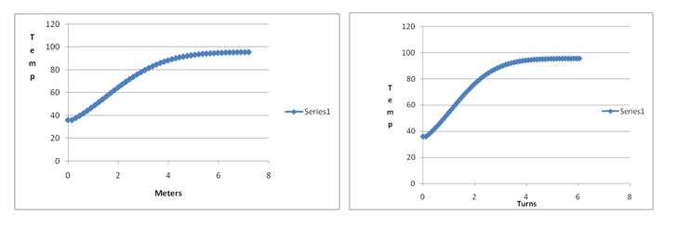
Fig. 14

The slope over the linear portion of the gradient is approximately 20 deg. C per turn. Figure 15 shows this temperature gradient imposed on the axisymmetric detailed FEA model of the bottom of the coil. The bottom of the coil in the model is attached to the G-10 base. The bottom of the base is kept fixed in the vertical (Y) direction and free from expansion in the radial (X) direction.

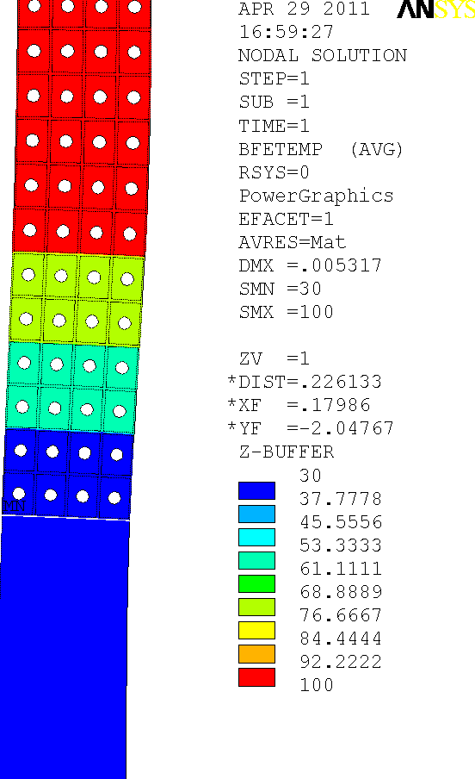
Fig. 15

Figure 16 and 17 show the contours of normal stress in the Y direction and XY shear stress.

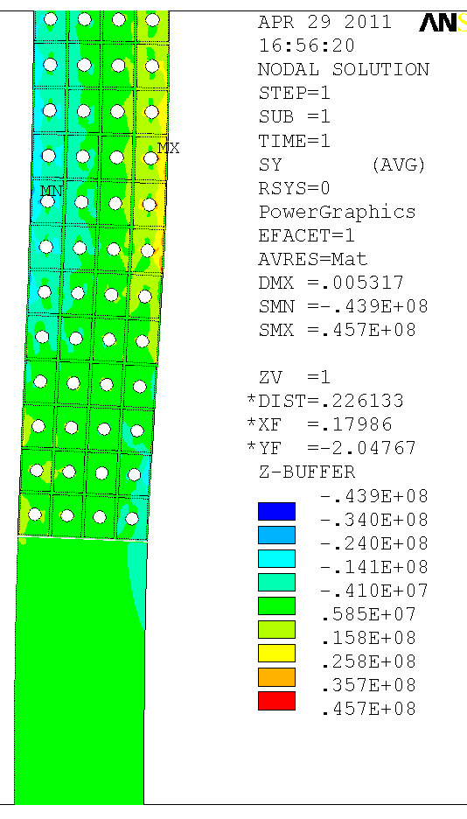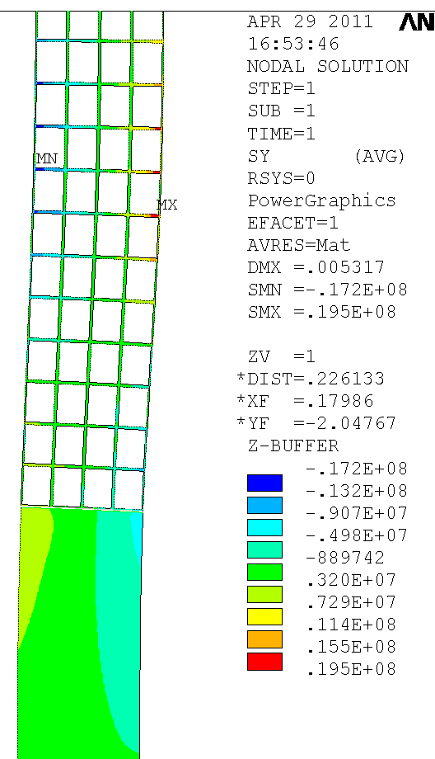
Fig. 16

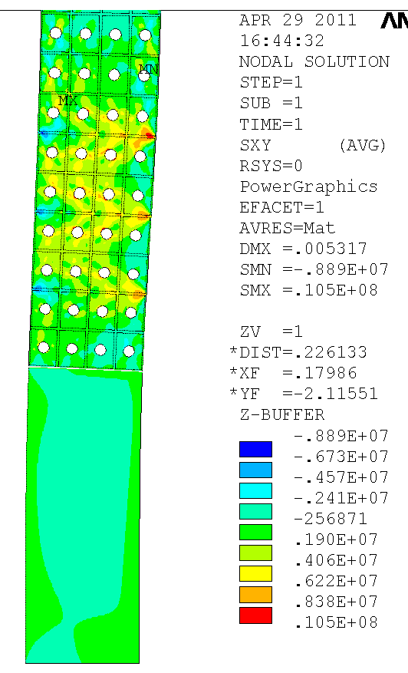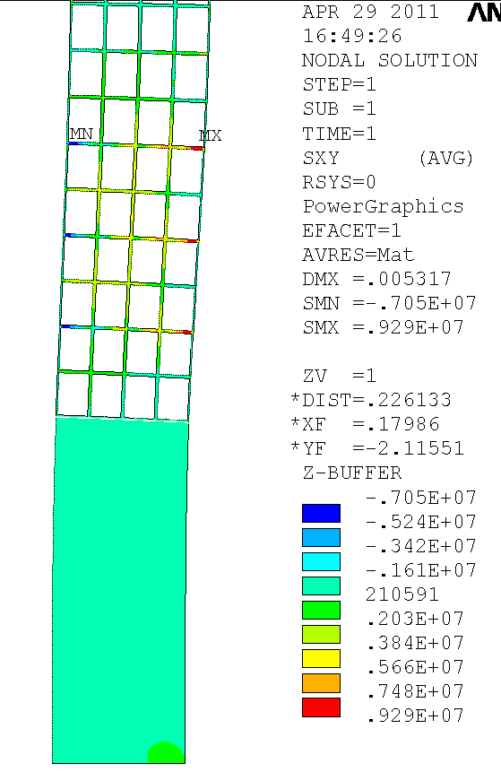
Fig. 17

The stress in the CTD101K epoxy insulation in some small areas higher than the static limit of 6.9 MPa and certainly higher the fatigue limit. But we believe that the separation of the insulation from the conductor in these areas will not lead to insulation failure.
Another scenario of concern is stress in the interface between the OH coil and the G-10 base after the coil has been heated to near 100 Deg. C during a short time while the base is near room temperature. Figure 18 shows the Coil/Base interface geometry in detail. As the hot OH coil expands outward, It is expected to put stress on the interface between the cool G-10 and the coil. To make the G-10 base more flexible to radial expansion with the OH coil, we plan to cut radial slots in the top of the G-10 base as shown in figure 18.

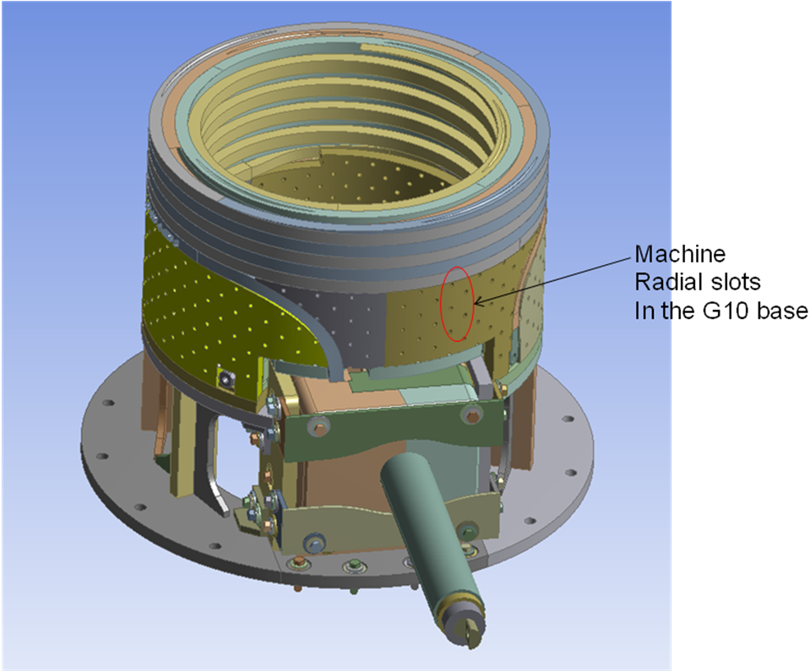
Fig. 18

To analyze this effect we used the same axisymmetric FEA model used above with changes to the G-10 orthotropic mechanical properties (shown in Figure 19) to simulate the slots in the G-10 base. We also added the 2.7mm epoxy ground insulation wrap to the OH coil and the base. Figure 20 shows the insulation and G-10 areas in the model.

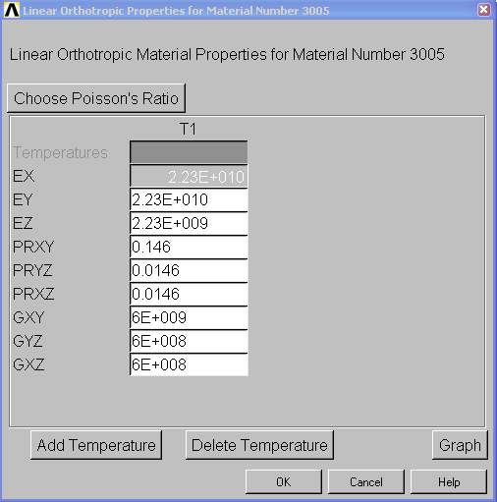
Fig. 19

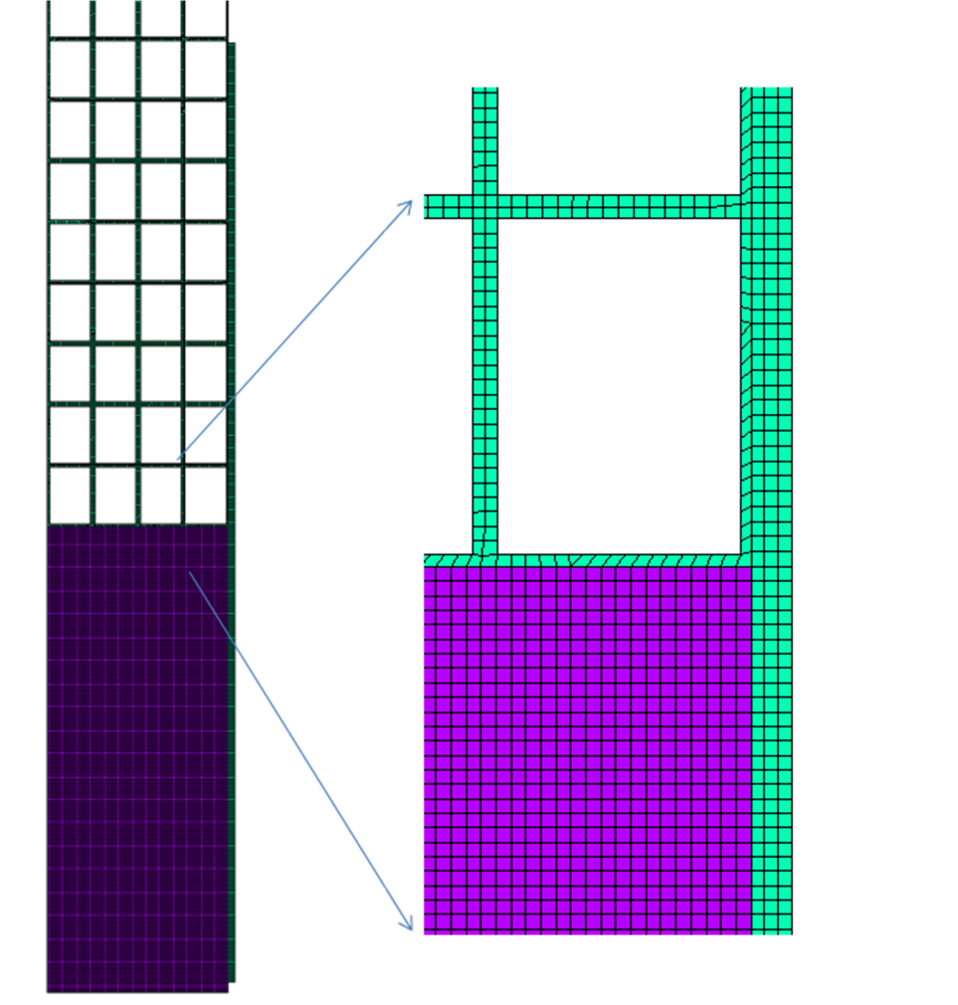
Fig. 20

Figures 21 and 22 show the resulting shear and vertical normal stress contours. It is recommended to put a slip plane at the interface of the base and the outside layer of the coil as pointed out in figure 21.

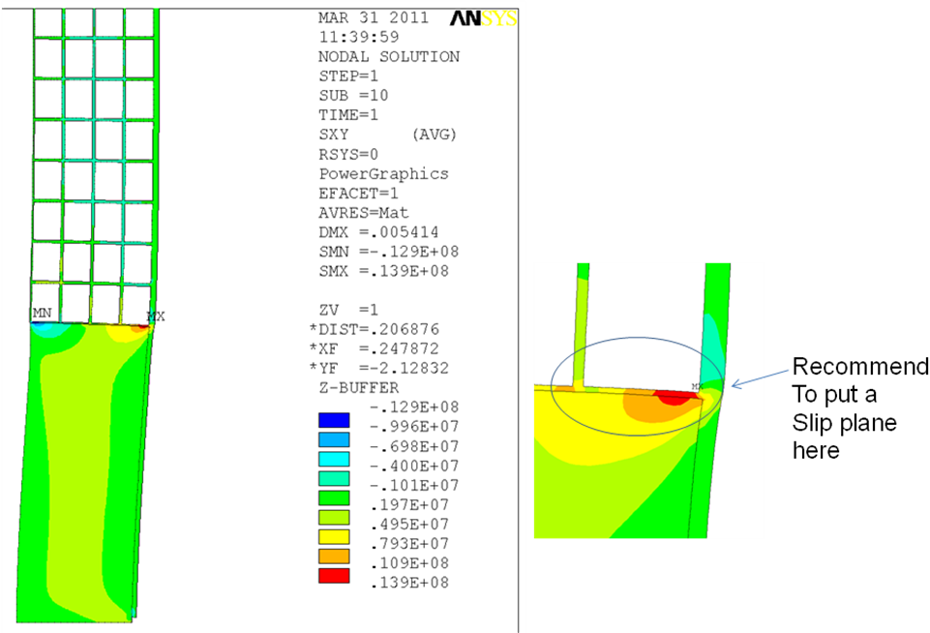
Fig. 21

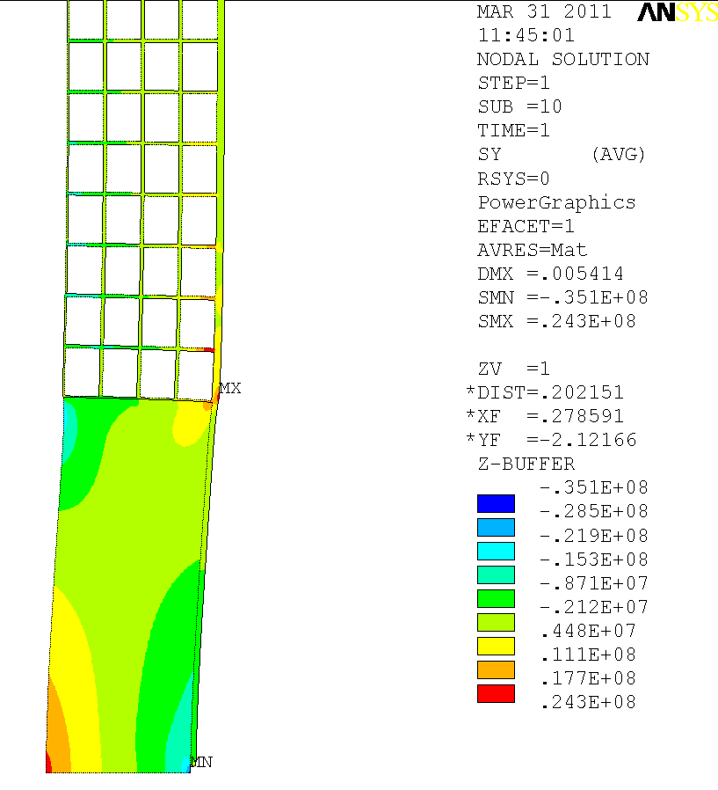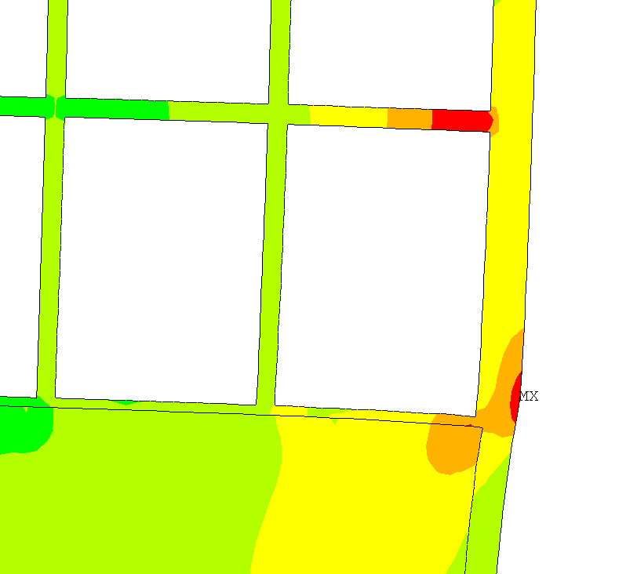
Fig. 22

