OH COIL COOLING IN THE NSTX CSU

NSTX-CALC-133-06-00

October 07, 2011

Prepared By:

___________________________________
Ali Zolfaghari, PPPL Mechanical Engineering

Reviewed By:

________________________________________
Michael Mardenfeld, Engineering Analysis Division

Reviewed By:

_______________________________________
James Chrzanowski, Cognizant Engineer

PPPL Calculation Form

Calculation # 133-06-00 Revision # 00 WP #, if any 1305
(ENG-032)

Purpose of Calculation: (Define why the calculation is being performed.)

To estimate the temperature rise in the OH coil during the discharge and to estimate cooling time between discharges.

References (List any source of design information including computer program titles and revision levels.)

Please see attached.

Assumptions (Identify all assumptions made as part of this calculation.)

100 PSI was set aside for pressure drops due to coil winding curvature and tubing, bends and fittings in the coolant path.

Calculation (Calculation is either documented here or attached)

Please see attached.

Conclusion (Specify whether or not the purpose of the calculation was accomplished.)

Our analyses show that the OH coil can carry the required 24kA current for Tesw=1.473 seconds without exceeding 100° C. We also show that the existing 430-PSI pressure pump can provide cooling time less than the 20 minutes required. We also pointed out the need to equalize flow velocity in the inside and outside OH turns in order to avoid large thermal stresses in the OH coil winding.

Cognizant Engineer’s printed name, signature, and date

I have reviewed this calculation and, to my professional satisfaction, it is properly performed and correct.

Checker’s printed name, signature, and date

Executive Summary

The objective of this analysis was to estimate the anticipated temperature rise in the new OH conductor in the upgraded NSTX OH coil during a discharge with 24 kA current and equivalent square wave time, Tesw, of 1.473 seconds. The objective also included estimating the cooling time between OH discharges as a function of pressure drop in the cooling pump. Based on these analyses the coolant channel size was to be checked in order to ensure that the maximum temperature of the coil remains below 100° C. The pump pressure required to keep the cooling time less than 20 minutes were to be estimated.

The in-house Fcool code was employed to perform the analysis. The results of the analysis showed that a coolant channel diameter of 0.225 in. is sufficient for achieving the required Tesw in the coil without exceeding 100° C. The results also show that a 430 PSI pump pressure can provide cooling times less than the 20 minutes required.

A structural analysis of the differential cooling stresses in the coil resulting from unequal flow velocities in the turns was performed. The results pointed out the need to equalize flow velocity in the inside and outside turns in order to avoid large thermal stresses in the OH coil winding.

Objective

The NSTX center stack upgrade includes designs for a larger OH coil to provide higher Ohmic heating and current drive. The OH coil is designed to be cooled by water flowing in a coolant channel in the center of the conductor (Fig.1). The water is pumped in 8 parallel conductor/coolant paths in the coil (two per layer, 4 layers) during and after the discharge. Fig. 2 shows one of the eight conductor paths in the OH winding.

During the discharge the current passing in the OH coil results in resistive heating in the coil. This heat is removed by the coolant flow during the time between the discharges. The purpose of this calculation is to predict the cooling time and required pressure drop in the coolant path in the coil. The conductor cross section, number of turns & layers in the coil, coil size, and current are parameters that are given by the CSU design point. Table 1. lists the OH coil design parameters.

The coolant channel diameter needs to be sized in order to achieve the following:

- Coil temperature not exceeding 100° C for coil current I=24kA and equivalent square wave pulse width, Tesw = 1.473sec.
- 20 minutes or less cooling time between discharges.
- Pump pressure of less than 600 PSI, preferably 430 PSI in order to use existing NSTX pumps.

Larger coolant channel leads to higher coil resistance and higher Ohmic heating and initial temperature in the coil. However it also leads to more efficient cooling and lower cooling time. Higher pressure drop leads to higher mass flow and shorter cooling time.

Coolant channel
Copper conductor
Fig.1- OH coil conductor cross section

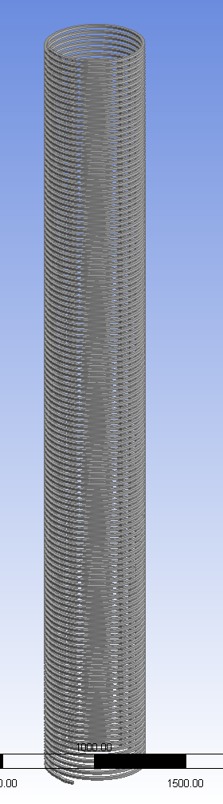
Fig. 2 OH winding showing one of the eight cooling paths

OH Inner Radius (Copper) | 0.2074 m
OH Outer Radius (Copper) | 0.2768 m
OH Ground & turn insulation | 0.004 m
OH Height | 4.2416 m
OH #turns | 884
OH #layers | 4
OH Conductor width | 0.0155 m
OH Conductor height | 0.0168 m
OH Cooling hole diameter | 0.0057 m
OH Packing fraction | 0.7013
OH Voltage | 6077 V
OH Current Base | 24000 A
OH Inlet Coolant Temp | 12 °C
OH Maximum temp | 100 °C
OH Copper Mass | 2800 kg

Table 1. OH Coil Design Parameters

The optimization of the conductor size and the hole size were performed by C. Neumeyer since these parameters are inter-related to the OH performance parameters such as flux and power supply voltage etc. For this reason in this calculation we took the parameters of table 2 as given.

Calculation:

Fcool code was used for the calculation. Fcool is a 1D finite-difference transient simulation code used in calculation of flow and cooling parameters in magnets. Fcool was developed by Fred Dahlgren and the PPPL team. Fcool uses input about the current flow and pulse length, coolant flow length, pressure drop, coolant channel size, and conductor size to model the cooling wave propagation in the coil and calculate the cooling time. It does this by dividing the coil into small finite length sections and sequentially solving the cooling and hydraulic parameters in the length sections. Predictions of cooling time vs. pressure drop across the coil was calculated using this tool.

Analysis Results:

The following Mathcad calculation is a simple heat balance calculation between the resistive heat from the flow of current and the heating of the coil copper conductor. This is meant to give us an approximate value for the max copper temp as a function of conductor and hole size. Since the copper resistivity increases as a result of increase in temperature is not taken into account in this calculation the real max copper temperature is expected to be slightly higher than the 89 deg. C calculated. Fcool does take into account the change in copper resistivity as a function of temperature and as we’ll see in the Fcool results below the peak temperature is approximately 96 deg. C.

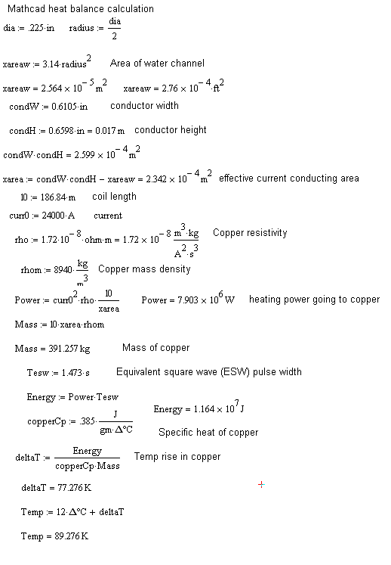

As a part of this study we examined measured temperature data in the existing NSTX OH coil during the discharge and cooling. Our analysis (not shown here but presented during NSTX CSU meetings Ref. 1) showed that the simulations results of cooling time agreed with measured data when the pump pressures used were approximately 100 PSI higher than the pressure drop values used in simulations. Considering the fact that in Fcool simulations we have simulated a straight (un-winded) coil, we attribute this difference to pressure drops due to curvature of the winding and connections and fittings used in connecting the pump to the coil. Therefore, when determining the actual cooling time vs. pump pressure, we added 100 PSI to the pressure used in the simulation in order to estimate the pump pressure. The coolant mass flow rate is higher in the upgraded OH than in the existing OH, therefore (since pressure drop is proportional to velocity squared) we need to make sure the tube and fittings between the pump and the coil are upgraded in size from the existing tube and fittings (e.g. to 5/8” from 3/8”). This would ensure that the higher mass flow rate does not lead to higher velocity in the tube and fittings and we can keep the drop to 100 PSI.

Figures 5 and 6 are the Fcool results of the cooling time for the longest cooling path length (613 ft. corresponding to the outer layer) and the shortest cooling path length (502 ft. corresponding to the inside layer) in the OH coil.

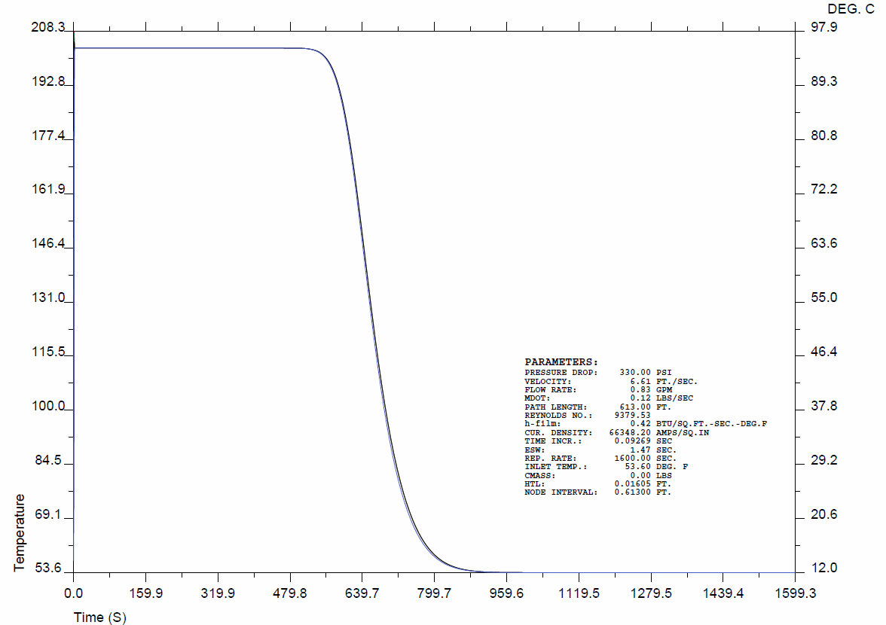

Fig. 5 OH coil cooling with 430 PSI pump. Longest cooling path 613 ft.
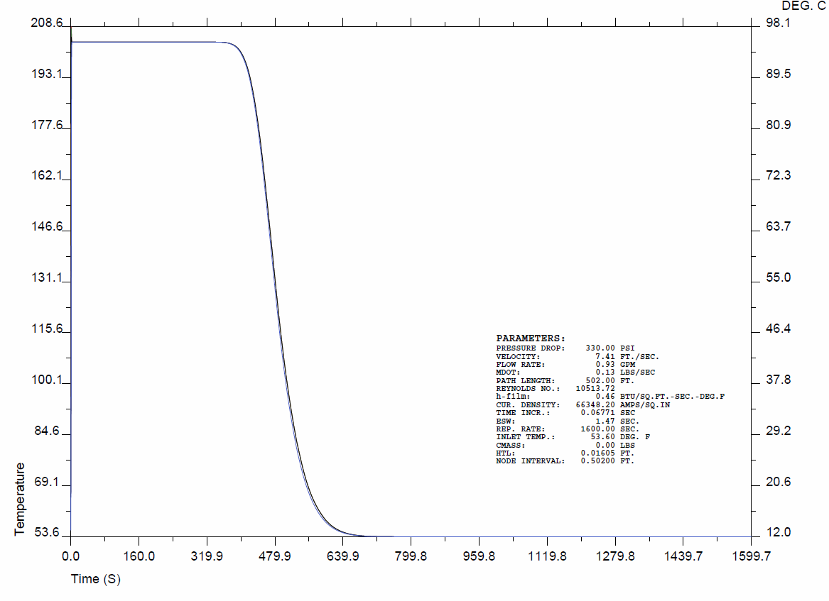
Fig. 6 OH coil cooling with 430 PSI pump. Shortest cooling path 502 ft.

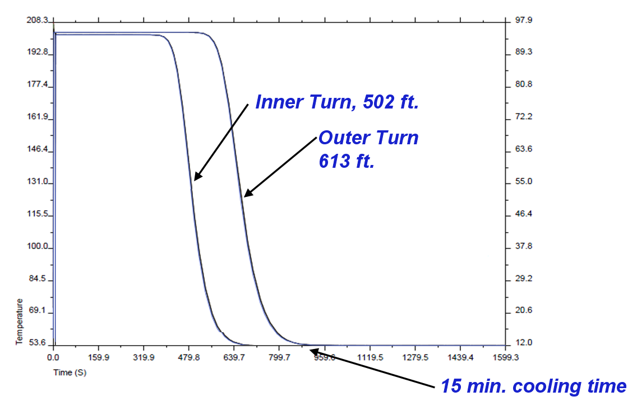

Fig. 7: Superposition of cooling plot for the shortest and longest cooling paths.

Fig. 7 is a superposition of the cooling curves for the longest path (outside layer) and the shortest cooling path (inside layer). The figure shows that at 700 seconds into the cooling, at the end of the coil the inner layer has cooled down completely while the outer layer is still at the peak temperature. This was identified as a possible source of thermal stress on the coil structure. To study this effect we used an Ansys axisymmetric FEA model of the end of the coil with imposed temperatures of 12, 40, 70, and 100 deg. C on the layers. Figure 8 shows the model and the corresponding mesh.

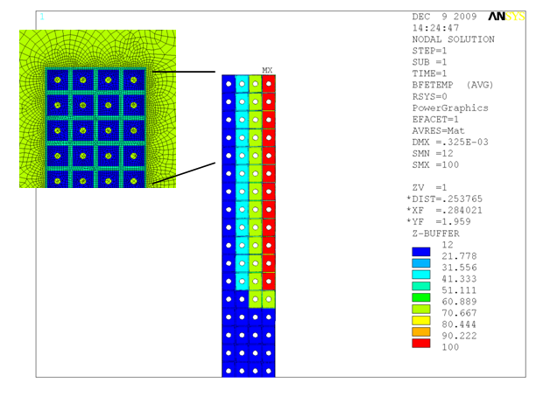
Fig. 8: Ansys FEA axisymmetric model of the end of the OH coil

Figure 9 shows the resulting stresses in OH copper conductors. The stresses are high but below the 233 MPa limit for copper. However fatigue might become an issue with this stress (See NSTX-CALC-133-08-00). Figure 10 shows the resulting stress in the epoxy insulation between the conductors. The figure shows areas on the inside of the OH coil where the tension stresses are beyond the limits for epoxy. For these reasons we must try to avoid this situation altogether by throttling the flow speed in the short inside layers (e.g. by using pressure reduction valves) to equalize the flow velocity and thereby cooling wave velocity in the layers.

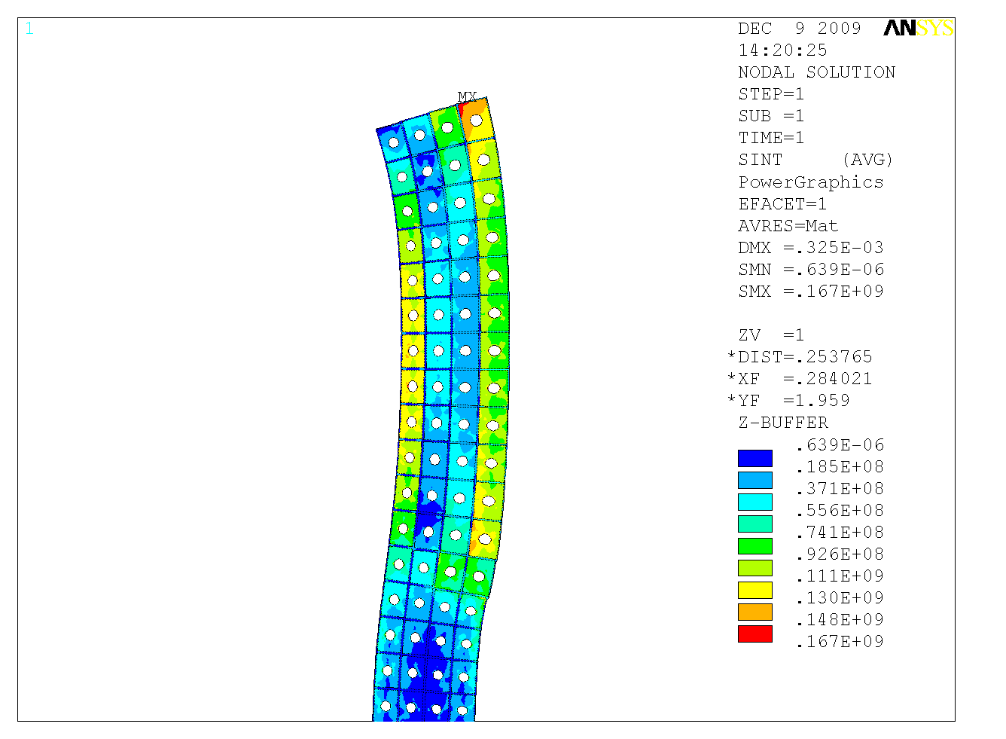
Fig. 9: Thermal stress in the OH coil

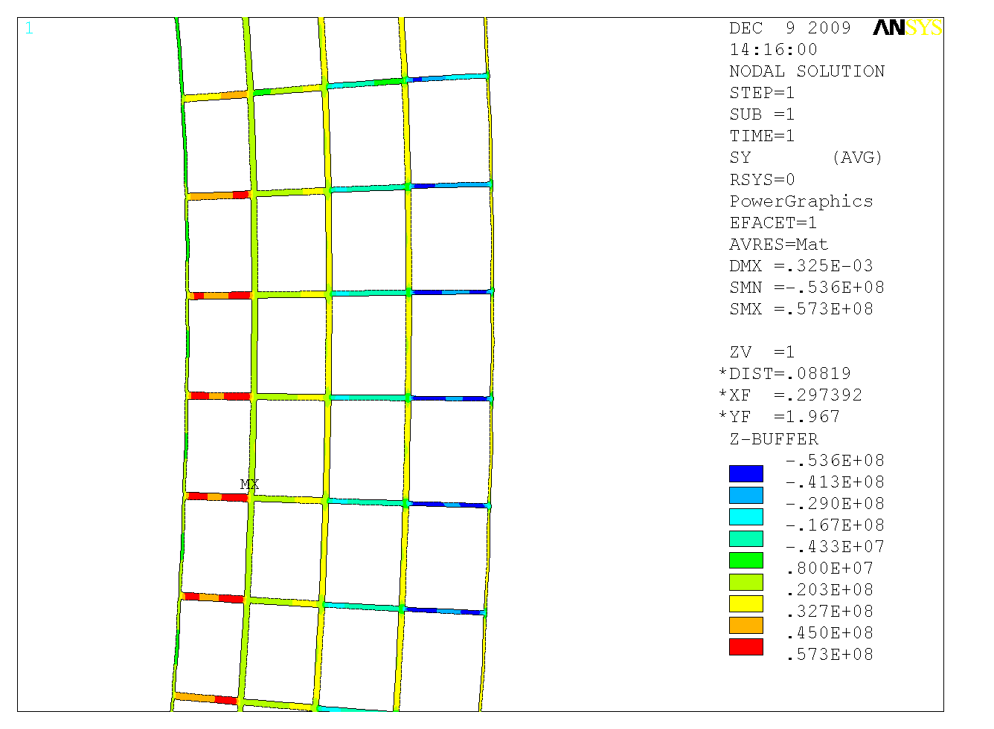
Fig. 10: Thermal stress in the OH coil insulation

Conclusions:

Our analyses of the OH coil resistive heating during the discharge and the subsequent cooling between two discharges show that the final design of the OH coil (Table 1) can carry the required 24kA current for Tesw=1.473 seconds without exceeding 100° C. We also showed that the existing 430-PSI pressure pump can provide cooling time less than the 20 minutes required. We also pointed out the need to equalize flow velocity in the inside and outside OH turns in order to avoid large thermal stresses in the OH coil winding.

References:

- NSTX OH Coil Optimization, Presentation by A. Zolfaghari on 6/24/09 at NSTX Upgrade meeting:
http://nstx-upgrade.pppl.gov/Project_Meetings/CenterStackUpgrade/CY2009/CSU_Mtg_06242009/

