NSTX

Halo Current Analysis of Center Stack

NSTX-CALC-133-05-00

April 13, 2010

Prepared By:

___________________________________
Art Brooks, Engineering Analyst

Reviewed By:

________________________________________
Peter Titus, Branch Head, Engineering Analysis Division

Approved By:

_______________________________________
Jim Chrzanowski, Cognizant Engineers
PPPL Calculation Form

Calculation # NSTX-CALC-133-05-00 Revision #00 WP: 1672
(ENG-032)

Purpose of Calculation: (Define why the calculation is being performed.)

Calculate the transient halo current distribution in the CS

References (List any source of design information including computer program titles and revision levels.)

See attached report

Assumptions (Identify all assumptions made as part of this calculation.)

See attached report

Calculation (Calculation is either documented here or attached)

See attached report

Conclusion (Specify whether or not the purpose of the calculation was accomplished.)

See attached report

Cognizant Engineer’s printed name, signature, and date

I have reviewed this calculation and, to my professional satisfaction, it is properly performed and correct.

Checker’s printed name, signature, and date

Executive Summary

An analysis was done to estimate the inductive effects during a halo current strike. Previous analyses and guidance have assumed the flow of halo current thru structures is resistively distributed. The halo currents were modeled as a current source entering at one poloidal location and leaving at another. This assumed resistive distribution results in a potentially non conservative prediction of EM loads on the structures. Results presented herein show that the time constant for establishing the halo current flow is fairly long relative to the disruption timescale.

Introduction

The current distribution in the plasma during a disruption is fairly complicated. The current in general follows the helical magnetic field lines. From an engineering viewpoint it is convenient to decompose the distribution into toroidal and poloidal currents. Most disruption analyses concerns itself with the rapid movement and decay of the toroidal currents. Here there is only an inductive coupling between the toroidal currents representing the plasma and the induced eddy currents in the structures. Where there are poloidally electrical continuous structures surrounding the plasma, the inductive coupling of the poloidal currents (both large scale and small - ie the spiraling of electrons around field lines), characterized by toroidal flux changes in the plasmas, can have a significant impact as well. And when the plasma makes contact with the structure, a portion of the current flowing in the plasma is intercepted and effectively shorted thru the structure. It is these currents that are addressed here. While they do not occur alone, it is useful to separate them to try and understand their impact. Further, the halo is assumed to occur due to a plasma instability that distorts the shape and position of the plasma causing an asymmetry of the intercepted halo currents.

Assumptions

To estimate the inductive effects it is necessary to know the conditions that precede a halo current strike. The assumptions made here is that initially current is flowing in the outer region of the plasma (herein modeled as a set of TF like coils) with a portion of it (ie the inboard leg) in close proximity to the CS. This portion in close proximity is driven to zero as the current it was carrying is injected at the top and removed from the bottom of CS and returned thru the outboard leg of the plasma. This is assumed to occur very quickly and hence should be flux preserving.

Since the current that is driven in the structure comes from shorting the halo in the plasma, on the short time scale this should produce currents in the structure that very nearly parallel the currents in the shorted halo to preserve flux. This current then redistributes on the time scale of the structure to a resistive distribution. For a halo strike with a toroidal peaking factor of 2 this implies that immediately after current strikes the CS the vertical current flow thru the CS also has a toroidal peaking factor of 2, then redistributes to a resistive distribution where the peaking factor between the halo entry and exit points has been found to be much closer to one. This is significant because the net force on the CS from the interaction of the vertical halo currents with the TF field is zero in a region where the peaking factor is 1 (uniform current density) since forces on opposites sides of the CS would balance. For non uniform currents there is a force imbalance and a resulting net force.

Method of Analysis

An ANSYS 3D Electromagnetic Model was generated of the CS and excited by a set of TF like coils representing the plasma halo region as shown below (a half plane of vacuum elements is removed to expose the interior).

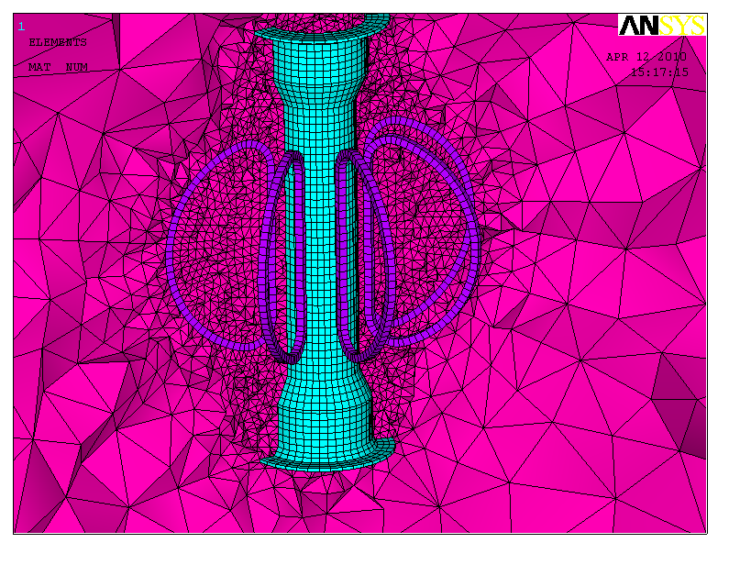
The model uses solid97 elements with eddy current capability activated for the CS. The CS is assumed to be inconel with a resistivity of 130.e-8 ohm-m. The coils representing the plasma halo are assumed to carry an initial current distribution totaling 400 kA but modulated to provided a (1+cos(phi)) distribution. The halo current strike is assumed to occur very quickly (a finite value 0.1 ms was used in the analysis) by ramping the current in the straight legs of the coils representing the plasma halo to zero while at the same time injecting equal current into the neighboring CS structure at z=+/- 0.6m
as shown below 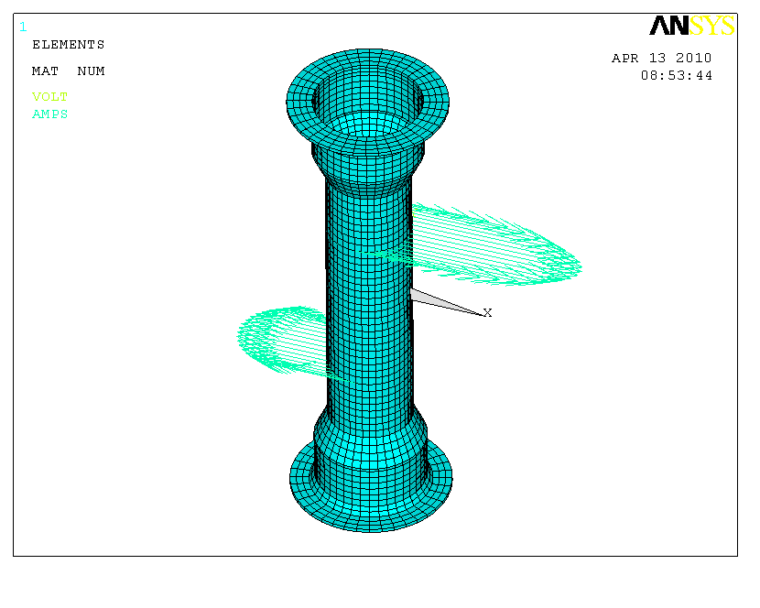
The injected halo current is assumed to persist (which could be argued, perhaps a waveform would be more appropriate) while the eddy currents in the CS redistribute over time.

Results

The halo currents flowing in the CS change significantly from the initial inductive distribution to their final resistive distribution. More importantly this takes several milliseconds which is significant compared to the 1 ms time disruption time. The plots below show the distribution of currents in the entire CS and then in just a slice thru the midplane where the variation is more visible.

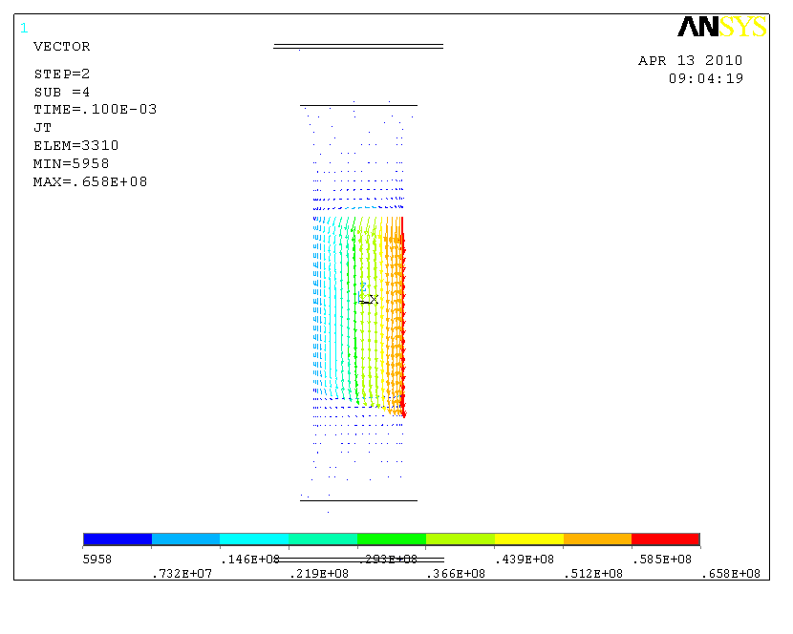
Inductive Distribution immediately following the halo current strike on the CS. Distribution mirror initial assumed plasma distribution

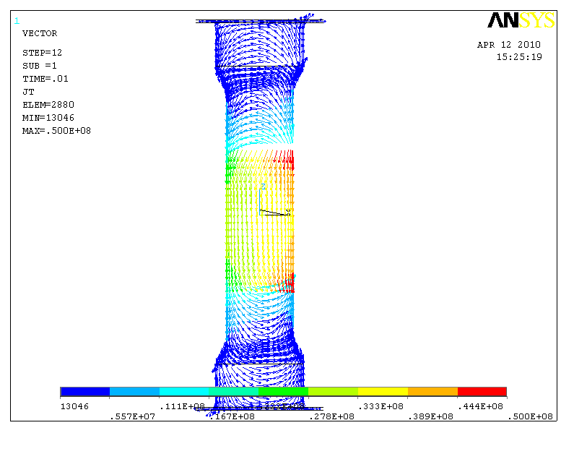
Resistive distribution 10 ms after halo current strike
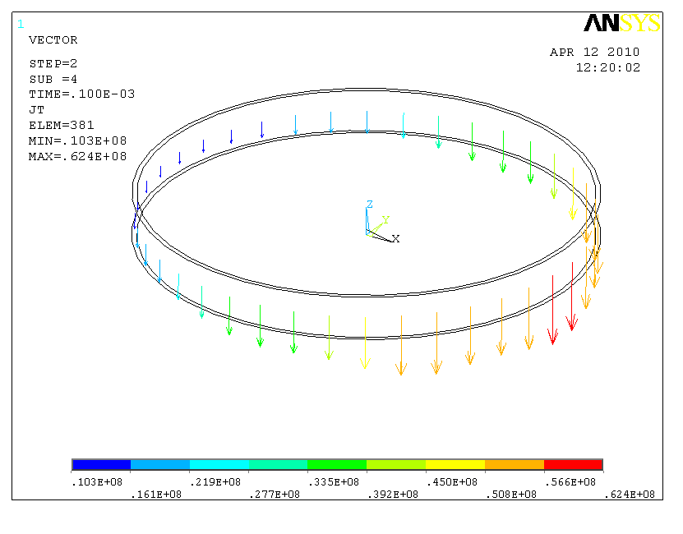
Inductive Distribution immediately following the halo current strike on the CS shows large distribution in current density consistent with a toroidal peaking factor of 2 source.

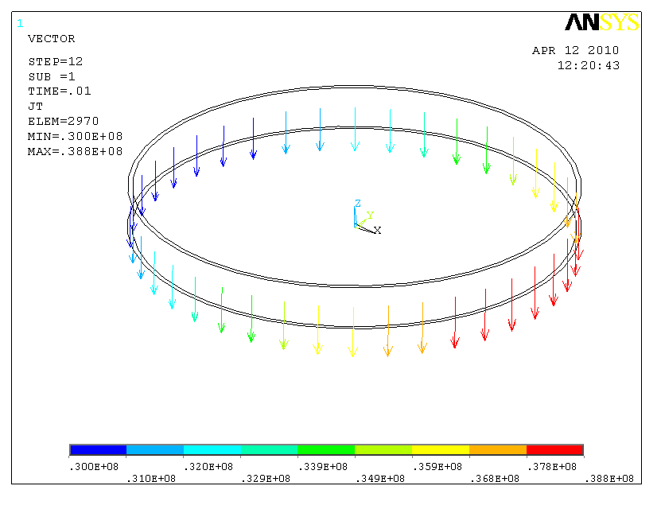
Resistive distribution 10 ms after halo current strike shows fairly small residual peaking factor at midplane.

The figure above shows the penetration of the Halo current in the CS measured at the midplane. The figure below shows the same data with a simple exponential decay best fitted with a time constant 1.31 ms.

The vertical halo currents flowing in the CS interact with the TF field producing local radial forces. If the current distribution is uniform, these radial forces produce hoop stresses within the CS but no net force since forces on opposite sides of the CS oppose each other. The peaked current distribution seen immediately following the halo current strike results in an imbalance in the load distribution as well which must be taken out by any structure supporting the CS. This imbalance is found to be significant as seen below resulting in a net force of over 522 kN (117,000 lbs):

Summary

The results presented here show the inductive effects to be potentially significant for the halo model assumptions presented. The impact should be further quantified by investigating the dynamic impact on the loads found on the CS.

