NSTX

Center Stack Casing Disruption Inductive and Halo Current Loads

NSTXU-CALC-133-03-00

August 31, 2009

Prepared By:

________________________________________
Peter Titus, Branch Head, Engineering Analysis Division

Reviewed By:

________________________________________
???

Approved By:

_______________________________________
Phil Heitzenroeder, Head, Mechanical Engineering
PPPL Calculation Form

Calculation # NSTXU-CALC-133-03 Revision # 00 WP #, if any 1672
(ENG-032)

Purpose of Calculation: (Define why the calculation is being performed.)

References (List any source of design information including computer program titles and revision levels.)

Assumptions (Identify all assumptions made as part of this calculation.)

Calculation (Calculation is either documented here or attached)

Conclusion (Specify whether or not the purpose of the calculation was accomplished.)

Cognizant Engineer’s printed name, signature, and date

I have reviewed this calculation and, to my professional satisfaction, it is properly performed and correct.

Checker’s printed name, signature, and date

Memo to Charlie Neumeyer and the NSTX Team
From: Peter Titus
Subject: Center Stack Casing Disruption Inductive and Halo Current Loads

Summary:

With only one halo entry and exit point considered and only one inductive disruption case considered, and only the static stress analysis performed, the stress results are acceptable, but dispacements are large – up to 8 mm laterally. Dynamic analyses are in progress .

Criteria from the GRD:

Current and field directions (referring to Figure 2.2-2) shall be as follows:
Plasma current Ip into the page (counter-clockwise in the toroidal direction,
viewed from above)
Halo current exits plasma and enters the structure at the entry point, exits the
structure and re-enters the plasma at the exit point (counter-clockwise poloidal
current, in the view of the figure)
Toroidal field into the page (clockwise in the toroidal direction, viewed from
above)

For the halo currents a toroidal peaking factor of 2:1 shall be assumed in all cases. Thus the
toroidal dependence of the halo current is [1 + cos (⎞ - ⎞0)], for ⎞ = 0 to 360o where ⎞ is the
toroidal angle.
Analysis Procedure and Results

Sri Avasarala and Ron Hatcher’s disruption analyses were used to provide a vector potential “environment” for a model of the center stack casing. Sri has developed a procedure which starts with Ron Hatcher’s OPERA disruption simulation, and transfers the axisymmetric vector potential results into a 3 D model of the vessel and passive plates. With modest changes any of the internal components can be evaluated with this procedure. A model of the center stack casing was input to Sri’s electromagnetic analysis. The results are shown in Figures 1 and 2
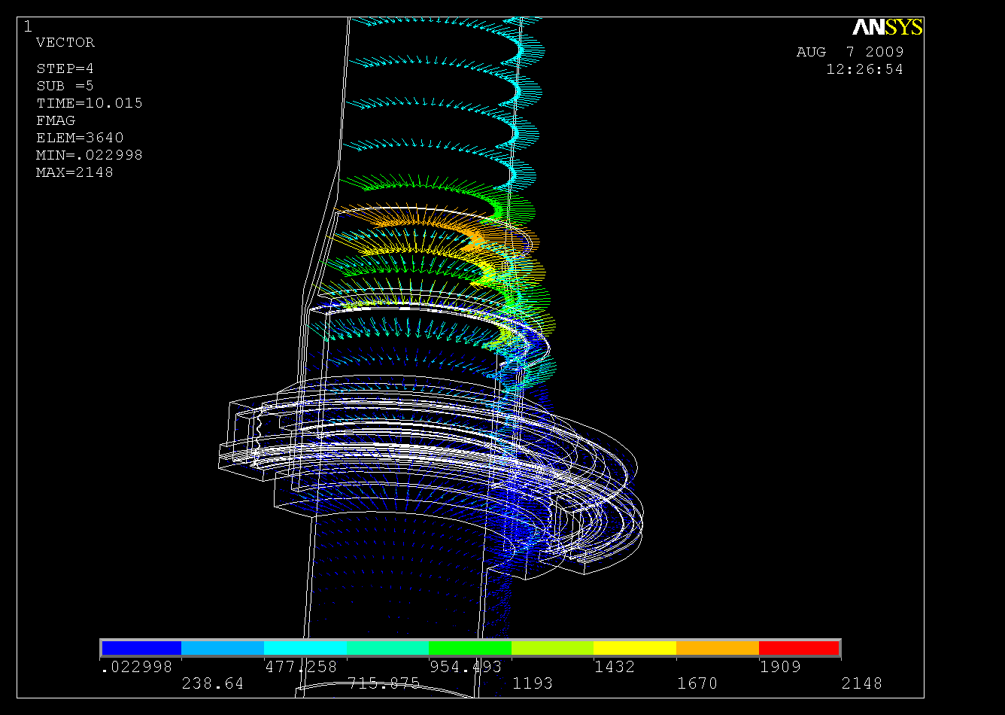
Figure 2 Inductive Disruption Lorentz Forces
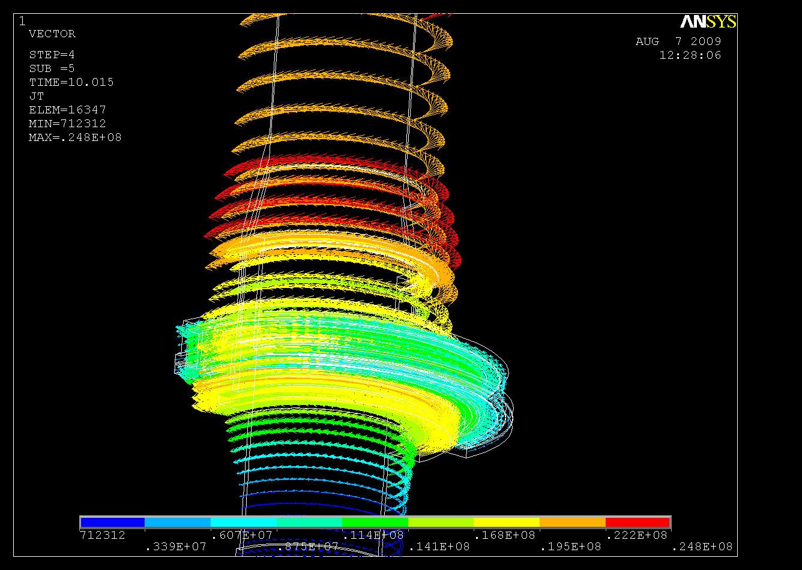
Figure 1 Inductively Driven Disruption
Currents in the Casing
Halo currents also load the vessel internals. The following spec is from the CSA Upgrade GRD:

Halo loads were calculated outside of ANSYS and read in after reading the inductive loads with the LDREAD command, and with FCUM,ALL
Lorentz loads from these current entry and exit points were calculated assuming a peaking factor of 2. At present, only the equatorial plane halo current distribution has been evaluated.
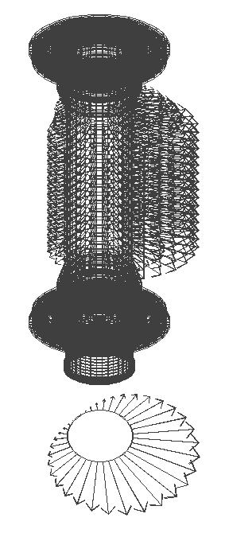
Figure Halo Loading
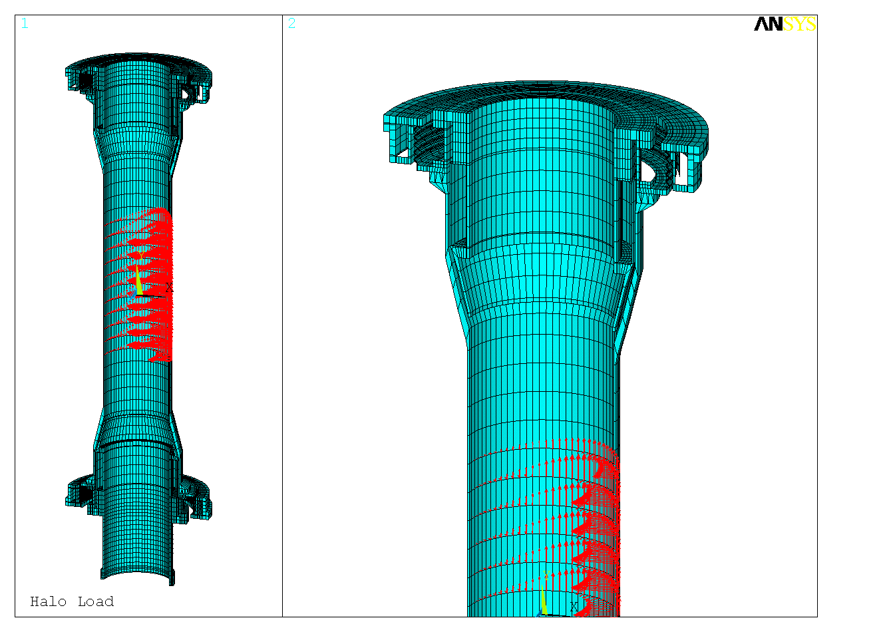
Figure _ Inductive + Halo Current Loads
 | INCONEL | 625
Test | Ultimate | Yield | Elongation
Temperature, | Tensile | Strength | in 2"
°F(°C) | Strength, | at 0.2% | percent
 | ksi (MPa) | offset,ksi (MPa)
Room | 138.8 (957) | 72.0 (496) | 38
200 | 133.3 (919) | 67.3 (464) | 41
400 | 129.4 (892) | 62.2 (429) | 44
600 | 125.6 (866) | 59.5 (410) | 45
800 | 122.2 (843) | 59.2 (408) | 45
1000 | 119.9 (827) | 58.8 (405) | 46
1200 | 119.6 (825) | 57.0 (393) | 47
1400 | 88.4 (609) | 55.3 (381) | 70
1600 | 52.1 (359) | 34.9 (241) | 69
1800 | 25.0 (172) | 10.8 (75) | 108
2000 | 13.3 (92) | 6.1 (42) | 89

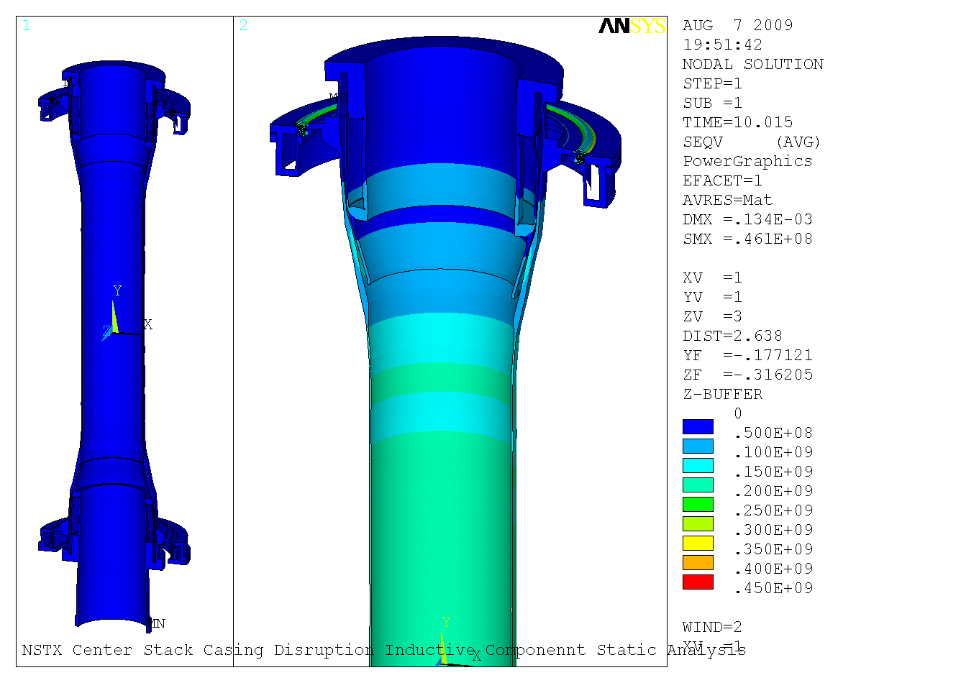
Static Results ~200 MPa
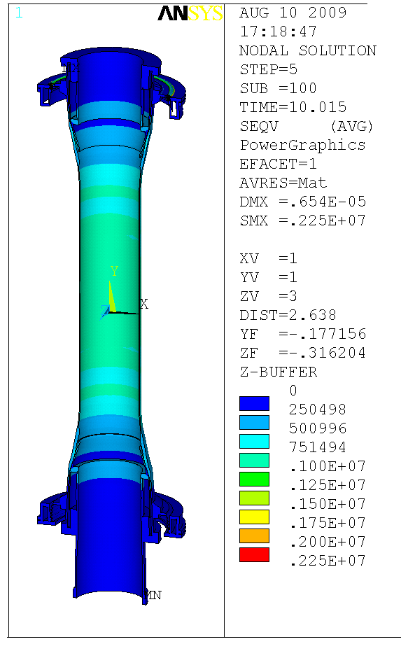
Dynamic Results ~ 1 MPa
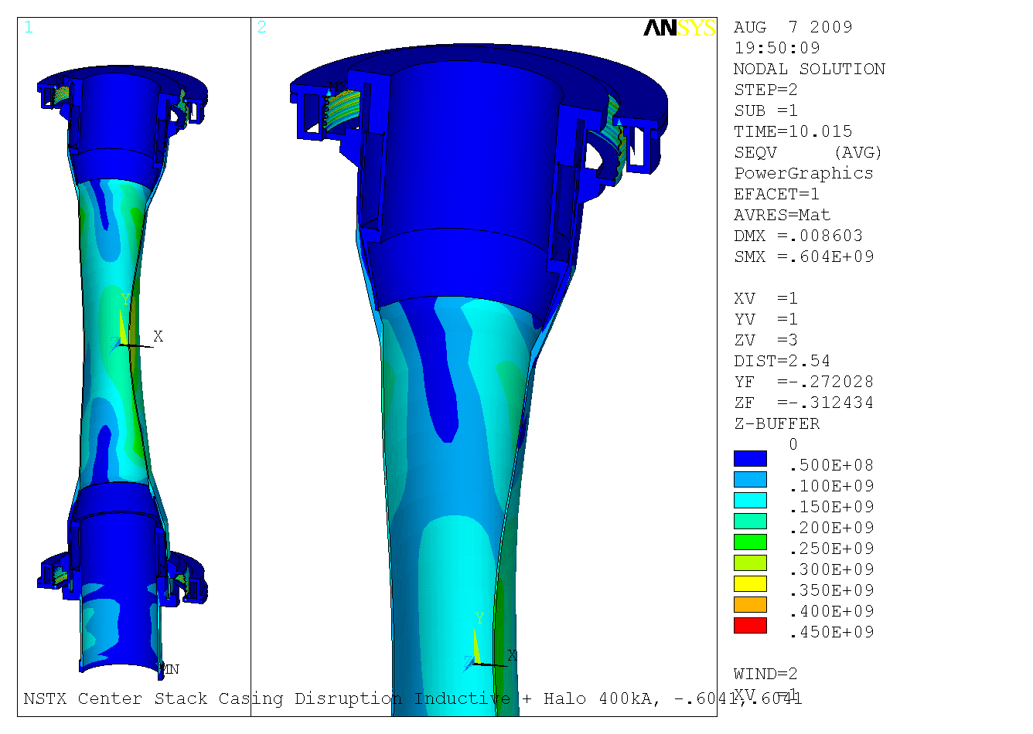
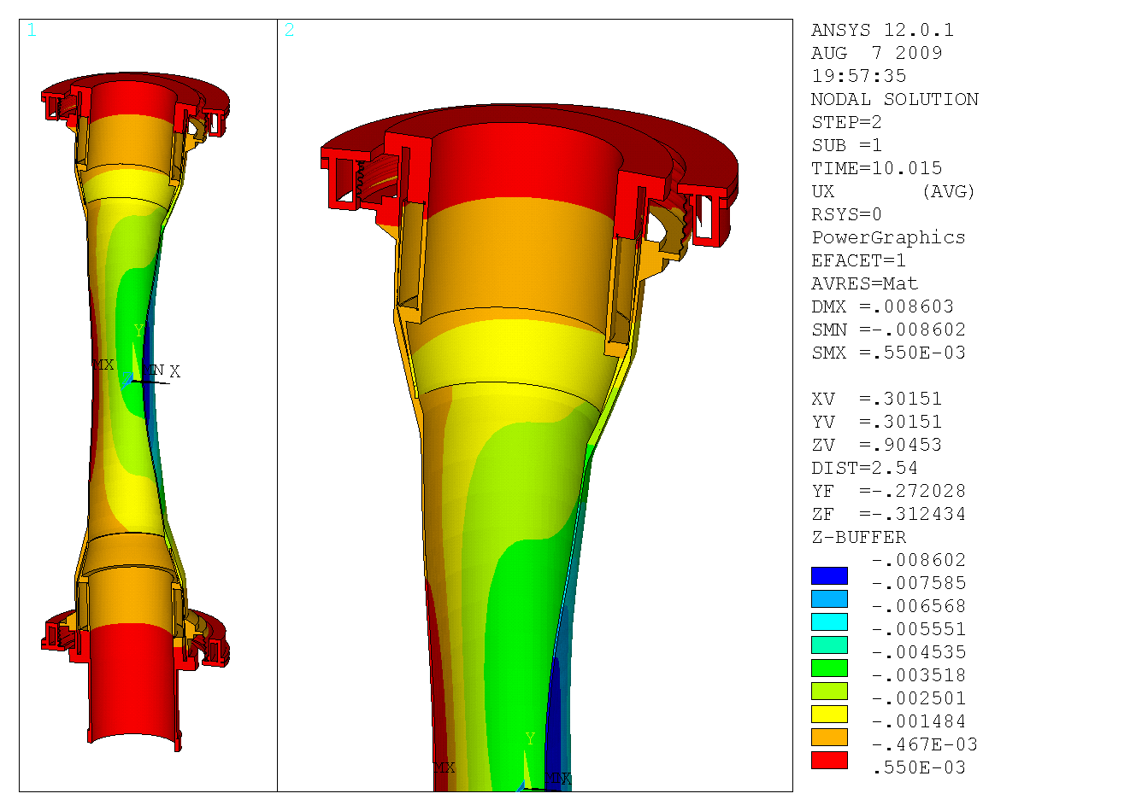
Figure Static Analysis Lateral Displacements, Mid-Height Halo + Inductive Disruption
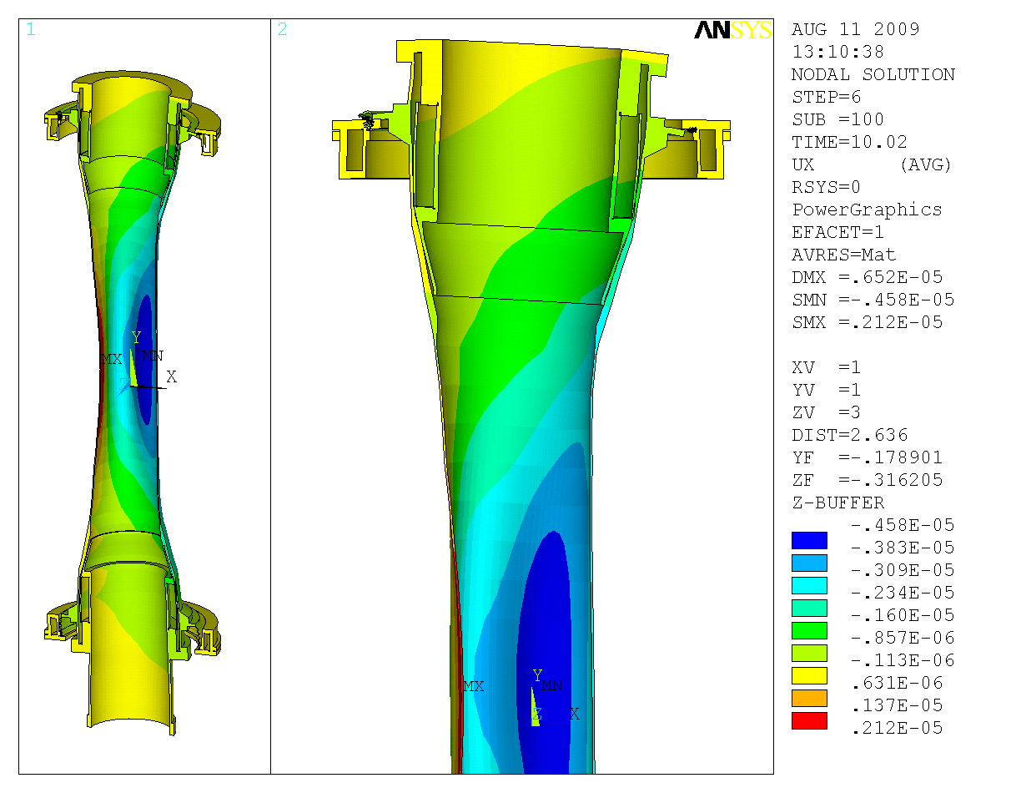
Figure Dynamic Analysis Lateral Displacements, Mid-Height Halo + Inductive Disruption

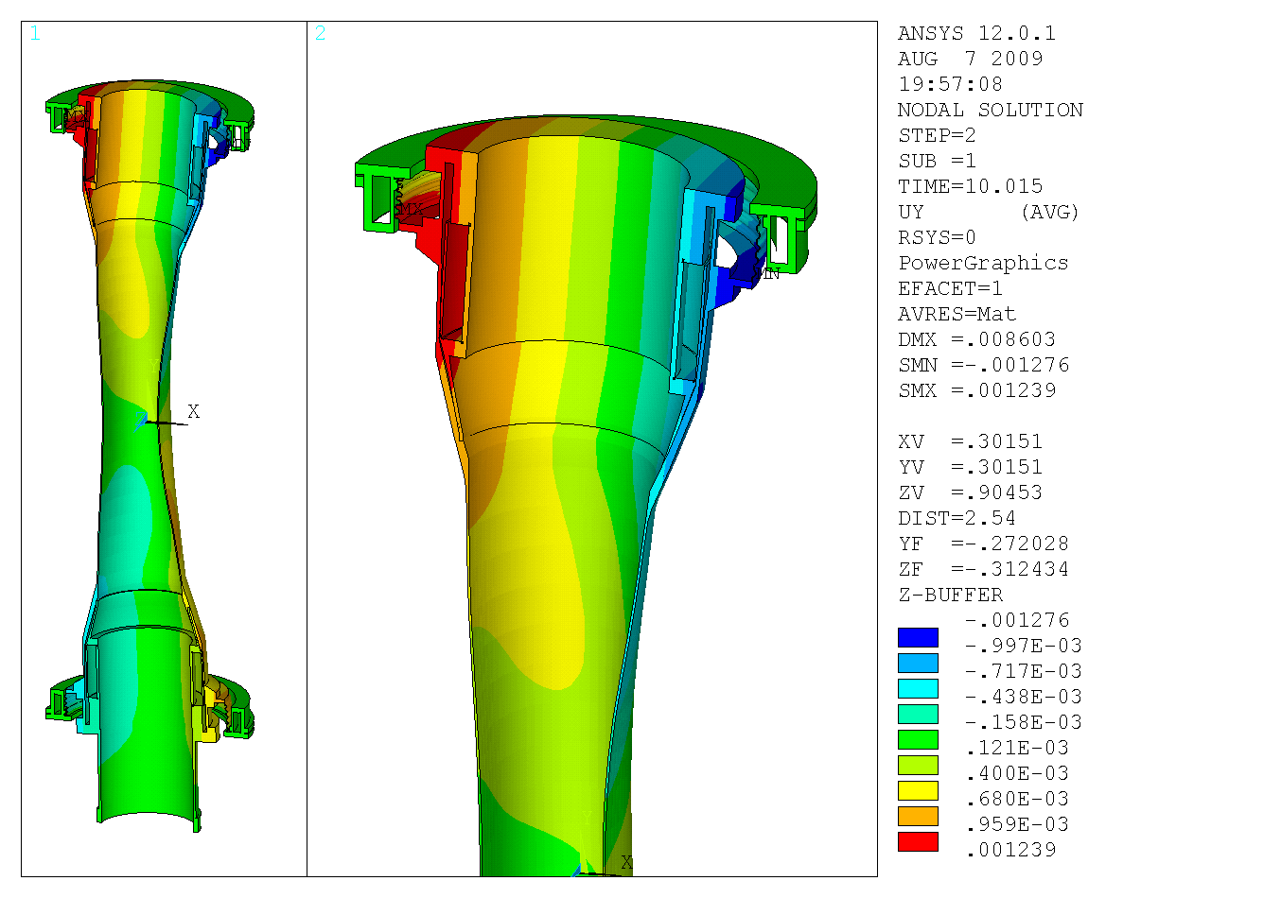
Figure Vertical Displacements, Mid-Height Halo + Inductive Disruption

Regulatory Guide 1.61 - Damping Values for Seismic Design of Nuclear Power Plants

Table 1 Damping Values¹
(Percent of Critical Damping)
Structure or Component | Operating Basis Earthquake or ¹/₂ Safe Shutdown Earthquake² | Safe Shutdown Earthquake
Equipment and large-diameter piping systems³, pipe diameter greater than 12 in | 2 | 3
Small-diameter piping systems, diameter equal to or less than 12 in. | 1 | 2
Welded steel structures | 2 | 4
Bolted steel structures | 4 | 7
Prestressed concrete structures | 2 | 5
Reinforced concrete structures | 4 | 7
¹ Table 1 is derived from the recommendations given in Reference 1.
² In the dynamic analysis of active components as defined In Regulatory Guide 1.48, these values should also be used for SSE.
³ Includes both material and structural damping. If the piping system consists of only one or two spans with little structural damping, use values for small meter piping.

