NSTX

TF coupled thermal electromagnetic diffusion analysis (rev 2)

NSTXU-CALC-132-05-02

January 2, 2013

Prepared By:

___________________________________
Han Zhang PPPL Mechanical Engineering
Reviewed By:

________________________________________
Peter Titus, Branch Head, Engineering Analysis Division

PPPL Calculation Form

Calculation # NSTXU-CALC-132-05-02 Revision # 02 WP #, if any 1672
(supersedes NSTXU-CALC-132-05-01 of Sept, 2009) (ENG-032)

Purpose of Calculation: (Define why the calculation is being performed.)
This current diffusion analysis is performed to calculate the temperature and stresses in the TF inner coils. In the upgrade, the exiting connections between the inner and outer TF coils will be replaced by flags and laminated copper arches. TF current will be promoted to 130KA. Due to the higher current and slew rate, current will distribute non-uniformly, as a function of, coil resistance, inductance and contact pressure between the flag and arch contact joint. This produces localized high temperatures with associated high thermal stress and an increased risk of overheating the coil epoxy. Active water cooling will be added to the inner and outer coils to reduce joule heat. The effect of cooling on thermal stress needs to be investigated. This analysis is based on the previous analysis of Peter Titus.

References (List any source of design information including computer program titles and revision levels.)

See the Body of the Calculation

Assumptions (Identify all assumptions made as part of this calculation.)
1. In the model, the geometry of upper flag, and that of the connector between laminated arch and outer coil are not accurate. Their designs were not totally finalized when building this model.
2. Cooling is first calculated by a separate code especially for beam and then added to the model by specifying the temperature of corresponding nodes.

Calculation (Calculation is either documented here or attached)

See the attached document.

Conclusion (Specify whether or not the purpose of the calculation was accomplished.)
The max temperature for inner coil is 113°C with active cooling, within the temperature allowable of epoxy. It is possible to use high strength copper for the upper flag material, which is only slightly different in temperature. The max temperature in the connectors between laminated arch and outer coil may not be accurate.
Currently the requirement for cooling rate is not yet determined. But to reduce the thermal stress, it is better to cool down slowly. Using thinner tubes, lower coolant speed and different cooling line positions are all possible options to be further evaluated.

Cognizant Engineer’s printed name, signature, and date

I have reviewed this calculation and, to my professional satisfaction, it is properly performed and correct.

Checker’s printed name, signature, and date

Executive Summary
The objective of this analysis is to calculate the temperature and stresses during TF coil ramp up, flat top and ramp down (Fig. 1). PF field is not considered. This analysis is based on the coupled field electromagnetic and thermal analysis for a simple model by P. Titus [1], [2].
The distribution of current in TF coil depends on the resistance, inductance and contact pressure in the contact area. Coil temperature reaches highest at the end of the pulse, i.e., 10.136s for normal operation. Maximal temperature is 117ºC, at the inner side of arch and inner TF leg. Comparing with C. Neumeyer’s result (101 ºC temperature rise [3]) this analysis with current diffusion effect results in a little higher temperature. But within this temperature range, active cooling is not necessary. Max coil temperature is 47 ºC in TF outer coil at the end of pulse. But the temperature at the end of the coil can reach 65 ºC because it connects to the arch which has higher temperature.
In this model, the arch is modeled by two solid pieces. But in reality, they are made of many straps. So the arches in this model have anisotropic material properties (mechanical properties are based on the local structure model results of T. Willard [4]), Current density, magnetic flux density and temperature from this analysis have been provided to T. Willard for his detailed simulation of the joint.
Using high strength copper (80% IACS) in the flag extension increases the temperature only by < 1ºC. Thus high strength copper can be used if required to increase the pressure of joint bolt insert over the capacity of pure copper.
The central beam has maximal hoop tension stress of 72.7MPa at 9.512s (i.e. the end of flat top) and 58.5MPa at 10.136s (i.e. the end of pulse), similar to Titus’s result [2]. But there is another even higher hoop stress point of 95.5MPa at 9.512s, at the connection between central beam and flag, which is due to the L-shape connection part between the arch and TF outer leg.
Toroidal field contours have been provided for use in other calculations—in particular the background field in the antenna calculation.
Structure response at the joint has been included for comparison with more detailed modeling of the joint [4].
Part II was added in Oct. 2010. The radius to the upper TF Flag Corner becomes bigger and the peak temperature was recalculated. Active water cooling was added to the inner leg model to see how long it takes to cool the coil down. Two different cooling line positions are evaluated and compared the cooling time and stress. With active water cooling (0.25” diameter tube, 3 m/s coolant velocity and inlet temperature of 12 ºC), the maximal temperature of lower flag drops to 113.4 ºC and that of upper flag becomes 110.8 ºC. There are two options for cooling line placement, one in the middle of the coil, the other at the side. Putting cooling line at side produces lower S_{theta} (i.e. stress component that can cause delamination) of 90 MPa when compared to putting cooling lines in the middle. The latter will cool the coil down faster and result in more shrinkage. In these analyses, 0.3” tube is used with 3 m/s velocity and it takes 5 minutes to cool the inner coil down to room temperature. If the cooling process can be slower, for example, by using a 0.25” tube and the same velocity, the stress S_{theta} can be reduced to 48 MPa. To reduce S_{theta}, it is better to cool down slowly. Using thinner tubes, lower coolant speed and different cooling line positions are all possible options to be further evaluated.
Part III was added in Oct. 2012. After the NSTX bundle failure, there was some concern that cooling results in thermal stress and may cause delamination. So the cooling scheme was changed that takes the exit water from the outer leg TF and feeds it into the inner leg [7]. Comparing with previous design, cooling line is also moved inside (toward the center of inner leg bundle) a little, to avoid high torsional shear area (according to Pete’s results). Cooling line temperatures were calculated by Ali [7] and then these temperatures are applied to the specific nodes on the cooling line in Han’s model. Temperatures of other nodes on the cooling line are calculated by linear interpolation. In this way, thermal stress was reduced to 33MPa.

Figure 1: NSTX normal operation waveform.

Table of Contents

Executive Summary…………………………………………………………………………….. 3
Table of Contents……………………………………………………………………………….. 5
Revision Status Table…………………………………………………………………………... 5
List of Tables 6
List of References 6
Modeling 8
Comparison of using high strength copper and pure copper 10
Temperature rise 14
Coil deformation 15
Coil deformation 16
Contact pressure 19
Coil stresses 20
Coil stresses 21
Current density, temperature and toroidal field in the arch area 23
Appendix: ANSYS code for pulse waveform (from [1]) 26
Part II: Fillet Radius and Active Cooling Addition 28
Part III: Outer TF Coolant Fed Into Inner Leg 33
NSTX Upgrade TF Inner Leg Cooling (Ali Zolfaghari) 37
Appendix: The batch code for solution 41

Revision Status Table

Rev# | Preparer | Reviewer | Date
Rev 0 | Han Zhang | Yuhu Zhai
Rev 1 | Han Zhang | Yuhu Zhai |  | Added material in the corner radii of the TF to improve the temperature response. Also active cooling is added to TF inner leg to evaluate the stress and compare different cooling design.
Rev2 | Han Zhang  Ali Zolfaghari | P. Titus |  | Updated Executive Summary, Added Revision Status Table
Rev 2 |  |  |  | Added Appendix Containing Ali Zolfaghari’s FCOOL run with the outer leg coolant input to the inner leg, Added Ref [7] Ali’s rev 1 of the FCOOL calculations

List of Figures
Figure 1: NSTX normal operation waveform. 3
Figure 2: Electromagnetic model. 8
Figure 3: Thermal and structural model. 9
Figure 4: Comparison of using pure copper and high strength copper as flag material. 11
Figure 5: Temperature (K) in the coil. 14
Figure 6: Time history plot of temperature (K). 14
Figure 7: Time history plot of temperature (K). 15
Figure 8: Coil deformation (m). 16
Figure 9: The L-shape connection results in the theta deformation. 18
Figure 10: Time history plot of joint displacement Ux and Uz (m). 19
Figure 11: Stress in contact regions (Pa). 20
Figure 12: Coil Von Mises stress (Pa) 21
Figure 13: Close view of Von Mises stress (Pa). 21
Figure 14: Hoop stress (Pa). 23
Figure 15: Current density (A/m²). 24
Figure 16: Temperature (K). 25
Figure 17: Toroidal field estimation. 25

List of Tables
Table 1: Contact resistance data [5]. 3

List of References
[1] Peter Titus, “Coupled Electromagnetic-Thermal Analysis (04072009)”, NSTX-CALC-132-01-00, 2009.
[2] Peter Titus, “Coupled Electromagnetic-Thermal Analysis (04202009)”, NSTX-CALC-132-02-00, 2009.
[3] Charles L. Neumeyer, http://www.pppl.gov/~neumeyer/NSTX_CSU/Design_Point.html, dated 7-29-2009.
[4] Tom Willard, “TF Flex Joint and TF Bundle Stub”, NSTX-CALC-132-06-00, 2009.
[5] Robert D. Woolley, “TF Joint Pressure VS Temperature In NSTX CSU Upgrade”, CSU-CALC-132-090211-RDW-01, 2009.
[6] Email from Ali Zolfaghari with data from FCOOL run:
Date: Fri, Feb 24, 2012 at 10:39 AM
Subject: Temp along the outer and inner legs along the coil
To: Han Zhang <hzhang@pppl.gov>
Cc: Peter Titus <ptitus@pppl.gov>
Dear Han,
For the fcool and CFX analysis I use 135000 Amps for 7.6 seconds.
This email has two attachements one which is a out file for the fcool run (ascii text fie) for the outer leg. You are familiar with this file. Units of temperature is Fahrenheit.
Then there is an excel file with the results from the CFX on the Inner leg; it has the temp of the coolant, copper near the coolant wall, and copper average at inlet, quarter, mid, three-quarters and outlet of the inner leg at t=0, 100s, 200s, 300s, 400s, and 500s. Temps are in Kelvin
Let me now if you need more info or clarification.
Ali

fcouta.txt
6128K View Download

temperatures-along-the-TF-Inner.xls
22K View Open as a Google spreadsheet Download
[7] NSTX-CALC-132-10-01 “TF INNER LEG COOLING USING FCOOL” Revision 1, AZolfaghari, Jan 2013

Modeling

This is a transient and coupled field analysis. An electromagnetic model (Fig. 2) is used to calculate current diffusion effect and transfer the generated heat and Lorenz force to thermal and structural model. The thermal and structural model calculates the temperature, displacement, thermal stress, contact pressure at contact areas, and then transfer these data back to electromagnetic model. The materials have temperature dependent material properties, including electrical resistivity, thermal conductivity, specific heat, coefficients of thermal expansion. The arches have anisotropic resistivity and thermal conductivity to simulate the straps. Because the arch is made of many straps and not a solid copper, it becomes much more compliant. The modulus of the arch is estimated to be half of that of pure copper. The upper flag uses high strength copper which has 1/0.8 resistivity and 80% thermal conductivity of pure copper. In next section, the results show that using high-strength copper or pure copper doesn’t have much difference. The lower flag uses pure copper. In the electromagnetic model, the contact regions have pressure dependent resistivity and the data are from R. Woolley [5] (Table 1).

Figure 2: Electromagnetic model.
A. Model
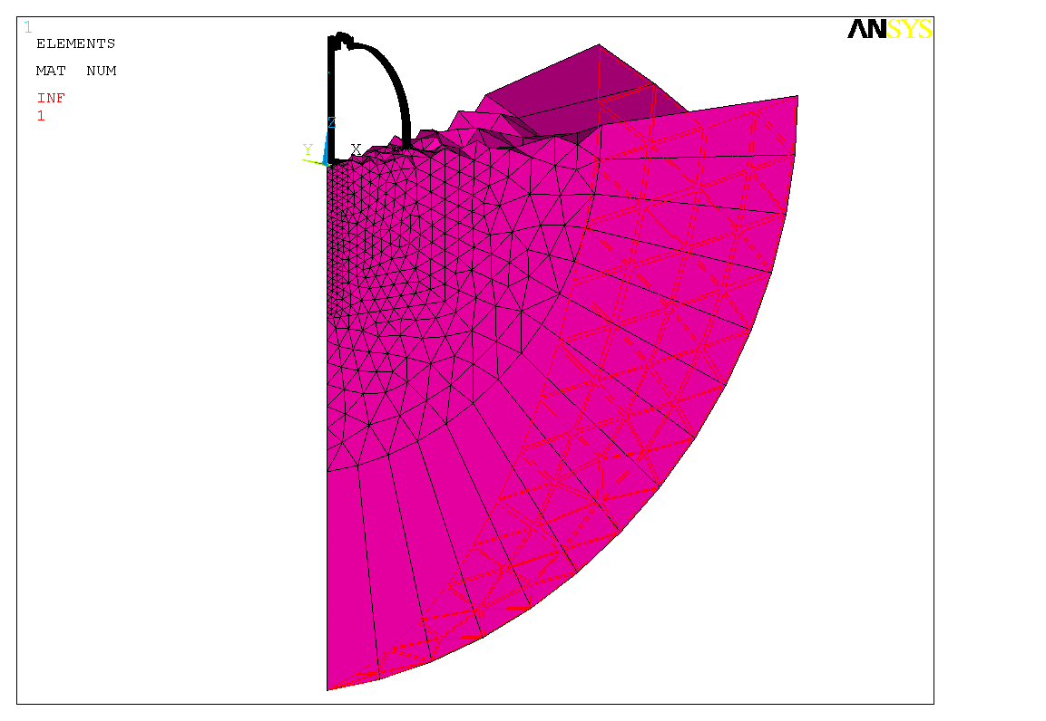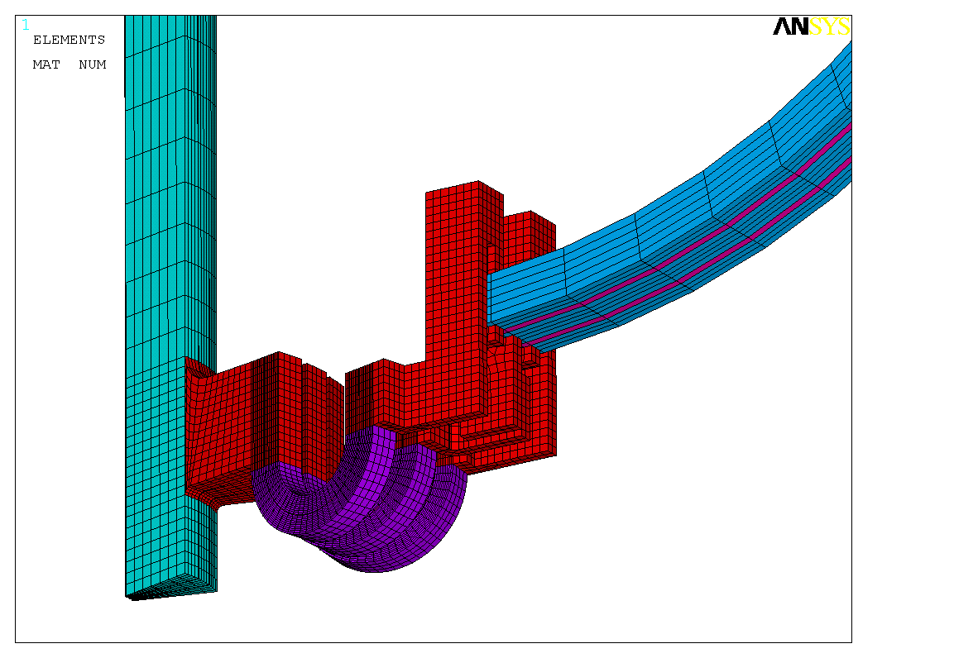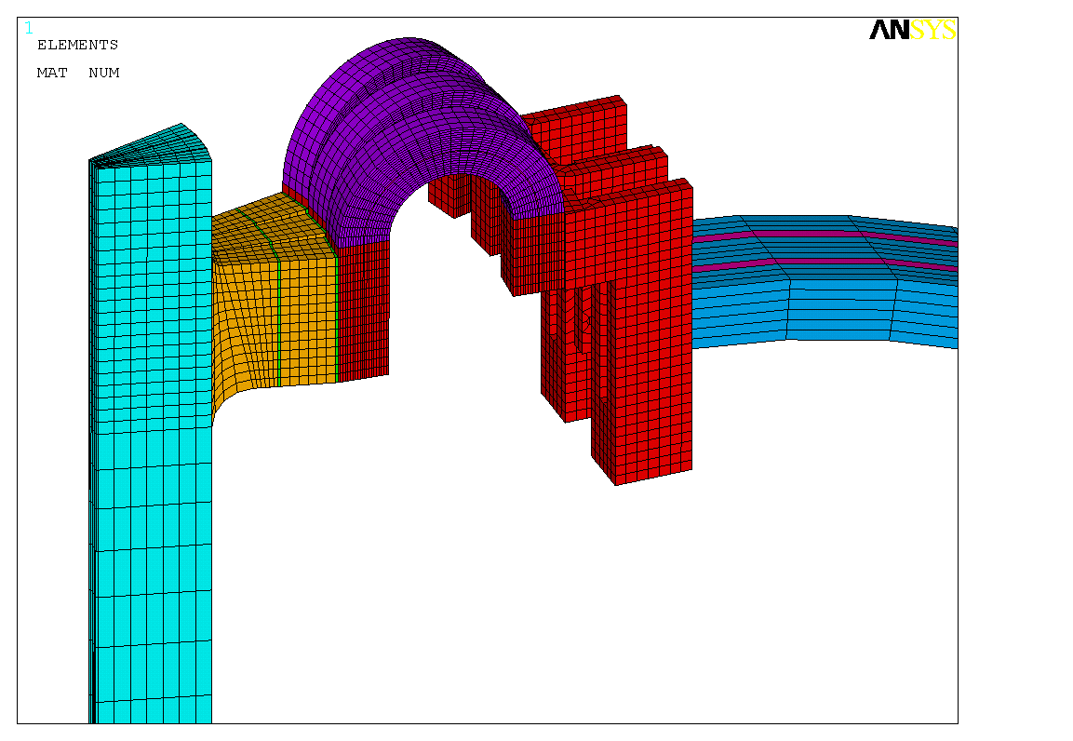
Arch: with anisotropic mat prop to simulate strips
Upper flag: high strength copper: with 1/0.8 resistivity and 80% thermal conductivity
Lower flag: pure copper
Contact area
Electrical insulation
TF coil
TF coil
air
B. Toroidal field plot
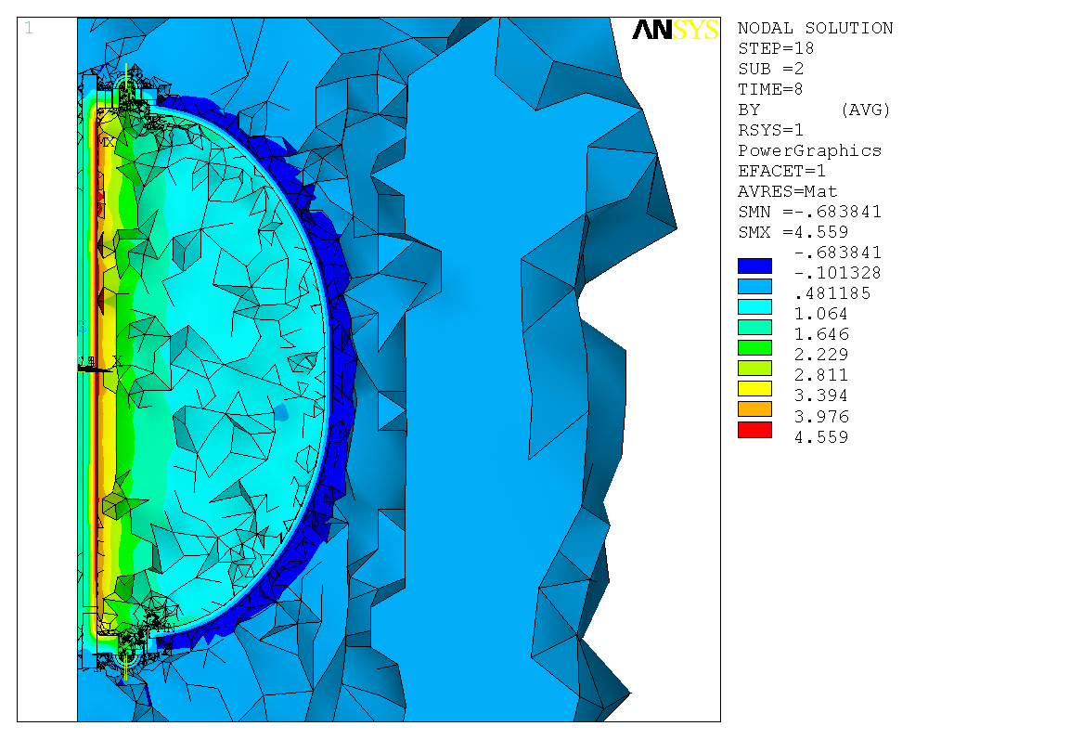
t=8s, flat top, Toroidal field (T)
Figure 3: Thermal and structural model.
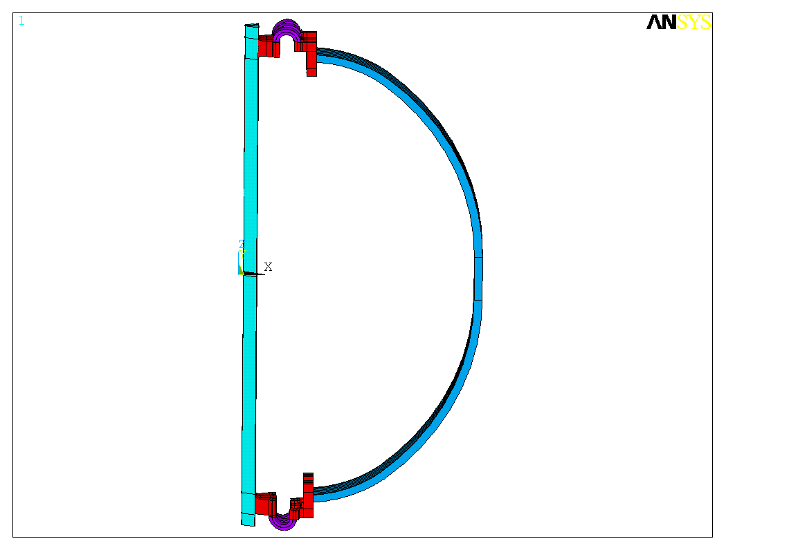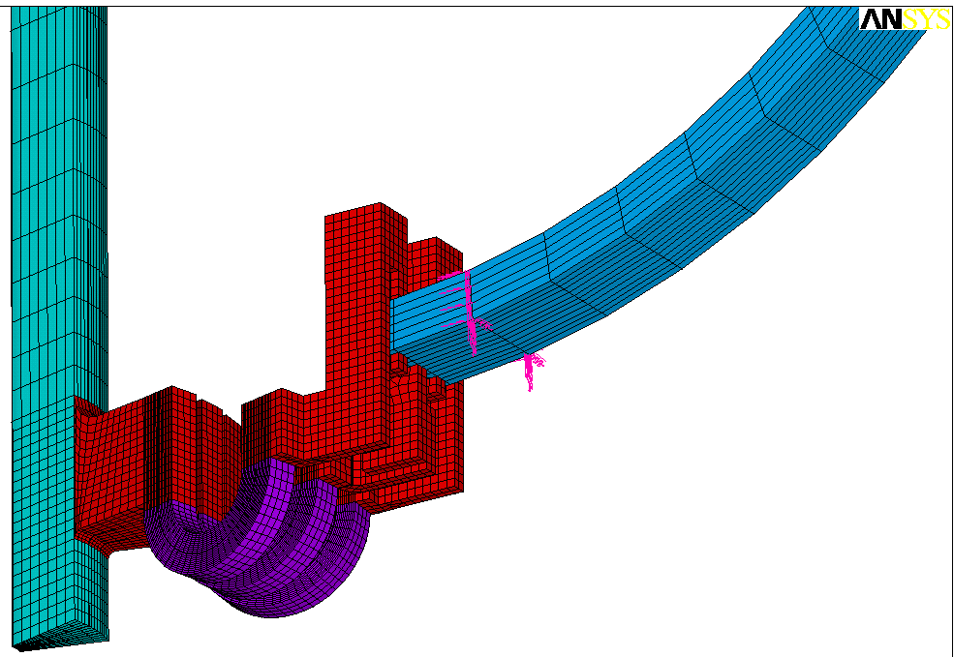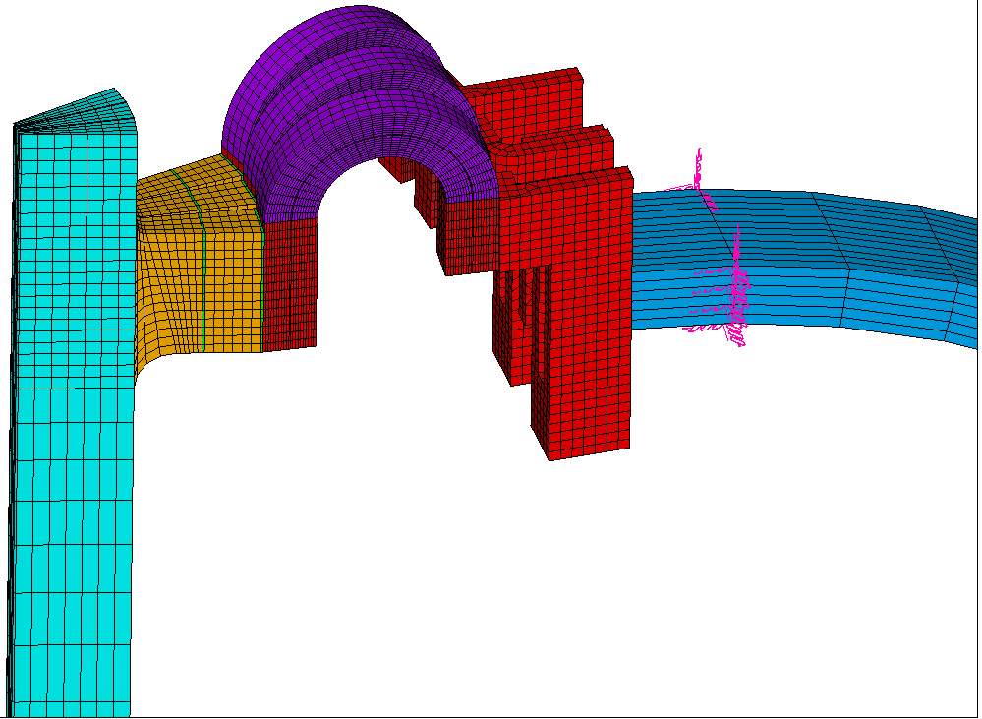
Arch: with anisotropic mat prop to simulate straps
Upper flag: high strength copper: with 1/0.8 resistivity and 80% thermal conductivity
Lower flag: pure copper
Contact regions
TF coil
Springs to fix TF coil to simulate umbrella structure

Table 1: Contact resistance data [5].
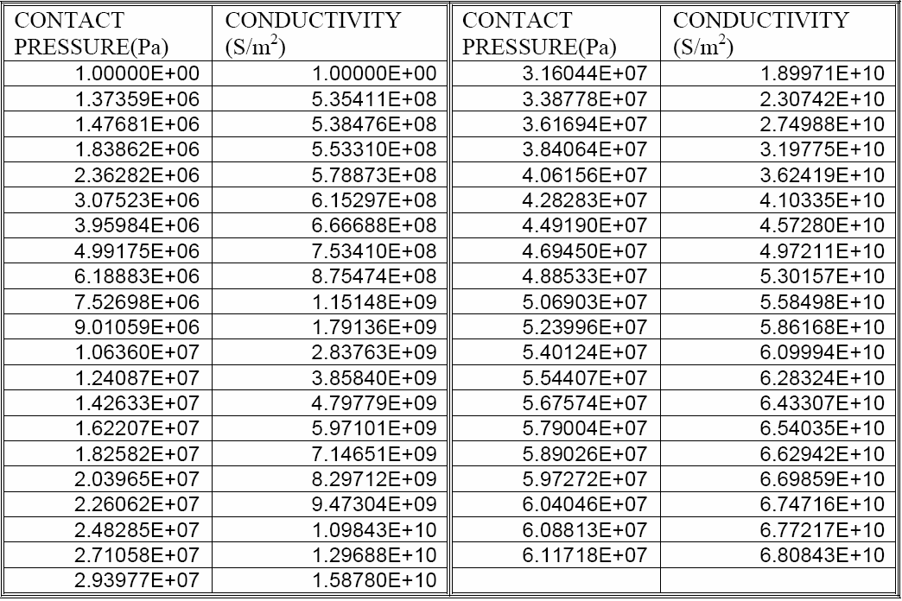

Comparison of using high strength copper and pure copper

Because the upper flag has two contact regions, using high strength copper as the flag material can help to maintain high and uniform contact pressure and also lower contact resistance. But high strength copper has higher resistance and lower thermal conductivity. The result shows that using high strength copper (1/0.8 resistivity and 80% thermal conductivity) causes temperature rise of less than 1ºC. So there is some margin to change to high strength copper.

Figure 4: Comparison of using pure copper and high strength copper as flag material.
A. Temperature (K).
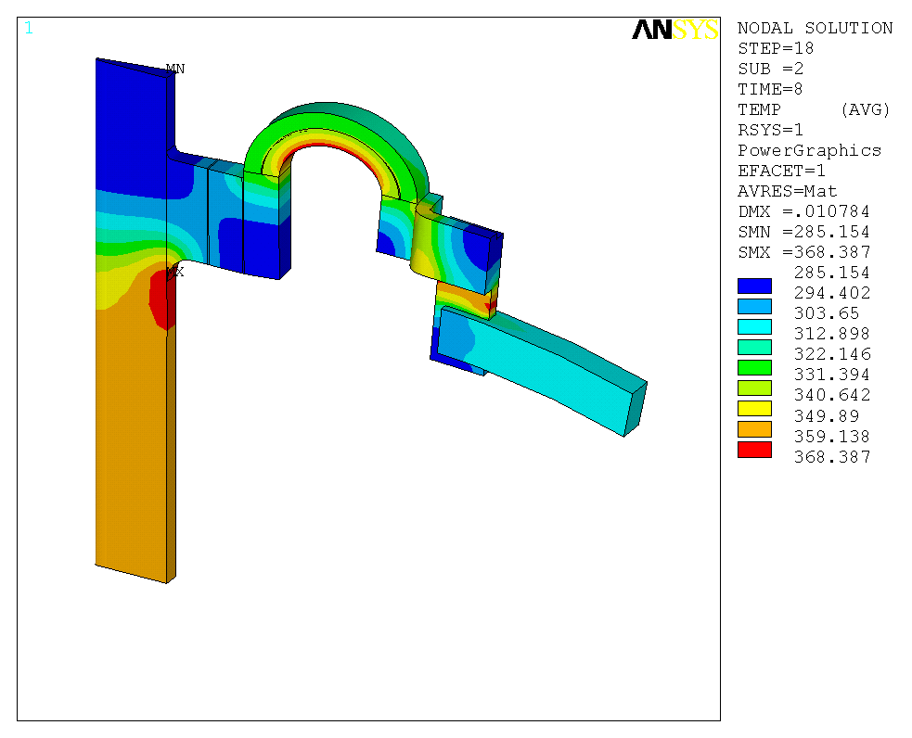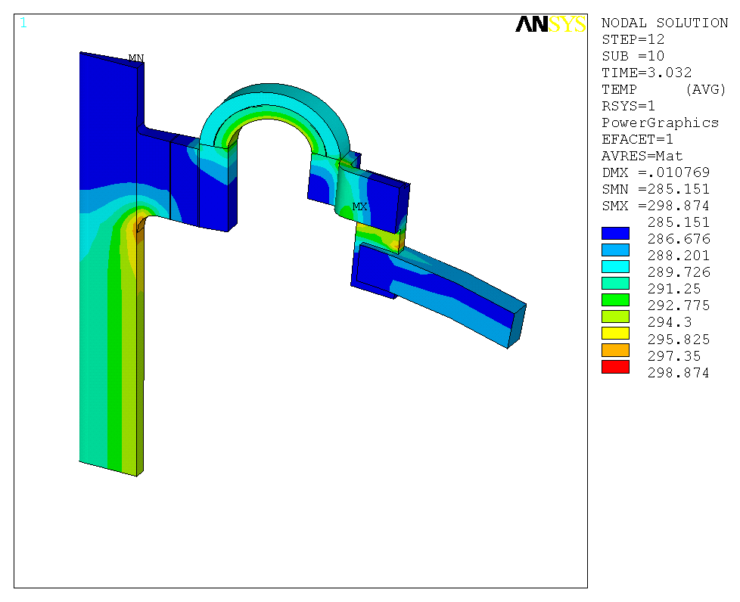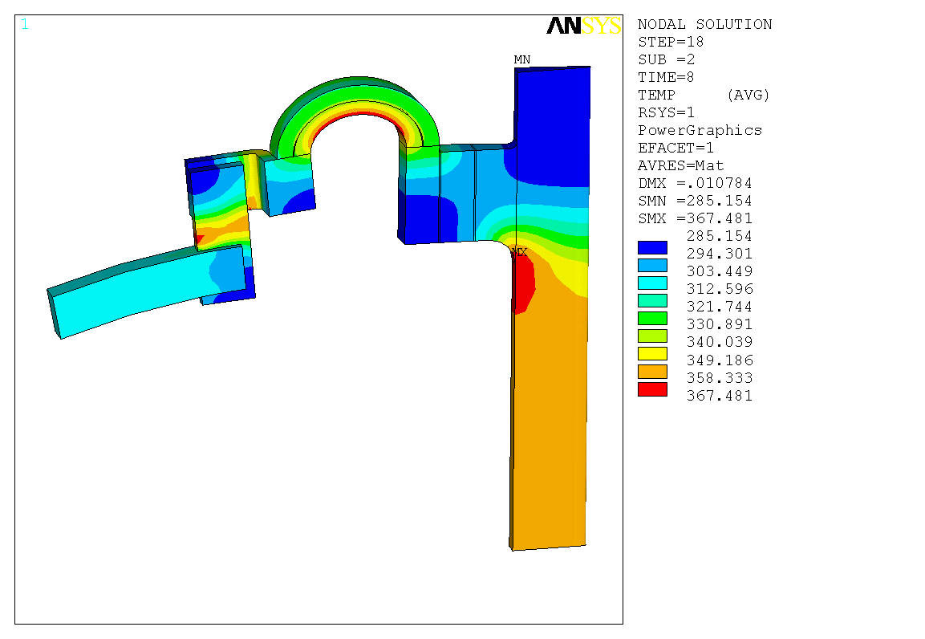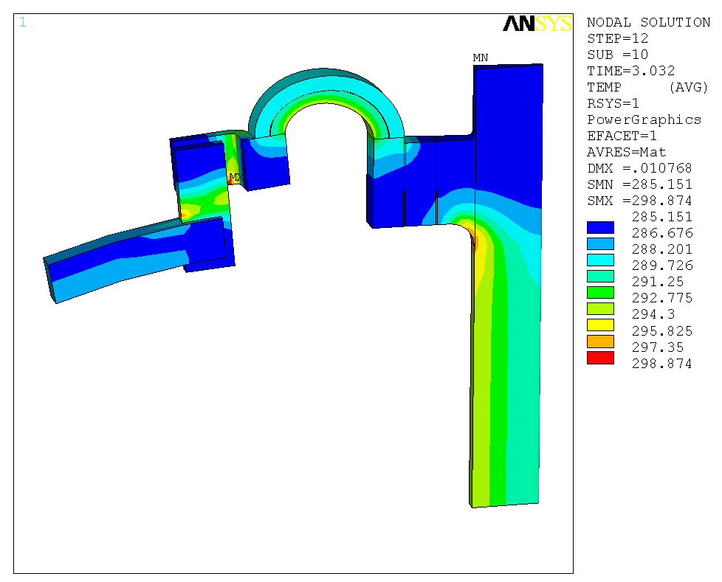
High strength copper
Pure copper
Temperature (K)
Temperature (K)
Temperature (K)
Temperature (K)
t=3.032s
t=3.032s
t=8s
t=8s
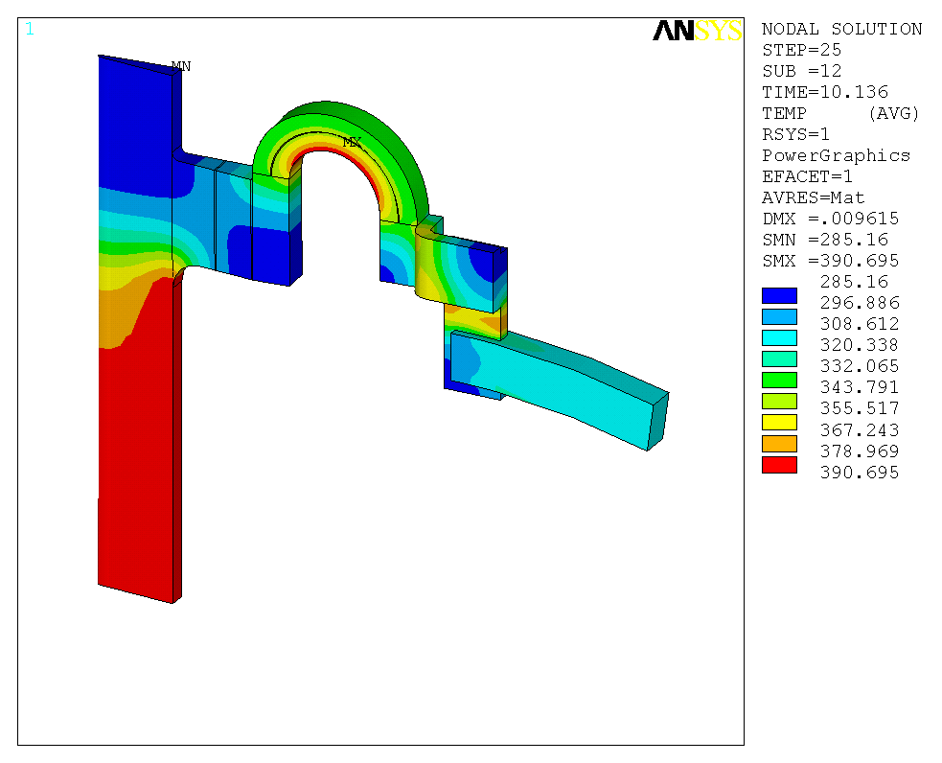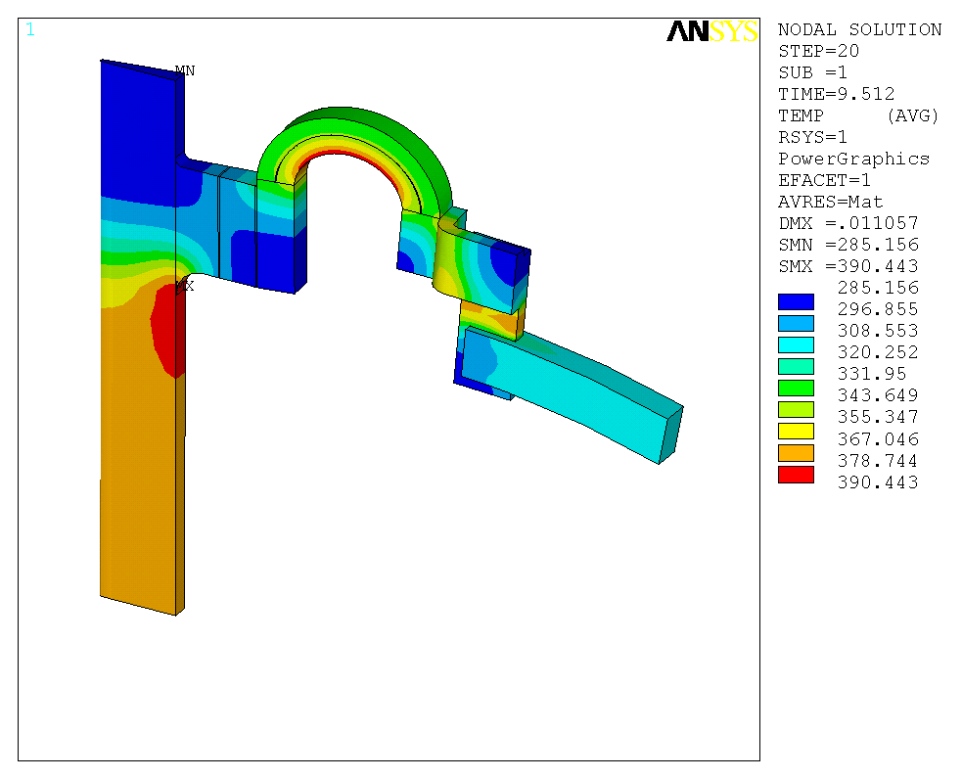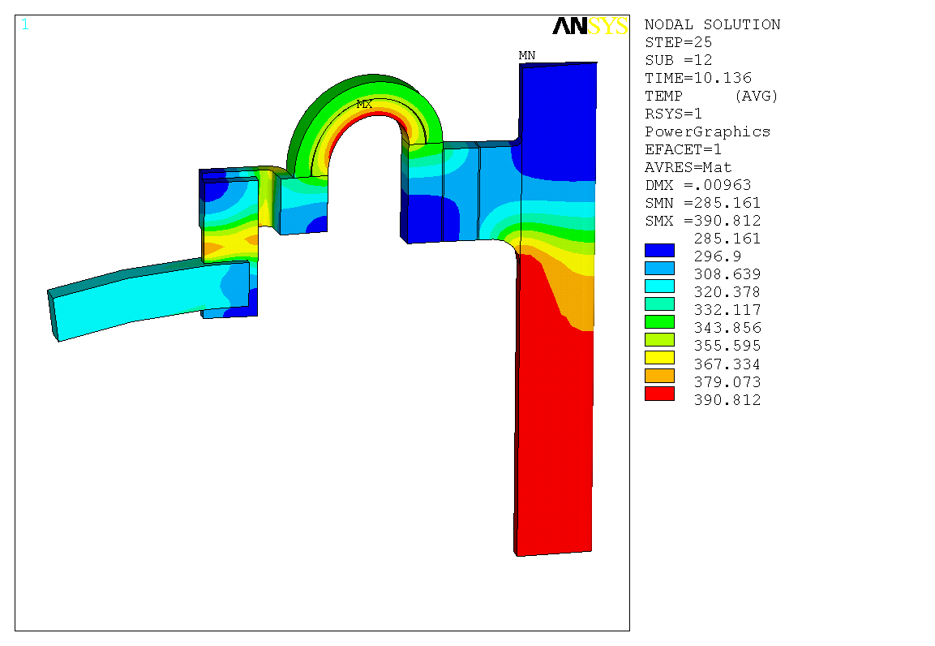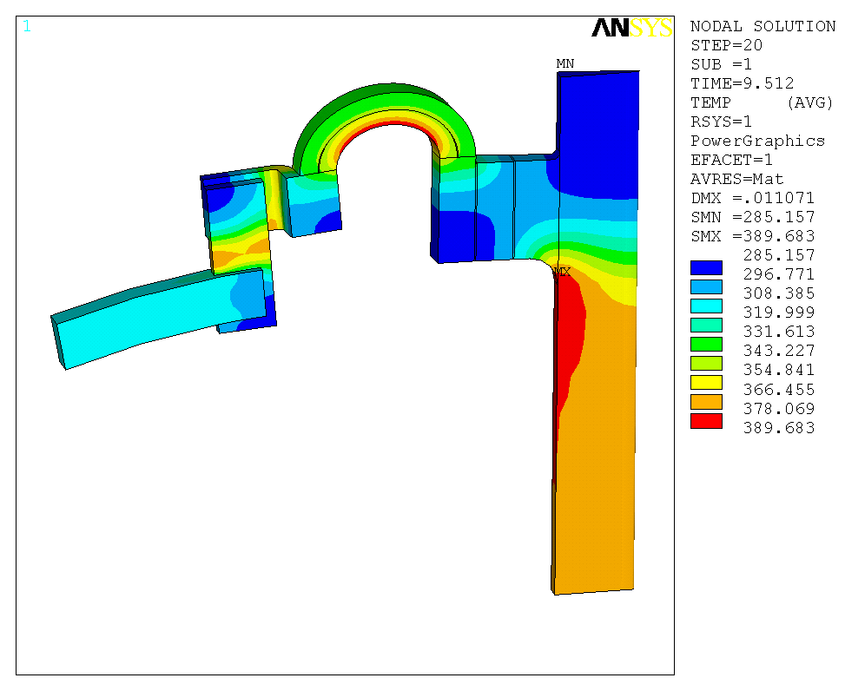
High strength copper
Pure copper
Temperature (K)
Temperature (K)
Temperature (K)
Temperature (K)
t=9.512s
t=9.512s
t=10.136s
t=10.136s
B. Current density (A/m²).
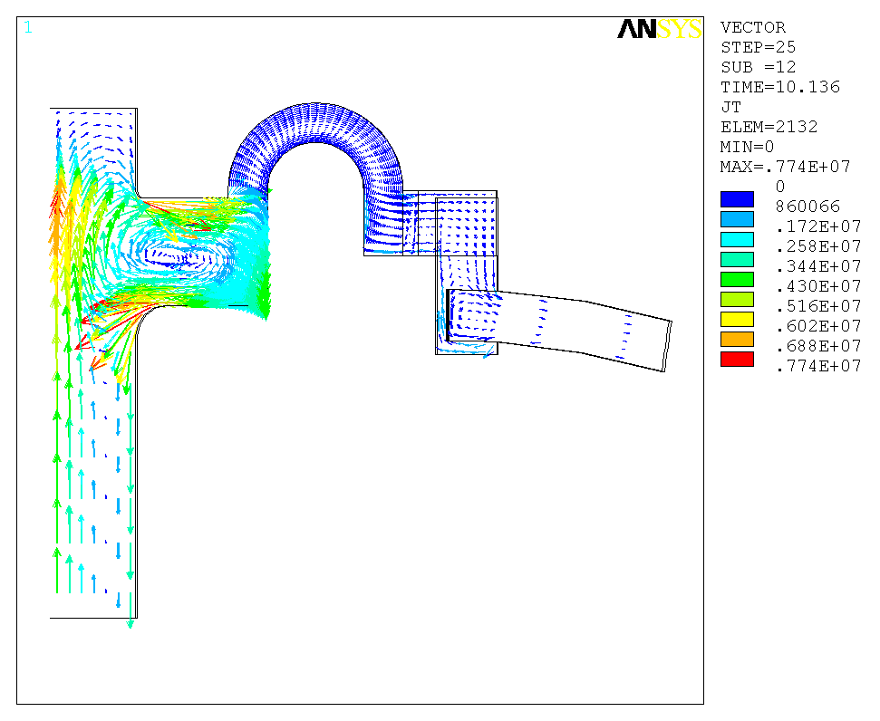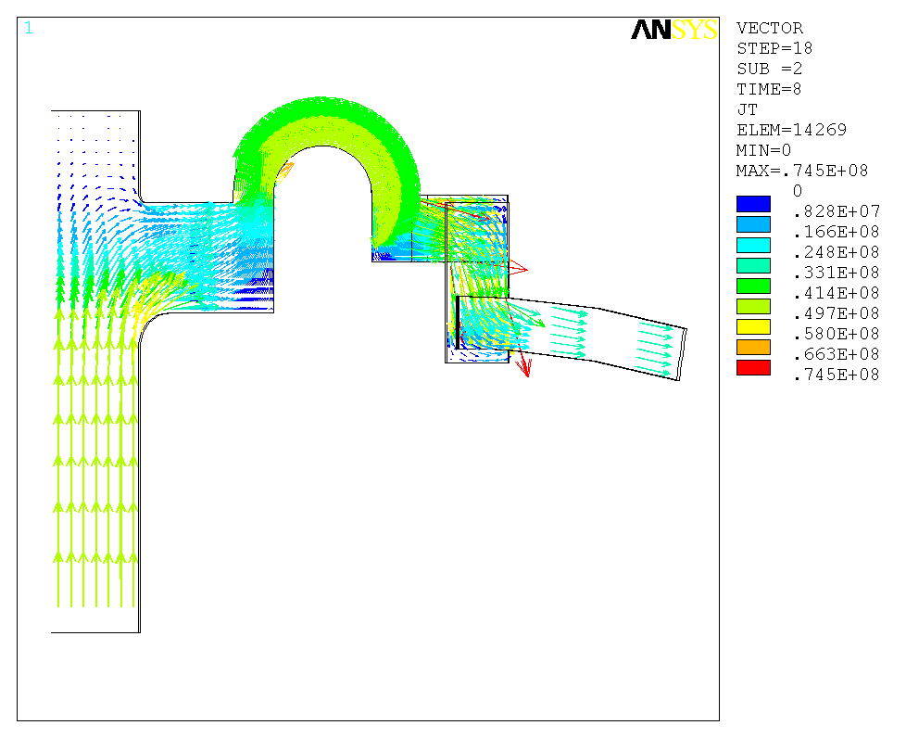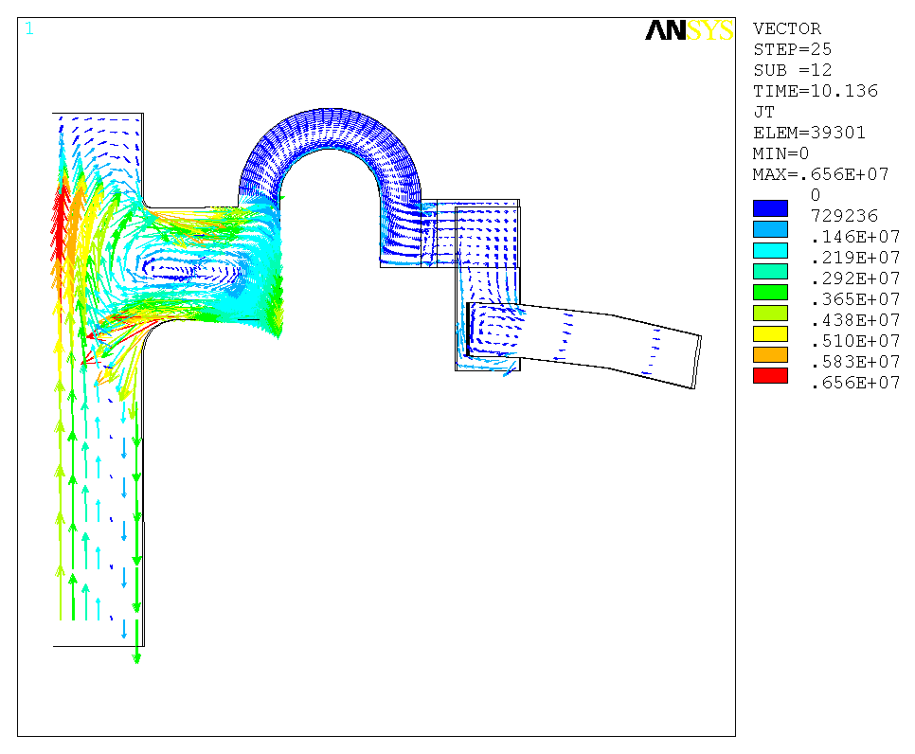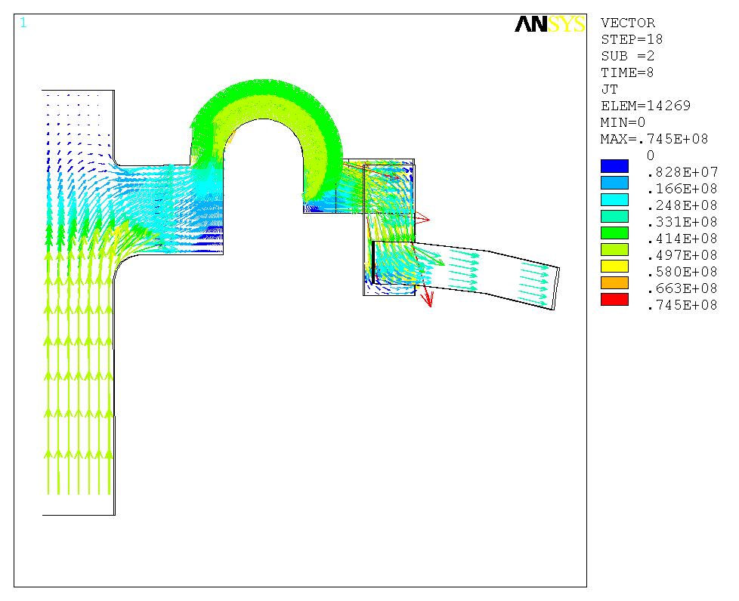
High strength copper
Pure copper
t=8s Current density (A/m²)
t=10.136s Current density (A/m²)
t=10.136s Current density (A/m²)
t=8s Current density (A/m²)

Temperature rise

Fig. 5 shows temperature rise. The maximal temperature is 117ºC at the inside of arch.
Fig. 6 is the time history plot of joint temperature. At the connection plane between central beam and flag, the max temperature difference can reach 103 ºC. Max Von Mises stress is also here (see next sections).
Fig. 7 is the time history plot of coil temperature. Coil temperature reaches highest of 47 ºC at the end of pulse. But the ends can reach 65 ºC and max temperature difference there is 47 ºC because they connected to the joints which have higher temperature and larger temperature difference.

Figure 5: Temperature (K) in the coil.
t=3.032s, start of flat top
t=8s, flat top
t=9.512s, end of flat top
t=10.136s, end of waveform

Figure 6: Time history plot of temperature (K).
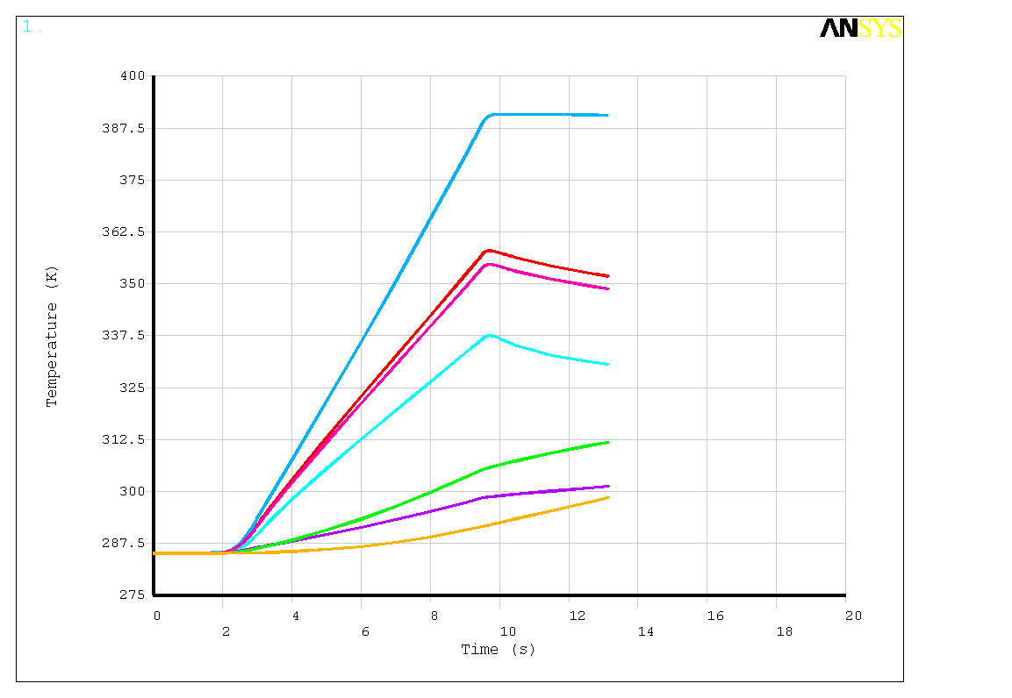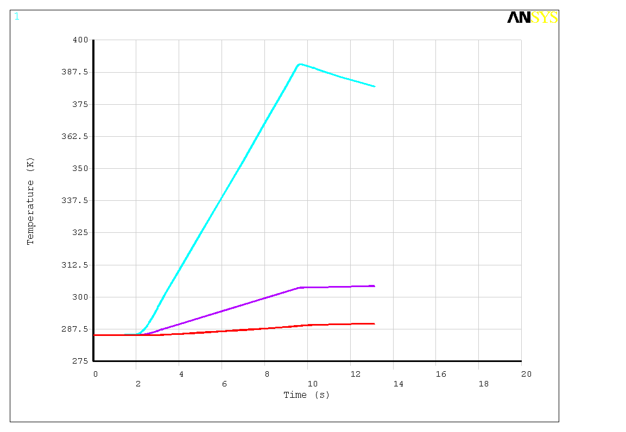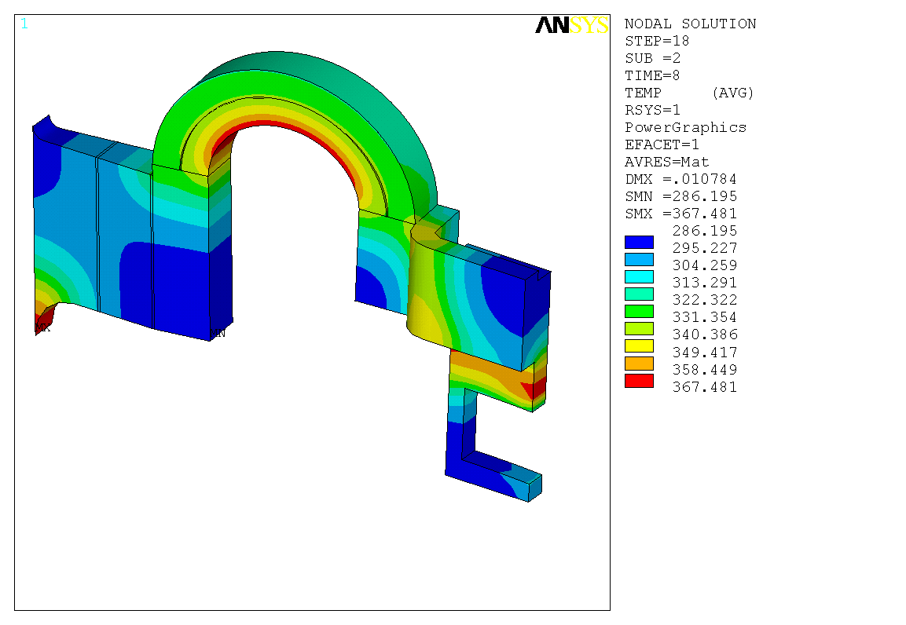
t=8s, flat top, temperature (K)

Figure 7: Time history plot of temperature (K).

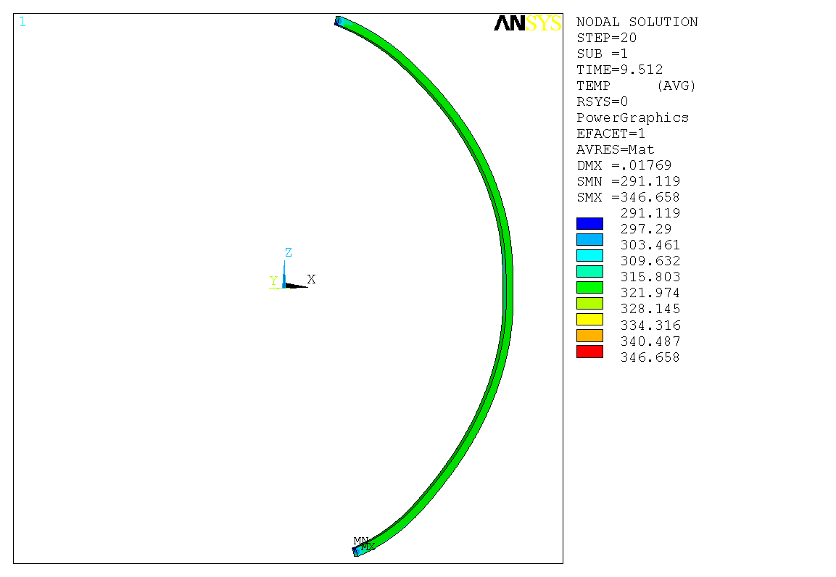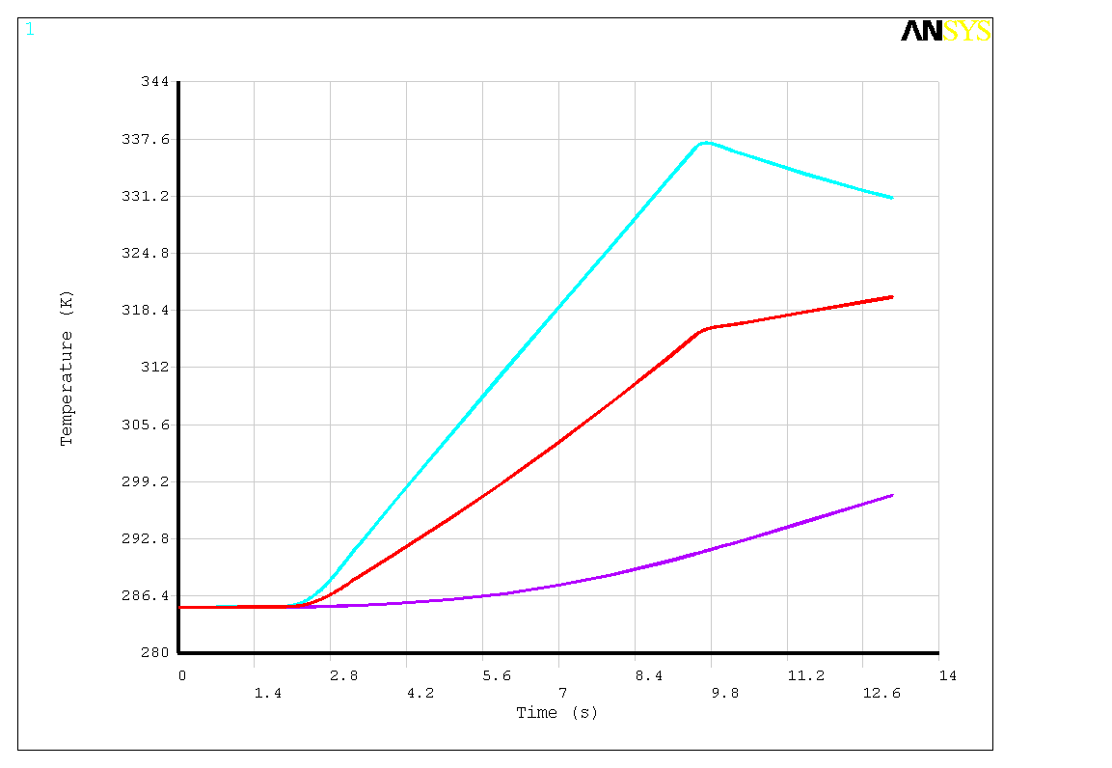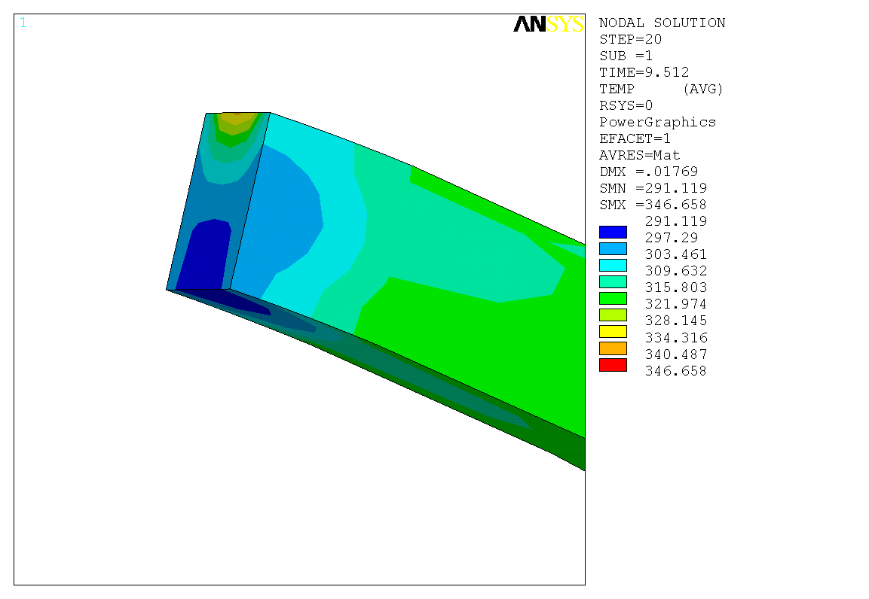

Coil deformation

Fig. 8 shows the deformation of the coil. Maximal radial deformation is 17.4mm (0.685”), theta deformation is <1mm and vertical deformation is 11mm (0.433”). There is no PF coil in this model and thus no out-of-plane force from poroidal field. The connection shape showed in Fig. 9 results in the theta deformation.
Fig. 10 is the time history plot of joint displacement Ux and Uz. The right end of the arch (close to outboard leg) is mainly affected by the magnetic force and thus has a curve shape similar to waveform. The left end and middle point of the arch are mainly affected by the thermal expansion of central beam and thus have a curve shape following temperature rise.

Figure 8: Coil deformation (m).
A. Radial deformation (m).
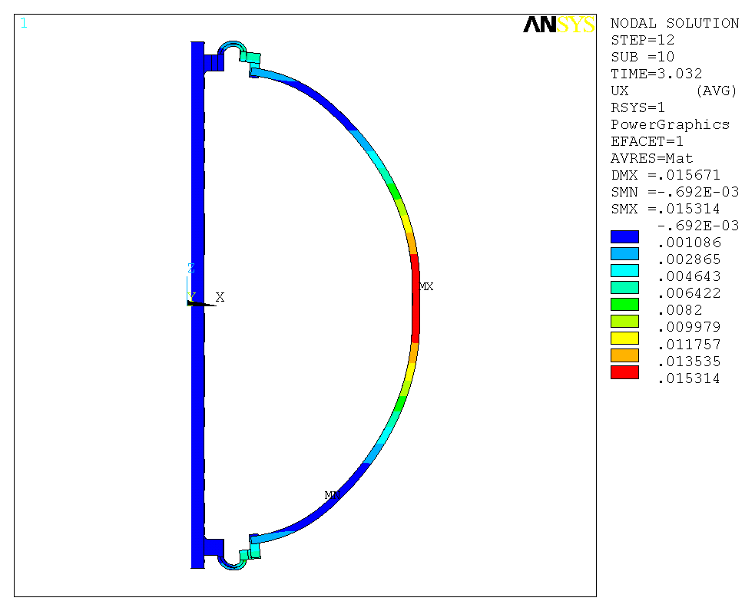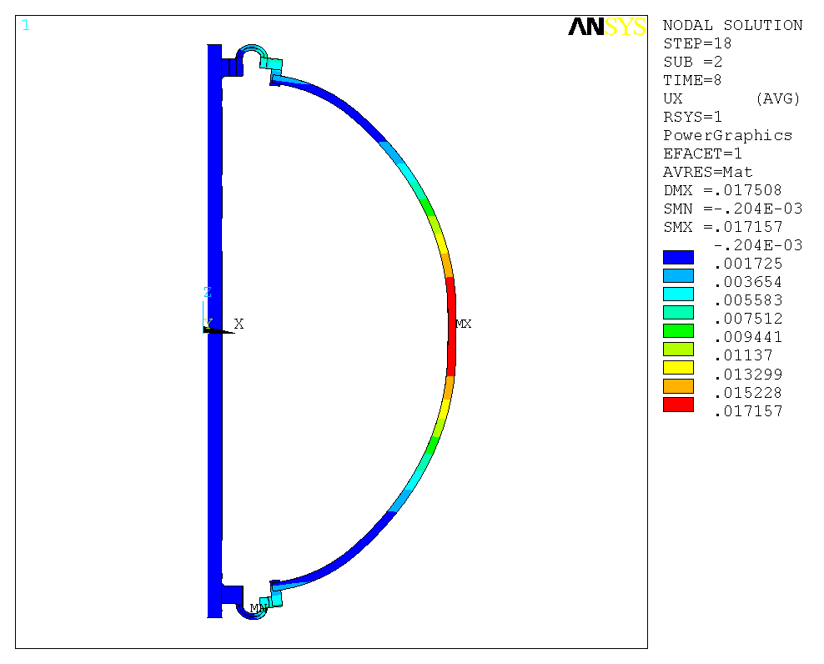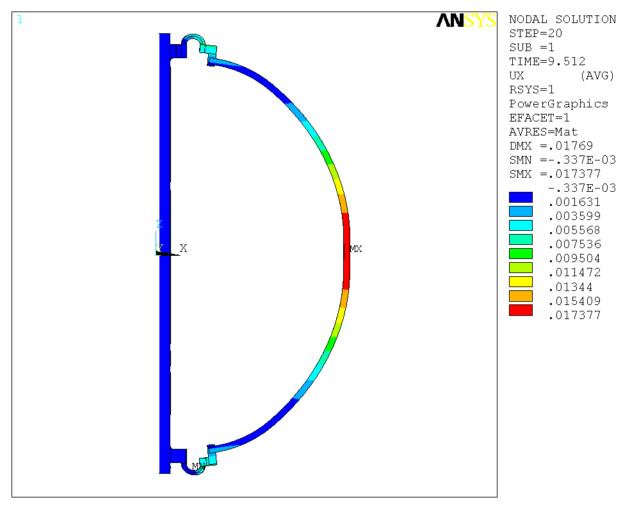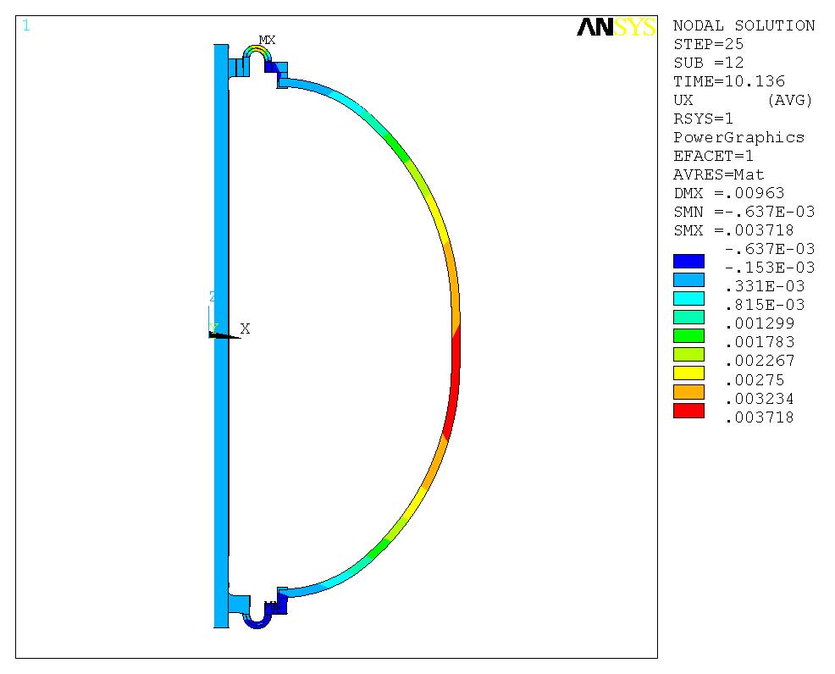
t=3.032s, start of flat top
t=8s, flat top
t=9.512s, end of flat top
t=10.136s, end of waveform
B. Theta deformation (m).
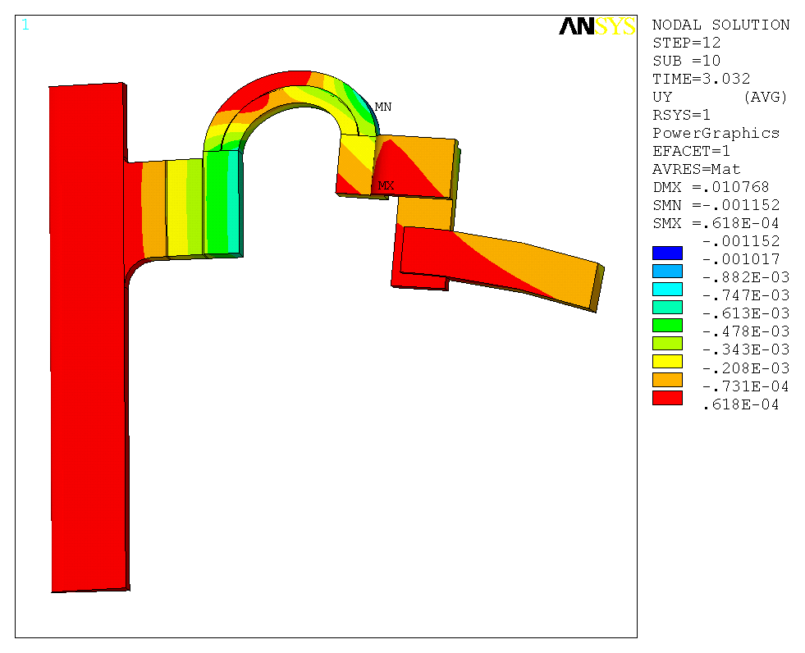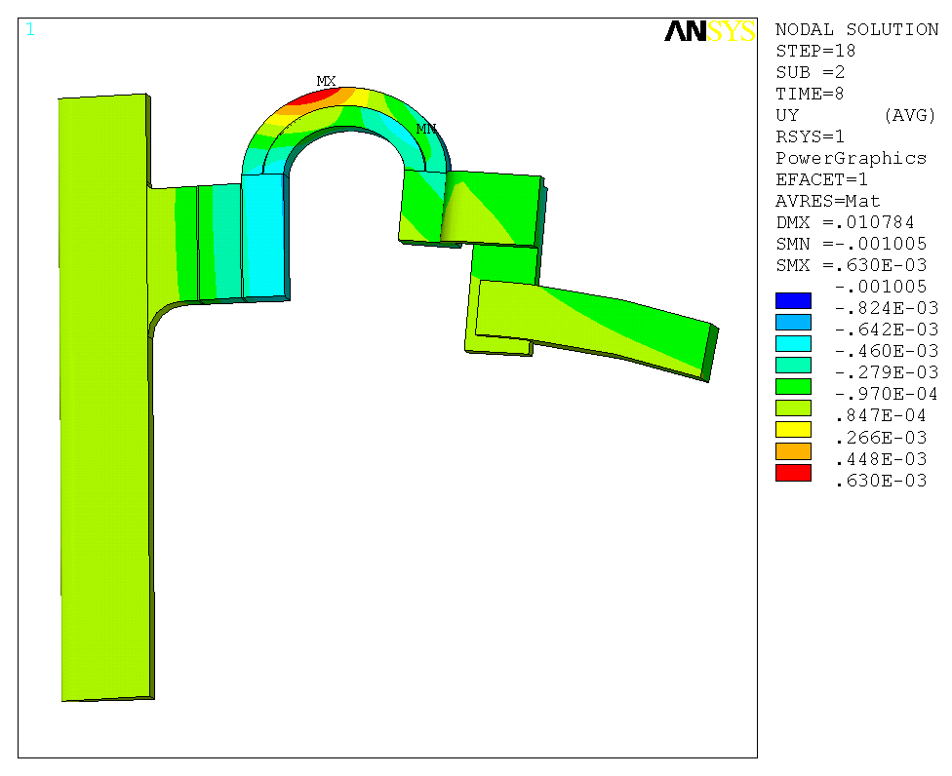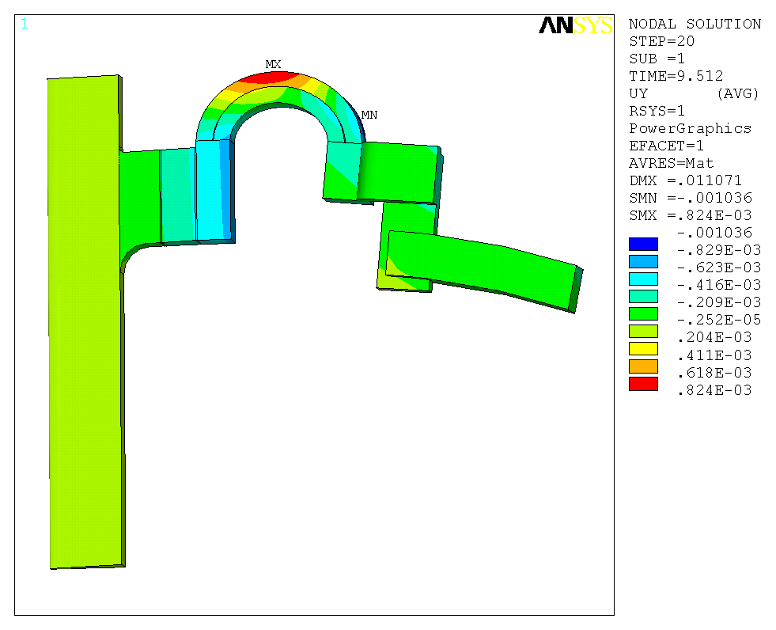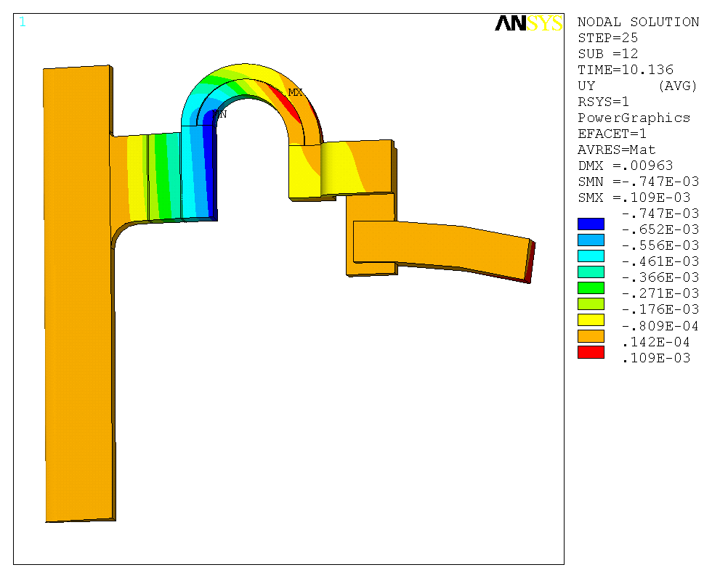
t=3.032s, start of flat top
t=8s, flat top
t=9.512s, end of flat top
t=10.136s, end of waveform
C. Vertical deformation (m).
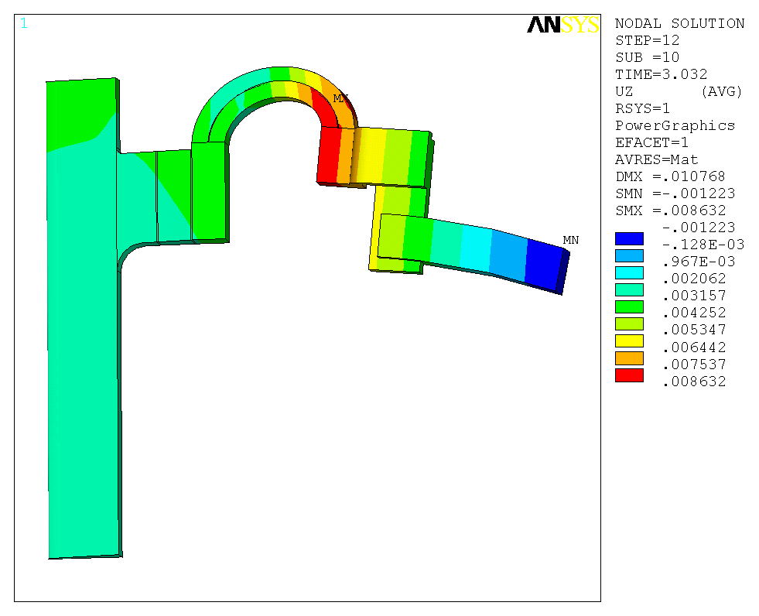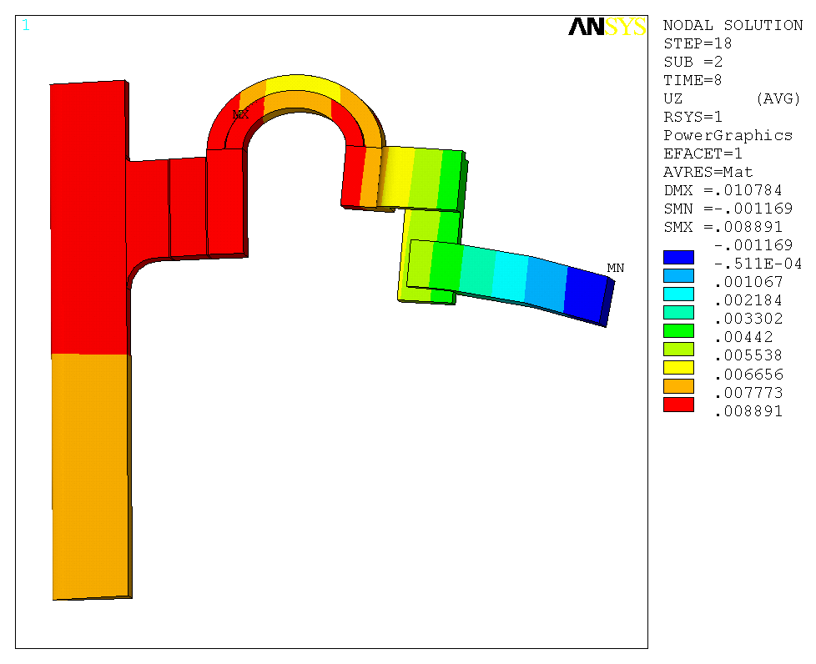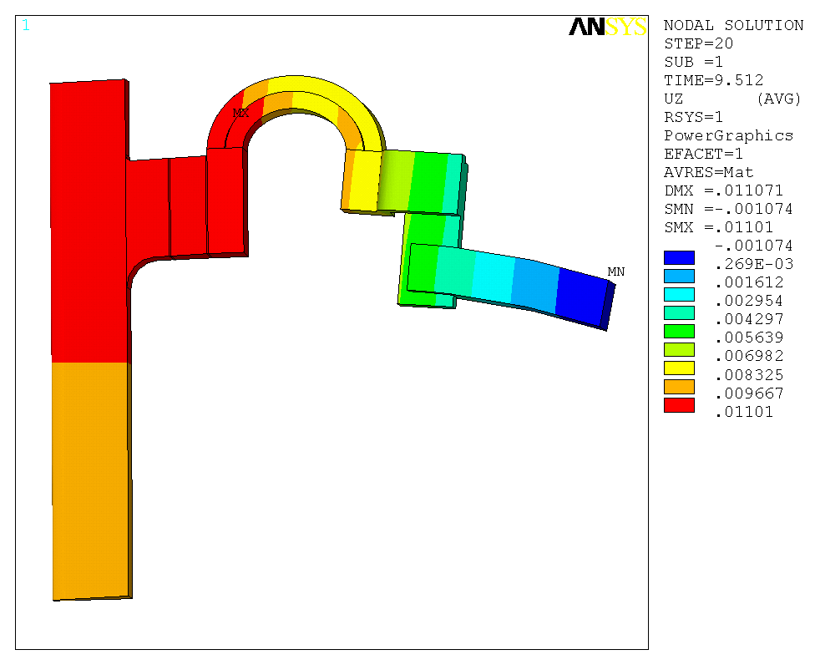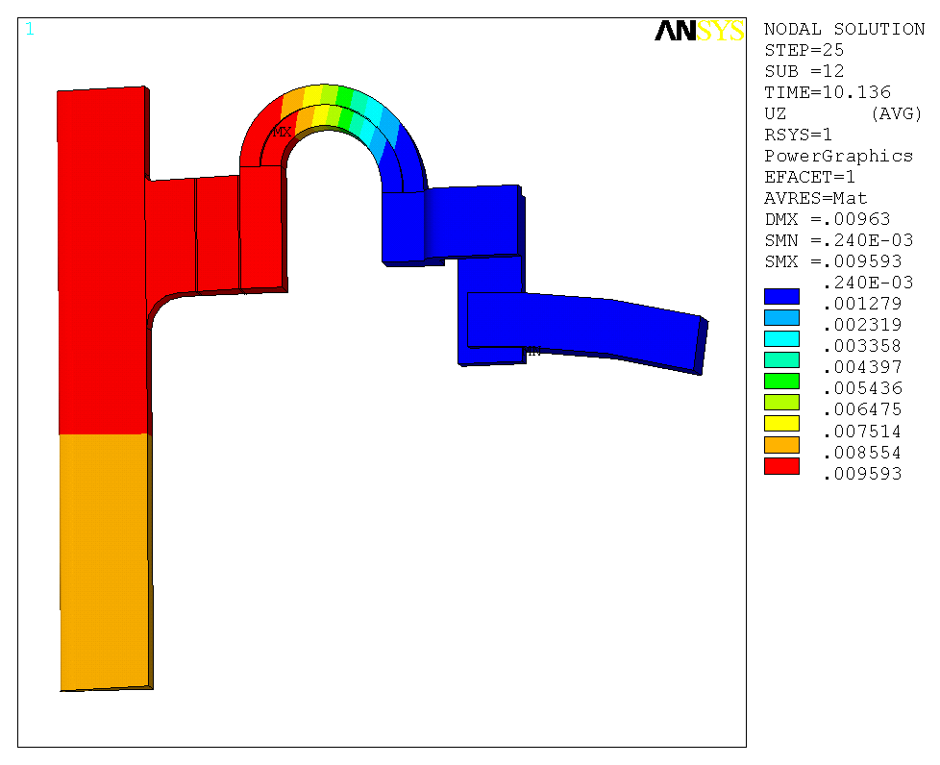
t=3.032s, start of flat top
t=8s, flat top
t=9.512s, end of flat top
t=10.136s, end of waveform

Figure 9: The L-shape connection results in the theta deformation.
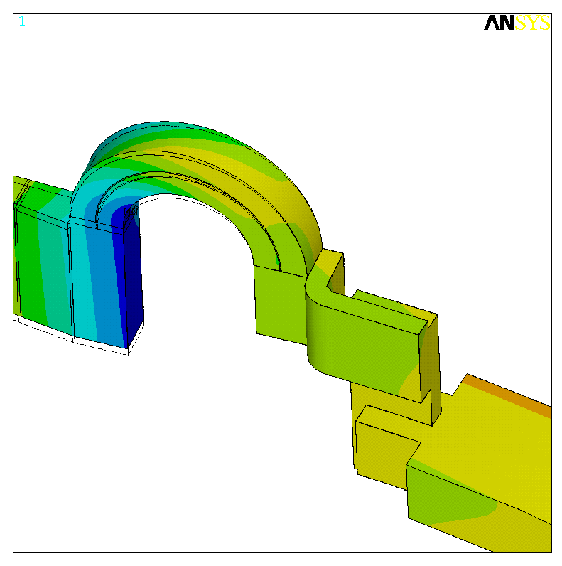
This L-shape connection results in the theta deformation upon self field

Figure 10: Time history plot of joint displacement Ux and Uz (m).
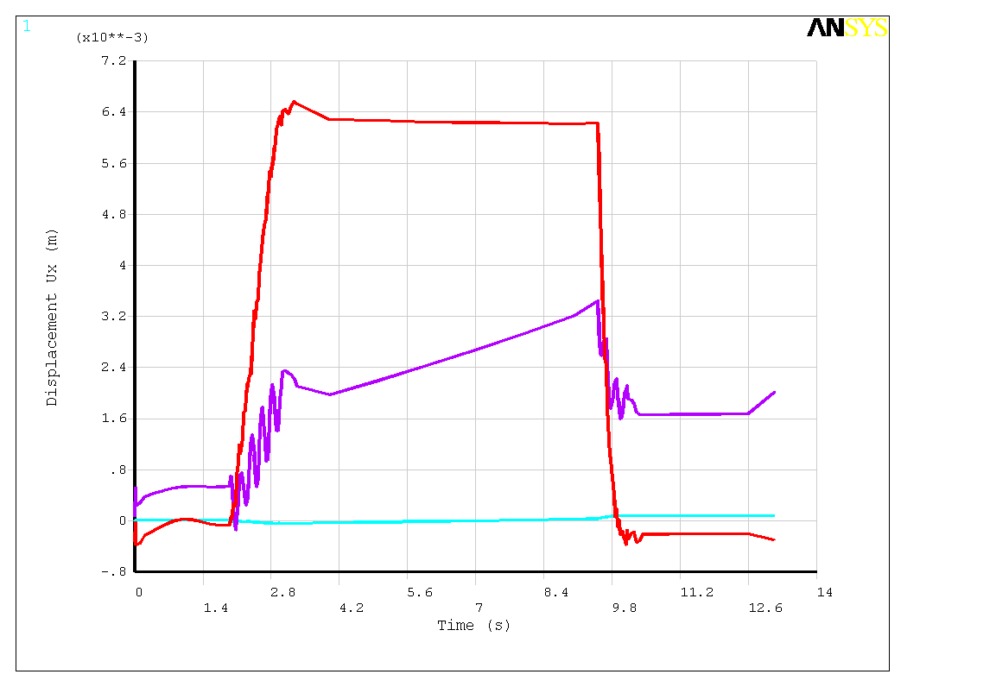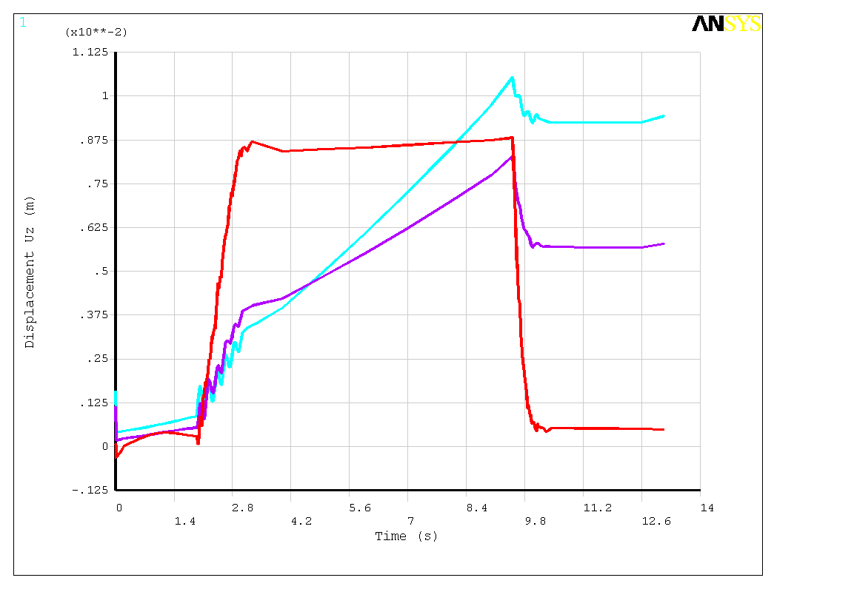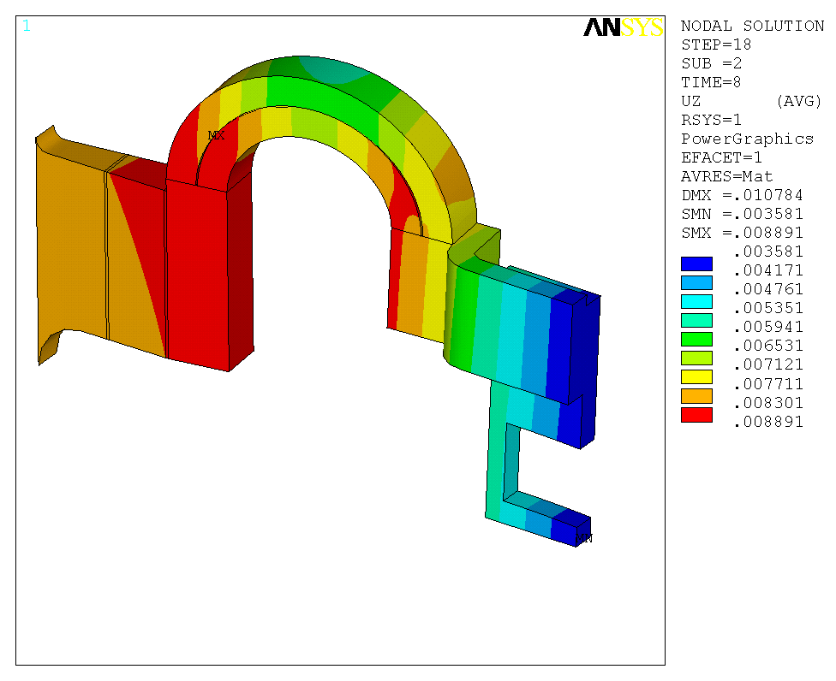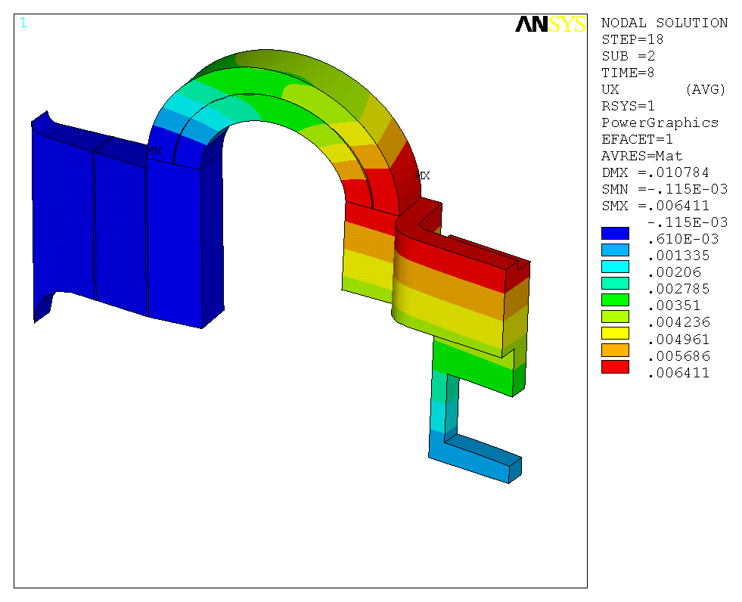
t=8s, flat top, displacement Ux (m)
t=8s, flat top, displacement Uz (m)

Contact pressure

Fig. 11 shows the stress in the contact regions. 30MPa (4.35ksi) pressure is given as shown in Fig. 11 as bolt pressure. The contact region close to arch can maintain adequate and uniform pressure. But the contact close to central beam has separation and requires more bolts pressure to maintain contact.

Figure 11: Stress in contact regions (Pa).

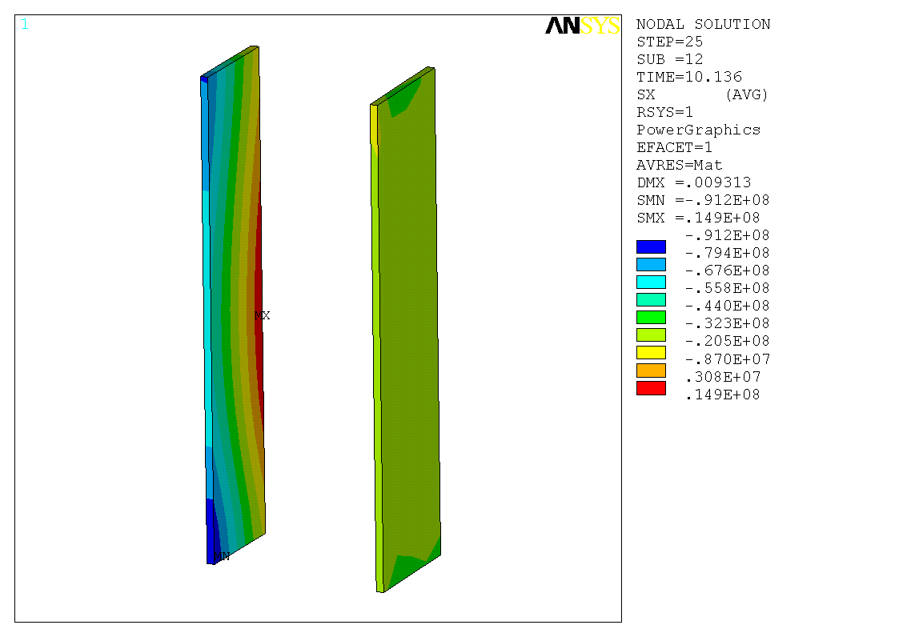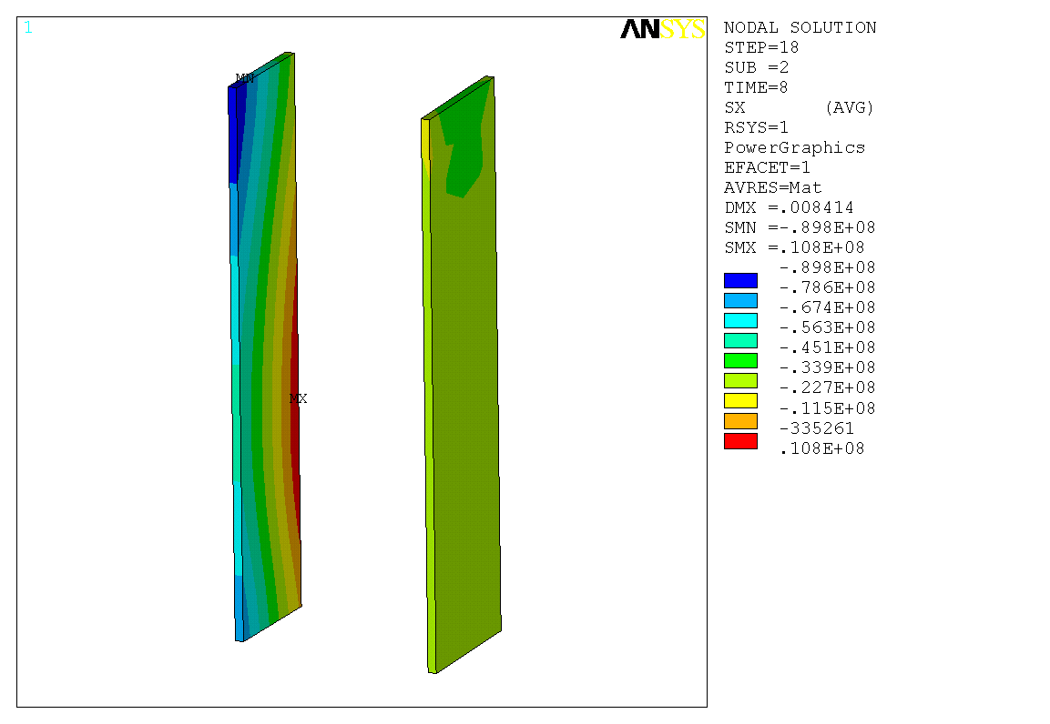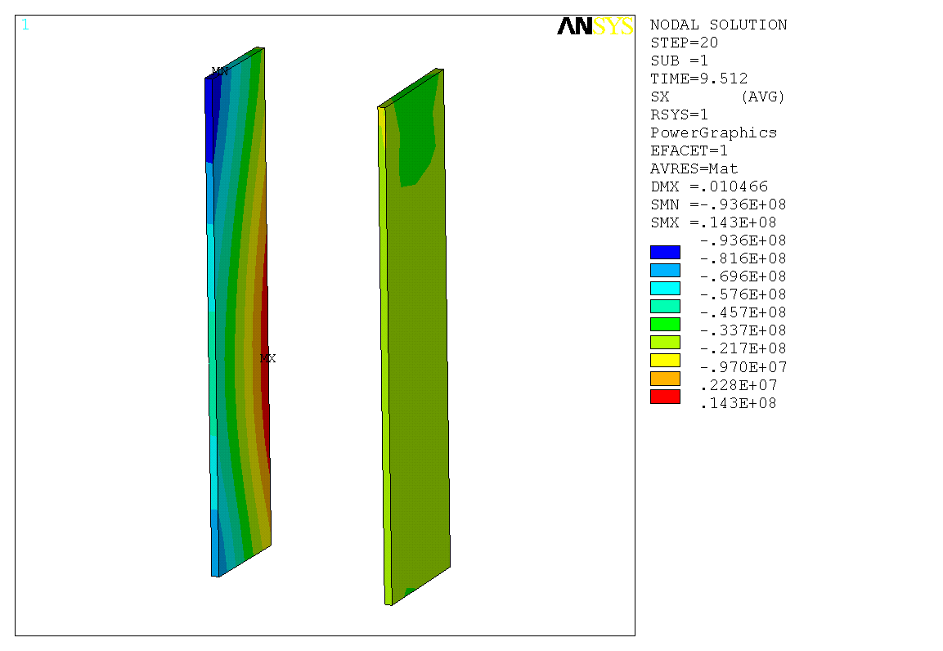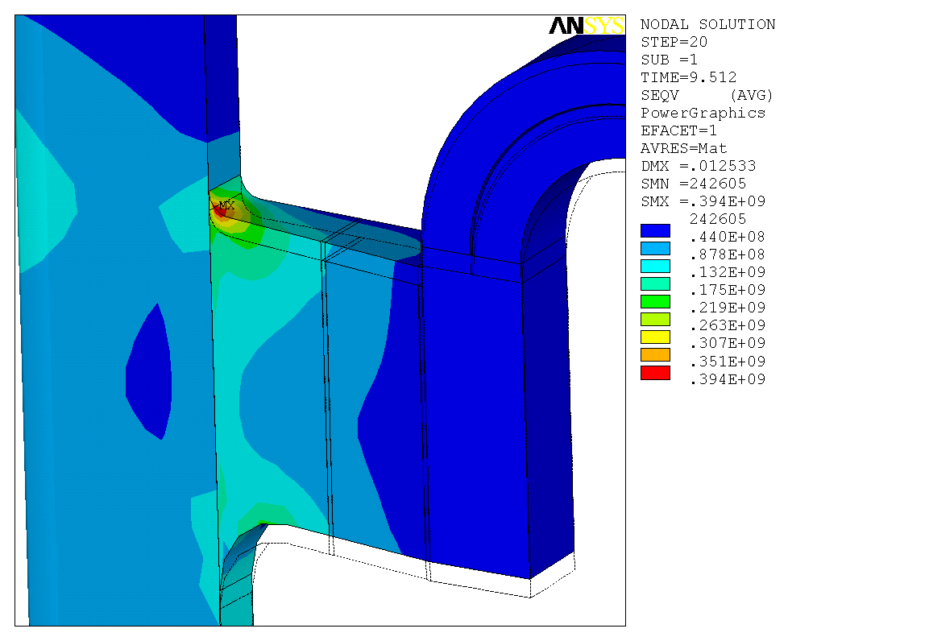
t=8s, flat top
t=10.136s, end of waveform
Close to central beam
Close to arch
30MPa (4.35ksi) uniform pressure
t=9.512s, end of flat top

Coil stresses

Fig. 12 shows the Von Mises stress and Fig. 13 is a closer view. Maximal stress is 371 MPa (53.7 ksi). Changing the small fillet into a bigger one or removing the extension of inner leg may help to reduce this stress concentration but this requires further study.
Fig. 14 shows the hoop stress in the upper part.

Figure 12: Coil Von Mises stress (Pa)
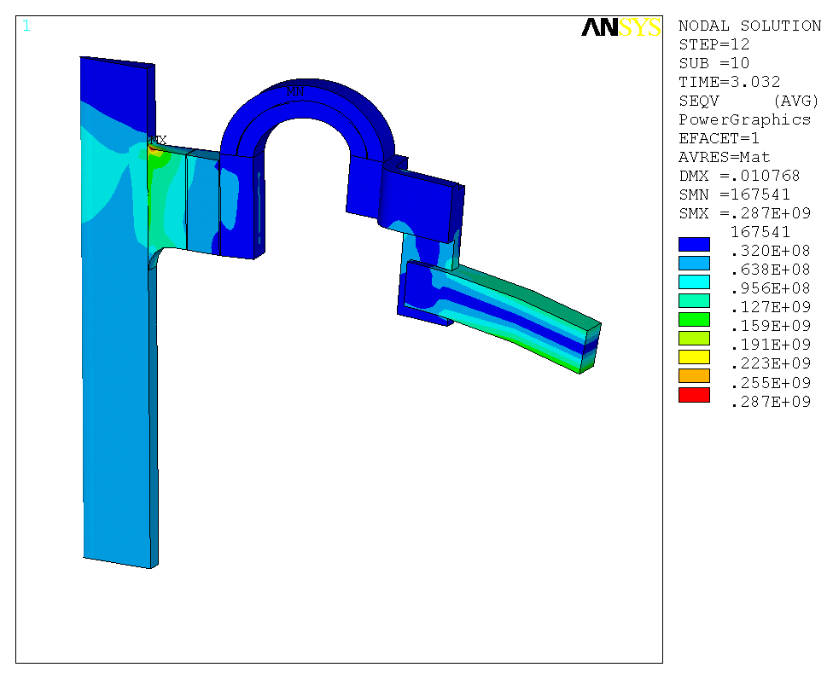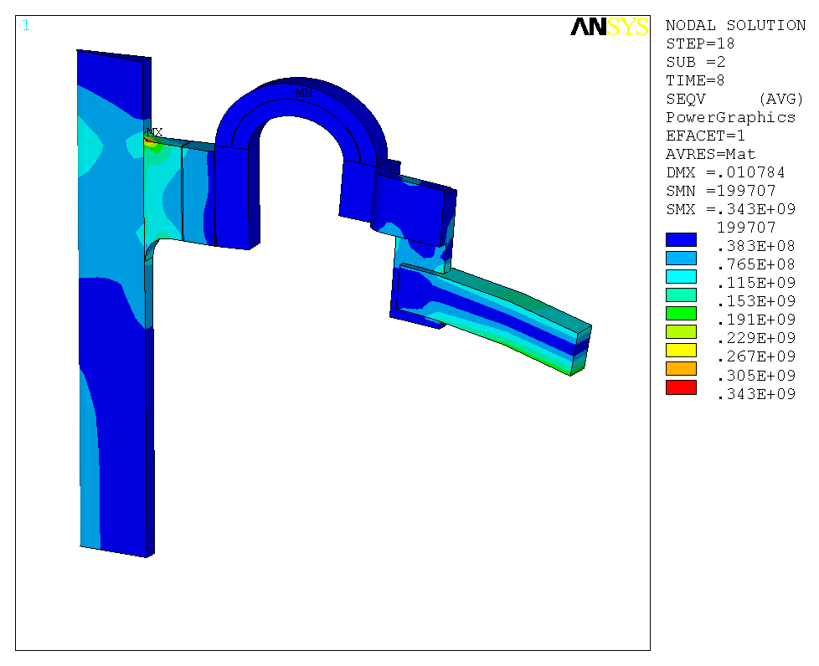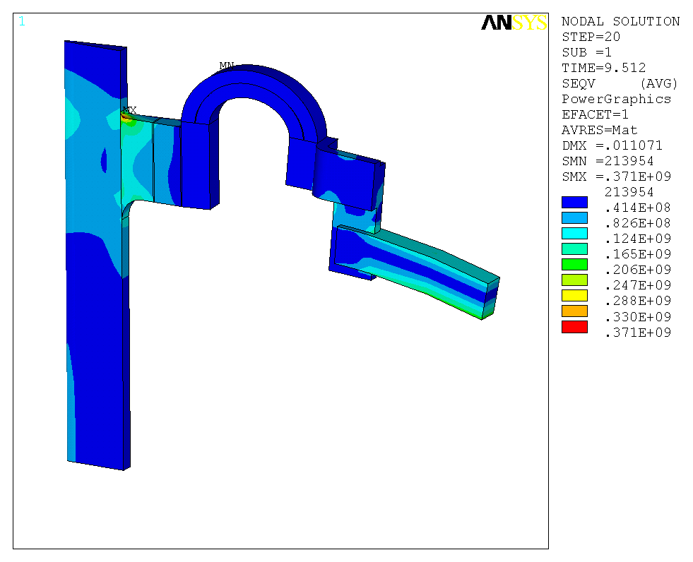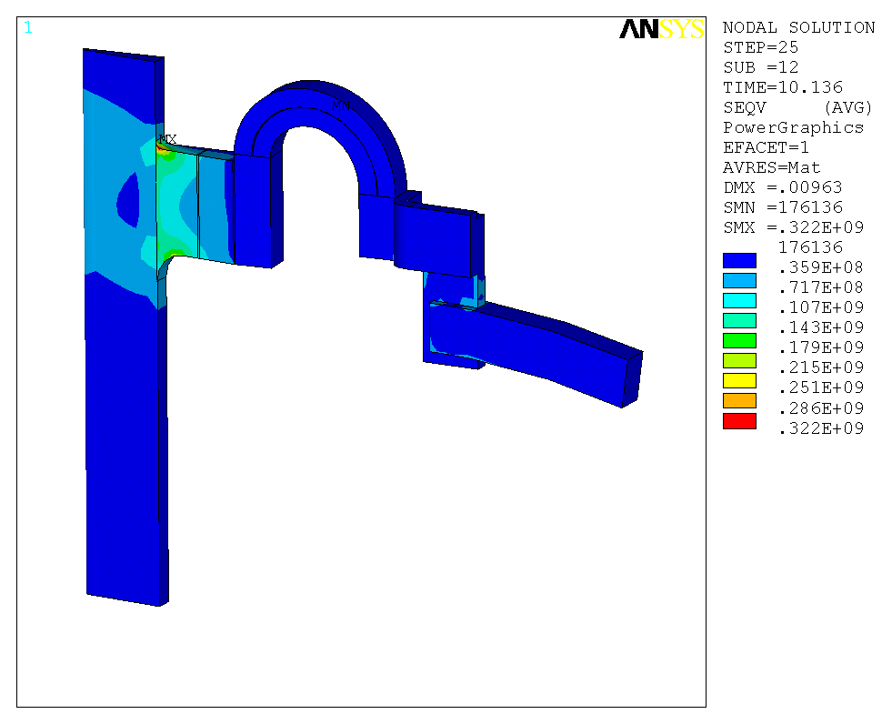
t=3.032s, start of flat top
t=8s, flat top
t=9.512s, end of flat top
t=10.136s, end of waveform

Figure 13: Close view of Von Mises stress (Pa).
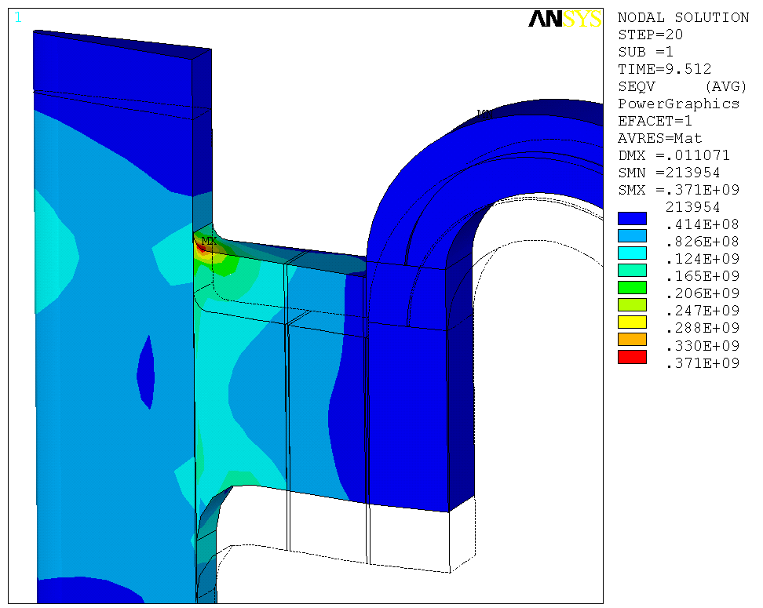

Figure 14: Hoop stress (Pa).
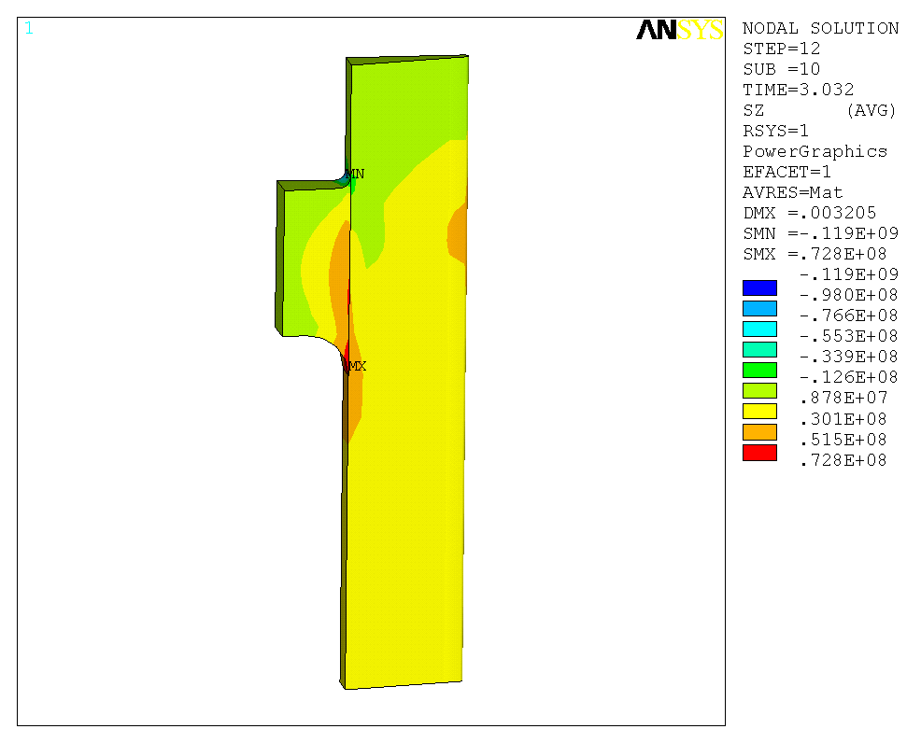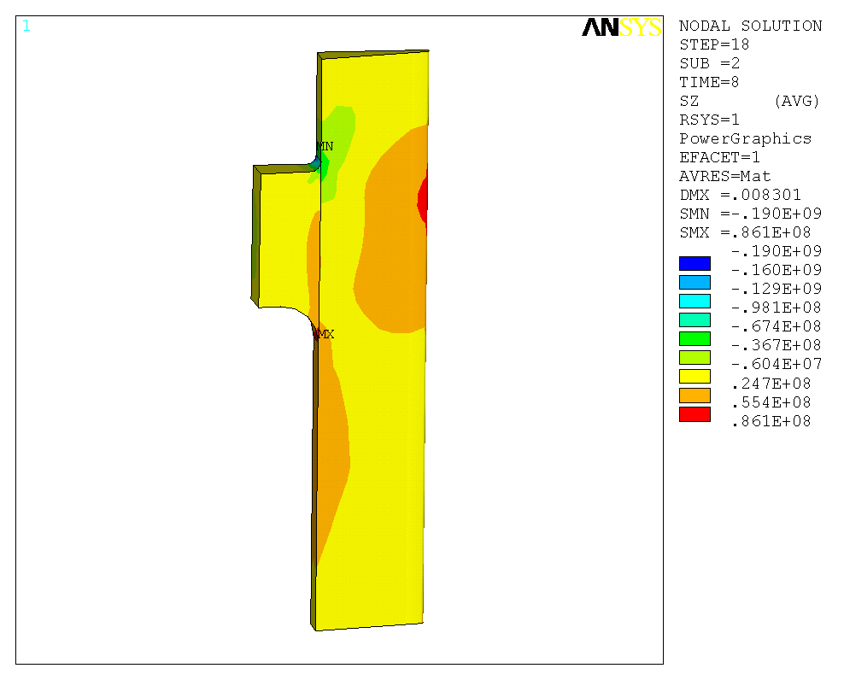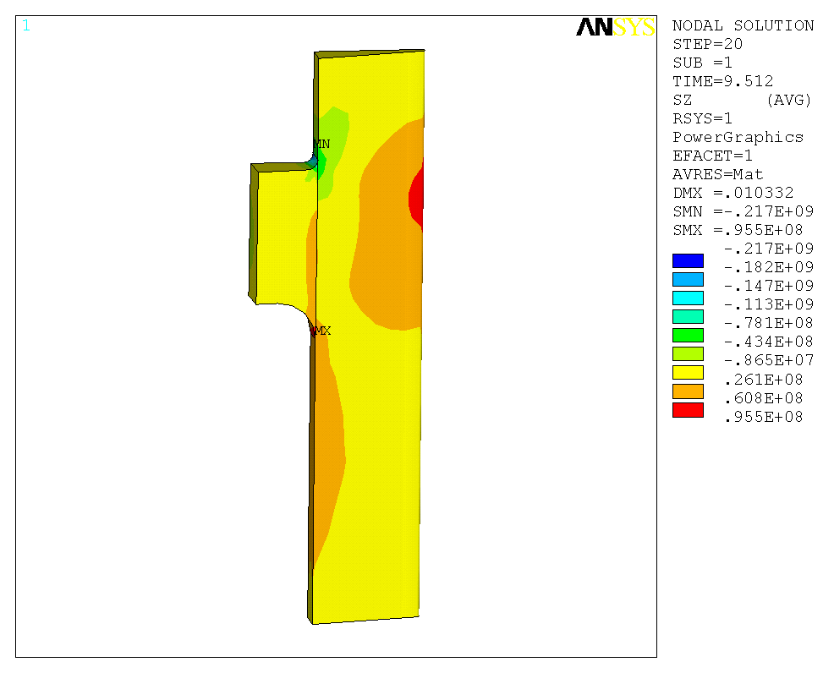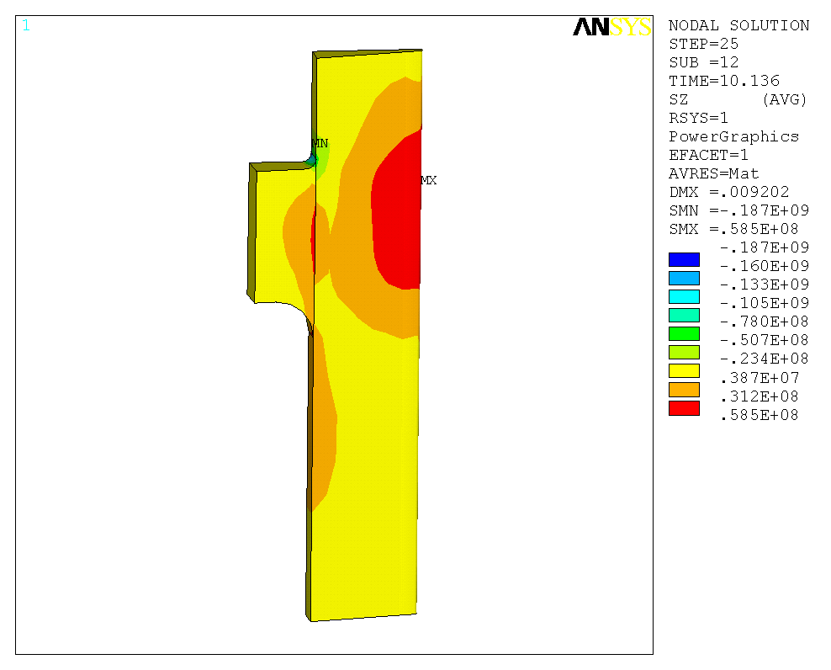
t=3.032s, start of flat top
t=8s, flat top
t=9.512s, end of flat top
t=10.136s, end of waveform

Current density, temperature and toroidal field in the arch area

Each arch is modeled with two solid parts but with anisotropic material properties to simulate the straps. Fig. 15 shows the current density and Fig. 16 shows the temperature in the straps (maximal temperature is 117ºC and maximal temperature difference between inside and outside is 61 ºC).
Fig. 17 shows the estimation of toroidal field in the arch area, which will be useful for the detailed modeling of joint force calculation. Average toroidal field is estimated by reading the radial component of Lorenz force and divided by conductor current and average length. Fig. 17A shows the location for Btheta estimation and B shows the results of radial component of Lorenz force (local coordinate center at the arch center), conductor current, length and the estimated Btheta.

Figure 15: Current density (A/m²).
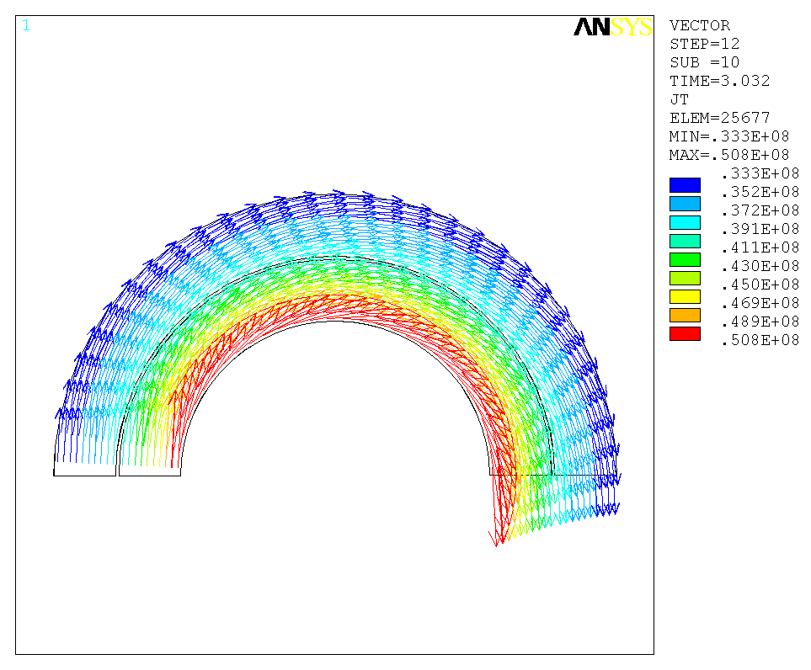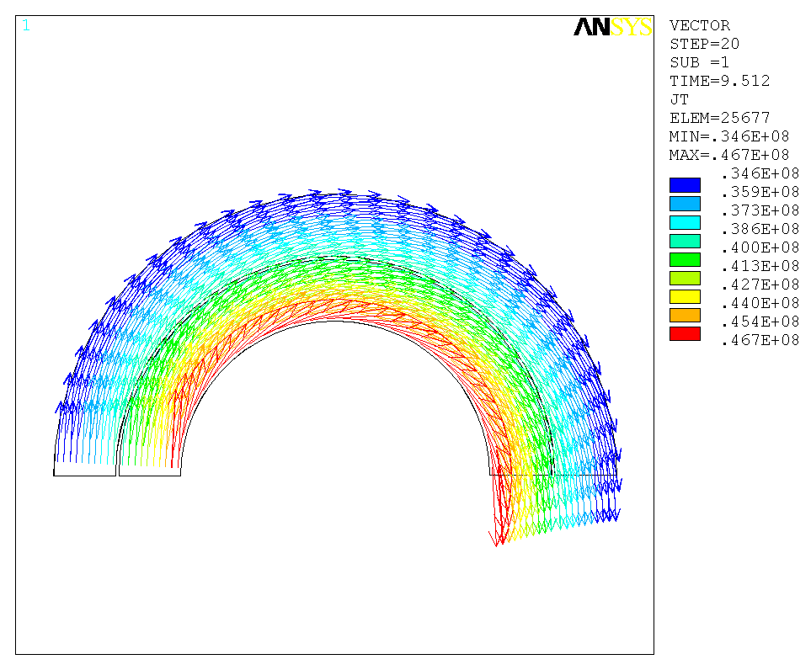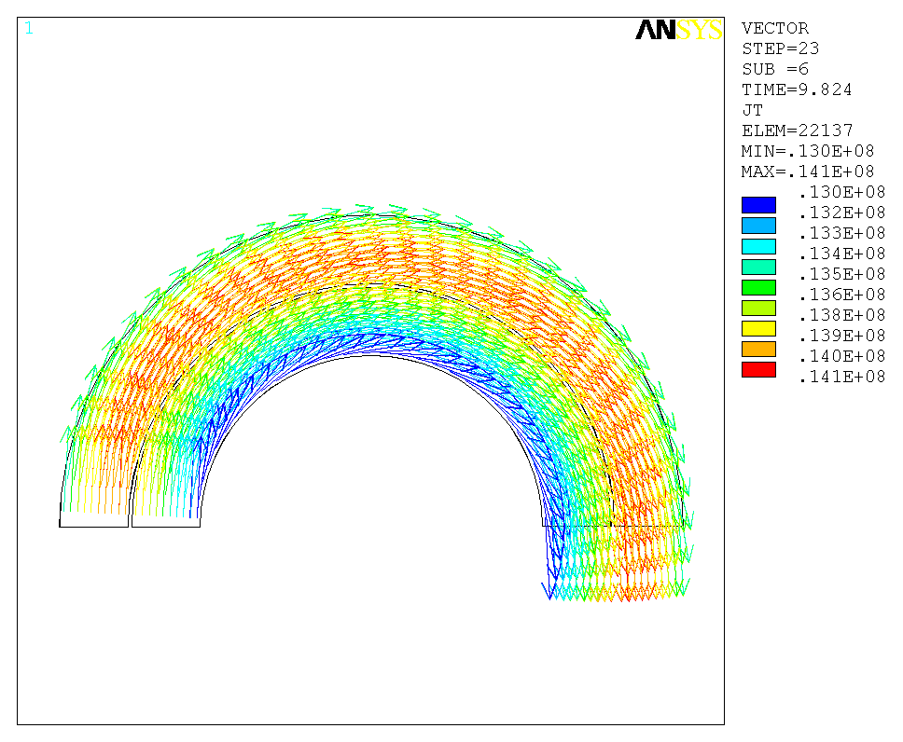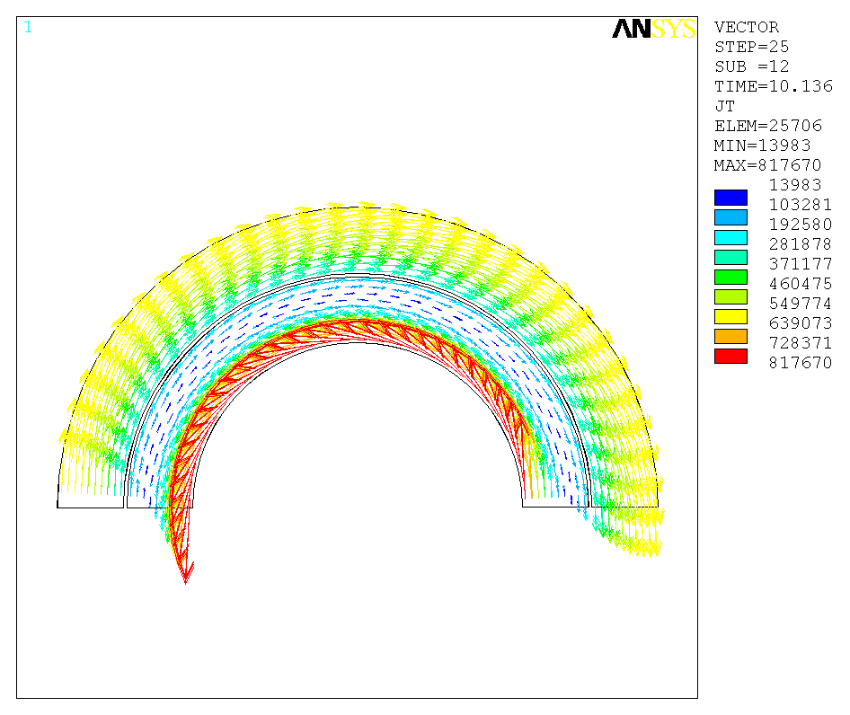 EMBED Package
t=3.032s, start of flat top
t=9.512s, end of flat top
t=9.824s, ramp down
t=10.136s, end of waveform
Figure 16: Temperature (K).
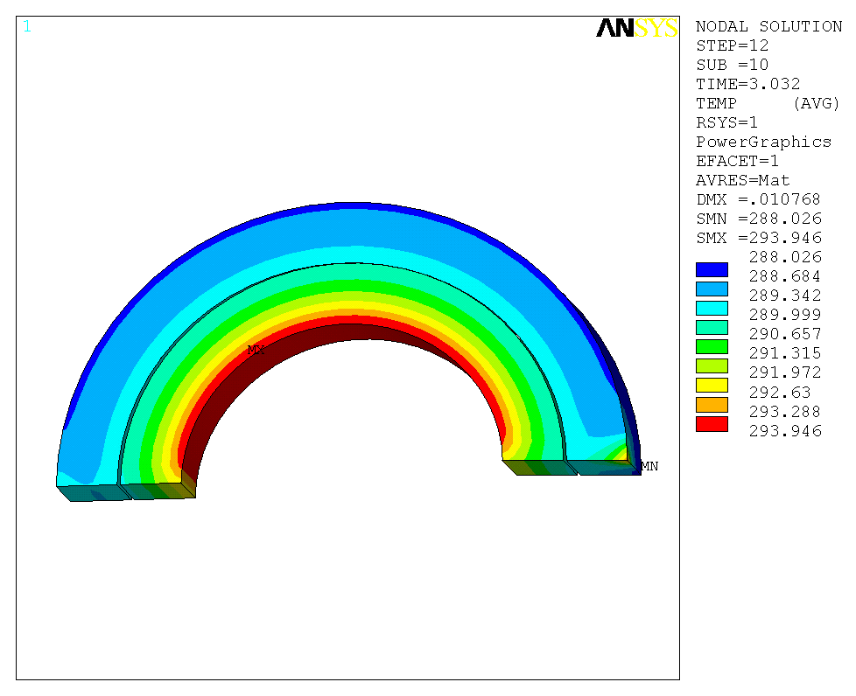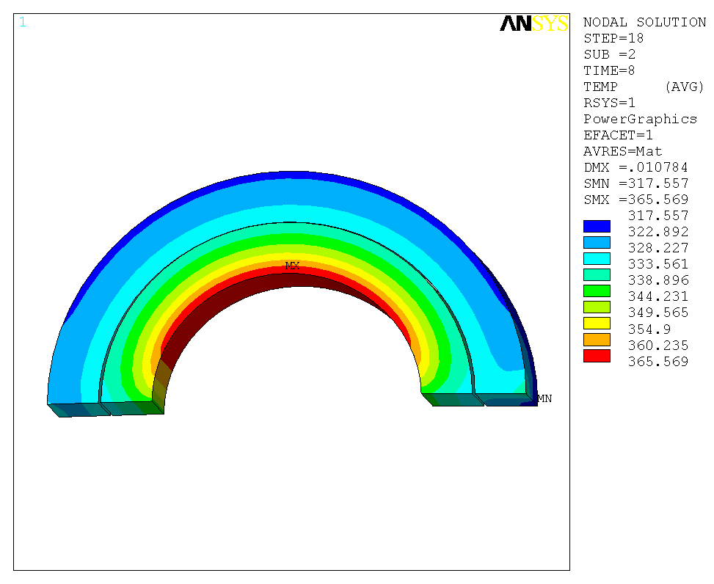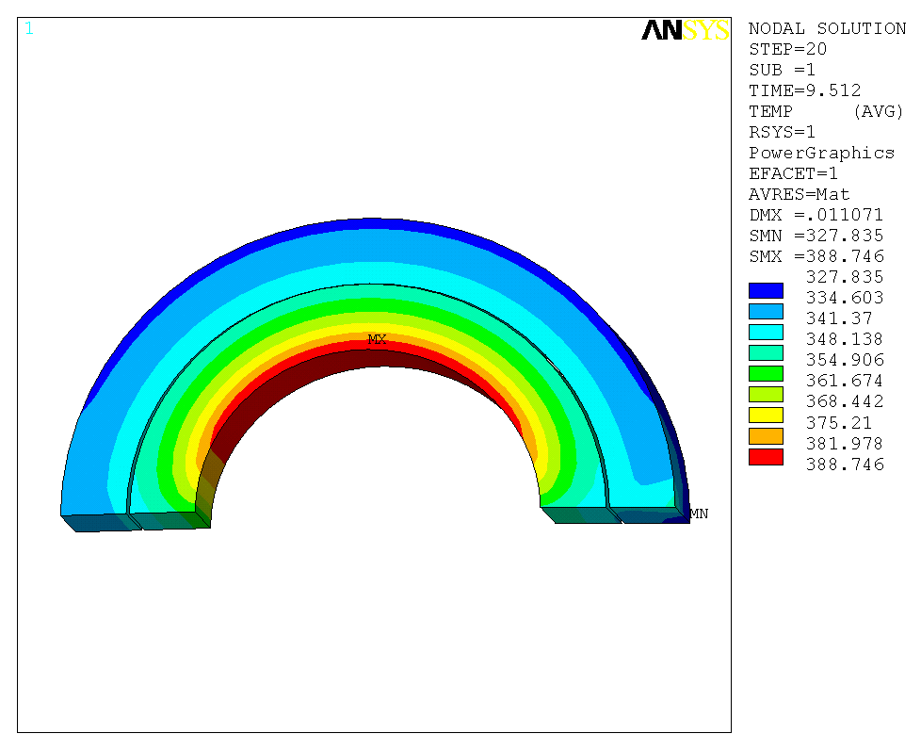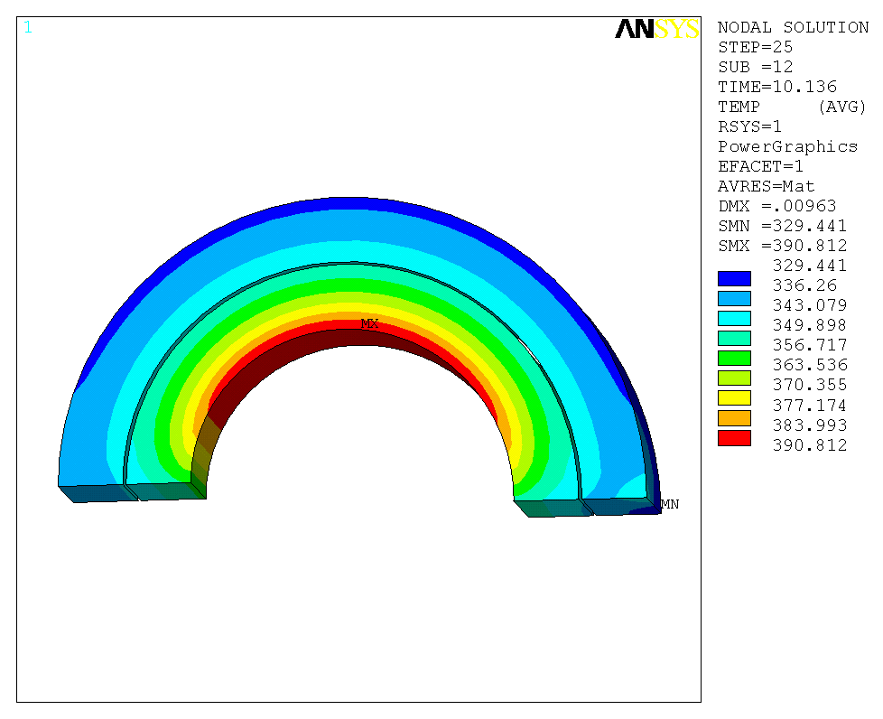
t=3.032s, start of flat top
t=8s, flat top
t=9.512s, end of flat top
t=10.136s, end of waveform

Figure 17: Toroidal field estimation.
A.
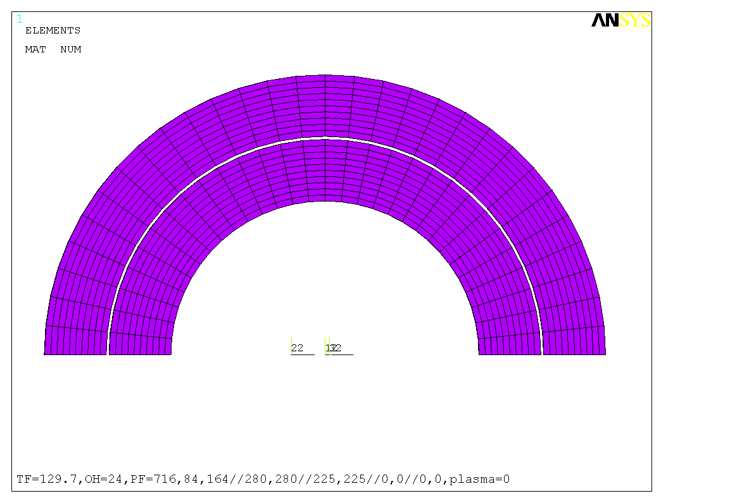
Outer arch
Inner arch
Top 36 degrees
Mid left
Mid right
left
right
B.
 | flat top (9s)
 | each section: 36 degree
 | inner arch |  |  |  |  | outer arch
 | total Fmag_rad (N) | curr (A) | length (m) | eqv B_theta (T) |  | total Fmag__rad (N) | curr (A) | length (m) | eqv B_theta (T)
top 36 degree | 5595 | 69465 | 0.120 | 0.673 |  | 1924 | 59402 | 0.162 | 0.200
mid left 36 degree | 5962 | 69465 | 0.120 | 0.717 |  | 2038 | 59402 | 0.162 | 0.212
left 36 degree | 6338 | 69465 | 0.120 | 0.762 |  | 2303 | 59402 | 0.162 | 0.240
mid right 36 degree | 5310 | 69465 | 0.120 | 0.639 |  | 1799 | 59402 | 0.162 | 0.187
right 36 degree | 4964 | 69465 | 0.120 | 0.597 |  | 1549 | 59402 | 0.162 | 0.161

Appendix: ANSYS code for pulse waveform (from [1])

! NSTX Normal Pulse
NumSteps=29
tfbscale=1.0
t1= .1 $ i1= 0
t2= .2 $ i2= 0
t3= 1.952 $ i3= 15690.906*tfbscale
t4= 2.072 $ i4= 38658.746*tfbscale
t5= 2.192 $ i5= 58169.054*tfbscale
t6= 2.312 $ i6= 74742.32*tfbscale
t7= 2.432 $ i7= 88820.681*tfbscale
t8= 2.552 $ i8= 100779.71*tfbscale
t9= 2.672 $ i9= 110938.46*tfbscale
t10= 2.792 $ i10= 119567.93*tfbscale
t11= 2.912 $ i11= 126898.33*tfbscale
t12= 3.032 $ i12= 129777.84*tfbscale
t13= 4.0 $ i13= 129777.84*tfbscale
t14= 5.0 $ i14= 129777.84*tfbscale
t15= 6.0 $ i15= 129777.84*tfbscale
t16= 7.0 $ i16= 129777.84*tfbscale
t17= 8.0 $ i17= 129777.84*tfbscale
t18= 9.0 $ i18= 129777.84*tfbscale
t19= 9.512 $ i19= 129777.84*tfbscale
t20= 9.632 $ i20= 91022.609*tfbscale
t21= 9.752 $ i21= 58895.183*tfbscale
t22= 9.872 $ i22= 32262.092*tfbscale
t23= 9.992 $ i23= 10183.711*tfbscale
t24= 10.136 $ i24= 0
t25= 15.0 $ i25= 0
t26= 20.0 $ i26= 0
t27= 30.0 $ i27= 0
t28= 40.0 $ i28= 0
t29= 1200.0 $ i29= 0

Part II: Fillet Radius and Active Cooling Addition

To avoid bending of TF inner leg, some structural supports will be added to the upper flags and the fillet radius of upper flag is modified to be bigger, which will help to reduce the temperature at the corner. Thus the model was modified and ran again to know how much temperature reduction. To avoid the work of re-mesh, only the positions of the nodes at fillet are modified and the radius may not be accurate. Also active water cooling is added with changeable parameters. Current waveform is same as before, normal operation pulse.
Coil temperature reaches maximum at the end of the flat top (Fig. 1), i.e., 10.136 s for normal operation. Without active cooling during the pulse, maximal temperature of the inner coil is 117 ºC, at the inner side of lower flag. Upper flag has more material (Fig. 1) and thus the max temperature is a little lower, 112 ºC. With active water cooling (0.25” diameter tube, 3 m/s coolant velocity and inlet temperature of 12 ºC), the maximal temperature of lower flag drops to 113.4 ºC and that of upper flag becomes 110.8 ºC (Fig. 1).

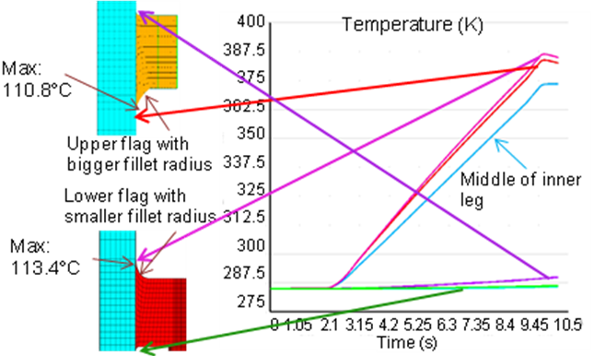
Figure 1: Temperature rise in TF inner coil with water cooling (0.25” diameter tube, 3 m/s coolant velocity and inlet temperature of 12 ºC).

The epoxy to bond TF coils has thermal expansion coefficient of 1.362E-5 /°C. The thermal expansion coefficient of copper is 1.54E-5 /°C at 0 °C and 1.6E-5 /°C at 100 °C. Different thermal expansion between copper and epoxy may cause delamination. Currently there are two ideas to place the cooling line, in the middle or at the side of the coil. Both are evaluated. Fig. 2 shows that putting cooling line at side produces lower Stheta (i.e. stress component that can cause delamination) of 90 MPa than putting cooling lines in the middle, because latter will cool the coil down faster and result in more shrinkage. In these analyses, 0.3” tube is used with 3 m/s velocity and it takes 5 minutes to cool the inner coil down to room temperature. If the cooling process can be slower, for example, by using a 0.25” tube and the same velocity, the stress Stheta can be reduced to 48 MPa (Fig. 3). Total cooling time of using 0.25” tube hasn’t been calculated yet. It is still unknown to us how much stress will cause delamination but we are trying to reduce it as much as possible. To reduce Stheta, it is better to cool down slowly. Using thinner tubes, lower coolant speed and different cooling line positions are all options. Note that the analysis process of Fig. 2 and 3 are different. In Fig. 2, when I run the coupled field (EM and thermal) simulation, there is no cooling during the pulse. Cooling parameters were calculated by Ali Zolfaghari using FCOOL, then transferred the temperature data to me. I directly applied the temperature profile to the cooling line (nodes) in the model and calculated from 10.136 s. Thus the start time point in Fig. 2 is 10.136 s (the end of the pulse). In Fig. 3, I added a cooling calculation in the model (similar to the code of ACOOL) and re-run the coupled field simulation and cooling is added during pulse. Fig. 3 simulates the time period from 0 s to 10.136 s (during the pulse).

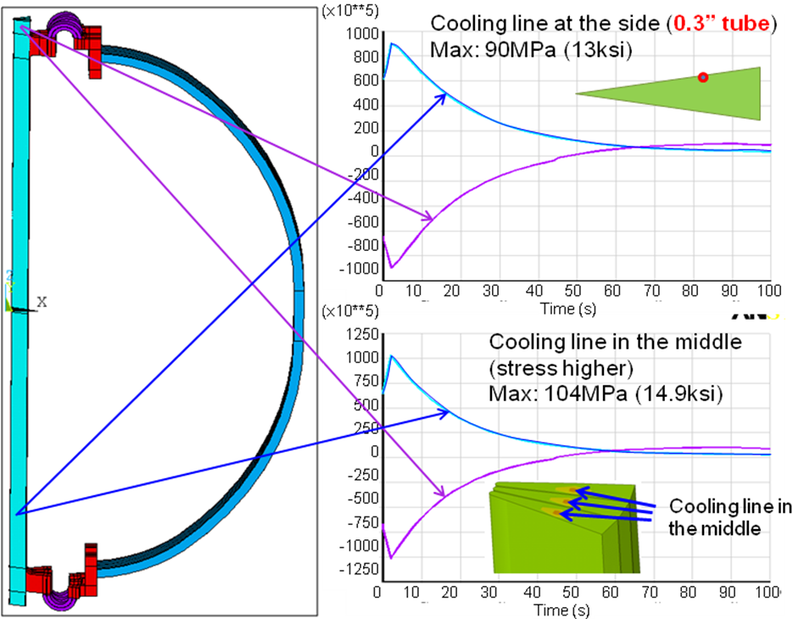
Figure 2: History plot of stress S_{theta} (Pa) in TF coil with water cooling (0.3” tube, 3 m/s).

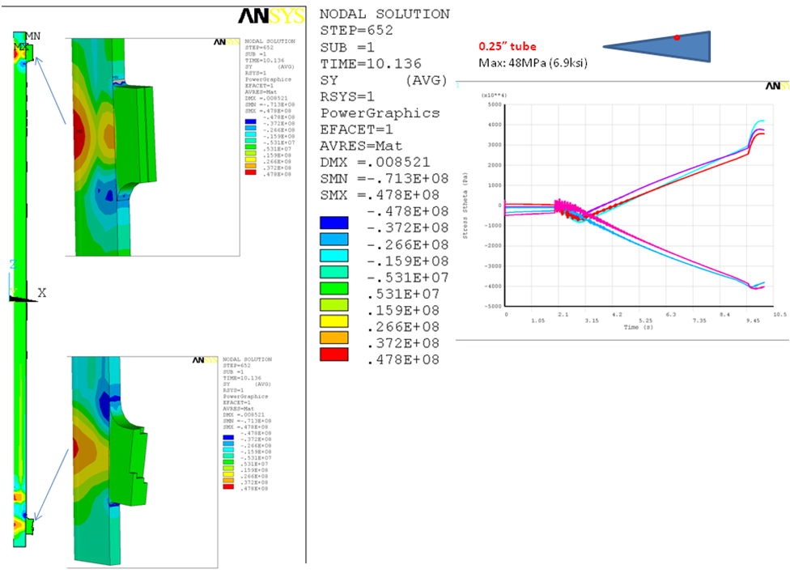
Figure 3: History plot of stress S_{theta} (Pa) in TF coil with water cooling (0.25” tube, 3 m/s, tube at the side).

The max temperature in outer coil reaches only 47 ºC at the end of pulse. But to avoid further temperature rise upon following pulses, active cooling is simulated. With cooling line of 0.5” tube diameter, 3 m/s velocity and tube attached to the surface of outer coil (Fig. 4), the coil can be cooled down to 25 ºC in 5 minutes (Fig. 5, 6).
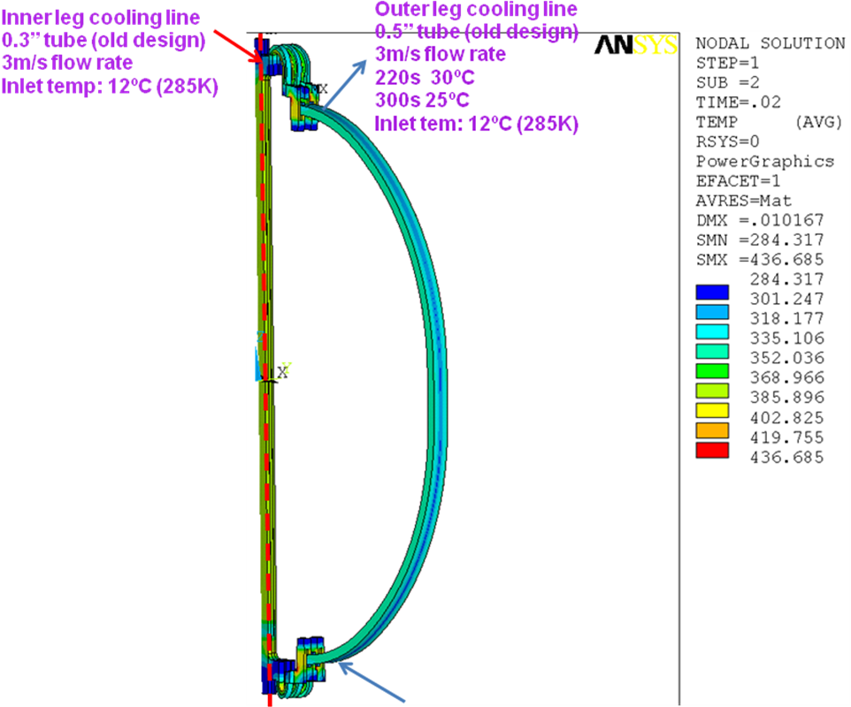
Figure 4: Add cooling line to TF outer coil, attached to the outer surface (0.25” tube, 3 m/s).

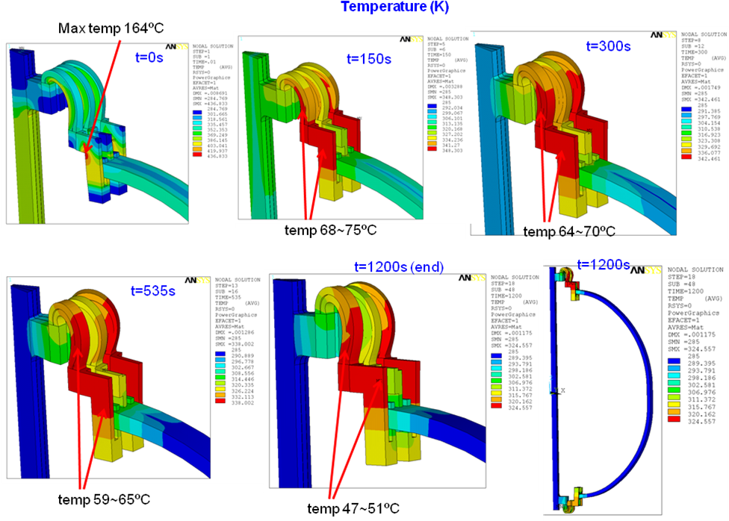
Figure 5: Temperature distribution at different time points, with active cooling in inner and outer coils (parameters shown in Fig. 4).

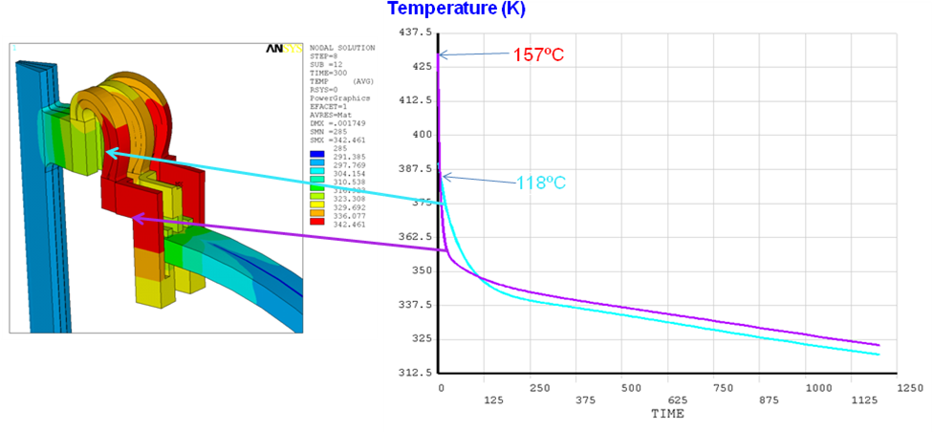
Figure 6: Temperature history plot, with active cooling in inner and outer coils (parameters shown in Fig. 4).

In this model, the flex straps is modeled by two solid pieces. But in reality, they are made of many straps. So the arches in this model have anisotropic material properties. Mechanical properties are based on the local structure model results of Ref. [3]: the force to deflect 31 lamination assembly 0.3" vertically is 76.2 lbf; The flex assembly rotates 2.57 degrees with a torque of 100 in-lbf applied. I converted these data into the modulus of flex straps as follows:
mp,ex,2,0.92e9
mp,ey,2,0.92e9
mp,ez,2,0.92e9
mp,gxy,2,0.08e9
mp,gyz,2,0.08e9
mp,gxz,2,0.35385e9
(x is the arch circumferential direction, y is the arch radial direction and z is the arch central axis). In the Figs. 11 and 12 of Part I, the upper corner of upper flag has a high stress point, which is due to the high modulus used in the previous model. After re-calculate the modulus of flex strap and replot the stress, it is shown in Fig. 7, maximal stress is 124 MPa at 10.136 s.

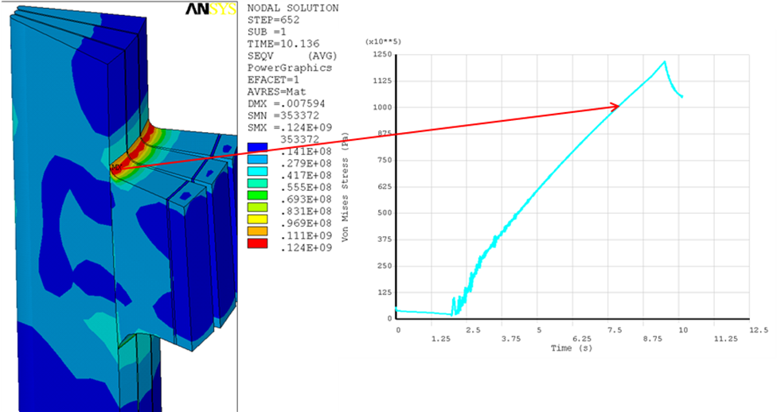
Fig. 7: Von Mises stress in the upper flag (Pa).

Because the upper flag has two contact regions, using high strength copper as the flag material can help to maintain high and uniform contact pressure and also lower contact resistance. But high strength copper has higher resistance and lower thermal conductivity. From the analysis, using high strength copper (1/0.8 resistivity and 80% thermal conductivity) causes temperature difference of less than 1 ºC. Thus high strength copper can be used if required to increase the pressure of joint bolt insert load over the capacity of pure copper.

Part III: Outer TF Coolant Fed Into Inner Leg

In Feb. 2012, the cooling scheme of NSTX inner leg was changed. Previous cooling scheme is to pump 12°C coolant from bottom of the inner leg. For the inner leg, the hottest area is the section between the top of the lower flag and the bottom of the upper flag. Highest thermal stress is at ~1 foot distance from the bottom of inner leg (Part II, figure 2). In the latest design, the coolant first flows through outer leg and then into inner leg from the bottom. In this way, the coolant in inner leg is already warm and thus reduces the thermal stress, but it takes more time for the inner leg to cool down.
In this simulation, to evaluate worst case, fault operation TF current is used, according to NSTX_CS_Upgrade_100504.xls (design point May 4, 2010 version). Coolant temperature is from Ali. Ali models the TF inner leg as a simplified long and thin cylindrical conductor with current and coolant. And read out the temperature at 5 positions. Then I applied the temperatures to the corresponding positions in my detailed model to calculate thermal stress. There is a little difference between Ali’s model and my model. In Ali’s model, the current flows from bottom to top of the inner leg and thus all the conductor is heated by Joule effect. In my model, the current density is determined by the resistance and inductance of the coil, and thus the top and bottom ends are cold and middle section of the conductor gets heated. When coolant flows into inner leg, bottom and top of inner leg has the biggest delta T and result in high thermal stress. But these places are only used for structural fixation and don’t participate the current conduction, high thermal stress should not be a problem.
Figure 1 shows the cooling line position in my model. Comparing with previous design, cooling line is moved inside (toward the center of inner leg bundle) a little, to avoid high torsional shear area (according to Pete’s results). Cooling line temperatures are shown in Figure 1 at 0s, 100s, 200s, 300s, 400s, 500s respectively. These temperatures are applied to the specific nodes on the cooling line in my model. Temperatures of other nodes on the cooling line are calculated by linear interpolation. Figure 2 shows the temperature and Sy in inner leg at the end of pulse.

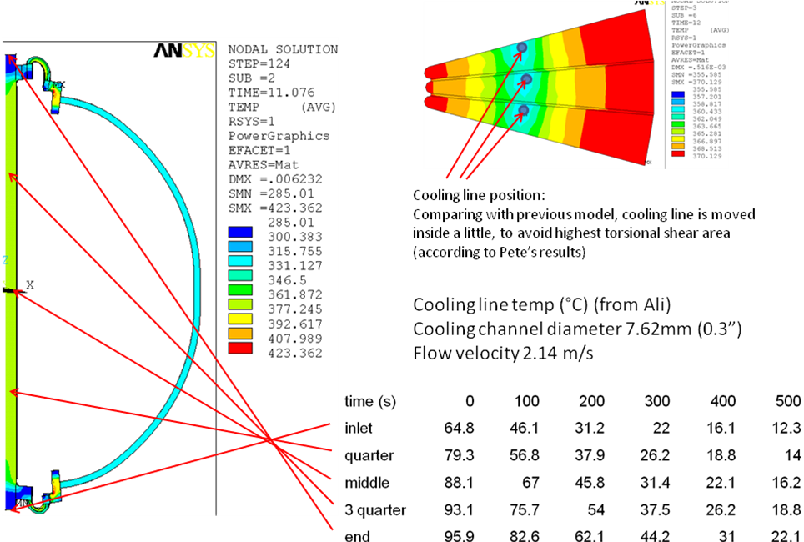
Fig. 1: Cooling line position and temperature.

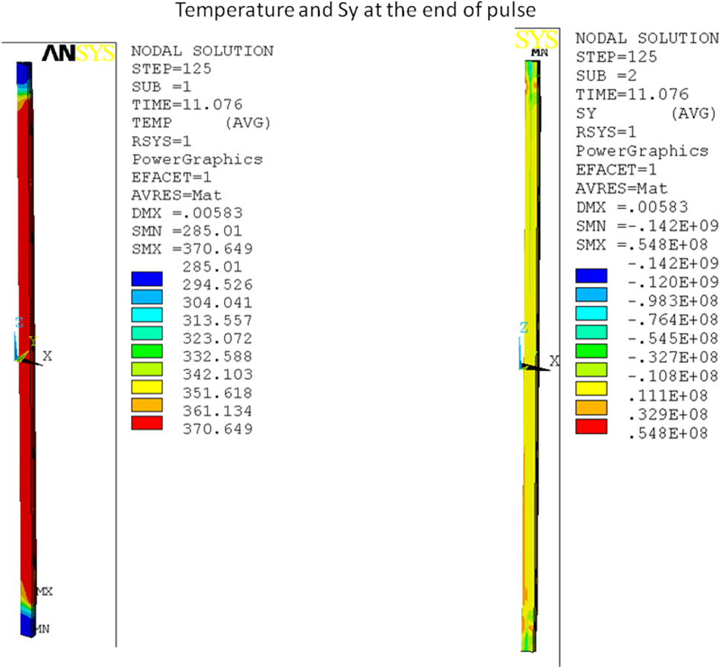
Fig 2: Temperature and Sy (normal to the bonding interface between Copper and epoxy) at the end of pulse (11.076s).

Figure 3 is the history plot of stress Sy at different positions in Cu bond. Highest tensile stress is 33MPa (the stress may cause delamination). The Bottom and top ends have compressive stress which has been discussed before. Figure 4 shows the stress at the connections to flags are getting higher at the end of the cooling period, 500s. This is due to the un-cooled flags with high temperatures, which is not true.
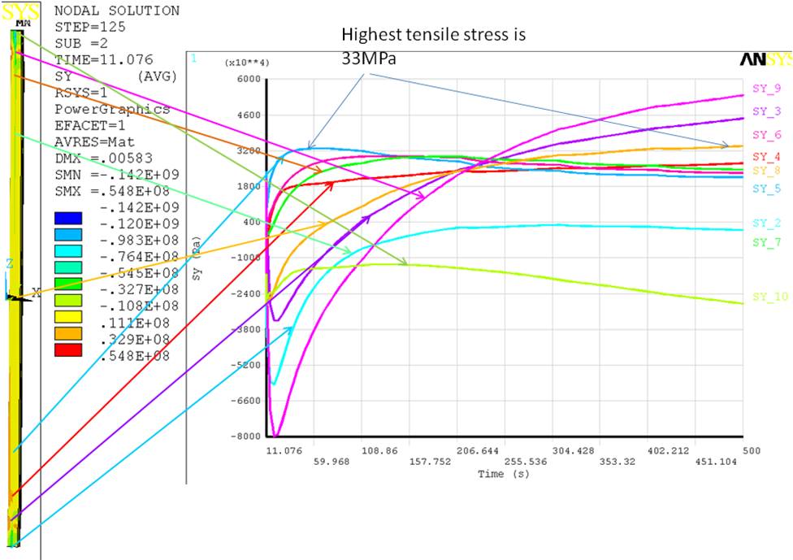
Fig 3: Cu bond thermal stress Sy (normal to the bonding interface between Copper and epoxy).
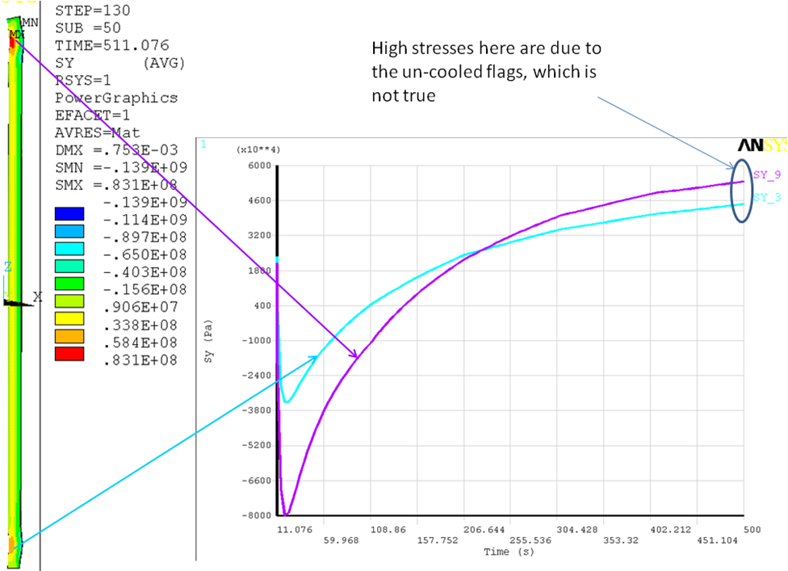
Fig 4: Cu bond thermal stress Sy (normal to the bonding interface between Copper and epoxy) at the connections to flags is not true.

NSTX Upgrade TF Inner Leg Cooling (Ali Zolfaghari)
The output of the TF outer leg coolant will be input in the TF inner leg during cool-down. The outlet temperature of the TF outer leg coolant was obtained from a separate fcool run. Figure 1 is the fcool cooling plot for the outer leg.
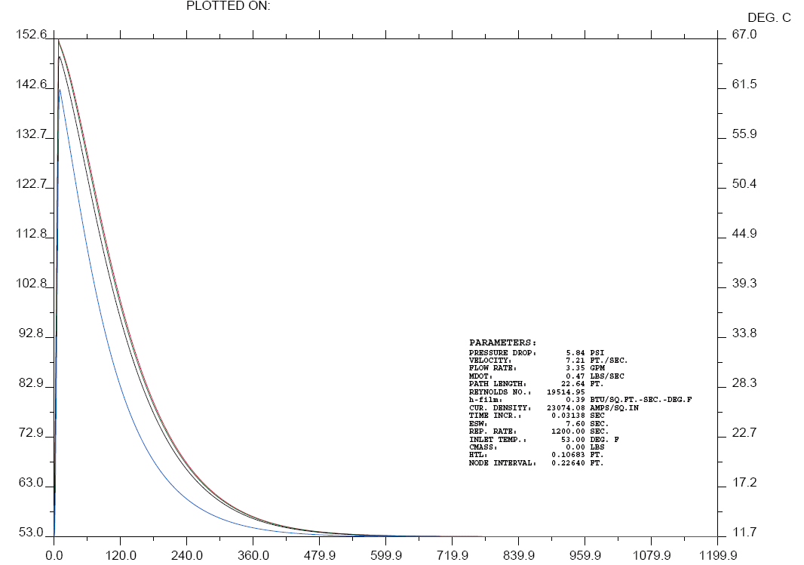
Figure 1
We fit the outlet cooling temperature of the outer TF vs. time (obtained from the fcool run) to a polynomial as seen on figure 2. Then we build a model of the TF inner leg and input the polynomial as the input water temperature as a function of time. The coolant channel on the TF inner leg is 7.62 mm in diameter and the flow velocity is 2.14 m/s. The length of the TF leg is 5.43 meters.
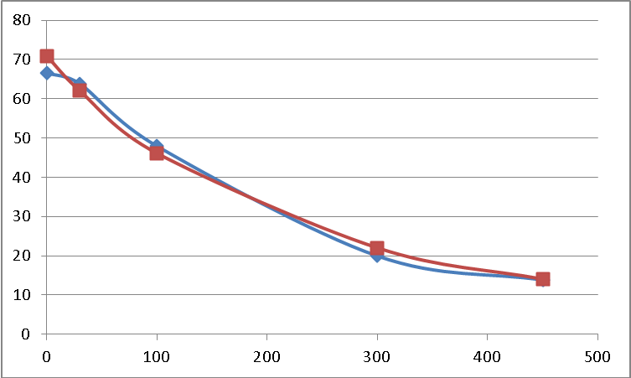
Figure 2- Data from fcool run is in blue, the polynomial fit is in red.

In Ansys CFX we model one inner leg which is wedge shaped in cross section with the coolant channel to the side as a circular cross section of equal copper area and the coolant hole in the center. This simpler model is quick to run and because copper has such a high thermal conductivity, it is a good approximation. Figure 3 shows the modeled TF leg cross section.
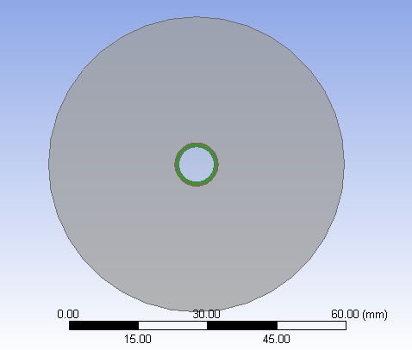
Figure 3

Figure 4 is the cooling plot for the TF inner leg and the outlet and inlet refers to the inner leg. “mid” in the legends means mid-way out radially in cross section (not in length). Each time-step in 1 sec.

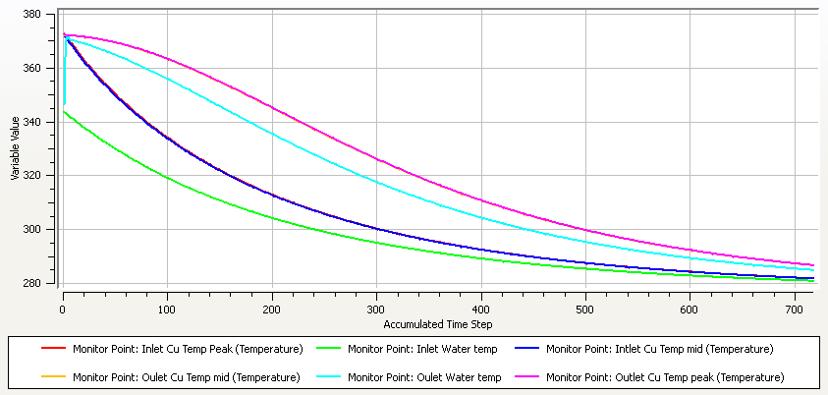
Figure 4
From figure 4 we can guess that at t=200s there is large temperature gradient in the coil. Figure 5 shows the temperature distribution in the inner leg at t=200s
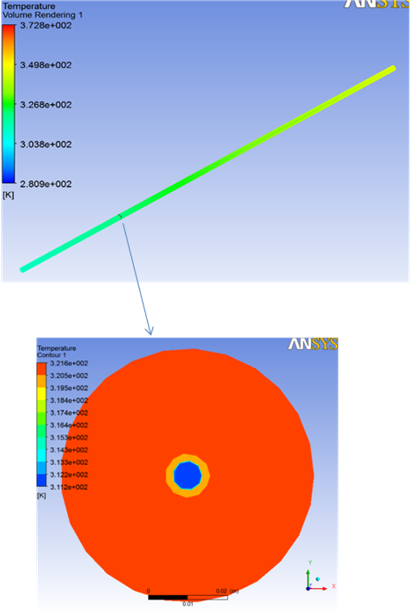
Figure 5

REFERENCES

[1] Peter Titus, “Coupled Electromagnetic-Thermal Analysis (04072009)”, NSTX-CALC-132-01-00, 2009.
[2] Peter Titus, “Coupled Electromagnetic-Thermal Analysis (04202009)”, NSTX-CALC-132-02-00, 2009.
[3] Charles L. Neumeyer, http://www.pppl.gov/~neumeyer/NSTX_CSU/Design_Point.html, dated 7-29-2009.
[4] Tom Willard, “TF Flex Joint and TF Bundle Stub”, NSTX-CALC-132-06-00, 2009.
[5] Robert D. Woolley, “TF Joint Pressure VS Temperature In NSTX CSU Upgrade”, CSU-CALC-132-090211-RDW-01, 2009.
[6] Email from Ali Zolfaghari with data from FCOOL run:

Appendix: The batch code for solution

/clear,start
/NERR,,10000000 ! MAX ERROR/WARNING MESSAGE 10,000,000
/CONFIG,NRES,100000
/CONFIG,NBUF,30
/CONFIG,NPROC,2 ! 2 processors

/filnam,electromag_bc
resume,electromag_bc,db

/solu
allsel,all
csys,0
antype,trans ! transient solution

!t_init=1E-10 ! initialize time for static solution

EQSLV,SPARSE
!EQSLV,PCG,,3
!EQSLV,ICCG,1e-6,2 ! toler=1e-6

t_init=0.01 ! initialize time for static solution

timestep=0.002
risetime=0.01
timint,ON ! time-integration effects on for transient solution
time,risetime ! step down within "risetime"
KBC,1 ! step load KBC,1. ramp load KBC,0
deltim,timestep
outres,,2
allsel,all
csys,0
F,curr_nd1,amps,0
F,curr_nd2,amps,0
F,curr_nd3,amps,0
solve

save
finish

!!!================================================
!!!calculate convection heat transfer coefficient
!!!================================================
!!read temperature
*create,hcoef
t_avg=arg1
t_coolant=arg2

csys,1
allsel,all
*if,t_avg,ge,273+0,and,t_avg,lt,273+10,then
PR=13.67
*elseif,t_avg,ge,273+10,and,t_avg,lt,273+20
PR=9.47 !viscosity: m-Pa-s
*elseif,t_avg,ge,273+20,and,t_avg,le,273+30
PR=7.01
*elseif,t_avg,ge,273+30,and,t_avg,lt,273+40
PR=5.43
*elseif,t_avg,ge,273+40,and,t_avg,lt,273+50
PR=4.34
*elseif,t_avg,ge,273+50,and,t_avg,lt,273+60
PR=3.56
*elseif,t_avg,ge,273+60,and,t_avg,lt,273+70
PR=2.99
*elseif,t_avg,ge,273+70,and,t_avg,lt,273+80
PR=2.56
*elseif,t_avg,ge,273+80,and,t_avg,lt,273+90
PR=2.23
*elseif,t_avg,ge,273+90,and,t_avg,lt,273+100
PR=1.96
*elseif,t_avg,ge,273+100,and,t_avg,lt,273+120
PR=1.75
*elseif,t_avg,ge,273+120,and,t_avg,lt,273+140
PR=1.45
*elseif,t_avg,ge,273+140,and,t_avg,lt,273+160
PR=1.25
*endif
visc=2.414E-5*(10**(247.8/(t_avg-140)))
RE=1000*flu_v*DH/visc
*if,t_avg,ge,t_coolant,then
nnn=0.4
*else
nnn=0.33
*endif
NU=0.023*(RE**0.8)*(PR**nnn)
h_coef=0.6*NU/DH

*end

!!!================================================
!!! cooling
!!!================================================

!!!================================================
!!!end
!!!================================================

/filnam,thermstress
resume,thermstress,db

/solu
allsel,all
csys,0
antype,trans ! transient solution

!t_init=1E-10 ! initialize time for static solution

EQSLV,SPARSE
!EQSLV,PCG,,3
!EQSLV,ICCG,1e-6,2 ! toler=1e-6

t_init=0.01 ! initialize time for static solution

timestep=0.002
risetime=0.01
timint,ON ! time-integration effects on for transient solution
time,risetime ! step down within "risetime"
KBC,1 ! step load KBC,1. ramp load KBC,0
deltim,timestep
outres,,2
allsel,all
csys,0
ldread,hgen,last,,,,electromag_bc,rst
ldread,forc,last,,,,electromag_bc,rst

allsel,all
csys,0
cmsel,s,cooling_line
d,all,temp,12+273
allsel,all

solve

save
finish

/post1

set,last
allsel,all
csys,1
rsys,1
i=1
*get,cn_pres,node,cn_no(i),s,x
*if,cn_pres,ge,429E6,then
cn_pres=429E6
*elseif,cn_pres,lt,-30E6
cn_pres=-30E6
*endif

/OUTPUT,contacnd_pres,txt
*VWRITE,(-cn_pres/1E6+430)
(F20.5)
/OUTPUT

*do,i,2,cn_n,1
*get,cn_pres,node,cn_no(i),s,x
*if,cn_pres,ge,429E6,then
cn_pres=429E6
*elseif,cn_pres,lt,-30E6
cn_pres=-30E6
*endif
/OUTPUT,contacnd_pres,txt,,APPEND
*VWRITE,(-cn_pres/1E6+430)
(F20.5)
/OUTPUT
*enddo

finish

*create,EM !arg1=timestep,arg2=endtime,arg3=curr,arg4=outres

parsav,all,parfile,data

/filnam,electromag_bc
resume,electromag_bc,db

/solu
allsel,all
csys,0
antype,trans,rest ! transient solution
EQSLV,SPARSE

timestep=arg1 ! 5 steps.
risetime=arg2
timint,ON ! time-integration effects on for transient solution
time,risetime ! step down within "risetime"
KBC,0 ! step load. ramp load KBC,0
deltim,timestep
outres,,arg4
allsel,all
csys,0
F,curr_nd1,amps,arg3
F,curr_nd2,amps,arg3
F,curr_nd3,amps,arg3
ldread,temp,last,,,,thermstress,rst

! *************************************************************************
! apply contact pressure
! *************************************************************************
*dim,cn_pres,array,cn_n
*VREAD,cn_pres(1),contacnd_pres,txt
(F20.5)
*do,i,1,cn_n,1
bf,cn_no(i),temp,cn_pres(i)
*enddo

solve

save
finish

parres,new,parfile,data

*end

*create,thermstress

parsav,all,parfile,data

/filnam,thermstress
resume,thermstress,db

/solu
allsel,all
csys,0
antype,trans,rest ! transient solution
EQSLV,SPARSE

timestep=arg1 ! 5 steps.
risetime=arg2
curr=arg3
timint,ON ! time-integration effects on for transient solution
time,risetime ! step down within "risetime"
KBC,0 ! step load. ramp load KBC,0
deltim,timestep
outres,,arg4
allsel,all
csys,0
ldread,hgen,last,,,,electromag_bc,rst
ldread,forc,last,,,,electromag_bc,rst

!!!hcool
tm_step=arg1

allsel,all
csys,1
t2_coolant(1)=12+273
t1_coolant(1)=12+273
z_bottom=NZ(cooling_nd(1))

*do,i,1,83,1
allsel,all
esel,s,mat,,1
nsle,s
nsel,r,loc,z,NZ(cooling_nd(i))-5e-4,NZ(cooling_nd(i))+5e-4
n_str=0
tc_avg=0
*get,nnum,node,,count
*do,j,1,nnum,1
n_nxt=NDNEXT(n_str)
*get,n_temp,node,n_nxt,temp
tc_avg=tc_avg+n_temp
*enddo
tc_avg=tc_avg/nnum
*if,i,eq,1,then
l_elem=(NZ(cooling_nd(i+1))-NZ(cooling_nd(i)))/2
l_flow=l_elem
*elseif,i,eq,83
l_elem=(NZ(cooling_nd(i))-NZ(cooling_nd(i-1)))/2
l_flow=l_elem
*else
l_elem=(NZ(cooling_nd(i+1))-NZ(cooling_nd(i-1)))/2
l_flow=NZ(cooling_nd(i+1))-NZ(cooling_nd(i))
*if,l_flow,gt,NZ(cooling_nd(i))-NZ(cooling_nd(i-1)),then
l_flow=NZ(cooling_nd(i))-NZ(cooling_nd(i-1))
*endif
*endif

KA_L1=170/0.136525
a_transf=3.1415926*DH
*use,hcoef,tc_avg,t2_coolant(NZ(cooling_nd(i)))
HA2=h_coef*a_transf
t_wall=(KA_L1*tc_avg+HA2*t2_coolant(NZ(cooling_nd(i))))/(KA_L1+HA2)
*if,t_wall,ge,(100+273),then
t_wall=100+273
*endif
q_heat=KA_L1*(tc_avg-t_wall)*l_elem
m_coolant=1000*l_elem*3.1415926*(DH**2)/4
t1_coolant(i)=t2_coolant(NZ(cooling_nd(i)))+q_heat*tm_step/4186/m_coolant
*if,t1_coolant(i),ge,(100+273),then
t1_coolant(i)=100+273
*endif
allsel,all
cmsel,s,cooling_line
nsel,r,loc,z,NZ(cooling_nd(i))-5e-4,NZ(cooling_nd(i))+5e-4
d,all,temp,t_wall

*enddo

allsel,all
csys,1
t2_coolant(1)=12+273
z_bottom=NZ(cooling_nd(1))
*do,i,2,83,1
*if,(NZ(cooling_nd(i))-tm_step*flu_v),gt,z_bottom,then
t2_coolant(i)=t1_coolant(NZ(cooling_nd(i))-tm_step*flu_v)
*else
t2_coolant(i)=12+273
*endif
*if,t2_coolant(i),ge,(100+273),then
t2_coolant(i)=100+273
*endif
*enddo
t1_coolant(1)=12+273

allsel,all
csys,0

!!!===================================
!!! end
!!!===================================

solve

save
finish

/post1

set,last
allsel,all
csys,1
rsys,1
i=1
*get,cn_pres,node,cn_no(i),s,x
*if,cn_pres,ge,429E6,then
cn_pres=429E6
*elseif,cn_pres,lt,-30E6
cn_pres=-30E6
*endif

/OUTPUT,contacnd_pres,txt
*VWRITE,(-cn_pres/1E6+430)
(F20.5)
/OUTPUT

*do,i,2,cn_n,1
*get,cn_pres,node,cn_no(i),s,x
*if,cn_pres,ge,429E6,then
cn_pres=429E6
*elseif,cn_pres,lt,-30E6
cn_pres=-30E6
*endif
/OUTPUT,contacnd_pres,txt,,APPEND
*VWRITE,(-cn_pres/1E6+430)
(F20.5)
/OUTPUT
*enddo

finish

parres,new,parfile,data

*end

t_step=5e-2
*use,EM,(5e-2),t2,i2,2 !before ramp up.
*use,thermstress,(5e-2),t2,i2,2 !before ramp up.

! *************************************************************************
! ramp up
! *************************************************************************
*do,step,1,5,1

! *use,EM_thermstress,(0.1),t3,i3,2 !timestep,endtime,curr,outres
t_step=(t3-t2)/10
*use,EM,((t3-t2)/10),(t2+(t3-t2)/5*step),(i2+(i3-i2)/5*step),2
*use,thermstress,((t3-t2)/10),(t2+(t3-t2)/5*step),(i2+(i3-i2)/5*step),2
!timestep,endtime,curr,outres
*enddo

loopp=4
*do,step,1,5,1
t_step=(t4-t3)/10
i_step=(i4-i3)/10
*use,EM,t_step,(t3+t_step*2*step),(i3+i_step*2*step),2
*use,thermstress,t_step,(t3+t_step*2*step-t_step),(i3+i_step*2*step-i_step),1
*use,thermstress,t_step,(t3+t_step*2*step),(i3+i_step*2*step),1
!!timestep,endtime,curr,outres
*enddo

loopp=5
*do,step,1,5,1
t_step=(t5-t4)/10
i_step=(i5-i4)/10
*use,EM,t_step,(t4+t_step*2*step),(i4+i_step*2*step),2
t_step=(t5-t4)/10
i_step=(i5-i4)/10
*use,thermstress,t_step,(t4+t_step*2*step-t_step),(i4+i_step*2*step-i_step),1
t_step=(t5-t4)/10
i_step=(i5-i4)/10
*use,thermstress,t_step,(t4+t_step*2*step),(i4+i_step*2*step),1
!!timestep,endtime,curr,outres
*enddo

loopp=6
*do,step,1,5,1
t_step=(t6-t5)/10
i_step=(i6-i5)/10
*use,EM,t_step,(t5+t_step*2*step),(i5+i_step*2*step),2
*use,thermstress,t_step,(t5+t_step*2*step-t_step),(i5+i_step*2*step-i_step),1
*use,thermstress,t_step,(t5+t_step*2*step),(i5+i_step*2*step),1
!timestep,endtime,curr,outres
*enddo

loopp=7
*do,step,1,5,1
t_step=(t7-t6)/10
i_step=(i7-i6)/10
*use,EM,t_step,(t6+t_step*2*step),(i6+i_step*2*step),2
*use,thermstress,t_step,(t6+t_step*2*step-t_step),(i6+i_step*2*step-i_step),1
*use,thermstress,t_step,(t6+t_step*2*step),(i6+i_step*2*step),1
!timestep,endtime,curr,outres
*enddo

loopp=8
*do,step,1,5,1
t_step=(t8-t7)/10
i_step=(i8-i7)/10
*use,EM,t_step,(t7+t_step*2*step),(i7+i_step*2*step),2
*use,thermstress,t_step,(t7+t_step*2*step-t_step),(i7+i_step*2*step-i_step),1
*use,thermstress,t_step,(t7+t_step*2*step),(i7+i_step*2*step),1
!timestep,endtime,curr,outres
*enddo

loopp=9
*do,step,1,5,1
t_step=(t9-t8)/10
i_step=(i9-i8)/10
*use,EM,t_step,(t8+t_step*2*step),(i8+i_step*2*step),2
t_step=(t9-t8)/10
i_step=(i9-i8)/10
*use,thermstress,t_step,(t8+t_step*2*step-t_step),(i8+i_step*2*step-i_step),1
t_step=(t9-t8)/10
i_step=(i9-i8)/10
*use,thermstress,t_step,(t8+t_step*2*step),(i8+i_step*2*step),1
!timestep,endtime,curr,outres
*enddo

loopp=10
*do,step,1,5,1
t_step=(t10-t9)/10
i_step=(i10-i9)/10
*use,EM,t_step,(t9+t_step*2*step),(i9+i_step*2*step),2
t_step=(t10-t9)/10
i_step=(i10-i9)/10
*use,thermstress,t_step,(t9+t_step*2*step-t_step),(i9+i_step*2*step-i_step),1
t_step=(t10-t9)/10
i_step=(i10-i9)/10
*use,thermstress,t_step,(t9+t_step*2*step),(i9+i_step*2*step),1
!timestep,endtime,curr,outres
*enddo

loopp=11
*do,step,1,5,1
t_step=(t11-t10)/10
i_step=(i11-i10)/10
*use,EM,t_step,(t10+t_step*2*step),(i10+i_step*2*step),2
t_step=(t11-t10)/10
i_step=(i11-i10)/10
*use,thermstress,t_step,(t10+t_step*2*step-t_step),(i10+i_step*2*step-t_step),1
t_step=(t11-t10)/10
i_step=(i11-i10)/10
*use,thermstress,t_step,(t10+t_step*2*step),(i10+i_step*2*step),1
!timestep,endtime,curr,outres
*enddo

loopp=12
*do,step,1,5,1
t_step=(t12-t11)/10
i_step=(i12-i11)/10
*use,EM,t_step,(t11+t_step*2*step),(i11+i_step*2*step),2
t_step=(t12-t11)/10
i_step=(i12-i11)/10
*use,thermstress,t_step,(t11+t_step*2*step-t_step),(i11+i_step*2*step-t_step),1
t_step=(t12-t11)/10
i_step=(i12-i11)/10
*use,thermstress,t_step,(t11+t_step*2*step),(i11+i_step*2*step),1
!timestep,endtime,curr,outres
*enddo

! *************************************************************************
! start of flat top
! *************************************************************************
!loop=12
!*use,EM_thermstress,(0.03),(t%looprrr%+0.3),i%looprrr%,2
*do,step,1,5,1
t_step=0.03
*use,EM,(0.03),(t12+0.3/10*2*step),(i12),2 !timestep,endtime,curr,outres
t_step=0.02
*use,thermstress,(0.02),(t12+0.3/10*2*step-0.04),(i12),1 !timestep,endtime,curr,outres
t_step=0.02
*use,thermstress,(0.02),(t12+0.3/10*2*step-0.02),(i12),1 !timestep,endtime,curr,outres
t_step=0.02
*use,thermstress,(0.02),(t12+0.3/10*2*step),(i12),1 !timestep,endtime,curr,outres
*enddo

*do,step,1,2,1
t_step=(t13-t12-0.3)/4
*use,EM,((t13-t12-0.3)/4),(t12+0.3+(t13-t12-0.3)/2*step),(i13),2
!timestep,endtime,curr,outres
*enddo

*do,step,1,50,1
t_step=(t13-t12-0.3)/50
*use,thermstress,((t13-t12-0.3)/50),(t12+0.3+(t13-t12-0.3)/50*step),(i13),1
!timestep,endtime,curr,outres
*enddo

! *************************************************************************
! flat top
! *************************************************************************
!*do,loopp,14,19,1
loopp=14
*do,step,1,5,1
t_step=((t18-t13)/5)
*use,EM,((t18-t13)/5),(t13+(t18-t13)/5*step),i14,1
*enddo

*do,step,1,400,1
t_step=((t18-t13)/400)
*use,thermstress,((t18-t13)/400),(t13+(t18-t13)/400*step),i14,1
*enddo

loopp=19
t_step=((t19-t18)/2)
*use,EM,((t19-t18)/4),(t18+(t19-t18)/2),i19,2
*use,EM,((t19-t18)/4),(t19),i19,2

*do,step,1,40,1
t_step=((t19-t18)/40)
*use,thermstress,((t19-t18)/40),(t18+(t19-t18)/40*step),i14,1
*enddo

! *************************************************************************
! ramp down
! *************************************************************************
!*do,loopp,20,24,1
loopp=20
*do,step,1,5,1
t_step=(t20-t19)/10
i_step=(i20-i19)/10
*use,EM,t_step,(t19+t_step*2*step),(i19+i_step*2*step),2
t_step=(t20-t19)/10
i_step=(i20-i19)/10
*use,thermstress,t_step,(t19+t_step*2*step-t_step),(i19+i_step*2*step-i_step),1
t_step=(t20-t19)/10
i_step=(i20-i19)/10
*use,thermstress,t_step,(t19+t_step*2*step),(i19+i_step*2*step),1
!timestep,endtime,curr,outres
*enddo
!*enddo

!*do,loopp,20,24,1
loopp=21
*do,step,1,5,1
t_step=(t21-t20)/10
i_step=(i21-i20)/10
*use,EM,t_step,(t20+t_step*2*step),(i20+i_step*2*step),2
t_step=(t21-t20)/10
i_step=(i21-i20)/10
*use,thermstress,t_step,(t20+t_step*2*step-t_step),(i20+i_step*2*step-i_step),1
t_step=(t21-t20)/10
i_step=(i21-i20)/10
*use,thermstress,t_step,(t20+t_step*2*step),(i20+i_step*2*step),1
!timestep,endtime,curr,outres
*enddo
!*enddo

!*do,loopp,20,24,1
loopp=22
*do,step,1,5,1
t_step=(t22-t21)/10
i_step=(i22-i21)/10
*use,EM,t_step,(t21+t_step*2*step),(i21+i_step*2*step),2
t_step=(t22-t21)/10
i_step=(i22-i21)/10
*use,thermstress,t_step,(t21+t_step*2*step-t_step),(i21+i_step*2*step-i_step),1
t_step=(t22-t21)/10
i_step=(i22-i21)/10
*use,thermstress,t_step,(t21+t_step*2*step),(i21+i_step*2*step),1
!timestep,endtime,curr,outres
*enddo
!*enddo

!*do,loopp,20,24,1
loopp=23
*do,step,1,5,1
t_step=(t23-t22)/10
i_step=(i23-i22)/10
*use,EM,t_step,(t22+t_step*2*step),(i22+i_step*2*step),2
t_step=(t23-t22)/10
i_step=(i23-i22)/10
*use,thermstress,t_step,(t22+t_step*2*step-t_step),(i22+i_step*2*step-i_step),1
t_step=(t23-t22)/10
i_step=(i23-i22)/10
*use,thermstress,t_step,(t22+t_step*2*step),(i22+i_step*2*step),1
!timestep,endtime,curr,outres
*enddo
!*enddo

!*do,loopp,20,24,1
loopp=24
*do,step,1,5,1
t_step=(t24-t23)/10
i_step=(i24-i23)/10
*use,EM,t_step,(t23+t_step*2*step),(i23+i_step*2*step),2
t_step=(t24-t23)/10
i_step=(i24-i23)/10
*use,thermstress,t_step,(t23+t_step*2*step-t_step),(i23+i_step*2*step-i_step),1
t_step=(t24-t23)/10
i_step=(i24-i23)/10
*use,thermstress,t_step,(t23+t_step*2*step),(i23+i_step*2*step),1
!timestep,endtime,curr,outres
*enddo
!*enddo

! *************************************************************************
! ramp down ends
! *************************************************************************

