NSTX

NSTXU-CALC-12-03-00
2D Disruption Analysis with OPERA

May 11, 2011

Prepared By:

________________________________________
Ronald Hatcher, Electrical Design

Reviewed By:

________________________________________
Art Brooks, Analysis Division

Approved By:

_______________________________________
Peter Titus, Branch Head, Analysis Division

PPPL Calculation Form

Calculation # NSTXU-CALC-12-03-00 Revision # 00 WP #, if any 1511
(ENG-032)
2D Disruption Analysis with OPERA

Purpose of Calculation: (Define why the calculation is being performed.)
The National Spherical Torus Experiment Center Stack Upgrade project (NSTX_CSU) General Requirements Document (NSTX_CSU-GRD) specifies a set of conditions and simulations be performed to estimate the effect of plasma disruptions on the NSTX_CSU device. At the most basic level, simulations of plasma current quenches and plasma displacement events are simulated in two-dimensional (axisymmetric) geometry. In this memo we will describe the process of converting the data of the configuration spreadsheets into 2D Opera models, details of the Opera model, the standard set of simulations performed, and using the 2D results to drive 3D analysis.

References (List any source of design information including computer program titles and revision levels.)

As the CSU design evolves, details are summarized in the configuration spreadsheet. The configuration spreadsheet is a tool that, succinctly in one place, lists both the physics parameters of the upgrade and information derived from the physics parameters that drive both the engineering analysis and design. For a given design, the spreadsheet has all of the relevant information needed to construct the axisymmetric model in Opera. A Matlab™ script is used to extract information from the configuration spreadsheet that is in turn used to write a command script used by Opera to build the 2D model.

Assumptions (Identify all assumptions made as part of this calculation.)
- This 2D model does not include TF coils or any representation of the toroidal field.
- In this model, the mult-turn PF coils are modeled by a single turn with the same total area as a the multi-turn coil with the current set to equal the total ampere-turns of the multi-turn coil.
- The PF coils are meshed so that (in each dimension) they have at least as many elements as the actual coil has turns.
- The vacuum vessel and center stack casing are modeled as single pieces with conductivity set to match the material they are constructed from and are meshed in the radial direction with enough elements to accurately measure current penetration effects (e.g., skin effect).
- The passive stabilizer and outboard divertor are modeled as fully axisymmetric elements with conductivities modified to match the experimental observed effective conductivity (this includes the effects of things like different materials, segmented plates, connetions to other structures, etc.).

Calculation (Calculation is either documented here or attached)
See the attached memo (R.E. Hatcher to Distribution), dated February 24, 2011

Conclusion (Specify whether or not the purpose of the calculation was accomplished.)
The calculation was successfully used for electromagnetic analysis of the CSU device in the axisymmetric limit. Outputs from the analysis are used to drive fully 3D models and to provide a sanity check for the results thereof.

Cognizant Engineer’s printed name, signature, and date

I have reviewed this calculation and, to my professional satisfaction, it is properly performed and correct.

Checker’s printed name, signature, and date

PRINCETON UNIVERSITY: PLASMA PHYSICS LABORATORY
Electrical Design Branch

TO: Distribution DATE: 24-Feb-11

FROM: R.E. Hatcher SUBJECT: 2D Disruption Analysis with Opera

INTEROFFICE MEMORANDUM

The National Spherical Torus Experiment Center Stack Upgrade project (NSTX_CSU) General Requirements Document (NSTX_CSU-GRD) specifies a set of conditions and simulations be performed to estimate the effect of plasma disruptions on the NSTX_CSU device. At the most basic level, simulations of plasma current quenches and plasma displacement events are simulated in two-dimensional (axisymmetric) geometry. In this memo we will describe the process of converting the data of the configuration spreadsheets into 2D Opera models, details of the Opera model, the standard set of simulations performed, and using the 2D results to drive 3D analysis.

Opera Model

As the CSU design evolves, details are summarized in the configuration spreadsheet. The configuration spreadsheet is a tool that, succintly in one place, lists both the physics parameters of the upgrade and information derived from the physics parameters that drive both the engineering analysis and design. For a given design, the spreadsheet has all of the relevant information needed to construct the axisymmetric model in Opera. A Matlab™ script is used to extract information from the configuration spreadsheet that is in turn used to write a command script used by Opera to build the 2D model. This basic model contains all of the details particular to the configuration that it is derived from. Other machine details that are needed to complete the model (e.g., vacuum vessel, passive structure, etc.) that are common to both NSTX and the upgrade, are added to the basic model by executing addtional command scripts.

The 2D Opera model for disruptions does not include TF coils or any other representation of the toroidal field. In this model, the multi-turn poloidal field (PF) coils are modeled by a single turn, with the same total area as the multi-turn coil, with the current set to equal to the total ampere-turns of the multi-turn coil. The PF coils are meshed so that (in each dimension) they have at least as many elements as the actual coil has turns. The vacuum vessel and center stack casing are modeled as single pieces with conductivity set to match the material they are constructed from and are meshed in the radial direction with enough elements to accurately measure current penetration effects (e.g., skin effect). Finally, the passive stabilizer and outboard divertor are modeled as fully axisymmetric elements with conductivities modified to match the experimental observed effective conductivity (this includes the effects of things like different materials, segmented plates, connetions to other structures, etc.).

The problem boundary, which represents infinity in electromagnetic problems, must be set at a distance where the tangential magnetic field boundary condition does not significantly affect the solution. A set of scoping analyses were performed to determine a boundary where the worse case field error would be comparable to the nominal background field (i.e., the earth’s magnetic field).

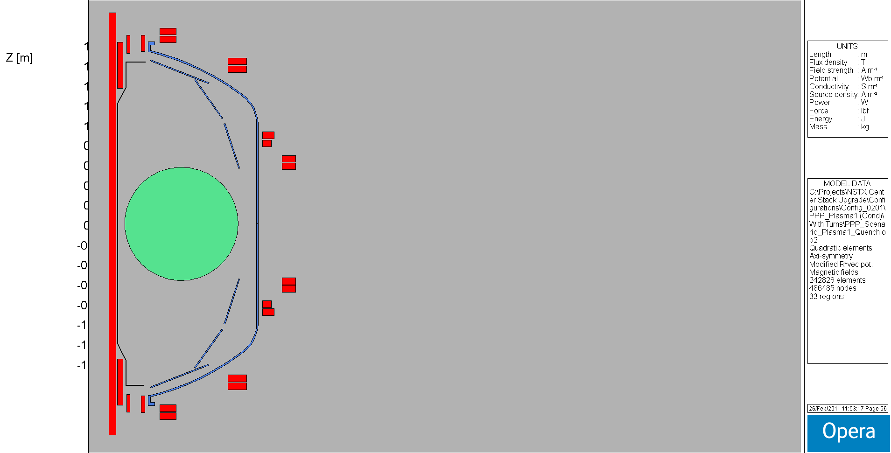

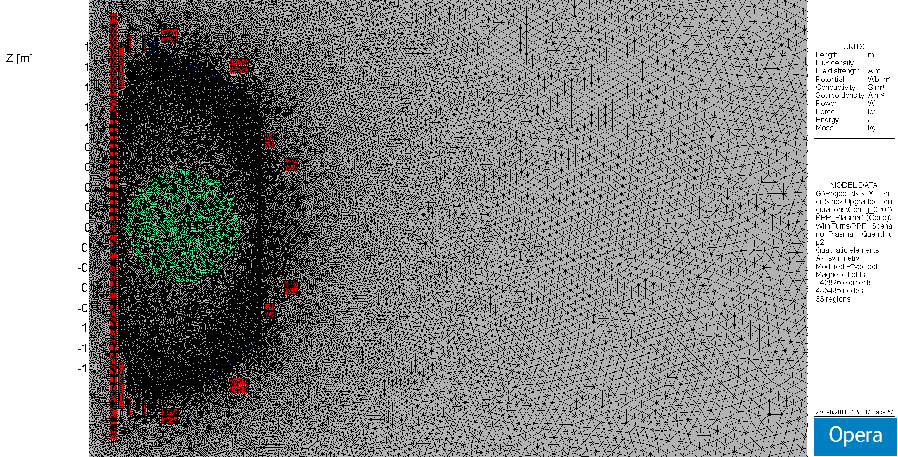

Figure 1 Portion of the Opera NSTX_CSU model with and without the finite element mesh.
The background region for these simulations was 0 ≤ R ≤ 20 m and -10 ≤ Z ≤ 10 m. Meshing of the background region is biased so that the element density is higher in the region where the NSTX_CSU device is located. After meshing the problem area is meshed with approximately 243,000 quadratic elements. A portion of the Opera model (with and without mesh) is shown in Fig. 1. In the figure a circular mid-plane plasma as specified in the NSTX_CSU-GRD is shown.

2D Dirsuption Simulation Scenarios

The GRD specifies five different plasma locations and sizes to be used in disuption analyses. The locations and dimesions of the plasmas are shown in Table 1 with outlines in Fig. 2. Is should be noted that the GRD specifies a circular sharped plasma for all disruption and/or displacement event analyses.

 | Centered | Offset Midplane | Offset,Inboard | Offset, Central | Offset, Outboard
R_{maj} [m] | 0.9344 | 0.5996 | 0.7280 | 0.8174 | 1.0406
Z_{maj} [m] | 0.0000 | 0.0000 | -1.1376 | -1.1758 | -0.8768
a_{min} [m] | 0.5696 | 0.2848 | 0.2848 | 0.2848 | 0.2848

Table 1 GRD plasma models for disruption analysis
Figure 2 Plot of plasma shapes inside NSTX_CSU model
The plasma is modeled by a circular axisymmetric element with constant current density, zero conductivity, and nominal toroidal plasma current of 2 MA.

Initial disruption simulations focused on worst case scenarios for the passive structure and outboard divertor. First, PF current vector sets were derived that maximized the field at the center of each element (individual current vectors are derived for each structure). In the analysis, the PF coils have zero conductivity and are initialized to the current set previously derived for the structure with the plasma current set to 2 MA. The PF coils are modeled with zero conductivity due to the assumption that there is no significant response from the coil-power supply combinations on the time scale of the disruption current quench. The current quench is simulated by ramping the plasma current to zero with dI_{p}/dt = 1 MA/ms. In the simulations, adaptive time stepping is used in Opera to ensure solution accuracy. For each structure, the time history of the toroidal current and the radial and vertical forces are saved as output. In these initial simulations, no displacement events were simulated. After discussing these intial results with NSTX researchers, it was determined that subsequent simulations would use dI_{p}/dt = 2 MA/ms.

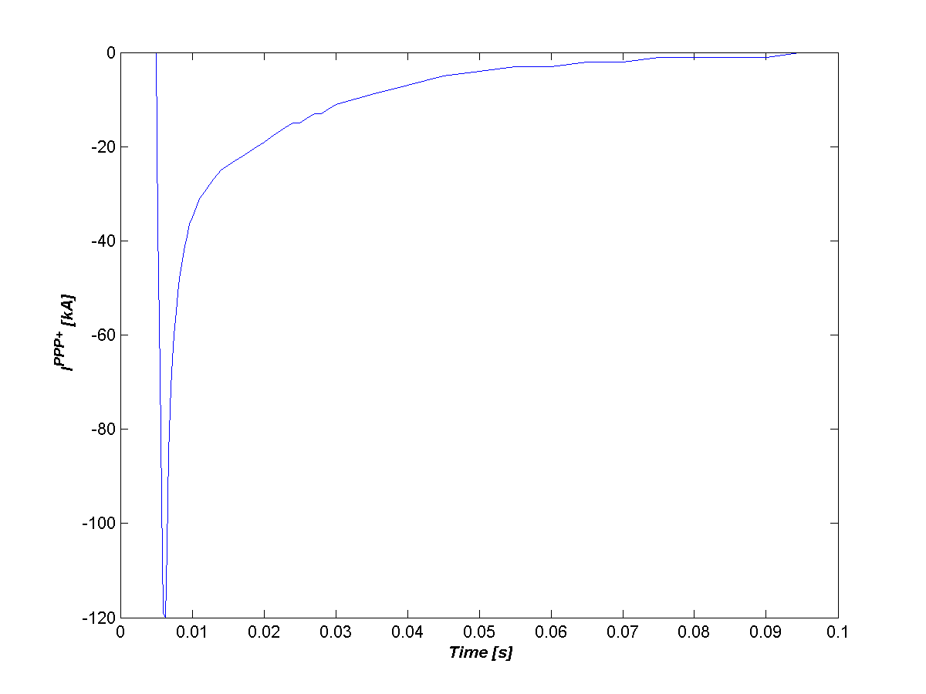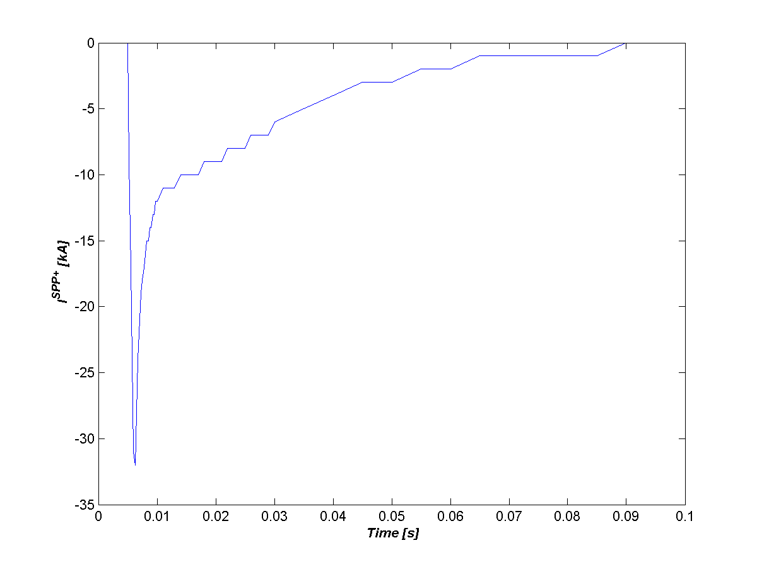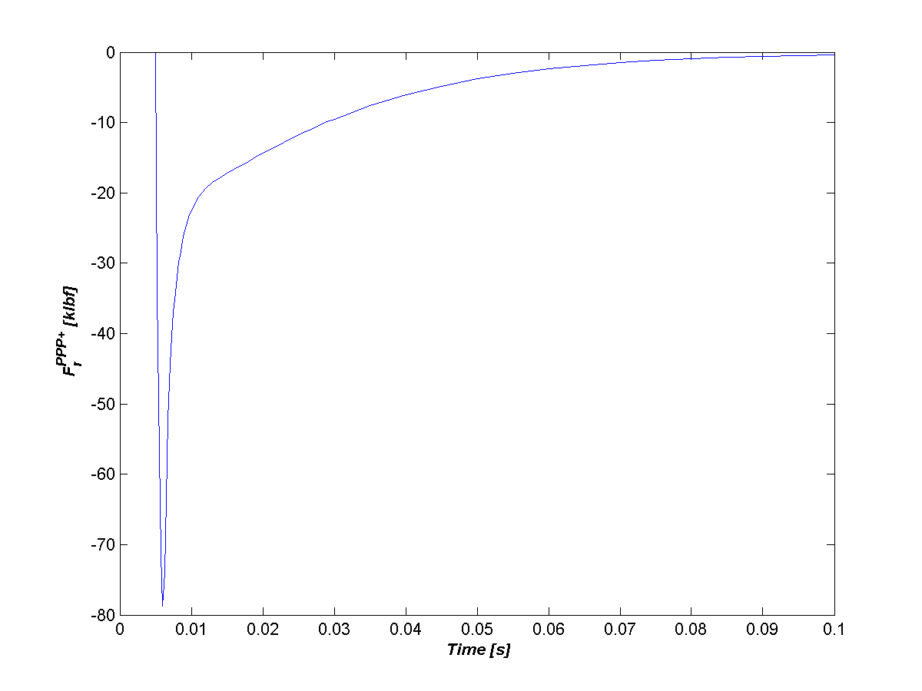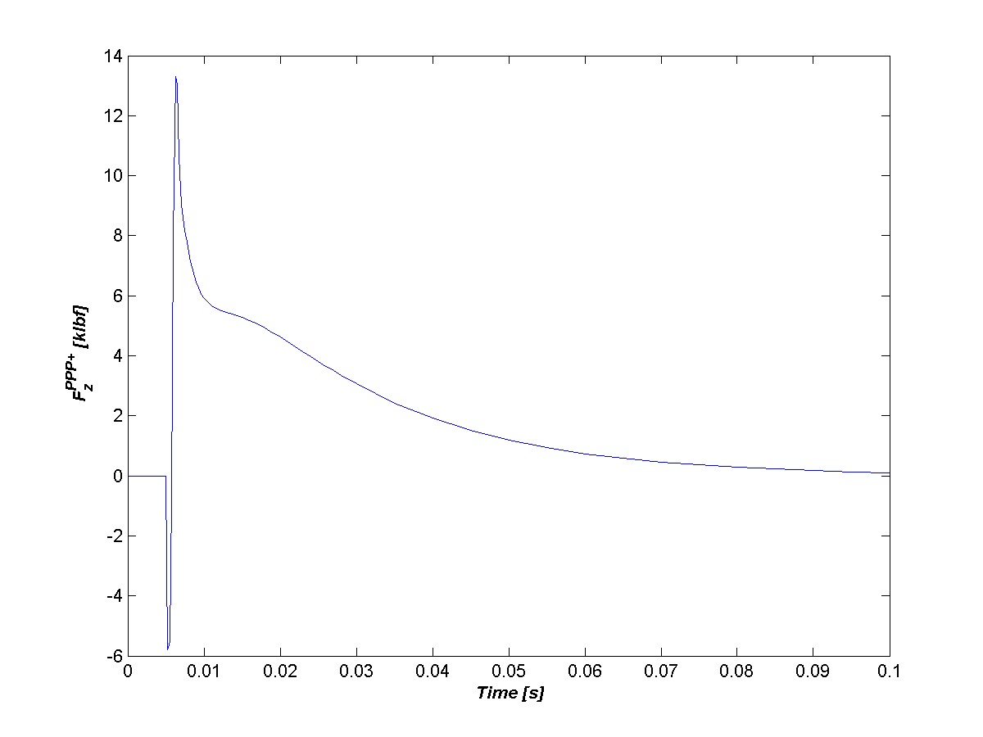
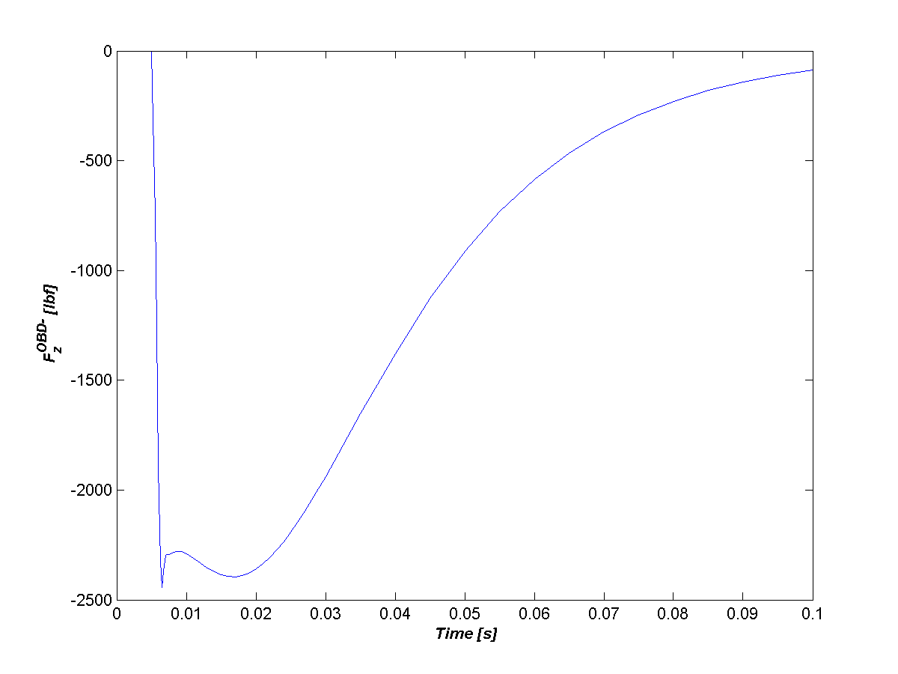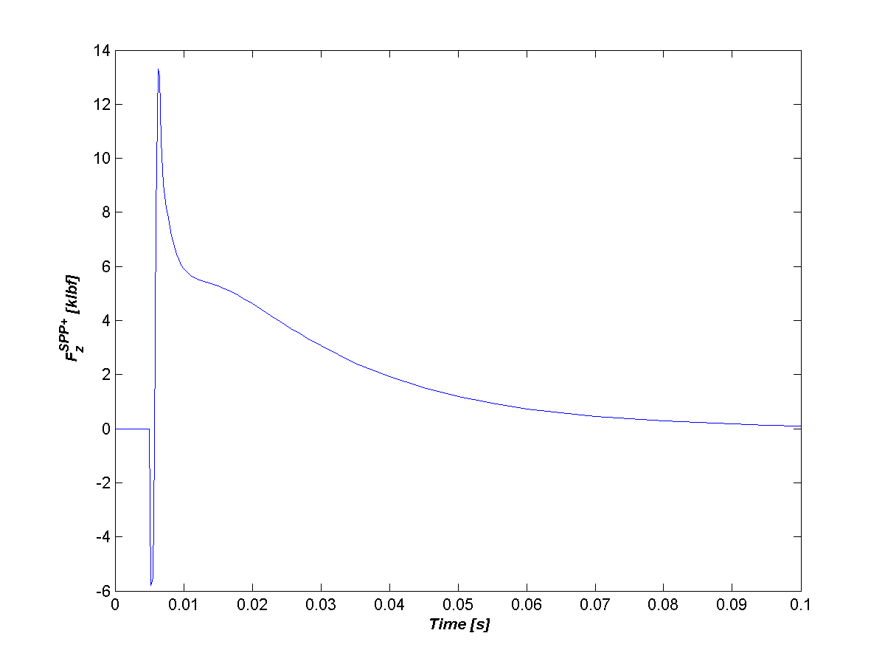
Figure 3: Selected output from initial disruption studies (a – upper primary passive current, b – upper seconday passive current, c – upper passive radial force, d – upper passive vertical force, e – lower outboard divertor vertical force, f – upper secondary vertical force)

Opera Vector Potential Input to 3D ANSYS Model

Opera 2D axisymmetric analysis is also used to drive the 3D non-axisymmetric analysis. For these simulations, Opera is used to provide a time varying vector potential solution that can be superimposed onto 3D geometry ANSYS models. These simulations do not include any PF coil contributions (i.e., background fields or inductive response). Again, the simulations use adaptive time stepping and with the full solution saved at a set of predetermined times. A post-processor script is used to extract the data used as input to the ANSYS model. At each output time, a text file is written with the following data on an 81 x 81 point grid: R, Z, A/R, B_{r}, and B_{z}.

Twenty-two disruption/displacement event simulations are performed for each configuration. The set of simulations are chosen to cover the cases without halo current as enumerated in the spreadsheet attached to the 7/2/2010 J. Menard email (Disruption_scenario_currents_JEMv1.xls).
Model generation is automated by use of Opera pre-processor scripts (.comi files). All cases are derived from the basic configuration specific model described above. For each confirguration we do the following simulations (22 total):

- Fast Quench – dI_{p}/dt = 2 MA / ms current quench for each plasma (5 total).
- Medium Quench – dI_{p}/dt = 0.5 MA / ms current quench for the centered plasma model (1 total).
- VDE Fast Quench – centered plasma translation to each of the other four plasma models in 10 ms followed by a fast (dI_{p}/dt = 2 MA / ms) current quench (4 total).
- VDE Medium Quench – centered plasma translation to each of the other four plasma models in 10 ms followed by a medium (dI_{p}/dt = 0.5 MA / ms) current quench (4 total).
- VDE Slow Quench – centered plasma translation to each of the other four plasma models in 10 ms followed by a slow (dI_{p}/dt = 0.05 MA / ms) current quench (4 total).
- VDE Very Slow Quench – centered plasma translation to each of the other four plasma models in 10 ms followed by a very slow (dI_{p}/dt = 0.02 MA / ms) current quench (4 total).

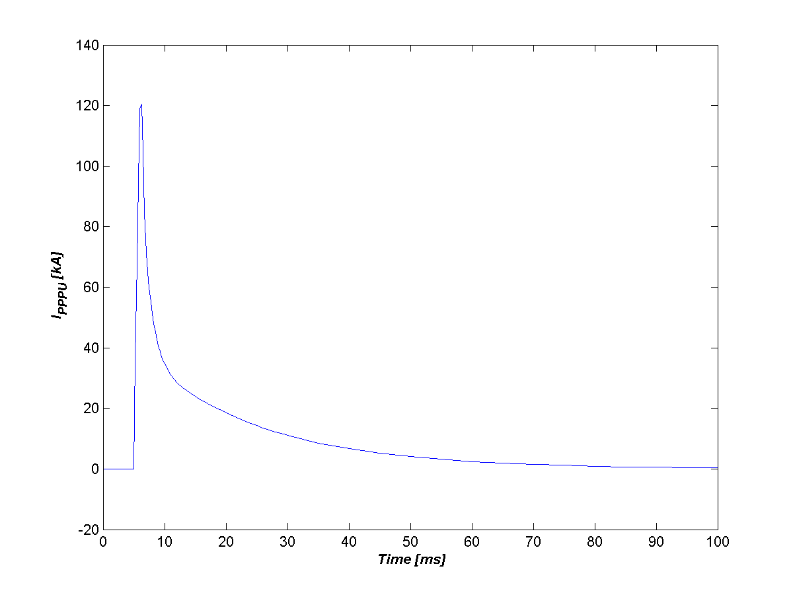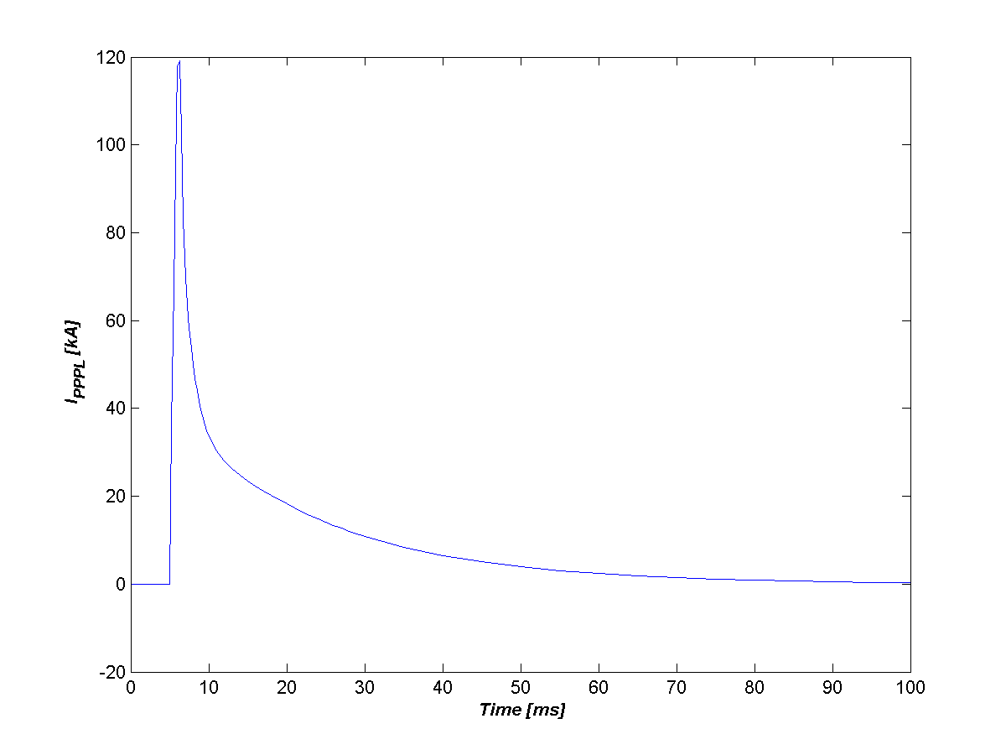

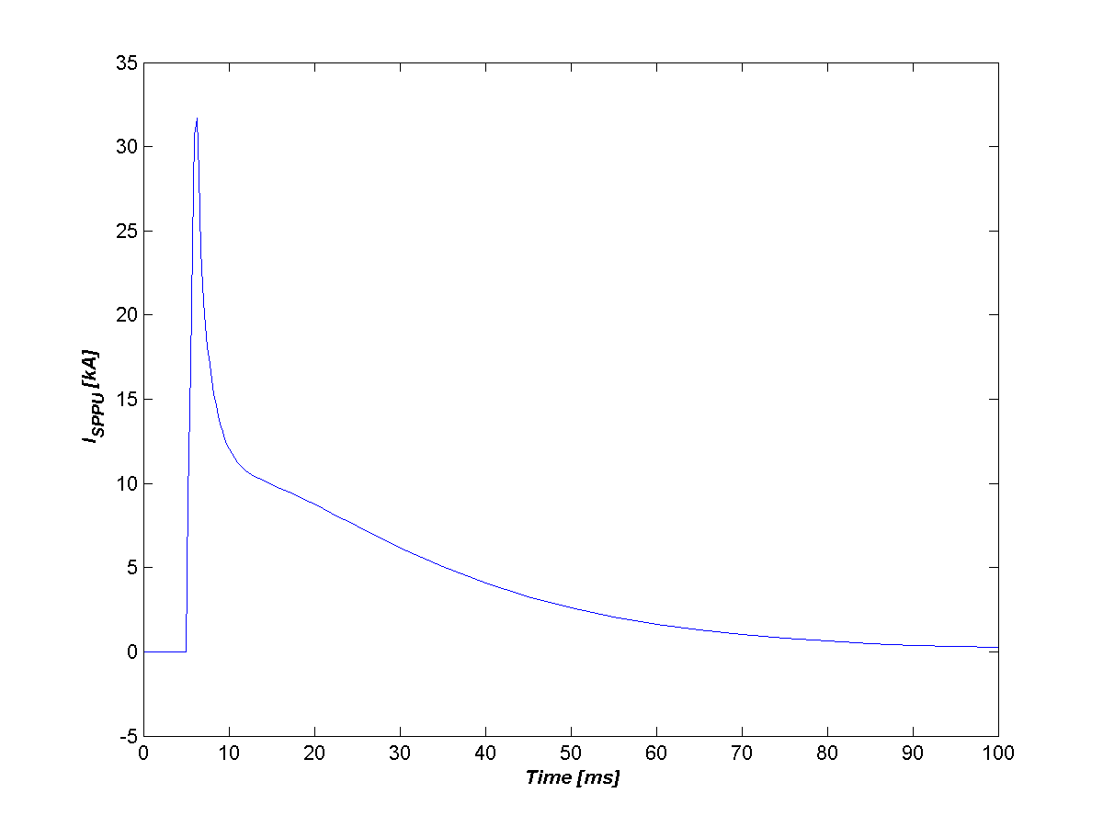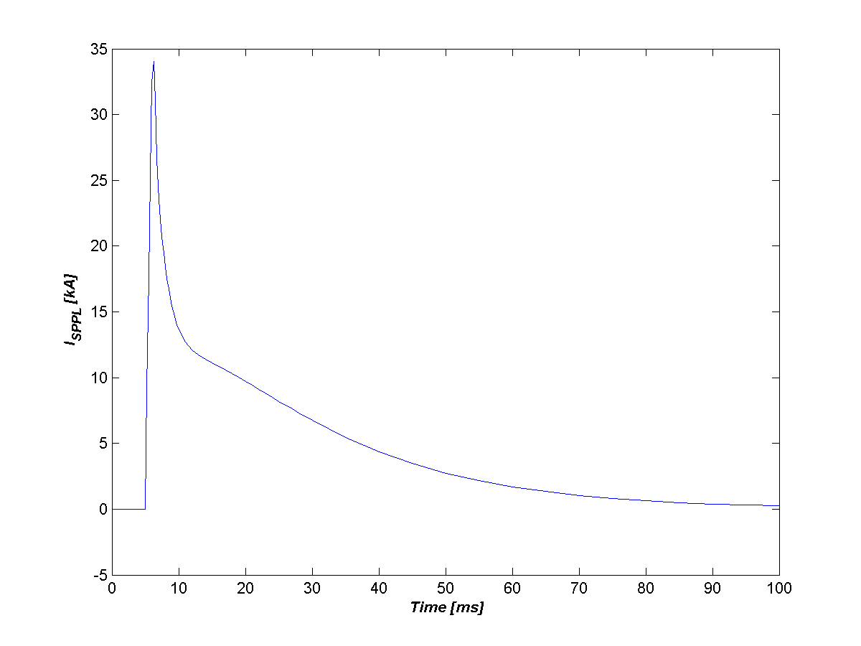
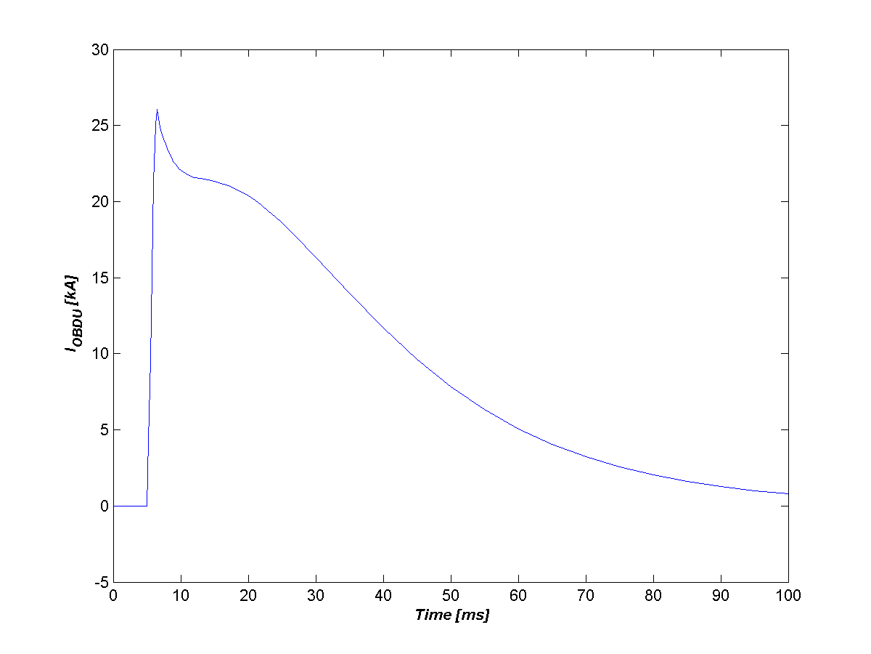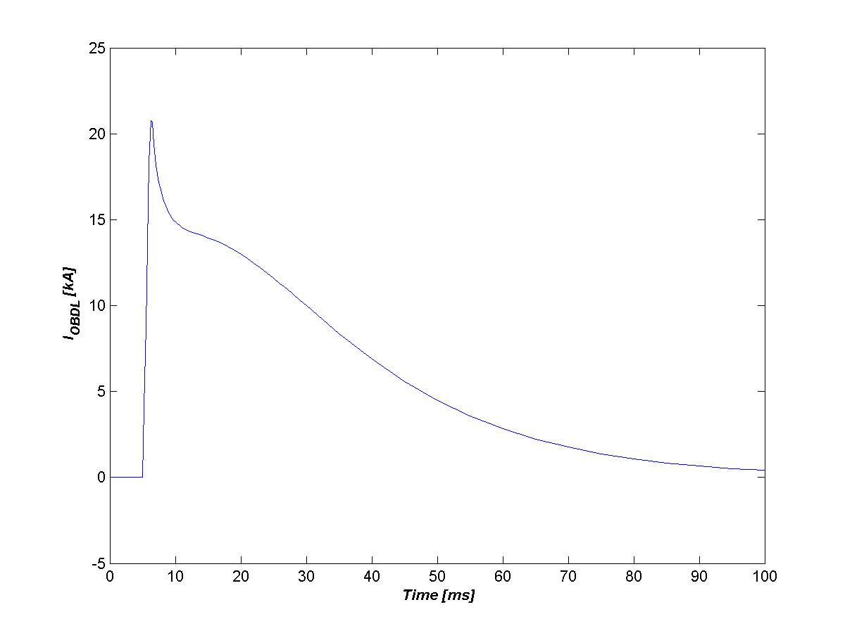

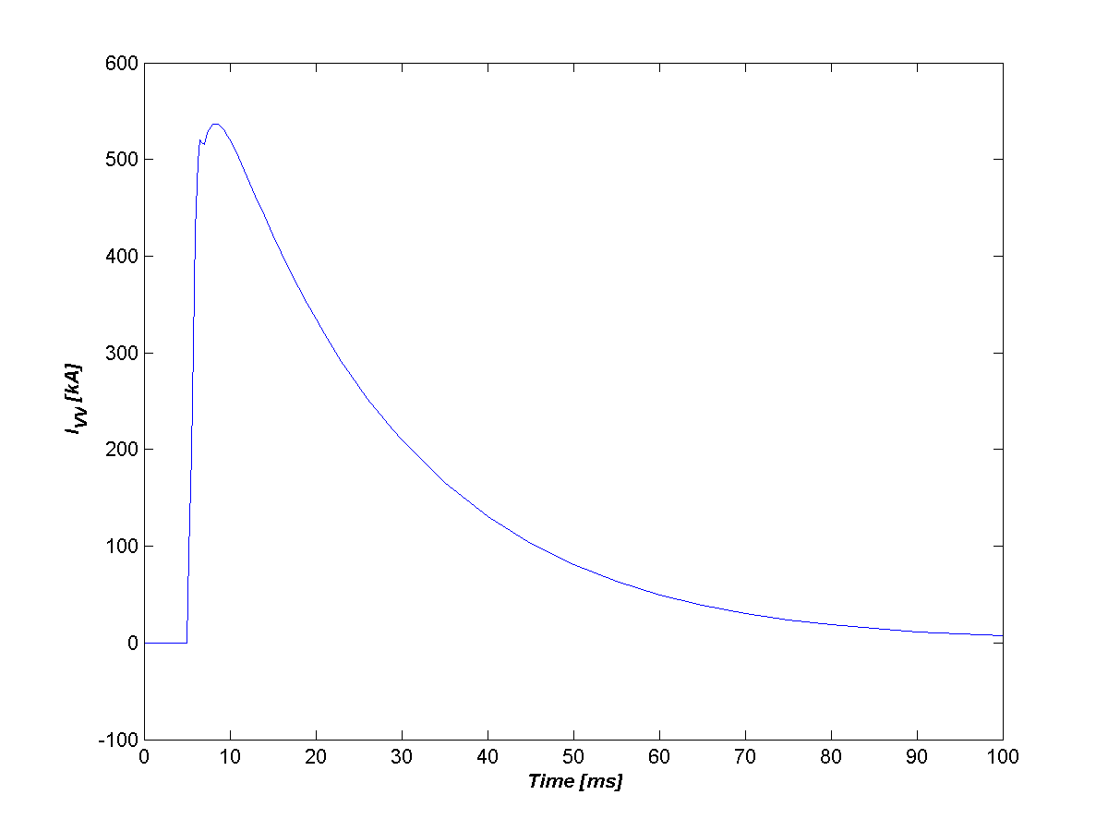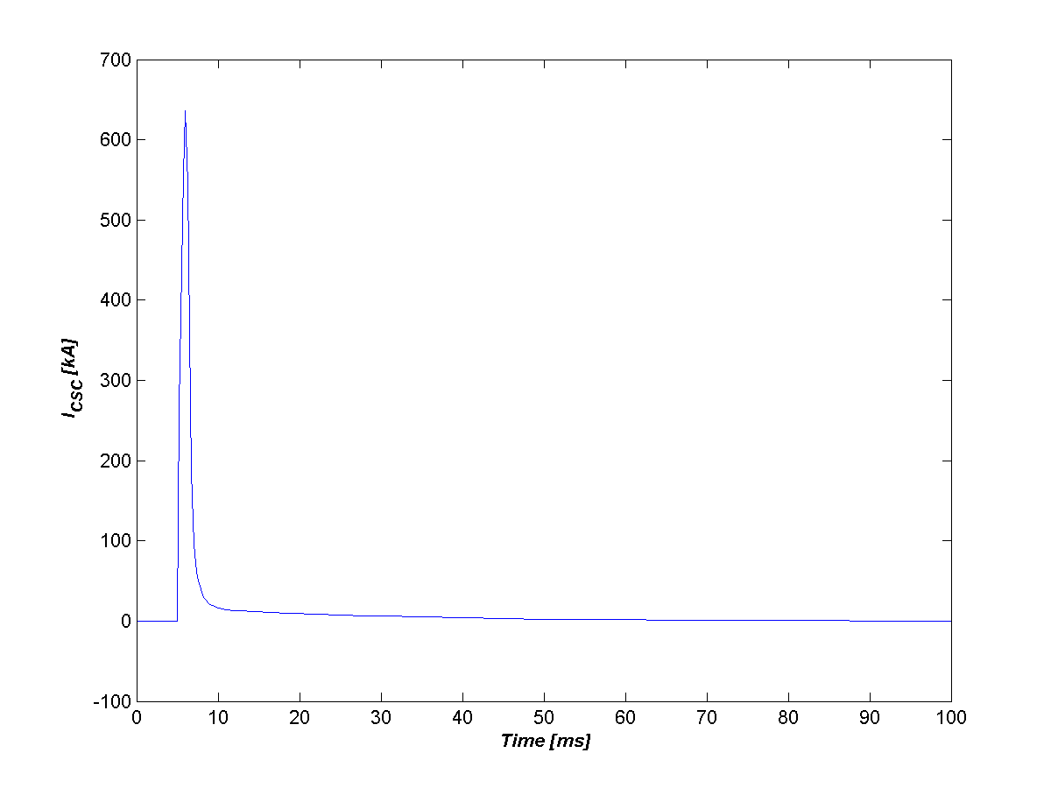
Figure 4 Currents in conducting structures during a Plasma 1 fast quench.

Fig. 4 shows plots of the currents in conducting structures during a fast plasma quench simulation. In these plots, one can see that all of the structures respond in a similar manner to the plasma quench. The current in the structures initially increase in response to the loss of plasma current and then decay on a resistive time scale.

Figure 5 shows plots of the currents in conducting structures during a VDE plus slow plasma quench simulation. In these plots, one sees that the "upper" structures (primary passive plate, secondary passive plate, and upper outboard divertor) initially react to the plasma movement in a manner that resists the motion of the plasma (increased current). The induced current decays away on a resistive time scale during the plasma quench. In the lower elements, again initially the induced current (negative) acts to resist the plasma motion (dIp/dt < 0), but during the quench the induced current acts in opposition to the loss of the plasma current (dIp/dt >0). Combined behavior is seen in the vacuum vessel and center stack casing.
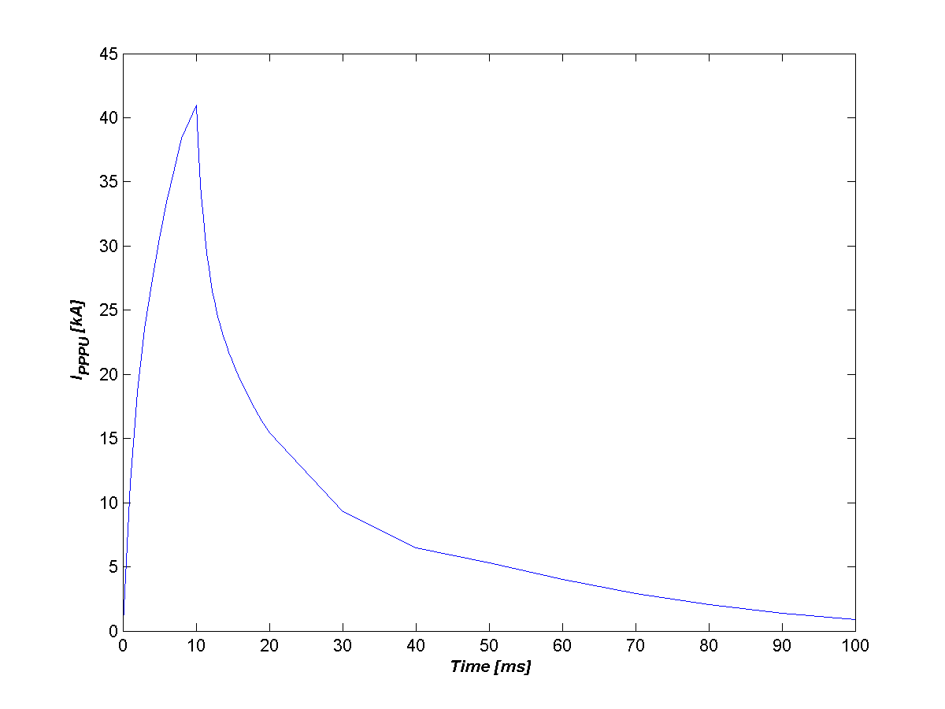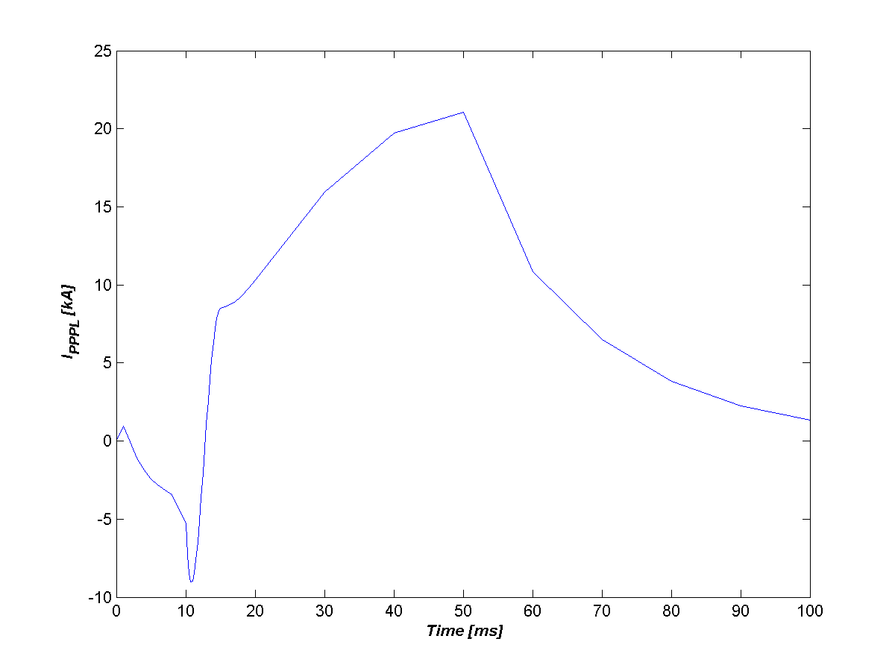
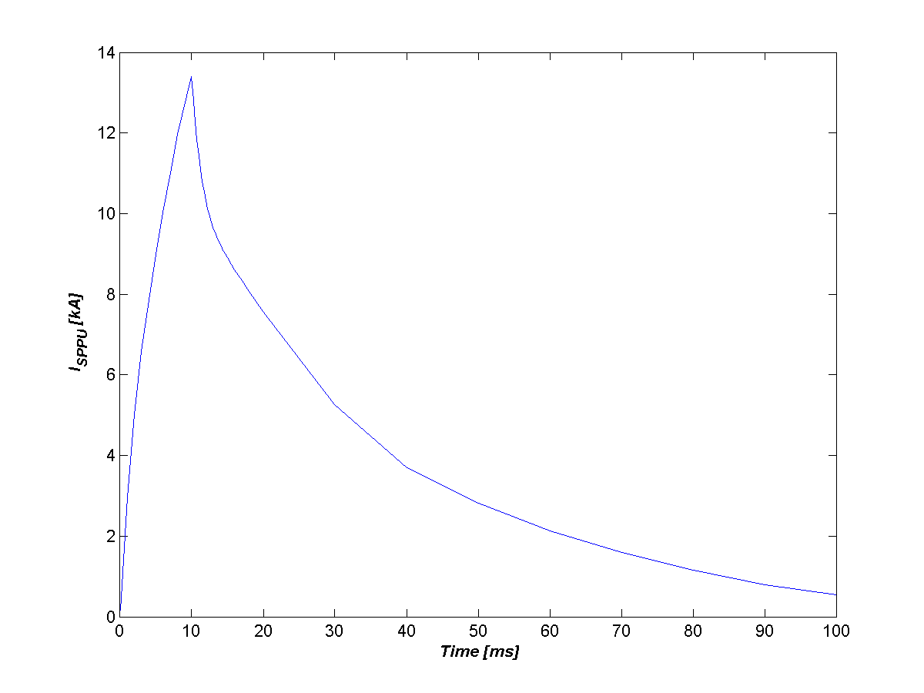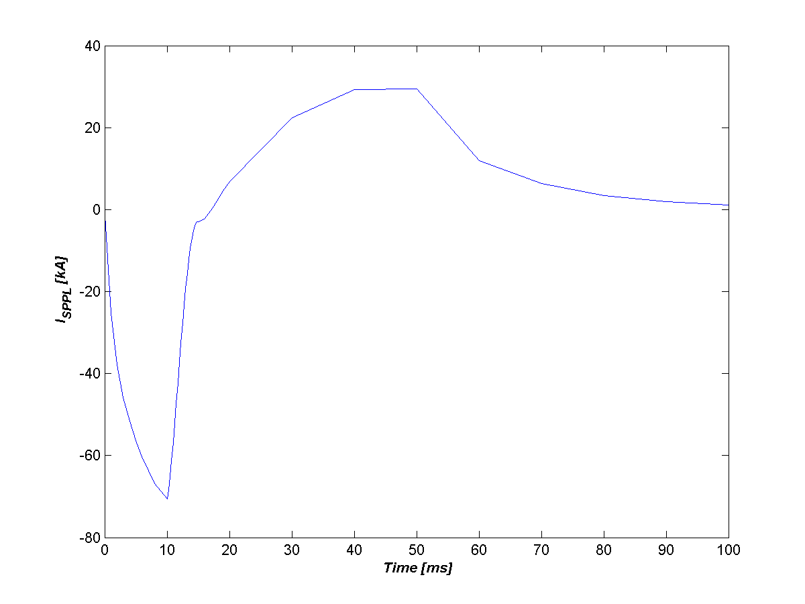

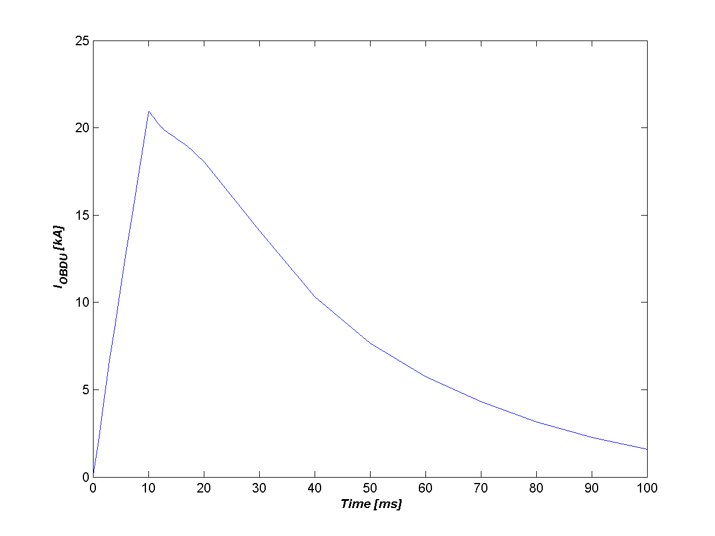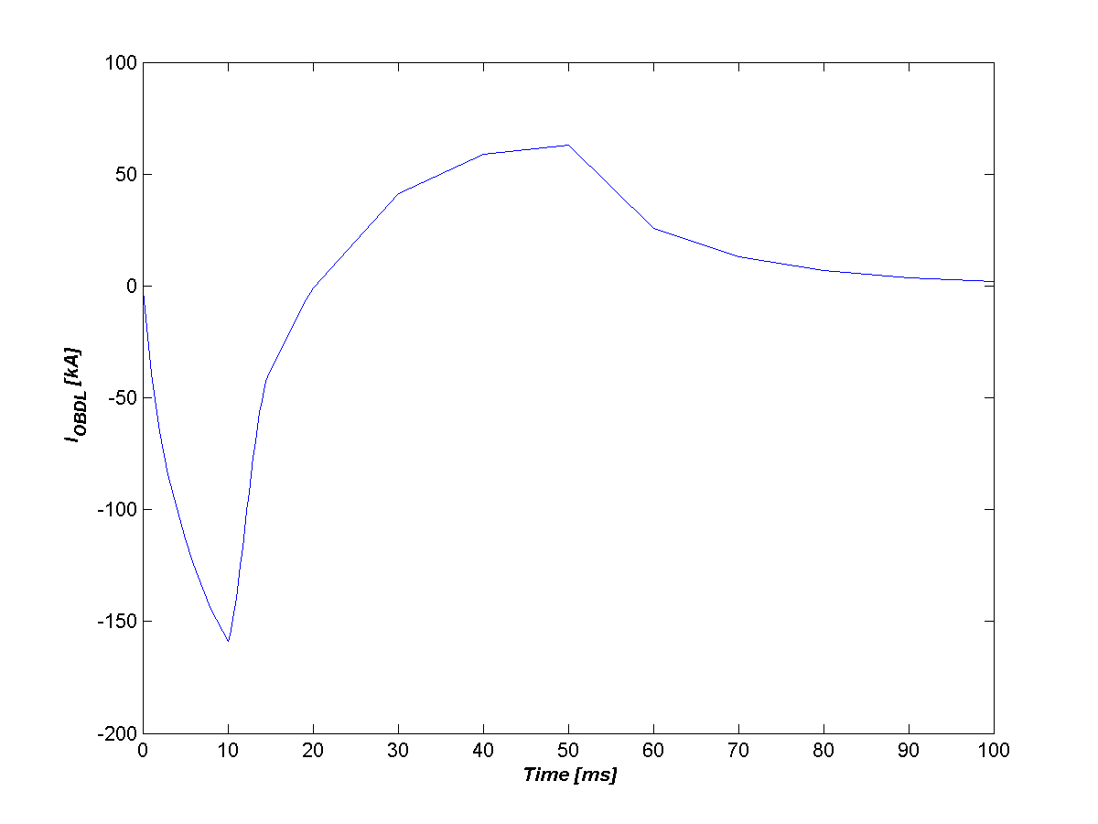
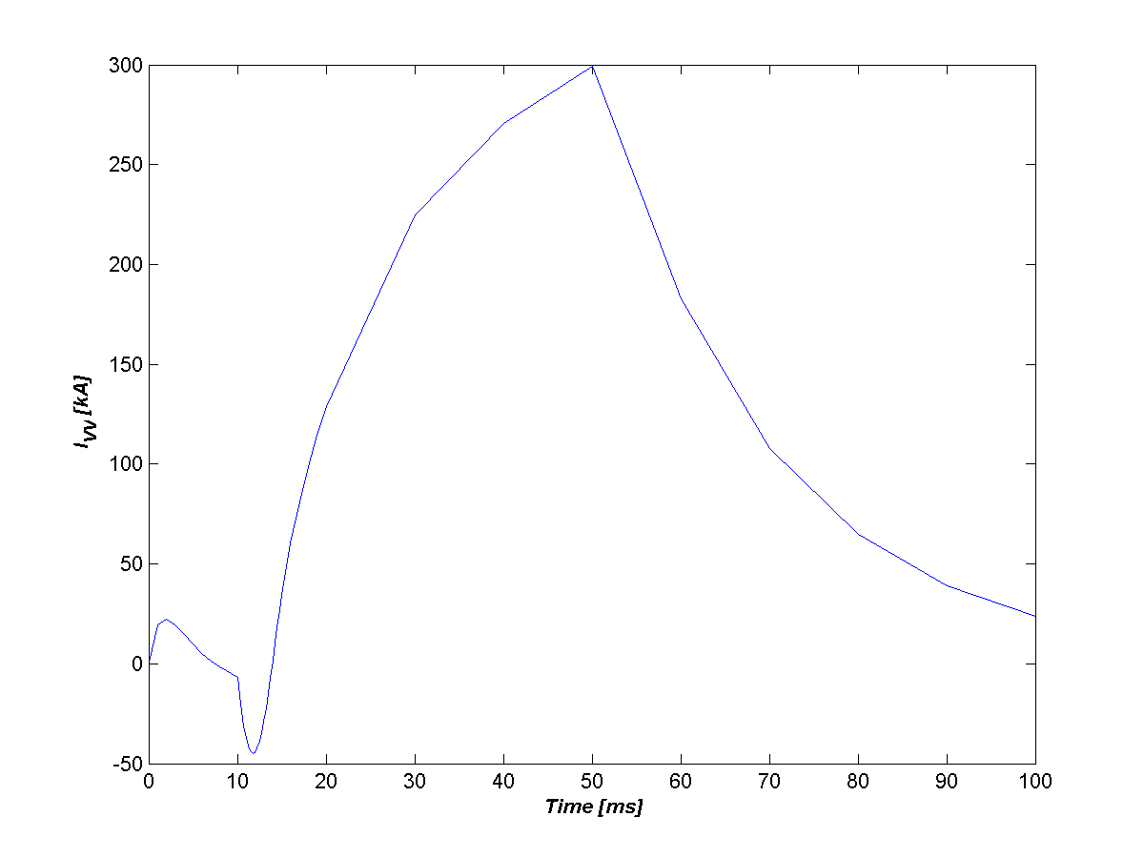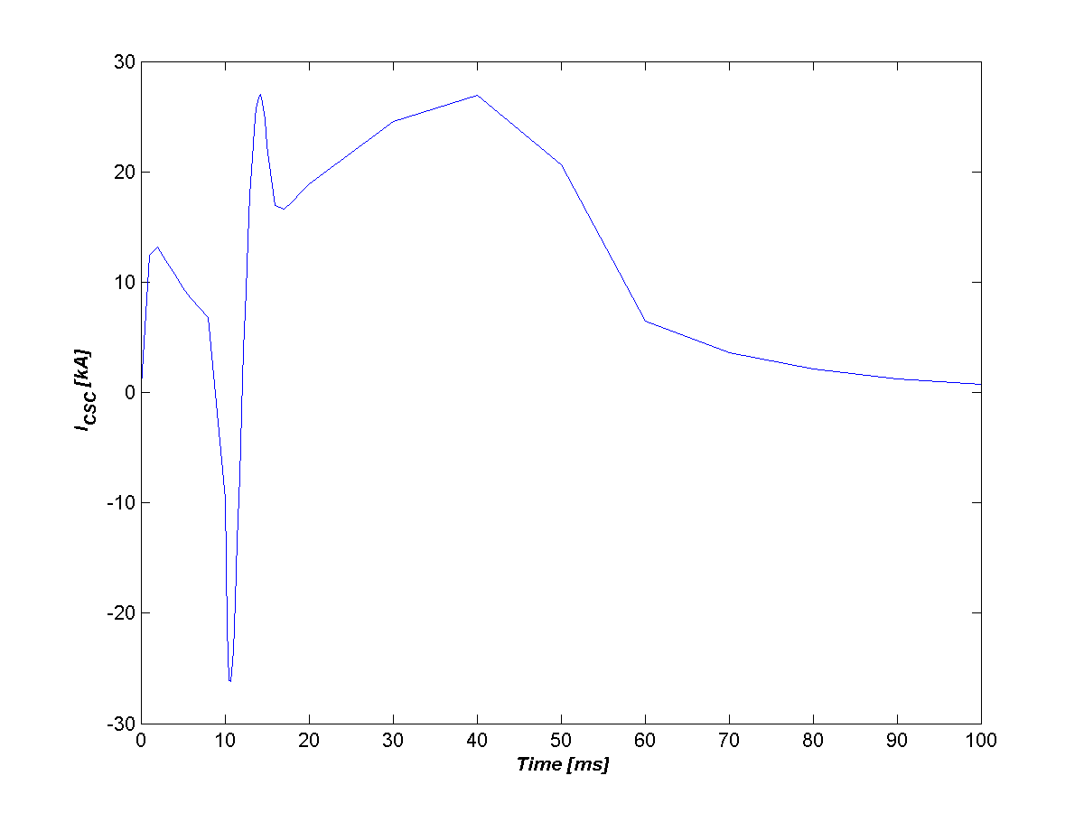
Figure 5 – Currents in conducting structures during a Plasma 1 to Plasma 4 "VDE Slow Quench" simulation.

Distribution: C. Neumeyer, P. Titus, M. Smith, R. Simmons

Recent findings (R.E. Hatcher – CSU Plasma Model Comparison memo) show that this modeling technique can lead to erroneous results in some transient analyses. In the future, PF coils will be modeled as multi-turn Opera elements for transient simulations.
Opera uses the modified vector potential, r*A, in 2D axisymmetric magnetic analyses.

