NSTX

Disruption Analysis Of Vacuum Vessel

NSTXU-CALC-12-001-00

September 22, 2009

Prepared By:

___________________________________
Srinivas Avasarala, PPPL Mechanical Engineering

Reviewed By:

________________________________________
Peter Titus, Branch Head, Engineering Analysis Division

Approved By:

_______________________________________
Phil Heitzenroeder, Head, Mechanical Engineering
PPPL Calculation Form

Calculation # NSTXU-CALC-12-001 Revision # 00 WP #, if any
(ENG-032)

Purpose of Calculation: (Define why the calculation is being performed.)

References (List any source of design information including computer program titles and revision levels.)

Assumptions (Identify all assumptions made as part of this calculation.)

Calculation (Calculation is either documented here or attached)

Conclusion (Specify whether or not the purpose of the calculation was accomplished.)

Cognizant Engineer’s printed name, signature, and date

I have reviewed this calculation and, to my professional satisfaction, it is properly performed and correct.

Checker’s printed name, signature, and date

Executive Summary
The objective of this analysis is to estimate the stresses in the vacuum vessel and passive plates caused by the plasma disruption. The Vector Potential solution for a 2D axisymmetric simulation of disruption in OPERA is imposed on the 3-D model in ANSYS to obtain the eddy currents and Lorentz forces. A static and dynamic stress pass is then run and the stresses are computed. Only the outboard diverter disruption scenario is discussed in this report.

The solid models of the vessel, umbrella structure, port extensions and support legs are imported from Pro-E. The model retains all the complex 3-D geometry but the port extensions, legs and the vessel are merged together to form one solid. The umbrella structure is a separate solid. This model is meshed with 8 node bricks in workbench and the mesh is carried into ANSYS classic. To get around the DOF compatibility issues, the mesh is rebuilt in ANSYS classic, retaining the number of nodes and elements and the connectivity. A vector potential gradient is then applied on this model to see if the model works. Eddy currents and Lorentz forces obtained agreed with intuition. An approximate model of the passive plates, in agreement with the 2-D model used in OPERA, is modeled in ANSYS. This is tied to the vessel using constraint equations. The degree of freedom coupled is Volt during the E-mag run and Displacement during the structural run.

Vector potentials obtained from OPERA are arranged in 80x80 tabular form so that they can be fed into ANSYS. The first 11 tables are considered for the study and these tables are spaced 0.5 ms apart. Macros are developed that read these values into ANSYS. The meshes in OPERA and ANSYS are dissimilar, but since ANSYS interpolates the tables between two adjacent indices, proper indexing of the coordinates yields a reasonable approximation of the Vector Potentials. The element type used was SOLID 97 and the material properties used are that of Stainless Steel except for the passive plates which are made up of Copper. This model is then solved for eddy currents and Lorentz forces..

The model is then converted into a structural model by switching the SOLID 97s into SOLID 45s. 11 load steps, 5ms apart are written for the stress pass. Forces are read from the earlier E-mag results fie using LDREAD command and both the Static and Dynamic analyses are performed. A 0.5% damping factor is used in the dynamic run.

The maximum stress obtained during the static analysis (ignoring the sharp corners) is 1600 Mpa and that from the dynamic analysis is 290 Mpa. Four nodes are picked in the model to compute the DLFs and the stresses seem to have reduced by a factor of 0.18-0.23.

Table of Contents
List of Figures 44
List of Tables Error! Bookmark not defined.4
Modeling:
Solid Modeling……………………………………………………………………………………5
Finite Element Model……………………………………………………………………..............7
Reading the Vector Potentials from OPERA…........................................................................10
Disruption Simulation………………………………………………………………………….12
Static Analysis…………………………………………………………………………………..14
Dynamic Analysis……………………………………………………………………………….15
Comparison of Static and Dynamic Analysis............................................................................16
Conclusions……………………………………………………………………………………...19
Macro to Generate Eddy currents..............................................................................................19
Macro for Static Structural Analysis………………………………………………………….25
Macro for Dynamic Structural Analysis………………………………………………………31

List of Figures
Figure 1. Solid Model of the Vessel-Umbrella assembly. 5
Figure 2. Neutral Beam Port Extension 5
Figure 3. Vessel and Supports. 6
Figure 4. Umbrella Structure 6
Figure 5. Finite Element Model 7
Figure 6. Vector Potential gradient. 8
Figure 7. Eddy Currents around the Port Extensions 8
Figure 8. The FE Model of the passive plates. 9
Figure 9. The Constraint Equations used to tie the passive plates to the vessel………….............10
Figure 10. Poloidal Fields on the Hollow Cylinder………………………………………...........11
Figure 11. Toroidal Field on the hollow cylinder. 11
Figure 12. Current Density near the Neutral Beam Port 12
Figure 13. Eddy currents in the vessel and passive plates. 13
Figure 14. Eddy currents in the passive plates at 10.0065 sec 13
Figure 15. Eddy currents flowing in and out of the passive plates………………………… ……14
Figure 16. Von-Mises Stress on Passive Plates from Static Analysis……………........................14.
Figure 17. Von-Mises Stress on Vacuum Vessel from Static Analysis 15
Figure 18. Von-Mises Stress on Passive Plates from Dynamic Analysis……………..................15
Figure 19. Von-Mises Stress on Vacuum Vessel from Dynamic Analysis…………………...…16
Figure 20. Stress from static analysis on nodes 47059,29593,19132 and 76456… ……..…….16
Figure 21. Stress from dynamic analysis on nodes 47059,29593,19132 and 76456.....................17
Figure 22. Displacements from static analysis on nodes 47059,29593 & 19132 ……………….17
Figure 23. Displacements from Dynamic analysis on nodes 47059,29593 & 19132……............18
Figure 24. Displacements from static analysis on node 76456……………………………..........19
Figure 25. Displacements from dynamic analysis on node 76456 ………………………............20

MODELING:

THE SOLID MODEL:
The solid model of the Vessel, Port Extensions legs and umbrella structure are modified (components merged) to yield a relatively simpler model for FEA. The umbrella structure is modeled as a separate solid to incorporate the sliding joint at a later stage in analysis.

Figure1: Solid Model of the Vessel-Umbrella assembly 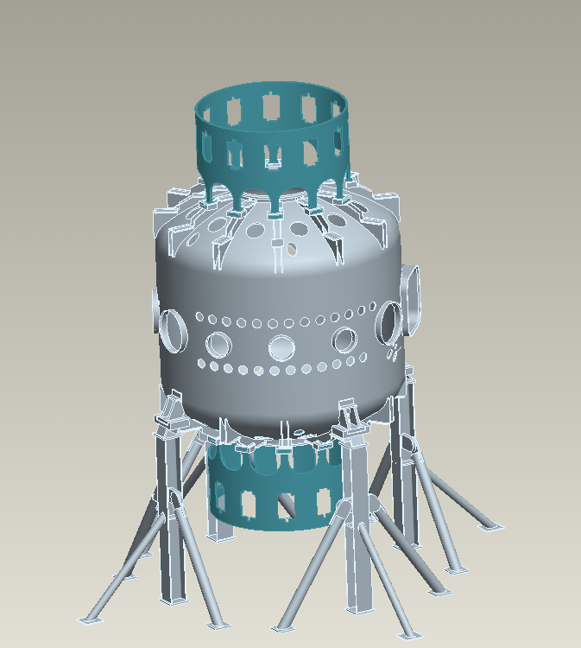

Figure 2: Neutral Beam Port Extension
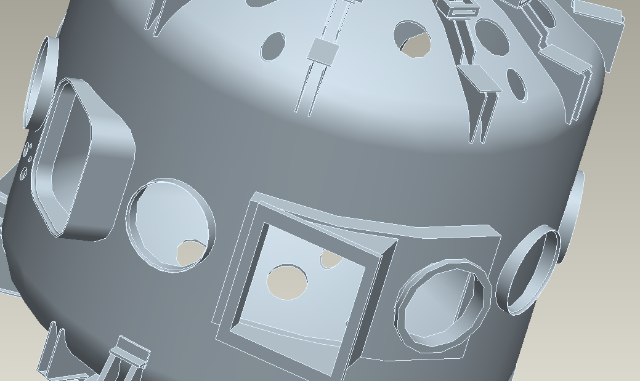

Figure 3: Vessel and Supports
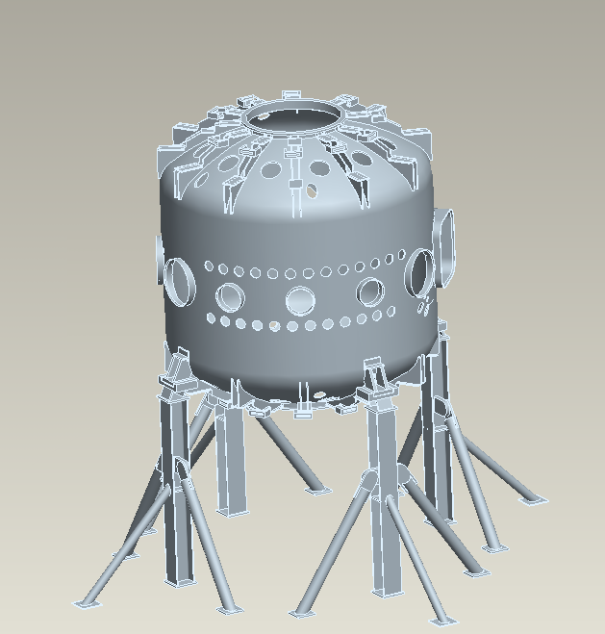

Figure 4: Umbrella Structure
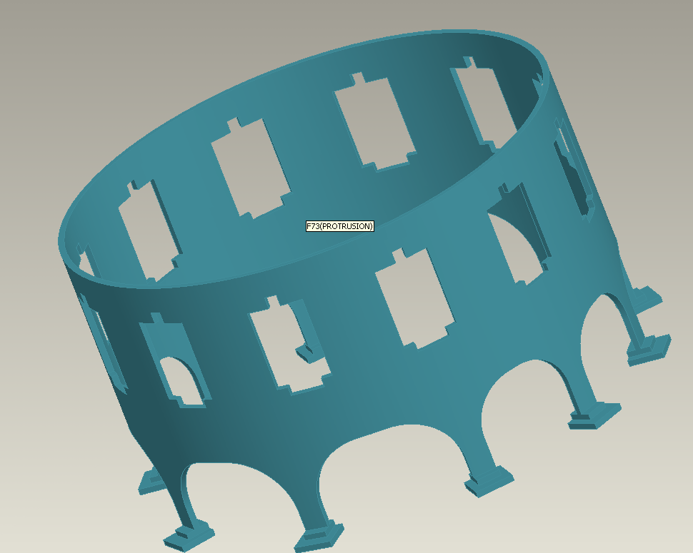

THE FINITE ELEMENT MODEL:
The model is meshed in ANSYS- Workbench with an 8-node brick element and the mesh is transferred to ANSYS-Classic. The preferred element type is SOLID 97 because of its capability to handle Vector Potentials. However, there were some DOF compatibility issues when the mesh is transferred to ANSYS-Classic. Several methods to circumvent this obstacle, like using the CDWRITE and CDREAD commands failed. The mesh was reconstructed in ANSYS retaining the same nodes, elements and the connectivity. The Model has 216112 elements and 76436 nodes.

Figure 5: Finite Element Model

Before taking the analysis further the model is tested—a Vector Potential gradient is applied to see if it yielded eddy currents and Lorentz forces as expected. The model seemed to work as expected.

Figure 6: Vector Potential gradient.
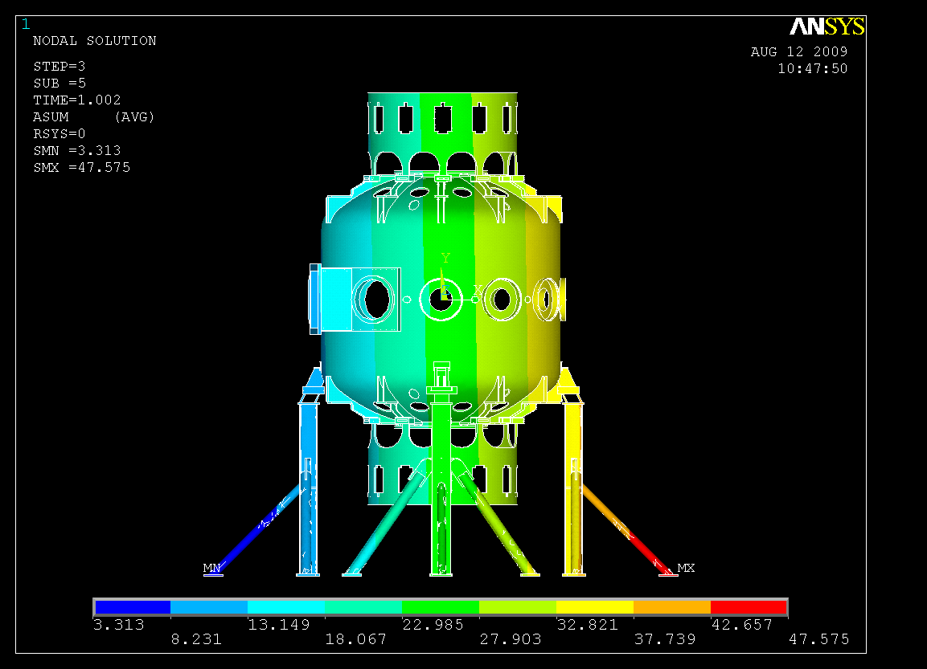

Figure 7: Eddy Currents around the Port Extensions
An approximate FE model of the passive plates is built based on the 2-D opera model and a earlier axisymmetric model of the vessel. This model could not be glued to the vessel because of the difference in dimensions. Hence, the CEINTF command was used to tie the passive plates to the vessel both electrically and structurally.

Figure 8: The FE Model of the passive plates.
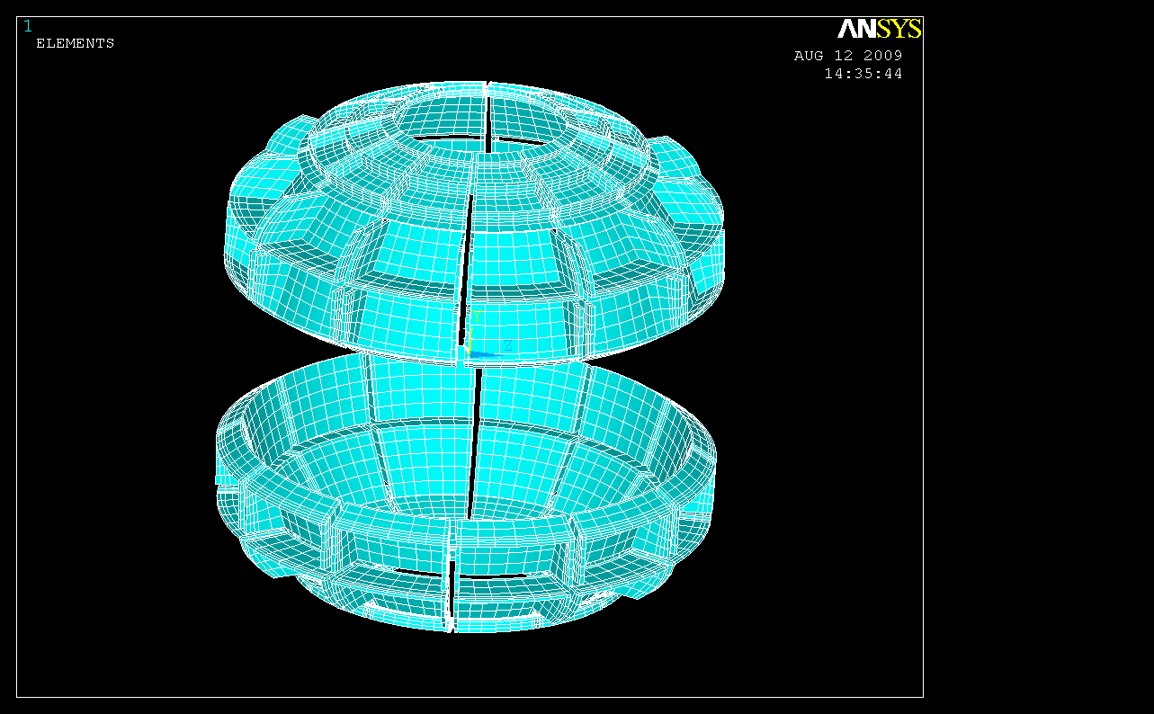

Figure 9: The Constraint Equations used to tie the passive plates to the vessel
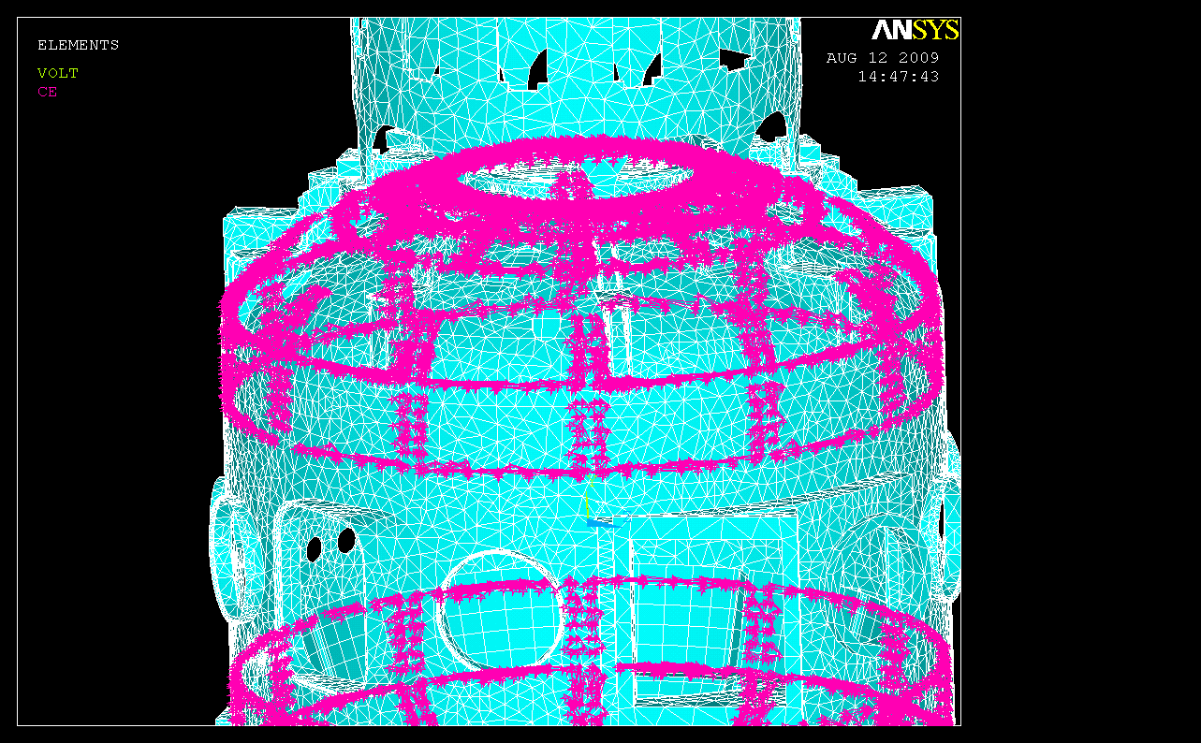

READING THE VECTOR POTENTIALS FROM OPERA:

The vector potentials from OPERA, which are generated in cylindrical coordinate system, are arranged in a matrix format to be compatible with ANSYS requirements. MATLAB is used to achieve this. These values are imposed on the nodes using TREAD command. ANSYS uses linear interpolation and will use an approximated vector potential on nodes that are not coincident with the nodes is OPERA. A toroidal field is also applied along with the values from OPERA. Before running the disruption simulation on the vessel, the vector potentials are applied on a hollow cylinder and the poloidal and toroidal fields are plotted.

Figure 10: Poloidal Fields on the Hollow Cylinder
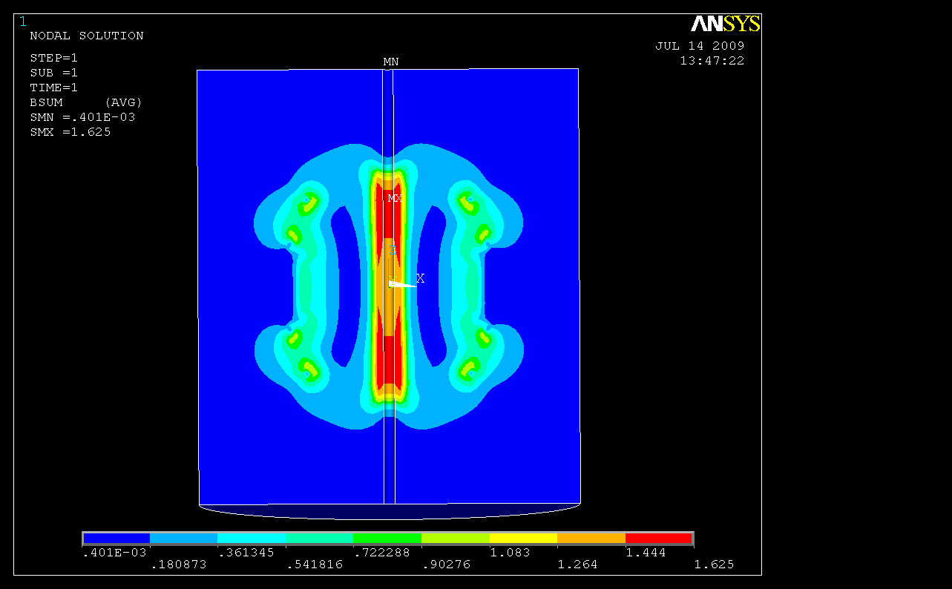

Figure 11: Toroidal Field on the hollow cylinder
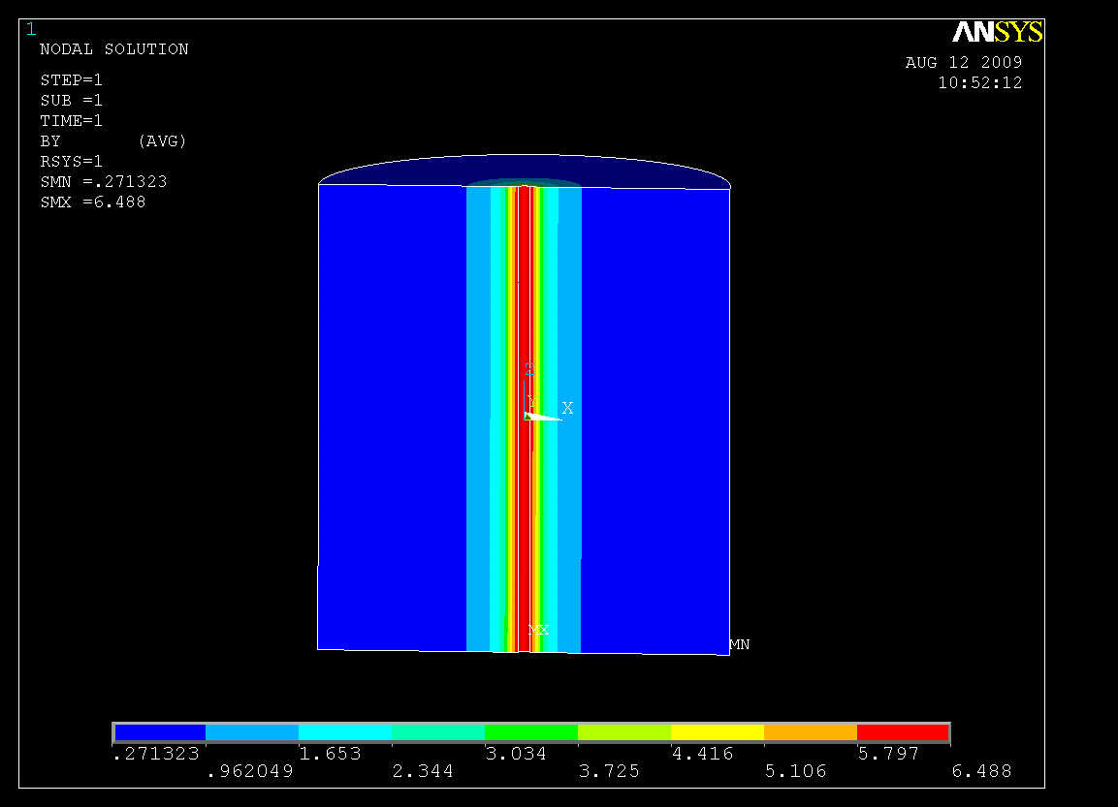
DISRUPTION SIMULATION:

OPERA results are spaced 0.5 ms apart and hence the load steps in ANSYS are written 0.5 ms apart too. Only the first load step was written at 10 sec to allow for the model to settle and not produce any currents due to the steep change in vector potentials over a short period. A total of 11 load steps are written for the plasma quench.

E-mag Analysis:

Figure 12: Current Density near the Neutral Beam Port

The above figure shows that the currents are maximum at time =10.0065 seconds.

Figure 13: Eddy currents in the vessel and passive plates
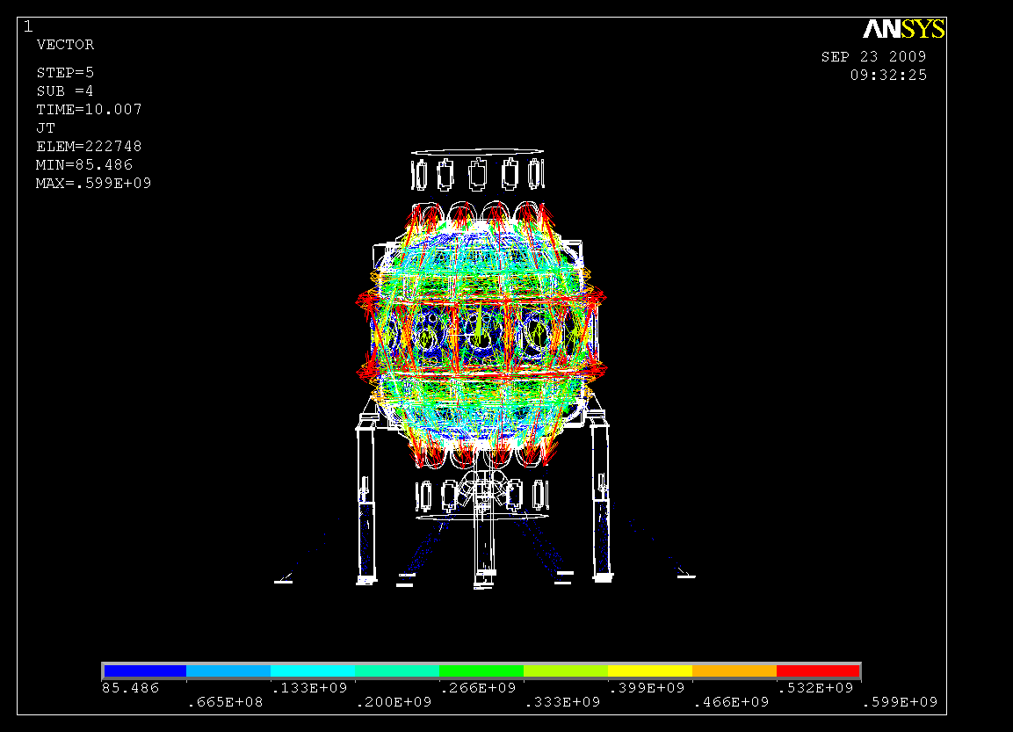

Figure 14: Eddy currents in the passive plates at 10.0065 sec

The above figure shows that the eddy currents in Cu are quite larger compared to those in the Stainless Steel.

Figure 15: Eddy currents flowing in and out of the passive plates
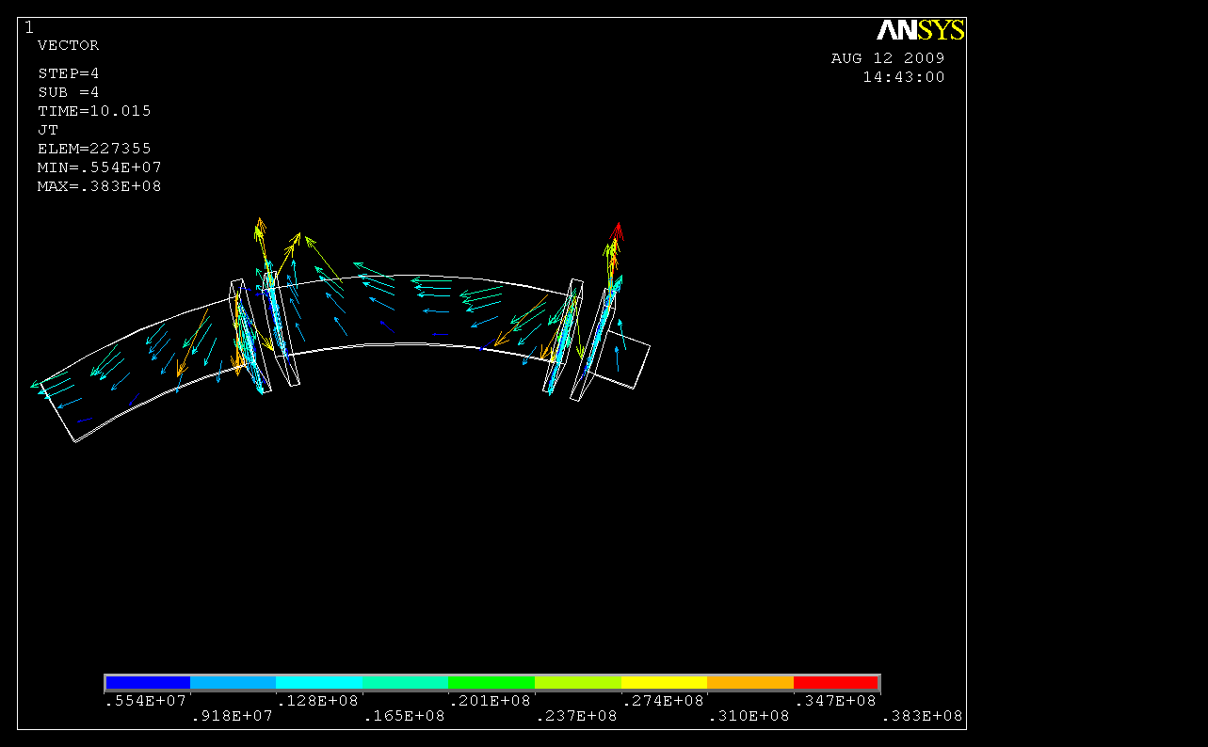

The above figure shows the eddy currents making a loop from the vessel into the passive plates and then back into the vacuum vessel. This indicates that the constraint equations have tied the plates to the vessel as expected.

STATIC ANALYSIS:

Figure 16: Von-Mises Stress on Passive Plates from Static Analysis
Maximum Stress (ignoring sharp corners) = 1600 Mpa
Figure 17: Von-Mises Stress on Vacuum Vessel from Static Analysis
Maximum Stress= 165 Mpa

DYNAMIC ANALYSIS:

Figure 18: Von-Mises Stress on Passive Plates from Dynamic Analysis
Maximum Stress (ignoring sharp corners) = 290 Mpa

Figure 19: Von-Mises Stress on Vacuum Vessel from Dynamic Analysis
Maximum Stress= 45 Mpa

COMPARISION OF DYNAMIC AND STATIC ANALYSIS
About four regions are selected on the vacuum vessel and the passive plates to compare displacements and stresses.

Figure 20: Stress from static analysis on nodes 47059,29593,19132 and 76456

Figure 21: Stress from dynamic analysis on nodes 47059,29593,19132 and 76456

Figure 22: Displacements from static analysis on nodes 47059,29593 & 19132.

Figure 23: Displacements from Dynamic analysis on nodes 47059,29593 & 19132.

Figure 24: Displacements from static analysis on node 76456

Figure 25: Displacements from dynamic analysis on node 76456

CONCLUSIONS:

- The Dynamic Load Factors are found to less than 0.25
- The stresses are under acceptable limit.
- Macros developed here could be used for other models to simulate disruption stresses.
- This method (of imposing Vector Potentials) circumvents the modeling of air and other complexities involving complex 3-D geometry.
- The disruption scenario studied here is just the Out Board Diverter disruption. The other two scenarios : Primary Passive Plate and Secondary Passive Plate should be studied.
- All the high stress modes of vibration might not have been picked up by the dynamic analysis because of memory limitations of PC
- CAD model of the Passive Plates is yet to be obtained and integrated into the model.

MACRO FOR GENERATING EDDY CURRENTS

/prep7
/nerr,,99999997,,0,,
resume,vesselpp,db ! 360 degree model of the vessel, leg supports, umbrella & passive plates
et,5,97,1 ! vessel, legs and umbrella structure
et,12,97,1 ! passive plates

mp,dens,1,8950 ! vessel, legs and umbrella structure
mp,murx,1,1.
mp,rsvx,1,753e-8

mp,dens,5,8950 ! Passive plates
mp,murx,5,1
mp,rsvx,5,.85*2.443e-8 ! @400K

mp,dens,6,8950 ! Passive plates
mp,murx,6,1
mp,rsvx,6,753e-8

csys,5 ! Opera output is in Cylindrical System
nrotat,all

nsel,s,loc,z,-3.9342,-3.9215
d,all,volt,0
nsel,all
d,75528,volt,0
d,75864,volt,0

! Write the equations to constrain the passive plates to the vessel

esel,s,type,,5
nsel,s,loc,z,.6504,1.0084
nsel,a,loc,z,-.6504,-1.0084
nsle,r,
nsel,r,loc,x,0,1.6892
esel,s,real,,12
ceintf,3,volt,3

allsel,all

esel,s,type,,5
nsel,s,loc,z,1.0742,1.3676
nsel,a,loc,z,-1.0742,-1.3676
nsle,r,
nsel,r,loc,x,0,1.7491
esel,s,real,,11
ceintf,3,volt,3

allsel,all

esel,s,type,,5
nsel,s,loc,z,1.7276,1.4998
nsel,a,loc,z,-1.7276,-1.4998
nsle,r,
nsel,r,loc,x,0,1.2377
esel,s,real,,10
ceintf,3,volt,3

allsel,all
!
fini
/solu
antype,4
trnopt,full
outres,all,last

time,10
autots,1
deltim,1,.5,3
kbc,0
*dim,vect0,table,81,81,1,x,z,,5 ! read from the table
*tread,vect0,'0','txt'
nall
BR=130000*12*3*2e-7
*get,nmax,node,,num,max
*do,i,1,nmax
z=nz(i)
x=nx(i)
d,i,ay,vect0(x,z)
d,i,az,-0.5*BR*log(x*x) ! apply toroidal
*enddo
d,all,ax,0.
lswrite,1

time,10.005
autots,1
deltim,.001,.0005,.002
kbc,0
*dim,vect5,table,81,81,1,x,z,,5
*tread,vect5,'5','txt'
nall
BR=130000*12*3*2e-7
*get,nmax,node,,num,max
*do,i,1,nmax
z=nz(i)
x=nx(i)
d,i,ay,vect5(x,z)
d,i,az,-0.5*BR*log(x*x)
*enddo
d,all,ax,0.
lswrite,2

time,10.0055
autots,1
deltim,.0001,.00005,.0002
kbc,0
*dim,vect55,table,81,81,1,x,z,,5
*tread,vect55,'55','txt'
nall
BR=130000*12*3*2e-7
*get,nmax,node,,num,max
*do,i,1,nmax
z=nz(i)
x=nx(i)
d,i,ay,vect55(x,z)
d,i,az,-0.5*BR*log(x*x)
*enddo
d,all,ax,0.
lswrite,3

time,10.006
autots,1
deltim,.0001,.00005,.0002
kbc,0
*dim,vect6,table,81,81,1,x,z,,5
*tread,vect6,'6','txt'
nall
BR=130000*12*3*2e-7
*get,nmax,node,,num,max
*do,i,1,nmax
z=nz(i)
x=nx(i)
d,i,ay,vect6(x,z)
d,i,az,-0.5*BR*log(x*x)
*enddo
d,all,ax,0.
lswrite,4

time,10.0065
autots,1
deltim,.0001,.00005,.0002
kbc,0
*dim,vect65,table,81,81,1,x,z,,5
*tread,vect65,'65','txt'
nall
BR=130000*12*3*2e-7
*get,nmax,node,,num,max
*do,i,1,nmax
z=nz(i)
x=nx(i)
d,i,ay,vect65(x,z)
d,i,az,-0.5*BR*log(x*x)
*enddo
d,all,ax,0.
lswrite,5

time,10.007
autots,1
deltim,.0001,.00005,.0002
kbc,0
*dim,vect7,table,81,81,1,x,z,,5
*tread,vect7,'7','txt'
nall
BR=130000*12*3*2e-7
*get,nmax,node,,num,max
*do,i,1,nmax
z=nz(i)
x=nx(i)
d,i,ay,vect7(x,z)
d,i,az,-0.5*BR*log(x*x)
*enddo
d,all,ax,0.
lswrite,6

time,10.0075
autots,1
deltim,.0001,.00005,.0002
kbc,0
*dim,vect75,table,81,81,1,x,z,,5
*tread,vect75,'75','txt'
nall
BR=130000*12*3*2e-7
*get,nmax,node,,num,max
*do,i,1,nmax
z=nz(i)
x=nx(i)
d,i,ay,vect75(x,z)
d,i,az,-0.5*BR*log(x*x)
*enddo
d,all,ax,0.
lswrite,7

time,10.008
autots,1
deltim,.0001,.00005,.0002
kbc,0
*dim,vect8,table,81,81,1,x,z,,5
*tread,vect8,'8','txt'
nall
BR=130000*12*3*2e-7
*get,nmax,node,,num,max
*do,i,1,nmax
z=nz(i)
x=nx(i)
d,i,ay,vect8(x,z)
d,i,az,-0.5*BR*log(x*x)
*enddo
d,all,ax,0.
lswrite,8

time,10.0085
autots,1
deltim,.0001,.00005,.0002
kbc,0
*dim,vect85,table,81,81,1,x,z,,5
*tread,vect85,'85','txt'
nall
BR=130000*12*3*2e-7
*get,nmax,node,,num,max
*do,i,1,nmax
z=nz(i)
x=nx(i)
d,i,ay,vect85(x,z)
d,i,az,-0.5*BR*log(x*x)
*enddo
d,all,ax,0.
lswrite,9

time,10.009
autots,1
deltim,.0001,.00005,.0002
kbc,0
*dim,vect9,table,81,81,1,x,z,,5
*tread,vect9,'9','txt'
nall
BR=130000*12*3*2e-7
*get,nmax,node,,num,max
*do,i,1,nmax
z=nz(i)
x=nx(i)
d,i,ay,vect9(x,z)
d,i,az,-0.5*BR*log(x*x)
*enddo
d,all,ax,0.
lswrite,10

time,10.0095
autots,1
deltim,.0001,.00005,.0002
kbc,0
*dim,vect95,table,81,81,1,x,z,,5
*tread,vect95,'95','txt'
nall
BR=130000*12*3*2e-7
*get,nmax,node,,num,max
*do,i,1,nmax
z=nz(i)
x=nx(i)
d,i,ay,vect95(x,z)
d,i,az,-0.5*BR*log(x*x)
*enddo
d,all,ax,0.
lswrite,11
!

lssolve,1,11,1
fini
/post1
plnstr,bsum

MACRO FOR STATIC STRUCTURAL ANALYSIS
/pmacro
/nerr,,99999997,,0,,
/prep7
resume,vesselpp,db
shpp,off
et,5,45
et,12,45

mp,ex,1,2e11
mp,prxy,1,0.3
mp,dens,1,8900

mp,ex,5,1.17e11
mp,prxy,5,0.3
mp,dens,5,8900

mp,ex,6,2e11
mp,prxy,6,0.3
mp,dens,6,8900

csys,5
nrotat,all

nsel,s,loc,z,-3.9342,-3.9215
d,all,,,,,,ux,uy,uz,,,
nsel,all

d,1157,,,,,,ux,uy,uz,,,
d,1162,,,,,,ux,uy,uz,,,
d,12469,,,,,,ux,uy,uz,,,
d,1164,,,,,,ux,uy,uz,,,
d,12470,,,,,,ux,uy,uz,,,
d,12471,,,,,,ux,uy,uz,,,
d,12472,,,,,,ux,uy,uz,,,
d,8106,,,,,,ux,uy,uz,,,
d,8111,,,,,,ux,uy,uz,,,
d,8113,,,,,,ux,uy,uz,,,
d,16644,,,,,,ux,uy,uz,,,
d,16645,,,,,,ux,uy,uz,,,
d,16646,,,,,,ux,uy,uz,,,
d,16647,,,,,,ux,uy,uz,,,

d,9645,,,,,,ux,uy,uz,,,
d,1650,,,,,,ux,uy,uz,,,
d,9652,,,,,,ux,uy,uz,,,
d,17609,,,,,,ux,uy,uz,,,
d,17610,,,,,,ux,uy,uz,,,
d,17611,,,,,,ux,uy,uz,,,
d,17612,,,,,,ux,uy,uz,,,
d,8872,,,,,,ux,uy,uz,,,
d,8877,,,,,,ux,uy,uz,,,
d,8879,,,,,,ux,uy,uz,,,
d,17108,,,,,,ux,uy,uz,,,
d,17109,,,,,,ux,uy,uz,,,
d,17110,,,,,,ux,uy,uz,,,
d,17111,,,,,,ux,uy,uz,,,

cp,next,all,4767,73875
cp,next,all,4764,73874
cp,next,all,4732,73871
cp,next,all,4729,73870
cp,next,all,5794,73867
cp,next,all,5791,73866
cp,next,all,5191,73839
cp,next,all,5188,73838
cp,next,all,5160,73843
cp,next,all,5157,73842
cp,next,all,5096,73847
cp,next,all,5093,73846
cp,next,all,5025,73851
cp,next,all,5022,73850
cp,next,all,4258,73855
cp,next,all,4257,73854
cp,next,all,3110,73859
cp,next,all,3107,73858
cp,next,all,4443,73863
cp,next,all,4442,73862
cp,next,all,9570,73127
cp,next,all,9568,73126
cp,next,all,6945,73099
cp,next,all,6943,73098
cp,next,all,8836,73103
cp,next,all,8834,73102
cp,next,all,8772,73107
cp,next,all,8770,73106
cp,next,all,7369,73111
cp,next,all,7367,73110
cp,next,all,7648,73118
cp,next,all,7650,73119
cp,next,all,7515,73114
cp,next,all,7517,73115
cp,next,all,7931,73130
cp,next,all,7933,73131
cp,next,all,8002,73134
cp,next,all,8004,73135
cp,next,all,7783,73122
cp,next,all,7785,73123

esel,s,type,,5
nsel,s,loc,z,.6504,1.0084
nsel,a,loc,z,-.6504,-1.0084
nsle,r,
nsel,r,loc,x,0,1.6892
esel,s,real,,12
ceintf,3,all,3

allsel,all

esel,s,type,,5
nsel,s,loc,z,1.0742,1.3676
nsel,a,loc,z,-1.0742,-1.3676
nsle,r,
nsel,r,loc,x,0,1.7491
esel,s,real,,11
ceintf,3,all,3

allsel,all

esel,s,type,,5
nsel,s,loc,z,1.7276,1.4998
nsel,a,loc,z,-1.7276,-1.4998
nsle,r,
nsel,r,loc,x,0,1.2377
esel,s,real,,10
ceintf,3,all,3

allsel,all
!
fini
/solu
antype,0
outres,all,last

time,10
autots,1
deltim,1,.5,3
kbc,0
fdele,all,all
ldread,forc,1,,,,emag,rst,
lswrite,1

time,10.005
autots,1
deltim,.001,.0005,.002
kbc,0
fdele,all,all
ldread,forc,2,,,,emag,rst,
lswrite,2

time,10.0055
autots,1
deltim,.0001,.00005,.0002
kbc,0
fdele,all
ldread,forc,3,,,,emag,rst,
lswrite,3

time,10.006
autots,1
deltim,.0001,.00005,.0002
kbc,0
fdele,all
ldread,forc,4,,,,emag,rst,
lswrite,4

time,10.0065
autots,1
deltim,.0001,.00005,.0002
kbc,0
fdele,all
ldread,forc,5,,,,emag,rst,
lswrite,5

time,10.007
autots,1
deltim,.0001,.00005,.0002
kbc,0
fdele,all
ldread,forc,6,,,,emag,rst,
lswrite,6

time,10.0075
autots,1
deltim,.0001,.00005,.0002
kbc,0
fdele,all
ldread,forc,7,,,,emag,rst,
lswrite,7

time,10.008
autots,1
deltim,.0001,.00005,.0002
kbc,0
fdele,all
ldread,forc,8,,,,emag,rst,
lswrite,8

time,10.0085
autots,1
deltim,.0001,.00005,.0002
kbc,0
fdele,all
ldread,forc,9,,,,emag,rst,
lswrite,9

time,10.009
autots,1
deltim,.0001,.00005,.0002
kbc,0
fdele,all
ldread,forc,10,,,,emag,rst,
lswrite,10

time,10.0095
autots,1
deltim,.0001,.00005,.0002
kbc,0
fdele,all
ldread,forc,11,,,,emag,rst,
lswrite,11
!
lssolve,1,11,1

MACRO FOR DYNAMIC STRUCTURAL ANALYSIS
/pmacro
/nerr,,99999997,,0,,
/prep7
resume,vesselpp,db
shpp,off
et,5,45
et,12,45

mp,ex,1,2e11
mp,prxy,1,0.3
mp,dens,1,8900

mp,ex,5,1.17e11
mp,prxy,5,0.3
mp,dens,5,8900

mp,ex,6,2e11
mp,prxy,6,0.3
mp,dens,6,8900

csys,5
nrotat,all

nsel,s,loc,z,-3.9342,-3.9215
d,all,,,,,,ux,uy,uz,,,
nsel,all

d,1157,,,,,,ux,uy,uz,,,
d,1162,,,,,,ux,uy,uz,,,
d,12469,,,,,,ux,uy,uz,,,
d,1164,,,,,,ux,uy,uz,,,
d,12470,,,,,,ux,uy,uz,,,
d,12471,,,,,,ux,uy,uz,,,
d,12472,,,,,,ux,uy,uz,,,
d,8106,,,,,,ux,uy,uz,,,
d,8111,,,,,,ux,uy,uz,,,
d,8113,,,,,,ux,uy,uz,,,
d,16644,,,,,,ux,uy,uz,,,
d,16645,,,,,,ux,uy,uz,,,
d,16646,,,,,,ux,uy,uz,,,
d,16647,,,,,,ux,uy,uz,,,

d,9645,,,,,,ux,uy,uz,,,
d,1650,,,,,,ux,uy,uz,,,
d,9652,,,,,,ux,uy,uz,,,
d,17609,,,,,,ux,uy,uz,,,
d,17610,,,,,,ux,uy,uz,,,
d,17611,,,,,,ux,uy,uz,,,
d,17612,,,,,,ux,uy,uz,,,
d,8872,,,,,,ux,uy,uz,,,
d,8877,,,,,,ux,uy,uz,,,
d,8879,,,,,,ux,uy,uz,,,
d,17108,,,,,,ux,uy,uz,,,
d,17109,,,,,,ux,uy,uz,,,
d,17110,,,,,,ux,uy,uz,,,
d,17111,,,,,,ux,uy,uz,,,

cp,next,all,4767,73875
cp,next,all,4764,73874
cp,next,all,4732,73871
cp,next,all,4729,73870
cp,next,all,5794,73867
cp,next,all,5791,73866
cp,next,all,5191,73839
cp,next,all,5188,73838
cp,next,all,5160,73843
cp,next,all,5157,73842
cp,next,all,5096,73847
cp,next,all,5093,73846
cp,next,all,5025,73851
cp,next,all,5022,73850
cp,next,all,4258,73855
cp,next,all,4257,73854
cp,next,all,3110,73859
cp,next,all,3107,73858
cp,next,all,4443,73863
cp,next,all,4442,73862
cp,next,all,9570,73127
cp,next,all,9568,73126
cp,next,all,6945,73099
cp,next,all,6943,73098
cp,next,all,8836,73103
cp,next,all,8834,73102
cp,next,all,8772,73107
cp,next,all,8770,73106
cp,next,all,7369,73111
cp,next,all,7367,73110
cp,next,all,7648,73118
cp,next,all,7650,73119
cp,next,all,7515,73114
cp,next,all,7517,73115
cp,next,all,7931,73130
cp,next,all,7933,73131
cp,next,all,8002,73134
cp,next,all,8004,73135
cp,next,all,7783,73122
cp,next,all,7785,73123

esel,s,type,,5
nsel,s,loc,z,.6504,1.0084
nsel,a,loc,z,-.6504,-1.0084
nsle,r,
nsel,r,loc,x,0,1.6892
esel,s,real,,12
ceintf,3,all,3

allsel,all

esel,s,type,,5
nsel,s,loc,z,1.0742,1.3676
nsel,a,loc,z,-1.0742,-1.3676
nsle,r,
nsel,r,loc,x,0,1.7491
esel,s,real,,11
ceintf,3,all,3

allsel,all

esel,s,type,,5
nsel,s,loc,z,1.7276,1.4998
nsel,a,loc,z,-1.7276,-1.4998
nsle,r,
nsel,r,loc,x,0,1.2377
esel,s,real,,10
ceintf,3,all,3

allsel,all
!
fini
/solu
antype,4
trnopt,full
outres,all,5

time,10
nsubst,100
betad,0.005
kbc,0
fdele,all,all
ldread,forc,1,,,,emag,rst,
lswrite,1

time,10.005
nsubst,500
betad,0.005
kbc,0
fdele,all,all
ldread,forc,2,,,,emag,rst,
lswrite,2

time,10.0055
nsubst,500
betad,0.005
kbc,0
fdele,all
ldread,forc,3,,,,emag,rst,
lswrite,3

time,10.006
nsubst,500
betad,0.005
kbc,0
fdele,all
ldread,forc,4,,,,emag,rst,
lswrite,4

time,10.0065
nsubst,500
betad,0.005
kbc,0
fdele,all
ldread,forc,5,,,,emag,rst,
lswrite,5

time,10.007
nsubst,500
betad,0.005
kbc,0
fdele,all
ldread,forc,6,,,,emag,rst,
lswrite,6

time,10.0075
nsubst,500
betad,0.005
kbc,0
fdele,all
ldread,forc,7,,,,emag,rst,
lswrite,7

time,10.008
nsubst,500
betad,0.005
kbc,0
fdele,all
ldread,forc,8,,,,emag,rst,
lswrite,8

time,10.0085
nsubst,500
betad,0.005
kbc,0
fdele,all
ldread,forc,9,,,,emag,rst,
lswrite,9

time,10.009
nsubst,500
betad,0.005
kbc,0
fdele,all
ldread,forc,10,,,,emag,rst,
lswrite,10

time,10.0095
nsubst,500
betad,0.005
kbc,0
fdele,all
ldread,forc,11,,,,emag,rst,
lswrite,11

time,10.1
nsubst,500
betad,0.005
kbc,0
fdele,all
lswrite,12
!
lssolve,1,12,1

