NSTX

Global Thermal Analysis of Center Stack
Heat Balance

NSTX-CALC--11-01-00

February 15, 2011

Prepared By:

___________________________________
Art Brooks, Engineering Analyst

Reviewed By:

________________________________________
Peter Titus, Branch Head, Engineering Analysis Division

Approved By:

_______________________________________
Phil Heitzenroeder, Head, Mechanical Engineering

PPPL Calculation Form

Calculation # NSTX-CALC-11-01-00 Revision # 00 WP : 1672 & 1707
ENG-032)

Purpose of Calculation: (Define why the calculation is being performed.)

Perform Global Thermal Analysis of CS Casing and Tiles

References (List any source of design information including computer program titles and revision levels.)

See attached report

Assumptions (Identify all assumptions made as part of this calculation.)

See attached report

Calculation (Calculation is either documented here or attached)

See attached Report

Conclusion (Specify whether or not the purpose of the calculation was accomplished.)

See attached report

Cognizant Engineer’s printed name, signature, and date

I have reviewed this calculation and, to my professional satisfaction, it is properly performed and correct.

Checker’s printed name, signature, and date

Executive Summary

An analysis was done to assess the thermal response of the Center Stack (CS) during normal operation. The resulting temperature distributions and heat flows to active and passive cooling systems are presented. These results will feed further qualification analysis of associated components and systems.

The cooled sections at the inboard diverter are needed to protect the neighboring coils as well as limiting temperatures in the CS casing. If Grafoil were used under these tiles, the enhanced heat flow would exceed the capacity of the coolant tubes leading to excessive heating of the water. To avoid this it is recommended that the grafoil be removed from the design and rely on radiation from the back of the tile to the cooled CS case and the modest conduction thru the supports to augment the front face radiation.

For the un-cooled portion of the CS casing Grafoil has less of an impact. With or without Grafoil, the CS casing ratchets up to roughly the same temperature. The time to reach the max temperature however is shorter with the Grafoil. Its use should be based on other considerations.

The results assumed the PP, VV and OD were actively cooled with surface temperatures staying below 100C. If the temperatures of those components are allowed to increase to 200C, there is only a modest increase in IBD temperature (~1 C) and the power to the cooling system. The CS casing is more sensitive since it is only cooled by radiation. Its temperature increases ~50 C from 250 C to 300 C.

Introduction

The NSTX Center Stack Upgrade will incorporate a CS with a larger radial build but otherwise similar in design to the original. The backbone structure is an inconel casing on which protective ATJ Graphite tiles will be mounted. The CS is composed of a number of sections which for design purposed are subject to different heating and cooling requirements.

The smallest section is referred to simply as the CS and First Wall (CSFW). The CSFW will have the lowest heating from the plasma of all the sections (the use of the CSFW as a natural diverter as done in the original CS is not planned). There is no active cooling of the CSFW; it relies solely on radiative cooling to the cooler outboard surfaces of the Vacuum Vessel (VV), Passive Plates (PP) and outboard Diverter (OD). The region adjacent to the CSFW is referred to as the Angled Section of the CS (CSAS). Next is the Inboard Diverter composed of two sections – the Vertical section (IBSvs) and the Horizontal Section (IBDhs). Of these the IBDhs is the most higher loaded.

The CSAS, IBDvs and IBDhs are mounted on the region of the CS that is radially large enough to accommodate cooling tubes on the surfaces outside the vacuum boundary. The cooling tubes are required more for the protection of the neighboring coils (ie PF1a,b,c) and the O-rings at the Bellows and Ceramic Joint (see Figure 1 and Figure 2) than for cooling of the tiles. Part of the analysis herein was to determine how much heat could be safely removed by the cooling system without the risk of overheating (ie boiling) the water coolant. The tile mounting system, in particular the use of Grafoil to enhance thermal conduction to the tile, was examined to determine if there was an advantage to incorporating Grafoil into the design.

The plasma facing components (PFC, which include all tiles mounted on the CS and existing outboard components) are subject to heat fluxes as defined by the NSTX General Requirements Document (GRD). The machine is designed for 14 MW of power for a 5 sec pulse with a pulse reprate of 1200 sec. The design is governed by the heating power distribution for the Double Null (DN) operation where heat is distributed evenly between the upper and lower IBD. The Single Null (SN) operation are to withstand the specified power for whatever duration is allowable based on the choice of materials, geometry and cooling driven by the DN requirements.

The project has rejected the use of Carbon Fiber Composites (CFC) because of the high lithium retention in their porous structure. Consequently the machine performance may be limited by the use of isotropic graphite such as the ATJ. This will be addressed in subsequent structural analyses of the tiles.

Figure 1 CS Coils and O-Ring Locations

Figure 2 Cooling at CS Casing

Assumptions

The CSFW is assumed to be thermally insulated from the OH coil in that no credit is taken for heat loss to the OH during normal operation. (The adequacy of the insulation needs to be assessed to assure it provides protection of the OH during normal and off normal events).

The CSAS, IBDvs and IBDhs are assumed cooled by a single tube which spirals thru the inside adjoining surfaces of the CS casing. The coolant capacity is shown to be limited by the amount of water that can be pushed thru. At flow velocities limited to ~3 m/s, the flow rate is 0.15 kg/s thru the 3/8” OD tubes. This leads to an effective surface heat transfer coefficient of ~300 w/m-C. Allowing ~50 C rise in temperature going thru the tubes leads to an average cooling capacity of 30 kW per tube or 60 kW in total. The average input power over the full pulse is 14 MW *5/1200 = 58.3 kW. The inboard tubes should provide adequate cooling if the heat load is thermally buffered.

The analysis considers two conditions for the radiation environment – a surface emissivity of graphite (0.7) on all PFCs and the assumption that all surfaces may be Li coated with a much lower surface emissivity of 0.3.

The plasma heating on specific tiles is given in the table based on the GRD specs. This accounts for ~2/3 of the 14 MW. The balance is applied as the average thermal radiation from the plasma which is assumed to be uniform distributed over all plasma viewing surfaces.

Method of Analysis

An ANSYS 2D Axisymmetric Thermal Radiation Model was generated of the CS and outboard VV, PP & OD using PLANE55 elements as shown in Figure 3. The radiation exchange between all vacuum surfaces was modeled with MATRIX50 elements as shown in Figure 4 as are the cooled and heated surfaces.

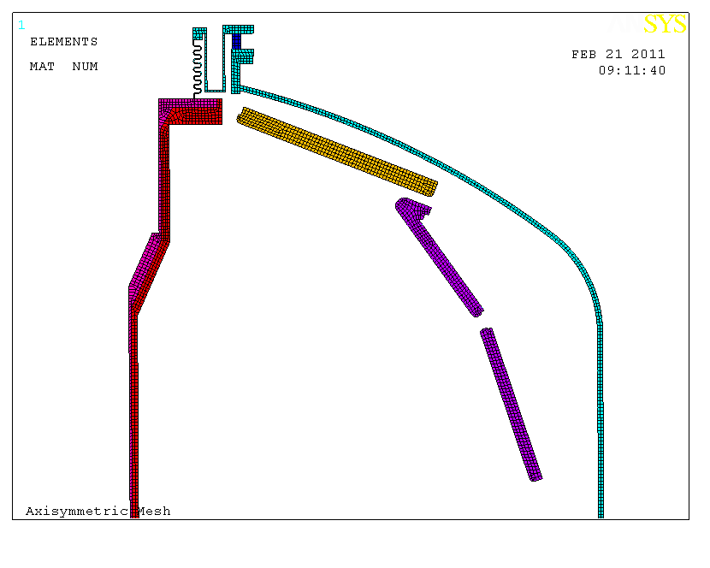
Figure 3 ANSYS Axisymmetric Mesh
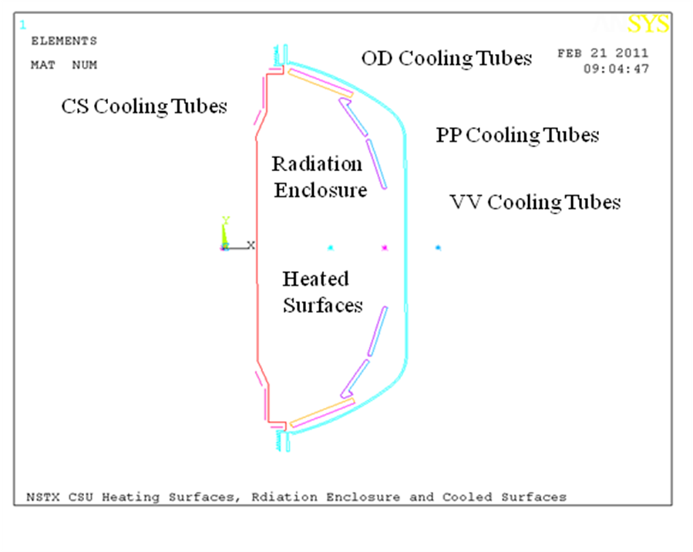
Figure 4 Heating Surfaces, Radiation Enclosure, and Cooled Surfaces
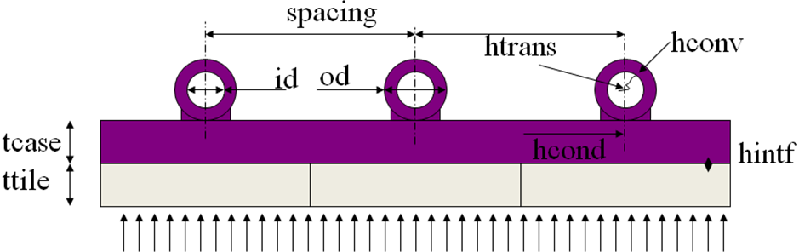
Figure 5 Effective Surface Heat Transfer

Table 1 Effect Surface Head Transfer
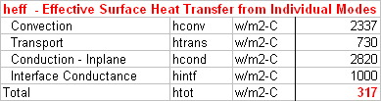

Table 2 Applied Heat Fluxes
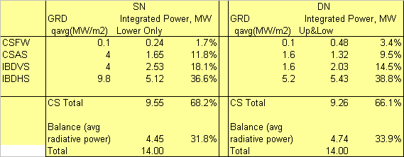

Results

The model was run initially thru four scenarios SN & DN with surface emissivity=.3 &.7. Since the design is to be driven by the DN and emis=.3 is a worst case scenario, exploration of the impact of tile conductance to the CS casing used that case.

Figure 6 thru Figure 21 below show results for DN at e=.7 then e=.3 followed by SN with e=.7 then e=.3. These results assumed IBD cooling only at the IBDhs and not at the IBDvs or CSAS. They also assume good thermal contact between the tiles and the casing. The resulting temperatures posed a threat to the neighboring coils as can be seen in the temperature distribution plots where temperatures exceed 300 C for even the DN with e=.7. The consequence of these results was to include the cooling of the IBDvs and CSAS.
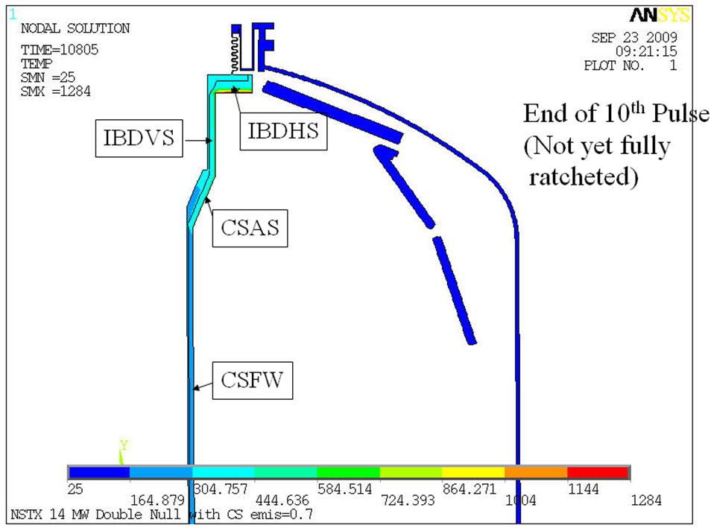
Figure 6 Ratcheted Temperature Distribution DN , e= 0.7
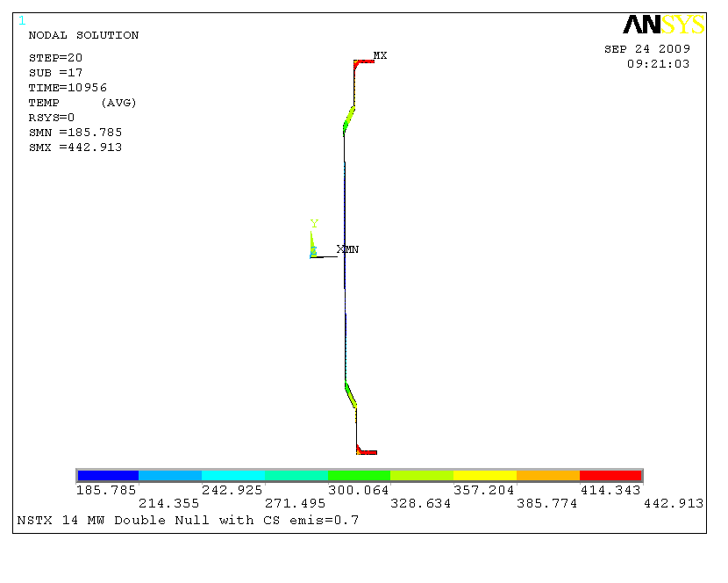
Figure 7 CS Casing - Ratcheted Temperature Distribution DN with 0.7 emissivity
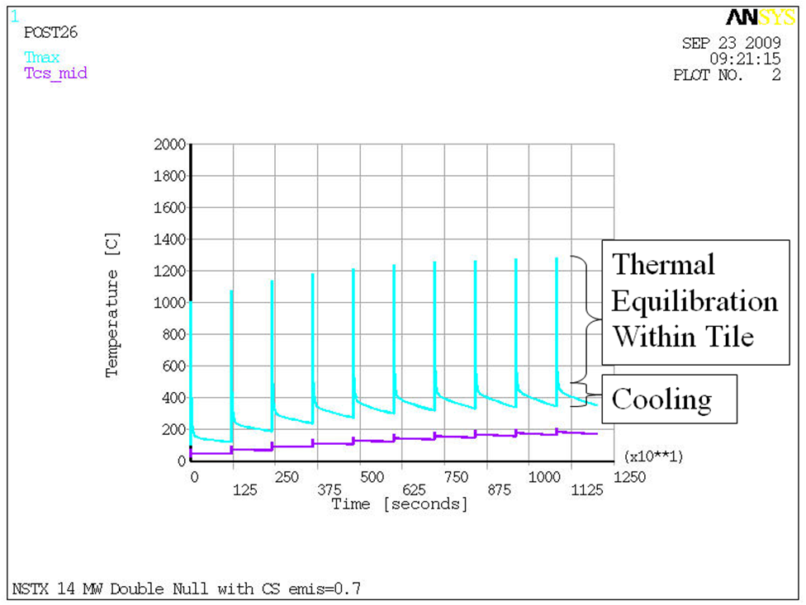
Figure 8 CS Transient Temperature Response, DN, e=0.7
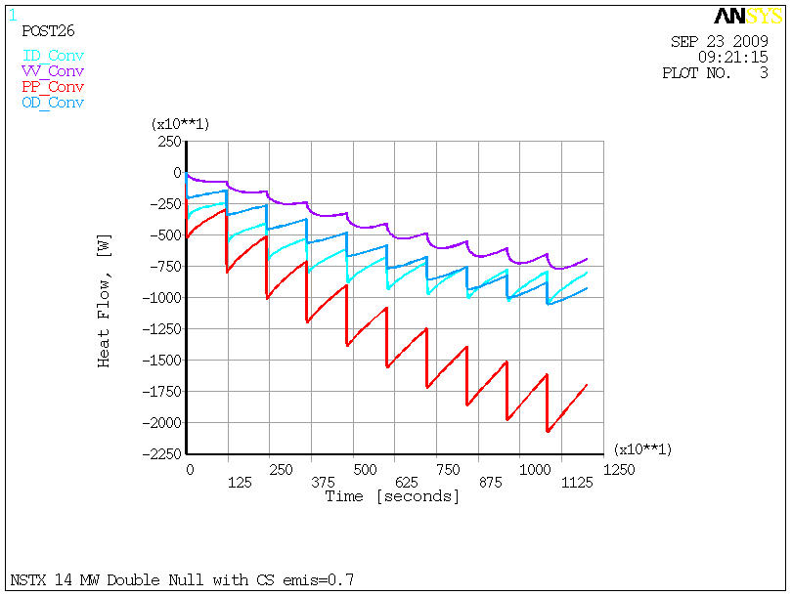
Figure 9 Heat Flow to Cooling Systems DN e=.7

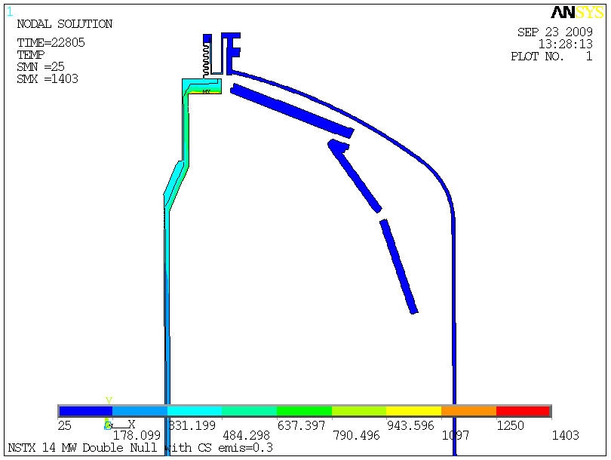
Figure 10 Ratchet Temperature Distribution DN e=.3

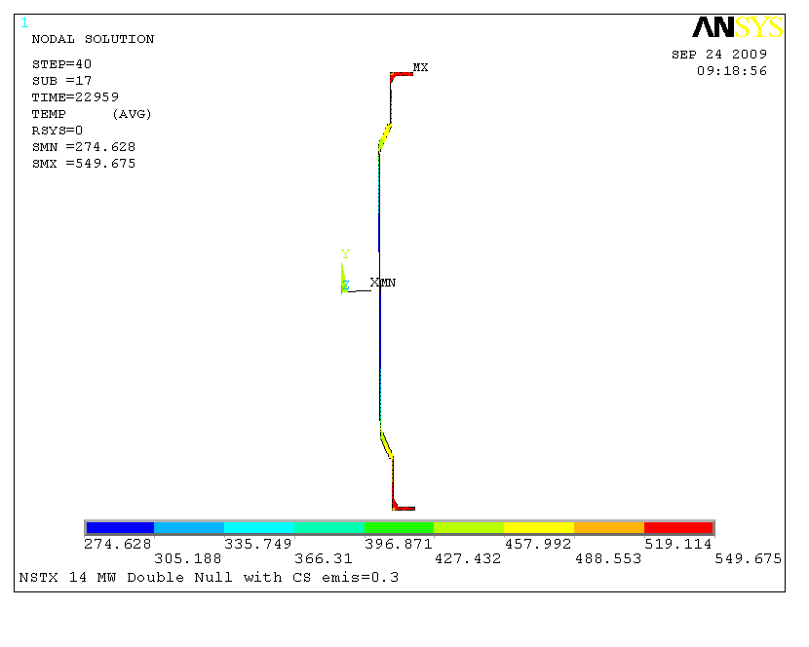
Figure 11 CS Ratcheted Temperature Distribution, DN, e=.3

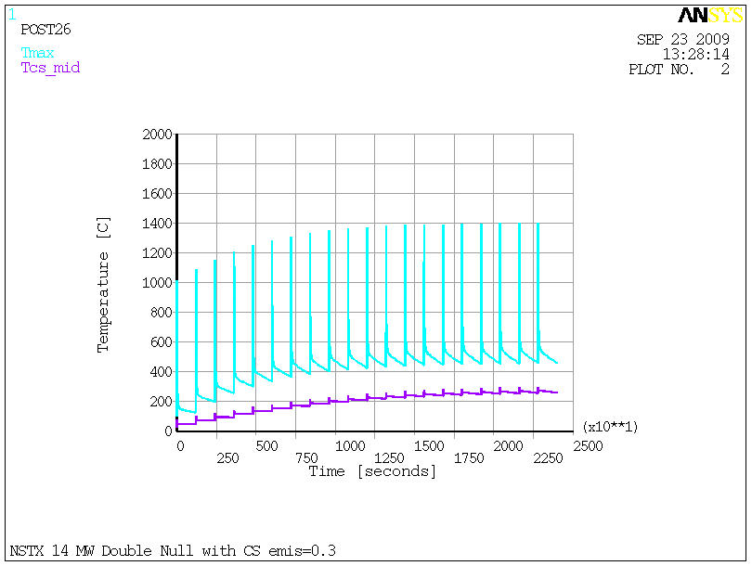
Figure 12 CS Transient Temperature Response, DN, e=.3

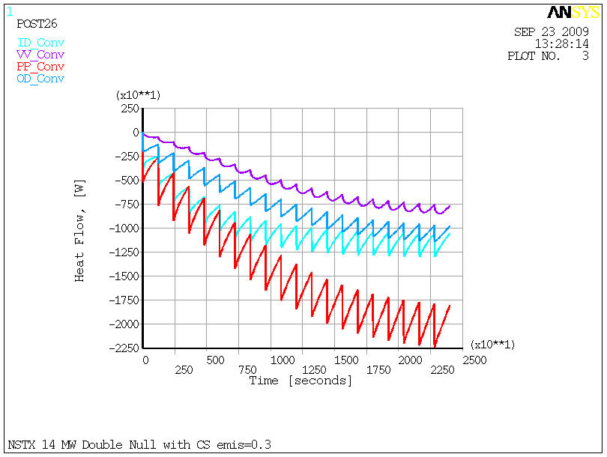
Figure 13 Heat Flow to Cooling Systems, DN, e=.3

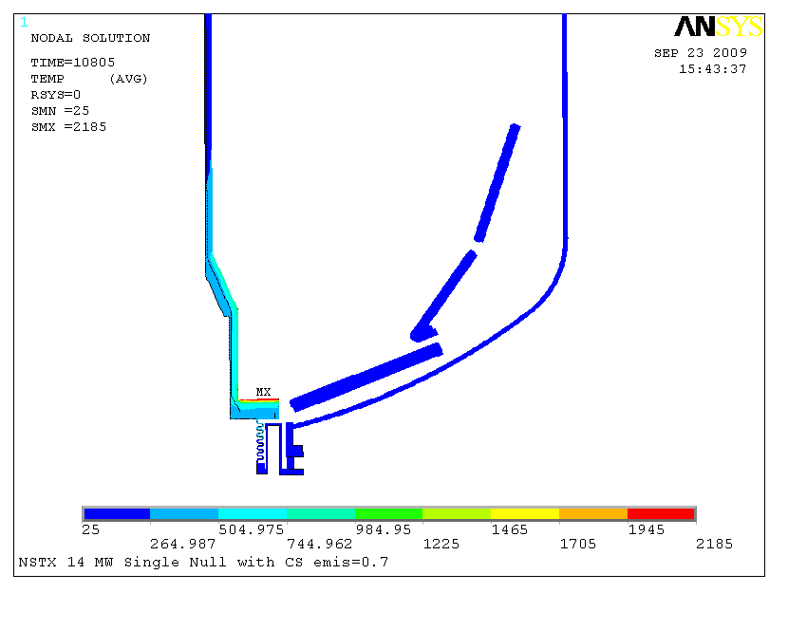
Figure 14 Ratcheted Temperature Distribution, SN, e=.7

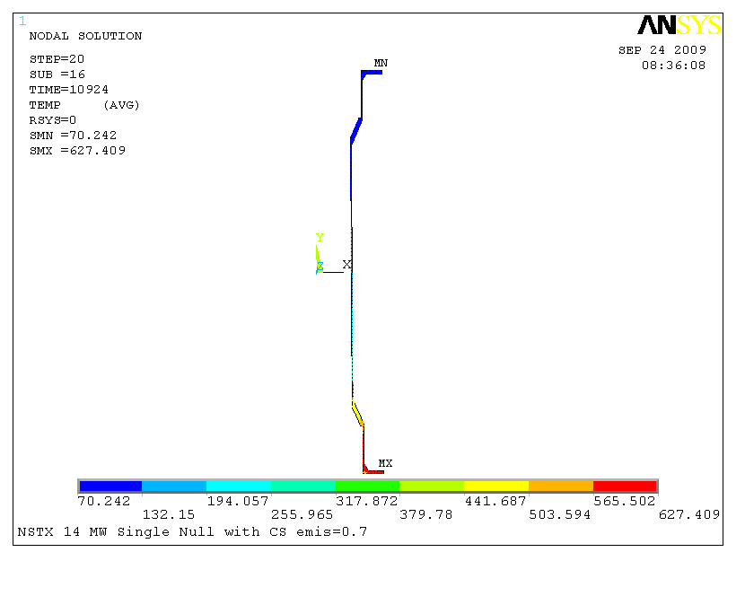
Figure 15CS Temperature Distribution, SN, e=.7

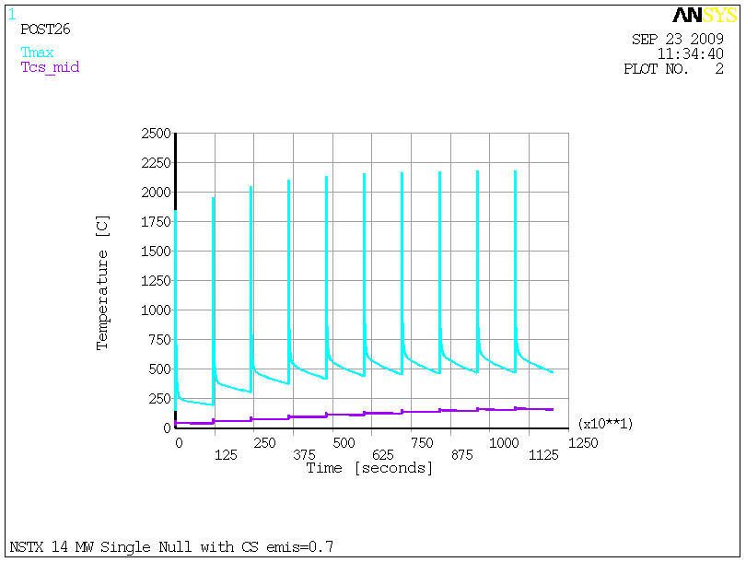
Figure 16 CS Transient Temperature Response, SN, e=.7

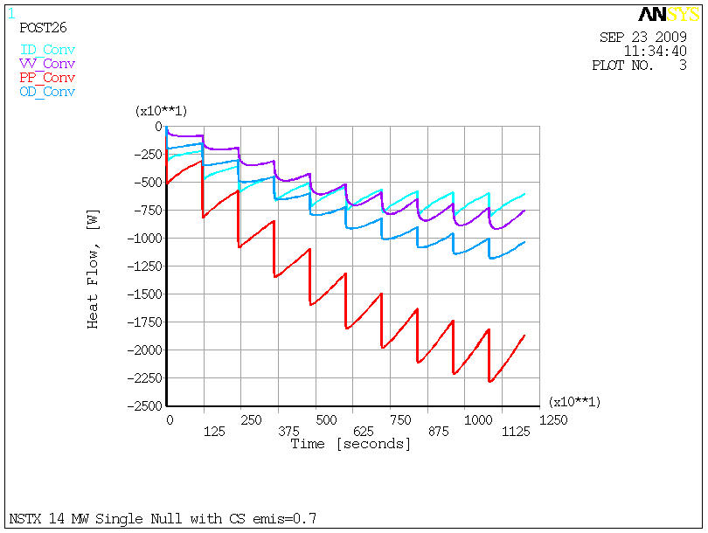
Figure 17 Heat Flow to Cooling Systems, SN, e=.7

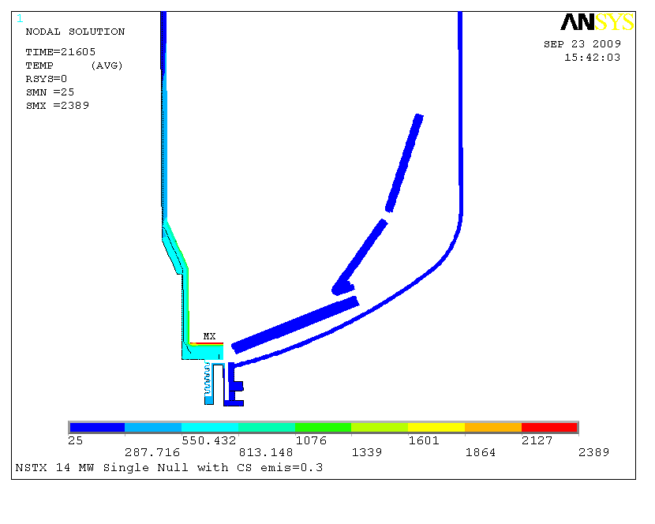
Figure 18 Ratcheted Temperature Distribution, SN, e=.3

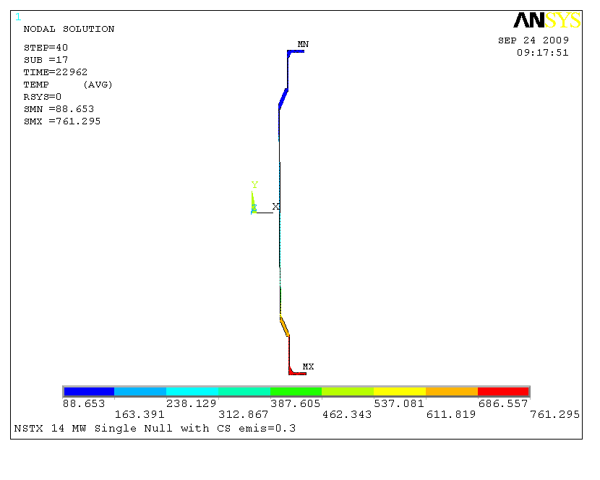
Figure 19 CS Ratcheted Temperature Distribution, SN, e=.3

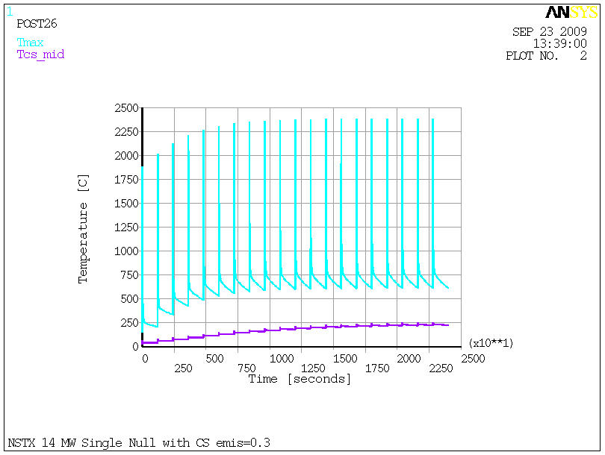
Figure 20 CS Transient Temperature Response, SN, e=.3

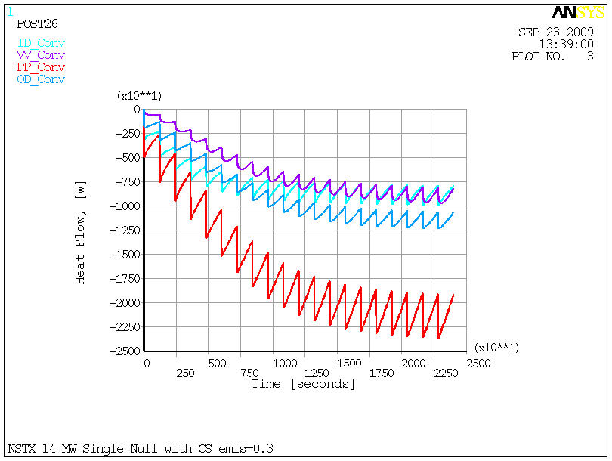
Figure 21Heat Flow to Cooling Systems, SN, e=.3

Figure 22 thru Figure 24 show results for including cooling at the CSAS and IBDvs. This is for the case of Tiles only radiatively coupled to the Casing. Results are for the SN with e=.3, a scenario that is much more severe than what the GRD calls for. Temperatures of the casing near the PF1a,b,c are greatly reduced. Results are better yet for the DN as evident in Figure 25.

Figure 26 shows the comparison for one scenario of inclusion of Grafoil vs the Radiative Coupling only.

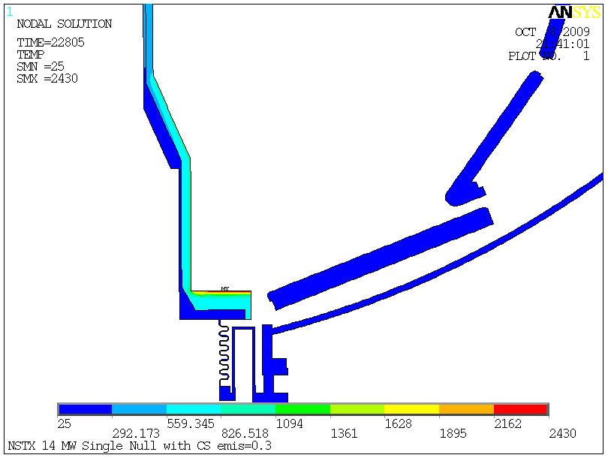
Figure 22 Added cooling at CSAS and IBDvs
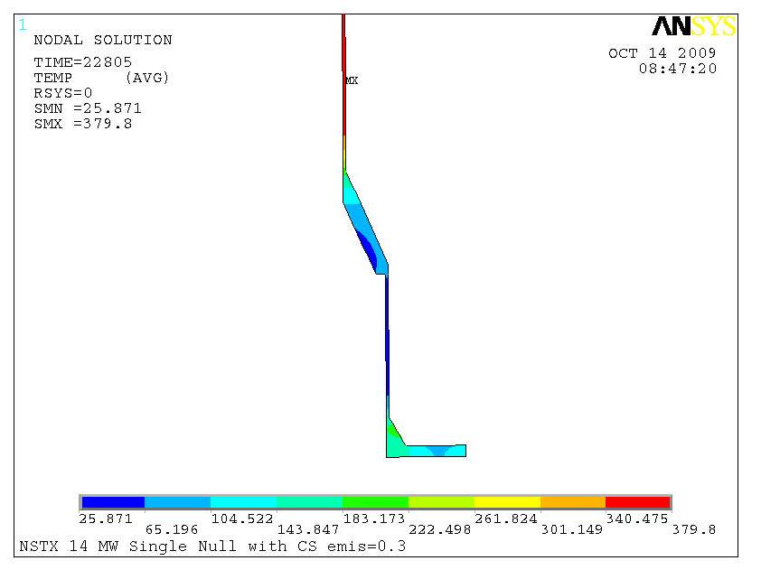
Figure 23 Temperatures Distribution at CS casing near PF 1a,b,c

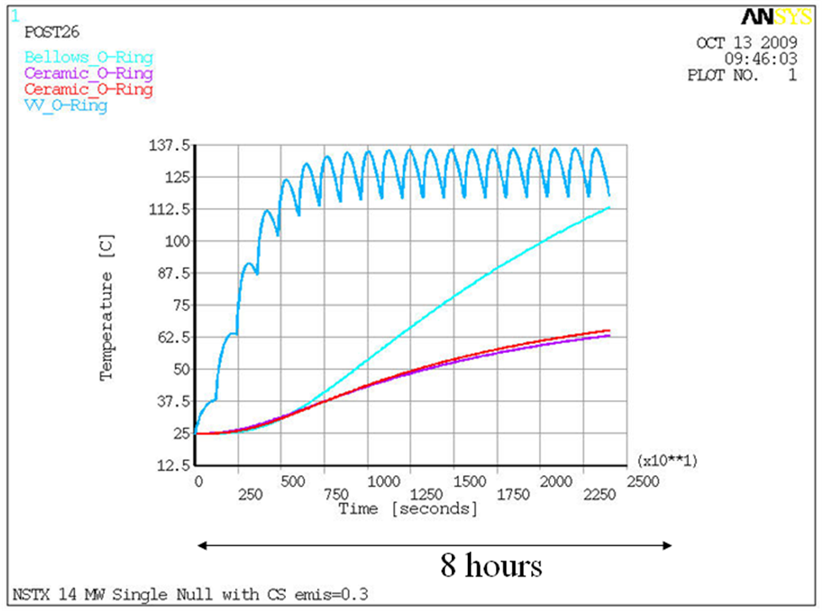
Figure 24 Worst Case Temperatures at O-Rings, SN, e=.3

Figure 25 Surface Temperatures at Cooling Tubes for Radiative Coupling between Tiles and Casing

Figure 26 Maximum Cooling Surface (Tube) Temperture For Radiatively Coupled vs Conduction Coupled Tiles to Casing

Below in Figure 27 and Figure 28 is the Tube surface temperature as a function of the effective heat transfer coefficient over the cooled surface is show. The Grafoil corresponds to h~1000 to 2000 w/m-C while the radiation at temperatures near 100 C is equivalent to an h~10 w/m-C. The results are for the DN with e=.3 (design basis) and show that a fairly low effective h (alla radiation) is needed to keep the water in the tubes from boiling at modest pressures.

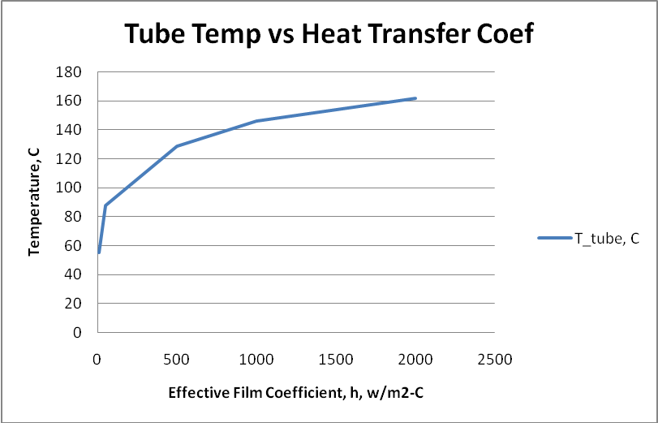
Figure 27 Tube Temperature vs Heat Transfer Coeficient

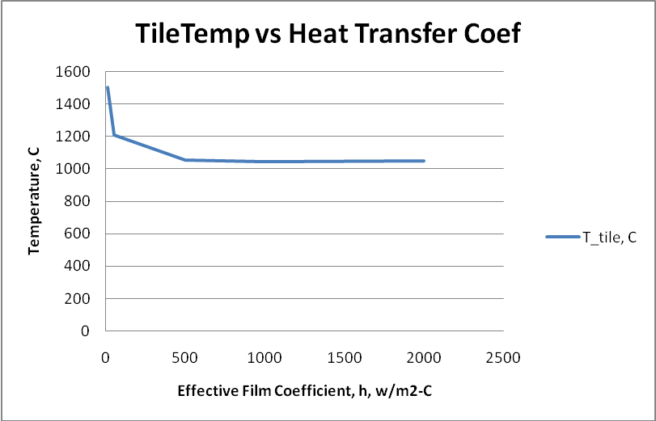
Figure 28 Tile Surface Temperature vs Heat Transfer Coefficient

Summary

The results presented here show:

Highest Tile temperatures at IBDhs where largest fraction of Power is deposited with SN much higher than DN as expected.

PP Cooling picks up largest fraction of total heat with VV, OD & ID picking up comparable smaller amounts. Variation of heat load to cooling systems not significantly different for scenarios analyzed.

Highest Bulk Heating of CS Inconel Casing is due to DN Operation (342C at e=.7, 455C at e =.3)

Also, the Enhanced Cooling and Radiation Only Coupled Tiles-Casing is effective at addressing the following concerns:

Protection of CS Coils and O-Rings at joints appears adequate

With reasonable back pressure, water boiling can be avoided

Thermal Stresses are not evaluated herein but temperatures and gradients are lowered

Cooling capacity demands are reasonable - heat loads have been thermally buffered

