1 INTRODUCTION 1
2 OVERVIEW OF SPREADSHEET 2
3 DESCRIPTION OF WORKSHEETS AND CALCULATIONS 4
3.1 WORKSHEET “BASE” 4
3.1.1 General Features Rows 1-568 4
3.1.2 Plasma Summary Rows 2-35 4
3.1.3 Engineering Summary Rows 36-87 8
3.1.4 PF1a Coil Rows 196-207 21
3.1.5 OH Coil Rows 208-479 22
3.1.6 PF Coils Rows 480 -487 43
3.1.7 MG Rows 488 -508 44
3.1.8 Transrex TF Power Supplies 509-526 46
3.1.9 Transrex OH Power Supplies 527-545 49
3.1.10 Other Cells in “Base” 49
3.2 WORKSHEET ÒPF_COIL_SUMMARYÓ 50
3.3 WORKSHEET ÒINNER_PF_DESIGNÓ 51
3.4 WORKSHEET ÒPFC_DIMSÓ 60
3.5 WORKSHEET “DISRUPTIONÓ 61
3.6 WORKSHEET “DISRUPT_CIRCÓ 62
3.7 WORKSHEET “DISRUPT_SHAPED Ó 64
3.8 WORKSHEET “FORCES_CIRCÓ 64
3.9 WORKSHEET “FORCES_SHAPEDÓ 65
3.10 WORKSHEET ÒPF_CURRENTS _FORCESÓ 65
3.11 WORKSHEET ÒFMIN_MAXÓ 67
3.12 WORKSHEET ÒCNTMTX_CIRCÓ 68
3.13 WORKSHEET ÒCNTMTX_SHAPEDÓ 70
3.14 WORKSHEET ÒHEAT_LOADSÓ 70
3.15 WORKSHEET “PARAMETERSÓ 73
3.16 WORKSHEET ÒPF_COIL_PARAMETERS _ANSYS_INPUTÓ 73
APPENDIX I Ð DERIVATION OF G-FUNCTIONS 74
APPENDIX II Ð TF STRESS FORMULAE 76

1 INTRODUCTION
1
Since the outset of planning for the NSTX CS Upgrade first began in April 2008, increasingly sophisticated calculations have been performed as necessary to characterize the design point. This characterization provides essential information to the engineers working on the detailed design of the electrical, mechanical, and structural components related to the upgrade. The information is generated in an XL spreadsheet and posted on the web at:
http://www.pppl.gov/—neumeyer/NSTXCSU/DesignPoint.html
Revisions are issued when necessary (at a decreasing frequency now that the design has settled) and the NSTX CS Upgrade design team is informed of same. The design point web site is referenced by the NSTX CSU General Requirements Document 1 (NSTX CSU GRD) and in this way conveys the “official” design -basis information. This approach provides the flexibility needed to revise design details as the project evolves while maintaining coordination of the integrated system design and performance under control of a central authority, namely the NSTX Project Engineer.
At the outset the calculations were performed to develop an understanding of the level of performance which could be achieved based on a limited number of basic boundary conditions, namely:
- Existing outer TF and PF coils
- Existing vacuum vessel and outboard hardware (fixed position of passive plates and R0+a)
- New center stack with aspect ratio — 1.5
- Full PPPL site power capability
• 2kV TF, 10kV OH, 2 MG
- Engineering limits on temperature rise and stress in coils
1 “NSTX Center Stack Upgrade General Requirements Document”, NSTX_CSU-RQMTS-GRD

With these assumptions, and maximal usage of the center stack cross sectional area, a capability of Ip=3.1MA with 5 sec flat top at B=1.4T was identified. Even higher performance levels were investigated for shorter pulse length.
2
In recognition that the spreadsheet analysis does not address coil support structures or the TF joint, and judging that reliance on both D-site MG sets was imprudent, it was decided to limit the power system to 1kV TF, 8kV OH, 1 MG and round down to Ip=2MA with 5 sec flat top at Bt=1T. The expectation was that these levels were more practical and would stand the test of time as the detailed design was developed.
The spreadsheet tool evolved over time as these calculations were refined and now serves as the source of the official design point as noted. The purpose of this report is to document the methodology. In addition, once suitably documented, the spreadsheet calculations can be cross checked against more sophisticated calculations (e.g. ANSYS, PSCAD, etc.) which have been performed so as to support of the engineering quality assurance requirements.
2 OVERVIEW OF SPREADSHEET
The spreadsheet was implemented on a Mac using Excel (XL) 2004 for Mac. Note that it includes some macros which are not implemented in later versions of XL. These macros are useful time-savers but are not essential to the calculations. The spreadsheet will also run on later versions of XL on both Mac and PC. This report is written based on the ÒNSTX_CS_Upgrade_110317.xlsÓ version. The 11/03/17 in the filename refers to year/month/day of creation.
The spreadsheet consists of several worksheets out of which there are two types. The first type (Type I) includes basic calculations whereas the second type (Type II) is only used to summarize the essential engineering information which is published on the web. Note that on all the Type II worksheets the data is given for both the base NSTX device (called NSTX_Base) and the upgraded NSTX device (called NSTX_CSU). The worksheets and their relationships are summarized in Table 2 1.
Calculations performed in the Type I worksheets are documented herein. The Type II worksheets merely link to the Type I.

Table 2-1 Summary of Worksheets
3
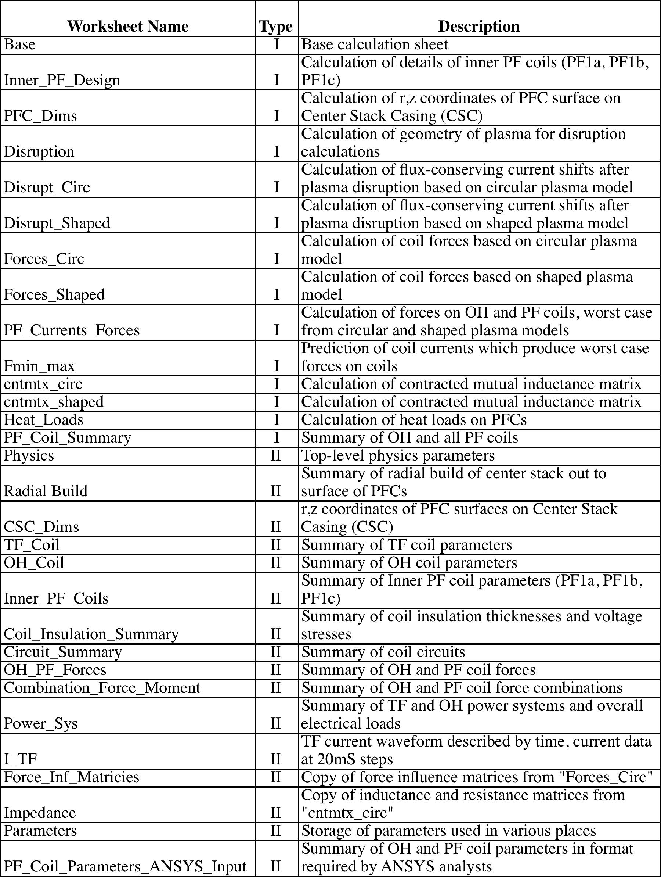

3 DESCRIPTION OF WORKSHEETS AND CALCULATIONS 3.1 WORKSHEET “BASE”
4
“Base” is the most important worksheet from which the data in most of the other worksheets is sourced. The following sections describe its content and usage. Terminology R[X] is used to refer to row X, C[Y] to refer to column Y and RC[X,Y] to refer to row X and column Y.
3. 1.1 General Features Rows 1-568
Parameter names are listed in C[A] and corresponding units in C[B]. C[C] contains values from NSTX_Base. C[F] is the active column where calculations are performed. Results from calculations in C[F] are copy/pasted into C[D] and C[E]. C[D] contains the results applicable to the nominal NSTX_CSU scenario which is “Long Pulse Partial Inductive” (LPPI) operation. C[E] contains the results applicable to an alternate operating mode where the pulse length is maximized while using the full double swing of the OH coil. This mode is referred to as “Short Pulse Full Inductive” (SPFI).
In general, cells with green shading are manual inputs but are seldom varied. Cells with yellow shading are frequently varied by manual input. Cells with blue shading are varied using the XL Solver feature when searching for optimized solutions. Cells with orange shading contain criteria values which are targeted by the XL Solver.
3.1.2 Plasma Summary Rows 2-35
Refer to Figure 3 1. This shows a simplified representation of the NSTX plasma based on the following:
r() = R₀ + a * cos(+ * sin()) z() = K * a * sin()
where:
6 = poloidal angle R0 = major radius a = minor radius %=elongation
S = triangularity

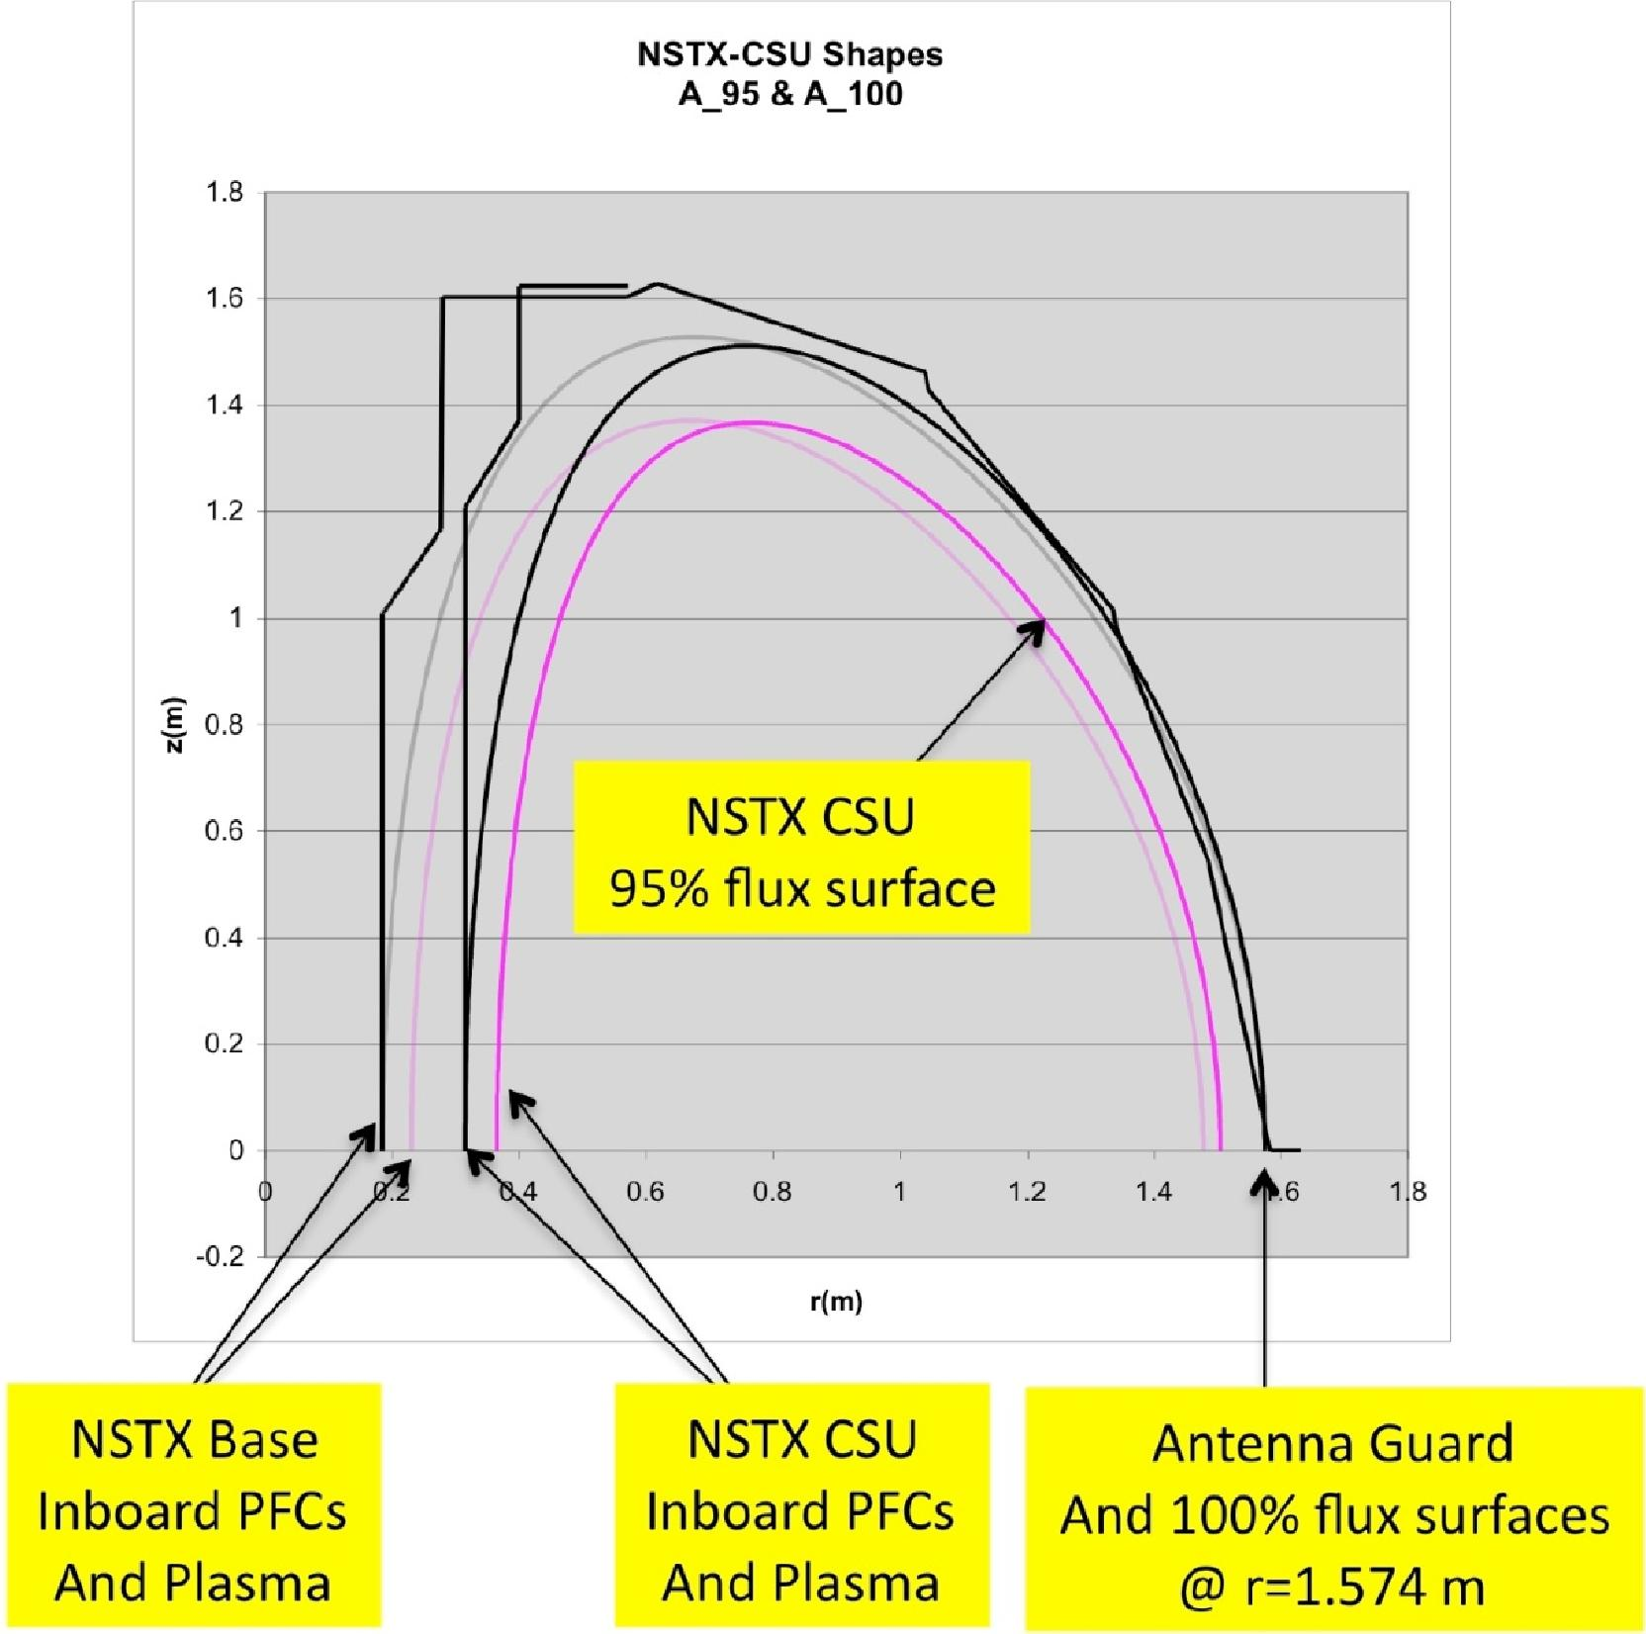
Figure 3-1 NSTX Plasma Cross Sections (Black =100 % flux surface, Magenta =
95 % flux surface, semi-transparent = NSTX_Base, full opaque = NSTX CSU)
5
- “Antenna guard” is the radius of the innermost component on the outboard mid-plane which protrudes into the plasma region. The value of 1.574 m was given by R. Ellis who designed the HHFW antenna. The outboard plasma edge corresponding to the 100% flux surface is positioned at the antenna guard. NSTX_Base and NSTX_CSU are the same in this regard (the outer edge is preserved).
- “Outboard gapÓ is the gap from the nominal plasma outboard edge (95% flux surface) to the complete plasma edge (100% flux surface) which is positioned at the

antenna guard. The gap is set to 0.07 m for NSTX_CSU based on advice from J. Menard.
- “R0+a” is the radius of the nominal plasma outboard edge (95% flux surface) on the mid-plane, equal to the antenna guard radius minus the outboard gap. Here “a” is the plasma minor radius.
- “A_95” is the aspect ratio “A” based on the 95% flux surface. It is solved for using XL “Goal Seek” such that the aspect ratio based on the 100% flux surface, A_100, R[12], is equal to 1.5 which is the NSTX_CSU mission objective.
For both the 95% flux surfaces we have, by definition:
A_95 = R0
a
We can rearrange to determine the R[8] quantity, the plasma major radius, R0 as a function of R0+a and A as follows:

R₀ =
1
¹⁺A_95
R₀+a

Knowing R0 we can then determine the R[9] quantity, the minor radius “a”:
R₀A_95

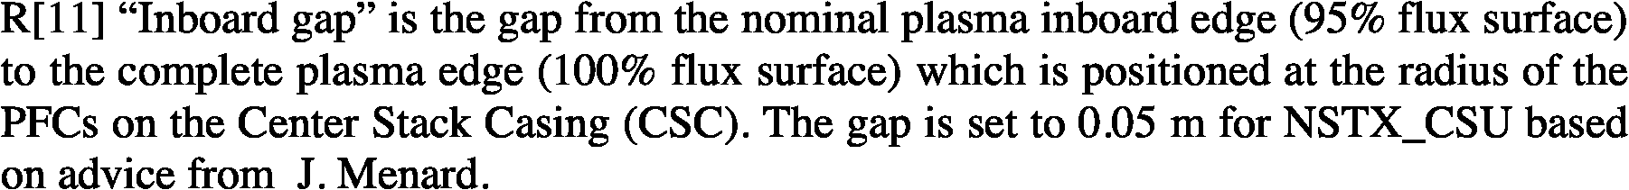
- “A_100” is the aspect ratio “A” based on the 100% flux surface which is set to a value of 1.5 (the NSTX_CSU mission objective) by adjustment of A_95 (R[7]) using XL Goal Seek.
- x and R[14] S are the plasma elongation and triangularity, respectively, and are manually entered according to the NSTX_CSU mission objectives.
R[15] is the maximum plasma elevation and R[16] is the radius of the maximum elongation, based on the 95% flux surfaces as follows:
a=
- “R0-a” is the radius of the nominal plasma inboard edge (95% flux surface) on the mid-plane.

“Inboardgap”
is the gap from the nominal plasma inboard edge (95% flux surface) to the complete plasma edge(100% flux surface) which is positioned at the radius of the PFCs on the Center Stack Casing (CSC). The gapis set to 0.05 m for NSTX_CSU based on advice fr
om J. Menard.
6

Zmax=a
Rzmax =R₀2a
R[17-20] are the mission objectives for plasma current Ip, plasma ramp-up rate dIp_up/dt, plasma flat top time Tflat, and pulse repetition period.
R[21] ÒIp Duration” is t he time duration when the plasma current is non-zero which is equal to the time that the TF current is at flat top. The overall duration is:

T = Tflat + Tinit + | I_{p} | + | I_{p}
 | dI p_up  dt |  | dI p _down  dt

Tinit is the time consumed during plasma initiation, entered in R[439] and dIp_down/dt, is the plasma ramp-down rate, entered in R[479]. Note that the second two terms above are computed in R[456] and R[480]. Since they are of secondary importance they area not included in the plasma summary section.
7
R[22] ÒfqcylÓ along with R[23] Òqcyl_minÓ are used to determine the minimum allowable value of cylindrical safety factor (MHD safety factor, number of toroidal rotations per poloidal rotation of a field line on the 95% flux surface) which translates, in effect, to the minimum toroidal field at a given plasma current. The fqcyl is chosen such that qcyl_min is equal to 2.5, based on physics guidance from J. Menard. The values of qcyl_min and qcyl are computed as follows²:
qcyl_min = fqcyl * (12.259 13.58A + 6.4286A² 1.0417A³ )
qcyl = | 5a²B_{T} |  | 1+K²
 | IpR0 |  | 2

R[24], ÒBt@R0Ó, the value of toroidal field at the plasma major radius, is a mission objective which is manually entered.
R[26], ÒTF Inner Leg Radius over CuÓ is the difference between R[62] ÒTF Inner Leg Radius over GroundwallÓ and R[105] ÒTF Ground & turn insulation”. R[27-29] are summary OH coil dimensions equal to values calculated in the section on the OH Coil.
R[30] “Center stack radius” is equal to R[10] (R0-a) minus the inboard gap R[11].
² “Spherical Torus Design Point Studies”, C. Neumeyer et al, PPPL Report PPPL-4165, June 2006

- is the “OH Single Swing Flux” which is computed as follows³:
8
µ0Javg (R0 3 — R_{i}³ )  3 | * ff

where:
Javg = average current density in coil R[310]
R_{o}, Ri = outer and inner radius of coil R[298], R[283]
ff = form factor to account for finite length solenoid R[308]
- through R[35] are values of flux which are delivered during different portions of the OH waveform based on the fraction of current swing of that portion multiplied by the single swing flux R[31].
3.1.3 Engineering Summary Rows 36-87
- “Coolant Inlet Temp” is manually entered value for the cooling water inlet temperature after complete cooldown. The value of 12ºC is the guaranteed value achievable by the PPPL D-site cooling water system (even under summertime conditions) and is also the permissive interlock temperature.
- “TF Inner leg maximum temp (L/R Decay)” is the manually entered design-allowable value for maximum temperature under conditions where there is a power supply fault occurring at the end of flat top so that the current shutdown follows an L/R decay (under normal conditions the power supply would invert and drive the current to zero more rapidly than and L/R decay). An allowable of 101.15ºC is used and is applied to calculations based on adiabatic conditions (no credit for entrained water or water cooling during a pulse). This is slightly above the canonical 100ºC based on a study⁴ which showed that this allowable temperature would result in an allowable pulse I2T yielding 100ºC after proper accounting for the water at a water flow of 2.5GPM per turn. This flow rate is easily achieved with the existing cooling water system and corresponds to a flow velocity which should not cause erosion problems (3.3m/s).
- “TF Stress Allowable” of 161MPA is based on 2/3 yield of 241MPA. This value is appropriate for the typical temper used for TF coil copper. The value is stored in the “Parameters” worksheet. It corresponds to 36ksi with 3% reduction for elevated temperature (100ºC).
³ “The Design of the Center Core of a Spherical Tokamak”, R. Colchin et al, Fusion Technology Vol. 31 May 1997, eq. B6
⁴ See KCOOL_TF_Inner_090708.xls

R[40] and R[41], number of series and parallel TF power supply sections, are manual entries which were chosen based on the earlier trade studies mentioned at the start of this report along with other considerations⁵ related to the upgrade of the TF power supply system and power cables.
9
The following section covers the OH system in which several events are defined as follows:
SOP = Start of Pulse, OH current has reached pre-charge value SOI = Start of Discharge, high voltage is applied to initiate plasma SOFT = Start of Flat Top, plasma current has reached flat top EOFT = End of Flat Top, end of plasma flat top period
EOD = End of Discharge, plasma current is extinguished
- ÒOH Inlet Coolant Temp” is set equal to R[37] (in prior studies, sub-cooling was considered in which case a different value would have been entered).
- ÒOH Temp Allowable” is a manual input set equal to 100ºC which is below the temperature at which the coil insulation epoxy resin begins to soften.
- ÒOH Maximum temp (L/R Decay)” is the larger of the temperature computed based on L/R decay (due to power supply fault) at the SOD event R[80] and the EOFT event R[81].
- ÒOH Tresca Stress Allowable” is a manual input based on advice from P. Titus.
- ÒOH Tresca Stress MaxÓ is the larger of the stress computed at the peak of the 1st and 2nd swings of the OH (R[78] and R[79]).
- ÒOH Forcing Factor” is, in effect, the ratio of available power supply voltage to the I*R drop at full load, including the equivalent resistance of the power supply. If this factor becomes too small the rise time of the current becomes excessive. It is a constraint used by the XL Solver so that it converges on good solutions. It is computed as the ratio of the number of series power supplies available to the number corresponding to the coil voltage drop as follows:
OHff = NS
IOH * (Rcoit + Rexs )
Vdo — IOH * R_{eq} / NP
⁵ ÒTF Paralleling for NSTX CS Upgrade”, C. Neumeyer, 10/16/08, NSTX_CSU_TF_1.ppt

where:
10
IOH = peak OH coil current R[52]
RCoil = Coil resistance R[426]
Rext = external circuit resistance R[429]
Req = equivalent resistance per power supply section R[428] Vdo = power supply section open circuit direct voltage R[530] NS = number of series power supply sections R[48]
NP = number of parallel power supply sections R[49]
R[48] and R[49] are the number of series and parallel (for each current direction) power supply sections in the OH power supply.
R[50] and R[51] are the number of turns in the OH coil (sometimes chosen as value to be adjusted by the XL Solver).
R[50] through R[56] are used to set the base value of OH current and the value at SOP.
R[57] through R[60] are the values of OH current (in some cases in amperes, in other in Òper unit” (p.u.)). Blue cells are typically adjusted by the XL Solver.
- ÒTF Inner Leg Radius over GroundwallÓ in % is a very important variable representing the fraction of the available center stack radius that is used for the TF copper, with the remainder available to the OH coil. It is adjusted by the XL Solver such that the amount allocated is sufficient for the TF coil to meet its performance requirement.
- ÒTF Inner Le g Radius over GroundwallÓ in m is the product of R[61] multiplied by the radius over the OH coil copper R[297]. Note that R[297] is set working inwards from the plasma R0-a dimension and so is an initial condition to the center stack TF/OH optimization.
- ÒTF Flat Top Time” is the flat top capability of the TF coil computed in R[170]. This value is compared (must be > or =) to R[21], the plasma current duration, by the XL Solver as a condition for valid solutions since we require that the TF current be at flat top for the full duration of plasma current flow.
- ÒTF VM Stress” is the Von Mises stress computed in R[178] which is compared (must be > or =) to R[39], the stress allowable, by the XL Solver as a condition for valid solutions.
- ÒTF CurrentÓ is the TF flat top current per turn based on:

ITF  11 | ²R0BT
 | ,u₀N

where:
R0 = plasma major radius
BT = toroidal field at R0
μ0=4πx 10⁻⁷
N = number of turns in TF coil
- ÒTF Average Branch Current” is the TF current R[65] divided by the number of branches R[41].
- ÒTF TESW (nominal waveform)” is the equivalent square wave time (square wave duration which, at flat top current, would yield the same “action”, i.e. ∫i(t) ²dt, as the actual waveform) based on the rise and fall action integrals calculated in R[164] and R[168] plus the flat top action divided by the flat top current R[65]. This is for the “nominal waveform” where the power supply successfully inverts after flat top and drives the current to zero.
- ÒTF Action (nominal waveform) is the action integral corresponding to R[67].
- ÒTF Peak Power” is the peak apparent power of the TF power supply which occurs when the current reaches flat top. It is computed based on:
STF = NS * Vdo * ITF
where:
STF = TF apparent power R[69]
NS = number of series power supply sections R[40]
Vd_{o} = average no-load open circuit voltage of Transrex AC/DC converter R[5 12] ITF = TF current R[65]
- ÒOH Javg @ I PrechargeÓ is the average current density in the OH coil at pre-charge (SOP) computed in R[310].
- ÒOH TESW @ I PrechargeÓ is the available equivalent square wave time (square wave duration which, at pre-charge current, would yield the same “action”, i.e. ∫i(t)2dt, as the actual waveform). It is based on the G-function integral R[287] divided by the max current density (i.e. that in t he OH conductor), R[320], squared. Note that R[287] is based on the full allowable OH coil temperature rise.

R[72] “Flux Required Ramp” is the OH flux requirement of the plasma during plasma current ramp-up, calculated in R[475]. R[73] is the OH flux actually provided during plasma current ramp-up based on the OH current swing fraction during ramp-up multiplied by the single swing flux R[31]. These two values are compared by the XL solver as a condition required for a valid solution.
12
- ÒOH Single Swing Flux Fraction Used for Ramp” is the fraction of flux used during plasma current ramp-up.
- ÒOH Flux Flat Top Actual” is the OH flux actually provided during plasma current flat top based on the OH current swing fraction during flat top multiplied by the single swing flux R[31].
- “Flux Consumption Flat TopÓ is the plasma flux consumption during flat top calculated in R[472]. Note that the actual OH flux available during flat top does not necessarily have to equal the consumption since per the NSTX CSU mission there may be a substantial flux contribution from non-inductive current drive and/or the OH coil may have excess flux capacity for a given plasma scenario. R[77] expresses the fraction of flat top flux available from the OH coil as a %.
R[78] ÒOH Max Tresca Stress 1st Swing” is calculated in R[356] and occurs at SOP. Similarly R[79] is calculated in R[368] and occurs at EOFT.
R[80] ÒOH Tmax (fault at SOI)Ó is the max OH conductor temperature which would result if a power supply fault and subsequent L/R decay were to occur at SOI. It is computed using the G-function based on the action integral calculated in R[438] divided by the conductor area R[326] squared, yielding the corresponding dG, plus the G-function value at the initial temperature G0 from R[217]. R[81] is calculated in similar fashion for a fault at EOFT. The maximum of these two values is used in R[44] for comparison to the allowable in R[43].
- OH Bcenter is the B field (magnetic flux density in Tesla) in the bore of the OH coil computed in R[310].
- ÒOH TESW (nominal waveform)” is the actual equivalent square wave time (square wave duration which, at pre-charge current, would yield the same “action”, i.e. ∫i(t)2dt, as the actual waveform). Note that if the OH conductor temperature in R[44] reaches the full allowable in R[43] then the ESW values computed in R[71] and R[83] should be exactly equal. However this may not be true due to the finite accuracy of the G-function, i.e. G(T(G)) not exactly equal to G.
- ÒOH Peak PowerÓ is the peak apparent power of the OH power supply which occurs when the current reaches pre-charge. It is computed on the same basis as the TF power in R[69].
- ÒMG TF + OH Peak Power” is an estimate of the total peak apparent power on the motor-generator (MG) set(s) which typically occurs just as the OH is at pre-charge (SOP

and SOI) and the TF is at flat top. Note that other loads (e.g. NBI and PF are zero at this time). It is taken as the sum of the TF R[69] and the OH R[84]. Strictly speaking this is not correct because one should add the real and reactive powers of each system and then compute the net apparent power. However since both systems are operating with firing angle a near 0o at this point (providing full available voltage) their power factors are similar and this justifies the approximation. Note for reference that one PPPL MG set is rated at 475MVA. The mission objective is to avoid the use of two MG sets so it is desirable that R[85] be less than 475MVA.
13
R[86] ÒMG TF + OH Energy” is the energy demand of the TF and OH systems. It is calculated based on the inductive and resistive energy consumption as follows:
1
W = 2L
2 TFITF + ITFTESW _TF (RTF_Coil + _{RTF_Ext)} + 2 LOHIOH + IOHTESW _OH (ROH_Coil + ROH_Ext )
In the above, the coil resistances are (conservatively) taken to be at the maximum coil temperature. The TF resistance includes both the inner and outer legs.
R[87] ÒCHI Voltage” is a manual input for the maximum voltage to be used for “Coaxial Helicity Injection” (CHI).
3.1.4 TF Coil Rows 88-195
- ÒTF RcuinnerÓ is a manual input for the radius which must be reserved at the center of the inner TF coil bundle in recognition of the fact that the individual TF wedge-shaped turns must have a radius at their tips, i.e. they cannot be knife-edge. The value entered is based on advice from J. Chrzanowski.
- ÒTF RcuouterÓ is equal to R[26], ÒTF Inner Leg Radius over CuÓ, previously described.
- ÒTF Voltage” is the no-load average DC voltage of the TF power supply, equal to the number of series power supply sections R[40] multipled by the no-load voltage of the Transrex AC/DC converter R[512].
- ÒTF Turn hipot voltage” is equal to 2E+1kV where E is the TF power supply voltage R[91]. Note that, because the inner TF bundle turns are not connected to the outer turns until final assembly, the turn-turn hipot is an easy test to perf orm.
- ÒTF Ground hipot voltage” is equal to 2E+1kV where E is the sum of the TF power supply voltage R[91] plus the CHI voltage R[87]. Inclusion of the CHI voltage is appropriate because the TF ground plane is at the CHI potential and the TF groundwall insulation sees the sum of the TF power supply plus CHI voltages.
- - R[96] are manual inputs used to specify the turn insulation features. Note that the thicknesses are selected from standard sizes listed on the “Parameters” worksheet

RC[1,I]:RC[13,J]. The TF turn insulating tape is assumed to consist of fiberglass only (no kapton).
14
R[97] “TF Turn insulation” is the turn insulation thickness in inches based on the number of half-lapped layers with accounting for the compression. R[98] is the same in meters.
R[99]-R[105] cover the ground insulation in a manner similar to the turn insulation as described above. Note that the total thickness of insulation between conductor and ground is equal to the turn insulation plus the ground insulation.
R[106]-R[109] are the average values of voltage stress, i.e. electric field, in the turn insulation of the worst turns (where the first and last turns of the winding face each other directly) during normal operation and hipot.
R[110] “TF Turn insulation dielectric strength constant” and R[111] “TF Turn insulation dielectric strength” are based on the approach outlined in the paper⁶ with excerpts included in the “Parameters” worksheet.
R[112] and R[113] give the “safety factor” during normal operation and hipot, i.e. the ratio of dielectric strength to voltage. Note that the choices for turn insulation for NSTX_CSU are identical to NSTX_Base and that the safety factor > 20 during turn hipot is deemed adequate.
R[ 114] – R [ 121 ] treat the ground insulation in the same manner as the turn insulation described above. Note that additional ground insulation thickness is used on NSTX_CSU compared to NSTX_Base which is deemed appropriate.
R[122] “TF Cooling hole diameter” in inches is specified as a manual input. R[123] is the value in meters. The value chosen 0.305” is because it is the inside diameter of standard 3/8” OD Type K copper tubing, and a trade study⁷ determined that this size tubing was consistent with the range of flow rates, pressure drops, and cooldown times appropriate for NSTX_CSU.
R[122]-R[127] are used with XL Goal Seek to set the mass flow to 2.5GPM which was deemed an appropriate value for NSTX_CSU, yielding a flow velocity slightly above 3m/s where erosion will not be a concern. Also, simulations of cooldown⁸ show that this flow is sufficient to achieve cooldown in less than 10 minutes which is more than adequate for NSTX_CSU as shown in Figure 3-2.
⁶ “Effects of cryogenic irradiation on electrical strength of candidate ITER insulation materials”, J. Schutz et al, Cryogenics 35 (1995) 759-762
⁷ See weekly meeting presentations: “TF Cooling Hole Optimization”, C. Neumeyer, 7/8/9
8 KCOOL_TF_Inner_090708.xls

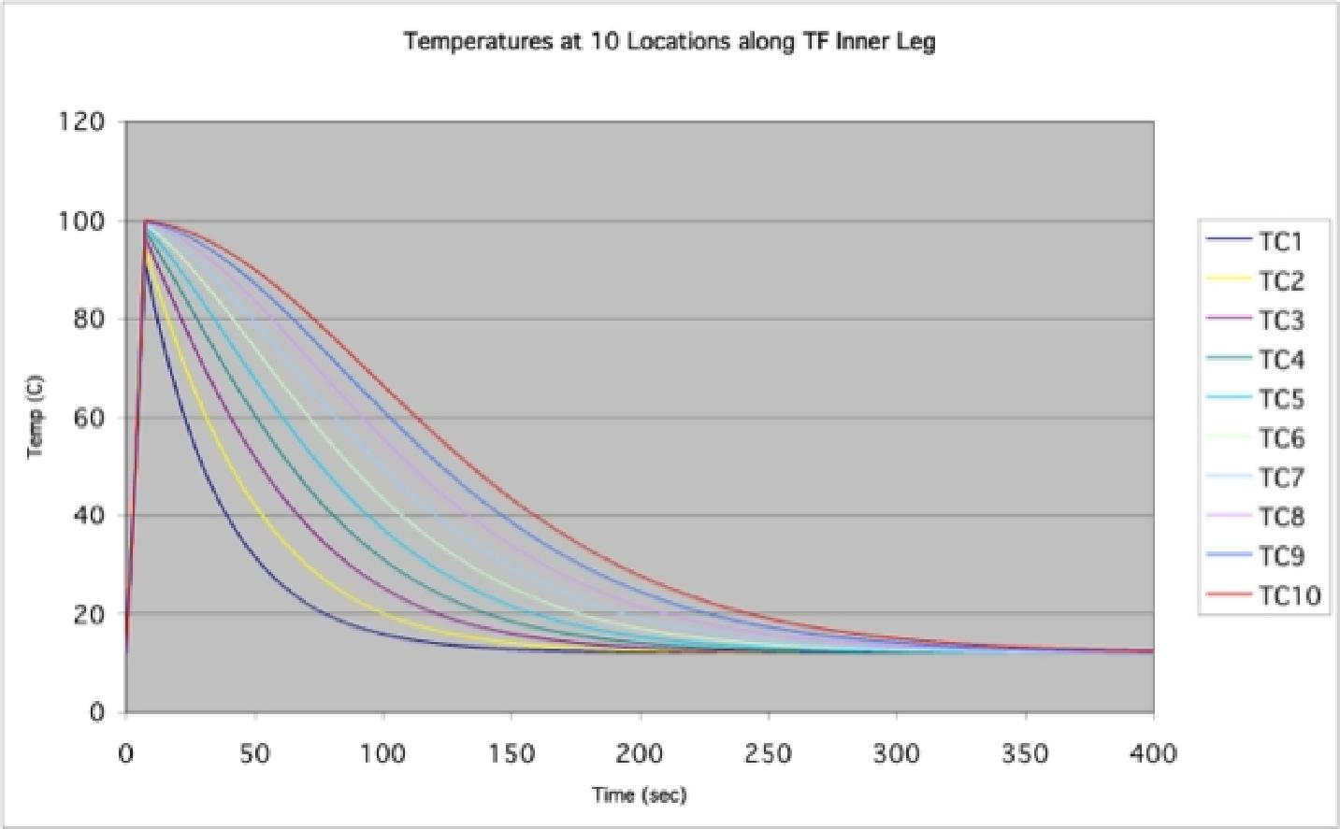
Figure 3-2 TF Inner Leg Cooldown
15
- ÒTF #turnsÓ is set equal to 36 which is a constraint imposed by the fact that NSTX_CSU will use the 12 sets of 3 outer legs from NSTX_Base.
- ÒTF Conductor corner radius” is a manual input in inches based on advice from J. Chrzanowski. R[130] is the same in meters.
- ÒTF Packing fraction” is the ratio of copper area to total area in the TF bundle, to the outer radius of the conductor. This is less than 1 because of area lost to the turn insulation, the cooling hole, and the corner radii. The calculation is as follows:
Atotal — A inner _ hole — N ( A _{insulation} + Acooling _ hole + Acorner _ radii )
f =
Atotal
_{d}2
* Router
( )
² Rinner
2 2
N ₄ + ²tinsulation Router
( )
Rinner + 2 2rcorner
( )2 rcorner
=
_{R}2
outer
where:
Atotal = total area inside outer radius of TF bundle conductor Ainner_hole = area lost to inner hole
N = number of TF turns
Ainsulation = area lost to turn insulation per turn

Acooling_hole is area lost to cooling hole
16
Acorner_radii = area lost to corner radii
Router = outer radius of TF bundle conductor R[90] Rinner = inner radius of TF bundle conductor R[89] dwater = diameter of cooling water hole R[123] tinsulation = thickness of turn insulation R[98]
rcorner= conductor corner radius R[130]
R[132] ÒAcuÓ is total TF copper area and R[133] ÒAcu per turn” is the area of each inner leg turn.
- ÒJmaxÓ is the current density in the TF inner leg turn, equal to the total TF current in amp-turns divided by the total TF copper area.
- ÒTF Inlet Coolant Temp” is equal to the system inlet temperature R[37].
- ÒTF G0Ó is the value of the G-function of the TF conductor at the inlet temperature. Refer to Appendix I for a derivation of the G-function.
- ÒTF Inner Leg Temp Allowable” is the max allowable temperature equal to the input value at R[37].
- ÒGmaxÓ is the value of the G-function at max temperature R[137].
- ÒdGÓ is the difference between the G-function at max temperature minus the G-function at the initial (inlet) temperature.
- Ò TF Tesw (L/R Decay)” is the ESW time corresponding to the dG value R[139] (yielding the maximum allowable temperature) divided by the TF inner leg current density. Thus the L/R condition (power supply fault at end of TF flat top) will correspond to the maximum temperature condition.
- ÒTF Action” is the ∫i(t)2dt action integral corresponding to dG, R[139], equal to dG multiplied by the conductor area per turn squared.
- ÒTF Outer Radius over Insulation” in inches and R[143] in meters is the outer radius of the TF bundle over the groundwall insulation.
R[144] ÒTF dZcuÓ is the effective vertical height of the TF center stack based on drawing C-DC 1402. The design is based on the need to connect the NSTX_CSU TF inner legs to the existing outer legs of NSTX_Base at their existing elevation. It corresponds to the height to the middle of the flag stub. See Figure 3-3.

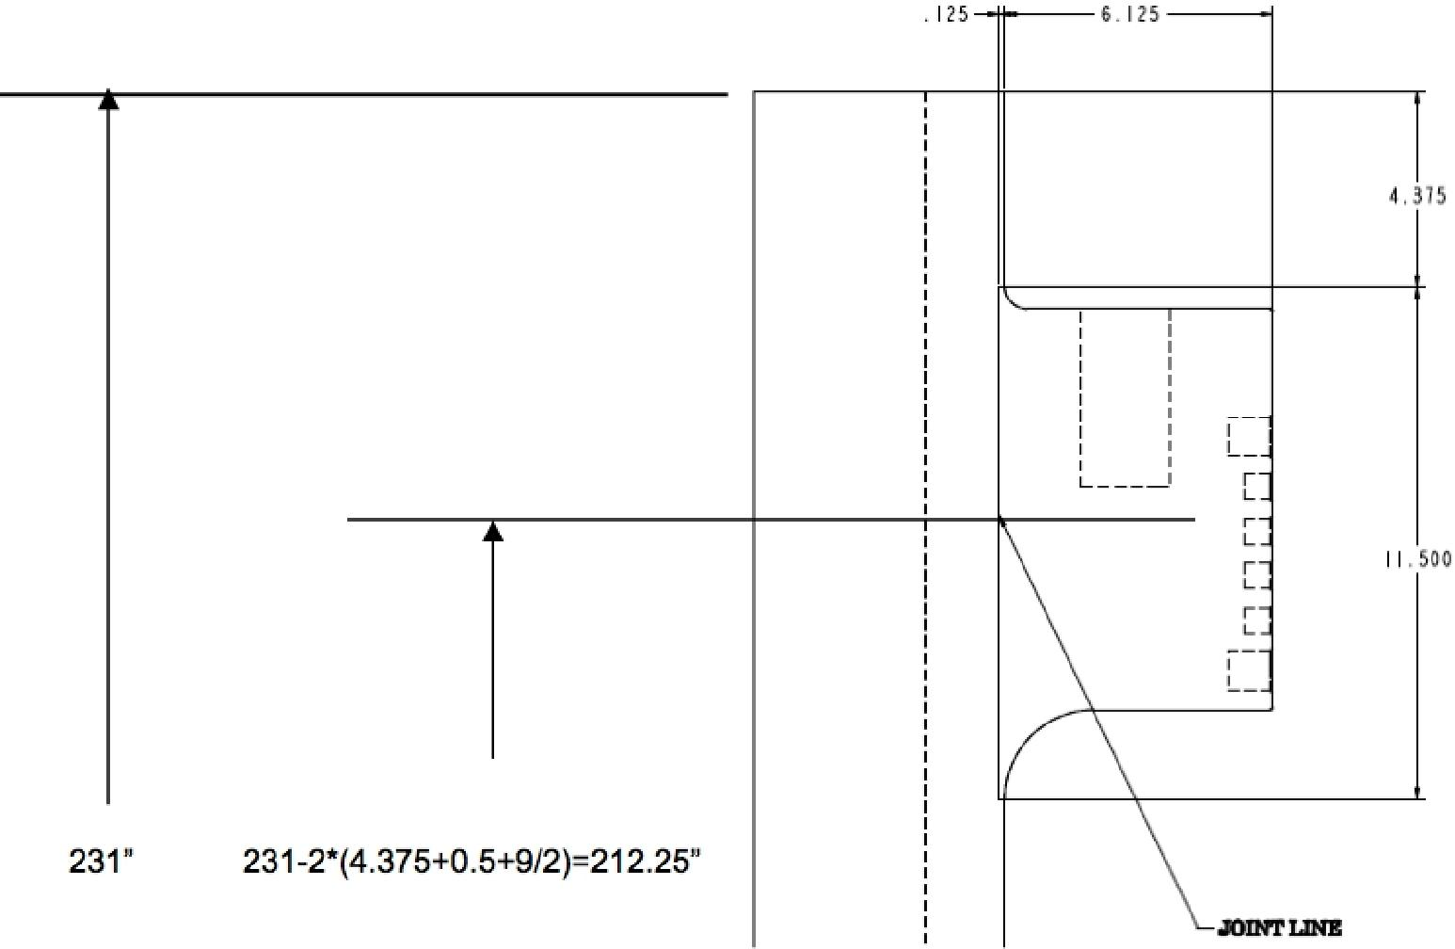
Figure 3-3 TF Inner Leg Effective Height
- “Total Copper Inner Legs” is the copper volume equal to the area R[132] multiplied by the height R[ 144] .
- “TF Outer Leg & Misc Resistance at 20C” is the room temperature resistance of the TF outer legs based on the original NSTX_Base design⁹. This is the sum of the upper/lower flags and connectors and outer legs.
- “Resistivity @ 20C” is the copper 100% IACS resistivity equal to the manual input R[211 ] .
- “Coefficient” is the copper temperature coefficient of resistance which is equal to a value “TCRCu” entered on the “Parameters” worksheet.
- “TF Inner Leg Resistance @ Tinlet” is the total series resistance attributable to the TF inner legs at the initial (inlet) water temperature. It is calculated as follows:

R=N | dZ  A | (1+a(7;nlet -20))

⁹ “TF As-Built Circuit Parameters” NSTX memo 13-001108-CLN-01
17

where:
18
R = total inner leg resistance R[149]
p = copper resistivity at 20ºC R[147]
dZ = effective height of TF inner leg R[144]
A = conductor area per turn equal R[132] divided by #turns R[128] a = temperature coefficient of resistance R[148]
Tinlet = water inlet temperature
R[150] “TF Net Coil Resistance @ Tinlet” is the sum of the inner leg and outer leg resistance at the inlet temperature and R[151] the same except at the maximum allowable temperatures (R[38] for the inner leg and R[189] for the outer leg).
- “TF PSS Equiv Resistance” is the equivalent resistance of the Transrex AC/DC converter computed in R[517].
- “TF External Circuit Resistance per branch” is the branch resistance of the FCPC TF circuit after reconfiguration for NSTX_CSU. The value in use was supplied by S. Ramakrishnan¹⁰.
- “TF External Circuit Resistance” is the net value after accounting for the number of parallel FCPC branches in R[41].
- and R[156] are the total effective circuit resistances at the inlet and maximum temperatures, respectively, including the effective AC/DC converter resistance which is the effective resistance per section R[152] times the number in series divided by the number in parallel.
- “TF Coil inductance” is based on the NSTX_Base value¹¹ multiplied by the upgrade/base turns ratio squared. This approach is valid since the geometry of the outer legs which dominates the effect is unchanged.
- “TF External circuit inductance” is equal to the inductance of the standard FCPC DC CLR, 265 pH, divided by the number of parallel FCPC branches R[41].
- “TF Net Circuit Inductance” is the sum of the coil inductance R[157] plus the external inductance R[158].
10 “TF branch resistances 032309.xls”
11 “TF As-Built Circuit Parameters” NSTX memo 13-001108-CLN-01

- “TF Peak active power” is calculated as follows, corresponding to the instant where full power supply voltage is applied just as the TF current reaches its flat top value:
19
P = ITF * (VTF — ITF *
Req )
N_{P}
where:
P = TF active power
ITF = TF current at flat top R[65]
VTF = TF no-load power supply voltage R[91]
Req = AC/DC converter equivalent resistance per section R[152] NP = number of parallel TF branches R[41]
- “TF Peak reactive power” is calculated as follows:
Q= S2 — P² = (VTF * ITF) ²
_{TF})² — P²
where:
Q = TF reactive power
P = TF active power
ITF = TF current at flat top R[65]
VTF = TF no-load power supply voltage R[91]
- “TF Flat top active power” is equal to the I2R power at flat top where R is the sum of the coil and external circuit resistance (not including the AC/DC converter equivalent resistance). Coil resistance is based on the value at maximum temperature (conservative).
- “Rise Time” is calculated as follows, based on the rise time of a single time constant L-R circuit:
ln 1— R_{TF} * ITF

Trise
LTF RTF
VTF
- “∫i(t)2dt Rise” is the action integral during TF current rise, computed as follows:

R[165] “Fall Time” is calculated as follows, based on the fall time of a driven single time constant L-R circuit. The 0.66 factor accounts for the fact that, in inverter mode, the AC/DC converter cannot produce full rated voltage magnitude because of the inversion angle limit.

I_{TF}(t) = VTF
RTF
1 | tR_{TF}  LTF

I_{TF}²(t)dt = VTF 2TRise +
RTF
2 LTF
RTF
TRise *RTF
2E LTF — 0.5 *
2* TRise *RTF
LTF 1.5

Tfall = | LTF RTF | ln | ( V_{TF} * 0.66)  0  RTF  ( V_{TF} * 0.66)  ITF RTF

In R[166]-R[168] the action integral is calculated for the case where the current fall is controlled (driven) by the power supply. This involves intermediate variables A and B as follows:
20
VTF * 0.66
A = ITF
RTF
VTF * 0.66
B=
RTF
^{2*}TFall *RTF TFall *RTF
A2LTF 2ABLTF A2LTF + 2ABLTF
ITF 2 (t)dt = B2ITF LTF LTF +
²RTF
RTF ~ ²RTF RTF
- “ ∫i(t)2dt Fall (L/R Decay)” is the action integral in case of a power supply fault at the end of TF flat top followed by an L/R decay:
z
I _{TF}²(t)dt = 2 ^{TF}
RTF
- “Flat Top Time” is the maximum available TF flat top time based on the ESW derived from the G-function R[140] minus the ESW’s attributable to the current rise and fall. This must exceed the plasma current duration R[21] to meet the XL Solver critera for a valid solution.
- “TF ESW Max” is the ESW derived from the above action integrals for rise, flat top, and fall.

R[172] – R[179] provide a calculation of the Von Mises and Tresca stress in the TF inner leg. Derivation (developed by R. Woolley) is supplied in Appendix II. Note that this expression has been checked by the writer by comparison with equivalent expressions given in the derivation developed by G. Voss of MAST¹².
21
R[180] “TF-OH dR clearance” is a manual input for the gap between the outside of the TF bundle and the inside of the OH coil. This gap is necessary to allow for radial and axial thermal expansion of the TF bundle in such a way that it does not interfere with the OH coil. The value of 0.100” is recommended by J. Chrzanowski. R[181] is the gap value in meters.
R[182]-R[187] Provide geometry data for the TF outer leg. Note that on NSTX_CSU the original NSTX_Base outer legs are used.
- “TF Outer Leg Temp Allowable” is a manual entry for the allowable maximum temperature of the TF outer leg. The value of 100ºC is chosen based on avoidance of softening of the epoxy resin component of the insulation and room temperature boiling.
- “Gmax_outer_leg” is the G -function value corresponding to the allowable max temperature R[188].
- “dGmax_outer_leg” is the maximum permissible dG value in order to limit the temperature to the allowable.
- “dG _ outer _leg” is the actual dG value based on the TF action integral from L/R decay R[141] divided by the outer leg conductor cross section R[186] squared.
- “TF Outer leg maximum temp (L/R Decay)” is the final temperature of the outer leg based on the G-function. For valid XL Solver solutions this temperature must be less than the allowable R[188].
R[193]-R[195] Provide the total copper mass in the TF inner legs, TF outer legs, and sum of both based on a copper density of 8.95 gm/cc. This result is provided for information only.
3.1.4 PF1a Coil Rows 196-207
Details of the inner PF coils (PF1a, PF1b, and PF1c) are develop on worksheet “Inner_PF_Design”. However the B field of PF1a has a strong impact on the forces of the OH coil due to its tight coupling so this calculation is included in the “Base” worksheet.
Geometry details of PF1a in R[197]-R[200] are linked to “Inner_PF_Design”.
12 “Stress Analysis of Centre Rod and Solenoid Under Self-generated Electro-magnetic Loads”, G. Voss, MAST Design Report F/MAST/31/T29, 7/17/2003

The peak PF1a current during the first R[201] and second R[202] swing of the OH current is linked to cells on worksheet ÒPF_Currents_ForcesÓ where the required currents are specified.
22
- “Turns” is the number of turns in the PF1a coil which is linked to ÒInner_PF_DesignÓ.
- ÒJavg 1st Swing” is the average PF1a current density during the first swing (average amp-turns over the full coil cross section).
- ÒBpf1a 1st SwingÓ is the magnetic flux density in the bore of PF1a due to its own current during the 1st swing. It is calculated as if an infinite solenoid (conservative) based on¹³:
B = µ₀Jdr
where:
J = average current density R[204]
dr = radial extent of conductor pack R[199]
- and R[207] are calculated in the same way as R[204] and R[205] except for the 2nd swing condition.
3.1.5 OH Coil Rows 208-479
R[209] through R[211] set the OH conductor resistivity. A conductivity of 100% IACS is assumed.
- ÒOH Temp CoeffÓ is the temperature coefficient of resistance which is set equal to the variable ÒTCRCuÓ which is input on the “Parameters” worksheet.
- ÒnuÓ is a manual input for the Poisson Ratio set equal to 0.32 for copper.
- ÒOH Inlet Coolant Temperature” is set equal to the manual input value in R[37]
- ÒOH GoÓ is the value of the G-function at the initial (inlet) temperature R[214].
- ÒdR tension tube” is used to enter the radial build of the “tension tube” in inches, on to which the NSTX_Base OH coil was wound. Note, however, that NSTX_CSU will not use a tension tube. The NSTX_CSU OH coil is wound directly on to the TF bundle.
- is the same in meters.
13 ÒThe Design of the Center Core of a Spherical Tokamak”, R. Colchin et al, Fusion Technology Vol. 31 May 1997, eq. B2

R[218] and R[219] “OH R inside tension tube” is the radius at which the OH coil begins, in meters and inches.
23
R[220] – R[223] are used to enter and characterize the build of the “Teflon slip plane” which is a half-lapped layer on the inner bore of the OH coil.
- “OH Voltage” is the no-load average DC voltage of the OH power supply, equal to the number of series Transrex AC/DC converter sections R[48] multipled by the open circuit voltage of each section R[530].
- “OH Hipot Voltage” is the ground hipot voltage based on 2E+1kV where E is the sum of the OH voltage R[224] and the CHI voltage R[87]. The CHI voltage is included because the OH ground plane operates at the CHI potential during CHI operations.
- – R[244] refer to features of the “inner” ground insulation of the OH coil, whereas R[260] – R[280] refer to features of the “outer”. On NSTX_Base there was indeed a difference between inner and outer whereas on NSTX_CSU this is not envisioned.
R[226] - R[228] are manual inputs used to specify the ground insulation features. Note that the thicknesses are selected from standard sizes listed on the “Parameters” worksheet RC[1,I]:RC[13,J]. The OH ground insulating tape is assumed to consist of fiberglass only (no kapton).
R[229] and R[230] give the thickness of the OH groundwall insulation. R[231] and R[232] give the total thickness of the OH insulation between conductor and ground, equal to the turn insulation thickness R[252] (details in later rows) plus the groundwall thickness R[229].
R[233]-R[234] are the average values of voltage stress, i.e. electric field, in the ground plus turn insulation of the worst turns (where the first and last turns of the winding face each other directly) during normal operation.
R[235] “OH Ground insulation dielectric strength constant (inner)” and R[236] “OH Ground insulation dielectric strength (inner)” are based on the approach outlined in the paper¹⁴ with excerpts included in the “Parameters” worksheet.
- gives the “safety factor” during normal operation, i.e. the ratio of dielectric strength to voltage. Note that the choices for ground and turn insulation for NSTX_CSU result in an improved safety factor compared to NSTX_Base which was not robust.
- – R[240] provide similar information as the prior section except for the hipot condition.
14 “Effects of cryogenic irradiation on electrical strength of candidate ITER insulation materials”, J. Schutz et al, Cryogenics 35 (1995) 759-762

R[241]-R[245] provide details concerning the geometry of the ground plane conducting tape to be applied to provide an electrostatic shield over the OH groundwall.
R[246]–R[251] provide manual inputs for the features of the OH turn insulation. Note that the thicknesses are selected from standard sizes listed on the “Parameters” worksheet RC [ 1 j]:RC[13,J]. The OH turn insulating tape is assumed to consist of interleaved layers of fiberglass and kapton.
R[252] “OH Turn insulation” is the thickness of the turn insulation in inches and R[253] in meters.
R[254] “OH Turn-Turn voltage stress factor” is a multiplier on the applied terminal-toterminal voltage which reflects the fact that winding pattern determines the fraction of applied voltage which appears between turns. As shown in Figure 3-4with the four layer, two-in-hand winding, the appropriate factor is 0.5.
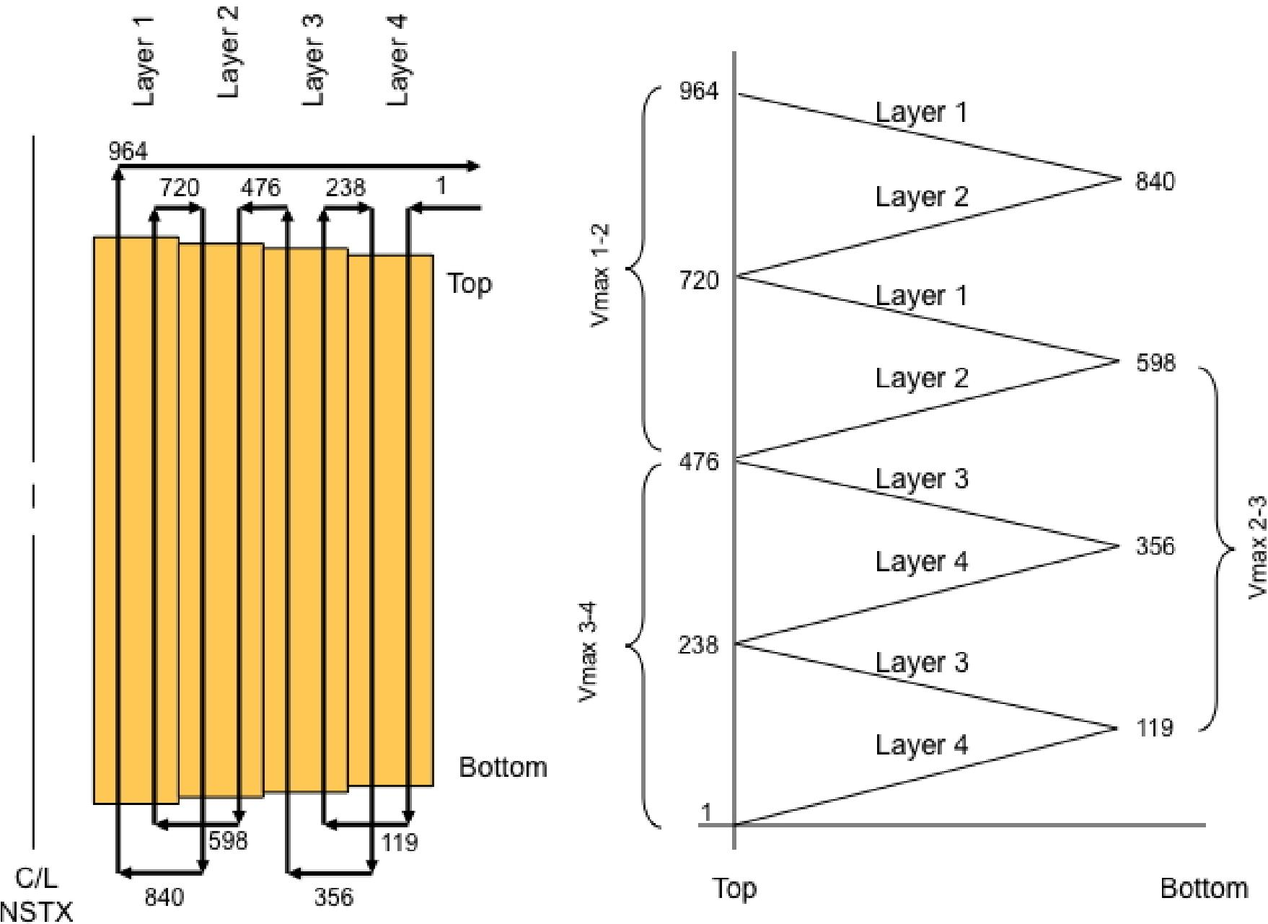
Figure 3-4 OH Winding Pattern & Voltage Distribution (NSTX_Base)
24

R[255] and R[256] ÒOH Turn-Turn voltage stress maxÓ is the product of the applied voltage R[224] times the stress factor R[254] divided by twice the turn insulation thickness (two layers of turn insulation thickness separate adjacent turns).
25
R[257]-R[259] involve the calculation of dielectric strength and safety factor similar to previous sections. Note that the dielectric strength factor in this case is based up epoxy/glass/kapton as entered in the “Parameters” worksheet.
R[260]-R[280] treat the outer OH ground insulation in the same fashion as the treatment of the inner OH ground insulation in R[226]-R[244].
R[281] ÒOH RcuinnerÓ is the radius of the inside surface of the OH conductor, in meters, and R[282] in inches. It is based on the TF outer radius over the insulation R[142] plus the TF -OH clearance gap R[181] plus the radial build of the tension tube R[217] plus the radial build of the Teflon slip plane R[223] plus the inner groundwall insulation R[230] plus the inner ground plane R[244] plus the turn insulation R[253]. R[282] is the same in inches.
- ÒTmaxÓ is the maximum allowable OH temperature, equal to the input at R[43].
- ÒGmaxÓ is the G-function value at Tmax R[283] and R[285] ÒdGÓ is the corresponding maximum delta G from the initial condition R[215].
- “Center stack radius” is the dimension out to the edge of the PFC tiles, equal to R[30] .
- Ð R[294] are used to set the dimension of the PFC tiles, center stack casing, the microtherm insulation, and the gap between the outside of the OH coil and the microtherm insulation. On NSTX_CSU, compared to NSTX_Base:
- the tile thickness has been increased to ease fabrication, to handle greater heat
loads
- the center stack casing thickness has been increased slightly and set to a standard
thickness for ease of procurement
- the clearance gap has been decreased slightly but is still adequate for installation
and inclusion of various diagnostics (flux loops, thermcouples, and Ip Rogowski coils)
- the microtherm thickness is the same
R[295] ÒRoutside OH groundwallÓ is the outer radius of the OH coil, set based on the center stack radius R[286] minus the space taken by the various components in-between R[287]-R[294] .

Summary OH conductor pack dimensions are computed in R[296]-R[302]. Half-coil information (required by various users which represent coils via separate pieces in the upper and lower half-planes) is computed in R[303]-R[305].
26
R[306] “Solenoid form factor” is a fraction applied to the flux R[74] which accounts for the finite solenoid length and is calculated as follows¹⁵:
dz
2
ff =
Rinner + dr
dz2 2
where:
ff = form factor
dz = solenoid height R[302]
Rinner = radius to inner bore of solenoid R[281]
dr = solenoid conductor pack radial build R[296]
- Ò#SwingsÓ is a fractional number typically equal to 1 + x where x is <_ 1 representing the fraction of the second swing.
- ÒJavgÓ is the average current density in the conductor pack.
- ÒOH Cooling hole diameter” is the manual entry for the hole diameter in inches.
- is the same in meters. The chosen value of 0.2250” was arrived at based on parametric optimization studies¹⁶ of the OH coil. The final result was chosen because it meets physics requirements, cools down in less than 20 minutes without modifications to the existing pump and plumbing systems, and can optionally be cooled down in less than 15 minutes if pump and plumbing modifications are undertaken. Parametric scan results are contained in RC[H16:AX47] of “Base”.
- ÒOH Conductor corner radius” is a manual input based on advice from J. Chrzanowski.
15 From S. Jardin
16 See weekly meeting presentations: ÒOH_Conductor_Study_091119.pptÓ,
ÒOH_Conductor_Study_091202.pptÓ, ÒOH_Conductor_Study_100104.pptÓ, ÒOH_Conductor_100106.pptÓ, ÒOH_Conductor_100107.pptÓ, ÒOH_Conductor_100112.pptÓ
- ÒOH #layersÓ is the number of layers in the OH coil. Note that the coil is wound 2-in-hand resulting in 8 separate windings which are connected electrically in series but hydraulically in parallel.
27
- ÒOH Conductor width” and R[314] ÒOH Conductor height” are per turn values computed based on the overall winding pack dimensions, the number of turns, and the turn insulation as follows:
Width = | Router — Rinner — ² (NLayer —1) tturn _insulation
 | NLayer

where: | Height = dz  NTurns NLayer | ²tturn _insulation

Router is radius to outside of conductor pack Rinner is radius to inside of conductor pack NLayer is number of layers
tturn_insulation is thickness of turn insulation
dz is height of conductor pack
NTurns is total number of turns
R[315] “Conductor area” in inches (R[316] in meters) is calculated based on the width
R[313] multiplied by the height F[314] minus the area lost to the cooling hole and corner radii as follows:
 | A=W *H— 7cd | 2 | 22 ((²Rcorner) — ⁷rRcorner
where: | 4  A = conductor area R[314] W = conductor width R[313] H= conductor height R[314]  d = cooling hole diameter R[309] Rcorner = corner radius R[311]

- “OH packing fraction” is the fraction of the dr x dz conductor pack area occupi ed by conductor (the remainder occupied by coolant and insulation). This is equal to the product of the conductor area R[315] multiplied by the number of turns divided by the area of the conductor pack.
28
- “Jmax” is the current density in the conductor, equal to the average current density R[308] divided by the packing fraction R[317].
- “Boh” is the magnetic flux density in Tesla in the bore of the coil which calculated as if an infinite solenoid based on¹⁷:
B = µ₀Jdr
where:
J = average current density R[308]
dr = radial extent of conductor pack R[29]
- “Hoh” is the magnetic field intensity in amps/meter:
B
H=
µ₀
- “OH Coil inductance” is computed as follows¹⁸:
L = g0TN2  3dZ | ( ² )  Ro ² + R_{o}R_{i} + R_{i}

Based on past experience this formula overestimates the inductance compared to more precise computational methods (which are not amenable to use in an XL spreadsheet). However, for the purpose at hand this is conservative because the inductance is used to compute the power supply driven transient current waveforms and leads to a more sluggish response compared to real conditions.
- “OH External circuit inductance” is the external inductance including the FCPC CLRs. For NSTX_CSU the value is taken to be 1mQ divided by the number of parallel branches R[49].
- “OH Net circuit inductance” is the sum of coil R[321] plus external R[322] inductances.
¹⁷ “The Design of the Center Core of a Spherical Tokamak”, R. Colchin et al, Fusion Technology Vol. 31 May 1997, eq. B2
18 ibid eq. B8

- “Turn Area” is redundant to “Conductor Area” R[316].
₌J*B
pf
+
- “Hoop Stress (Self -field at max OH current)” is the conductor hoop stress at Javg R[308] which corresponds to the base OH current R[5 2] and is calculated as follows¹⁹:
4
(7 + 5 )R0 ⁴ 8(2 + )R0Ri 3 + 3(3 + )R'
2
24(R₀ R_{i} )(R0 — R_{i}² )

(1 + 2)R₀R_{i}
3(R₀ — R_{i} )
)Ri ²
(1+ 3
+
8(R₀R_{i})

2
29
R0 ² (7 + 5 )R0 ² 8(2 + _{)R0Ri} + 3(3 + )R'
24(R₀ — R_{i})(R₀² R_{i}²)
where:
6₀ = Peak hoop stress in conductor
J = average current density in winding pack R[308] B = field in bore of solenoid = R[319]
pf = packing fraction R[317]
R_{o} = outer radius of conductor pack R[296]
Ri= inner radius of conductor pack R[281]
v = Poisson’s Ratio R[213]
Note that this expression has been checked by the writer by comparison with equivalent expressions given in the derivation developed by G. Voss of MAST²⁰.
R[326] “Hoop Stress (Self-field 1st Swing)” is calculated in the same way as B[325] except multiplied by the fraction of base current at SOP R[55] squared.
R[327]-R[330] are the radial centers of each layer of the OH coil.
R[331] “Total Area” is the total cross sectional area of the OH conductor pack when viewed in the axial direction.
19 R. Roark & W. Young, Formulas for Stress & Strain, McGraw-Hill, p. 505, Table 32, eq. 1e, 1f.
²⁰ “Stress Analysis of Centre Rod and Solenoid Under Self-generated Electro-magnetic Loads”, G. Voss, MAST Design Report F/MAST/31/T29, 7/17/2003

R[332] – R[335] is the area out of R[331] which is lost to the coolant passages and R[336]-R[338] to the insulation between the layers.
- “Net area” is the total area R[331] minus the area lost and R[340] is the corresponding fraction.
- “Area fraction” is the net R[339] divided by total area R[331].
- “Area fraction Approximation” is a coarse estimate of the above area fraction to cross check R[339]. It is not otherwise used.
- “Effective Axial Stress Area Fraction” is the actual fraction used in the stress calculations, set equal to R[339].
- “Axial Stress (Self-field 1st Swing)” is calculated as follows based on the expression derived in Appendix III:
² Router
fr₀ NI z = 6 dZ
( ² )
² + _{RouterRinner} + Rinner
(Router — Rinner ) f_{A}
2
where:
N =# OH turnsR[51]
I = IOH at precharge R[52]
dZ = height of OH coil R[302]
Router = radius to outside of conductor pack R[296] Rinner = radius to inside of conductor pack R[281] fA = area fraction bearing the load R[342]
- “Radial Stress (Self-field 1st Swing)” is set to zero based on equilibrium boundary conditions (refer to Appendix III).
- “Von Mises Stress (Self-field 1st Swing)” occurs at the inner bore of the coil and is computed as follows:

VonMises = |  | ( - a_{z})² +(6_{B} - 6_{r})² +(6_{r} - _{az )}2
 |  | 2

where:
6_{e} = Peak hoop stress in conductor
30
σ_{z} = Peak axial stress in conductor ⁶r = Peak radial stress in conductor
31
- ÒTresca Stress (Self-field 1st Swing)” occurs at the inner bore of the coil and is computed as follows:
Tresca z
This simplification is possible since the radial stress is zero at the boundary.
- ÒMax Ioh at Ip Flat Top (max PF1a)Ó is the maximum fractional value of the OH current during the 1st swing when the plasma current has reached flat top (recall that the OH current decreases from its initial precharge value in the process of generating the plasma current., and that PF1a current reaches its maximum when the plasma is at flat top). This is important because it corresponds to the maximum combined load arising from both the OH and PF1a currents. Out of the 96 equilibria current sets specified by the physics requirements on the ÒPF_Currents_ForcesÓ worksheet, 1/3 of them correspond to the OH current at the start of plasma current flat top (SOFT) and the value in R[347] is the maximum fractional value out of all the 96/3=32 values specified by phys ics.
- “Hoop Stress (w/PF1a during 1st Swing)” computes the peak hoop stress on the OH conductor due to the OH current at plasma flat top R[347]crossing with the field from PF1a R[205] plus the OH current at plasma flat top R[347] crossing with its self-field. The former calculation uses the same formula as R[325] above and the latter takes the result from R[325] and multiples by the fractional value in R[347] squared since the force due to self-field depends on the square of the current. R[349] through R[354] are calculated in the same way as R[343]-R[346] for the combined effect with PF1a in the 1st swing.
R[359] through R[366] are calculated in the same fashion as the self-field and combined field cases above except with the OH current at its maximum second swing fractional value R[59] at EOFT and with PF1a at its second swing maximum magnitude R[207].
- Ò#Windings in hand” refers to the number of conductors which are helically wound over the length of the OH coil to form the winding.
- ÒMax winding length” is the longest of the windings in meters and is calculated as follows based on the radius of the outermost coil layer:
L = 27r R _ dRConductor N * 2.54
Cu __ outer 2 N N 100
Layer Hand
where:
RCU_outer= radius to outer edge of conductor pack R[297]

dRConductor= width of conductor R[313]
32
N= total number of turns in OH coil R[51]
NLayer= number of layers in OH coil R[312]
NHand= number of winding in hand in OH coil R[367]
- “Max winding length” is the longest of the windings in feet.
- “OH Cooling hole diameter (minimum fraction of nominal)” is a manual input used to set the diameter used in water cooling and pressure drop calculations to a value lower than nominal, reflecting some conservatism and the fact that there will be a +/- tolerance subject to local and overall variation TBD. A value of 95% is used based on engineering judgement and assessment of NSTX_Base cooldown behavior 21.
- “OH Cooling hole diameter (minimum)” is the diameter used in water cooling and pressure drop calculations.
- “Flow velocity” is a manual input for water flow velocity in feet per second, and
- is the corresponding value in meter per second. The value chosen was arrived at based on the aforementioned optimization study and is constrained by the desire to maintain the existing pump and plumbing system which can produces an inlet pressure of 430 psi (based on input from M. Kalish) R[397].
- “Mass flow” is m3/sec and in gallon per minute (GPM) R[375] is based on the product of the velocity and the cooling hole cross section calculated from the nominal (full) cooling hole diameter.
- “Transit time” is the time for water to pass through the winding, equal to the maximum winding length R[368] divided by the velocity R[373].
- – R[383] are coefficients use to calculate the water dynamic viscosity based on temperature. The algorithmic curve fit to published data is derived in
“Water_Properties_091109.xls”. These fits are accurate up to around 200 ºC. For this calculation the inlet water temperature is used which is conservative since it results in the highest viscosity and maximum pumping pressure.
R[385] – R[387] are coefficients similarly used for the water density calculation.
- “Water Kinematic Viscosity” is the viscosity R[384] divided by the density R[388].
- “Water Reynold’s Number” is calculated as follows:
21 See weekly meeting presentations: “OH_Conductor_Study_091119.ppt”,

Vd
33
R=
µ
where:
R = Reynold’s Number R[390]
V = Water velocity R[371]
d = Coolant passage diameter R[371] (minimum value) µ = Water kinematic viscosity R[389]
- “Water Friction Factor” is calculated as follows:
0.3164
f =
_{R}0.25
- “OH Coil Water Pressure Drop” is calculated in Pascal as follows:
2_{L}
P=.~
2d
where:
f = friction factor R[391]
V = Water velocity R[371]
L = Maximum winding length R[368]
d = Coolant passage diameter R[371] (minimum value)
- is the pressure drop in psi.
- “OH Plumbing Water Pressure Drop” is the drop in the local piping and is scaled from the NSTX_Base data (input in column C based on advice from M. Kalish) based on the ratio of the NSTX_CSU velocity divided by NSTX_Base velocity, squared.
- “Total Pressure Drop” is the sum of drops in the coil R[392] and the plumbing R[394].
- “Return Pressure” is a manual input for the return pressure drop per advice from M. Kalish”.
- “Inlet Pressure” is the pressure at the inlet of the coil which, in NSTX_CSU, we aim to limit to the same as NSTX_Base.

R[398] ÒMax winding volume” in m3 and R[399] in in3 are the volumes of the longest winding within the OH coil, equal to the longest length R[368] mulitplied by the turn area R[324].
34
- ÒMax Billet for winding w/o joint” is the billet size required to extrude a winding of sufficient length such that no joint is required, based on the volume of the longest turn R[398] multiplied by the denisity of copper (0.321 lbs/in3).
- “Total Copper” is the total OH copper volume, based on the number of turns R[51] multiplied by the area per turn R[324] multiplied by the average turn length, equal to 2at*Ravg, where Ravg is the average turn radius.
- “Total Copper” is the total OH copper mass in pounds, based on the volume R[401] multiplied by a density of 8.940 gm/cc and 2.205 lbs/kG
- ÒOH Copper Volume” is redundant to R[401], calculated based on coil height multiplied by at*(R2outer-R2inner) and then by packing fraction R[317].
- ÒOH Copper Mass” in tonne is redundant to R[402] based on volume from R[403] multipled by 8.94 tonne per m3.
- ÒOH Net coil resistance @ TinletÓ is the coil resistance at the inlet water temperature based on:
where: | R = P20Nl  A | (1 + a (Ti nlet — 20 ) )

20 = 20 ºC resistivity R[211]
N = number of turns R[51]
l=average turn length
a=temperature coefficient of resistance R[212] Tinlet= inlet water temperature R[42]
and:
l=2 (Router + Rinner J
2
where:
Router, Rinner are outer and inner dimensions of conductor pack R[281] and R[296]
- “OH Net coil resistance @ Tmax” is the coil resistance at the maximum allowable temperature R[283] based on R[405] adjusted for temperature.
- “OH PSS equiv resistance” is the equivalent resistance of one Transrex power supply section used in the OH system, which accounts for the voltage drop due to commutation notches by an equivalent resistance. It is (conservatively) computed in R[535] based on the nominal MG starting frequency in R[506] which is set to 80Hz.
- “OH External circuit resistance” including cabling and DC CLRs is set to 4.6mQ based on input from S. Ramakrishnan. This is the same value is in the existing system but could change depending on the new CLR purchased for NSTX CSU.
- “OH Net circuit resistance at Tinlet” is the total resistance, equal to the sum of coil R[405] at Tinlet, PSS R[407] multiplied by the number in series R[48] and divided by the number in parallel R[49], and external R[408].
- “OH Net circuit resistance at Tmax” is the same as R[409] except the coil resistance at maximum temperature R[406] is used.
- “Rise Time” is the time for the OH coil current to rise to the precharge current, calculated based on a simple L/R circuit as follows:
V
t
1
i(t)=
R
t=—zln 1—
i(t)R
V
where:
R = OH coil resistance at Tinlet (at start
of pulse) R[405]
ti = L/R where L =net OH circuit inductance R[323]
- “OH Peak active power” is the maximum active power demand (MW) which will occur just prior to reaching precharge current:
Pox = IVox = I (Vao_ox — IR e )
where:
VOH = OH power supply output voltage
Vdo_OH = total no-load power supply voltage as equal to V above
V =total no-load power supply voltage =number series PSS R[48] multiplied by voltage per PSS R[530]
35

I = precharge current R[56]
Req = is equivalent resistance of OH power supply
- “OH Peak reactive power” is the maximum reactive power demand (MVA) occurring just prior to reaching precharge current:
S2 —P2 QOH OH OH
2 2
QOH (Vdo_OHI) POH
- “ ∫i2(t)dt Rise” is the “action integral” during the rise of the OH current:

i(t)= V
R 1
i²(t) = V
R 2
t
t 2t
12 +

i²(t)dt = | V  R | 2 | t+2 | t |  | 2t
 |  |  |  |  | 2

2T
T | i²(t)dt = | V  R | 2 | T+2 | T |  | 02+  2
0 |  |  |  |  |  | 2

2T

T | i²(t)dt = | V  R | 2 | T+2 | T |  | 3
0 |  |  |  |  |  | 2 | 2

2T
T | i²(t)dt = | V  R | 2 | T+ 2 | T |  | 3
0 |  |  |  |  |  | 2 | 2

- “Precharge Flat Top Time” is a brief interval during which the OH current is maintained constant at the precharge value. This allows the feedback control loop to stabilize and for eddy current generated by induction durign the rise -up transient to stabilize. It is a manual input.
36
- “ ∫i2(t)dt Precharge Flat Top” is the “action integral” during the precharge flat top, equal to the current R[56] squared times the flat top duration R[415].
- “ ∫i2(t)dt Fault (L/R decay at SOI)” is the action integral in case of a fault followed by an L/R decay just at the start of plasma initiation (SOI). This is the sum of the action up to SOI (equal to R[414] + R[416]) plus that from the L/R decay, equal the initial

current R[56] squared times the L/R time constant divided by 2. Here L is the total circuit inductance R[323] and R is the total circuit resistance equal to the hot coil resistance R[406] (conservative) plus the external circuit resistance R[408]. Note that the PSS equivalent resistance is not included since the power supplies are in bypass during L/R decay.
37
- “Initiation time duration” is a manual input for the time during which plasma initiation takes place. Value of 20mS is consistent with NSTX experience²² and in accordance with NSTX CSU GRD section 2.2.3.a.
- “Breakdown radius” is assumed at the center stack radius R[30] since this is the location of maximum electric field Vloop/2n r.
- “Fraction of Bt_nom for breakdown” is a manual input for the minimum value of toroidal field at which breakdown criteria should be met, set equal to 0.6 in accordance with NSTX CSU GRD section 2.2.3.a.
- “Bt _breakdown at R0” is the toroidal field at the nominal major radius R0 at the fractional value specified in R[420].
- “Bt _breakdown at breakdown radius” is the toriodal field at the breakdown radious R[419] corresponding to the field at R0 at breakdown R[421].
- “E_phi*B_phi/B_perp” is a manual input for the electric field required for breakdown, which is a function of the toroidal field B_phi divided by the error field B_perp. Value input is in accordance with NSTX CSU GRD section 2.2.3.a.
- “Field error in breakdown region” is a manul input for the error field. Value input is consistent with NSTX experience and in accordance with NSTX CSU GRD section 2.2.3.a.
- “Initiation Vloop” is the voltage per turn required to meet the criteria developed via R[418] Ð R[424] as follows:
Vloop = 2Rbreakdown | EB Berror  BP B _ breakdown

- “Effective Flux Area” is the effective area linked by the breakdown radius, equal to the OH single swing flux R[31] at base OH current divided by the corresponding peak OH field R[319].
- “Initiation dB/dt” is the rate of change of OH field required to generate the initiation loop voltage. Since the induced voltage is proportional to rate of change of
22 “Ohmic Flux Consumption During Initial Operation of the NSTX Spherical Torus”, J. Menard et al, PPPL Report 3940 and Nuclear Fusion, Vol. 41, No. 9, 2001

linked flux and since linked flux is proportional to field and area the rate of change of field is simply the loop voltage R[425] divided by the area R[426]. A negative sign is applied since the initiation is achieved by a ramp down of the OH current and field.
38
- “Initiation dIoh/dtÓ is the rate of change of OH current corresponding to change in field R[427], equal to the required change in field R[427] multipled by the ratio of base OH current R[52] to field B[318].
- ÒdIohÓ is the change in OH current occuring during initiation, equal to the rate of change R[428] multiplied by the time duration R[418].
- ÒLoh*dIoh/dtÓ is the inductive voltage drop during plasma initiation, equal to the rate of change of OH current R[428] multiplied by the net OH circuit inductance R[323].
- ÒI*R drop” is the resistive voltage drop during plasma initiation, equal to the OH current at the start of discharge (SOD) R[57] multiplied by the net OH circuit resistance when cold (conservative) R[409]. Note that the PSS equivalent resistance is included because it helps drive the current down to initiate the plasma.
- ÒV power supply” is the total voltage required from the power supply during plasma initiation, equal to the difference between the inductive voltage R[430] and the resistive R[431] drops. This is a negative number because the power supply must have to act as an inverter in this mode.
- ÒV power supply” is the fractional voltage required from the power supply during plasma initiation, equal to the required voltage R[432] divided by the number of series PSS R[48] divided by the voltage available per PSS in the inverter mode R[543]. This ratio must be < 1.0 for a valid design solution (indicating that sufficient voltage is available).
- Ò ∫i2(t)dt Initiation” is the action integral during plasma initiation. This is computed assuming a linear decay as follows:
3
i(t) = I₀ — Kt
i2 (t) = I₀² — 2I₀Kt + K²t²
rK²t i²(t)dt = I0 ²t I₀Kt² +
3
3
T
0
I0KT ² + K2T
i²(t)dt = I0 ^{2T}
3
- ÒIp Ramp Up Time” is equal to the plasma current Ip R[17] divided by the ramp-up rate R[18].
- through R[442] accomplish the calculation of the plasma external inductance, which represents the geometry -dependent portion of plasma inductance, independent of

internal current distribution. The method follows the Hirshman Ð Neilson formulation^{23,24}, and is not further elaborated here.
- “Li” is the plasma internal inductance which is a manual input based on advice from J. Menard.
- “Beta_P” is a measure of the plasma pressure against the poloidal magnetic field and is a manual input based on advice from J. Menard.
- “C_ejima” is the Ejima coefficient which relates resistive flux consumption to plasma radius and current and is a manual input based on advice from J. Menard.
- “fBS+fNICD” is the fraction of plasma flat top flux supplied by Bootstrap (BS) and Non-Inductive Current Drive (NICD) and is a manual input. The value can be chosen by the XL Solver or Goal-Seek to match the flux required from the OH coil during flat top R[451] to the value specified in the NSTX CSU GRD 2.2.3.c (1.2 Wb).
- “Te” is the electron temperature, a manual input based on advice from J. Menard.
- “Zeff” is the effective atomic number of the plasma impurities, a manual input based on advice from J. Menard.
- “Flux Factor” is an input to the calculation of resistive flux consumption during flat top based on Te R[447] and Zeff R[448] as follows²⁵:
0.02^{Te}
1.5
^{Z}eff
FF =
10
1.4
- “T_flat” is the plasma flat top time R[19].
- “Flux_flat top” is the OH flux requirement to sustain the plasma current during flat top, computed as follows:
flat _top= µ0IpR0 (1— fBS — fNICD) * FF * Tflat
23 “External Inductance of an Axisymmetric Plasma”, S. Hirshman, G. Neilson, Phys. Fluids, 29, 790 (1986)
24 “System Analysis of a Compact Next Step Burning Plasma Experiment”, S. Jardin et al, Fusion Science & Technology, Vol. 43, March 2003
25 ibid
39

- “Flat top voltage” is the rate of flux consumption during flat top, equal to the flat top flux F[451] divided by the flat top duration F[450].
- “Total flux requirement” is the total OH flux requirement, computed as follows²⁶:

flat_top = µ0IpR0 I Lext + | L_{i}  2 | + _{CEjima} + 1 ( )*fBS — fNICD FF*Tflat

- “Flux_ramp” is the OH flux requirement during Ip ramp-up, equal to the total flux R[453] minus the flat top flux R[451].
40
- “∫i2(t)dt Ip Ramp Up” is the OH action integral during plasma current ramp up, calculated as follows:
i(t) = I₀ — Kt
3
i2 (t) = I₀² — 2I₀Kt + K²t²
rK²t i²(t)dt = I0 ²t I₀Kt² +
3
3
T
0
I0KT ² + K2T
i²(t)dt = I0 ^{2T}
3
where:
I0 = Ioh_SOD= R[52]*R[57]
T = I_{p} ramp-up time = R[435]
K = (Ioh_SOFT - Ioh_SOD)/T = R[58]*R[52] - R[52]*R[57]
- “ ∫i2(t)dt Ip Flat Top” is the OH action integral during plasma flat top, calculated the same way as R[455] except with:
I0 = Ioh_SOFT = R[59]*R[52]
T = I_{p} flat top time = R[435]
K = (Ioh_EOFT - Ioh_SOFT)/T = R[59]*R[52] - R[58]*R[52]
- “Ip Ramp Down Rate” is a manual input set to 4MA/s based on advice of J. Menard.
26 ibid

- “Ip Ramp Down Time” is equal to Ip R[17] divided by the ramp down rate R[457].

2
t
+
2t
^{i} +
2VI₀
R
V²
R 2 +
t
2V²
R²
2VI₀
R
t
t
1
- “Ioh at EOD” is the value of OH current when the plasma current has ramped to zero. It is a manual input, set to zero for the design-basis OH waveform computation.
- “∫i2(t)dt Ip Ramp Down” is the OH action integral during plasma ramp down, calculated the same way as R[455] except with:
I0 = Ioh_EOFT = R[59]*R[52]
T = Ip ramp down time = R[458]
K = (Ioh_EOD - Ioh_EOFT)/T = R[459]*R[52] - R[59]*R[52]
- “Fall Time EOD to EOP” is the time required for the OH power supply to bring the current to zero (End of Pulse EOP) after extinguishing the plasma (End of Discharge EOD).
- through R[465] provide the calculation of the “∫i2(t)dt EOD to EOP” which the OH action integral associated with the shutdown of the OH current from its EOD value to zero as follows:

t
V 1 t
R
i(t) = I₀ +
2t
i²(t)= I₀² ^{i} +
^{V2} 1
_{R}2

2

2VI₀
R
A
A
+2B
+
T
i +
2
2
i²(t)= I02+ R2
V
A = I₀
R
V  B=  R  i2 (t) = A² | 2t  +B ² + 2AB | t
 |  | 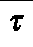 | 2T
T
i²(t)dt = B²T — A 2B
0
where:

I0 = Ioh_EOD = R[459]*R[52]
41

V = total no-load power supply voltage = number series PSS R[48] multiplied by voltage per PSS in inverter mode R[543]
42
R = OH coil resistance at Tmax (end of pulse) R[406] + OH external circuit resistance R[408]
ti = L/R where L = net OH circuit inductance R[323]
- ÒOH Action (nominal waveform)” is the OH action integral of the nominal waveform, coming from the sum of the current rise R[414], precharge flat top R[415], initiation R[434], ramp up R[455], flat top R[456], ramp down R[460], and shutdown R[465] .
- ÒOH Tesw (nominal waveform)” is the equivalent square wave corresponding to the nominal waveform, equal to the action interval R[466] divided by the base current R[52] squared.
- ÒOH Action (L/R decay)” is the OH action integral in case of a fault at the end of flat top when the OH is at full current in the second swing, coming from sum of the current rise R[414], precharge flat top R[415], initiation R[434], ramp up R[455], and flat top R[456], plus I02L/2R per definitions given for R[465]. The last term is based on the fact that the ESW of an L/R decay is equal to L/2R.
- ÒOH Tesw (L/R decay)” is the equivalent square wave corresponding to the case of a fault at end of flat top, equal to the action interval R[468] divided by the base current R[52] squared.
- ÒTmax (nominal waveform)” is the temperature at the end of a pulse with the nominal waveform, based on the G-function.
- ÒTF Delay Time” is a manual input corresponding to a delay of the start of TF flat top following T=0, i.e. the start of plasma initiation. This is nominally set to zero.
- ÒTF Start Time” is equal to the -1 times the rise time R[163] plus the delay time R[471].
- ÒTF SOFT” is the time corresponding to the start of the TF flat top, equal to the delay time R[471].
- ÒTF EOFTÓ is the time corresponding to the end of the TF flat top, equal to the SOFT time plus the TF flat top time R[19].
- ÒItf @ 1st Swing” is the value of TF current when the peak of the first swing of OH takes place. It is calculated using a single time constant exponential as follows:
V
1
i(r)=
R

where:
43
V = TF power supply open circuit voltage equal to number of series power supply sections R[40] times voltage per section F[512]
R = TF circuit resistance including coil, external circuit, and power supply equivalent R[155]
T = L/R time constant based on net circuit inductance R[159] divided by net circuit resistance R[155]
R[476] ÒBoh 1st Swing” and R[477] ÒBoh 2nd Swing” are the values of magnetic flux density in the bore of the OH coil during the peaks of the 1st and second swing. These are calculated based on the field at full base current R[319] multiplied by the per unit currents at SOP R[55] and at EOFT R[59].
R[478] ÒIxB 1st Swing” and R[479] ÒIxB 2nd Swing” provide a measure of the relative shear stress on the turn insulation in the TF bundle, which is proportional to this quantity by a geometry factor, dependent on location in the bundle.
3.1.6 PF Coils Rows 480-487
- ÒPF Inlet Coolant Temp” is a manual input for the PF cooling water temperature.
- ÒPF G0Ó is the value of the G-function of the PF coils’ copper at the pre-pulse (inlet) temperature R[481].
- ÒPF TeswÓ is the equivalent square wave time of the PF coils. It is assumed that the PF coil currents have a waveform which is proportional to the plasma current with a linear ramp-up, flat top, and linear ramp-down. For the linear ramp up we can compute the ESW as follows:
i(t) = KT
K= = IPF
T Tru
i2 (t)= K²t²
K²t³
T
i²(t)dt = ₃
² Tru
i²(t)dt = IPF
0
3
ESW = Tru
3
where:

IPF = PF current at flat top
44
Tru= Ip ramp-up time = R[435]
For flat top the ESW is simply the Ip flat top time R[19]. For the linear ramp down we can compute the ESW as follows, yielding the same ESW expression as the ramp up:
i(t) = I_{PF} + Kt
K= = IPF
T Trd
i2 (t) = IPF
² + K²t² + 2I_{PF}Kt
K²t³
+ I_{PF}Kt²
i²(t)dt = IPF
² t +
3
2 i²(t)dt = IPFTd
T
0
3
ESW = Trd
3
Thus the total ESW is:
ESW = T  3 | +Tl., + | Td  3

- “PF Temp Allowable” is a manual input for the maximum allowable PF coil temperature.
- “Gmax_PF” is the G-function value corresponding to the allowable temperature R[484] .
- “dGmax_PF” is the difference between Gmax R[485] and G0 R[482].
- “Jmax_PF” is the maximum allowable current density for the PF coils, equal to the square root of dG allowable dR[486] divided by the equivalent square wave time R[483].
3.1.7 MG Rows 488-508
- “MG Peak active power (TF+OH)” is the peak active power (MW) taken by the TF R[160] and OH R[412] which occurs when the TF and OH both reach their flat top currents. Note that other loads are insignficant at this time since the plasma and PF currents have not been established yet and the NBI system is off.
- “MG Peak reactive power (TF+OH)” is the peak reactive power (MVAR) taken by the TF R[161] and OH R[413] which occurs when the TF and OH both reach their flat top currents.

- “MG Peak apparent power (TF+OH)” is the peak apparent power (MVA) taken by the TF and OH which occurs when the TF and OH both reach their flat top currents. It is calculated based on the square root of the sum of the squares of the active R[489] and reactive R[490] power which are equal to the sum of the TF and OH contributions. It is important that this quantity should be less than 475MVA since that is the rating of a TFTR MG set and the CS Upgrade Project wishes to be able to accomplish its mission using a single MG.
45
- “MG Energy TF+OH” is equal to the value calculated in R[86].
- “#NBI” is a manual input for the number of neutral beam lines, nominally 2 for the upgrade.
- “Pnbi_out” is a manual input for the power output per beamline. Note that, per the Table 2-3 of the NSTX CSU GRD (copied below), the available output power is a function of pulse duration. For computation of peak power demand it is appropriate to use the maximum power of 9MW per beamline but for energy calculations the maximum demand occurs at 5MW for 5 seconds.
Table 3-1 NBI Power To Plasma per Beam Line
Pulse length (sec) | Power to Plasma (MW)
5 | 5.0
4 | 5.4
3 | 6.0
2 | 6.8
1.5 | 7.5
1.25 | 8.2

- “NBI efficiency” is a manual input for the ratio of output power to input power (so-called “wall plug efficiency”). Typical value for the TFTR NBI “accel” system (whis is the load taken from the MG sets) is 0.277 per advice from S. Ramakrishnan.
- “MG Power NBI” is the total input active power to the NBI system based on the number of beamlines R[493], power per beamline R[494], and efficiency R[49 5].
- “Pulse length” is the maximum NBI pulse time for energy consumption, assumed equal to the plasma flat top time R[19].
- “MG Energy NBI” is the NBI energy consumption based on the power R[496] times the pulse length R[497].
- “MG Power PF” is an estimate of the PF power demand based on the maximum I2R power of all the plasma scenarios (see “PF_Currents_Forces” worksheet, cell DO63), then multipled by 2 to account for inductive power.

- ÒMG Energy PFÓ is the PF energy demand based on the power R[499] and the pulse length R[497].
46
- ÒMG Total Energy” is the total energy demand equal to the sum of TF + OH R[492] plus NBI R[498] plus PF R[500].
- ÒkÓ is the rotational moment of inertia of the MG set, based on nameplate-rated 2250MJ extraction resultant from frequency reduction from 87.5Hz to 60Hz.
- Ò#MGÓ is a manual entry for the number of MG sets (could be 1 or 2, NSTX CSU prefers to use 1).
- ÒMG f_endÓ is a manual entry for the MG frequency at the end of a pulse, nominally equal to 60.
- ÒMG f_start_minÓ is the minimum MG starting frequency such that the ending frequency does not fall below R[504]. It is calculated as follows:
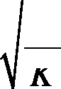
{ W 2
start =
— fe
n
d
K
- ÒMG f_startÓ is a manual input for the MG starting frequency, which should reflect the minimum allowable R[505] plus a margin. Note that it is conservative to pick a slightly higher speed than necessary because power supply performance (equivalent resistance due to commutation voltage drop) is worse at higher frequency. The value entered here is used in subsequent power supply voltage drop calculations.
- ÒdfÓis the MG speed (frequency) change during a pulse.
- ÒMG P_avgÓ is the average power output of the MG sets equal to the energy per pulse R[501] divided by the pulse period R[20].
3.1.8 Transrex TF Power Supplies 509-526
This section characterizes the performance of the Transrex power supplies used in the TF system. Refer to Figure 3-5 below which shows a one-line diagram of the typical AC feeder.

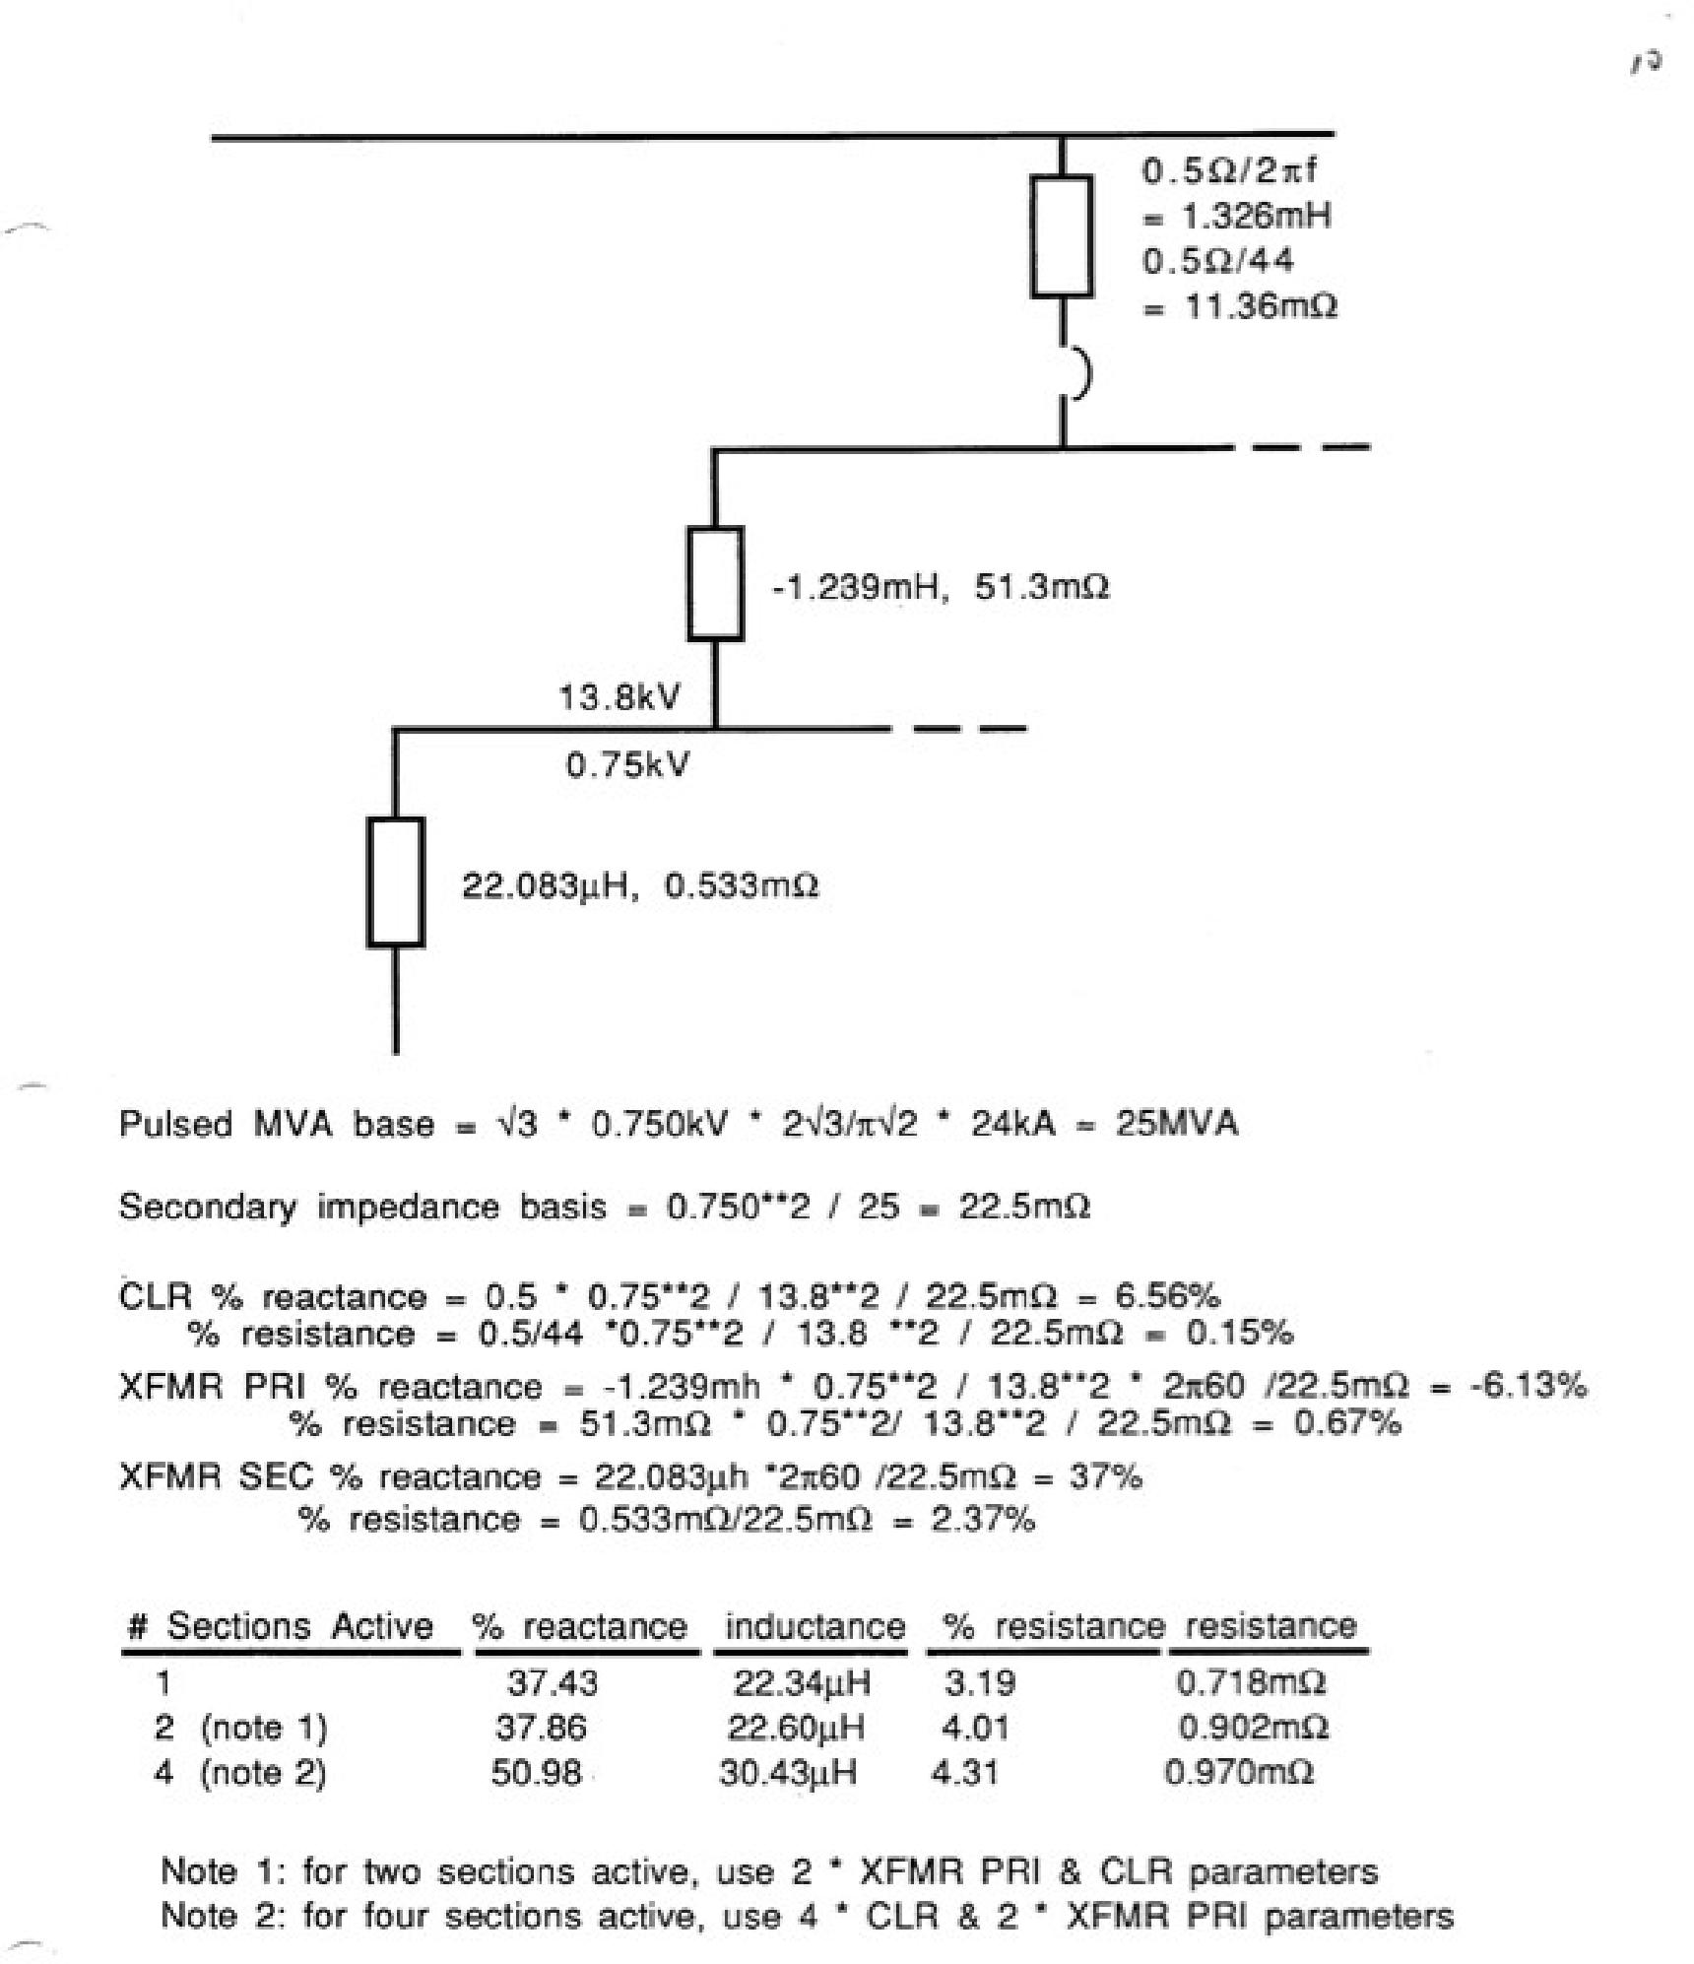
Figure 3-5 Transrex AC Feeder Impedances
47
- “S” is the base MVA rating.
- “Vac_rms” is the rms line-to-line AC input voltage rating

- “Vdo” is the open circuit voltage, calculated as follows per standard 6-pulse bridge rectifier theory²⁷ based on the rms line-to-line voltage Vac:
48
3 2
Vdo = Vac
- “gamma” is a manual input for the inversion margin angle which is set to 15º per standard practice at PPPL.
- “Xsc” is a manual input for the source reactance in % at 60Hz. Note that for the TF rectifier as deployed for the NSTX CSU the there will be 2 PSS active on a feeder, but from two separate transformers. So the effective impedance is 2*6.56+37-6.13=44%.
- “X” is the source reactance adjusted for frequency based (conservatively) on the MG starting frequency R[506] and converted to ohms via the base impedance equal to V2/S where V = R[511] and S = R[510].
- “L” is the source inductance corresponding to X where L = X/2Rf and f = the MG starting frequency R[506].
- “Req” is the equivalent power supply section (PSS) resistance, equal to 6*f*L where f is the MG starting frequency R[506] and L is the source (commutating) inductance R[516].
- “Id _max” is the maximum DC current per PSS equal to the TF load current R[65] divided by the number of parallel PSS branches R[41].
- “a_max” is the inversion angle limit based on the commutation process plus the margin angle gamma R[513] and is calculated as follows:
—1 2XI
_{d}m= cos — cos _{r} + _max
ax
²Vac
- “u_a_max” is the commutation angle at full load Id_max R[518] and full inversion angle R[519] as follows:
—1 2XId
ua max = —Omax C + cos COS max
2Vac
- “a_min” is a manual input for the minimum allowable delay angle. PPPL practice sets this to 0.
27 “DC Transmission”, E. W. Kimbark, Wiley-Interscience, 1971

- Òu_a_minÓ is the commutation angle at full load Id_max R[518] and minimum delay angle R[521] as follows:
49
2XI
ua min = —a_{m} + COS⁻¹ COS ann,i — d _max
in
²Vac
- ÒVd_a_minÓ is the average DC output voltage at full load Id_max R[518] and minimum delay angle R[521] as follows:
Vd _min — Vdo cos amin — Regjd
- Ò%regÓ is the percent voltage drop (a.k.a. “regulation”) at full load Id_max R[518] and minimum delay angle R[521] based on R[523] and Vdo R[512].
- ÒVd_a_maxÓ is the average DC output voltage at full load Id_max R[518] and maximum delay angle R[519] as follows:
Vd_max = Vdo cosamax — RegId
- Ò%regÓ is the percent voltage drop (a.k.a. “regulation”) at full load Id_max R[518] and maximum delay angle R[519] based on R[525] and Vdo R[512].
3.1.9 Transrex OH Power Supplies 527-545
This section characterizes the performance of the Transrex power supplies used in the OH system. Methodology is the same as for the TF above, except that the feeder configuration and AC source impedance is different. Referring to Figure 3-5, the configuration corresponds to 2 sections active on a feeder.
3.1.10 Other Cells in “Base”
Rows 545 and beyond are used to create plots of the coil and plasma currents.
Cell range I2:M14 is used to display various parameter values often used as constraints in XL Solver runs.
Cell range H16:AX47 is used to store values obtained during a parametric study of OH conductor optimization²⁸.
²⁸ See weekly meeting presentations: ÒOH_Conductor_Study_091119.pptÓ,
ÒOH_Conductor_Study_091202.pptÓ, ÒOH_Conductor_Study_100104.pptÓ, ÒOH_Conductor_100106.pptÓ, ÒOH_Conductor_100107.pptÓ, ÒOH_Conductor_100112.pptÓ

3.2 WORKSHEET “PF_COIL_SUMMARY”
50
This worksheet is used to summarize the PF and OH coil geometry and ratings.
Cell range B3:I14 is used to input the basic geometry in inches. Cell range B19:B29 contains the same information converter to centimeters.
Coil headroom multipliers, which provide a margin over the equilibrium currents entered in worksheet “PF_Current_Forces”, are entered in column L.
Logic in colums M and O take the equilibrium currents entered in worksheet “PF_Current_Forces”, apply the headroom multipliers, and then round up to the nearest 0.1kA in the case of the PF1 coils, and to the nearest kA for the others. The results in columns M and O are converted from amps per turn to amp-turns in columns N and P.
The maximum current magnitude is calculated in column Q based on the maximum absolute value of the min and max values in columns M and O.
The maximum current available in the “Long Pulse Partial Inductive” (LPPI) mode is computed in column R. If the current density corresponding to the current in row Q is less than the allowable for the long pulse duration (computed in worksheet “Base” R[487]) then this current is reported. If not then the current is reduced below the value in row Q such that the current density matches the limit from “Base” R[487].
The equivalent square wave times for LPPI are given in column S. For OH the value is linked to “Base” D71. For the PF1 coils the values are linked to the values calculated in worksheet “Inner_PF_Design”. Note that several of the inner PF coils cannot operate at their rated current for the full ESW duration in the LPPI mode. For the outer PF coils the LPPI ESW time is linked to “Base” D483.
The equivalent square wave times for “Short Pulse Full Inductive” (SPFI) mode are given in column T. In this mode the OH is operated with a full double swing and the pulse length is limited by the OH temperature rise. For OH the value is linked to “Base” D71. For the PF1 coils the values are linked to the lesser of the values computed in “Inner_PF_Design” and the full ESW duration in the SPFI mode from “Base” E483.
Column U reports the action integral for LPPI mode, equal to the current from column R squared and multipled by the PF equivalent square wave for LPPI mode in column S.
Column V converts the action integrals in column U to G-function values in column V. Then, using the T(G) function, the corresponding temperatures for LPPI are reported in colum W.
Columns X, Y, and Z for the SPFI mode are calculated in the same way as U, V, W for the LPPI mode.

3.3 WORKSHEET “INNER_PF_DESIGN”
51
This worksheet is used to develop a design for the inner PF coils, consisting of PF1AU/L, PF1BU/L, and PF1CU/L. The upper (U) and lower (L) coils of each type are identical. Column C describes the existing PF1a coil as a reference case, since it is similar in some ways to the new upgrade coils. Columns D, E, and F describe the new coils. In the same way that “Base” was described in the prior section rows are referenced using R[x] where, in this case, x = C, D, E, or F.
The design of the inner PF coils evolved over time based on various factors elaborated elsewhere²⁹.
- “Current” is read from the “PF_Coil_Summary” worksheet in kA-turn.
- “ESW at Max Current” is the lesser of the PF ESW as developed in “Base” R[483] or the time duration at which the coil would heat up to its maximum allowable temperature according to the G-function. Note that it would be desirable if all three coils could run for the full PF ESW time, but this is not possible due to the limited available space in which to install the coils. Therefore it may be that some duration less than PF ESW is limiting.
- “T_inlet” is read from “Base” R[37] since these coils will be fed from the existing cooling water system.
- “G_zero” is the value of the G-function computed at the inlet temperature R[4].
- “Conductor width” is a manual input in meters for the turn width (turn dr) typically varied using XL Goal Seek such that, given the number or radial layers and insulation thickness, the overall radial build of the coil fits within the available space.
- “Conductor width” is based on R[6] converted to inches.
- and R[9] are the same as R[6] and R[7] except for the turn height (turn dz).
R[10] “Cooling hole diameter” is a manual input in meters typically varied such that coil cooldown can be accomplished within 1200 seconds³⁰ using cooling water delivered at the pressure of the existing cooling water system (400 psi). R[11] is the same, in inches.
29 See weekly meeting presentations: “NSTX_CSU_Inner_PF_090616.ppt”, “NSTX_CSU_Inner_PF.ppt” Jan 27, 2010, “NSTX_CSU_Inner_PF_100202.ppt”
30 Simulated using KCOOL, described elsewhere

R[12] “Corner radius” is a manual input for the conductor corner radius, based on advice from J. Chrzanowski. R[13] is the same, in inches.
52
R[14] “Conductor area” is the net area as follows:
 | A=W *H— 7d | 2 | ( )  22 (2R.,,,,e,) — 7rR~,,,,e,
where: | 4

A = conductor area R[14]
W = conductor width R[6]
H= conductor height R[8]
d = cooling hole diameter R[10]
Rcorner = corner radius R[12]
- is the same as R[14], in square inches.
- “Turn insulation” is the effective turn insulation build, calculated in R[81]
- “Layer-layer insulation” is a manual input for layer to layer insulation thickness.
- “nr” is a manual input for the number of turns in the radial direction.
- “dr (over Cu)” is the total radial build of the conductor pack, measured over the copper, calculated as follows:
dr = Nrdrc onductor + (N_{r} 1) * ( 2tturn + tlayer )
where:
N_{r} = number of turns in radial direction R[18] dr = conductor width R[6]
tturn= turn insulation build R[16]
tlayer= layer insulation thickness R[17]
- “dr (over groundwall)” is the same as R[19] except over the groundwall insulation, based on R[19] plus twice the groundwall build calculated in R[96].

- Òr_centerÓ is a manual input for the center of the conductor pack, based on advice from J. Chrzanowski. The center was initially selected base d on physics analysis but then adjusted after several iterations with due consideration of available space.
53
- ÒnzÓ is a manual input for the number of turns in the vertical direction.
- Òdz (over Cu)Ó is the total vertical build of the conductor pack, measured over the copper, calculated as follows:
dz = Nzdzconductor + (Nz 1) * 2tturn
where:
N_{z} = number of turns in radial direction R[22] dz = conductor height R[8]
tturn= turn insulation build R[16]
- Òdz (over groundwall)Ó is the same as R[23] except over the groundwall insulation, based on R[23] plus twice the groundwall build calculated in R[96].
- Òz_centerÓ is a manual input for the center of the conductor pack, based on advice from J. Chrzanowski. The center was initially selected based on physics analysis but then adjusted after several iterations with due consideration of available space.
- Òz_minÓ is the vertical position of the conductor pack copper surface closest to the midplane, equal to the coil center R[25] minus have the vertical build of the conductor pack R[23].
- ÒnÓ is the number of turns, equal to the nr R[18] times nz R[22].
- “Conductor length” is equal to the circumference based on the center of the conductor pack R[21] multiplied by the number of turns.
- Same as R[28] in feet.
- ÒCooling hole diameter (minimum fraction of nominal)” is a manual input used to set the diameter used in water cooling and pressure drop calculations to a value lower than nominal, reflecting some conservatism and the fact that there will be a +/- tolerance subject to local and overall variation TBD. A value of 95% is used based on engineering judgement and assessment of NSTX_Base cooldown behavior³¹.
31 See weekly meeting presentations: ÒOH_Conductor_Study_091119.pptÓ,

- “Cooling hole diameter (minimum)” is the diameter used in water cooling and pressure drop calculations.
- “Flow velocity” is a manual input for water flow velocity in feet per second, and
- is the corresponding value in meter per second. The value chosen was arrived at based on the aforementioned optimization studies and is constrained by the desire to maintain the existing pump and plumbing system which can produces an inlet pressure of 430 psi (based on input from M. Kalish) R[397] while still cooling the coils in 1200 seconds.
- “Mass flow” is m3/sec and in gallon per minute (GPM) R[35] is based on the product of the velocity and the cooling hole cross section calculated from the nominal (full) cooling hole diameter.
- “Transit time” is the time for water to pass through the winding, equal to the winding length R[28] divided by the velocity R[33].
- – R[44] are coefficients use to calculate the water dynamic viscosity based on temperature. The algorithmic curve fit to published data is derived in “Water_Properties_091109.xls”. These fits are accurate up to around 200ºC. For this calculation the inlet water temperature is used which is conservative since it results in the highest viscosity and maximum pumping pressure.
R[45] – R[47] are coefficients similarly used for the water density calculation.
- “Water Kinematic Viscosity” is the viscosity R[44] divided by the density R[48].
- “Water Reynold’s Number” is calculated as follows:
Vd
R=
µ
where:
R = Reynold’s Number R[50]
V = Water velocity R[33]
d = Coolant passage diameter R[31] (minimum value) µ = Water kinematic viscosity R[49]
- “Water Friction Factor” is calculated as follows:
0.3164
f =
_{R}0.25
R[52] “Coil Water Pressure Drop” is calculated in Pascal as follows:
54

_{P=}fV²L
55
2d
where:
f = friction factor R[51] V = Water velocity R[33] L = winding length R[28]
d = Coolant passage diameter R[31] (minimum value)
- is the pressure drop in psi.
- “Plumbing Water Pressure Drop” is a manual input based on engineering judgement.
- “Total Pressure Drop” is the sum of drops in the coil R[53] and the plumbing R[54].
- “Return Pressure” is a manual input for the return pressure drop per advice from M. Kalish”.
- “Inlet Pressure” is the pressure at the inlet of the coil which, in NSTX_CSU, we aim to limit to the same as NSTX_Base (430 psi).
- “Packing fraction” is the fraction of the conductor pack occupied by copper, equal to the number of turns R[27] multiplied by the area per turn R[14] divided by the total conductor pack area, equal to the width dr R[19] times the height dz R[23].
- “Current per turn” is equal to the kA-turns R[2] times 1000 divided by the number of turns R[27].
- “J” is the current density, equal to the current per turn R[59] divided by the area per turn R[14].
- “J^2T” is the change in the G-function over the pulse duration, equal to the current density R[60] squared, then multiplied by the equilvalent square wave duration R[3].
- “Action” is the action integral, equal to the current per turn R[59] squared, then multiplied by the equivalent square wave duration R[3].
- “T_allowable” is a manual input for the maximum allowable conductor tempreature.
- “G_allowable” is the G-function value corresponding to the allowable temperature R[63].

- ÒG_maxÓ is the total value of the G_function at the end of the pulse, equal to the initial value R[5] plus the change over the pulse duration R[61]. Note that, for a valid solution, G_max R[65] should be less than or equal to G_allowable R[64]. See R[3] for the linkage with the ESW.
- ÒT_maxÓ is the temperature at the end of the pulse corresponding to the final value of the G-function R[65].
- “Power Supply Vac_rmsÓ is a manual input for the power supply section voltage. 750 volts is chosen, based on the existing Transrex power supply ratings. Note, however, that the PF1b and PF1c power supplies will probably be purchased new at a later date (the energization of these coils is an upgrade) so this number does not necessarily have to match the Transrex rating for PF1b and PF1c.
- “Maximum #Series PSSÓ is a manual input for the number of series power supply sections which may be connected across the coil.
- “Maximum Power Supply Vdc (Vdo)Ó is the maximum average DC no-load voltage which can be applied to the coils, equal to:

V = NS * Vac rms
*3 2

R[70] Ò3-wire Stack-up factor” is a manual input to account for the possibility that the maximum voltage to ground may be influenced by the interconnection of the upper and lower coils with a common midpoint conductor, i.e. a 3-wire connection as compared to two 2-wire connections. See Figure 3-6.
Figure 3-6 Voltage Stack-up Due to Ground Faults
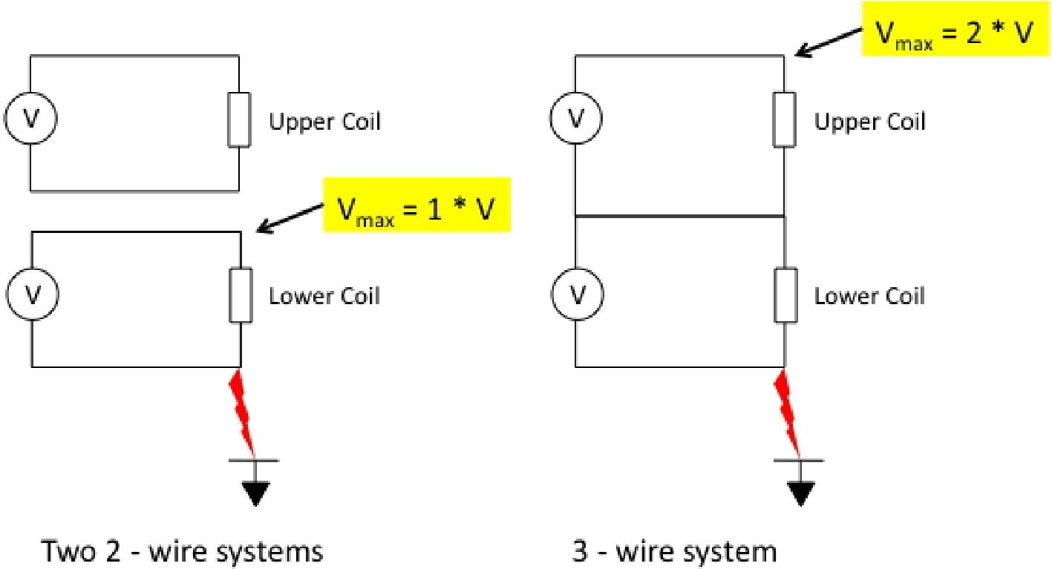
56

- “CHI Voltage” is a manual input for the Coaxial Helicity Injection (CHI) voltage, which can be imposed on the inner vacuum vessel of NSTX with respect to ground. This voltage adds to the voltage which must be withstood by the groudwall insulation of the inner PF coils.
57
- “Hipot voltage” is equal to 2E+1 where E is the maximum power supply voltage R[69] multiplied by the stack-up factor R[70] plus the CHI voltage R[71].
- “Voltage per turn” is the voltage per turn, equal to the total power supply voltage R[69] divided by the number of turns R[27].
- “Layer-layer voltage” is the maximum voltage between layers of the winding, equal to the voltage per turn R[73] multiplied by the number of turns per layer R[22] multiplied by 2. Note that the turns are wound vertically up and down in each layer (a layer-wound coil, not a pancake-wound coil).
- “Turn voltage stress fraction” is the ratio of the layer-to-layer voltage R[74] to the power supply voltage R[69].
R[77] through R[79] are manual inputs for the details of the turn insulation.
R[80] and R[81] “Turn insulation” is the total build of the turn insulation in inches and meters, respectively, equal to 2 times the number of half-lapped layers times the tape thickness times 1 minus the compression factor.
R[82] “Layer-layer barrier” is a manual input for the thickness of additional insulation located between layers in inches, and R[83] is the thickness in meters.
R[84] and R[85] “Turn insulation maximum stress (layer-layer)” is the maximum layer to layer stress, based on the layer-layer voltage R[74] divided by the total insulation thickness between layers, equal to 2 times the turn insulation build R[81] plus the layer to layer barrier R[83].
R[86] “Turn insulation dielectric strength constant” and R[87] “Turn insulation dielectric strength” are based on the approach outlined in the paper³² with excerpts included in the “Parameters” worksheet.
R[88] “Turn insulation safety factor” is the ratio of the dielectric strength R[86] divided by the maximum voltage R[74].
R[90] through R[92] are manual inputs for the details of the Ground insulation.
32 “Effects of cryogenic irradiation on electrical strength of candidate ITER insulation materials”, J. Schutz et al, Cryogenics 35 (1995) 759-762

R[93] and R[94] “Ground insulation” is the total build of the ground insulation in inches and meters, respectively, equal to 2 times the number of half-lapped layers times the tape thickness times 1 minus the compression factor.
58
R[95] and R[96] “Ground & turn insulation” is the thickness of the insulation between conductor and ground, equal to the turn insulation plus the groundwall, in inches and meters, respectively.
R[97] “Turn-ground stress” is the maximum average voltage stress on the insulation between conductor and ground under nomarl operating conditions and R[98] under hipot conditions, in kV/mm. R[99] and R[100] are the same in Volts/mil.
R[ 101 ] “Ground insulation dielectric strength constant” and R[ 102] “Ground insulation dielectric strength” are based on the approach outlined in the paper³³ with excerpts included in the “Parameters” worksheet.
R[103] “Ground insulation safety factor” is the ratio of the dielectric strength R[102] divided by the maximum voltage R[69] under normal operating conditions, and R[104] under hipot conditions.
R[105] through R[114] are related to the calculation of the coil inductance “Lcoil”
- per the formula cited³⁴ on the spreadsheet.
- “Lext” is a manual input for the external circuit inductance. A value equal to the standard TFTR Current Limiting Reactor (CLR) is assumed, equal to 265 microhenries.
- “Ltot” is the total circuit inductance equal to the coil R[114] plus external inductance R[115].
- “Rcoil” is the coil resistance computed as follows:
²RcenterN

R= | cu 20 | l  A | cu20

A
where:
R = coil resistance at 20ºC R[117]
cu20 = copper resistivity
at ^{oC}
20
Rcenter = radius to center of conductor pack R[21]
33 “Effects of cryogenic irradiation on electrical strength of candidate ITER insulation materials”, J. Schutz et al, Cryogenics 35 (1995) 759-762
34 “The Theory and Design of Inductance Coils”, Welsby, V. G, John Wiley and Sons, 1960, p. 44

N = number of turns R[27]
59
A = conductor area per turn R[14]
- ÒRextÓ is a manual input for the external circuit resistance. A value equal to the standard TFTR Current Limiting Reactor (CLR) is assumed, equal to 1 milliohm.
- ÒRtotÓ is the total circuit resistance equal to the coil R[117] plus external resistance R[118].
- ÒL/RÓ is the circuit time constant, equal to total inductance R[116] divided by total resistance R[ 119] .
- ÒOH induced voltage” is an estimate of the maximum voltage induced in the coil due to mutual coupling with the OH coil, which has a strong influence (the inner PF coil is concentric with the OH coil with relatively small gap in between). The value is computed in the worksheet Òcntmtx_circÓ based on M*dIoh/dt. Here the dIoh/dt maximum is estimated by taking the maximum OH power supply voltage and dividing by the OH self-inductance.
R[123] through R[130] provide an assessment of the performance with one series power supply section in circuit, while R[132] through R[139] provide the same with two series power supply sections. Normally it is expected that NS=1 will be used, but for CHI operations, NS=2 is more likely.
R[123] ÒOH induced voltage” is the per unit value of the induced voltage from the OH R[121] with respect to the power supply voltage rating R[69]. It is desirable that this value should be kept low to ensure that the coil current is controllable and not overpowered by induction from the OH.
R[124] ÒIdot_max=(V-I*R)/LÓ is an estimate of the maximum slew rate of the coil current at full current in amp-turn/sec, and R[125] the same in per unit per second. The requirement for CHI is 38kA-turns/ms³⁵.
- ÒI*RÓ is the resistive voltage drop across the coils.
- “Forcing factor” is the ratio of power supply voltage R[69] divided by I*R drop
R[125] and is a measure of the ability of the power supply to perform effective feedback control of the coil current. Higher values are more desirable, and the NSTX baseline values provide guidance on the range of acceptable values.
st st
R[128] ÒMax 1 harmonic (360Hz) is the 1
maximum harmonic produced by the power supply at a firing delay angle a = 90º in amps rms and R[129] in per unit of rated load current. Lower values are more desirable, and the NSTX baseline values provide
35 Ò PF Coil Current Requirements for CHI in NSTX-UÓ, R. Raman et al, 9/25/2009

guidance on the range of acceptable values. The tradeoff here is high slew rate R[124] which favors low inductance and high forcing factor, and low harmonic content which favors high inductance and lower forcing factor. The calculation is performed as follows³⁶:
60
where:

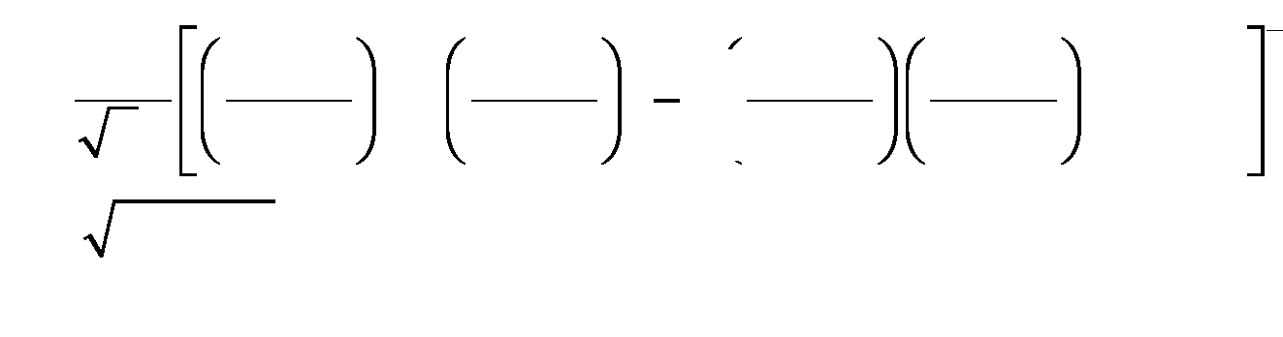
2
2
1
1
+
(h1)
(h+1)
2 ¹
(h 1)
1
(h + 1)
Z= R2 +X2 X = 2JL

I= V
2Z
1
2
cos(2)
h = 1st harmonic number (6 for 6-pulse, 12 for 12-pulse) a = firing delay angle = 90º for worst case
V = power supply voltage (no load DC average R[69]) R = total circuit resistance R[119]
f = 1st harmonic frequency = h*60Hz (worst case based on minimum MG frequency)
L = total circuit inductance R [ 116] .
R[130] “Volts/turn” is another rough measure of forcing factor to be compared with the base NSTX value.
3.4 WORKSHEET “PFC_DIMS”
This worksheet is used to identify the geometry of the plasma facing surfaces of the (new) center stack which were agreed to with project physics (J. Menard) . Since the outer PFCs already exist, they need not be addressed in this way. The results are included as Table 3-1 and Figure 3.1-1 of the NSTX CSU GRD (see Figure 3-8).
36 “DC Transmission Volume I”, E. Kimbark, Wiley-Interscience,1971, p. 307, eq 46 with u=0 (worst case)

Figure 3-7 PFC Dimensions 3.5 WORKSHEET ÒDISRUPTIONÓ
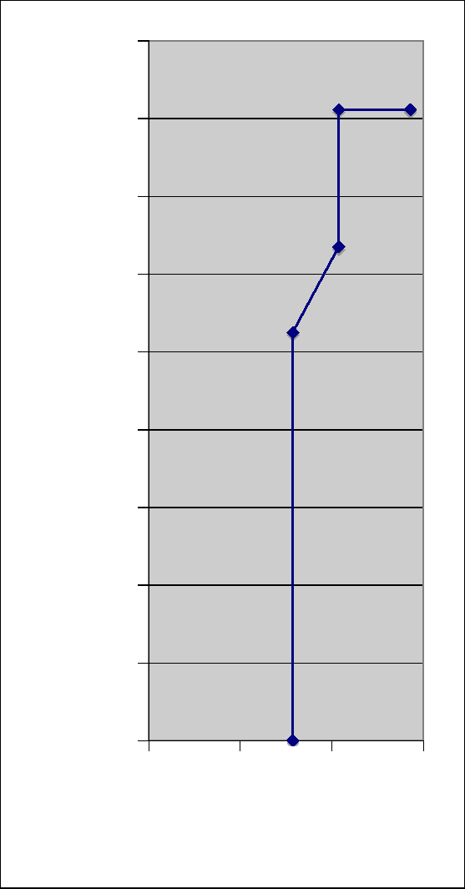
(m)
0.8
0.6
0.4
0.2
0.0
1.8
1.6
1.4
1.2
1.0
0.0 0.2 0.4 0.6
(m)
61
This worksheet is used to identify the geometry of plasma models to be used to evaluate disruption effects. The results are included as Table 3-1 and Figure 3.1-1 of the NSTX CSU GRD (see Figure 3-7).
These five cases are chosen based on engineering judgement to represent design-driving conditions for disruption events and vertical disruption events (VDEs). The centers of the various cases are chosen to be equidistant from the midpoints or the components they are associated with (i.e.IBD, OBD, SPP, PPP).
Geometry of the plasma facing surfaces is linked to worksheet ÒPFC_DimsÓ.

Figure 3-8 Disruption Geometries 3.6 WORKSHEET “DISRUPT_CIRC”
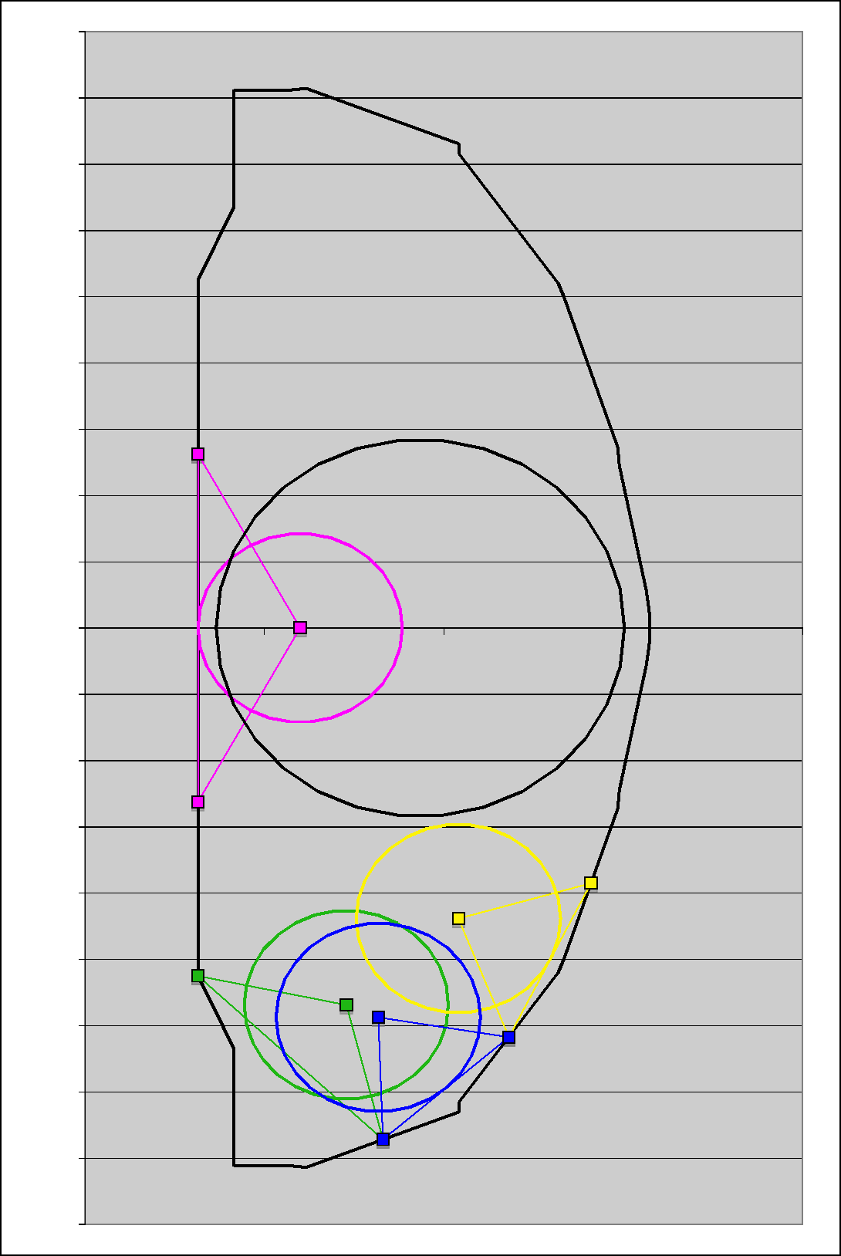
-0.20
-0.40
-0.60
-0.80
-1.00
-1.20
-1.40
-1.60
-1.80
0.80
0.60
0.40
0.20
0.00
1.80
1.60
1.40
1.20
1.00
0.00
0.50 1.00 1.50 2.00
62
This worksheet is used to estimate the shift in PF and OH coil currents in the event of a plasma disruption, based on a circular, uniform current density plasma model³⁷ and the corresponding mutual inductance matrix contained in worksheet “cntmtx_circ”. Methodology is as follows³⁸.
37 “CSU Plasma Model Comparison”, R. Hatcher, 21 February 2011
³⁸ “Coil Protection Current Transients”, R. Woolley, 13-270410-RDW-01, 27 April 2010

A flux-conserving adjustment is made to the coil currents based on the assumption that the plasma disruption occurs so fast that the resistive losses contributing to voltage drops in coil circuits during the disruption can be ignored. Then currents during the voltage transient obey the following vector-matrix differential equation:
Lcoils M plcoils
d I coils =0
dt I pl
,
M pl—coils Lpl
Here, the matrix on the left is the full mutual inductance matrix [M] but subdivided into coil and plasma parts. Note also the absence of resistance terms; this makes it possible to integrate the differential equation in closed form over the time interval of the plasma disruption, obtaining the following:

 | Lcoils M plcoils | I coils  Ipl after  disruption | I coils  Ipl before  disruption | =0
M
pl—coils Lpl

The first n-1 lines of this n x n equation can be rewritten as follows while the last line corresponding to the plasma is henceforth ignored.
L _{I}after — Ibefore + M _{I}after _ Ibefore 0
coils coils coils pl—coils pl pl
Since the postulated plasma disruption is assumed to completely extinguish the plasma current, the remaining terms are solved for the change in coil currents as follows:

before + L

_{I}after
coils = I
1
M
coils
coils
_{I}before pl—coil pl

We see that this formula provides fixed coefficients calculated directly from the inductance matrix to multiply by the initial pre-disruption plasma current in order to determine the disruption-induced increments to each coil current. The coefficients are in matrix [P] as follows:
63
1
P = Lcoils M plcoil
Thus the current shift is obtained by the vector multiplication [P] times the plasma current prior to the disruption.
In the worksheet, the above procedure is followed for multiple cases, to account for the
fact that the current shift depends on which circuits are active. This is necessary because

NSTX often operates without PF4 (i.e. PF4 open-circuited) and in the upgrade will often operate without PF1b and PF1c. To account for this effect, the yellow cells in the range B20:N20 are used to toggle circuits in and out of the calculation. When toggled out their self-inductance is set very high and their mutual inductance is set very low in the “Effective Inductance Matrix” contained in A39:O53.
64
So, for any condition specified in B20:N20 the [P] matrix is computed in B 116:B 128 and the current shifts in C 116:C 128.
Using a manual procedure, various combinations of coils in and out of circuit are set up and the current shifts copy/pasted into the cell range G116:M128.
The formulae in cell range D116:F:128 serve to pick out the worst case current shifts from all of the combinations, which are used later on in worksheet “Forces_Circ” which calculates the coil forces.
3.7 WORKSHEET “DISRUPT_SHAPED”
This worksheet is used to estimate the shift in PF and OH coil currents in the event of a plasma disruption, based on a shaped, uniform current density plasma model³⁹ and the corresponding mutual inductance matrix contained in worksheet “cntmtx_shaped”. Methodology is identical to that used for the circular plasma as described in section 3.6.
3.8 WORKSHEET “FORCES_CIRC”
This worksheet is used to compute the radial and vertical forces on the PF and OH coils based on a circular, uniform current density plasma model and the corresponding force influence matrices contained in worksheet “cntmtx_circ”.
The force influence matrices⁴⁰ are entered in cell range AJ3 1:BR47.
Coil currents are located in cell range W64:AI160 and are linked to worksheet “PF_Currents_Forces” where they are input.
Radial forces without plasma are computed in cell range AK65:AY160, and vertical forces without plasma in cell range BB65:BP160, as follows:
Fi = KiIi ^{j:} Ci,FjKjIj
j
where:
39 “CSU Plasma Model Comparison”, R. Hatcher, 21 February 2011
40 “NSTX-CSU Force Influence Matrix (Update)”, R. Hatcher, NSTX Memo13-05062011-REH-01

Fi = radial or vertical force on coil “i"
65
Ki, Kj = “headroom” multipliers on equilibrium current in coils i and j Ii, Ij = equilibrium current in coils i and j
C^{F}i,j= influence matrix coefficient relating force on coil i to current in coils i and j
Various combination vertical forces are computed in cell range BQ65:CP160 based on the vertical forces on individual coils computed in cell range BB65:BP160.
The TF outer leg moment and TF half -plane moment are computed⁴¹ in cell range CQ65:CR160.
Min and Max values from the above cell ranges are computed in R[163], R[164], and maximum coil current magnitudes in R[165].
Cell AQ 167 is used to enter the plasma current. Then the procedures described above are repeated for the case with plasma in rows 168 -277.
Finally, the procedures described above are repeated for the case without plasma following a disruption, in rows 168-277. Here the current shifts computed in worksheet “Disrupt_Circ” are added to the equilibria currents.
The min/max results from the above cases is linked to the summary values in rows 391- 397 and this data is used to create bar charts summarizing the findings.
3.9 WORKSHEET “FORCES_SHAPED”
This worksheet is used to compute the radial and vertical forces on the PF and OH coils based on a shaped, uniform current density plasma model and the corresponding force influence matrices contained in worksheet “cntmtx_shaped”. The methodology is identical to that described in the prior section 3.8.
3.10 WORKSHEET “PF_CURRENTS_FORCES”
This worksheet is used to compute the radial and vertical forces on the PF and OH coils, selecting the maxima of the results from the circular plasma model “Forces_circ” and the shaped plasma model “Forces_shaped”, and adding another case with coil currents only, set to min/max values which yield the maximum forces for each coil.
An additional calculation predicts the total power demand on the MG set for the various plasma equilibria cases.
41 “Out-Of-Plane (OOP) PF/TF Torques On TF Conductors in NSTX CSU”, R. Woolley, 13-260709, July 26,2009

The PF and OH currents corresponding to 96 different 2MA plasma equilibrium conditions are cut/pasted from a spreadsheet provided by J. Menard, the latest version of which is entitled:
66
ÒNSTX_CSU_PFscenarios_rampupOH_versionH_20100415_midbeta.xlsÓ
The plasma information and currents from this spreadsheet are pasted into cell range A64:AI160.
Note that there are actually 32 basic plasma shapes and for each shape an equilibrium is described with OH at three different values. The (+) value corresponds to the maximum value that the OH current could end at after ramping down from precharge at +24kA to ramp the plasma current from zero to 2MA. The second value is zero, and the third value is -24kA, the full negative current available. By including all three of these cases the worst case OH force influences are bracketed.
The calculations in cell range AK65:CR160 are performed in a manner identical to that described for ÒForces_CircÓ except with Ip=0. Note that the currents used in the calculation include the “headroom” in cell range AK57:AW57 and another manually input multiplier in AK59:AW59 called “turns adjust”. This feature was included early on when in some cases the number of turns in the coils assumed in the plasma equilibrium calculations and reflected in the equilibrum currents did not match the turns in the latest design. However, at this point all such multipliers are set to 1.0, and the net multiplier equal to the headroom multiplied by the turns adjust is computed in cell range AK61:AW61.
The calculations in rows 169-184 are used to determine the worst case conditions in the coil currents are allowed to deviate from the equilibrium currents and go to their minimum and maximum values so as to maximize a particular force condition. The blue cells in range W170:AI170 are varied using the XL Solver to achieve a selected worst case condition (e.g. to maximize or mimimize a particular force or force combination), subject to the constraint that the currents must be within the minimum and maximum values (the power supply limits) in cell range W173:AI174. Using a manual procedure, the XL Solver is used to minimize or maximize all forces and combinations, one at a time, in cell range AK170:CR170, corresponding to a total of 114 unique combinations. Each case is assigned a label in the green cells and after the result is obtained via the Solver it is copy/pasted into the cells in range AK173:CR174 as applicable, and the value of the currents is copy/pasted into cell range W180:AI293 for storage.
The XL Solver uses a non-linear optimizer which sometimes converges on a false solution. As a check against this, a method was developed and programmed into worksheet ÒFmin_maxÓ which computes the worst case min/max for each condition. These results are compared against the Solver results in cell range AK183:CR184. Note, however, that the Fmin_max method is imperfect due to the fact that in PF4 and PF5 currents the upper and lower currents are constrained to be equal since the upper and lower coils are in series. As a result the Fmin_max results are only a guide and do not always provide the correct answer.

The final results are contained in cell range AK211:CO218. These cells are linked to the ÒOH_PF_ForcesÓ and ÒCombination_Force_MomentÓ worksheets which are published on the web.
67
With the above results in hand, and with the reults from the circular and shaped plasma models in hand, the final summary of conditions is obtained in cell range AJ210:CO218 for all coils and coil combinations:
Min w/o pls = minimum due to equilibria currents and headroom, without plasma
Min w/pls = minimum due to equilibria currents and headroom, with plasma, worst case from circular and shaped calculations
Min post-dis = minimum due to equilibria currents and current shift after disruption, worst case from circular and shaped calculations
Min = minimum due to any combination of power supply and coil limits
Then we have the same with the maxima. These results are linked to ÒOH_PF_ForcesÓ and ÒCombination_Force_MomentÓ worksheets where the final summary is presented.
Columns CW through DA are used to find the min and max PF1A currents for each polarity of OH current. These results are used in worksheet “Base” R[201] and R[202] to find the worst case OH stress (which is strongly influenced by PF1A which is concentric with small gap in-between).
Columns DC through EJ are used to determine the flat top power demand of the overall load for each equilibrim case. Neutral beam parameters are entered in DD55:DD56. Active power consumption during flat top of the PF and OH coils is computed based on I²R in columns DC through DQ. The reactive power is combuted in columns DR through EE. Total apparent power is computed in EF. Various cases with differing neutral beam power and OH second swing operation are copy/pasted in EF through EJ. These results show that the upgrade power demand can be satisfied using a single MG set (a mission objective).
3.11 WORKSHEET “FMIN_MAX”
This worksheet is used to predict the worst case minimum and maximum force conditions on the coils based on the coil current limits. Using the fo rce influence matrices (columns A through R) and the min/max coil currents (columns S and T), logical statements are coded into columns U through AC identify the minimum and maximum force conditions. Due to limitations in the technique, the method does not apply to PF4 and PF5 because in these circuits the upper and lower coils are in series.

3.12 WORKSHEET “CNTMTX_CIRC”
68
This worksheet is used to capture the “contracted mutual inductance matrix” (abbreviated ÒcntmtxÓ) based on a circular plasma model, along with external circuit inductances and resistances.
Cell range B3:O16 contains the coil and plasma inductances (supplied by R. Hatcher).
Cell range B18:N18 contains the coil resistances computed by the writer via PPPL Magnetics Library⁴² code Òicc6.fÓ. The mutual inductance matrix is also calculated, but only the resistance file is used here (the inductanc file supplied by R. Hatcher is used). Input data in file Òiccin.dÓ follows:
14,3,14,0 1,2,3,4,5,6,7,8,10,12,14,16,18,20
0.2421 1.0604 2.1208 0.0693 442.0 2 1.724 0.701 0 0.0
0.3193 1.5906 0.4578 0.0606 64.0 1 1.724 0.8610 0.0
0.3193 -1.5906 0.4578 0.0606 64.0 1 1.724 0.8610 0.0
0.4004 1.8042 0.1812 0.0336 32.0 1 1.724 0.794 0 0.0
0.4004 -1.8042 0.1812 0.0336 32.0 1 1.724 0.794 0 0.0
0.5505 1.8136 0.1664 0.0373 20.0 1 1.7240 0.8560 0 0.0
0.5505 -1.8136 0.1664 0.0373 20.0 1 1.7240 0.8560 0 0.0
0.7999 1.9334 0.0680 0.1627 14.0 1 1.724 0.7410 0.0
0.7999 1.8526 0.0680 0.1627 14.0 1 1.724 0.741 0 0.0
0.7999 -1.9335 0.0680 0.1627 14.0 1 1.724 0.7410 0.0
0.7999 -1.8526 0.0680 0.1627 14.0 1 1.724 0.7410 0.0
1.4945 1.6335 0.0680 0.1864 15.0 1 1.724 0.692 0 0.0
1.4945 1.5526 0.0680 0.1864 15.0 1 1.724 0.692 0 0.0
1.4945 -1.6335 0.0680 0.1864 15.0 1 1.724 0.692 0 0.0
1.4945 -1.5526 0.0680 0.1864 15.0 1 1.724 0.692 0 0.0
1.7946 0.8072 0.0680 0.0915 8.0 2 1.724 0.752 0 0.0
1.8065 0.88810.0680 0.1153 9.0 2 1.724 0.672 0 0.0
2.0128 0.65210.0685 0.1353 12.0 2 1.724 0.773 0 0.0
2.0128 0.5780 0.0685 0.1353 12.0 2 1.724 0.773 0 0.0
0.9340 0.0000 0.0000 0.5700 1.0 1 1.0 0. 999 10.0 10*0
In the above:
Line 1 = #coil groups, 3 for MKS units, coil group # of plasma, # of passive loops Line 2 = #of coil beginning each group
Remaining lines up to last line = r, z, dz, dr, symmetry, resistivity, fill factor, ncc, alf
42 “Documentation of EAD Magnetics Codes”, EAD-3705

where:
69
symmetry 1 = for single coil, 2 for mirror image coils w.r.t. midplane, -2 for mirror image coils with opposite current directions
resistivity = resistivity * 10⁸ in ohm-m
fill factor = conducting area divided by conductor pack area
ncc = 0 for rectangular coil
alf = 0 for rectangular coil
Last line 10*0 marks the end of file.
Cell range B21:O34 is used for manual input of the external circuit inductances, and B36:N36 the external circuit resistances. The nominal value of external circuit inductance is 265µH based on the standard FCPC CLR which dominates the inductance. However, in the OH, an new CLR is being purchased for the upgrade, assumed equal to 1mH. The external resistances arise from the CLRs plus the additional cable and bus impedance. Values entered were supplied by S. Ramakrishnan.
Cell range B40:O53 contains the total circuit inductances, obtained by adding the coil and external inductances. B55:N55 contains the total circuit resistances obtained by adding the coil and external resistances.
Cell range B60:N72 provides an estimate of the maximum voltage that can be induced on a coil if that coil is open circuited and all other coils are ramped at maximim rate of change of current (“Idot”) based on maximum power supply voltage. For each coil the maximum Idot is taken to be V/L where V is the number of power supply sections entered in B58:N58. Then the voltage induced on each coil is taken as the sum of the M*Idot terms in O60:O72.
The approach described above is very approximate and overestimates the induced voltage because the Idot values in each circuit are mutually influenced by one another. To perform a more accurate calculation, the program LRSIM⁴³ was used and the results are summarized in Q60:R72. These calculations⁴⁴ were important in the design of the new inner PF coils which have a strong coupling to the OH coil.
Cell range B80:N93 provides the data needed as input to the Power Supply Real Time Control code “PSRTC” which is identical to the totals in B40:O53 and B55:N55 except that the standard FCPC CLR values are subtracted out.
43 “Simulation Code LRSIM and Related Codes”, C. Neumeyer, 11/24/97
44 “NSTX_CSU_Inner_PF_100202.ppt”, C. Neumeyer, weekly meeting presentation

3.13 WORKSHEET “CNTMTX_SHAPED”
70
This worksheet is identical to the first 55 rows of “cntmtx_circ” except that the mutual inductance matrix is based on a shaped, constant current density plasma model.
3.14 WORKSHEET “HEAT_LOADS”
This worksheet is used to estimate the heat loads on the PFCs, which populate Table 3-2 in the GRD. The methodology⁴⁵ and terminology was developed by S. Kaye and expanded on by the writer. Columns B, C, and D cover the cases of “Natural Divertor” (ND), “Single Null Divertor” (SND), and “Double Null Divertor” (DND). As it turns out the ND case (inboard limited) was never used, so for the CS upgrade we only consider cases SND and DND as delineated in colums E, F, and G.
- “Major Radius [R0]” is the major radius, linked to worksheet “Base”.
- “Aspect Ratio [A]” is the aspect ratio, linked to worksheet “Base”.
- “Minor Radius [a]” is the minor radius, linked to worksheet “Base”.
- “Total Heating power (nbi+rf+ohmic) [Pheat]” is a manual input for the total auxiliary + ohmic heating input to the plasma. For NSTX_CSU, ignoring ohmic heating (relatively small) the maximum rf + nbi power is 14MW per NSTX CSU GRD Table 3-3, resulting from 4MW RF + 2*5MW NBI.
- “Fusion Power Gain [Q]” is a manual input for fusion power gain, set to zero for NSTX CSU (minimal fusion power production in relatively cold D-D plasma).
- “Fusion Power [Pfusion]” is the total fusion power, equal to the heating power R[6] multiplied by the gain R[7].
- “Alpha Power [Palpha]” is the fusion alpha power, equal to 1/5 of the total fusion power R[8].
- “Neutron Power [Pneutron]” is the fusion neutron power, equal to the total fusion power R[8] minus the alpha power R[9].
- “Power fraction radiated from core [frad_core]” is a manual input for the power radiated from the core, set to 0.125 based on NSTX experience.
- “Power fraction in SOL [fsol]” is the fraction of power which exhausts along the scrape-off-layer (SOL) to the divertors, equal to 1 minus the radiat ed power R[11].
45 “NSTX Divertor Heat Flux Estimates”, S. Kaye, 10/24/96

- “Total power in SOL [Psol]” is the SOL power, equal to the sum of the heating power R[6] plus the alpha power R[9] multiplied by the SOL power fraction R[12].
71
- “Single Null (1) or Double Null (2)” is a manual entry for the number of divertor separatrices.
- “SOL Power fraction to Center Stack [fcs]” is a manual input for the fraction of SOL power to the center stack, set to zero for NSTX CSU because the ND case is not applicable.
- “Total Power to Center Stack [Pcs]” is the SOL power flow to the center stack, equal to the SOL power R[13] multiplied by the center stack power fraction R[16].
- “Power Dissipation Half-Height” is a manual input for the axial length, above and below the midplane, which is subject to power dissipation from the SOL.
- “Power Dissipation Area [Acs]” is the area for center stack power dissipation,
equal to 2rdz where r is the center stack radius R0 -a (R[3]–R[5]) and dz is the axial distance, equal to 2 times the half height R[18].
- “Average Loss Power Flux [qcs]” is the area-average power dissipation on the center stack during a pulse, equal to the power R[17] divided by the area R[19].
- “Peaking factor” is a manual input which relates the peak power flux to the area-average power flux on the center stack.
- “Peak Power Flux” is the peak power flux on the center stack, equal to the area- average R[20] multiplied by the peaking factor.
- “Tpulse” is a manual input for the design-basis plasma pulse duration. For the CSU it is the same as the plasma flat top time, equal to 5 seconds.
- “Energy Flux Center Stack” is the area-average energy flux on the center stack, equal to the average power flux R[20] multiplied by the pulse duration R[23].
- “Trep” is a manual input for the pulse repetition period.
- “Power Flux Center Stack” is the time- and area-average power flux on the center stack, equal to the area-average power flux R[20] multiplied by the pulse duration R[23] divided by the repetition period R[25].
- “SOL Power fraction to divertor [fdiv] is a manual input for the fraction of SOL power to the inboard divertor.
- “Power fraction radiated at divertor [frad,div]” is a manual input for the fraction of SOL power radiated before it reaches the divertor, set to zero for NSTX since this mode of operation (gas puffing at the divertor) is not available on NSTX.

- “Up/Down asymmetry [Ku/l]” is a manual input to reflect uneven power dissipation on the upper and lower divertors, set to zero for NSTX.
72
- “Power flux width at midplane [mp]” is a manual input for the SOL width at the midplane, set to 10cm based on NSTX experience.
- “Flux expansion factor [fflux]” is a manual input to account for the expansion of the flux surfaces associated with the SOL at the point of impingement on the divertor plates.
- “Private flux region additional area factor [fpfr]” is a manual input to reflect additional power deposition area in the divertor private flux region.
- “Incidence angle [alpha]” is a manual input for the angle at which the flux surfaces intercept the divertor plates.
- “Radius to strike point [Rsp]” is the radius to the strike point of the last closed flux surface on to the divertor plate, linked to worksheet “PFC_Dims” entry for the radius of the inboard divertor.
- “Power flux width at divertor [div]” is the width of the deposition zone at the divertor, equal to the midplane SOL width R[31] multiplied by the flux expansion factor R[32] multiplied by 1 plus the additional private flux area factor R[33], then divided by the sine of the incidence angle R[34].
- “Divertor target area” is the area on the divertor plate receiving SOL power, equal to to 2rdr where r is the strike point radius R[35] and dr is the width of the deposition zone R[36].
- “Power to divertor” [Pdiv] is the maximum SOL power incident on the divertor plate, equal to the total power in the SOL R[13] divided by the number of divertors R[14] multiplied by the fraction of power to the inboard divertor multiplied by 1 minus the radiation fraction R[29] multiplied by the upper/lower asymmetry factor R[30].
- “Average power flux [qavg]” is the area-average power dissipation on the inboard divertor during a pulse, equal to the power R[38] divided by the area R[37].
- “Peak power flux [qpeak]” is the peak power flux, equal to the area-average R[39] divided by 1-exp(-1) based on the assumption of 1 e-folding of the power over the power flux width.
- “Total Power in Inboard Divertors [Pibd]” is the number of divertors R[14] multiplied by the power per divertor R[38] divided by the asymmetry factor R[30].
R[43] through R[56] cover the outboard divertor using the same methodology as described for R[28] through R[41] for the inboard divertor.

- “Total Power to First Wall [Pfw]Ó is equal to the total heating power R[6] plus the alpha power R[9] minus the power to the center stack R[17] minus the power to the inboard divertors R[41] minus the power to the outboard divertors R[56].
73
- “Area of First Wall [Afw]Ó is estimated (conservatively) by taking the area of the plasma which is calculated as follows:
2R₀² 1+x²
Aplasma = 4 A 2
where:
R0 = major radius (“Base” R[8]) A = aspect ratio (“Base” R[12]) is = elongation (“Base” R[13])
- “Average Neutron Power Flu x [qnfw]Ó is the neutron power R[10] divided by the area R[59].
- “Average Loss Power Flux [qfw]Ó is the area-averaged power flux to the first wall, equal to the power R[58] divided by the area R[59].
- “Peaking factor” is a manual input to reflect local peaking in the power flux.
- “Peak power flux” is the peak power flux, equal to the average R[61] multiplied by the peaking factor F[62] .
- ÒTpulseÓ is a manual input for the pulse duration.
- ÒW first wall” is the area-averaged energy flux per pulse to the first wall.
- ÒTrepÓ is a manual input for the repetition period.
- ÒPavg first wall” is the time- and area-averaged power flux to the first wall. 3.15 WORKSHEET “PARAMETERS”
This worksheet is used to input various parameters used elsewhere in the calculations. 3.16 WORKSHEET “PF_COIL_PARAMETERS_ANSYS_INPUT”
This worksheet reformats information on the worksheet ÒPF_Coil_SummaryÓ according to the preferred format of ANSYS analysis, making it easier and less error-prone to revise their input when changes occur.

Appendix I – Derivation of G-Functions
74
Derivation of G Functions for CDA 107 Copper Over Range 0 – 120ºC Assume:
20ºC Resistivity = 1.7241µ-cm * 100/100.2
Temp Coeff of Resistance () = 0.0041/deg C
20ºC Specific Heat = 393.5J/kg-deg C
Temp Coeff of Specific Heat () = 0.105 J/kg-deg C/deg C
Density = 8.95 gm/cc
P_{e} = electrical resistivity
eT0e = electrical resistivity at temperature T0e
T = temperature
e = PeT0e (1+ (X(T-T0e))
C_{p} = specific heat
CpT0c = specific heat at temperature T0c
C_{p} = CpT0c + (T-T0_{c})
For an adiabatic conductor:
_{e}J²dt = dCpdT
Rearranging and integrating results in the G function:
J²dt = I Pd p
J_{e}
f C dT G(T )

Curve fits⁴⁶ were used to develop G(T) and T(G) functions for Cu over the temperature range of interest. These are of the form:
G(T) = gt₁ + gt₂T + gt₃T ² + gt₄T ³ T (G) = tg₁ + tg₂G + tg3G2 + tg4G3
Coefficients are as follows (see also “Parameters” worksheet):
gt1 | 1.361e-1 | tg1 | 6.295e13
gt2 | 4.549e-15 | tg2 | 2.093e14
gt3 | 5.331e-32 | tg3 | -2.871e1 1
gt4 | 0 | tg4 | 0

On this basis the conductor current density J which is allowable given a temperature limit T can be determined as follows:
G (Ta llow) — G (T0)
TESW
J=

46 Spreadsheet “Copper G & H Functions CDA10700”
75

Appendix II – TF Stress Formulae
76
Approximate TF Center Post Stress Formulae
Robert D. Woolley
Abstract
This note recommends formulae to assess stress in the TF center-post portion of a low aspect ratio tokamak, assuming constant current density and assuming current parallel to the cylinder axis. These recommended formulae, which are adapted directly from references instead of being derived herein, are approximate rather than exact, but their deviations from exact stress solutions are claimed to be small. These formulae address conditions with only the TF in operation, ignoring e.g. torsional interactions between TF currents and leakage poloidal magnetic flux from OH windings. However, they should be suitable for use in searching parameter space for optimize d designs, and are simple enough to be implemented as spread sheet algorithms.
References
- A Treatise on the Mathematical Theory of Elasticity, by A.E.H. Love (of Oxford, UK). (First edition 1892, Fourth edition 1927) 1st American edition=4th Ed. NY Dover Publications 1944 (In PPPL Library)
- Theory of Elasticity, by S.P. Timoshenko and J.N. Goodier, (First edition 1934) 3rd Ed. McGraw-Hill, Inc. 1970 (In PPPL Library)
- Mechanics of Materials, by E.P. Popov , (First edition 1952) 2nd Ed 1976 (In PPPL Library)
The Problem
The TF center post is modeled as a solid rod of circular cross section with a constant diameter independent of vertical position along the axial direction. The cylinder's total

length, 2c, is typically much larger than its diameter, 2a, in the low aspect ratio tokamaks of interest for possible magnetic fusion applications.
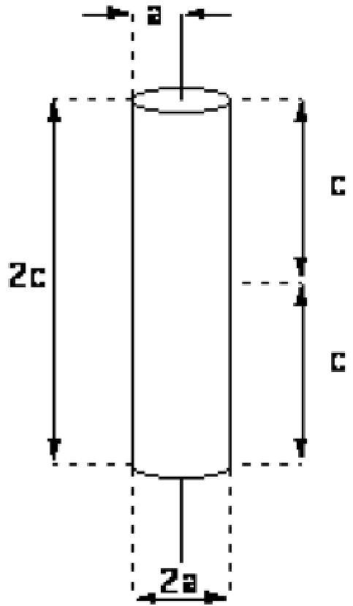
A cylndrical coordinate system, (r, , z) , is used herein, with the z-axis coinciding
with the cylinder's axis and with the origin located at the cylinder's center. The state of
stress at any point is given in these cylindrical coordinates by the second order symmetric
rr r rz
tensor, r . (P(P z . Of special interest is the combination of these stress
rz z zz
components which were identified by Von Mises as correlating with and predicting material failure.
Body Forces
Gravitational acceleration forces are neglected in this model, which only includes the

volumetric electromagnetic force density,
~
F v =
~J B . Here we take current density as

a constant, J = J öz , where ^{öz} denotes an axial unit vector. Together with Amperes Law, V x B = µ0i , this implies that
77
µ0Jr  B (r) = ₂ | ö

where ^{ö} is a toroidally directed (i.e., azimuthal) unit vector. Thus, the maximum toroidal field strength is developed at the edge of the center post and its strength is

µ0Ja
78
Bmax = 2
This lets us express the constant current density as
J= ²Bmax
µp a
Then the magnetic field within the center post can be expressed as
B (r) = I r Bmax ö
a
and the volumetric electromagnetic force density becomes
F v _ J B
²Bmax  y0a | zö | r  a | Bmax P ö

2Bm 2
,u0a²
ax rö r
where r is a radially directed unit vector.
Surface Forces
Since the resultant vector sum of body forces over the entire cylinder is zero, surface forces are not explicitly included herein. Uniform z-direction tension or compression can be superposed, however, to evaluate TF system effects on center post Von Mises stresses.
Rotating Cylinder Solutions
References 1 and 2 each include various analyses of stresses developed by centrifugal
(inertial) forces in a rotating cylinder. For an object rotating at a constant angular rate, ,
about its "z- axis", the apparent body force per unit volume experienced in the rotating
frame attached to the body varies as i_{v} = (CO 2 ) rö r , where p is mass density. This
body force distribution is similar to the one for the TF Center Post problem. In both cases, force is radially directed and has a strength directly proportional to the radial distance from the cylindrical axis of symmetry. Since the body shapes are also the same (i.e., both cylindrical), the derived stress formulae must be directly applicable with only a

change in the constant coefficients. We need only multiply the results for the rotating
79
²Bmax²
cylinder by the constant factor, — .
2 2
w joµ0a
It is important to note that rotating cylinder solutions cannot be used to calculate TF center post stresses in situations including a central hole or any departures from constant current density. Centrifugal force density in a rotating cylinder is directly proportional to radius, regardless of whether or not a central hole exists. But electromagnetic force density in a center post with a hole is not proportional to radius.
(1) Long Shaft Formulae
The most appropriate set of formulae are presented in Reference 1's Section 102 Rotating Cylinder, Case (a) Rotating Shaft. It begins on its page 146 with the following introduction "An approximate solution can be obtained in the case of a long shaft, by treating the problem as one of plain strain, with an allowance for uniform longitudinal extension, e." This approach properly requires zero surface stress on cylinder sides, i.e.,
rr _{r}=_{a} = 0. The approximation assumes throughout the cylinder that = 0 (which is
rz
not precisely true) and relaxes the zero surface stress requirement on top and bottom, i.e., the requirement that ⁶zz z=±c = 0 for all r, 0 <_ r <_ a , instead merely requiring that the
r=a
total surface force on top or bottom be zero, i.e., that f zz r dr = 0 at z= ±c. The
r=0
Reference 1's stress formulae results for the rotating shaft are
2(a2 — r 2) 32
=0
=0
=0
8 1— V -r

rr —
2
=
2 1+2
32
r 2
a —
8 1 1
²(a² — 2r²)
zz — 4 1— V °rz
Applying the constant, we obtain the recommended center post stress formulae:

=  = 0 . Its results for a thin rotating  r=a | Bmax² |  | 32 |  | 1+2 | r | 2 | =0
 | 2µ0 |  | 2(1— ) |  | 2(1— ) | a

zz | Bmax²  2,u0 1 | 1-2^{r}  a | 2 | rz=⁰

It is of interest that stress components in these formulae vary with r but not with z or c. (2) Thin Disk Formulae
rr = | Bmax² | 32 _{1_} (r)  2(1— ) a | 2  r = 0
 | 2µ0

These formulae may not be appropriate for our purposes since they assume a cylinder with c<a, and we are interested in c>>a.
References 1 and 2 both present the case of a thin cylindrical disk, arriving at identical
results. They treat this problem as one of plane stress. Their approximate solution
satisfies ZZ = 0 and = 0 throughout the body, which also forces surface pressure
rz
on the top and bottom faces to be zero. However, it does not force the lateral surface
pressure to be everywhere precisely zero. Instead, their approximate solution requires a
z=c

radial pressure integral to vanish, i.e., ~f rrdz
z=c

disk are:  80  rr | = ^{X2}"(3+v)(a² —r2)+0)2PV1+v(c2-3z2) r =0  8 6 1  = ⁰¹²⁰((3+v)a² —(1+3v)r2)+w2pv1+v(c2-3z2) rpZ =0  8 6 1

zz=⁰ rz=⁰
Multiplying these by our constant, we obtain the stress distribution in a short TF center post:
rr = | Bmax 2  2µ0 | (3 + )  2 | r  1 a | 2 | + | 2v)~1— 1+  3 | c | 2 | 3^{z}  a | 2 |  | =0
 |  |  |  |  |  |  | a |  |  |  | r

2
r
+
a
Borax 2
(3 + )
2µ0 )( 2
(1 + 3)
2
^{2v})~1-¹⁺
3
2
2
c
3^{z}
a
=0
a

zz=⁰ rz=⁰
81
Inspection of these thin disk formulae reveals they predict radial and hoop stress components would both grow without bound as cylinder height is increased. This nonphysical prediction is avoided by restricting their application to cases where c<a.
3. Extremely Thin Disk Formulae
Reference 2 includes a particularly simple development of the 2-dimensional axisymmetric plain stress case, which only applies for extremely thin disks, where c<<a. Its results are
(3+)(a² r²)
rr = | 2
 | 8

((3 + ) a ² (1+ 3)r 2 )
2
=
8

Since this analysis is 2-D, the z-components are all zero by definition, i.e., ZZ = 0 , z = 0 , and rz = 0 . With no applied azimuthal force, we also have r = 0 .
82
Multiplying these by our constant, we obtain the radial and hoop stress distribution in an infinitesimally short TF center post:
rr = | Bmax² | 3+ | 1—  r  a | 2
 | 2 µ0 | 2

Bmax² 3+ 1+3 r 2
2µ0 2 2 a
It is of interest to note that the thin disk formulae reduce to these extremely thin disk formulae in the limit as c —> 0. Thus, these are not really independent formulae.
Comparison of Stress Components in Recommended vs Extremely Thin Disk Formulae
in order to approximate OFHC copper, and we normalize
1
We set Poisson's ratio to =
3
2
the stress components to the maximum magnetic pressure, p_{mag} = B2µb o . Then the
recommended formulae derived from the long shaft case become:
rr 7 _{1—} r 2
pmag LongShaft 4 a
7 5 r 2
pmag ) LongShaft 4 4 a

zz r 2 ₁
pmag LongShaft a 2
Similarly, the extremely thin disk formulae become:

rr
pmag ExtremelyThinDisk
₁_ r
3 a
2
5

5 r 2
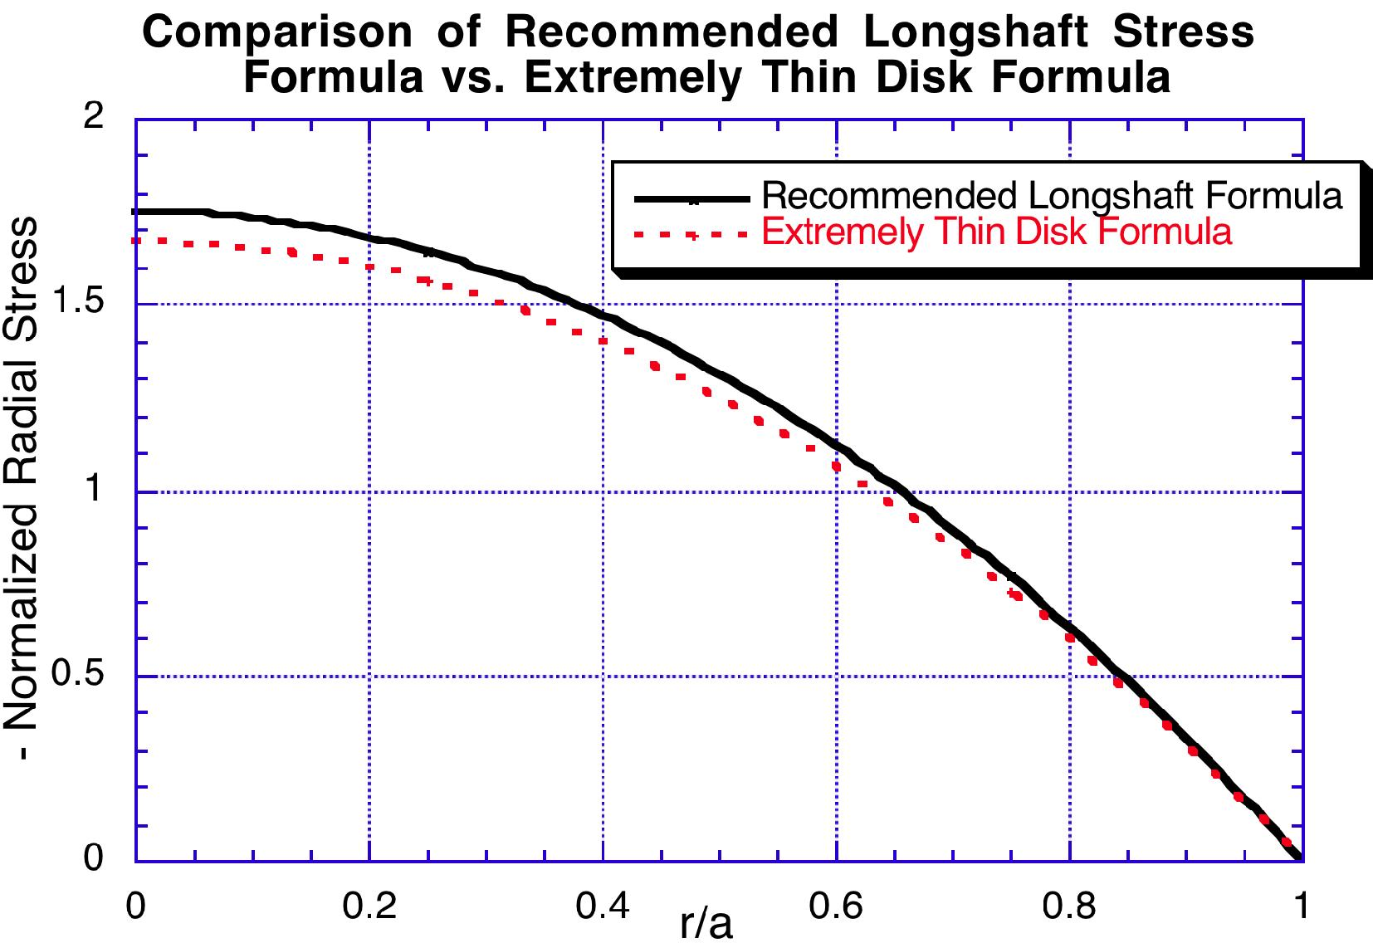
83
pmag ExtremelyThinDiskt 3 a
zz =0
pmag ExtremelyThinDiskt
The formulae, recommended and otherwise, are compared in the following three graphs:

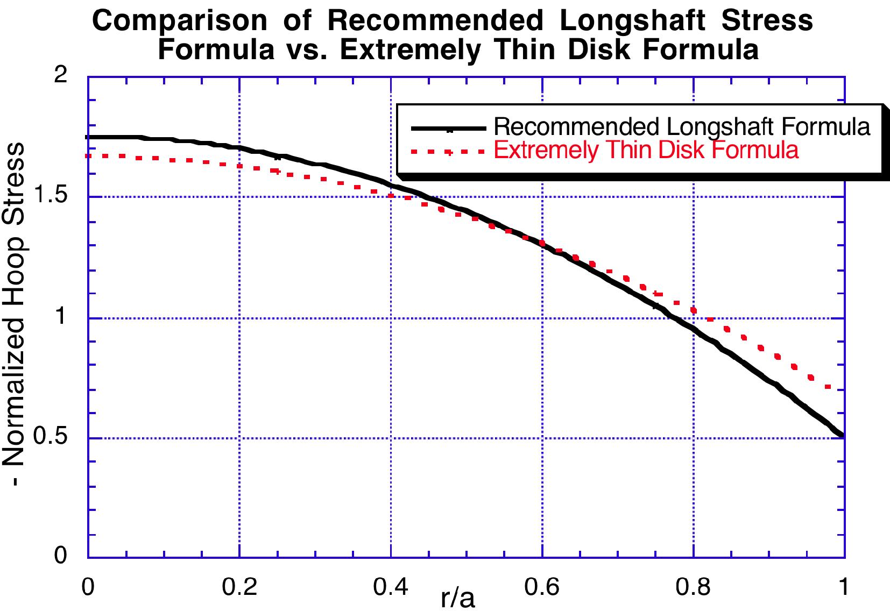
84

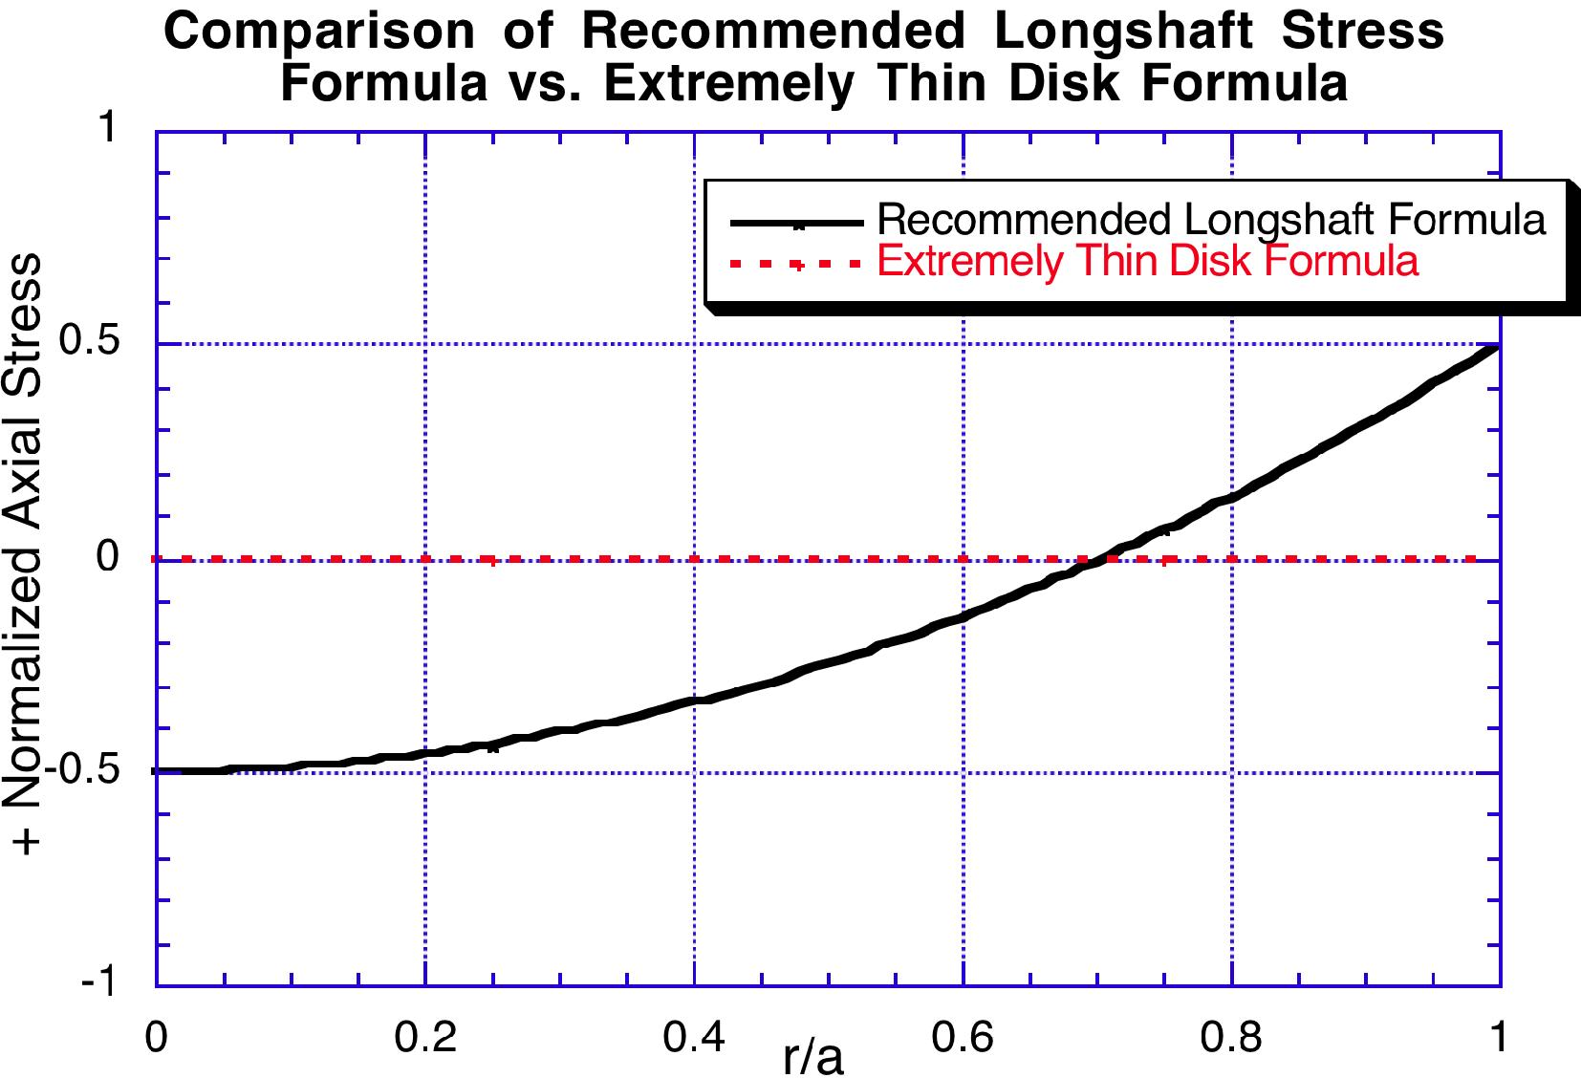
Von Mises Stress
85
Reference 3 asserts that in copper and in other ductile metals, the Von Mises Stress is a better predictor of material failure than the Tresca stress. The Von Mises stress can be expressed simply in terms of three principal stresses, as
(61 —62)² +(62 — 63)² + (63 — 1 )2
VonMises = | 2

Here, the principal stresses are the normal stresses in the directions of the principal axes, which are the directions for which shear stresses are zero. Our recommended LongShaft formulae have their shear stresses zero in the cylindrical coordinate system, so the three principal stresses are simply 61 = Err; 62 = aW; 63 = 6_{zz} . Thus, we compare
below the Von Mises stress, normalized to the maximum magnetic pressure, for recommended and Extremely Thin Disk formulae:

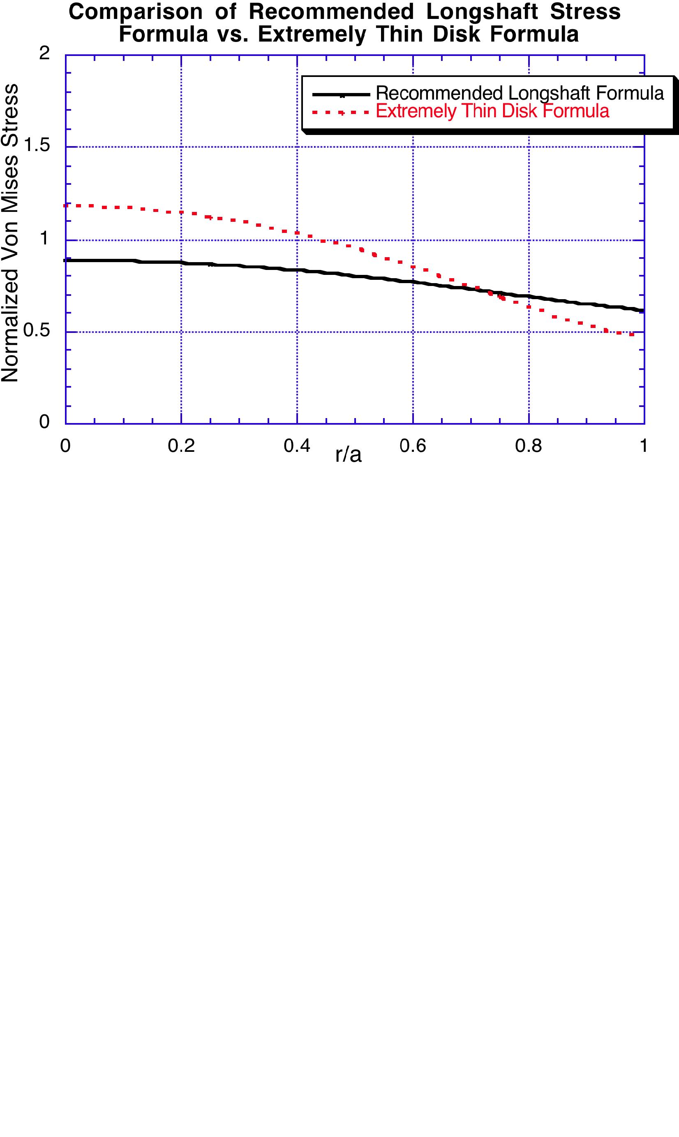
86

